**Project #4**

**Remote Test Harness Guide and Comparison**

**Instructor: Dr. Jim Fawcett**

Project 3 Comparison:

This project fully implements all the features mentioned in project 3.

Batch Files:

Compile.bat – Compiles all the packages.

Run.bat – Starts the the test executive GUI, the repository, the client and the test harness servers.

Screen1: GUI

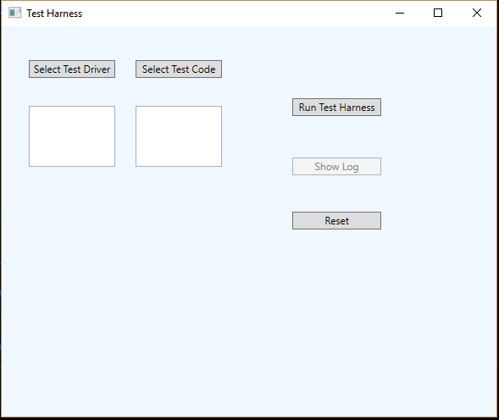

Screen 2: For test case 1, select TestDriver1.dll after clicking Select Test Driver

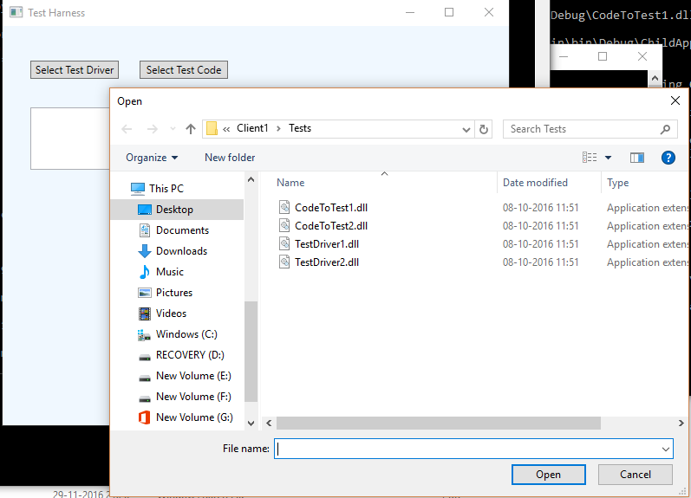

Screen 3: For test case 1, select CodeToTest1.dll after clicking Select Test Code

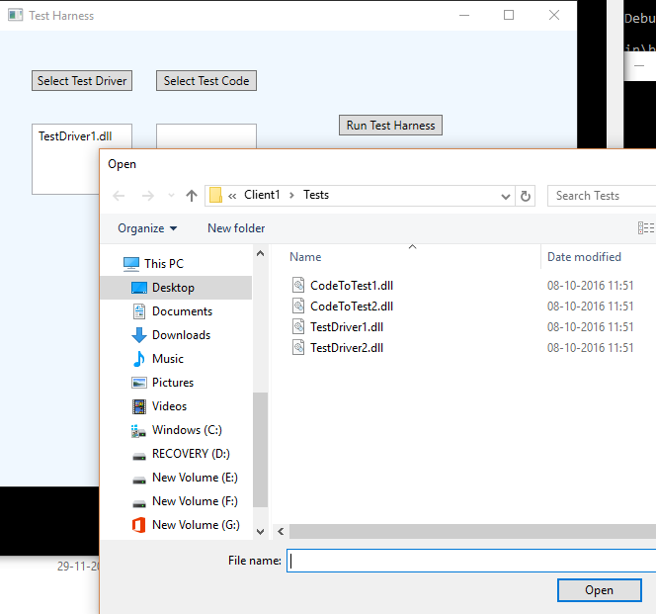

Screen 4: After clicking Run Test Harness, the test files would be sent to the Repository server and an xml test request would be sent to the Test Harness server.

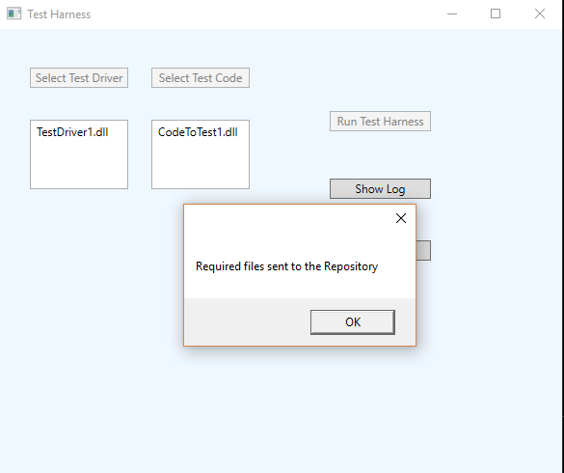

Screen 5: The test harness gets the files from the repository and executes it, following which we get the below screen

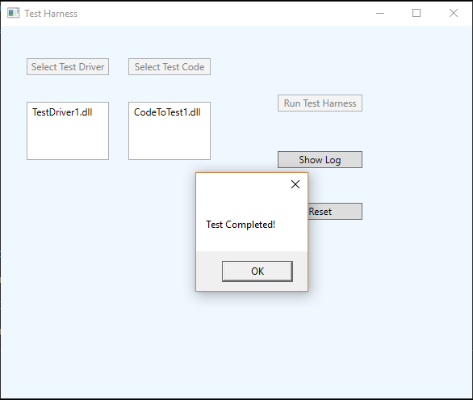

Screen 6: On click of Show Log, we get the log file of the executed test

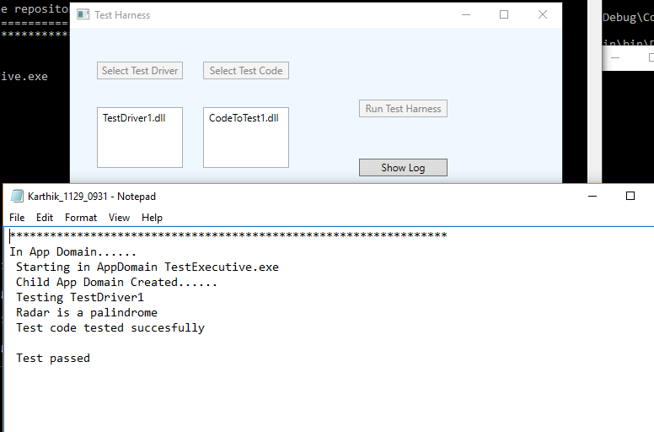

Screen 7: On click of Reset, we can go forward with the test case 2, by selecting the TestDriver2 and CodeToTest2 dlls respectively

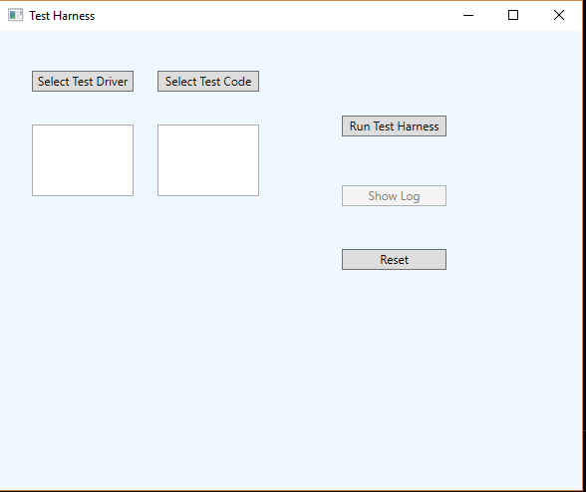

Screen 8: After test case 2 execution

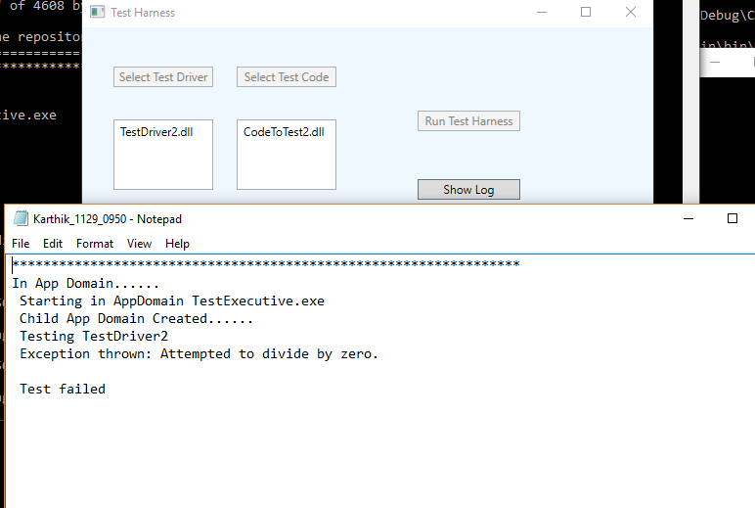

Screen 9: Console of the test harness server receiving the xml test request from the client server

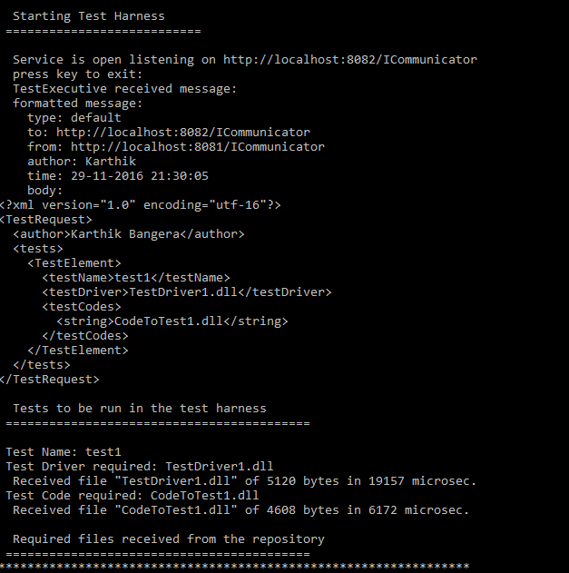

Screen 10: Extended console of test harness server showing the tests run

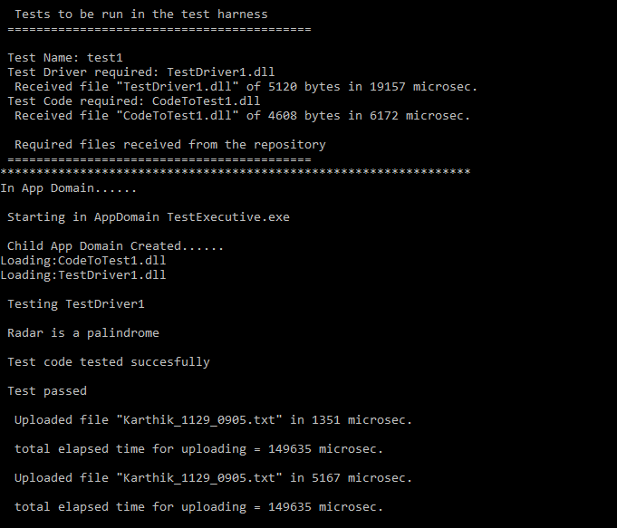

Screen 11: Similarly for test case 2

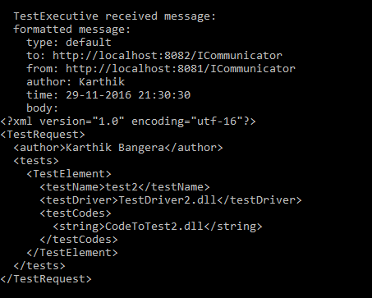

Screen 12: Extended test harness console of test case 2

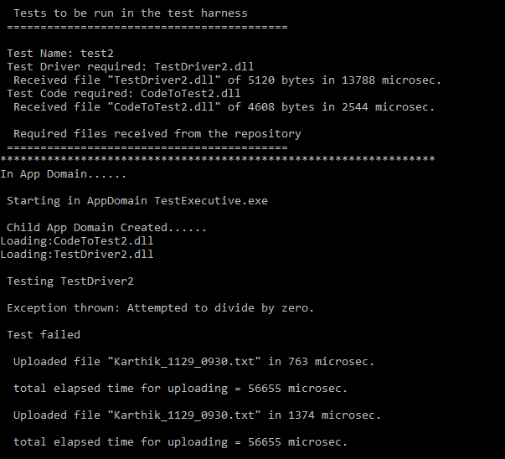

Screen 13: Repository console which receives the files at first from the Client server, sends it over to the Test Harness server on its request and then receives the log file from the test harness server

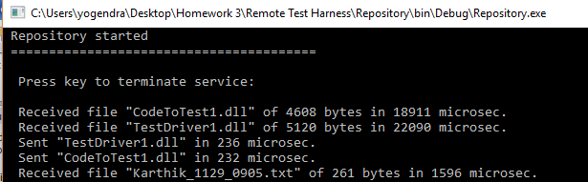

Screen 14: Client server console of receiving the log file from the Test Harness server

