

**Campaign Management System**

**A PROJECT REPORT**

SUBMITTED IN PARTIAL FULFILLMENT OF THE REQUIREMENT FOR THE AWARD OF THE DEGREE OF

**COMPUTER ENGINEERING**

**TO**

**RK UNIVERSITY, RAJKOT**

**SUBMITTED BY**

Name of Student Enrollment No.

Bhargav Kalaria 16SOECE1078

**UNDER THE GUIDANCE OF**

**Internal Guide** **External Guide**

JASMIN JASANI VANDITA DHARIYA

Assistant Professor Human Resource

RK University The Gateway Group of Companies

Rajkot Ahmedabad Gujarat

May 2020



**SCHOOL OF ENGINEERING, RK UNIVERSITY, RAJKOT**

# **DECLARATION**

I hereby certify that I am the sole author of this project work and that neither any part of this project work nor the whole of the project work has been submitted for a degree to any other University or Institution. I certify that, to the best of my knowledge, my project work does not infringe upon anyone’s copyright nor violate any proprietary rights and that any ideas, techniques, quotations, or any other material from the work of other people included in my project document, published or otherwise, are fully acknowledged in accordance with the standard referencing practices. I declare that this is a true copy of my/our project work, including any final revisions, as approved by my project review committee.

**Signature of Student**

Bhargav Kalaria (16SOECE11078)

Date: ___________

Place: _____________

# 

CE I

**INDUSTRY CERTIFICATE**

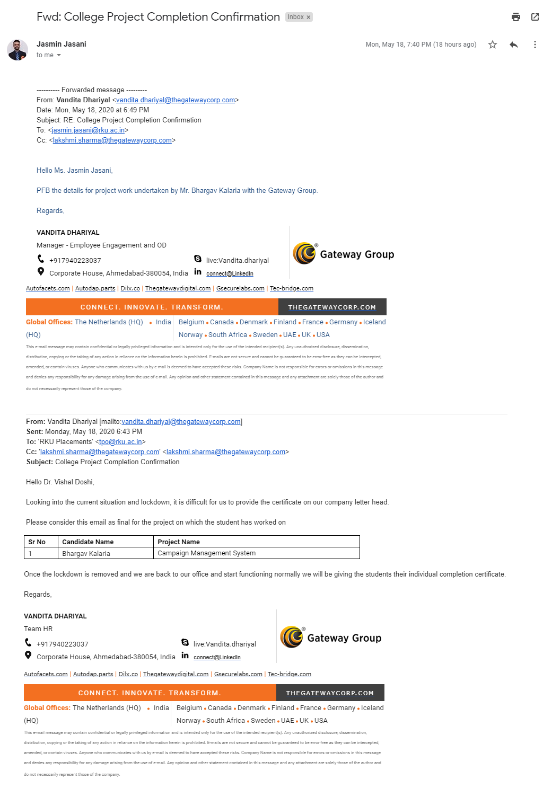

CE II



# **CERTIFICATE**

This is to certify that the work which is being presented in the Project Report entitled **“Campaign Management System”,** in partial fulfillment of the requirement for the award of the **Computer Engineering** and submitted to the School of Engineering, RK University, is an authentic record of my/our own work carried out during a period from **December 2019 to May 2020.**

The matter presented in this Project Report has not been submitted by me/us for the award of any other degree elsewhere.

**Signature of Student**

Bhargav Kalaria(16SOECE11078)

This is to certify that the above statement made by the student is correct to the best of my knowledge.

**Internal Guide External Guide Head of Department**

JASMIN JASANI Vandita Dhariya Prof. Ashwin Raiyani

Assistant Professor, Human Resource, CE / IT / BCA / MCA

RK University , Gateway Group of Companies, School of Engineering,

Rajkot Ahmedabad Gujarat RK University, Rajkot

May 2020



**SCHOOL OF ENGINEERING, RK UNIVERSITY, RAJKOT**

CE III

# **ACKNOWLEDGEMENT**

Any accomplishment requires the effort of many people and this work is not different and it is my prime duty to acknowledge the person who directly or indirectly helped me during completion of this project work. So, I take the opportunity to heartily thank my project guide respected **Prof. Jasmin Jasani** and External Guide **HR Vandita Dhariya** for their valuable guidance and touch of inspiration and motivation throughout the project work, without their help, the work would not have been in the shape. I also heartily thank **Senior developer** **Priti Agrawal** who greatly helped me in my work by acting as a Tech-Support for me. I also take the opportunity to heartily thank all staff members of the department and Gateway Corporation. for their cooperation, help and valuable guidance.

**Name of Student**  **Enrollment No.**

Bhargav Kalaria 16SOECE11078

CE IV

**ABSTRACT**

The **“campaign management system”**  is all about managing campaigns where marketing or management teams from specific organizations can add and manage campaigns .

Our System will send that specific campaign to customers via mail and then track customer responses and help the organization to decide whether the campaign was successful or not and represent it in chart format for the marketing team and will generate reports for the management team .

As per admin perspective admin can add customers from spreadsheet to database which can be used to send campaigns and also he can modify campaigns as needed and admin only will be adding organizations in the system as well as users .

The organization teams also can add customers as per required needs via spreadsheet to database and can also select that to which customer to send campaign and to which to not

So mainly the campaign management system is a bridge between organization and their customers .

CE V

**Naming Convention**

To develop reliable and maintainable applications, we have followed coding standards and best practices. We’ve followed C# coding standards from Microsoft for campaign management systems development.

CE VI

**LIST OF FIGURES**

|  |  |  |
| --- | --- | --- |
|  | **Title** | **Page No** |
| Figure 1.4 | MVC Architecture | 3 |
| Figure 4.3.1 | Use cases Diagram | 18 |
| Figure 4.4.2 | ER Diagrams | 23 |
| Figure 4.4.3 | Sequence Diagram | 24 |
| Figure 4.4.4 | Activity Diagram | 24 |
| Figure 4.5.1.1 | Data Flow Diagram(level 0) | 25 |
| Figure 4.5.1.2 | Data Flow Diagram(level 1) | 25 |
| Figure 4.5.1.3 | Data Flow Diagram(level 2) | 26 |
| Figure 4.6 | Main Module | 27 |
| Figure 5.1.1 | Tables and relationship | 29 |
| Figure 5.2.1 | Flow Chart | 30 |
| Figure 6.4 | Coding Standards | 32 |
| Figure 6.5.1 | Sample Coding(1) | 32 |
| Figure 6.5.2 | Sample Coding(2) | 33 |
| Figure 8.1 | Login Page | 38 |
| Figure 8.2 | Register User | 38 |
| Figure 8.3 | Forgot Password | 39 |
| Figure 8.4 | Dashboard Page | 39 |
| Figure 8.5 | Campaign List | 40 |
| Figure 8.6 | Add Campaign | 40 |
| Figure 8.7 | Edit Campaign | 41 |

CE VII

|  |  |  |
| --- | --- | --- |
| Figure 8.8 | Upload Page | 41 |
| Figure 8.9 | Email Template List | 42 |
| Figure 8.10 | Create Email Template | 42 |
| Figure 8.11 | Error Page | 43 |

CE VIII

**LIST OF TABLES**

|  |  |  |
| --- | --- | --- |
|  | **Title** | **Page No** |
| Table 2.1.3 | Schedule Representation | 7 |
| Table 4.4.1.1 | Campaign List | 19 |
| Table 4.4.1.2 | Campaign Status | 20 |
| Table 4.4.1.3 | Customers | 20 |
| Table 4.4.1.4 | Marketing Strategy | 20 |
| Table 4.4.1.5 | Marketing Types | 20 |
| Table 4.4.1.6 | User | 21 |
| Table 4.4.1.7 | Organizations | 21 |
| Table 4.4.1.8 | Customer Campaign | 21 |
| Table 4.4.1.9 | Responses | 22 |
| Table 7.1 | Test Cases | 37 |

CE IX

**TABLE OF CONTENTS**

|  |  |  |
| --- | --- | --- |
|  | **TITLE** | **Page no** |
|  | Cover Page |  |
|  | Candidate’s Declaration | I |
|  | Industry Certificate | II |
|  | College/ Institute Certificate | III |
|  | Acknowledgement | IV |
|  | Abstract/synopsis | V |
|  | Naming Convention | VI |
|  | List of Figures | VII |
|  | List of Tables | IX |
|  | Index(Table of Contents) | X |
|  | Company profile | XIV |
| 1 | Introduction | 1 |
| 1.1 | Project Summary | 1 |
| 1.2 | Purpose | 1 |
| 1.3 | Scope | 2 |
| 1.4 | Technology and Literature Review | 2 |
| 1.4.1 | .Net | 3 |
| 1.4.2 | MVC | 3 |
| 1.4.3 | Sql Server | 3 |
| 1.4.4 | C# | 4 |
| 1.4.5 | HTML and CSS | 4 |

CE X

|  |  |  |
| --- | --- | --- |
| 1.4.6. | Linq | 4 |
| 1.4.7 | Bootstrap | 5 |
| 1.4.8 | ADMINLTE | 5 |
| 2.0 | Project Management | 6 |
| 2.1 | Project Planning and scheduling | 6 |
| 2.1.1 | Project Development Approach | 6 |
| 2.1.2 | Project Plan | 6 |
| 2.1.3 | Schedule Representation | 7 |
| 2.2 | Risk Management | 7 |
| 2.2.1 | Risk Identification | 7 |
| 2.2.2 | Risk Analysis | 8 |
| 2.2.3 | Risk Planning | 10 |
| 3 | System Requirements Study | 11 |
| 3.1 | User Characteristics | 11 |
| 3.2 | Hardware and Software Requirements | 11 |
| 3.3 | Constraints | 11 |
| 3.3.1 | Hardware Constraints | 11 |
| 3.3.2. | Reliability Constraints | 12 |
| 3.3.3 | Safety and Security Considerations | 12 |
| 4 | System Analysis | 13 |
| 4.1 | Requirements of New System | 13 |

CE XI

|  |  |  |
| --- | --- | --- |
| 4.1.1 | Functional Requirement | 13 |
| 4.1.2 | Non-Functional Requirements | 15 |
| 4.1.3 | Hardware And Software Requirement | 16 |
| 4.2 | Feasibility Study | 17 |
| 4.2.1 | Technical Feasibility | 17 |
| 4.2.2 | Time Schedule Feasibility | 17 |
| 4.2.3 | Operational Feasibility | 17 |
| 4.2.4 | Implementation Feasibility | 18 |
| 4.3 | Use Cases | 18 |
| 4.4 | Data Modeling | 19 |
| 4.4.1 | Data Dictionary | 19 |
| 4.4.2 | E-R diagrams | 23 |
| 4.4.3 | Sequence Diagram | 24 |
| 4.4.4 | Activity Diagram | 24 |
| 4.5 | Functional and Behavioral Modeling | 24 |
| 4.5.1 | Data flow Diagram(0,1 level) | 24 |
| 4.6 | Main Modules of New System | 27 |
| 5 | System Design | 28 |
| 5.1 | Database Design/Data Structure Design | 28 |
| 5.1.1 | Tables and Relationship | 28 |

CE XII

|  |  |  |
| --- | --- | --- |
| 5.2 | System Procedural Design | 29 |
| 5.2.1 | Flow chart | 29 |
| 6 | Implementation Planning and details | 31 |
| 6.1 | Implementation Environment | 31 |
| 6.2 | Program/Modules Specification | 31 |
| 6.3 | Security Features | 31 |
| 6.4 | Coding Standards | 32 |
| 6.5 | Sample Coding | 32 |
| 7 | Testing | 34 |
| 7.1 | Testing Plan | 34 |
| 7.2 | Testing Strategy | 34 |
| 7.3 | Testing Methods | 34 |
| 7.4 | Test Cases | 35 |
| 8 | Screen shots and user manual | 38 |
| 9 | Limitation and Future Enhancement | 44 |
| 10 | Conclusion and Discussion | 45 |
| 11 | Bibliography | 46 |
| 12 | Reference | 47 |

CE XIII

**COMPANY PROFILE**

|  |  |
| --- | --- |
| **Company Name** | The Gateway Group of Companies |
| **Company Address** | B/81, Corporate House, Judges Bunglow Road, Bodakdev, Ahmedabad, Gujarat 380054 |
| **Company Established** | 1997 |
| **Contact Person** | Vandita Dhariya |
| **Contact no** | 8527221753 |
| **Website** | <https://thegatewaycorp.com/> |
| **Services** | Solution Consulting  Digital Transformation  IT Services  Products & Platforms |

The Gateway Corp, a privately held global enterprise, is headquartered in India and The Netherlands. The Gateway Corp is the principal holding company and promoter of all Gateway Group Companies, comprising 20 independent operating companies across 16 countries.

Over the last 22 years of Technology excellence, the Group has etched an enviable record of 80% client retention, in some of the most complex, non-English speaking markets, where we ensure that technology remains at the forefront of our clients’ business to achieve strategic differential advantage over their competition.

Vision 2023 is built on this foundation. The aggressive strategy for organic and inorganic growth entails – development of disruptive solutions, strategic initiatives & partnership and new markets penetration.

CE XIV

16SOECE11078 INTRODUCTION

1. **INTRODUCTION**

**1.1 PROJECT SUMMARY**

So campaign management systems are all about managing campaigns where marketing or management teams from specific organizations can add and manage campaigns .

And our system will send that specific campaign to customers via mail and then track customer responses and help the organization to decide whether the campaign was successful or not and represent it in chart format for the marketing team and will generate reports for the management team .

And as per admin perspective admin can add customers from spreadsheet to database which can be used to send campaigns and also he can modify campaigns as needed and admin only will be adding organizations in the system as well as users .

The organization teams also can add customers as per required needs via spreadsheet to database and can also select which customer to send campaign to and to which to not .

So mainly the campaign management system is a bridge between organization and their customers .

**1.2 PURPOSE**

This system is mainly used by organizations who want to launch any campaign. This system can help them manage the campaign and its respective customers in an easy way.

CE 1

16SOECE11078 INTRODUCTION

Using this system organization can also check the profit and who is interested in their campaign just by few clicks.

**1.3 SCOPE**

The scope of the CMS system is to manage huge campaigns and its huge customers. It helps the organization to manage campaigns by just adding it in the system then they just have to observe where the campaign is going to lose or to profit. The organization can check all its previous campaign and check which strategy was used and how much profit was gained by that campaign

**1.4 TECHNOLOGY AND LITERATURE REVIEW**

MVC is a design pattern used to decouple user-interface (view), data (model), and application logic (controller). This pattern helps to achieve separation of concerns.

Using the MVC pattern for websites, requests are routed to a Controller that is responsible for working with the Model to perform actions and/or retrieve data. The Controller chooses the View to display, and provides it with the Model. The View renders the final page, based on the data in the Model.

**Model**: Model represents shape of the data and business logic.It maintains the data of the application. Model objects retrieve and store model state in a database.

**View**: View is a user interface. View displays data using a model to the user and also enables them to modify the data.

**Controller**: Controller handles the user request. Typically, users interact with View, which in-turn raises appropriate URL requests, this request will be handled by a controller. The controller renders the appropriate view with the model data as a response.

CE 2

16SOECE11078 INTRODUCTION

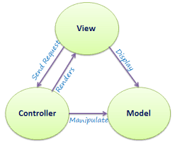

Figure 1.4 MVC Architecture

**1.4.1 .Net**

NET is a free, cross-platform, open source developer platform for building many different types of applications. with .Net, you can use multiple languages, editors, and libraries to build for web, mobile, desktop, gaming, and IoT.

**1.4.2 MVC**

The Model-View-Controller (MVC) is an architectural pattern that separates an application into three main logical components: the model, the view, and the controller. Each of these components are built to handle specific development aspects of an application. MVC is one of the most frequently used industry-standard web development frameworks to create scalable and extensible projects

**1.4.3 Sql Server**

The sql server is a relational database management system , or RDBMS, developed and marketed by Microsoft.

CE 3

16SOECE11078 INTRODUCTION

Similar to other RDBMS software, SQL Server is built on top of SQL, a standard programming language for interacting with the relational databases. SQL server is tied to Transact-SQL, or T-SQL, Microsoft's implementation of SQL that adds a set of proprietary programming constructs.

SQL Server has worked exclusively on Windows environments for more than 20 years. In 2016, Microsoft made it available on Linux. SQL Server 2017 became generally available in October 2016 that ran on both Windows and Linux.

**1.4.4 C#**

C# is a general-purpose, modern and object-oriented programming language pronounced as “C sharp”. It was developed by Microsoft led by Anders Hejlsberg and his team within the .Net initiative and was approved by the European Computer Manufacturers Association (ECMA) and International Standards Organization (ISO). C# is among the languages for Common Language Infrastructure and the current version of C# is version 7.2. C# is a lot similar to Java syntactically and is easy for the users who have knowledge of C, C++ or Java.

**1.4.5 HTML And CSS**

HTML (the Hypertext Markup Language) and CSS (Cascading Style Sheets) are two of the core technologies for building Web pages. HTML provides the *structure* of the page, CSS the (visual and aural) *layout,* for a variety of devices. Along with graphics and scripting, HTML and CSS are the basis of building Web pages and Web Applications.

**1.4.6 LINQ**

LINQ (Language Integrated Query) is uniform query syntax in C# and VB.NET to retrieve data from different sources and formats. It is integrated in C# or VB, thereby eliminating the mismatch between programming languages and databases, as well as providing a single querying interface for different types of data sources.

CE 4

16SOECE11078 INTRODUCTION

**1.4.7 BOOTSTRAP**

Bootstrap is the most popular CSS Framework for developing responsive and mobile-first websites.

**1.4.8 ADMINLTE**

Best open source admin dashboard & control panel theme. Built on top of Bootstrap, AdminLTE provides a range of responsive, reusable, and commonly used components.

CE 5

16SOECE11078 PROJECT MANAGEMENT

**2. PROJECT MANAGEMENT**

**2.1 PROJECT PLANNING & SCHEDULING**

**2.1.1 Project Development Approach**

The Agile Model is used for project development. We have selected Agile Model because of its beneficial speed without affecting the quality of product and agile makes the team so much more productive.

Agile SDLC model is a combination of iterative and incremental process models with focus on process adaptability and customer satisfaction by rapid delivery of working software products. Agile Methods break the product into small incremental builds. These builds are provided in iterations. Each iteration typically lasts from about one to three weeks. Every iteration involves cross functional teams working simultaneously on various areas like planning, requirements analysis, design, coding, unit testing, and acceptance testing. At the end of the iteration a working product is displayed to the customer and important stakeholders.

**2.1.2 Project Plan**

Planning is the most important activity in the development of any kind of software. It consists of studying through requirements of the system. That is what all things are to be required in the completion of the project. It consists of pre-planning and post-planning which consists of understanding the system requirements. Post planning consists of how the system will work, what will be its limitations, etc.

CE 6

16SOECE11078 PROJECT MANAGEMENT

**2.1.3 Schedule Representation**

|  |  |  |  |
| --- | --- | --- | --- |
| **TASK NAME** | **START** | **END** | **DURATION** |
| Requirement Gathering | 25 JAN, 2020 | FEB, 2020 | 15 |
| Analysis of require | 11 FEB, 2020 | 25 FEB, 2020 | 15 |
| System Design and Coding | 26 Feb, 2020 | 20 March, 2020 | 24 |
| System design and testing | 21 March 2020 | Continue… |  |

Table 2.1.3 Schedule Representation

**2.2 RISK MANAGEMENT**

**2.2.1 Risk Identification**

Risk Identification is a systematic attempt to specify threats to the project plan. By identifying the known and predictable risks, the project manager takes a first step towards avoiding them when possible and controlling them when necessary .

.One method of identifying risks is to create a risk item checklist. The checklist can be used for risk identification and focuses on some subset of known and predictable risks in the following subcategories .

* **Product Size:** -Risks associated with the overall size of the software to be Built or modified.
* **Business Impact:** -risks associated with constraints imposed by Management.

CE 7

16SOECE11078 PROJECT MANAGEMENT

* **Customer Characteristics:** - risks associated with the sophistication of the customer and the developer's ability to communicate with the customer in a timely manner.
* **Process Definition**: - risks associated with the degree to which the software process has been defined and is followed by development organization.
* **Development Environment**: - risks about the availability and quality of the tools to be used to build the project.
* **Technology to be built**: - risk on the complexity of the system to be built and the newness of the technology

**2.2.2 Risk Analysis & Planning**

Regardless of the prevention techniques employed, possible threats that could arise inside or outside the organization need to be assessed. Although the exact nature of potential disasters or their resulting consequences are difficult to determine, it is beneficial to perform a comprehensive risk assessment of all threats that can realistically occur to the organization

* **Types of Risks** 
  + **Performance Risk**: - The degree of uncertainty that the product will meet its requirements and be fit for its intended use. -As we are trainees, the performance risk is there in our project.

CE 8

16SOECE11078 PROJECT MANAGEMENT

* + **Cost Risk:** - The degree of uncertainty that the project budget will be maintained. The cost of our project is already decided by management
  + **Support Risk**: - The degree of uncertainty that the resultant software will be easy to correct, adapt, and enhance. Client of this project is in different premises.
  + **Known Risks**: - are those that can be uncovered after careful evaluation of the project plan.
  + **Experience Risks**: - Are extrapolated from past project experience. As we are trainees, this project has no such experience.
  + **Project Risks**: - Threaten the project plan. If project risk becomes real, it is likely that the project schedule will slip and that costs will increase. The budget of this project was decided before starting the project and it is enough to complete it. All the works are divided between team members. Required all the resources are available.
  + **Technical Risks**: - Threaten the quality and timeliness of the s/w to be produced. If technical risk becomes real, implementation may become difficult or impossible. -Technology is already decided for this project.
  + **Business Risks**: - Threaten the viability of the s/w to be built. This is a live project so no business risk is there.

CE 9

16SOECE11078 PROJECT MANAGEMENT

**2.2.3 Risk Planning**

To mitigate the risks, project management must develop a strategy for reducing turnover. Among the possible steps to be taken are

* Meet with current staff to determine causes for turnover (e.g. Poor working conditions, low pay, competitive job market).
* Mitigate those causes that are under our control before the project starts
* Once the project commences, assume turnover will occur and develop techniques to ensure continuity when people leave.
* Organize project teams so that information about each development activity is widely dispersed.
* Define documentation standards and establish mechanisms to be sure that documents are developed in a timely manner.
* Conduct peer reviews of all work.
* Assign a backup staff member for every critical technologist.

CE 10

16SOECE11078 SYSTEM REQUIREMENTS STUDY

**3. SYSTEM REQUIREMENTS STUDY**

**3.1 USER CHARACTERISTICS**

The Organization is the end user of the project. They can do all operations to add, delete or add specific permission of who can access what .

**3.2 HARDWARE AND SOFTWARE REQUIREMENTS**

**Software :**

Visual Studio 2017 or above version,

Sql Server 2017 or above version,  
 Visual Studio Code,

Browser: Chrome or Firefox (Any one of them)

**Hardware:**

OS:Windows 8 or above

Ram:8GB or above or more

HDD:500GB or more

**3.3 CONSTRAINTS**

**3.3.1 Hardware Constraints**

We have taken C# as Front-End and SQL server as our Back-End Tool so the installation of Microsoft Visual studio requires a minimum 2 GB RAM and the processor with 1.5 GHz speed as recommended in the hardware requirements. The Graphics User Interface is best viewed in 1024*768 Resolution.

CE 11

16SOECE11078 SYSTEM REQUIREMENTS STUDY

**3.3.2 Reliability Constraints**

Validation is the main reliability requirement that is used in the system. Without proper validation, the system does not allow to enter the value in the database.

**3.3.3 Safety and Security Considerations**

* **Safety**

If the use of this system is done by someone who is unauthorized but can access this system using valid authentication then he or she could be able to change any important data from the database.

* **Security**

If someone steals the password of the administrator or any regular user then he is able to change the database or misuse the system and can enter in a restricted area so for this purpose the system will provide encrypted password storage format in the database. When the first-time administrator or any regular user gives the password then the system will ask for entering one key and on the basis of that key the password will be encrypted and then onwards anyone who try to access that password then he will get it in encrypted form and for decrypting that password he must have that key so without that key he can’t able to decrypt that password.

CE 12

16SOECE11078 SYSTEM ANALYSIS

**4. SYSTEM ANALYSIS**

**4.1 REQUIREMENTS OF NEW SYSTEM**

**4.1.1 Functional Requirements**

Functional requirements define the internal working of the software: that is, the calculations, technical details, data manipulation and processing and other specific functionality that show how the use cases are to be satisfied.

The functional requirements of the beat are mentioned as follows:

* Login As Admin/Organization User

**Input:** Email Id And Password.

**Output:** Dashboard for Admin/Organization User.

**Description:** check for email id and password in database and role for found entry and providing dashboard as role

* Add New User

**Input**: User Details.

**Output**: User Add Success or failed notification.

**Description**: User details will be added in the database.

* Retrieve Password

**Input**: Email ID

**Output**: random generated password

**Description**: check in database for email id and send random generated password to given email id.

CE 13

16SOECE11078 SYSTEM ANALYSIS

* Add New Campaign

Input: Campaign Details.

Output: Campaign List with added campaign.

Description: Add campaign detail in database.

* Edit Campaign

**Input:** Edited Campaign Details.

**Output:** Campaign List With Edited Campaign.

**Description:** Edit campaign detail in campaign database

* Check Response.

**Input:** Campaign Id.

**Output:** Response Got from User for given campaign.

**Description:** systemwill .check for response for campaign id from database

* Generate Report.

**Input:** Campaign Id.

**Output:** Generated Report.

**Description:** system will generate reports for given campaign id.

CE 14

16SOECE11078 SYSTEM ANALYSIS

* Add Quick Campaign.

**Input:** Quick Campaign Detail.

**Output:** Send Mail to all customers.

**Description:** quick campaigns will be added in the database and mail will be sent to all its customers.

* Upload Spreadsheet.

**Input:** spreadsheet with customer email list.

**Output:** customers added to database.

**Description:** all the customers from spreadsheet will be added to database

* Send Automatic Mail.

**Input:** Email List.

**Output:** Welcome/Response Mail Will be sent.

**Description:** mail will be sent to all customers automatically.

**4.1.2 Non-Functional Requirements**

* **Accuracy**

As we were developing the system, we must make the system that is very accurate in its functions. All the functions should keep working properly, keep getting perfect input, process accurately and produce the perfect output. Accuracy is the most important non-functional characteristic or requirement of the system.

CE 15

16SOECE11078 SYSTEM ANALYSIS

* **Reliability**

Error handling mechanism must be robust to avoid failure of operation and in case of failure the system reports it to the admin without any due harm.

* **Performance and Automation**

Campaign management system is very fast as we are using dependency injection and we are automating response tracking and mail sending without user or admin interaction

* **Consistency**

In system data must should be consistent

* **Scalability**

System must should scalable and can be easily scaled horizontally or vertically as in our system we are using repository pattern and layered architecture scalability can be achieved

**4.1.3 Hardware And Software Requirements**

**Software :**

Visual Studio 2017 or above version,

Sql Server 2017 or above version,  
 Visual Studio Code,

Browser: Chrome or Firefox (Any one of them)

**Hardware:**

OS:Windows 8 or above

Ram:8GB or above or more

HDD:500GB or more

CE 16

16SOECE11078 SYSTEM ANALYSIS

**4.2 FEASIBILITY STUDY**

Once scope has been identified, it is reasonable to ask whether we can build software that meets this scope. Is this project feasible?

The feasibility of software can be tested in four dimensions:

**4.2.1 Technical Feasibility**

What we have planned to implement is technically feasible. Do we have sufficient knowledge or technology to make it a reality? And the answer is yes we are having knowledge of technologies which are required for making this system working, we can easily design frontend using html, css and bootstrap and for backend we can use .net, mvc, c# and sql for database.

**4.2.2 Time Schedule Feasibility**

We planned keeping all the development phase in our mind so our system can be ready in time without any error, after keeping this in mind we planned our deadline one week before actual submission date so we can complete system without error and we found out that we will require minimum 2 months to implementation of the complete project with all the features implemented. This also includes the testing and debugging phase.

**4.2.3 Operational Feasibility**

How the project will work and who will use it, all such concerns arise in this phase. As by using this system, campaigns and customers should be managed efficiently without any data loss, cohesion and errors .

CE 17

16SOECE11078 SYSTEM ANALYSIS

**4.2.4 Implementation Feasibility**

As we are using mvc framework for implementing this system we can use its different features in implementing this project like model, view and controller as well as we can use sql server for database related needs .

**4.3 FUNCTIONS OF SYSTEM**

**4.3.1 USE CASES**

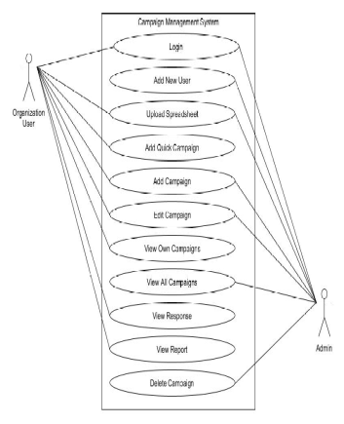

Figure 4.3.1 Use Case

CE 18

16SOECE11078 SYSTEM ANALYSIS

**4.4 DATA MODELING**

**4.4.1 Data Dictionary**

* **Campaign**

|  |  |  |
| --- | --- | --- |
| Srno | ColumnName | DataType |
| 1 | CampaignId | Int |
| 2 | CampaignName | Varchar |
| 3 | CampaignOwner | Varchar |
| 4 | Start_date | DateTime |
| 5 | End_date | DateTime |
| 6 | CampaignBudget | Decimal |
| 7 | ExceptedRevenue | Decimal |
| 8 | CreatedOn | DateTime |
| 9 | ModifiedOn | DateTime |
| 10 | CreatedBy | Int |
| 11 | CampaignStatusId | Int |
| 12 | MarketingId | Int |
| 13 | MarketingStrategyId | Int |

Table 4.4.1.1 Campaign List

CE 19

16SOECE11078 SYSTEM ANALYSIS

* **Campaign Status**

|  |  |  |
| --- | --- | --- |
| Srno | ColumnName | DataType |
| 1 | CampaignStatusId | Int |
| 2 | Status | Varchar |

Table 4.4.1.2 Campaign Status

* **Customers.**

|  |  |  |
| --- | --- | --- |
| Srno | ColumnName | DataType |
| 1 | CustomerId | Int |
| 2 | CustomerName | varchar |
| 3 | Email | varchar |

Table 4.4.1.3 Customers

* **MarketingStrategy**

|  |  |  |
| --- | --- | --- |
| Srno | ColumnName | DataType |
| 1 | MarketingStrategyId | Int |
| 2 | StrategyName | Varchar |

Table 4.4.1.4 Marketing Strategy

* **MarketingTypes**

|  |  |  |
| --- | --- | --- |
| Srno | ColumnName | DataType |
| 1 | MarketingTypeId | Int |
| 2 | MarketingTypeName | Varchar |

Table 4.4.1.5 Marketing Types

CE 20

16SOECE11078 SYSTEM ANALYSIS

* **User**

|  |  |  |
| --- | --- | --- |
| Srno | ColumnName | DataType |
| 1 | Uid | Int |
| 2 | Email | Varchar |
| 3 | Password | Varchar |
| 4 | Role | Varchar |
| 5 | FirstName | Varchar |
| 6 | LastName | Varchar |
| 7 | OrganizationId | int |

Table 4.4.1.6 User

* **Organizations**

|  |  |  |
| --- | --- | --- |
| Srno | ColumnName | DataType |
| 1 | OrganizationId | Int |
| 2 | Organizationname | Varchar |

Table 4.4.1.7 Organizations

* **CustomerCampaign**

|  |  |  |
| --- | --- | --- |
| Srno | ColumnName | DataType |
| 1 | CustomerCampaignId | Int |
| 2 | CampaignId | Int |

Table 4.4.1.8 Customer Campaign

CE 21

16SOECE11078 SYSTEM ANALYSIS

* **Responses**

|  |  |  |
| --- | --- | --- |
| Srno | ColumnName | DataType |
| 1 | ResponseID | Int |
| 2 | CampaignId | Int |
| 3 | Positive | Int |
| 4 | Negative | Int |
| 5 | Neutral | Int |

Table 4.4.1.9 Responses

CE 22

16SOECE11078 SYSTEM ANALYSIS

**4.4.2 E-R diagrams**

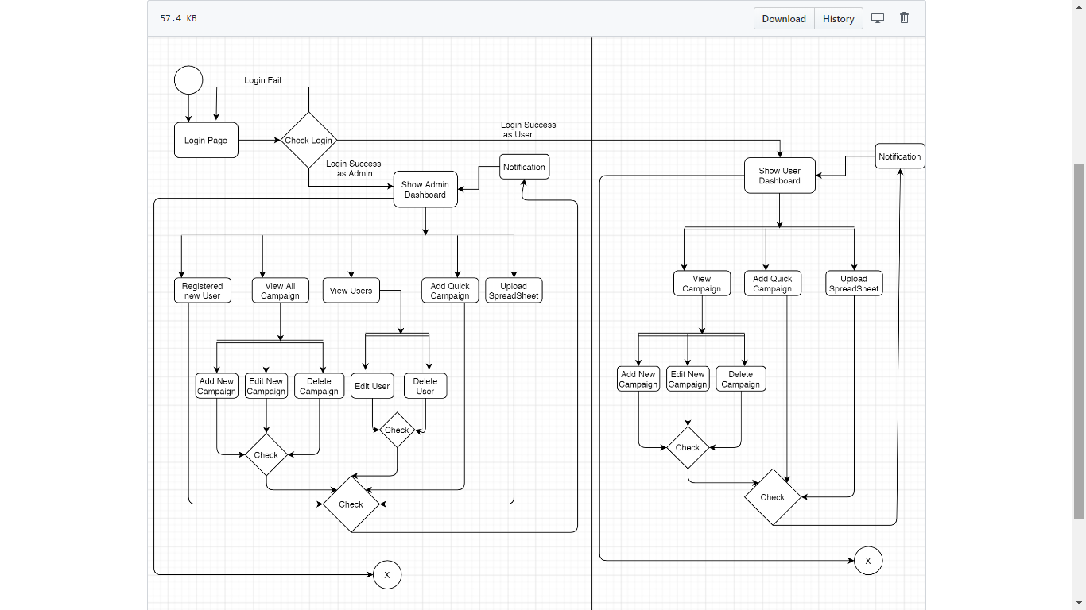

Figure 4.4.2 ER Diagrams

CE 23

16SOECE11078 SYSTEM ANALYSIS

**4.4.3 Sequence Diagram**

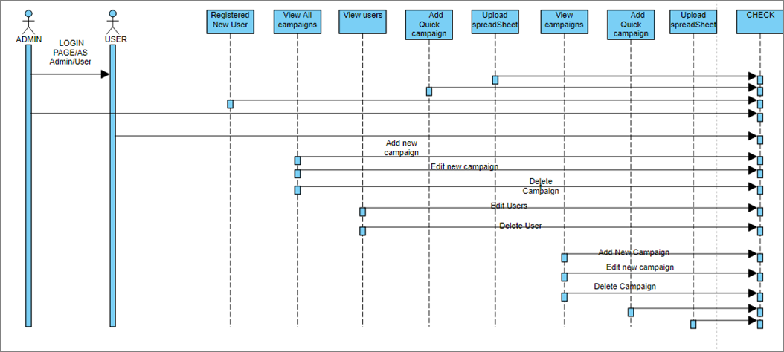

Figure 4.4.3 SequenceDiagram

**4.4.4 Activity Diagram**

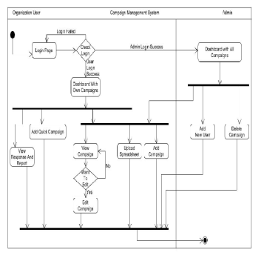Figure 4.4.4 Activity Diagram

CE 24

16SOECE11078 SYSTEM ANALYSIS

**4.5 FUNCTIONAL AND BEHAVIORAL MODELING**

**4.5.1 Data Flow Diagram (0 and 1 level)**

* **Level 0**

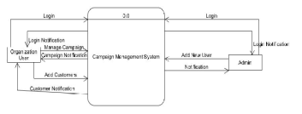

Figure 4.5.1.1 Data Flow Diagram (level 0)

* **Level 1**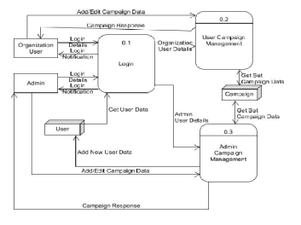 Figure 4.5.1.2 Data Flow Diagram (level 1)

CE 25

16SOECE11078 SYSTEM ANALYSIS

* **Level 2**

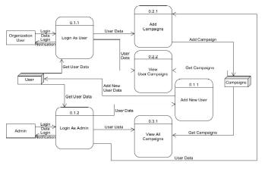

Figure 4.5.1.3 Data Flow Diagram (level 2)

CE 26

16SOECE11078 SYSTEM ANALYSIS

**4.6 MAIN MODULE OF NEW SYSTEM**

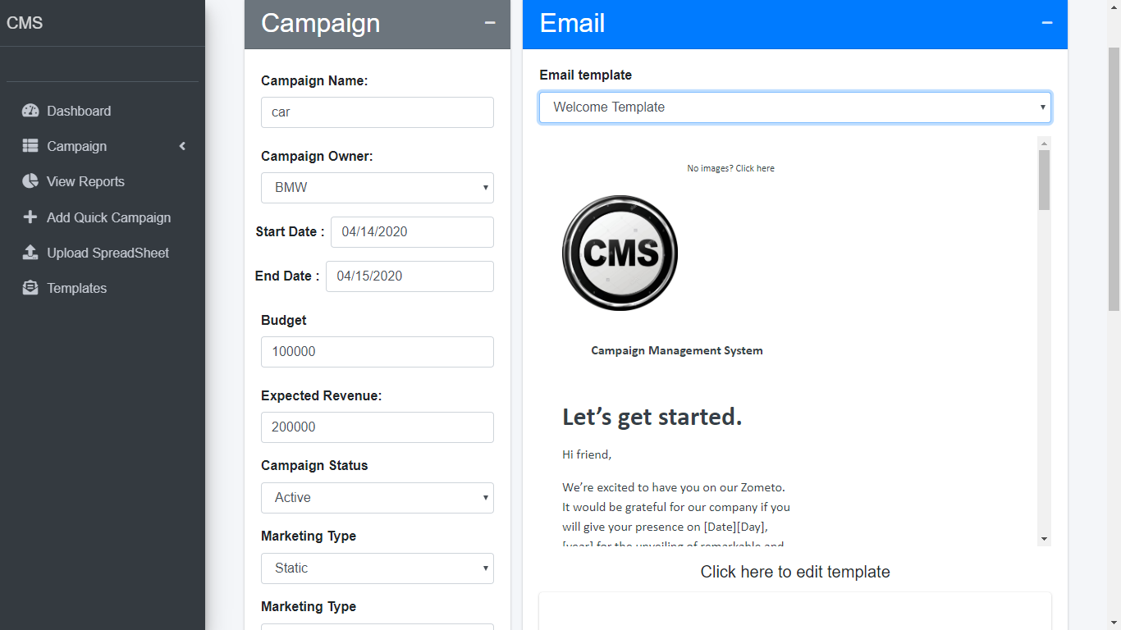

Figure 4.6 Main Module

CE 27

16SOECE11078 SYSTEM DESIGN

**5. SYSTEM DESIGN**

**5.1 DATABASE DESIGN/DATA STRUCTURE DESIGN**

**5.1.1 Tables and Relationship**

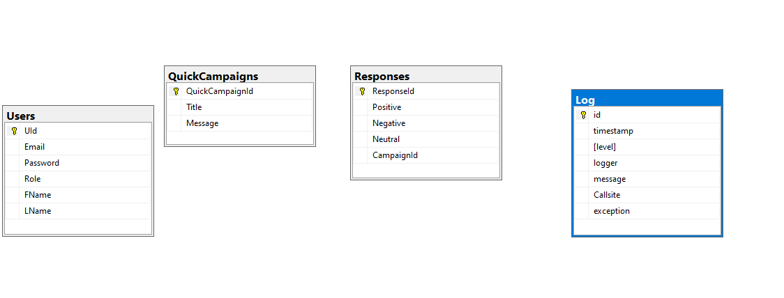

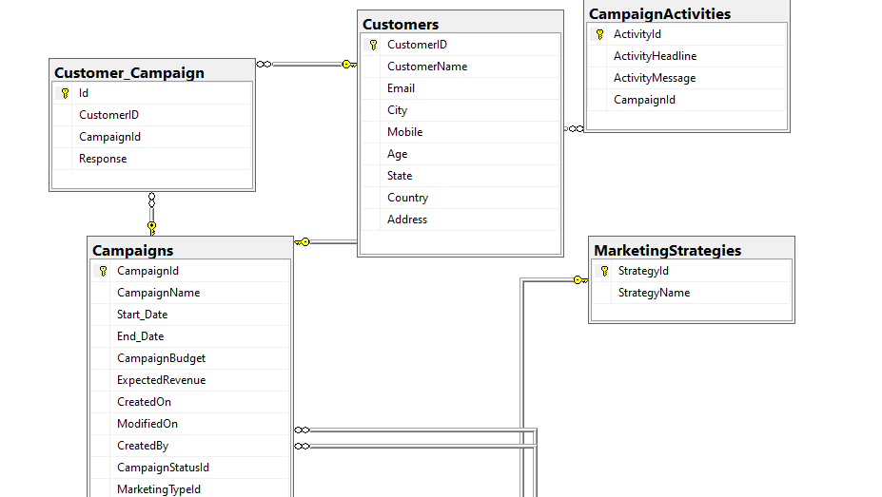

CE 28

16SOECE11078 SYSTEM DESIGN

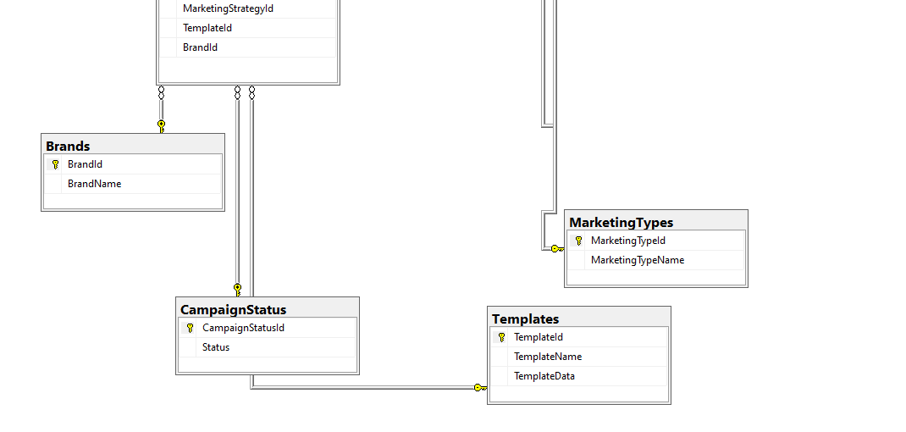

Figure 5.1.1 Tables and Relationship

**5.2 SYSTEM PROCEDURAL DESIGN**

**5.2.1 Flow chart or activity design**

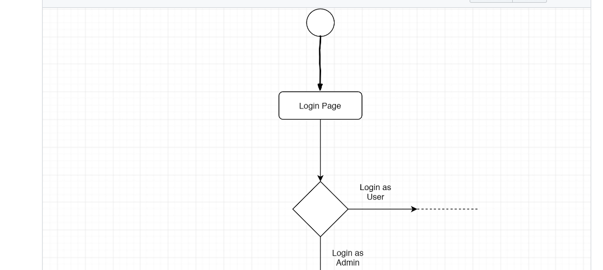

CE 29

16SOECE11078 SYSTEM DESIGN

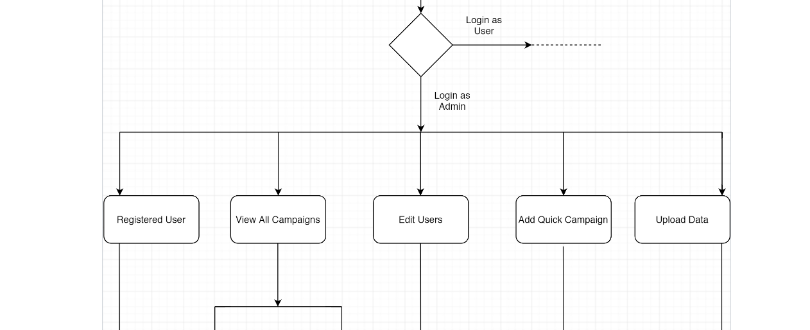

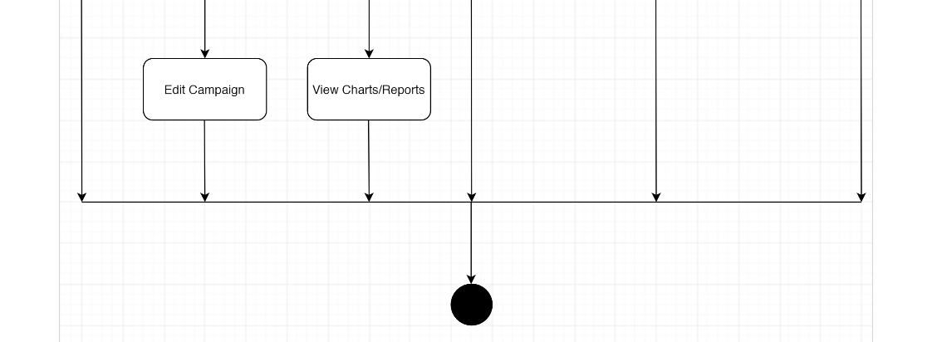

Figure 5.2.1 Flow Chart

CE 30

16SOECE11078 IMPLEMENTATION PLANNING AND DETAILS

**6. IMPLEMENTATION PLANNING AND DETAILS**

**6.1 IMPLEMENTATION ENVIRONMENT**

* Non-GUI application uses command Prompt for input and output while GUI application has graphics form to interface and other graphics property for various I/O operations and are easy to use Our System is a GUI based and thus easy and effective to use therefore user can easily give input and take Input.
* As our system is GUI application we are having different GUI pages for taking input and providing output like add new campaign page for taking campaign data as input while view campaign page for giving output to the user

**6.2 PROGRAM/MODULES SPECIFICATION**

* Login system for admin as well organization users
* Campaign with basic campaign details, schedule, financial and activity details.
* Data Import screen that will allow to import data from spreadsheets.
* Quick Campaign to send emails to bulk customers.
* Campaign Response Screen to track campaign response.
* Generate User-friendly Reports

**6.3 SECURITY FEATURES**

* Implement code for login system with encryption and authorization.
* Only One account is active at a time.
* If the system is idle for 30 minutes then, It will automatically logout.

CE 31

16SOECE11078 IMPLEMENTATION PLANNING AND DETAILS

**6.4 CODING STANDARDS**

To develop reliable and maintainable applications, you must follow coding standards and best practices. We’ve followed C# coding standards from Microsoft for campaign management systems development.

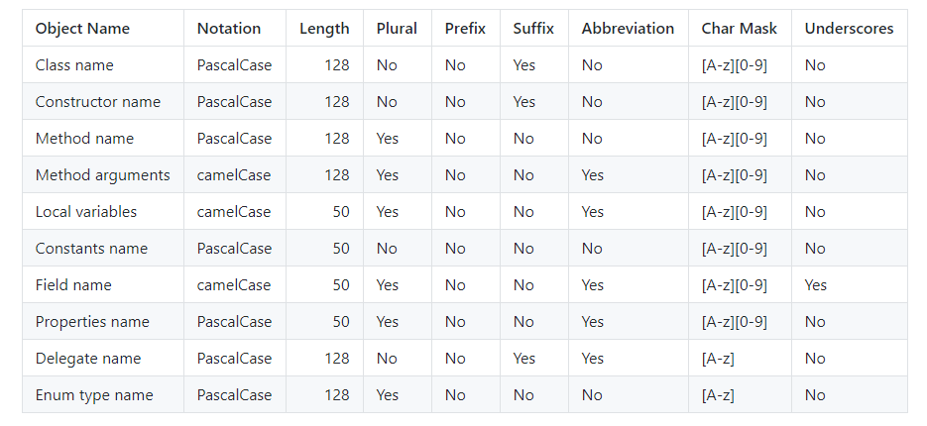

Figure 6.4 Coding Standards

**6.5 SAMPLE CODING**

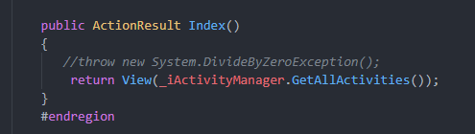

Figure 6.5.1 Sample Coding 1

CE 32

16SOECE11078 IMPLEMENTATION PLANNING AND DETAILS

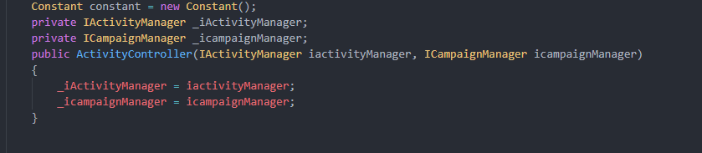

Figure 6.5.2 Sample Coding 2

CE 33

16SOECE11078 TESTING

**7. TESTING**

**7.1 TESTING PLAN**

The testing is a technique that is going to be used in the project is unit testing and system testing.

**7.2 TESTING STRATEGY**

Unit Testing tests a unit of code after coding of that unit is completed. System testing ensures that the system meets its stated design specifications. Acceptance testing is testing by users to ascertain whether the system developed is a correct implementation of the software requirements specification. Testing is carried out in such a hierarchical manner that each component is correct and the assembly/combination of components is correct. Merely testing a whole system at the end would most likely throw up errors in components that would be very costly to trace and fix.

So we will be performing both unit testing to test every component is working as desired or not and then we will perform system testing where we will check that system meets desired requirements or not

We have tested our application of Assets Management by inputting various valid and invalid data. We have checked all the input conditions required to store valid data. For this we have tried all the normal conditions as well as extreme conditions.

**7.3 TESTING METHODS**

* **Unit Testing**

Unit testing is focused on verifying small portions of functionality. Unit testing is an important part where each module and process of application is to be tested by possible input sets, range and desired output. Each Individual Module or process should generate (if any).

CE 34

16SOECE11078 TESTING

Applicable requirements are checked. Exercise every line of code. Check that the full range of possible input data works. Boundary analysis - logical statements that refer to threshold states are checked to ensure they are correct. Check for bad input data. Test for scientific validity.

**7.4 TEST CASES**

|  |  |  |  |  |
| --- | --- | --- | --- | --- |
| Sr.no | TestCase | Expected Output | Actual Output | Test Case Result |
| 1 | For Login as admin provides correct admin credentials. | System should return admin dashboard | Admin dashboard | Pass |
| 2 | For Login as Organization User Provide correct credentials | System should return User dashboard | User Dashboard | Pass |

CE 35

16SOECE11078 TESTING

|  |  |  |  |  |
| --- | --- | --- | --- | --- |
| 3 | Add New User. | details should be stored in the database | User details are stored in database | Pass |
| 4 | For Adding New Campaign details are provided | Campaign list should be returned and stored in database | Campaign list with new added campaign and stored in database | Pass |
| 5 | Delete Campaign button is clicked | Campaign should be removed from the database and list should be returned. | Campaign list is returned and campaign is removed from database | Pass |
| 6 | Check customer Response for Campaign | System should return Customer response screen for campaign | Customer response screen for campaign | Pass |
| 7 | Upload  spreadsheet | Customer in spreadsheet should be stored in database and list should be returned | Customers are stored in database and list is returned | Pass |

CE 36

16SOECE11078 TESTING

|  |  |  |  |  |
| --- | --- | --- | --- | --- |
| 8 | Forgot  password  Email address is provided | Random generated password should be mailed to given mail address | Random generated password is mailed | Pass |
| 9 | Welcome Mail | Welcome mail should sent to all customers on start date of campaign | Welcome mail is sent to all customers on start date | Pass |
| 10 | Send Feedback Mail | Feedback mail should be sent to all customers at end date of campaign | Feedback mail is sent to all customers on end date of campaign | Pass |

Table 7.1 Test Cases

CE 37

16SOECE11078 SCREEN SHOTS AND USER MANUAL

**8. SCREEN SHOTS AND USER MANUAL**

* **Login Page**

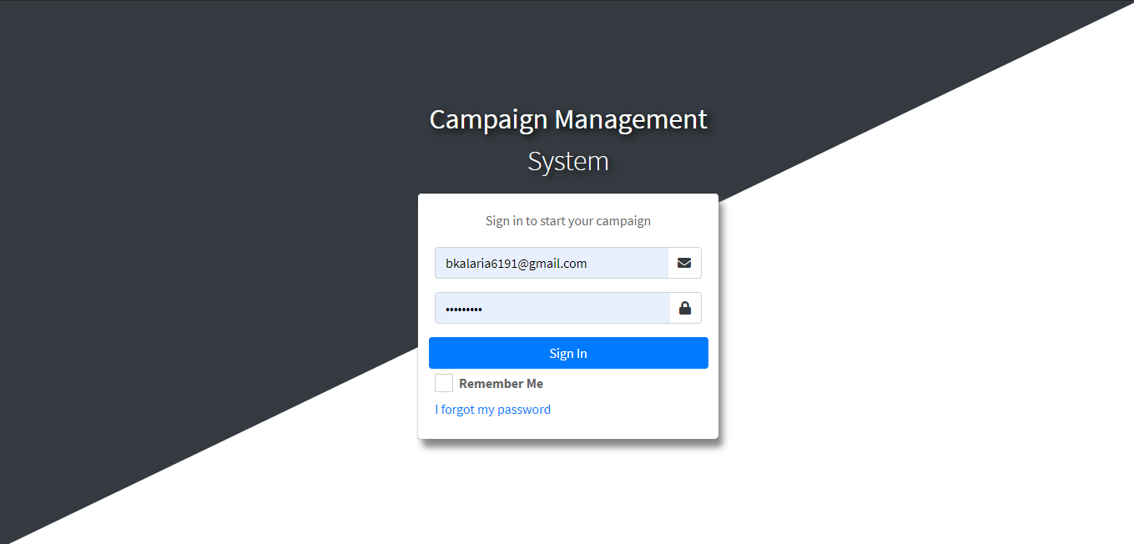

Figure 8.1 Login Page

* **Registration Page**

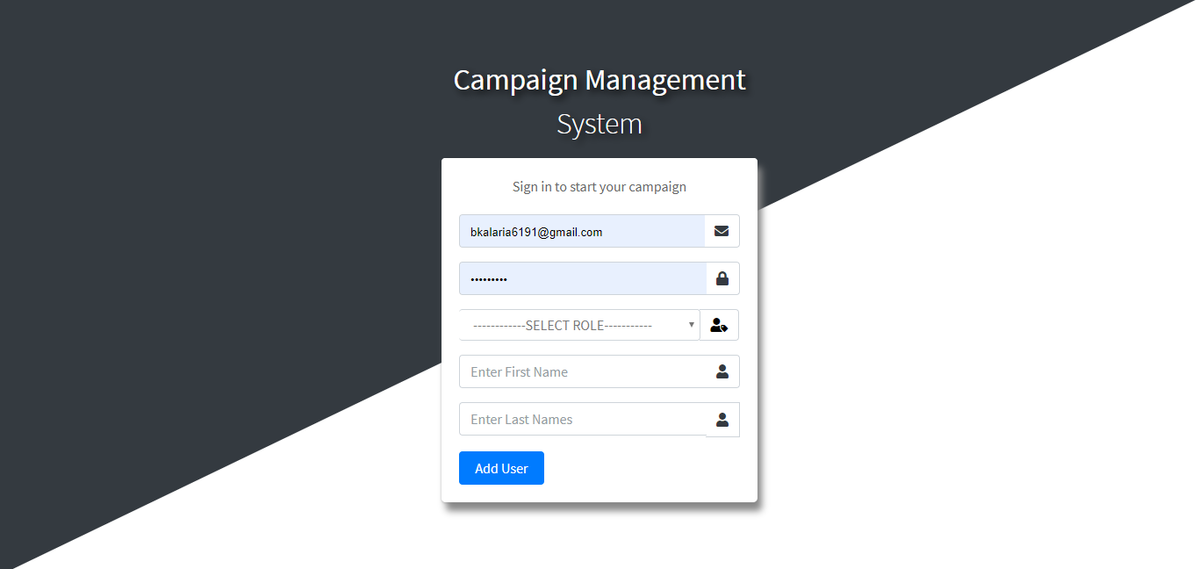

Figure 8.2 Registration Page

CE 38

16SOECE11078 SCREEN SHOTS AND USER MANUAL

* **Forgot Password**

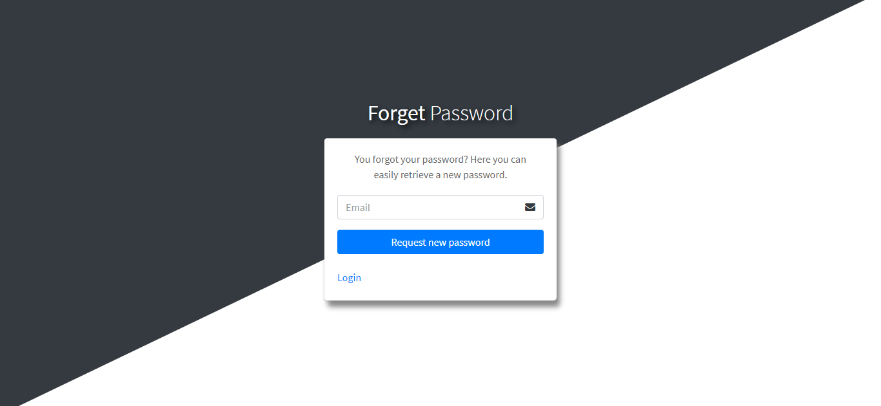

Figure 8.3 Forgot Password Page

* **Dashboard**

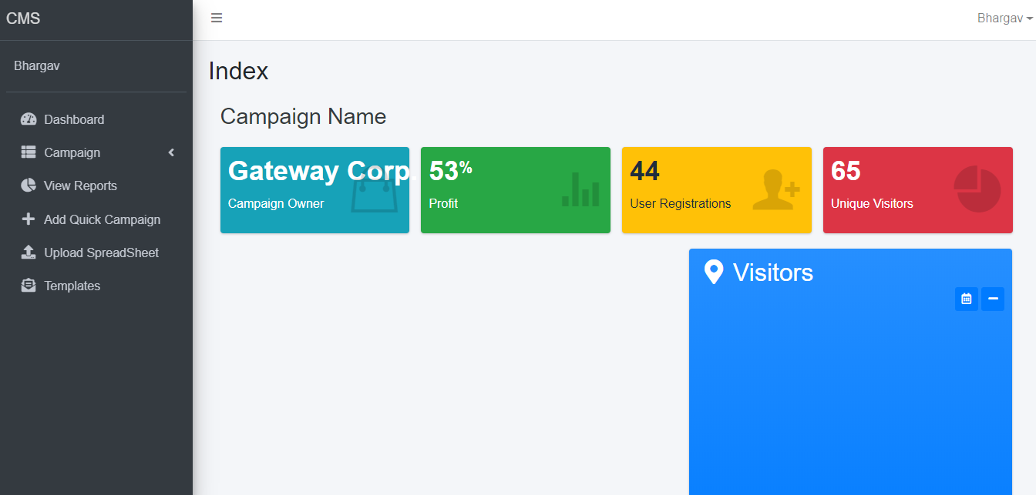

Figure 8.4 Dashboard Page

CE 39

16SOECE11078 SCREEN SHOTS AND USER MANUAL

* **Campaign List**

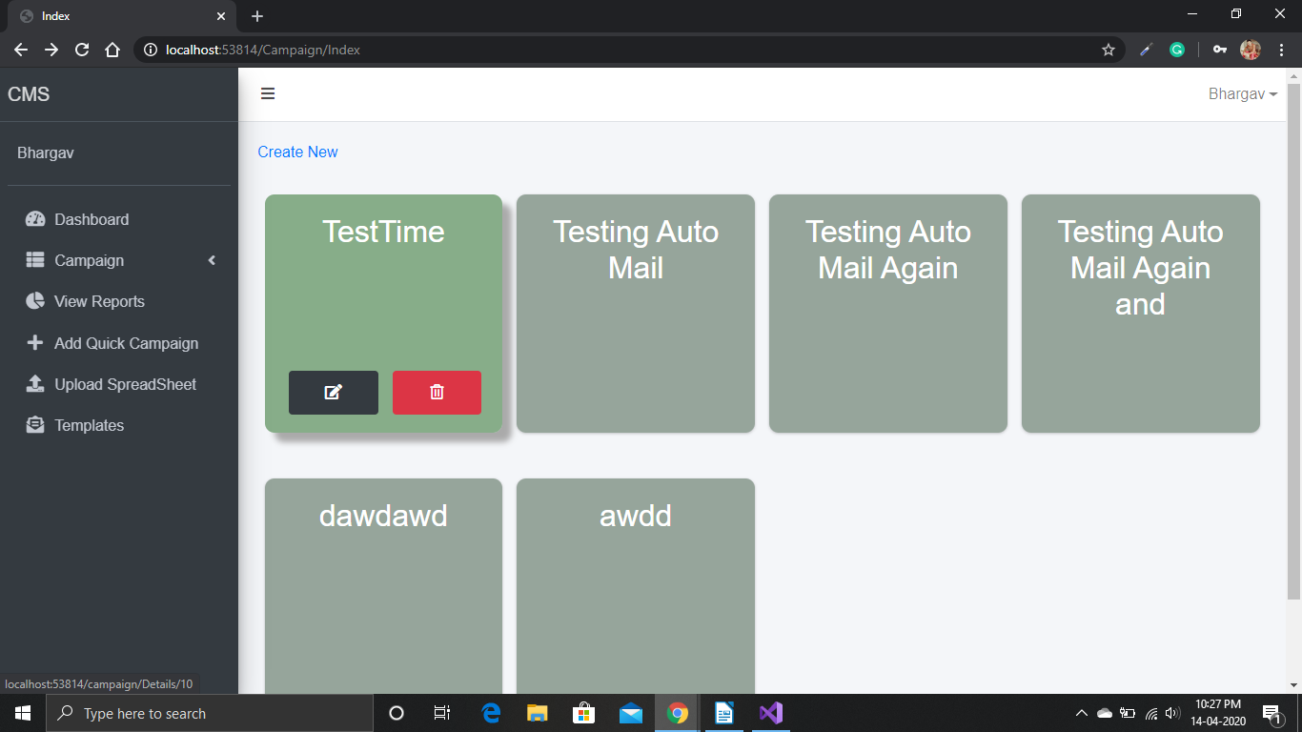

Figure 8.5 Campaign Page

* **Add Campaign**

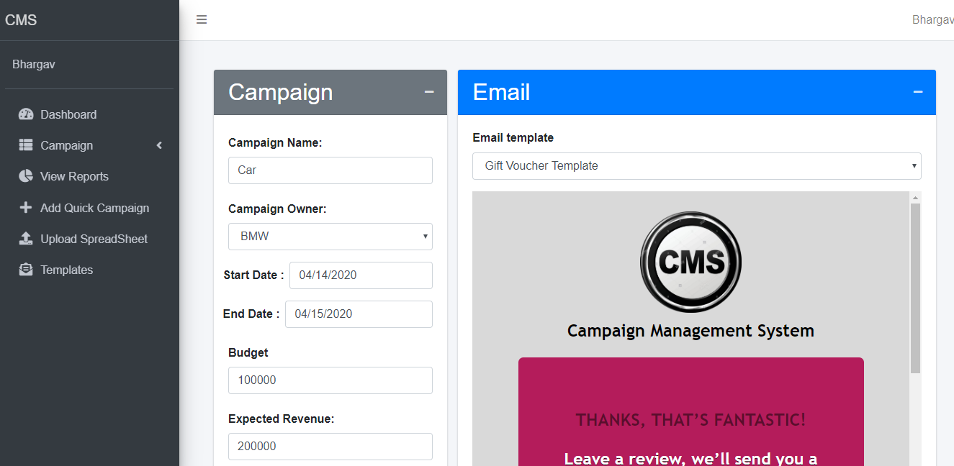

Figure 8.6 Add Campaign

CE 40

16SOECE11078 SCREEN SHOTS AND USER MANUAL

* **Edit Campaign**

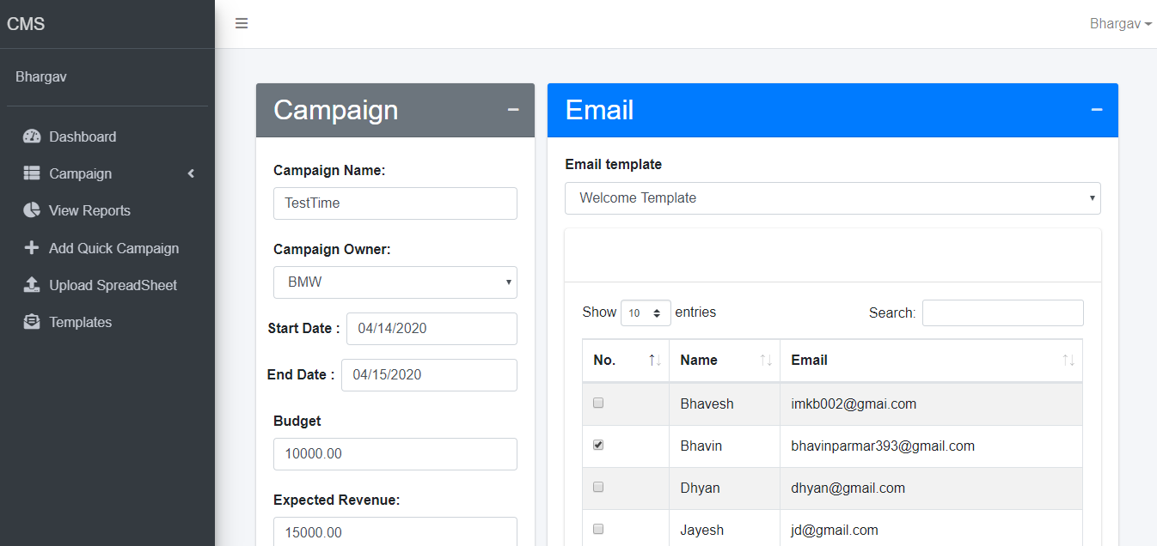

Figure 8.7 Edit Campaign

* **Upload Files**

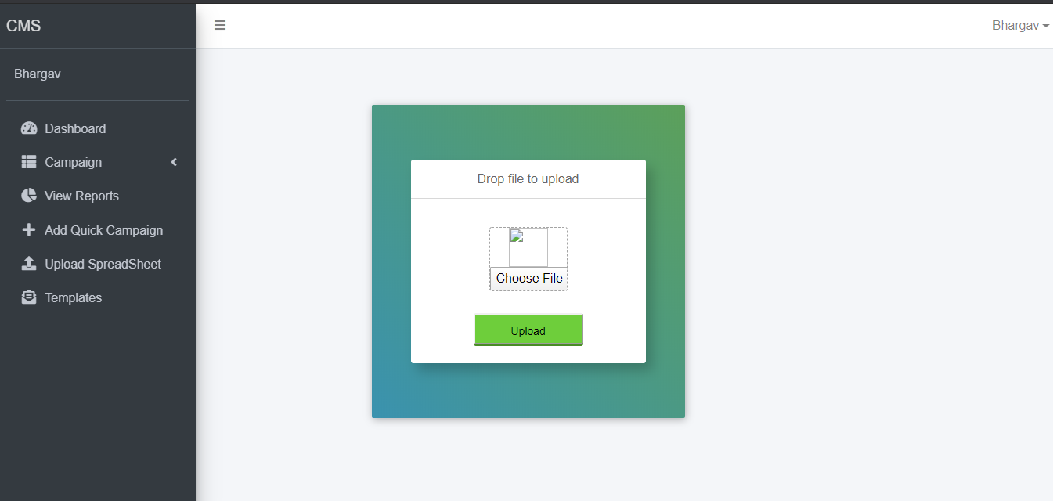

Figure 8.8 Upload Page

CE 41

16SOECE11078 SCREEN SHOTS AND USER MANUAL

* **Email Template**

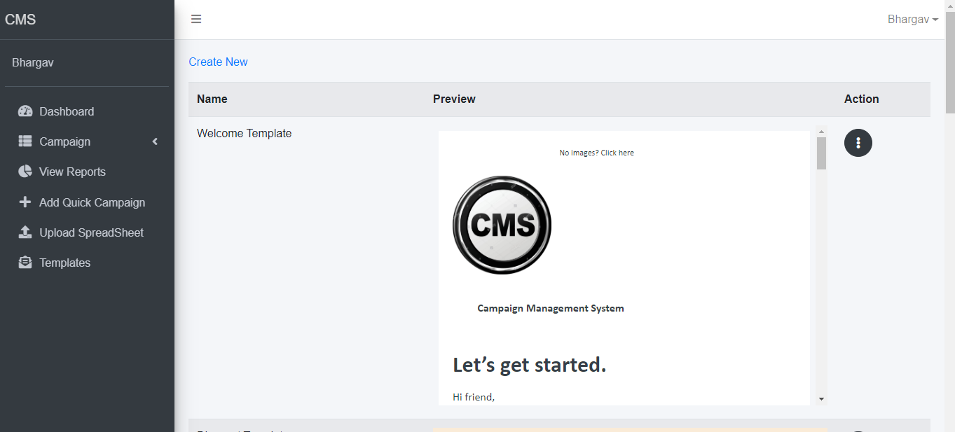

Figure 8.9 Email Page

* **Create Email Template**

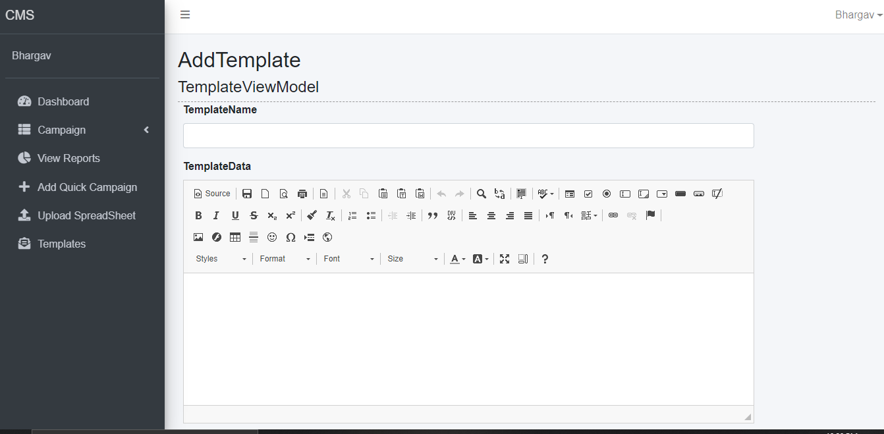

Figure 8.10 Create Email Page

CE 42

16SOECE11078 SCREEN SHOTS AND USER MANUAL

* **Error Page**

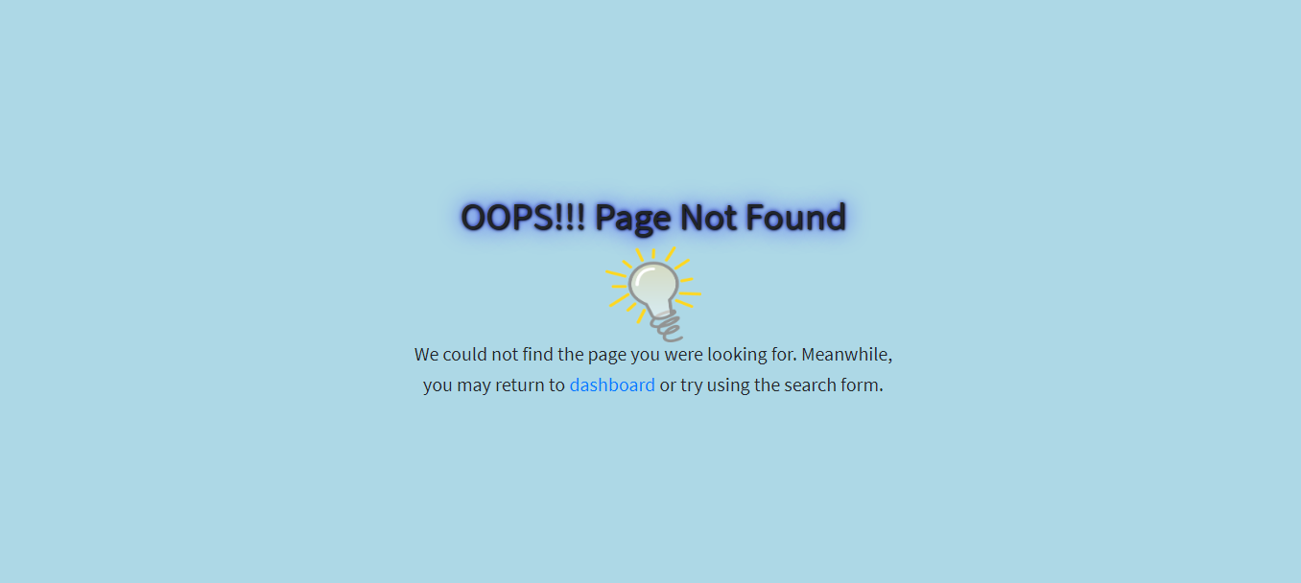

Figure 8.11 Error Page

CE 43

16SOECE11078 LIMITATION AND FUTURE ENHANCEMENT

**9. LIMITATION AND FUTURE ENHANCEMENT**

* Currently we are using only email to send campaigns but in future we will try to use sms and social media for sending campaigns.
* Currently we are using only buttons and radio buttons for response. In the future we will use a textbox for getting feedback .
* Currently we are not able to predict campaign response in future we will predict what response will campaign get using previous campaigns responses .
* In the future we are planning to extend our system to be able to automate responses and send it to organizations via email .

CE 44

16SOECE11078 CONCLUSION AND DISCUSSION

**10. CONCLUSION AND DISCUSSION**

Campaign management system eases the work of organizations or individuals who want to launch a campaign and want to manage that campaign easily.

* Campaign management is the main feature of this system.
* We are using sql server so it is easy to manage databases for this system.
* Mvc is most used web development technology so it is providing much functionality which is implemented in this system.
* The response tracking in this system is very efficient as we are using guid for tracking which customer is giving what response for which campaign so it is easy to track responses from users.
* We are using smtp for sending mails and it is very fast.
* We can easily extend or add new functionality in our system as we are using layered architecture in our system.
* Our system works very fast as we are using repository patterns into it.

CE 45

16SOECE11078 BIBLIOGRAPHY

**11. BIBLIOGRAPHY**

* **C# Docs**

<https://docs.microsoft.com/en-us/dotnet/csharp/>

* **SQL Server Docs**

<https://docs.microsoft.com/en-us/sql/sql-server/?view=sql-server-ver15>

* **MVC Docs**

<https://dotnet.microsoft.com/apps/aspnet/mvc>

* **HTML Docs**

<https://devdocs.io/html/>

CE 46

16SOECE11078 REFERENCE

**12. REFERENCE**

* <https://www.c-sharpcorner.com/>
* <https://www.infragistics.com/community/blogs/b/dhananjay_kumar/posts/how-to-implement-the-repository-pattern-in-asp-net-mvc-application>
* <https://stackoverflow.com/>
* <https://www.tutorialspoint.com/index.htm>

CE 47