Log-linear Analysis of Associations between Education Types, Self-perception of College Career, and Family Status in Teenagers in the U.S.

By:

Kathy Holt
Kristin Lilly
Spyros Mourtzinis

STAT 7030
Group Project
Fall 2011

Abstract

The National Longitudinal Survey of Youth 1997 (NLSY97) was a national survey commissioned to survey teenagers about various experiences, including family life and education. In this study, we are interested in investigating the associations between these teenagers’ educational experiences, their family life, and their own perception of how likely they are to obtain a college degree. A log-linear analysis is applied to the selected variables and preprocessed data set, and the third-order saturated model is deemed the best-fit model, according to the estimated dissimilarity indices. However, since there is no easy interpretation and the model is saturated, the simpler first-order model is selected as the final model. This leads to an invalid model; hence, recommendations are offered to use backwards elimination on the second-order interaction model, as well as including more variables, to arrive at a valid and more appropriate model for the purpose of this study.

Introduction

The National Longitudinal Survey of Youth 1997 (NLSY97) was a national survey conducted by the Bureau of Labor Statistics in the United States in 1997 to gather information from 8,984 teenagers (aged 12 to 16 as of December 31, 1996) across the country. The survey included questions to gain knowledge about the sampled youths’ educational and labor market experiences, relationship with parent(s), alcohol and drug use, possible criminal behavior, onset of puberty and sexual activity, and any participation in government assistance programs. The survey was intended to investigate how schooling and other environmental factors impact the youths’ transition from school to work. It also conveys how the youths’ experiences in school affect their future career and family life.
Of particular interest in this analysis are the following four variables: the type of school attended (R0032900), the percent chance of obtaining a four-year college degree (R0515100), living with a mother or mother figure (R0324100), and living with a father or father figure (R0325900). Since there is no obvious response variable, the purpose of this study is to determine if there is any type of association or relationship between the four variables, as well as determining the types of dependence, if any, exist between the variables. As a result, a log-linear analysis will be performed on the data.

Data

The data are from the National Longitudinal Surveys collected by the Bureau of Labor Statistics from the United States Department of Labor. This particular survey was conducted in 1997 on approximately 9,000 teenagers aged 12 to 16 years old as round one of the survey. (The youth respondents were continually interviewed annually for subsequent rounds.) For this first round, the youth were surveyed for about an hour using a computer-assisted personal interviewing (CAPI) system, which limited the probability of inconsistent data and also gave anonymity to the respondents regarding questions involving information about their drug, alcohol, and sexual activity. For each question, each respondent could choose to answer or skip the attempt; consequently, some variables included more non-responses than actual responses.

This analysis for this study was restricted to the four variables of interest listed in the table below:

Variable | Symbol | Description | Levels | Responses
RM0032900 | S | Type of school | 9 | 1-Public, 2-Technical, 3-Catholic, 4-Private (Other religion), 5-Private (No religion), 6-Alternative, 10-Home, 11-Special Education, 9-Other
RM0515100 | D | % chance of obtaining 4-year degree | 2 | 1-(0-49%), 2-(50-100%)
RM0324100 | M | Living with mother/figure | 2 | 0-No, 1-Yes
RM0325900 | F | Living with father/figure | 2 | 0-No, 1-Yes

Table 1. Table of variables used in this study.

For the actual data analysis, the data was preprocessed and cleaned. The missing values and non-responses were removed from the data set. Also, originally RM051500 (% chance of obtaining a 4-year degree) was given as an actual percentage, and it was transformed into a categorical variable such that a response between 0-49% was recorded as 1 and a response between 50-100% was recorded as 2. All other variables were left as is from the original source.

Methods

As mentioned before, a log-linear analysis was chosen and then performed on the data. A log-linear model for a 4-way table was thought to be ideal for our analysis, because there is no clear response variable among the four previously mentioned variables. Our objectives included determining if any relationships or associations exist between the variables, and if so, what type of associations. To complete these objectives, proc genmod was used in SAS to run an analysis for three different models: a model with the four variables of interest and no interaction terms, a model with the variables and second-order interaction terms, and a model with the variables and third-order (and therefore, also second-order) interaction terms. For simplicity, the letters in the second column on Table 1 will denote their corresponding variables.
After running a preliminary analysis on all three proposed models, the three models will be compared simultaneously using the dissimilarity index. Since our dataset is so large (around 9,000 observations), the dissimilarity index is preferred over the chi-square goodness-of-fit test, which is affected and misleading with large sample sizes. Then, a final model will be chosen based on having a small dissimilarity index, as well as having a simple set of parameters that can be practically interpretable.

Analysis

First, the log-linear maximum likelihood parameter estimates were calculated for the model with all the variables and no interaction terms (S,D,M,F). All of the parameters are significant at significance level 0.05 (Table 2). Next, the MLEs for the two-order interaction term model (SD, SM, SF, DM, DF, MF) were found, and the table of estimates and results is too large to include in the report. Unlike the previous table, none of the estimates are significant. Finally, the MLEs for the model with all third-order association terms (SDM, SDF, SMF, DMF) (and second-order terms, as well) were estimated, and the results were similar to the two-order interaction model, in that no estimates were significant.

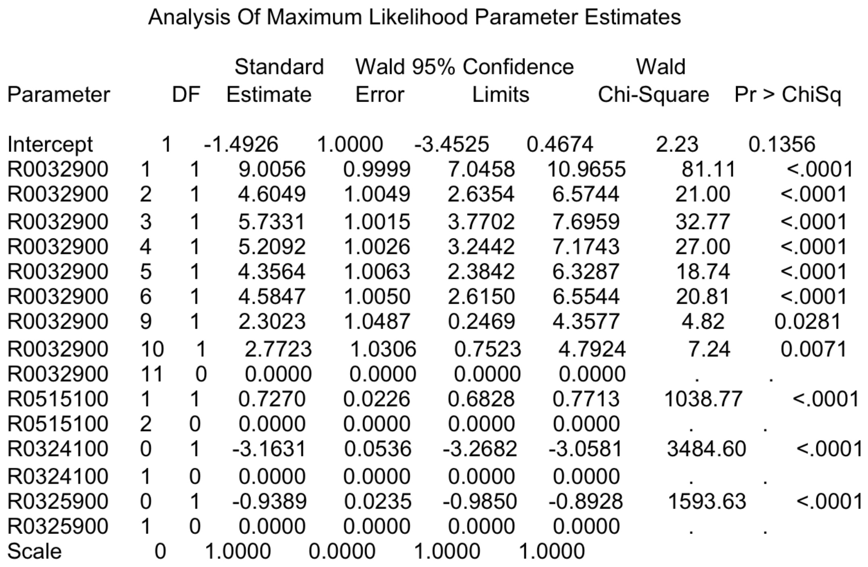

Table 2. ML estimates of parameters for first-order terms only.

Additionally, the dissimilarity indices were calculated for each of the three models (Table 3). The saturated third-order interaction term model has the smallest dissimilarity index, indicating it has the best model fit. In order to determine if there is a better fitting model with third-order association terms, but is not saturated, the dissimilarity indices of all subset models with the third-order terms are calculated and compared. By the measure of the dissimilarity index, the third-order term model is the optimal model for this analysis.

Model | Dissimilarity Index
d_no | 2.71
d_2 | 0.82
d_3 | 0.14
d_3_1 | 0.22
d_3_2 | 0.28
d_3_3 | 0.43
d_3_4 | 0.41
d_3_5 | 0.41
d_3_6 | 57.08
d_3_7 | 0.64
d_3_8 | 57.08
d_3_9 | 57.08

Table 3. Dissimilarity Indices for each of the models.

Conclusion and Recommendations

The best-fitting model, based on the above analyses, is the saturated third-order interaction term model. However, there were no significant parameters for this model. Therefore, the first-order model with no interaction terms (S,M,D,F) is preferable to the saturated model (SMD, SMF, SDF, MDF), especially because all the parameters in the first-order model are all significant and the model allows for a simpler interpretation. This model implies that there are no significant associations or interactions between the four variables, which is actually contrary to intuition and in practice.
Since the final model chosen was a bit inconclusive, a few recommendations are now proposed to lead to a better, more complete analysis and final model. The final sample size actually used was close to 100, rather than the original approximately 9,000 observations; thus, incorporating more variables such that there are less missing values and more observations might lead to more accurate results. Also, there were some incorrect calculations for the dissimilarity indices, such that a few of the point estimates were greater than one. No errors were easily found in the code or data set. Perhaps, a larger number of observations would have solved this problem as well. Lastly, a further step in selecting a final model would be to perform backwards elimination (or stepwise regression) on the second-order interaction term model to see if any of the interaction terms might have been significant and included in the final model. As a result, further analyses would be needed on this data to elucidate more information about the associations between variables describing the education, self-perception, and family status of teenagers in the United States.

References

Agresti, Alan. An Introduction to Categorical Data Analysis. Wiley-Interscience, 2007. Print.

Anderson, C.J.. Applied Categorical Data Analysis. (Dissimilarity Index for SAS). University of Illinois. Web. 18 November 2011. <http://www.ed.uiuc.edu/courses/EdPsy490AT/>

Bureau of Labor Statistics. The NLSY97. United States Department of Labor. Web. 1 October 2011. <http://www.bls.gov/nls/nlsy97.htm>

SAS programs

proc contents data=projdata;run;
proc print data=projdata;
run;quit;
*cleaning the data**;
data projdataclean;
set projdata;
if R0002000="-5" then R0002000=".";
if R0032200="-5" then R0032200=".";
if R0032900="-5" then R0032900=".";
if R0048100="-5" then R0048100=".";
if R0244700="-5" then R0244700=".";
if R0321300="-5" then R0321300=".";
if R0321400="-5" then R0321400=".";
if R0321500="-5" then R0321500=".";
if R0321600="-5" then R0321600=".";
if R0321800="-5" then R0321800=".";
if R0322700="-5" then R0322700=".";
if R0324100="-5" then R0324100=".";
if R0325900="-5" then R0325900=".";
if R0490300="-5" then R0490300=".";
if R0491200="-5" then R0491200=".";
if R0506500="-5" then R0506500=".";
if R0506900="-5" then R0506900=".";
if R0514900="-5" then R0514900=".";
if R0515000="-5" then R0515000=".";
if R0515100="-5" then R0515100=".";
if R0519700="-5" then R0519700=".";
if R0519900="-5" then R0519900=".";
if R0514900<26 then R0514900="1";
if R0515000<26 then R0515000="1";
if R0515100<50 then R0515100="1";
if R0515100>49 then R0515100="2";

if R0514900>25 and R0514900<51 then R0514900="2";
if R0515000>25 and R0515000<51 then R0515000="2";
*if R0515100>25 and R0515100<51 then R0515100="2";
if R0514900>50 and R0514900<76 then R0514900="3";
if R0515000>50 and R0515000<76 then R0515000="3";
*if R0515100>50 and R0515100<76 then R0515100="3";
if R0514900>75 and R0514900<101 then R0514900="4";
*if R0515000>75 and R0515000<101 then R0515000="4";
if R0515100>75 and R0515100<101 then R0515100="4";
run;quit;
proc print data=projdataclean;
run;quit;
****-------------------------------------------------------------*******;
proc sort data=projdataclean;
run;quit;
*Education vs Self perception;
proc freq data=projdataclean;
tables R0032900*R0515100*R0324100*R0325900/out= FreqCount1 outexpect sparse;
run;quit;
proc print data=FreqCount1;
run;quit;
******--------------------Loglinear models-------------------------************;
proc genmod data=FreqCount1;*no interaction terms*;
class R0032900 R0515100 R0324100 R0325900;
model count= R0032900 R0515100 R0324100 R0325900 /dist=poi link=log;
output out=pred_no pred=mwms_no;
run;

proc genmod data = FreqCount1 order = data;*a few interaction terms*;
class R0032900 R0515100 R0324100 R0325900;
model count= R0032900|R0515100 |R0324100 |R0325900 @2 /dist=poi link=log;
output out=pred_2 pred=mwms_2;
run;
proc genmod data = FreqCount1 order = data;*a few interaction terms*;
class R0032900 R0515100 R0324100 R0325900;
model count= R0032900|R0515100 |R0324100 |R0325900 @3 /dist=poi link=log;
output out=pred_3 pred=mwms_3;
run;

**************-------------------model validity-----------------------********************;
*Dissimilarity Index?*;
data all;
merge pred_no pred_2 pred_3;
d_no=abs(count-mwms_no)/(2*72);
d_2=abs(count-mwms_2)/(2*72);
d_3=abs(count-mwms_3)/(2*72);
* Note 72 is the total number of observations (counts) which I got by
looking at the output;
run;
proc print data=all;
run;quit;
proc means sum;
var d_no d_2 d_3;
title 'Here are the dissimilarity indices';
run;
*********-----------comparing 3 term interactions--------------------******************;
proc genmod data = FreqCount1 order = data;*a few interaction terms*;
class R0032900 R0515100 R0324100 R0325900;
model count= R0032900|R0515100 |R0324100 |R0325900 @2
R0032900*R0515100*R0325900 R0032900*R0324100*R0325900 R0515100*R0324100*R0325900/dist=poi link=log;
output out=pred_3_1 pred=mwms_3_1;
run;
proc genmod data = FreqCount1 order = data;*a few interaction terms*;
class R0032900 R0515100 R0324100 R0325900;
model count= R0032900|R0515100 |R0324100 |R0325900 @2
R0032900*R0515100*R0325900 R0032900*R0515100*R0325900 R0515100*R0324100*R0325900/dist=poi link=log;
output out=pred_3_2 pred=mwms_3_2;
run;

proc genmod data = FreqCount1 order = data;*a few interaction terms*;
class R0032900 R0515100 R0324100 R0325900;
model count= R0032900|R0515100 |R0324100 |R0325900 @2
R0032900*R0515100*R0325900 R0032900*R0515100*R0325900 R00329000*R0324100*R0325900/dist=poi link=log;
output out=pred_3_3 pred=mwms_3_3;
run;

proc genmod data = FreqCount1 order = data;*a few interaction terms*;
class R0032900 R0515100 R0324100 R0325900;
model count= R0032900|R0515100 |R0324100 |R0325900 @2
R0032900*R0515100*R0325900 R0032900*R0515100*R0325900/dist=poi link=log;
output out=pred_3_4 pred=mwms_3_4;
run;
proc genmod data = FreqCount1 order = data;*a few interaction terms*;
class R0032900 R0515100 R0324100 R0325900;
model count= R0032900|R0515100 |R0324100 |R0325900 @2
R0032900*R0515100*R0325900/dist=poi link=log;
output out=pred_3_5 pred=mwms_3_5;
run;
proc genmod data = FreqCount1 order = data;*a few interaction terms*;
class R0032900 R0515100 R0324100 R0325900;
model count=
R0032900*R0515100*R0325900 R0032900*R0515100*R0325900/dist=poi link=log;
output out=pred_3_6 pred=mwms_3_6;
run;
proc genmod data = FreqCount1 order = data;*a few interaction terms*;
class R0032900 R0515100 R0324100 R0325900;
model count=
R0032900*R0515100*R0325900 R0515100*R0324100 R0515100*R0325900/dist=poi link=log;
output out=pred_3_7 pred=mwms_3_7;
run;
proc genmod data = FreqCount1 order = data;*a few interaction terms*;
class R0032900 R0515100 R0324100 R0325900;
model count=
R0032900*R0515100*R0325900 R0032900*R0515100 R0515100*R0325900/dist=poi link=log;
output out=pred_3_8 pred=mwms_3_8;
run;
proc genmod data = FreqCount1 order = data;*a few interaction terms*;
class R0032900 R0515100 R0324100 R0325900;
model count=
R0032900*R0515100*R0325900 R0032900*R0515100/dist=poi link=log;
output out=pred_3_9 pred=mwms_3_9;
run;

************-Dissimilarity indices*********;
data all2;
merge pred_3 pred_3_1 pred_3_2 pred_3_3 pred_3_4 pred_3_5 pred_3_6 pred_3_7 pred_3_8 pred_3_9;
d_3=abs(count-mwms_3)/(2*72);
d_3_1=abs(count-mwms_3_1)/(2*72);
d_3_2=abs(count-mwms_3_2)/(2*72);
d_3_3=abs(count-mwms_3_3)/(2*72);
d_3_4=abs(count-mwms_3_4)/(2*72);
d_3_5=abs(count-mwms_3_5)/(2*72);
d_3_6=abs(count-mwms_3_6)/(2*72);
d_3_7=abs(count-mwms_3_7)/(2*72);
d_3_8=abs(count-mwms_3_8)/(2*72);
d_3_9=abs(count-mwms_3_9)/(2*72);
* Note 72 is the total number of observations (counts) which I got by
looking at the output;
run;
proc print data=all2;
run;quit;
proc means sum;
var d_3 d_3_1 d_3_2 d_3_3 d_3_4 d_3_5 d_3_6 d_3_7 d_3_8 d_3_9;
title 'Here are the dissimilarity indices';
run;

