#BindTheGap 001 Study Notes

# Date: 21.07.2022

# Topic: DevOps

Presenter: Michael Cade

Topic: #90DaysOfDevOps The DevOps Learning Journey

**What is and why are we using DevOps?**

* It’s the process and principle around your day-to-day job, whether you’re a cloud engineer or a sysadmin, DevOps should be an overarching theme across your role
* You don’t have to be a developer, or be in a house that develops software
* *Jack of all trades, master of none* - we have to know a lot about a lot of things – ranging from operating systems like Linux, having understanding of networking, Kubernetes, CI/CD, infrastructure as code, or config management.
* Everything starts with an application
* Continuous everything – how can we automate the things we do daily
* As a DevOps engineer you probably won’t be creating the application, but you do automate workflows within your environment
* *Plan > Code > Build > Testing > Release > Deploy > Operate > Monitor >* 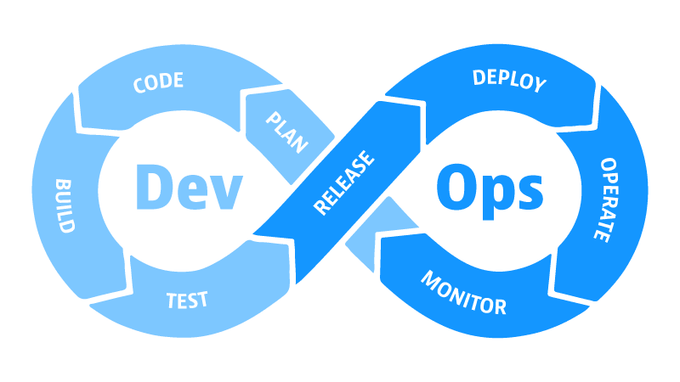

Continuation of what we are doing and how are we doing it

If we concentrate on Ops side, release may be of-the-shelf release – as an example Microsoft has release a containerised version of SQL, they are going to take care of the planning, coding, building, and testing of the release, but if you are using it, you will take care of how you release it in your organisation, and how do you automate that – think about continuous deployment, operation of that, how do we keep it alive, how do we scale it, how do we monitor it and get feedback.

**Twelve areas of DevOps**

1. Learning a programming language
2. Knowing Linux basics
3. Understanding Networking
4. Stick to one cloud provider
5. Use Git effectively
6. Containers
7. Kubernetes
8. Learning Infrastructure as Code
9. Automate Configuration Management
10. Create CI/CD pipelines
11. Observability
12. Store and Protect Data

* Taking the overwhelming image and dissecting it into smaller areas
* Understanding programming language, but not necessarily be a programmer. Get a foundation of a programming language
* Some of these may be already familiar, like Linux basics, shortcut keys around the terminal, knowing how to get around
* Understanding networking – experience from virtualisation point of view and infrastructure layer
* Cloud providers – advice is stick to one and take the knowledge to apply to others
* Using Git – it isn’t just used by programmers, let’s think about version control of everything, like documents, presentations, projects
* Containers and Kubernetes – apply knowledge from virtualisation
* How do I automate some of these tasks? Learning Infrastructure as Code
* Configuration management – how can I keep things in desired state
* How do I implement CI/CD?
* Observability – we need it, even if it is on the bottom of the list. How do we get logging metrics and visualisation of our infrastructure?
* How do we store and protect our data in a consistent fashion across platforms?

**Top tips from open discussion:**

* BindTheGap series will dive deeper into these topics each session
* Most of the tools are free to use (whether opensource, community edition, or free tier)
* Learn using hands-on experience – find a little use case and use that to build your knowledge
* Try to incorporate tools like git into your daily routine, even if it is for your private tasks or a lab
* Use Linux as your daily desktop if you want to get real foundation
* Keep up to date with Tech Twitter, YouTube, and Free Training
* Learn from the community, share your knowledge with the community
* Take the first step!

**Find out more:**

Github Logo - Free social media icons <https://github.com/MichaelCade/90DaysOfDevOps>

Github Logo - Free social media icons <https://github.com/KBrookfield/BindTheGap>

 <https://www.twitch.tv/videos/1538418153>

<https://twitter.com/BindTheGapX>