# 2403A51358 Batch : 14

# Task Description #1 (Password Strength Validator – Apply AI in (Security Context):

The given prompt : create a Password Strength Validator

The code given by google colab

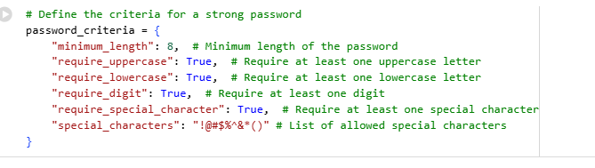

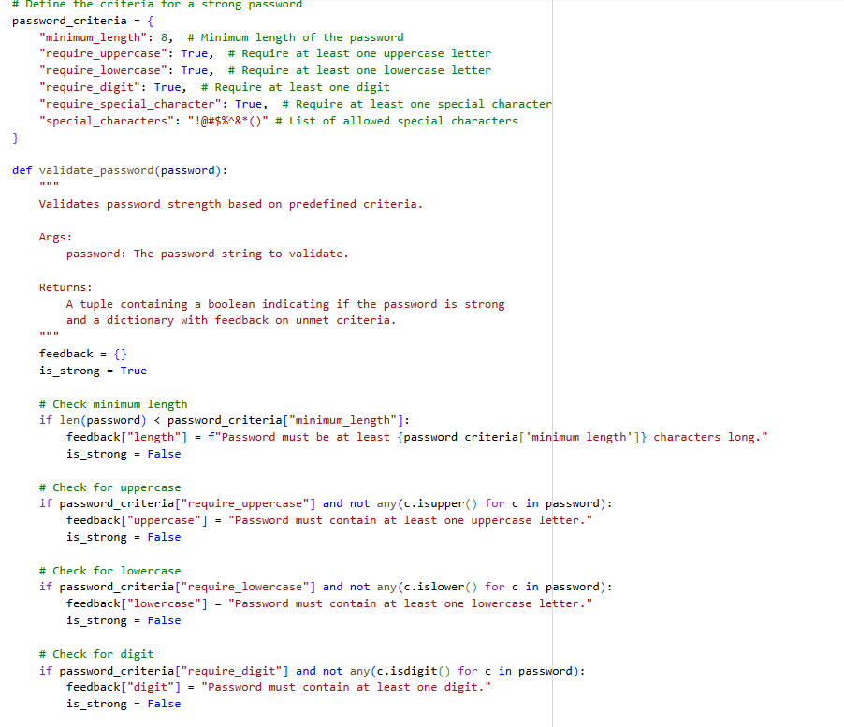

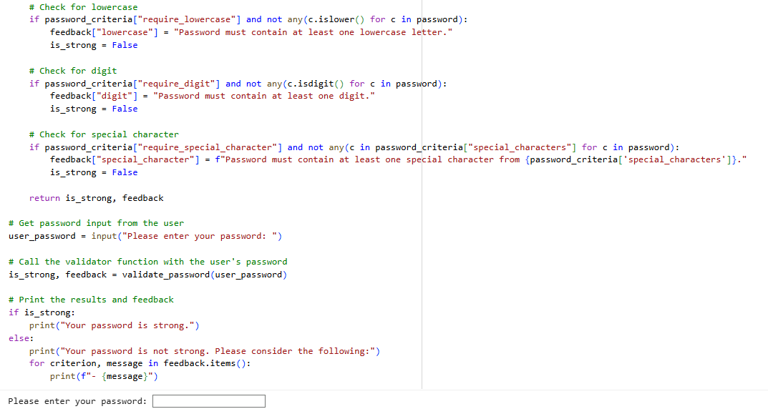

Test case :1



Test case:2

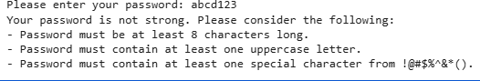

Test case :3



observation:  
The program successfully checks the strength of different passwords. For example, short passwords like “12345” are detected as weak, a mix like “Hello123” is medium, and stronger ones like “Hello@123” are recognized as strong.

# TASK DESCRIPTION #2 (Number Classification with Loops – Apply AI for Edge Case Handling):

The prompt ive given to google colab: create a Number Classification with Loops in one code cell and i need to enter the input

The code given by the gooogle colab:

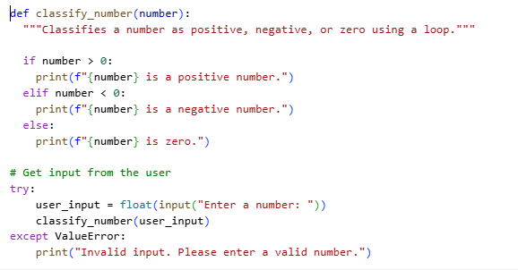

Test case 1:



Test case 2:



Test case 3:



Observation:  
The program works well for different cases. For example, input 5 shows positive, -3 shows negative, and 0 shows zero. The logic is clear and simple to understand.

## Task Description #3 (Anagram Checker – Apply AI for String Analysis):

The given prompt: create a Number Classification with Loops in one code cell and i need to enter the input

Code given by google colab:

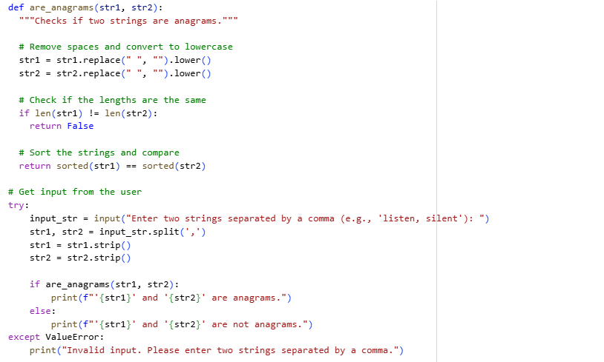

Test case 1:



Test case2:



Test case3:



observation:

The program is designed to correctly identify anagrams. For example, “listen” and “silent” are shown as anagrams, while “hello” and “world” are not. It demonstrates string analysis effectively.

## Task Description #4 (Inventory Class):

The prompt: create Inventory Class with class management

Code given by google colab:

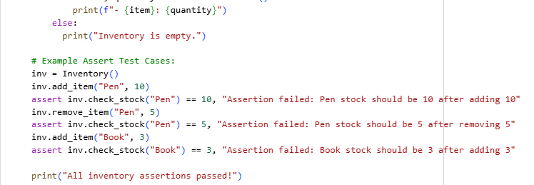



The output:

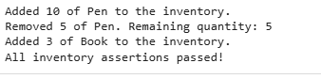

Observation:

The class works well for adding, updating, and displaying items. It shows how object-oriented programming can be used to manage data in a structured way.

# Task Description #5 (Date Validation & Formatting):

The prompt: create a Number Classification with Loops in one code cell and i need to enter the input

The code given by google colab:

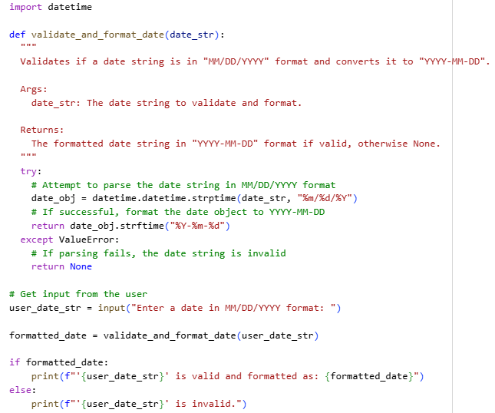

output

test case 1:



Test case 2:



Test case 3:



observation:

The program successfully validates dates and formats them properly. For example, 10/15/2023 is accepted as valid and converted into 2023-10-15, while incorrect dates like 02/30/2023 are identified as invalid.

***Overall Observation:***

**All the tasks were completed successfully and met the requirements of their prompts. Each program shows how AI-generated code can be applied in real situations such as password security, number classification, string analysis, class management, and date validation. The tasks were practical, easy to follow, and gave a clear understanding of applying programming concepts effectively.**