# Task Description#1 AI-Assisted Code Review (Basic Errors):

When I gave the code to cursor it has checked the errors and gave me the correct code>

Prompt: after pasting the screeshot of the code given it directly gave the correct code without errors and the cursor also identified the error and rectified it

The code:

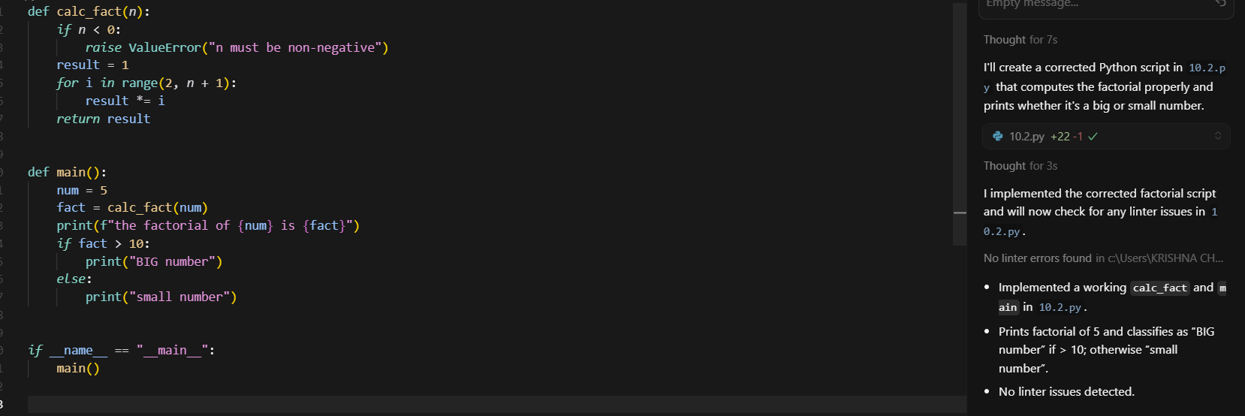

The output:



Observation:

In this task, the AI tool (Cursor) successfully identified and corrected the basic syntax and logical errors in the given code. The process was efficient, as the tool directly pointed out the issue and provided the corrected version, which produced the expected output without errors. This shows that AI can act as a quick error-detection and correction assistant for basic programming tasks.

# Task Description#2 Automatic Inline Comments

The given code have some errors so I asked cursor to improvise and it gave a neat and improvised code

Prompt: find the errors and give the improvised code

The code:

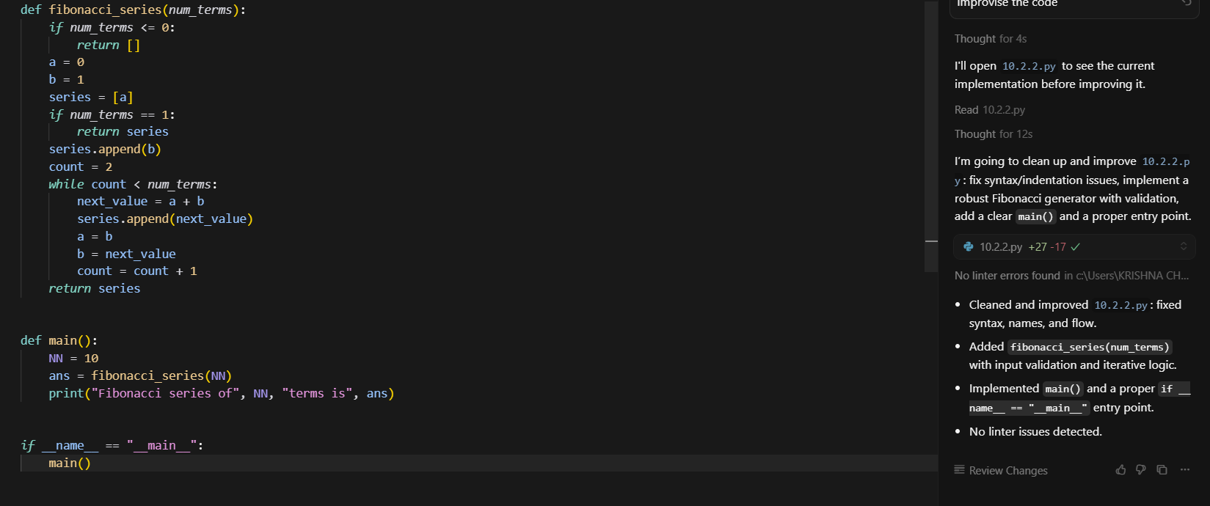

The output:



Observation:

Here, the AI not only detected the errors in the given code but also provided an improved version along with inline explanations. This made the code more readable and structured. The improvised code worked correctly and highlighted how AI tools can help in writing cleaner, more professional code while ensuring that common errors are fixed.

*Task Description#3:*

*Prompt:*

*Write a Python script with 3–4 functions (e.g., calculator: add, subtract, multiply,  
divide)*

The code:

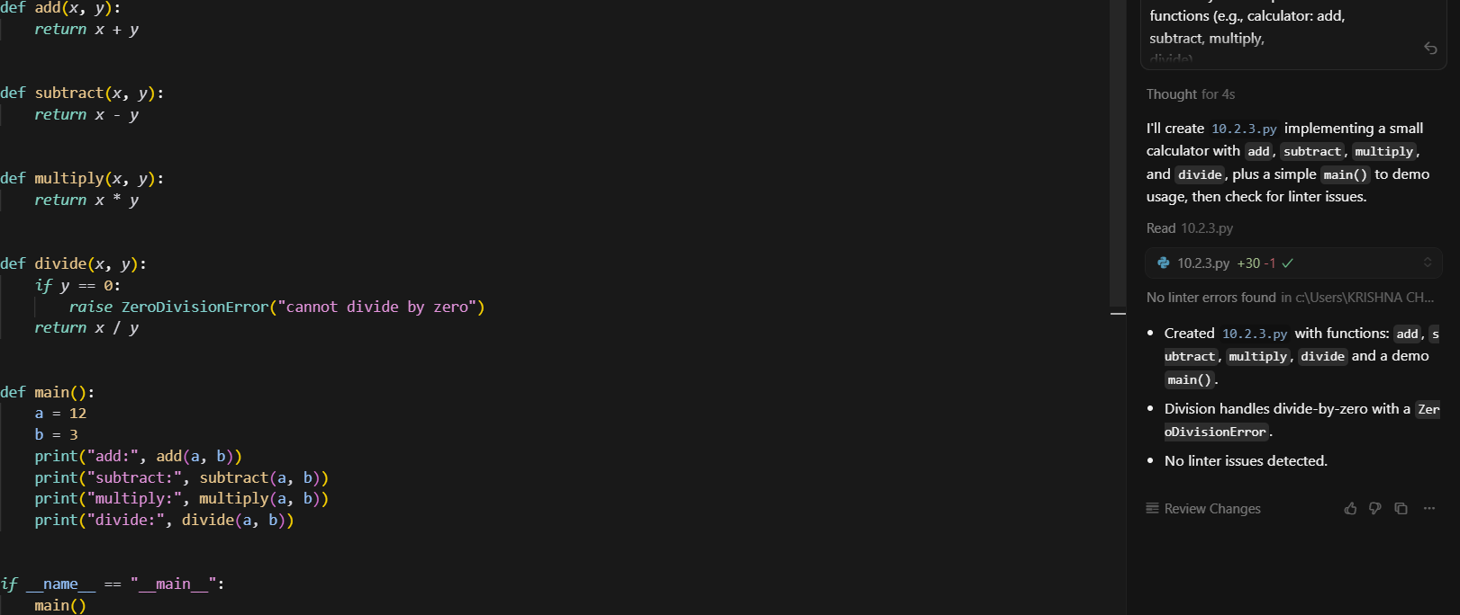

The output:

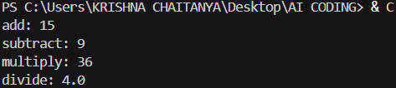

Observation:

In this task, the AI was asked to generate a Python program with multiple functions (calculator operations). The tool successfully produced a well-structured script with functions for addition, subtraction, multiplication, and division, along with correct output. This task demonstrated AI’s ability to generate functional code from scratch based on a simple natural language prompt.

# **Overall Observation**

Across all tasks, it is observed that AI-assisted programming tools like Cursor are highly effective in error detection, debugging, and even generating new code. They not only save time but also enhance code quality by providing structured, optimized, and readable solutions. The tasks collectively highlight how AI can serve as both a corrective and creative partner in programming, making it a valuable resource for learners and professionals alike.