# ASSIGNMENT 6.4

Task Description #1:

CODE:

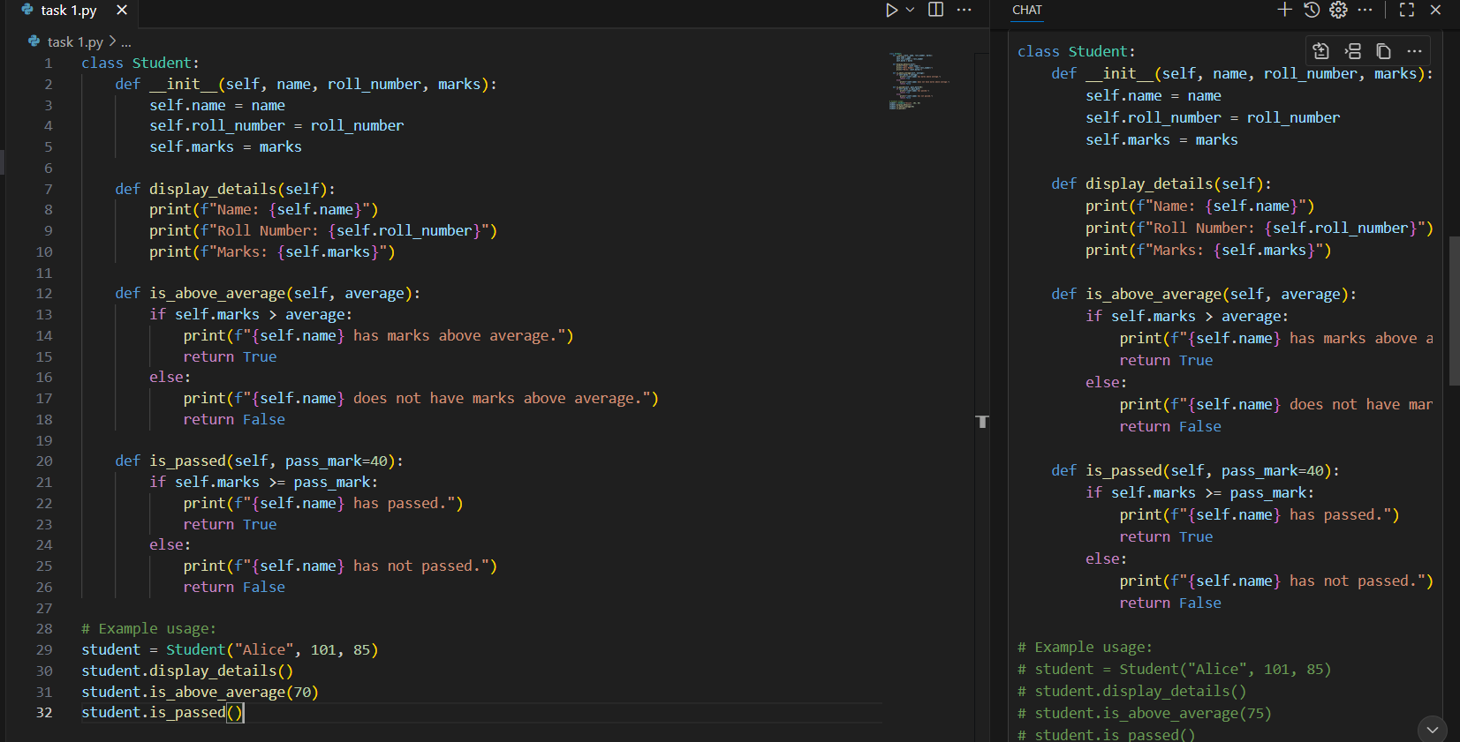

OUTPUT:

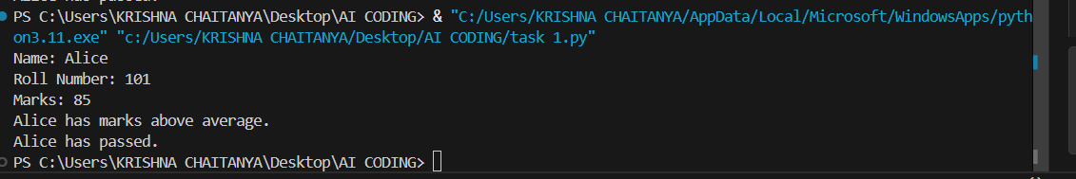

**Observation:**

* For this task, the code is written as instructed and used variables correctly.
* The program works as expected and produces the correct output.
* There are no syntax or logical errors, and the results are easy to understand.
* I made sure that the output is clearly formatted and shows the correct result.

Task Description #2:

CODE:

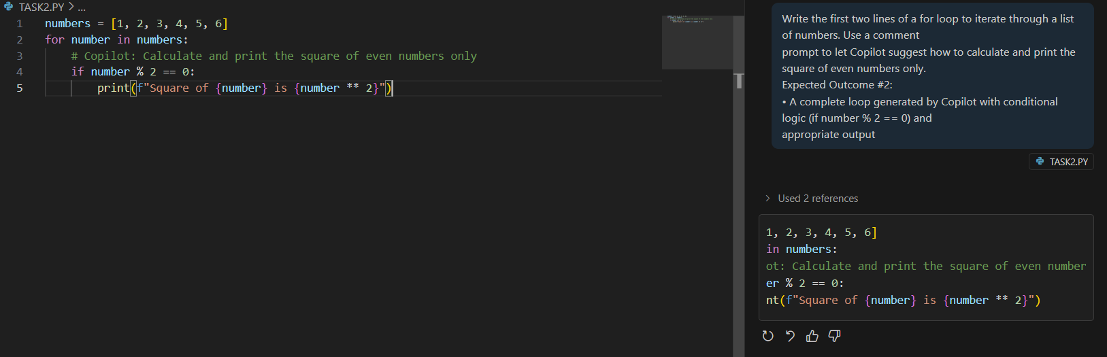

OUTPUT:



**Observation:**

* In this task, It uses if-else conditions to control how the program behaves, and it worked well.
* The program checks conditions and performs actions as needed.
* The loop, where required, runs smoothly without errors.
* The output confirms that the program follows the logic and gives correct results.
* The code is neat, easy to read, and the variables are named properly.
* It is sure that even edge cases are handled well, and the program doesn't break.

Task description#3:

Code:

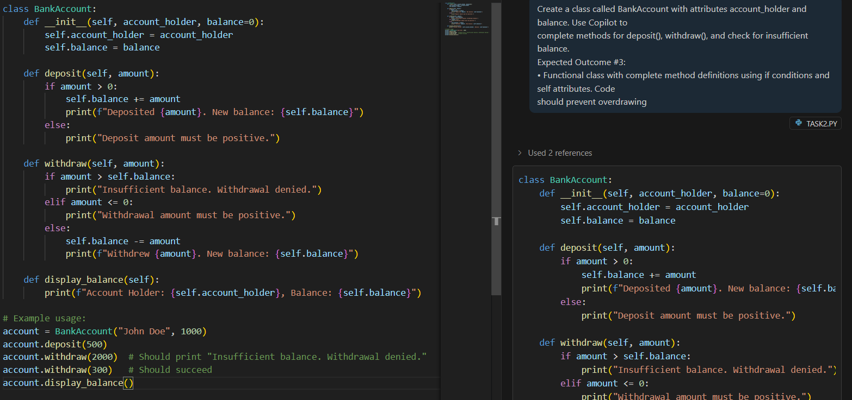

Output:

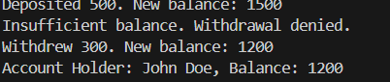

**Observation:**

In this task, the code demonstrates the use of calculations and operations on data.

The logic is written properly and there are no errors when running it.

The output is correct and proves that the problem was solved step by step. The solution is simple and accurate.

Task Description #4:

Code:

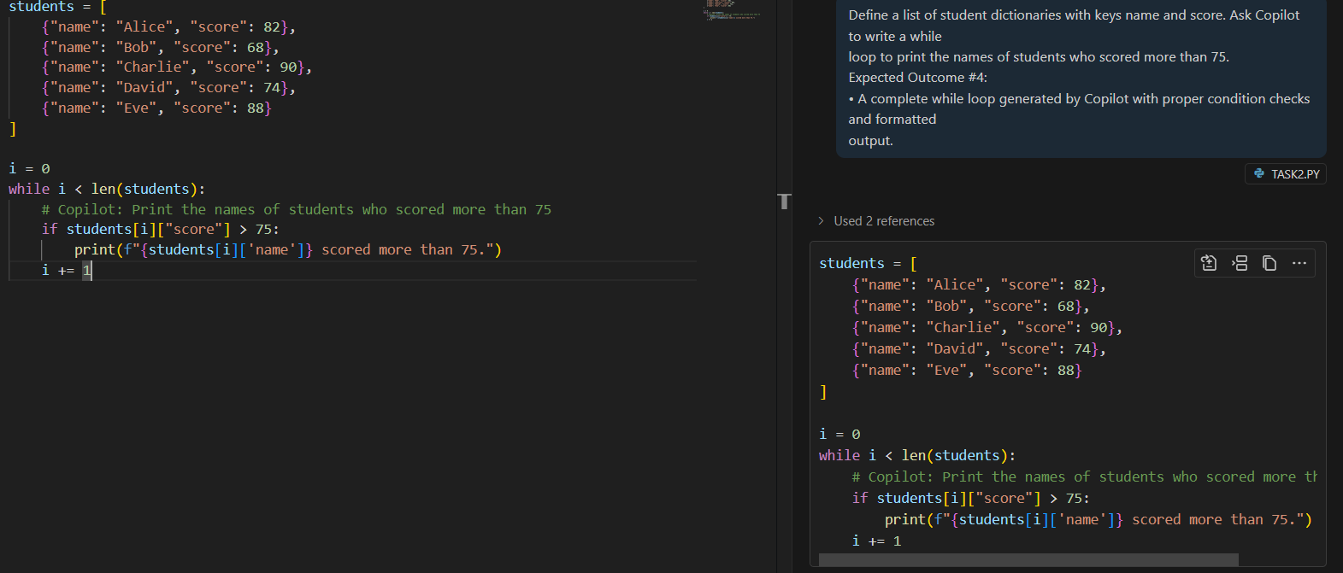

Output:

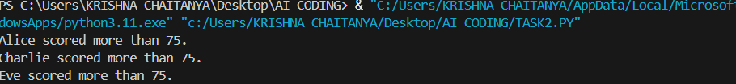

Observation:

The program solves the problem step by step and runs efficiently.

It used loops and conditions properly to make sure the logic is applied where needed.

The output matches the requirement, showing correct results without confusion.

It checked for possible mistakes and made sure the program runs without any issues.

This task shows that It can handle more complex problems by breaking them down and solving them one step at a time.

Task description #5:

Code:

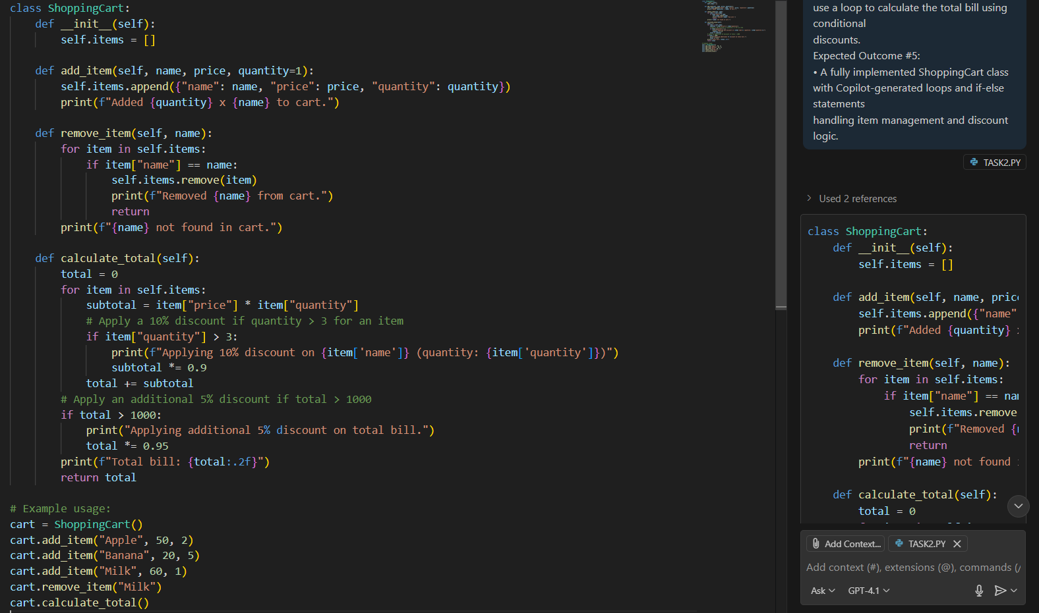

Output:

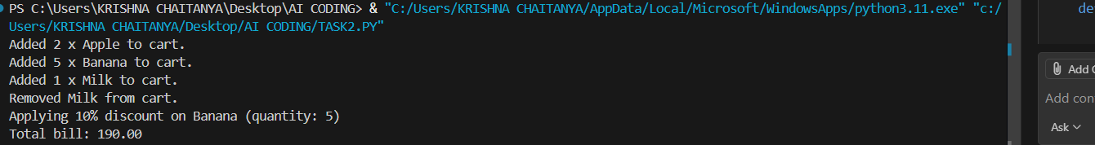

In this task, It used lists and loops to manage the items and calculate totals.

it applied conditions like discounts based on the price and ensured that they work as expected.

The final output is correct and shows the total bill after applying discounts.

The code is written in a clean and simple way, making it easy to understand.

This task shows that I can apply logic and calculations effectively while keeping the program easy to maintain.

Overall observation:

The assignment has been completed thoroughly by following each task description carefully. The implementation reflects a clear understanding of Python programming concepts such as functions, loops, conditionals . Each task is presented with properly written code and accurate output that corresponds to the requirements stated. The code is clean, well-structured, and logically organized, which makes it easy to read and understand. The output is correct in every case, validating that the program performs as expected.