Hackbright Fellowship May 2017
CS and Data Structures Assessment 1
« Back to Homepage

CS and Data Structures Assessment 1

Concept Review

Runtime Concepts
- Big O Notation
- Why it’s important to think about runtime
  - Interviews (be able to describe the runtime of your own solutions)
  - A language to describe algorithm efficiency, and compare alternate solutions
- Runtimes to know
  - Constant, or O(1): even when size of work increases, length of time is always the same
  - Linear, or O(n): as size of work increases, length of time the algorithm takes increases linearly
  - Logarithmic: binary searches (looking up a word in a dictionary, for example); the work is divided in half with each iteration of the algorithm
    - O(log n)
    - O(n log n) (do something with O(log n), n times)
  - Quadratic, or O(n2): nested for-loops, typically
  - Exponential: password cracking algorithms, for example
    - O(2n), O(3n), etc.
  - Factorial, or O(n!)

Stacks and Queues
- Concepts, not implementations
  - Stacks and queues are ways to manage and process information
  - You can build a stack or queue out of different implementations (lists, linked lists, etc)
- Stack: LIFO
- Queue: FIFO

Linked Lists
- A data structure for storing an iterable collection
- Can be used similarly to a regular Python list (“array”)
- But have performance differences

Trees
- Trees: storing hierarchical data (org charts, taxonomies)
- Binary Search Trees: searching a binary tree using a “rule”
- Navigating trees using BFS and DFS

Part 1: Discussion Questions

Runtime
- When calculating the Big O notation for a particular algorithm, it’s necessary to consider the length of time it takes for the algorithm to run as the algorithm’s workload approaches infinity. You can think of the workload as the number of tasks required to complete a job. What determines the workload of figuring out whether your box of animal crackers contains an elephant? Number of crackers
- Order the following runtimes in descending order of efficiency (that is, fastest runtimes first, slowest last) as napproaches infinity:
  - O(log n)
  - O(n2)
  - O(n log n)
  - O(n)
  - O(2n)
  - O(1)

  - O(1)
  - O(lon n)
  - O(n)
  - O(nlog n)
  - O(n^2)
  - O(2^n)
  - O(n!)

Stacks and Queues
- In the following cases, would a stack or queue be a more appropriate data structure?
  - The process of loading and unloading pallets onto a flatbed truck stack
  - Putting bottle caps on bottles of beer as they roll down an assembly line queue
  - Calculating the solution to this mathematical expression: 2+(7*4)-(3/ 2) stack
- Describe two more situations where a queue would be an appropriate data structure. Queue at grocery store, printer queue
- Describe two more situations where a stack would be an appropriate data structure. Pez dispenser, printer paper

Linked Lists
- Given the linked list below, which are the nodes? Apple, Berry, Cherry, None
What is the data for each node? 'Apple' and a pointer to Berry, 'Berry' and a pointer to herry, 'Cherry' and a pointer to None, None
Where is the head? In linked list object. It holds a pointer to Apple
Where is the tail? In linked list object. It holds a pointer to Cherry
(Please be as specific as possible — exactly which parts of the diagram correspond to each part? Arrows? Boxes? Text?)

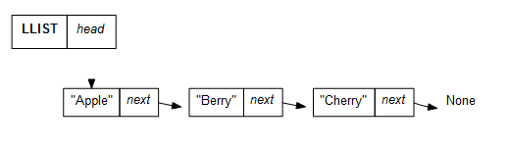
- What’s the difference between doubly- and singly-linked lists? It holds pointers to previous node, starting from tail Node.
- Why is it faster to append to a linked list if we keep track of the tail as an attribute? Because we know where the end of the linked list

Trees
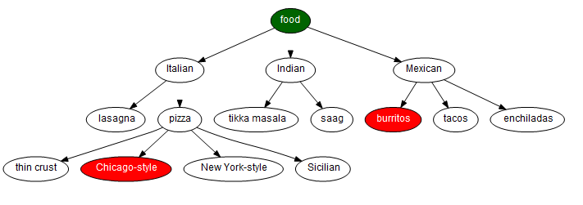
- Given the tree above, in what order would a Breadth First Search (BFS) algorithm visit each node until finding burritos (starting at food)? Just list the order of nodes visited; no need to recreate the state of the algorithm data in your answer. Food, Italian, Indian, Mexican, Lasagna,pizza, tikka masala, saag, burritos
- Given the tree above, in what order would a Depth First Search (DFS) algorithm visit each node until finding Chicago-style (starting at food)? Just list the order of nodes visited; no need to recreate the state of the algorithm data in your answer. Food, Mexican, Enchiladas, Tacos, Burritos, Indian, sag, tikka masala, Italian, pizza, Sicilian, New York-style, Chicago-style
- How is a binary search tree different from other trees? In a binary each node has two (and only two) children

Part 2: Skills Assessment

Runtime
In the file called runtime.py, there are 5 functions.
- What is the runtime for string_compare? Add your answer to the end of the function’s docstring.
- What is the runtime for has_exotic_animals? Add your answer to the end of the function’s docstring.
- What is the runtime for sum_zero_1? Add your answer to the end of the function’s docstring.
- What is the runtime for sum_zero_2? Add your answer to the end of the function’s docstring.
- What is the runtime for sum_zero_3? Add your answer to the end of the function’s docstring.

Stacks
In the file called stack.py, there is a class definition, along with some methods for a Stack class.
- Finish the method called length.
- Finish the method called empty.
- Finish the method called is_empty.

Queues
In the file called queue.py, there is a class definition, along with some methods for a Queue class.
- Finish the method called enqueue
- Finish the method called peek.

Linked Lists
In the file called linkedlist.py there is a class definition for a Node in a linked list, as well as a class definition for a LinkedList. There are methods already defined for remove_node_by_index, find_node (by data), and add_node.
- Finish the method called print_list.
- Finish the method called get_node_by_index.

Trees
In the file called tree.py there is a class definition for a Tree, which we might use for keeping track of an organizational chart at a company. There is also a class definition for a Node, which would represent an employee. Each node has an attribute called children, which is a list of other instances of nodes. In the real world, a node’s children would represent the people whom that node/person supervises.
- In the Node class, finish the method called get_num_children. This function could be used to count the number of people whom a person supervises.
- In the Tree class, finish the method called breadth_first_search. Hover over the section below if you need a hint.

