**Machine Learning with Python**

**Project: Emission of Co2 From Cars**

**By:**

**V V N S Krishna Chaitanya**

**1.INTRODUCTION:**

*1.1 Overview:*

The amount of CO2 emission from the transport sector (including cars) accounts for about 20% of total CO2 emissions. Accordingly, from the viewpoint of preventing global warming, reducing that proportion is a key issue. The simplest way to calculate the carbon emissions from cars is to use the fuel consumption. In the given dataset we have used fuel consumption in cities and highways, the fuel type, engine size and number of cylinders. We have built a web application which predicts the carbon emission from a car. This is achieved by building a machine learning model using the random forest algorithm and integrating it into the flask application.

*1.2 Purpose:*

To predict the car’s performance by taking user’s input in specified units. Our predictions help to see if the Emission of co2 of that particular car is more then the threshold value then that car details should be sent to the particular RTA region head to seize the car.

**2.LITERATURE SURVEY:**

*2.1 Existing Problem:*

The increasing amount of carbon emissions are leading to global warming, air pollution and various other problems. Some [impacts](https://www.ucsusa.org/climate/impacts)—such as record high temperatures, rising seas, and severe flooding and droughts—are already increasingly common.

*2.2 Proposed Solution:*

This model, by taking the required input is able to predict the amount of carbon emissions from a car and whether it is above the threshold. Therefore, it can help in reducing the carbon emissions.

**THEORETICAL ANALYSIS:**

*3.1 Block Diagram:*

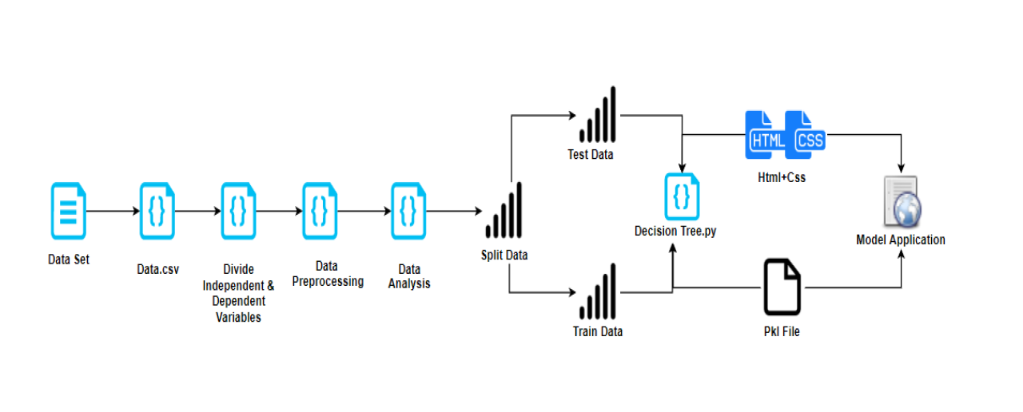

*3.2 Hardware/ Software designing:*

* Strategy: Matching the problem with the solution.
* Dataset preparation and pre-processing: Data collection, Visualization, Labelling, Data selection, Data pre-processing and transformation is done.
* Dataset is then split into training data and testing data.
* Modelling: Model training, evaluation and testing is done. Improving predictions with ensemble methods.
* Model deployment.

**4. EXPERIMENTAL INVESTIGATIONS:**

During our investigation we got to know the required parameters for predicting the carbon emissions from a car.

**5.FLOWCHART:**

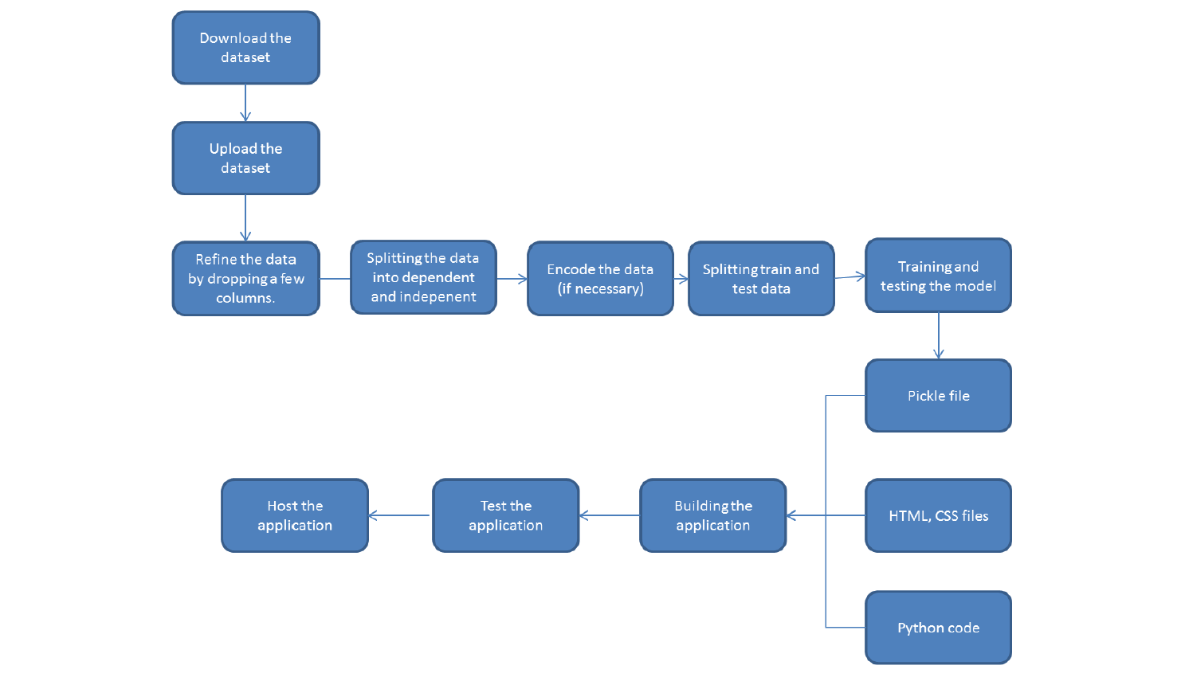

**6. RESULT:**

Based on all the inputs given by the user, the model is able to predict the carbon emissions of a car and determine whether it is above the threshold.

**7.ADVANTAGES & DISADVANTAGES:**

*Advantages:*

* Prediction of the carbon emissions from a car.
* Very accurate calculations and ability to determine whether above the allowed threshold.
* Extremely user friendly and easy to understand interface.
* Straight forward results.

*Disadvantages:*

* User should have an idea about all the parameters and their respective units.

**8. APPLICATIONS:**

* It can be used to predict the carbon emissions for a given car.
* It can also decide if a given car is above or below the threshold.

**9.CONCLUSION:**

It is necessary to reduce the amount of carbon emissions in order to control global warming and pollution. Our application is able to predict these emissions and help in controlling them.

**10.FUTURE SCOPE:**

In today’s world it is extremely important to reduce the emissions of carbon and other harmful gases into the atmosphere. Our application predicts these with a high accuracy and can be modified for other gases as well.

**11.BIBLIOGRAPHY APPENDIX**

**Model Building**

* **Dataset**
* **Notebook**

**Application Building**

* **HTML 5 and CSS 3 files**
* **Flask**