**Data Visualization**

**1. Data Overview**

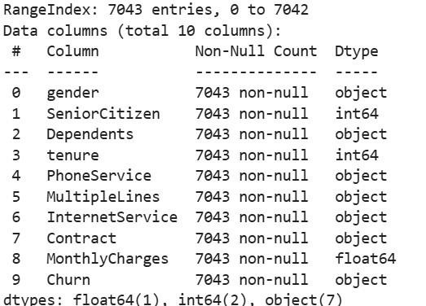

**2.**

**Data Statistics**

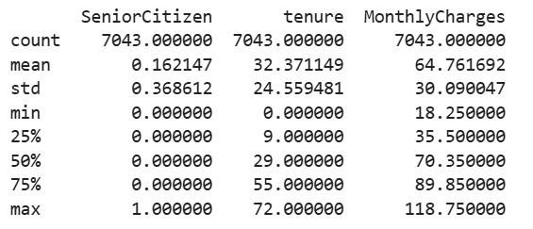

1. **Missing Values Before and After Imputation**

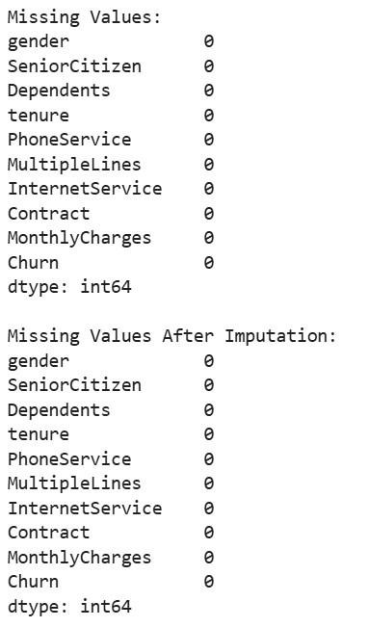

1. **Prepared and Normalised Data**

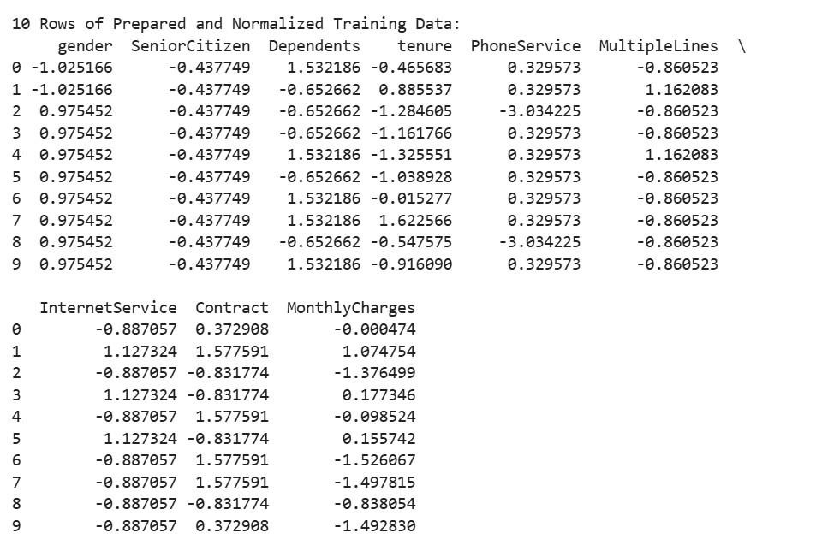

1. **Graphical representation of MonthlyCharge Distribution Before and After Scaling**

