# Project Proposal

## Overall

The project will provide an interactive environment containing useful information focused on Tourism for people who are willing to travel or visit Nepal. The Website that I am going to create explores travel information, maps, activities, activities, places and accommodation to help tourist who are planning to come over the Land of Beauty “NEPAL”. This site is mainly focused on the attraction of the tourist and foreigners by reflecting the natural resources, places, adventures, cultures and unique tradition of the country. This website contains different topics such as: Destination, things to do, recommended trips and so on.

## Project Goal

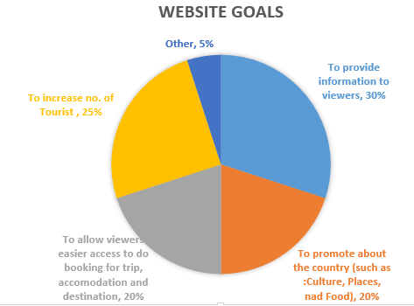The goal of the project is to provide information that is relevant to travellers who are thinking about and actively planning a visit to Nepal. Through this site, potential visitors will be able to learn about the diversity of what Nepal has to offer and how to make their visit a fantastic experience. People who use this site should be encouraged and be confident to plan their future trips.

## Target Audience

The target audience for my website is anybody interested in travelling to japan. The main demographic of the people looking interested in the information my website covers is people between 18-99 but can be under age of 18 if coming along with their parents, both male and female, who are interested in Nepal but lack knowledge on what they could expect if they travel there and what they could do. The technically capabilities of this wide demographic will be considered to be competent navigate basic website design, comfortable using navigation bars, slideshows and playing video and sounds will be the only knowledge expected to use the website. It is also targeted on those who literally love travelling to different places especially holy place, scenic beauty and cultural places

### Design

As these are people looking to found out what japan is about, for the design to appeal to them I will look to use pictures throughout the website, as what they are looking for is a visual idea, as well of basic information, of what they can expect Nepal to look like. Also, for the design I will stay away from using too much text that isn’t accompanied by pictures referencing what is being written as while they will need the information, just having pages of text without the visual references will be too jarring and turn them away.

The design should be responsive which is compatible for any electronic browsing devices. Lastly the design will certainly be both mobile and desktop compatible with Google chrome as a primary based platform, as desktop browsing in New Zealand only makes up 53.65% of views and most of them view using Google chrome as a browser, as of May 2019. (GlobalStats, 2019)

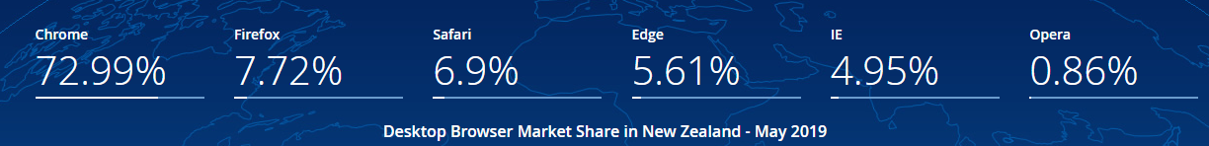

### Use

When it comes to amount of use this could be many times as it takes them to gain an understanding, they feel is reasonable so they can decide if Travelling to Nepal looks interesting to them. So, it’s important to have fresh content on it regularly, but still make it very simple to find something people want to find information about.

### Benefit after use

The website will have given prospective user very good details about Nepal they require in order to travel and what Nepal can offer to the tourist. They will have an understanding of the different things they can expect when it comes to food, accommodation and transport, also some attractions they could visit and overall be able to feel as if they understand more about what travelling to Nepal would entail than if they hadn’t visited the website.

### Personas

**Paul Anderson** – Paul is in his early 30s and single. He is from England; he has no children so spends a lot of time travelling to the new places. Paul’s a software engineer with some disposable income. He’s not rich and believes that money corrupts. He also believes in the power of collective activism.

He spends a lot of time volunteering for social works, developing campaign websites, managing social media. And he is very wary of “being sold” when he visits website. He’s very passionate, but he’s very smart.

**Narayan Monger** – Narayan is in his late 20s. He’s been married, has a daughter and is very passionate about Photography. He shares many of the same values that Andy has, but rarely gets past signing a petition or making small donations to causes he believes in.

Narayan wants to be part of something bigger than himself, but he’s a little skittish and shy. He needs to feel heard an understood before he’ll make substantial commitments. He’s been loving the nature through the lenses of his camera. So, he always wants to explore the new photographic scenes through his DSLR.

## Objectives

After visiting the website, the user will:

1. Have more knowledge about tourism places in Nepal and attractions that tourists can visit.
2. Be comfortable with knowing different native Nepalese food that they could try for the first time.
3. Know of the different kinds of transports that existences in Nepal.
4. Feel comfortable in their knowledge of the different options of accommodation in Nepal
5. Have an idea of if travelling to Nepal is right for them or if they need to do more research before coming to a conclusion.
6. Establish Nepal as a choice of holiday destination, enhance the capacity of service provider.

## Content

My website title, Experience Nepal, is about showing all the different things someone who is interested in travelling to japan will want to know before deciding if it is right for them.

* 8-12 pages in your website – Home page, about us, Nepal Overview, accommodation, contact us, destination, things to do, transport, media.
* Responsive design – All the pages are responsive so that they can view from any portable devices.
* one audio file and video file are included the media.html page
* A form is mentioned on the contact us page to contact to the experience Nepal.
* Some JavaScript – JavaScript is done on the media page and slider.html for the edition of video and images slider.
* All most all the pages have got at least one image beside contact us page.
* I have used slideshow of an Images in the home page for the animation.
* I have used Verdana as a text font with appropriate size and appropriate colours.
* I have used hover effect on nav items.

References I used for making of my website:

* I have used the jQuery in Media page for the video file and the Slider page of Desktop site for the Image slider.
* For the photo slider I have use online plugin for sliding image from “http://fancybox.net/”.
* jQuery resources from <http://code.jquery.com/jquery-2.1.3.min.js>. For the editing of video in the media page.
* I used free images for photo gallery from “google.com” like link <https://www.google.co.nz/search?q=high+resolution+images&espv=2&biw=1680&bih=965&source=lnms&tbm=isch&sa=X&ved=0CAYQ_AUoAWoVChMIi97N3a-MyQIVRSWmCh1crwi5>
* I used free video from YouTube.com link <https://www.youtube.com/watch?v=to1PNUCY_kU> and back ground music comes with the video.
* And I also use different forums suggestion for making my website responsive and designation of the layout.

## Content Treatment

When the website first loads the user will land on the homepage, the logo with Nepal map and title on top. The homepage will contain the navigation bar at the left side and the bottom of the browser window; this will contain all the different sections of the website. These different sections will also change colour when hovered over, and text will become red and shaded. There will be a slideshow that will cycle through a group of images showing off different parts of the website. Below slideshow there will be a description of the Nepal in terms of geography and tourism. Further down will be a section that is 3 columns wide and 2 rows deep which will feature images of different parts of the website, such as a contact us, about us, etc, this will light up when hovered over and if clicked will take the user to that specific area of the website. From the homepage the user will be able to go to the many content pages of the website by clicking on the appropriate heading they prefer from the navigation bar. These content pages will also keep the navigation bar in the same location, making it easy for the user to go travel around the website.

## Delivery Platform

The website will be accessible via Google Chrome, Firefox, Edge, Safari, Chrome Mobile, and Safari iOS. Compatibility with the discontinued Internet Explorer (last release 4 ½ years ago) is being considered, but may depend on compatibility with CSS, JavaScript, jQuery and HTML 5 techniques.

It will be designed to look as intended on mobile, tablet, laptop, and desktop screens. This will go down to 360 x 640 resolution, and up to 5120 x 2880 or higher.

## Media Assets

### Images

I will use JPEG, PNG and GIF to display my images for my project. These 3 formats are the most widely supported by web browsers; they also can each deal with specific images. JPEG will be used with photographs, PNG with logos and low colour count images and GIF for animated images.

### Graphics

I will use PNG format logo, because of its ability to support transparency and not suffer from JPEG compression artefacts.

### Animations

I have used jQuery for the animation of image slideshow in my home page. I have also used different CSS features on the navigation bar for the hover effect and change in font effect when click.

### Audio

I will use MP3 format as this format is supported by all major web browsers. Also, this format uses lossy compression, which means the file to size ratio of the files is a reasonable size for websites. This will aid in a faster loading file, and because of mp3’s wide support, fantastic compatibility.

### Videos

I will be using MP4 format for delivering my video. I choose this format because it provides an acceptable size to quality ratio, when compared with the other available formats. It is also the compatibility with browsers, this is the reason I have chosen Mp4, as MP4 is the only support format by internet explorer.

## Ethical / Legal Issues

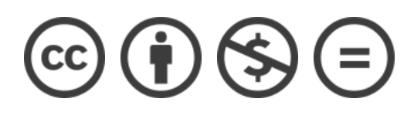The website itself will have a Creative Commons License of “Attribution-Non-commercial-No Derivatives 4.0 International”. This means that adaptions of the website and its content cannot be shared, and commercial use of the work is not allowed.

### Summary

Creative Commons Attribution-Non-commercial license in International version 4, that allows to do what they want with your work as long as it`s Non-Commercial.

### Attribution

You must give credit to the original author of the work, including a URI or hyperlink to the work, this Public license and a copyright notice.

### Attribution information revoke

Author can request to remove any attribution given information.

### Tivoization

You may not apply legal terms or technological measures that legally restrict others from doing anything the license permits.

### Disclaimer of warranties

Disclaimer of warranties is optional.

If separately undertaken, shared material must retain a notice to Disclaimer of warranties.

Otherwise, Disclaimer of warranties, is taken by default, providing the work as-is and as-available.

### Liable

Liable follows the same rules as Disclaimer of warranties, providing, by default, protection from defamation for the creator.

### Revoke

The licensor cannot revoke these freedoms as long as you follow the license terms.

( Benio, 2015)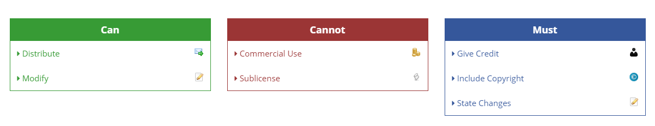

## Total Time Estimated

### Summary

Overall the bulk of the time will be spent in development of the media assets, plus the HTML and CSS. Getting the webpage to look how I want can be difficult and creating the original media assets. So, I’ve budgeted half of the total project time to that area.

The tasks have been divided into subtasks, listed on the next several pages.

|  |  |
| --- | --- |
| Initial Project Proposal | 7 hours |
| Initial Navigation Map | 1 hours |
| Initial Risk Assessment | 2 hours |
| Initial Test Plan | 4 hours |
| Initial Storyboard | 9 hours |
| Media & Design Created | 34 hours |
| Submit Prototype | 12 hours |
| Final Project | 18 hours |
| **Total Time Estimated** | **87 hours** |

### Detailed Time Breakdown

|  |  |  |  |
| --- | --- | --- | --- |
| Experience Nepal - Timeline | By KC | | | | |
| Final Version | | | |
| **Milestone** | **Task** | **Budgeted Hours** | **Due Date** |
| **Initial Project Proposal** | Establish project goal | 0.1 | 9/04/2019 |
| Research and define target audience | 1.5 |
| Create Personas | 0.5 |
| List objectives | 0.1 |
| Detail overall content and page content | 0.5 |
| Create a deliverable | 0.5 |
| Write about content treatment | 0.3 |
| Discuss the delivery platform | 0.1 |
| Cover the media assets the project will use | 0.5 |
| Write about possible ethical / legal issues | 0.2 |
| Breakdown into tasks and create time estimates | 0.4 |
| Proof of read and edit text | 1 |
| Generate copyright license | 0.1 |
| Polish document design | 0.7 |
| Final proof of read | 0.5 |
| **Subtotals** |  | **7** |  |
|  |  |  |  |
| **Initial Navigation Map** | Planning | 0.1 | 16/04/2019 |
| Creating pages | 0.4 |
| creating path | 0.3 |
| Final navigation map | 0.2 |
| **Subtotals** |  | **1** |  |
|  |  |  |  |
| **Initial Risk Assessment** | Brainstorm risks | 0.6 | 23/04/2019 |
| Create text for risks | 0.4 |
| Research probabilities | 0.5 |
| Final proof of read & spell check | 0.5 |
| **Subtotals** |  | **2** |  |
|  |  |  |  |
| **Initial Test Plan** | Write up the objectives of the test plan | 0.5 | 30/04/2019 |
| Decide and write about a testing approach and assumptions | 0.3 |
| Decide and write down what features and functionality will be tested | 0.3 |
| Detail what my expected results will be | 0.4 |
| Decide and write what the deliverables will be | 0.5 |
| Write up the test documentation | 1 |
| Write down what the testing procedures and walkthroughs are | 0.5 |
| List the schedules of when testing will take place | 0.5 |
| **Subtotals** |  | **4** |  |
|  |  |  |  |
| **Initial Storyboard** | Write rough draft of what each webpage contains | 1 | 30/04/2019 |
| Draw a draft of how the website and webpages will look | 2 |
| Analyse the designs and consider changes | 0.5 |
| Modify the drafts | 2 |
| Collect feedback on storyboard | 0.5 |
| Make final changes and storyboard design | 3 |
| **Subtotals** |  | **9** |  |
|  |  |  |  |
| **Media & Design Created** | Write text for pages | 2 |  |
| Take and collect photos to use | 1 |
| Collect a range of fonts to possibly use for the logo and website in general | 1 |
| Create the logo | 0.5 |
| Reduce photo file size | 1 |
| Create the two unique graphics to use | 2 |
| Create the two unique animations to use | 3 |
| Create the two videos to use | 3 |
| Find suitable music for one video and edit it | 2.3 |
| Record a voice over | 0 |
| Compare formats for media and decide which to use | 1 |
| Test playback on various devices of media | 1 |
| Decide on colour scheme for the website | 2 |
| Create home page | 4 |
| Create media page | 2 |
| Create accommodation page | 2 |
| Create overview page | 1 |
| Create transport page | 1.5 |
| Create things to do page | 1 |
| Create contact page | 1.5 |
| create destination page | 1 |
| Create about us page | 0.2 |
| **Subtotals** |  | **34** |  |
|  |  |  |  |
| **Submit Prototype** | Add more detail to storyboard | 1 | 31/05/2019 |
| Create basic page layout in HTML | 3 |
| Create basic navigation bar and footer | 1.5 |
| Put temporary photos and content in | 1 |
| Collect feedback | 0.5 |
| Plan changes | 1 |
| Apply changes | 0.5 |
| Test project | 0.5 |
| Present draft prototype for feedback | 2 |
| Analyse feedback, plan and implement changes | 1 |
| **Subtotals** |  | **12** |  |
|  |  |  |  |
| **Final Project** | Final documentation | 9 | 14/06/2019 |
| Check of project requirements and testing | 5 |
| Final debug & test | 4 |
| **Subtotals** |  | **18** |  |
|  |  |  |  |
|  |  |  |  |
| TOTALS: (Hours) |  | 87 |  |

## Proposal References

Benio. (2015). *Creative Commons Attribution-NonCommercial 4.0 International (CC BY-NC 4.0)*. Retrieved from Code License: https://tldrlegal.com/license/creative-commons-attribution-noncommercial-4.0-international-(cc-by-nc-4.0)

GlobalStats. (2019, May 7). *Browser Market Share New Zealand*. Retrieved March 7th, 2018, from Statcounter: http://gs.statcounter.com/browser-market-share/all/new-zealand