# Storyboard - Final

## Navbar

### 

### Desktop

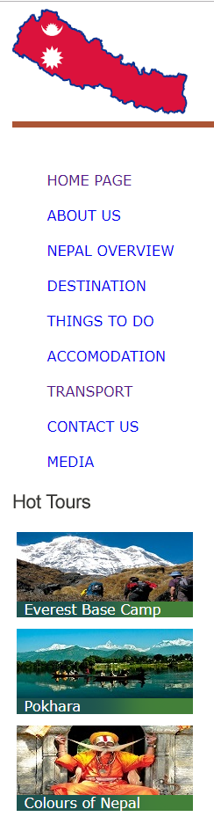

### Text & Media Assets

**Logo:** Nepal map on the header

**Text:** Included in all the Pages

Home Page directs a user to index.html

About Us directs a user to aboutus.html

Nepal Overview directs a user to Nepaloverview.html

Destination directs a user to destination.html

Contact us directs a user to contact.html

Transport directs a user to transport.html

Things to do directs a user to thingstodo.html

Media directs a user to media.html

Accommodation directs a user to accomodation.html

## Footer

### Desktop & Mobile



### Text & Media Assets

**Text:** About Us, Contact us, Desktop Site, Terms and Conditions and content (copyright symbol) KC 2019

Hyperlinks:

About us directs a user to aboutus.html

Contact us directs a user to contact.html

Desktop Site directs a user to index.html

Home Page

Desktop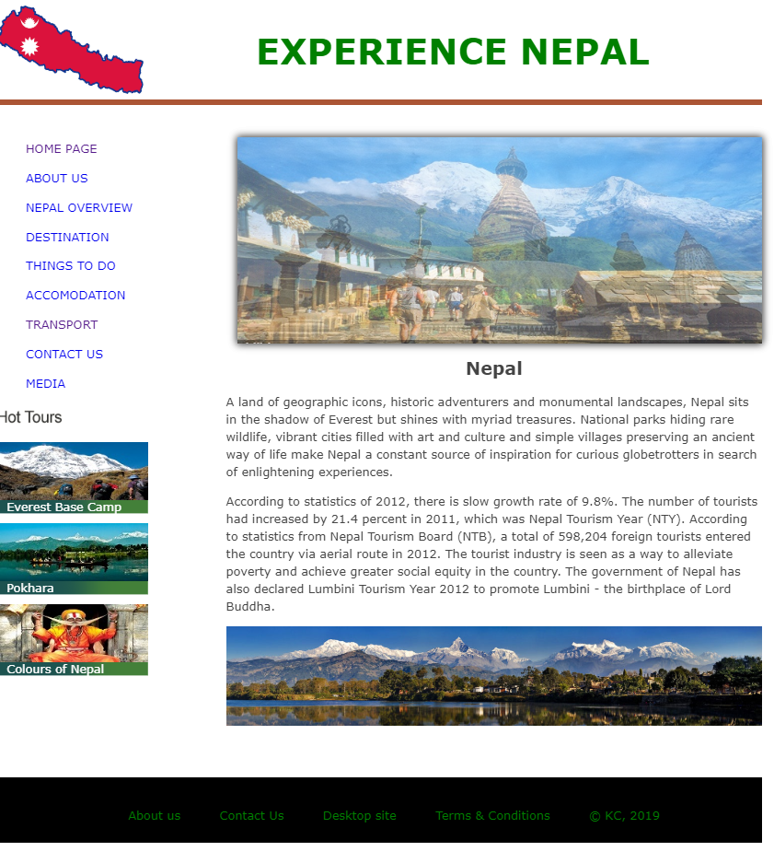

Slideshow is few images of the view of Nepal.

Items: Logo and Heading on Top. Nav bar in the left with some of the photos of hot deals. Slideshow and Text and panorama image. And Bottom footer with some navigations and copyright.

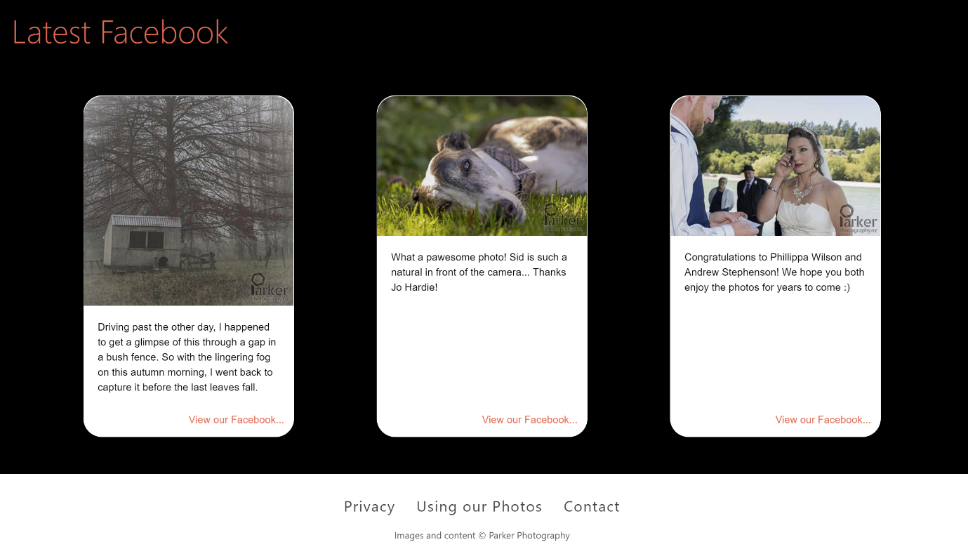

Quote slideshow changes quotes every 10 secs. Text centered. Quote text is 2rem, 3rem left & right padding. Author text is body font, but italics. Quote marks top left and right, 2rem padding, 3rem font size, #000. Links in #ff6b53.

## Mobile

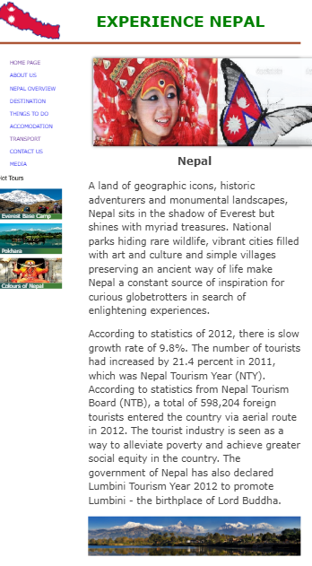

Almost same to the Desktop site.

#### Text & Media Assets

Item 1: Heading

**Type:** Text and Logo

**Colour:** Green

**Font:**  **Size:** 3em **weight:** Bold

**Position: Top** centred

**Logo:** logo.png **size**: 200*120

Item 2: Navigation bar

**Type: Link** Text

**colour**: #00FFFF; Blue

S**ize:** Auto **float**: Left

**Position: b**elow Item 1 and Left

**Font face:** Verdana, Arial, sans-serif;

**Font size:** 1.5em

**Hover** **effect**: Changes to Red in colour

Item 3: Slideshow

**Type:** Slideshow Image using jQuery

**Size: width:672px; height:280px;**

**Position:** absolute, below heading

**Source:** images/pic.JPG**,**

Item 4: Content

**Type:** Text

**margin-bottom:** 1em;

**size: max width:** 70%;

**Font face:** Verdana, Arial, sans-serif;

**Position:** below slideshow

Item 5: Image

**Type:** Image

**Style**: panorama

**Position:** below slideshow

**Size**: Auto

**Source**: images/pokhara.jpg

Item 6: Footer

**Type:** Text

**Font face:** Verdana, Arial, sans-serif;

**Font colour:** Green;

**Size:** 120*50

**Position:** bottom

**Hover** **effect**: Changes to Red in colour

## Rest of the Pages:

### Desktop and Mobile.

Since appearance of website on both mobile and desktop is same.

## About us Page

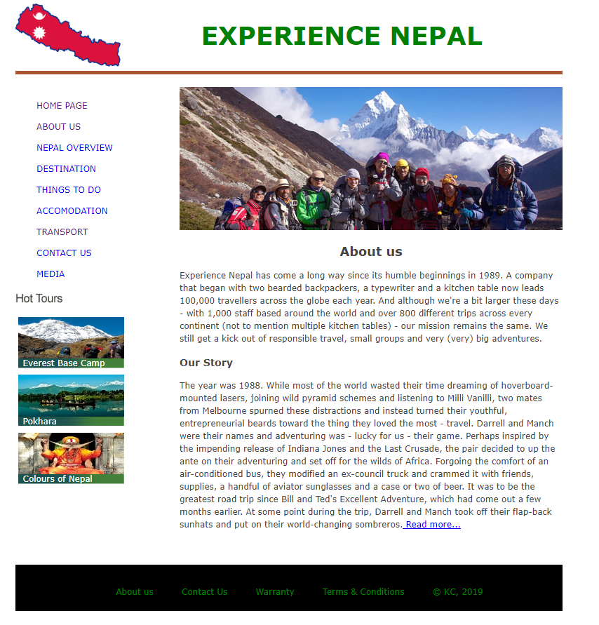

#### Text & Media Assets

Item 1: Heading

**Type:** Text and Logo

**Colour:** Green

**Font:**  **Size:** 3em **weight:** Bold

**Position: Top** centred

**Logo:** logo.png **size**: 200*120

Item 2: Navigation bar

**Type: Link** Text

**colour**: #00FFFF; Blue

S**ize:** Auto **float**: Left

**Position: b**elow Item 1 and Left

**Font face:** Verdana, Arial, sans-serif;

**Font size:** 1.5em

**Hover** **effect**: Changes to Red in colour

Item 3: Image

**Type:** Image

**Position:** below header

**Size**: Auto

**Source**: images/about.jpg

Item 4: Content

**Type:** Text

**margin-bottom:** 1em;

**size: max width:** 70%;

**Font face:** Verdana, Arial, sans-serif;

**Position:** below images

Item 5: Footer

**Type:** Text

**Font face:** Verdana, Arial, sans-serif;

**Font colour:** Green;

**Size:** 120*50

**Position:** bottom

**Hover** **effect**: Changes to Red in colour

### Nepal Overview Page

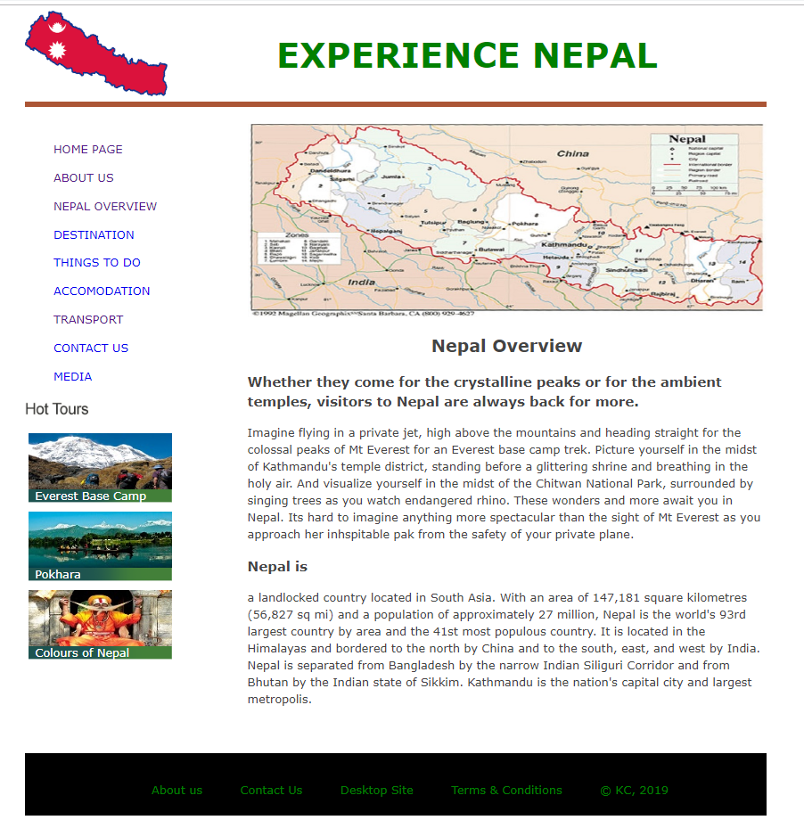

Text & Media Assets

Item 1: Heading

**Type:** Text and Logo

**Colour:** Green

**Font:**  **Size:** 3em **weight:** Bold

**Position: Top** centred

**Logo:** logo.png **size**: 200*120

Item 2: Navigation bar

**Type: Link** Text

**colour**: #00FFFF; Blue

S**ize:** Auto **float**: Left

**Position: b**elow Item 1 and Left

**Font face:** Verdana, Arial, sans-serif;

**Font size:** 1.5em

**Hover** **effect**: Changes to Red in colour

Item 3: Image

**Type:** Image

**Position:** below header

**Size**: Auto

**Source**: images/nepal.jpg

Item 4: Content

**Type:** Text

**margin-bottom:** 1em;

**size: max width:** 70%;

**Font face:** Verdana, Arial, sans-serif;

**Position:** below images

Item 5: Footer

**Type:** Text

**Font face:** Verdana, Arial, sans-serif;

**Font colour:** Green;

**Size:** 120*50

**Position:** bottom

**Hover** **effect**: Changes to Red in colour

### Destination Page

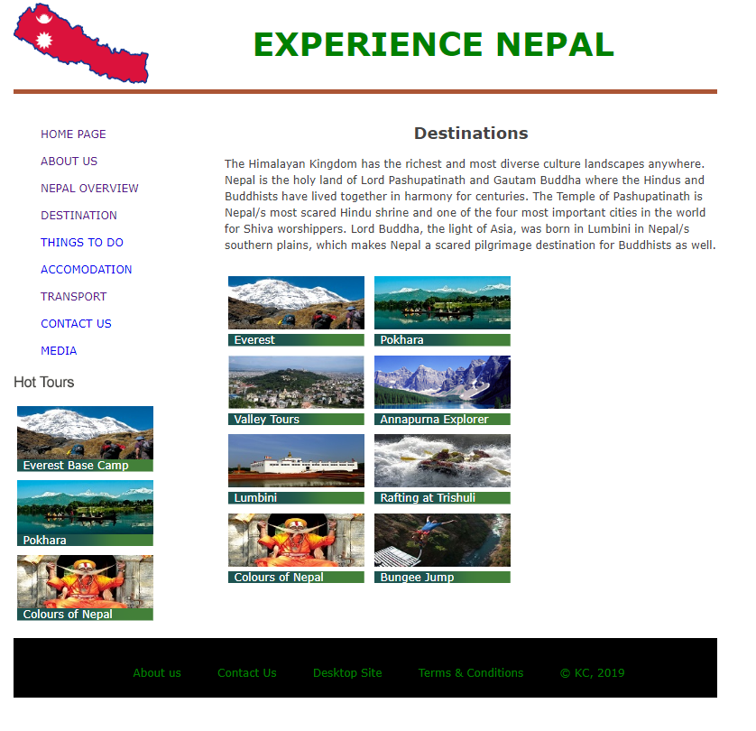

#### Text & Media Assets

Item 1: Heading

**Type:** Text and Logo

**Colour:** Green

**Font:**  **Size:** 3em **weight:** Bold

**Position: Top** centred

**Logo:** logo.png **size**: 200*120

Item 2: Navigation bar

**Type: Link** Text

**colour**: #00FFFF; Blue

S**ize:** Auto **float**: Left

**Position: b**elow Item 1 and Left

**Font face:** Verdana, Arial, sans-serif;

**Font size:** 1.5em

**Hover** **effect**: Changes to Red in colour

Item 3: Content

**Type:** Text

**margin-bottom:** 1em;

**size: max width:** 70%;

**Font face:** Verdana, Arial, sans-serif;

**Position:** below header

Item 4: Images

**Type:** Images

**Position:** below content and sub header

**Size**: View by Medium icons

**Source**: images/pic1.jpg, images/pic2.jpg, images/pic3.jpg

Item 5: Footer

**Type:** Text

**Font face:** Verdana, Arial, sans-serif;

**Font colour:** Green;

**Size:** 120*50

**Position:** bottom

**Hover** **effect**: Changes to Red in colour

### Things to do Page

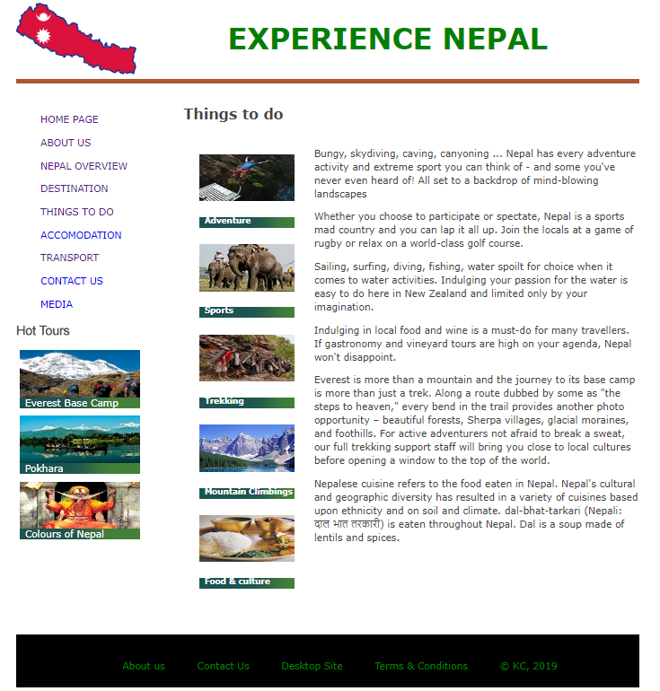

#### Text & Media Assets

Item 1: Heading

**Type:** Text and Logo

**Colour:** Green

**Font:**  **Size:** 3em **weight:** Bold

**Position: Top** centred

**Logo:** logo.png **size**: 200*120

Item 2: Navigation bar

**Type: Link** Text

**colour**: #00FFFF; Blue

S**ize:** Auto **float**: Left

**Position: b**elow Item 1 and Left

**Font face:** Verdana, Arial, sans-serif;

**Font size:** 1.5em

**Hover** **effect**: Changes to Red in colour

Item 3: Content

**Type:** Text

**margin-bottom:** 1em;

**size: max width:** 70%;

**Font face:** Verdana, Arial, sans-serif;

**Position:** below header and right to images

Item 4: Images

**Type:** Images

**Position:** below content and sub header and left to content

**Size**: View by Medium icons

**Source**: images/bungee.jpg, images/sport.jpg, images/trekking.jpg

Item 5: Footer

**Type:** Text

**Font face:** Verdana, Arial, sans-serif;

**Font colour:** Green;

**Size:** 120*50

**Position:** bottom

**Hover** **effect**: Changes to Red in colour

### Accommodation Page

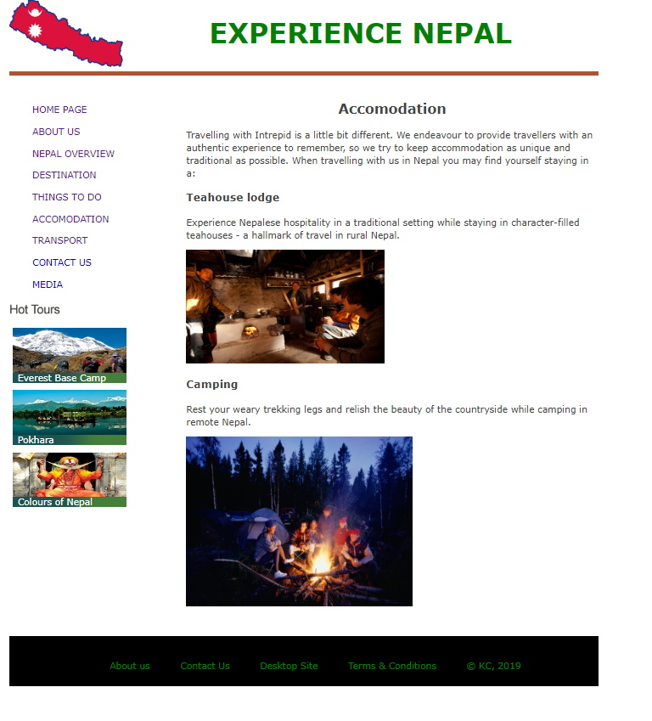

#### Text & Media Assets

Item 1: Heading

**Type:** Text and Logo

**Colour:** Green

**Font:**  **Size:** 3em **weight:** Bold

**Position: Top** centred

**Logo:** logo.png **size**: 200*120

Item 2: Navigation bar

**Type: Link** Text

**colour**: #00FFFF; Blue

S**ize:** Auto **float**: Left

**Position: b**elow Item 1 and Left

**Font face:** Verdana, Arial, sans-serif;

**Font size:** 1.5em

**Hover** **effect**: Changes to Red in colour

Item 3: Content

**Type:** Text

**margin-bottom:** 1em;

**size: max width:** 70%;

**Font face:** Verdana, Arial, sans-serif;

**Position:** below header

Item 4: Images

**Type:** Images

**Position:** below header

**Size**: View by Medium icons

**Source** images/teahouse.jpg, images/camping.jpg

Item 5: Footer

**Type:** Text

**Font face:** Verdana, Arial, sans-serif;

**Font colour:** Green;

**Size:** 120*50

**Position:** bottom

**Hover** **effect**: Changes to Red in colour

### Transport Page

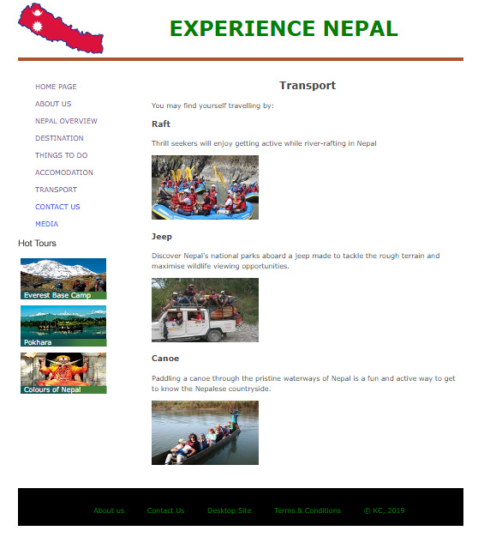

#### Text & Media Assets

Item 1: Heading

**Type:** Text and Logo

**Colour:** Green

**Font:**  **Size:** 3em **weight:** Bold

**Position: Top** centred

**Logo:** logo.png **size**: 200*120

Item 2: Navigation bar

**Type: Link** Text

**colour**: #00FFFF; Blue

S**ize:** Auto **float**: Left

**Position: b**elow Item 1 and Left

**Font face:** Verdana, Arial, sans-serif;

**Font size:** 1.5em

**Hover** **effect**: Changes to Red in colour

Item 3: Content

**Type:** Text

**margin-bottom:** 1em;

**size: max width:** 70%;

**Font face:** Verdana, Arial, sans-serif;

**Position:** below header

Item 4: Images

**Type:** Images

**Position:** below header

**Size**: View by Medium icons

**Source**: images/raft.jpg, images/jeep.jpg, images/canoe.jpg

Item 5: Footer

**Type:** Text

**Font face:** Verdana, Arial, sans-serif;

**Font colour:** Green;

**Size:** 120*50

**Position:** bottom

**Hover** **effect**: Changes to Red in colour

### Contact us Page

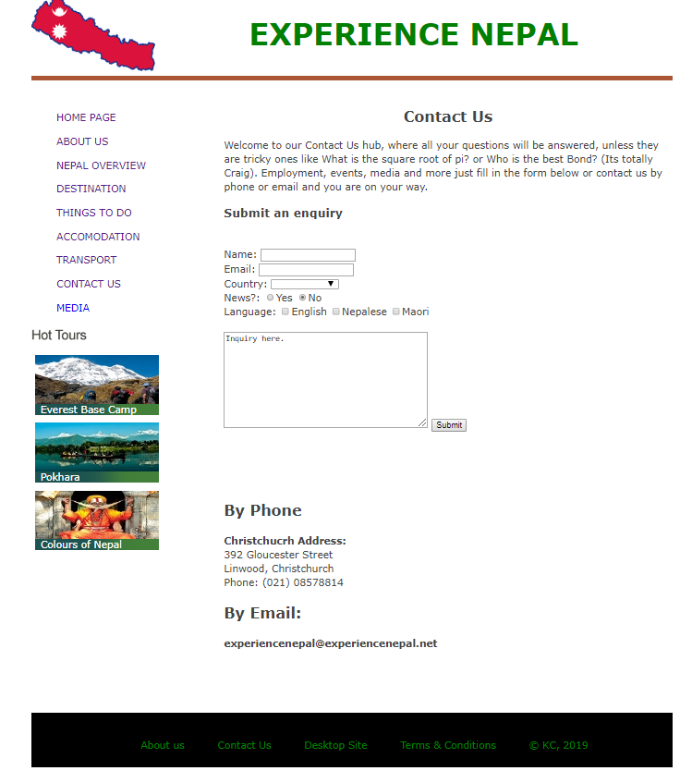

#### Text & Media Assets

Item 1: Heading

**Type:** Text and Logo

**Colour:** Green

**Font:**  **Size:** 3em **weight:** Bold

**Position: Top** centred

**Logo:** logo.png **size**: 200*120

Item 2: Navigation bar

**Type: Link** Text

**colour**: #00FFFF; Blue

S**ize:** Auto **float**: Left

**Position: b**elow Item 1 and Left

**Font face:** Verdana, Arial, sans-serif;

**Font size:** 1.5em

**Hover** **effect**: Changes to Red in colour

Item 3: Contact us form

**Type:** Text buttons and dropdown menu

**margin-bottom:** 1em;

**size: max width:** 70%;

**Font face:** Verdana, Arial, sans-serif;

**Position:** below header

Item 4: Footer

**Type:** Text

**Font face:** Verdana, Arial, sans-serif;

**Font colour:** Green;

**Size:** 120*50

**Position:** bottom

**Hover** **effect**: Changes to Red in colour

### Media Page

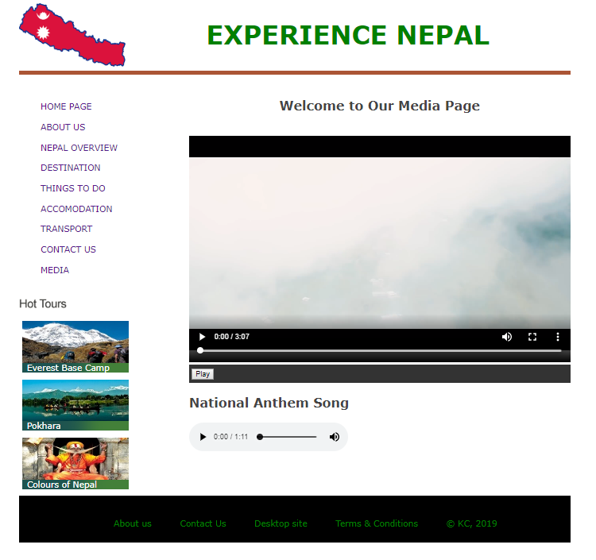

#### Text & Media Assets

Item 1: Heading

**Type:** Text and Logo

**Colour:** Green

**Font:**  **Size:** 3em **weight:** Bold

**Position: Top** centred

**Logo:** logo.png **size**: 200*120

Item 2: Navigation bar

**Type: Link** Text

**colour**: #00FFFF; Blue

S**ize:** Auto **float**: Left

**Position: b**elow Item 1 and Left

**Font face:** Verdana, Arial, sans-serif;

**Font size:** 1.5em

**Hover** **effect**: Changes to Red in colour

Item 3: Content

**Type:** Text

**margin-bottom:** 1em;

**size: max width:** 70%;

**Font face:** Verdana, Arial, sans-serif;

**Position:** below header

Item 4: Video

**Type:** Video

**Position:** below header and content

**Size**: width= "720" height= "450"

**Source**: media/video.mp4

Item 5: Audio

**Type:** Audio

**Position:** below video

**Size**: auto

**Source**: media/national.mp3

Item 6: Footer

**Type:** Text

**Font face:** Verdana, Arial, sans-serif;

**Font colour:** Green;

**Size:** 120*50

**Position:** bottom

**Hover** **effect**: Changes to Red in colour