# Storyboard – Initial

## Navbar

This is a simple clean looking navigation bar, at the top left of every page and with the text changing to red when hovered over. Clicking the links take the user to the relevant pages, which are detailed in the functionality section below.

### Functionality

Home Page directs a user to index.html

About Us directs a user to aboutus.html

Nepal Overview directs a user to Nepaloverview.html

Destination directs a user to destination.html

Contact us directs a user to contact.html

Transport directs a user to transport.html

Things to do directs a user to thingstodo.html

Media directs a user to media.html

Accommodation directs a user to accomodation.html

### Desktop

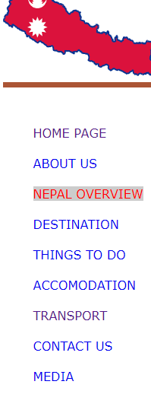

### Details

Location: Left of every page

Height: Auto

Font Size: 1rem

Colour: #00FFFF

Link Colour: Dark grey #555

Link Colour (Hover): Red

Link Decoration: None

## Footer

As a reflection of the navigation bar, this is a simple clean looking footer at the bottom of every page. The text darkens to Red when hovered over, a clicking the links take the user to the relevant pages, detailed below.

### Functionality

About us directs a user to aboutus.html

Contact us directs a user to contact.html

Desktop Site directs a user to index.html

### Desktop



### Details

Location: Bottom of every page

Font Size: 1rem

Background Colour: Black

Link Colour: Green

Link Colour (Hover): red

Link Decoration: None

## Home Page

### Desktop – Site Map

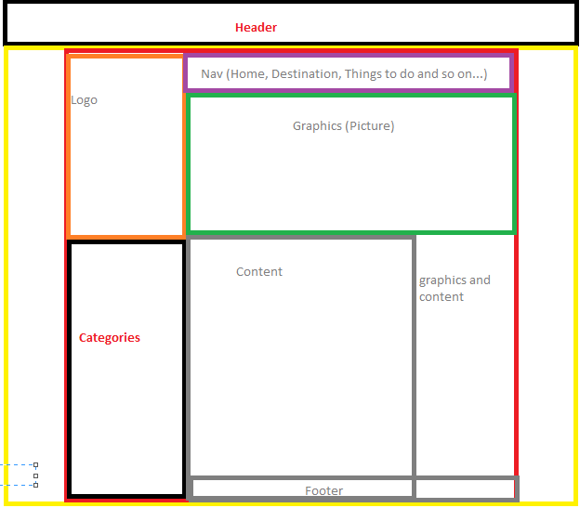

Page Design for Both Desktop and Mobile Version:

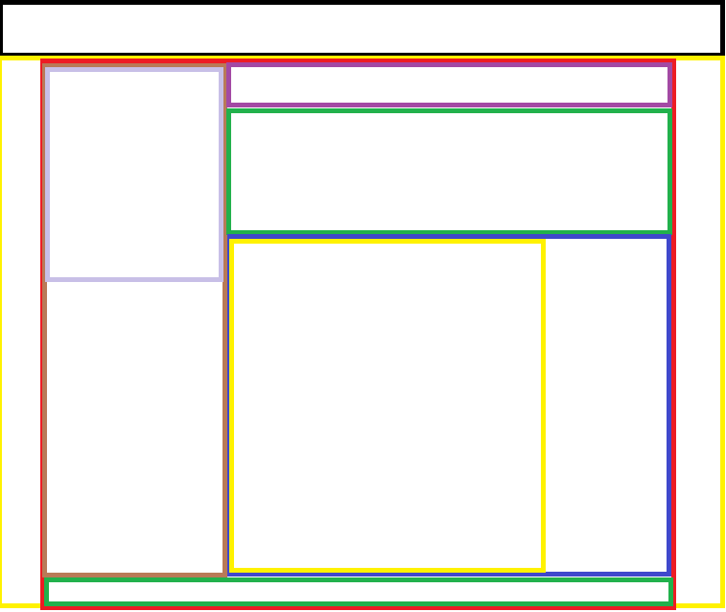The Page layout contains the header, title, about the homepage, graphics elements, footer, nav and copyright. The following are the layout of my webpage.

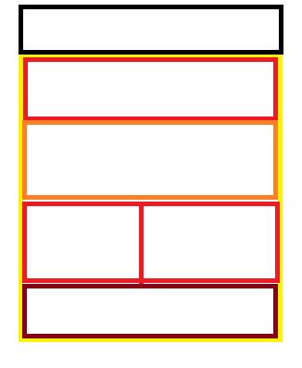 Fig: Design layout of the Website for desktop screen.

Fig: Design layout of the Website for desktop screen.