6/14/2019

KC Bishwash

ara institute of canterbury

# Experience Nepal Website

## BCIT254 – Interactive Media Application Development

# Contents

Experience Nepal Website 0

Contents 1

Project Proposal 2

Navigation Map - Initial 10

Navigation Map - Final 11

Risk Management – Initial 12

Risk Management – Final 13

Storyboard – Initial Beginning 15

Storyboard - Final 18

Testing Plan – Initial 37

Testing Plan - Final 42

What’s Next 47

# Project Proposal

## Overall

The project will provide an interactive environment containing useful information focused on Tourism for people who are willing to travel or visit Nepal. The Website that I am going to create explores travel information, maps, activities, activities, places and accommodation to help tourist who are planning to come over the Land of Beauty “NEPAL”. This site is mainly focused on the attraction of the tourist and foreigners by reflecting the natural resources, places, adventures, cultures and unique tradition of the country. This website contains different topics such as: Destination, things to do, recommended trips and so on.

## Project Goal

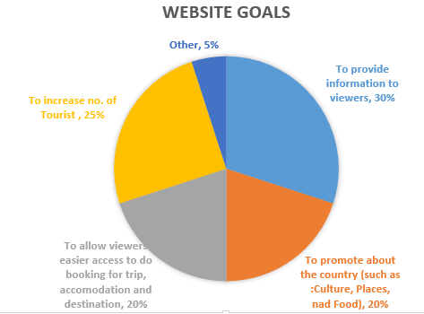The goal of the project is to provide information that is relevant to travellers who are thinking about and actively planning a visit to Nepal. Through this site, potential visitors will be able to learn about the diversity of what Nepal has to offer and how to make their visit a fantastic experience. People who use this site should be encouraged and be confident to plan their future trips.

## Target Audience

The target audience for my website is anybody interested in travelling to japan. The main demographic of the people looking interested in the information my website covers is people between 18-99 but can be under age of 18 if coming along with their parents, both male and female, who are interested in Nepal but lack knowledge on what they could expect if they travel there and what they could do. The technically capabilities of this wide demographic will be considered to be competent navigate basic website design, comfortable using navigation bars, slideshows and playing video and sounds will be the only knowledge expected to use the website. It is also targeted on those who literally love travelling to different places especially holy place, scenic beauty and cultural places

### Design

As these are people looking to found out what japan is about, for the design to appeal to them I will look to use pictures throughout the website, as what they are looking for is a visual idea, as well of basic information, of what they can expect Nepal to look like. Also, for the design I will stay away from using too much text that isn’t accompanied by pictures referencing what is being written as while they will need the information, just having pages of text without the visual references will be too jarring and turn them away.

The design should be responsive which is compatible for any electronic browsing devices. Lastly the design will certainly be both mobile and desktop compatible with Google chrome as a primary based platform, as desktop browsing in New Zealand only makes up 53.65% of views and most of them view using Google chrome as a browser, as of May 2019. (GlobalStats, 2019)

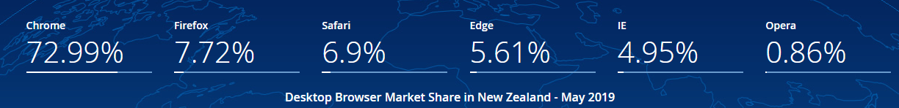

### Use

When it comes to amount of use this could be many times as it takes them to gain an understanding, they feel is reasonable so they can decide if Travelling to Nepal looks interesting to them. So, it’s important to have fresh content on it regularly, but still make it very simple to find something people want to find information about.

### Benefit after use

The website will have given prospective user very good details about Nepal they require in order to travel and what Nepal can offer to the tourist. They will have an understanding of the different things they can expect when it comes to food, accommodation and transport, also some attractions they could visit and overall be able to feel as if they understand more about what travelling to Nepal would entail than if they hadn’t visited the website.

### Personas

**Paul Anderson** – Paul is in his early 30s and single. He is from England; he has no children so spends a lot of time travelling to the new places. Paul’s a software engineer with some disposable income. He’s not rich and believes that money corrupts. He also believes in the power of collective activism.

He spends a lot of time volunteering for social works, developing campaign websites, managing social media. And he is very wary of “being sold” when he visits website. He’s very passionate, but he’s very smart.

**Narayan Monger** – Narayan is in his late 20s. He’s been married, has a daughter and is very passionate about Photography. He shares many of the same values that Andy has, but rarely gets past signing a petition or making small donations to causes he believes in.

Narayan wants to be part of something bigger than himself, but he’s a little skittish and shy. He needs to feel heard an understood before he’ll make substantial commitments. He’s been loving the nature through the lenses of his camera. So, he always wants to explore the new photographic scenes through his DSLR.

## Objectives

After visiting the website, the user will:

1. Have more knowledge about tourism places in Nepal and attractions that tourists can visit.
2. Be comfortable with knowing different native Nepalese food that they could try for the first time.
3. Know of the different kinds of transports that existences in Nepal.
4. Feel comfortable in their knowledge of the different options of accommodation in Nepal
5. Have an idea of if travelling to Nepal is right for them or if they need to do more research before coming to a conclusion.
6. Establish Nepal as a choice of holiday destination, enhance the capacity of service provider.

## Content

My website title, Experience Nepal, is about showing all the different things someone who is interested in travelling to japan will want to know before deciding if it is right for them.

* 8-12 pages in your website – Home page, about us, Nepal Overview, accommodation, contact us, destination, things to do, transport, media.
* Responsive design – All the pages are responsive so that they can view from any portable devices.
* one audio file and video file are included the media.html page
* A form is mentioned on the contact us page to contact to the experience Nepal.
* Some JavaScript – JavaScript is done on the media page and slider.html for the edition of video and images slider.
* All most all the pages have got at least one image beside contact us page.
* I have used slideshow of an Images in the home page for the animation.
* I have used Verdana as a text font with appropriate size and appropriate colours.
* I have used hover effect on nav items.

References I used for making of my website:

* I have used the jQuery in Media page for the video file and the Slider page of Desktop site for the Image slider.
* For the photo slider I have use online plugin for sliding image from “http://fancybox.net/”.
* jQuery resources from <http://code.jquery.com/jquery-2.1.3.min.js>. For the editing of video in the media page.
* I used free images for photo gallery from “google.com” like link <https://www.google.co.nz/search?q=high+resolution+images&espv=2&biw=1680&bih=965&source=lnms&tbm=isch&sa=X&ved=0CAYQ_AUoAWoVChMIi97N3a-MyQIVRSWmCh1crwi5>
* I used free video from YouTube.com link <https://www.youtube.com/watch?v=to1PNUCY_kU> and back ground music comes with the video.
* And I also use different forums suggestion for making my website responsive and designation of the layout.

## Content Treatment

When the website first loads the user will land on the homepage, the logo with Nepal map and title on top. The homepage will contain the navigation bar at the left side and the bottom of the browser window; this will contain all the different sections of the website. These different sections will also change colour when hovered over, and text will become red and shaded. There will be a slideshow that will cycle through a group of images showing off different parts of the website. Below slideshow there will be a description of the Nepal in terms of geography and tourism. Further down will be a section that is 3 columns wide and 2 rows deep which will feature images of different parts of the website, such as a contact us, about us, etc, this will light up when hovered over and if clicked will take the user to that specific area of the website. From the homepage the user will be able to go to the many content pages of the website by clicking on the appropriate heading they prefer from the navigation bar. These content pages will also keep the navigation bar in the same location, making it easy for the user to go travel around the website.

## Delivery Platform

The website will be accessible via Google Chrome, Firefox, Edge, Safari, Chrome Mobile, and Safari iOS. Compatibility with the discontinued Internet Explorer (last release 4 ½ years ago) is being considered, but may depend on compatibility with CSS, JavaScript, jQuery and HTML 5 techniques.

It will be designed to look as intended on mobile, tablet, laptop, and desktop screens. This will go down to 360 x 640 resolution, and up to 5120 x 2880 or higher.

## Media Assets

### Images

I will use JPEG, PNG and GIF to display my images for my project. These 3 formats are the most widely supported by web browsers; they also can each deal with specific images. JPEG will be used with photographs, PNG with logos and low colour count images and GIF for animated images.

### Graphics

I will use PNG format logo, because of its ability to support transparency and not suffer from JPEG compression artefacts.

### Animations

I have used jQuery for the animation of image slideshow in my home page. I have also used different CSS features on the navigation bar for the hover effect and change in font effect when click.

### Audio

I will use MP3 format as this format is supported by all major web browsers. Also, this format uses lossy compression, which means the file to size ratio of the files is a reasonable size for websites. This will aid in a faster loading file, and because of mp3’s wide support, fantastic compatibility.

### Videos

I will be using MP4 format for delivering my video. I choose this format because it provides an acceptable size to quality ratio, when compared with the other available formats. It is also the compatibility with browsers, this is the reason I have chosen Mp4, as MP4 is the only support format by internet explorer.

## Ethical / Legal Issues

The website itself will have a Creative Commons License of “Attribution-Non-commercial-No Derivatives 4.0 International”. This means that adaptions of the website and its content cannot be shared, and commercial use of the work is not allowed.

### Summary

Creative Commons Attribution-Non-commercial license in International version 4, that allows to do what they want with your work as long as it`s Non-Commercial.

### Attribution

You must give credit to the original author of the work, including a URI or hyperlink to the work, this Public license and a copyright notice.

### Attribution information revoke

Author can request to remove any attribution given information.

### Tivoization

You may not apply legal terms or technological measures that legally restrict others from doing anything the license permits.

### Disclaimer of warranties

Disclaimer of warranties is optional.

If separately undertaken, shared material must retain a notice to Disclaimer of warranties.

Otherwise, Disclaimer of warranties, is taken by default, providing the work as-is and as-available.

### Liable

Liable follows the same rules as Disclaimer of warranties, providing, by default, protection from defamation for the creator.

### Revoke

The licensor cannot revoke these freedoms as long as you follow the license terms.

( Benio, 2015)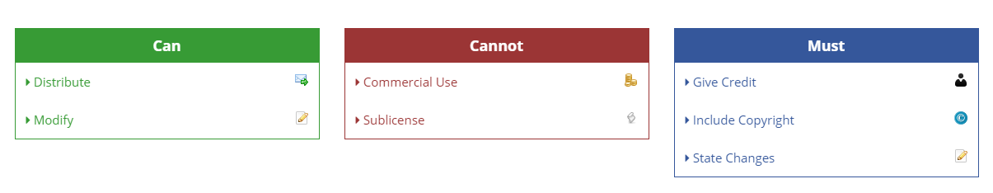

## Total Time Estimated

### Summary

Overall the bulk of the time will be spent in development of the media assets, plus the HTML and CSS. Getting the webpage to look how I want can be difficult and creating the original media assets. So, I’ve budgeted half of the total project time to that area.

The tasks have been divided into subtasks, listed on the next several pages.

|  |  |
| --- | --- |
| Initial Project Proposal | 7 hours |
| Initial Navigation Map | 1 hours |
| Initial Risk Assessment | 2 hours |
| Initial Test Plan | 4 hours |
| Initial Storyboard | 9 hours |
| Media & Design Created | 34 hours |
| Submit Prototype | 12 hours |
| Final Project | 18 hours |
| **Total Time Estimated** | **87 hours** |

### Detailed Time Breakdown

|  |  |  |  |
| --- | --- | --- | --- |
| Experience Nepal - Timeline | By KC | | | | |
| Final Version | | | |
| **Milestone** | **Task** | **Budgeted Hours** | **Due Date** |
| **Initial Project Proposal** | Establish project goal | 0.1 | 9/04/2019 |
| Research and define target audience | 1.5 |
| Create Personas | 0.5 |
| List objectives | 0.1 |
| Detail overall content and page content | 0.5 |
| Create a deliverable | 0.5 |
| Write about content treatment | 0.3 |
| Discuss the delivery platform | 0.1 |
| Cover the media assets the project will use | 0.5 |
| Write about possible ethical / legal issues | 0.2 |
| Breakdown into tasks and create time estimates | 0.4 |
| Proof of read and edit text | 1 |
| Generate copyright license | 0.1 |
| Polish document design | 0.7 |
| Final proof of read | 0.5 |
| **Subtotals** |  | **7** |  |
|  |  |  |  |
| **Initial Navigation Map** | Planning | 0.1 | 16/04/2019 |
| Creating pages | 0.4 |
| creating path | 0.3 |
| Final navigation map | 0.2 |
| **Subtotals** |  | **1** |  |
|  |  |  |  |
| **Initial Risk Assessment** | Brainstorm risks | 0.6 | 23/04/2019 |
| Create text for risks | 0.4 |
| Research probabilities | 0.5 |
| Final proof of read & spell check | 0.5 |
| **Subtotals** |  | **2** |  |
|  |  |  |  |
| **Initial Test Plan** | Write up the objectives of the test plan | 0.5 | 30/04/2019 |
| Decide and write about a testing approach and assumptions | 0.3 |
| Decide and write down what features and functionality will be tested | 0.3 |
| Detail what my expected results will be | 0.4 |
| Decide and write what the deliverables will be | 0.5 |
| Write up the test documentation | 1 |
| Write down what the testing procedures and walkthroughs are | 0.5 |
| List the schedules of when testing will take place | 0.5 |
| **Subtotals** |  | **4** |  |
|  |  |  |  |
| **Initial Storyboard** | Write rough draft of what each webpage contains | 1 | 30/04/2019 |
| Draw a draft of how the website and webpages will look | 2 |
| Analyse the designs and consider changes | 0.5 |
| Modify the drafts | 2 |
| Collect feedback on storyboard | 0.5 |
| Make final changes and storyboard design | 3 |
| **Subtotals** |  | **9** |  |
|  |  |  |  |
| **Media & Design Created** | Write text for pages | 2 |  |
| Take and collect photos to use | 1 |
| Collect a range of fonts to possibly use for the logo and website in general | 1 |
| Create the logo | 0.5 |
| Reduce photo file size | 1 |
| Create the two unique graphics to use | 2 |
| Create the two unique animations to use | 3 |
| Create the two videos to use | 3 |
| Find suitable music for one video and edit it | 2.3 |
| Record a voice over | 0 |
| Compare formats for media and decide which to use | 1 |
| Test playback on various devices of media | 1 |
| Decide on colour scheme for the website | 2 |
| Create home page | 4 |
| Create media page | 2 |
| Create accommodation page | 2 |
| Create overview page | 1 |
| Create transport page | 1.5 |
| Create things to do page | 1 |
| Create contact page | 1.5 |
| create destination page | 1 |
| Create about us page | 0.2 |
| **Subtotals** |  | **34** |  |
|  |  |  |  |
| **Submit Prototype** | Add more detail to storyboard | 1 | 31/05/2019 |
| Create basic page layout in HTML | 3 |
| Create basic navigation bar and footer | 1.5 |
| Put temporary photos and content in | 1 |
| Collect feedback | 0.5 |
| Plan changes | 1 |
| Apply changes | 0.5 |
| Test project | 0.5 |
| Present draft prototype for feedback | 2 |
| Analyse feedback, plan and implement changes | 1 |
| **Subtotals** |  | **12** |  |
|  |  |  |  |
| **Final Project** | Final documentation | 9 | 14/06/2019 |
| Check of project requirements and testing | 5 |
| Final debug & test | 4 |
| **Subtotals** |  | **18** |  |
|  |  |  |  |
|  |  |  |  |
| TOTALS: (Hours) |  | 87 |  |

## Proposal References

Benio. (2015). *Creative Commons Attribution-NonCommercial 4.0 International (CC BY-NC 4.0)*. Retrieved from Code License: https://tldrlegal.com/license/creative-commons-attribution-noncommercial-4.0-international-(cc-by-nc-4.0)

GlobalStats. (2019, May 7). *Browser Market Share New Zealand*. Retrieved March 7th, 2018, from Statcounter: http://gs.statcounter.com/browser-market-share/all/new-zealand

# Navigation Map - Initial

This is initial version of the navigation map created April 4th, 2019:

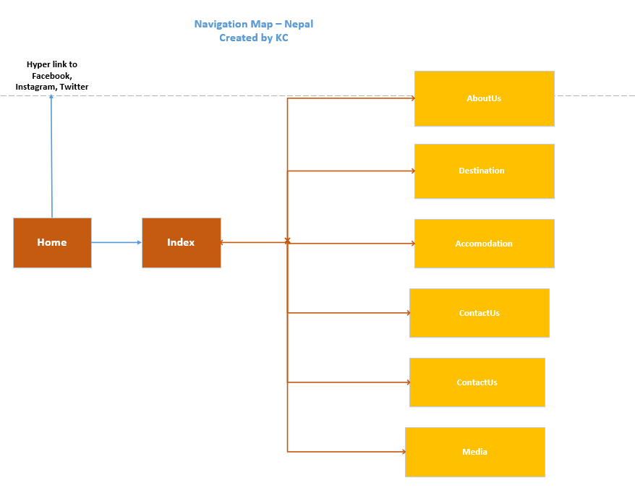

# Navigation Map - Final

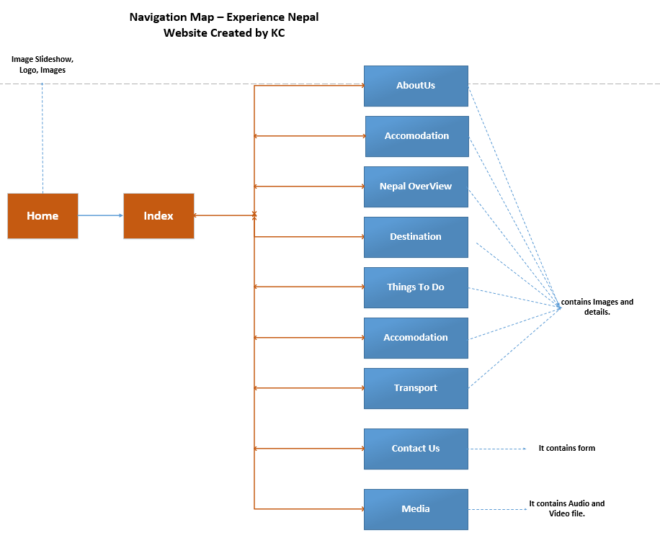This is final version of the navigation map created June 2nd, 2019:

# Risk Management – Initial

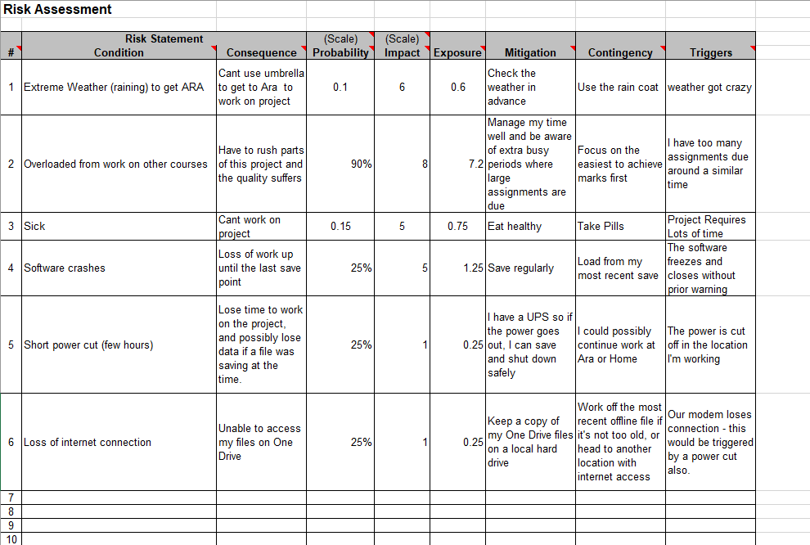

# Risk Management – Final

### Probability Reasoning:

#### Run out of time

Poor time management of my project can cost me the mark of the assignment.

#### Hard drive failure

Sometime hard drive may fail. There will be huge loss if we don’t do back up in multiple devices.

#### Major earthquake

Christchurch being one of the earthquake threat places, sometime this may happen which will delay the project completion on time.

#### Software crashes

I don't have any specific stats to justify this probability but instead I estimated based on my own experiences. Across a project period, I think there's a good chance some of the project application could fail such as Video editor- adobe premiere and so on.

#### Power cut

This is a rough estimate based on the number of power cuts we receive a year, and it may seem high because being in a rural area we have a higher number of annual power cuts.

#### Run out of time

Being in the final year of my degree in ICT there is a huge amount of work to be done for each of the papers, and also being a part time work sometime I might not be able to catch up on time if I didn’t manage my time for all the papers well.

#### Extreme weather and Sickness

It’s certainly possible since we're heading into winter when people are more likely to get sick. This chance is increased because as David Weir pointed out, all the air inside Ara is re-circulated so there's an increased chance of me catching something from someone else in Ara.

#### Requirements change

This is more of a real-world risk, but a massively reduced risk with a college assignment

#### Overloaded from work on other courses

This chance is very high because I'm now in the hardest year of the degree, and there's a very high chance that multiple subjects will have assignments due around the same time

#### Loss of internet connection

Like a power cut, this is a rough estimate based on the number of disconnects we receive a year. It's very rare for our internet to go off when the power is running, so I believe this is directly linked to the risk of power cuts.

# Storyboard – Initial Beginning

## Navbar

This is a simple clean looking navigation bar, at the top left of every page and with the text changing to red when hovered over. Clicking the links take the user to the relevant pages, which are detailed in the functionality section below.

### Functionality

Home Page directs a user to index.html

About Us directs a user to aboutus.html

Nepal Overview directs a user to Nepaloverview.html

Destination directs a user to destination.html

Contact us directs a user to contact.html

Transport directs a user to transport.html

Things to do directs a user to thingstodo.html

Media directs a user to media.html

Accommodation directs a user to accomodation.html

### Desktop

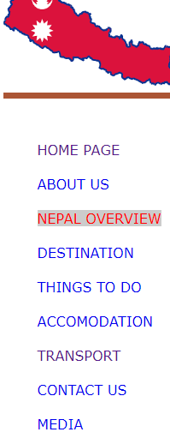

### Details

Location: Left of every page

Height: Auto

Font Size: 1rem

Colour: #00FFFF

Link Colour: Dark grey #555

Link Colour (Hover): Red

Link Decoration: None

## Footer

As a reflection of the navigation bar, this is a simple clean looking footer at the bottom of every page. The text darkens to Red when hovered over, a clicking the links take the user to the relevant pages, detailed below.

### Functionality

About us directs a user to aboutus.html

Contact us directs a user to contact.html

Desktop Site directs a user to index.html

### Desktop



### Details

Location: Bottom of every page

Font Size: 1rem

Background Colour: Black

Link Colour: Green

Link Colour (Hover): red

Link Decoration: None

## Home Page

### Desktop – Site Map

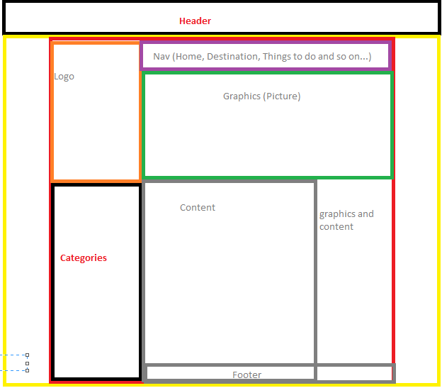

Page Design for Both Desktop and Mobile Version:

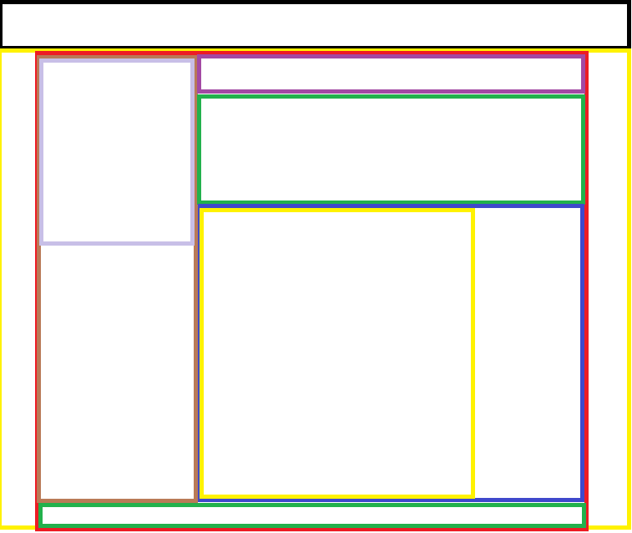The Page layout contains the header, title, about the homepage, graphics elements, footer, nav and copyright. The following are the layout of my webpage.

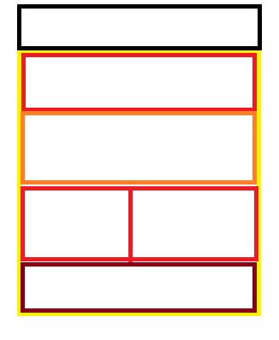 Fig: Design layout of the Website for desktop screen.

Fig: Design layout of the Website for desktop screen.

# Storyboard - Final

## Navbar

### 

### Desktop

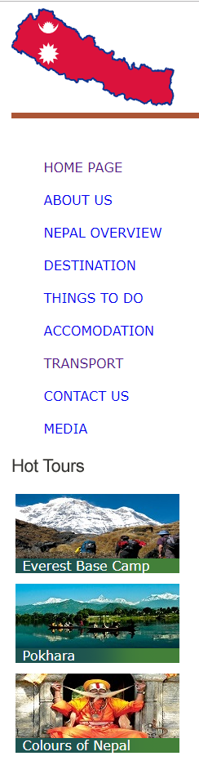

### Text & Media Assets

**Logo:** Nepal map on the header

**Text:** Included in all the Pages

Home Page directs a user to index.html

About Us directs a user to aboutus.html

Nepal Overview directs a user to Nepaloverview.html

Destination directs a user to destination.html

Contact us directs a user to contact.html

Transport directs a user to transport.html

Things to do directs a user to thingstodo.html

Media directs a user to media.html

Accommodation directs a user to accomodation.html

## Footer

### Desktop & Mobile



### Text & Media Assets

**Text:** About Us, Contact us, Desktop Site, Terms and Conditions and content (copyright symbol) KC 2019

Hyperlinks:

About us directs a user to aboutus.html

Contact us directs a user to contact.html

Desktop Site directs a user to index.html

Home Page

Desktop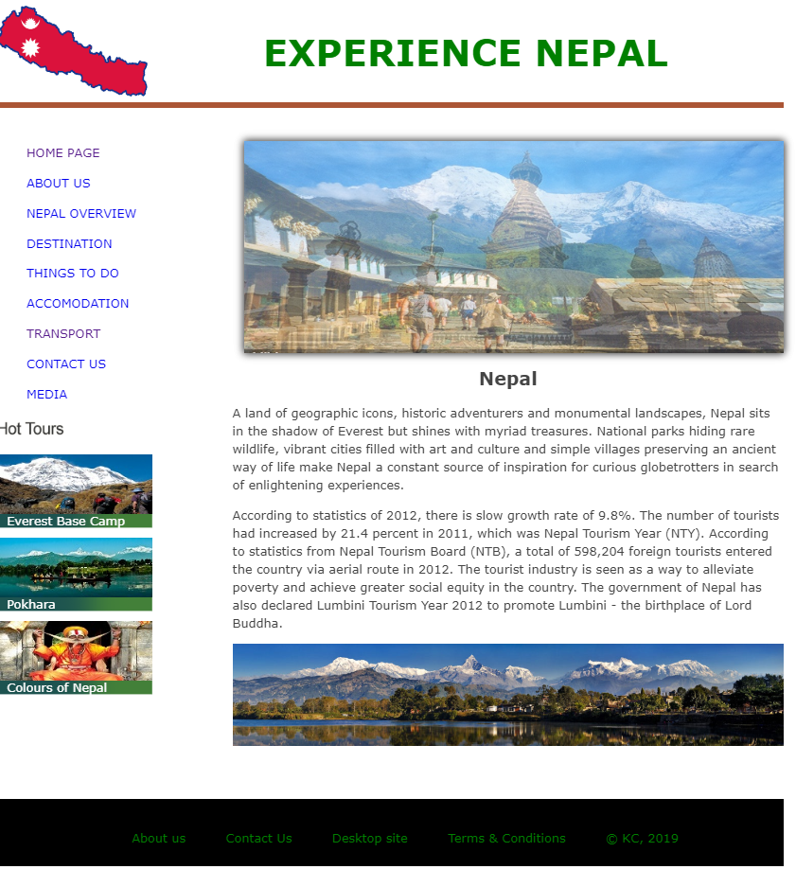

Slideshow is few images of the view of Nepal.

Items: Logo and Heading on Top. Nav bar in the left with some of the photos of hot deals. Slideshow and Text and panorama image. And Bottom footer with some navigations and copyright.

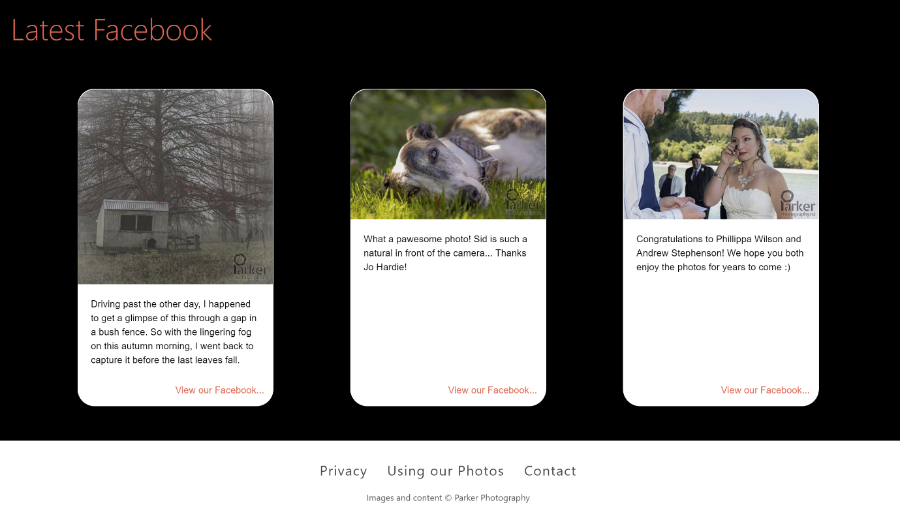

Quote slideshow changes quotes every 10 secs. Text centered. Quote text is 2rem, 3rem left & right padding. Author text is body font, but italics. Quote marks top left and right, 2rem padding, 3rem font size, #000. Links in #ff6b53.

## Mobile

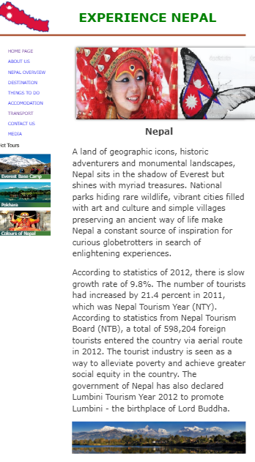

Almost same to the Desktop site.

#### Text & Media Assets

Item 1: Heading

**Type:** Text and Logo

**Colour:** Green

**Font:**  **Size:** 3em **weight:** Bold

**Position: Top** centred

**Logo:** logo.png **size**: 200*120

Item 2: Navigation bar

**Type: Link** Text

**colour**: #00FFFF; Blue

S**ize:** Auto **float**: Left

**Position: b**elow Item 1 and Left

**Font face:** Verdana, Arial, sans-serif;

**Font size:** 1.5em

**Hover** **effect**: Changes to Red in colour

Item 3: Slideshow

**Type:** Slideshow Image using jQuery

**Size: width:672px; height:280px;**

**Position:** absolute, below heading

**Source:** images/pic.JPG**,**

Item 4: Content

**Type:** Text

**margin-bottom:** 1em;

**size: max width:** 70%;

**Font face:** Verdana, Arial, sans-serif;

**Position:** below slideshow

Item 5: Image

**Type:** Image

**Style**: panorama

**Position:** below slideshow

**Size**: Auto

**Source**: images/pokhara.jpg

Item 6: Footer

**Type:** Text

**Font face:** Verdana, Arial, sans-serif;

**Font colour:** Green;

**Size:** 120*50

**Position:** bottom

**Hover** **effect**: Changes to Red in colour

## Rest of the Pages:

### Desktop and Mobile.

Since appearance of website on both mobile and desktop is same.

## About us Page

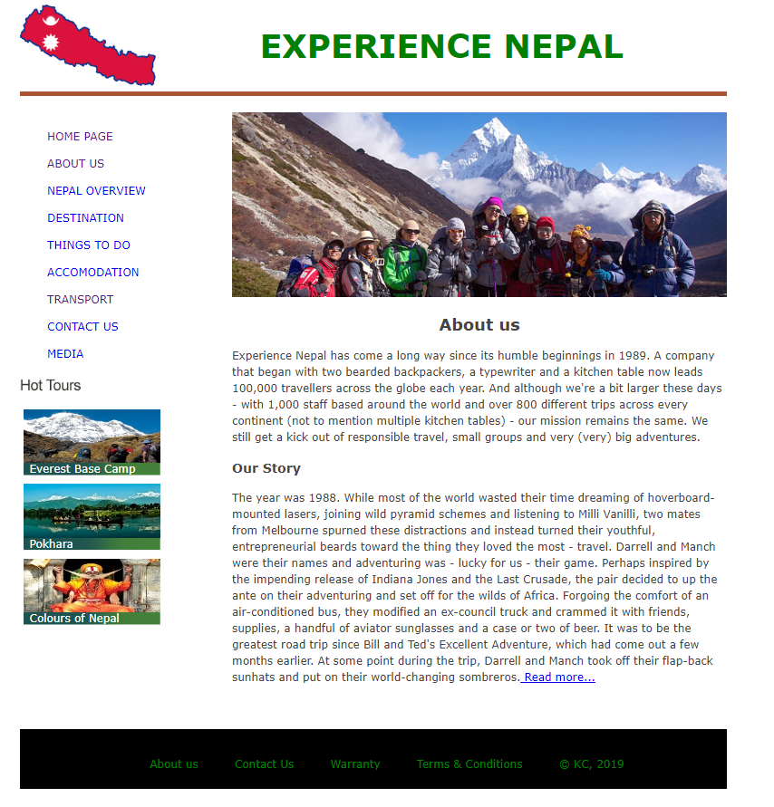

#### Text & Media Assets

Item 1: Heading

**Type:** Text and Logo

**Colour:** Green

**Font:**  **Size:** 3em **weight:** Bold

**Position: Top** centred

**Logo:** logo.png **size**: 200*120

Item 2: Navigation bar

**Type: Link** Text

**colour**: #00FFFF; Blue

S**ize:** Auto **float**: Left

**Position: b**elow Item 1 and Left

**Font face:** Verdana, Arial, sans-serif;

**Font size:** 1.5em

**Hover** **effect**: Changes to Red in colour

Item 3: Image

**Type:** Image

**Position:** below header

**Size**: Auto

**Source**: images/about.jpg

Item 4: Content

**Type:** Text

**margin-bottom:** 1em;

**size: max width:** 70%;

**Font face:** Verdana, Arial, sans-serif;

**Position:** below images

Item 5: Footer

**Type:** Text

**Font face:** Verdana, Arial, sans-serif;

**Font colour:** Green;

**Size:** 120*50

**Position:** bottom

**Hover** **effect**: Changes to Red in colour

### Nepal Overview Page

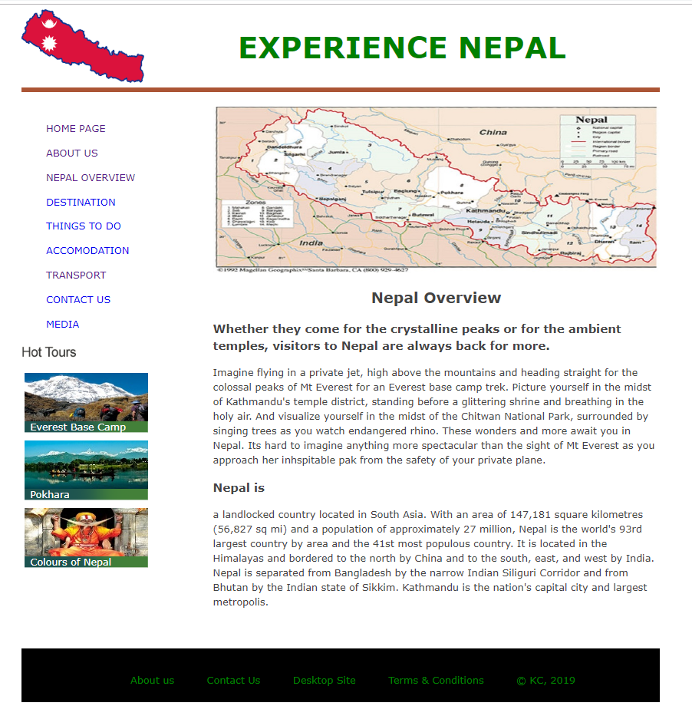

Text & Media Assets

Item 1: Heading

**Type:** Text and Logo

**Colour:** Green

**Font:**  **Size:** 3em **weight:** Bold

**Position: Top** centred

**Logo:** logo.png **size**: 200*120

Item 2: Navigation bar

**Type: Link** Text

**colour**: #00FFFF; Blue

S**ize:** Auto **float**: Left

**Position: b**elow Item 1 and Left

**Font face:** Verdana, Arial, sans-serif;

**Font size:** 1.5em

**Hover** **effect**: Changes to Red in colour

Item 3: Image

**Type:** Image

**Position:** below header

**Size**: Auto

**Source**: images/nepal.jpg

Item 4: Content

**Type:** Text

**margin-bottom:** 1em;

**size: max width:** 70%;

**Font face:** Verdana, Arial, sans-serif;

**Position:** below images

Item 5: Footer

**Type:** Text

**Font face:** Verdana, Arial, sans-serif;

**Font colour:** Green;

**Size:** 120*50

**Position:** bottom

**Hover** **effect**: Changes to Red in colour

### Destination Page

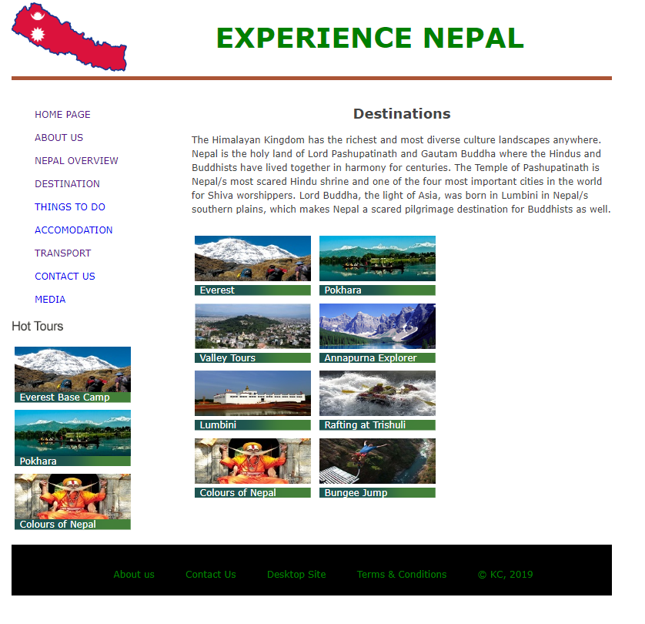

#### Text & Media Assets

Item 1: Heading

**Type:** Text and Logo

**Colour:** Green

**Font:**  **Size:** 3em **weight:** Bold

**Position: Top** centred

**Logo:** logo.png **size**: 200*120

Item 2: Navigation bar

**Type: Link** Text

**colour**: #00FFFF; Blue

S**ize:** Auto **float**: Left

**Position: b**elow Item 1 and Left

**Font face:** Verdana, Arial, sans-serif;

**Font size:** 1.5em

**Hover** **effect**: Changes to Red in colour

Item 3: Content

**Type:** Text

**margin-bottom:** 1em;

**size: max width:** 70%;

**Font face:** Verdana, Arial, sans-serif;

**Position:** below header

Item 4: Images

**Type:** Images

**Position:** below content and sub header

**Size**: View by Medium icons

**Source**: images/pic1.jpg, images/pic2.jpg, images/pic3.jpg

Item 5: Footer

**Type:** Text

**Font face:** Verdana, Arial, sans-serif;

**Font colour:** Green;

**Size:** 120*50

**Position:** bottom

**Hover** **effect**: Changes to Red in colour

### Things to do Page

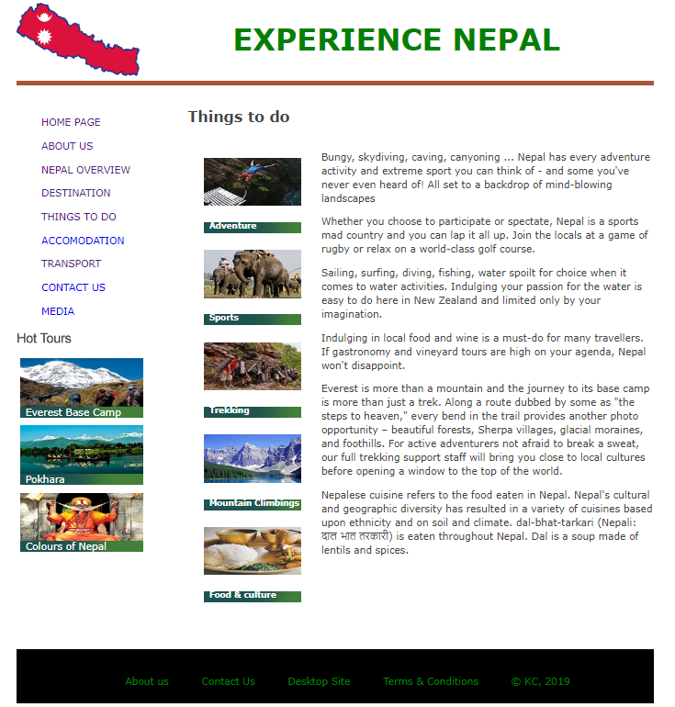

#### Text & Media Assets

Item 1: Heading

**Type:** Text and Logo

**Colour:** Green

**Font:**  **Size:** 3em **weight:** Bold

**Position: Top** centred

**Logo:** logo.png **size**: 200*120

Item 2: Navigation bar

**Type: Link** Text

**colour**: #00FFFF; Blue

S**ize:** Auto **float**: Left

**Position: b**elow Item 1 and Left

**Font face:** Verdana, Arial, sans-serif;

**Font size:** 1.5em

**Hover** **effect**: Changes to Red in colour

Item 3: Content

**Type:** Text

**margin-bottom:** 1em;

**size: max width:** 70%;

**Font face:** Verdana, Arial, sans-serif;

**Position:** below header and right to images

Item 4: Images

**Type:** Images

**Position:** below content and sub header and left to content

**Size**: View by Medium icons

**Source**: images/bungee.jpg, images/sport.jpg, images/trekking.jpg

Item 5: Footer

**Type:** Text

**Font face:** Verdana, Arial, sans-serif;

**Font colour:** Green;

**Size:** 120*50

**Position:** bottom

**Hover** **effect**: Changes to Red in colour

### Accommodation Page

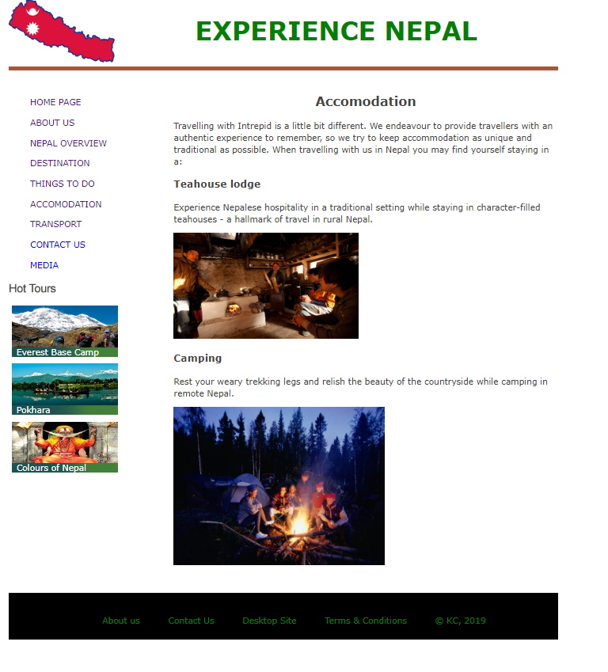

#### Text & Media Assets

Item 1: Heading

**Type:** Text and Logo

**Colour:** Green

**Font:**  **Size:** 3em **weight:** Bold

**Position: Top** centred

**Logo:** logo.png **size**: 200*120

Item 2: Navigation bar

**Type: Link** Text

**colour**: #00FFFF; Blue

S**ize:** Auto **float**: Left

**Position: b**elow Item 1 and Left

**Font face:** Verdana, Arial, sans-serif;

**Font size:** 1.5em

**Hover** **effect**: Changes to Red in colour

Item 3: Content

**Type:** Text

**margin-bottom:** 1em;

**size: max width:** 70%;

**Font face:** Verdana, Arial, sans-serif;

**Position:** below header

Item 4: Images

**Type:** Images

**Position:** below header

**Size**: View by Medium icons

**Source** images/teahouse.jpg, images/camping.jpg

Item 5: Footer

**Type:** Text

**Font face:** Verdana, Arial, sans-serif;

**Font colour:** Green;

**Size:** 120*50

**Position:** bottom

**Hover** **effect**: Changes to Red in colour

### Transport Page

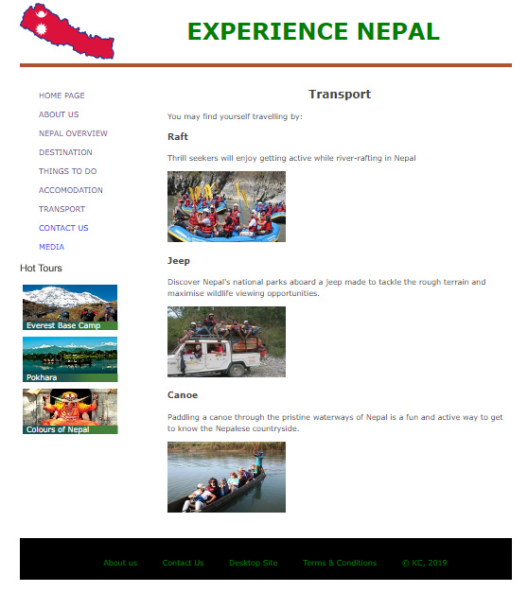

#### Text & Media Assets

Item 1: Heading

**Type:** Text and Logo

**Colour:** Green

**Font:**  **Size:** 3em **weight:** Bold

**Position: Top** centred

**Logo:** logo.png **size**: 200*120

Item 2: Navigation bar

**Type: Link** Text

**colour**: #00FFFF; Blue

S**ize:** Auto **float**: Left

**Position: b**elow Item 1 and Left

**Font face:** Verdana, Arial, sans-serif;

**Font size:** 1.5em

**Hover** **effect**: Changes to Red in colour

Item 3: Content

**Type:** Text

**margin-bottom:** 1em;

**size: max width:** 70%;

**Font face:** Verdana, Arial, sans-serif;

**Position:** below header

Item 4: Images

**Type:** Images

**Position:** below header

**Size**: View by Medium icons

**Source**: images/raft.jpg, images/jeep.jpg, images/canoe.jpg

Item 5: Footer

**Type:** Text

**Font face:** Verdana, Arial, sans-serif;

**Font colour:** Green;

**Size:** 120*50

**Position:** bottom

**Hover** **effect**: Changes to Red in colour

### Contact us Page

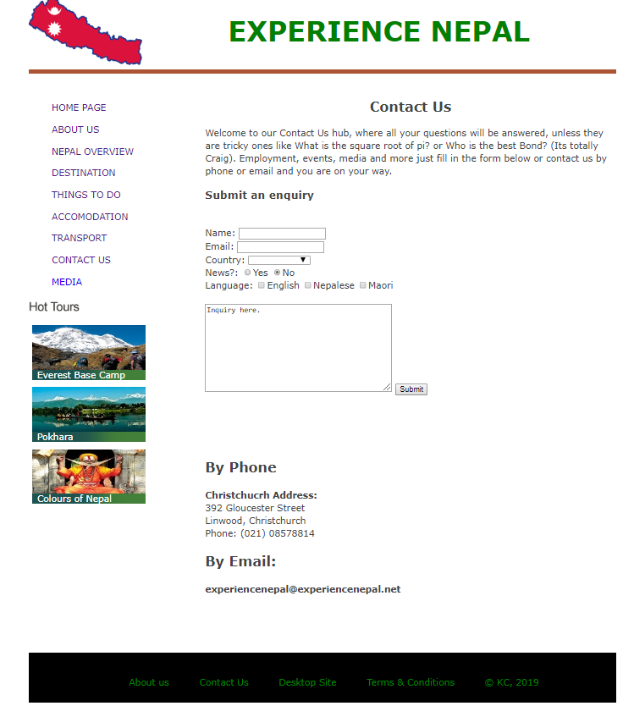

#### Text & Media Assets

Item 1: Heading

**Type:** Text and Logo

**Colour:** Green

**Font:**  **Size:** 3em **weight:** Bold

**Position: Top** centred

**Logo:** logo.png **size**: 200*120

Item 2: Navigation bar

**Type: Link** Text

**colour**: #00FFFF; Blue

S**ize:** Auto **float**: Left

**Position: b**elow Item 1 and Left

**Font face:** Verdana, Arial, sans-serif;

**Font size:** 1.5em

**Hover** **effect**: Changes to Red in colour

Item 3: Contact us form

**Type:** Text buttons and dropdown menu

**margin-bottom:** 1em;

**size: max width:** 70%;

**Font face:** Verdana, Arial, sans-serif;

**Position:** below header

Item 4: Footer

**Type:** Text

**Font face:** Verdana, Arial, sans-serif;

**Font colour:** Green;

**Size:** 120*50

**Position:** bottom

**Hover** **effect**: Changes to Red in colour

### Media Page

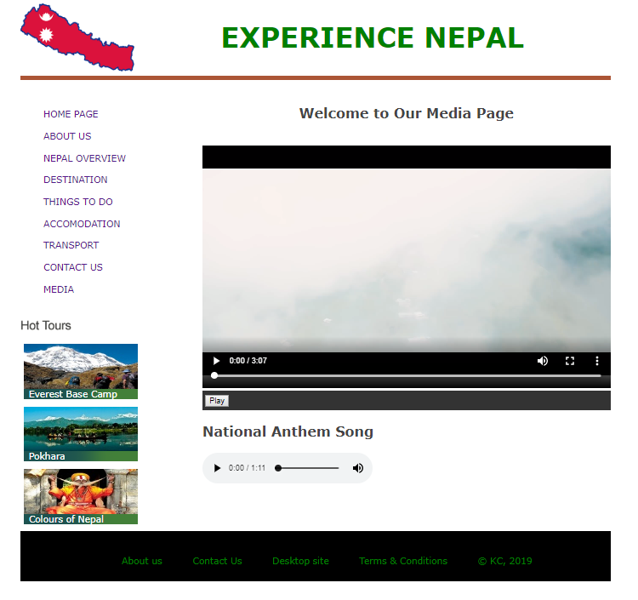

#### Text & Media Assets

Item 1: Heading

**Type:** Text and Logo

**Colour:** Green

**Font:**  **Size:** 3em **weight:** Bold

**Position: Top** centred

**Logo:** logo.png **size**: 200*120

Item 2: Navigation bar

**Type: Link** Text

**colour**: #00FFFF; Blue

S**ize:** Auto **float**: Left

**Position: b**elow Item 1 and Left

**Font face:** Verdana, Arial, sans-serif;

**Font size:** 1.5em

**Hover** **effect**: Changes to Red in colour

Item 3: Content

**Type:** Text

**margin-bottom:** 1em;

**size: max width:** 70%;

**Font face:** Verdana, Arial, sans-serif;

**Position:** below header

Item 4: Video

**Type:** Video

**Position:** below header and content

**Size**: width= "720" height= "450"

**Source**: media/video.mp4

Item 5: Audio

**Type:** Audio

**Position:** below video

**Size**: auto

**Source**: media/national.mp3

Item 6: Footer

**Type:** Text

**Font face:** Verdana, Arial, sans-serif;

**Font colour:** Green;

**Size:** 120*50

**Position:** bottom

**Hover** **effect**: Changes to Red in colour

# Testing Plan – Initial

Arrows on left and right, 4rem wide, 5rem from bottom (to leave space for video controls), #434343 background colour, #fff 2rem font. 0.7% transparent, but not transparent on hover. Clicking them replaces current photo with next or previous one.

Photo is either to fit 100% of the modal height, or 100% of the width, depending on being a tall or wide photo.

Modal takes up 85% of the viewport, and is centered. #000 background colour.

This document contains my testing plan for the Experience Nepal website. That includes two types of testing, functional and usability testing. I’ll go over who will be involved in each type, and how good coverage will be achieved by varying tests, environments, requirements and testers. Lastly, I’ll go over the risks and tools involved in the testing.

## Schedule

### Functional Testing

This will be done after I finish my prototype, although informal testing will be done throughout development.

### Usability Testing

This will be done after I finish my project, after the functional testing has been done, and after the prototype has been completed.

|  |  |  |  |  |  |  |  |
| --- | --- | --- | --- | --- | --- | --- | --- |
| **Page name** | **Filename** | **Valid** | **Access** | **Total Size (kb)** | **All Browsers** | **CSS and HTML Validated** | **Responsive** |
| **About us** | **aboutus.html** | **Yes** | **Yes** |  | **Yes** | **Yes** | **Yes** |
| **accommodation** | **accomodation.html** | **Yes** | **Yes** |  | **Yes** | **Yes** | **Yes** |
| **Contact us** | **contactus.html** | **Yes** | **Yes** |  | **Yes** | **Yes** | **Yes** |
| **Destination** | **destination.html** | **Yes** | **Yes** |  | **Yes** | **Yes** | **Yes** |
| **index** | **index.html** |  |  |  |  |  |  |
| **media** | **media.html** |  |  |  |  |  |  |
| **Nepal overview** | **nepaloverview.html** |  |  |  |  |  |  |
| **stylesheet** | **stylesheet.css** |  |  |  |  |  |  |
| **Things to do** | **Thingstodo.html** |  |  |  |  |  |  |
| **Transport** | **Transport.html** |  |  |  |  |  |  |
| **Desktop site** | **Slider.html** |  |  |  |  |  |  |

## Functional Testing Plan

Functional testing ensures that the website physically works as intended. And format looks like following:

|  |  |  |  |  |
| --- | --- | --- | --- | --- |
| Web page Document Test Plan | | | | |
| File Name: |  | | Date: |  |
| Page Title: |  | | Tester: |  |
| Browser capability | | | | |
|  | 1024x800 | 1280x800 | 400x900 | Notes |
| IE |  |  |  |  |
| Chrome |  |  |  |  |
| Firefox |  |  |  |  |
| Document Validation | | | | |
|  | 1024x800 | 1280x800 | 400x900 | Notes |
| HTML validation |  |  |  |  |
| CSS Validation |  |  |  |  |
| Check Spelling |  |  |  |  |
| Usability |  |  |  |  |

### Participants

Those tests will be written and conducted by myself.

### Methodology

The testing will be done through the webpage one page at a time, and at these resolutions to imitate a desktop PC, tablet and mobile device:

* 1024x800
* 1280x800
* 400x900

On each page, these will be tested (if they’re present on the page):

* Hyperlinks; that they all work and take the user to the correct pages
* Images; that they all display on the page
* Navbar; that the full size and mobile versions display when they should, and that the hamburger icon works on the mobile version
* Form; that the contact form submits and sends a message
* Animation; the animations play correctly
* Videos; the videos and their controls all function correctly
* Audio; the intendent audio clip (separate from the video) and its controls work

A document will be made to show that each specific item was tested. If anything was found to be not working, the code will be fixed and then re-tested across each of three resolutions.

## Usability Testing

* Test to identify your target audience and determine which assets will be evaluated by participants (e.g., prototype, live website or application, etc.).
* Test the task scenarios and moderator questions that will be used to ensure all necessary feedback is gathered during the test sessions
* Schedule participants who meet your target audience.
* The results are analysed and compiled into a report, which contains actionable recommendations for fixing the observed issues with the website or application.

I will test it by using the following tool created in spreadsheet.

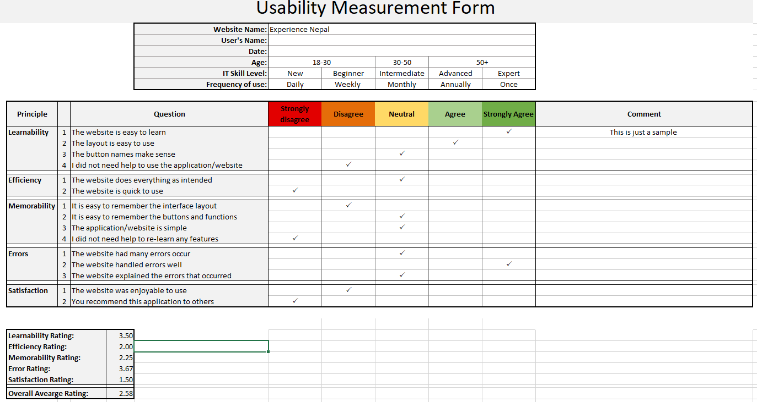This will help to ensure the website isn’t just coded technically correct, but that visitors throughout the target audience can use the website to find specific information they want. This testing helps identify areas of the design that aren’t user friendly or make for a poor user experience. The format will look like:

### Participants

I will select five members of the website’s target audience, which will include:

* 18-30 years old
* 30-50 years old
* 50+ years old
* Someone who English isn’t their first language

### Methodology

Specific people will be selected so that the participants cover a range of past website browsing experience from not a lot to very experienced.

The users will be asked to perform the following tasks:

1. Learnability
2. Efficiency
3. Memorability
4. Errors
5. Satisfaction

Everything the testers struggled with or did wrong will be written down in one document, so changes to the website can be considered before it’s re-tested. I created the blank document over the page for this purpose.

## Risks / Assumptions

Testing with only five subjects is an incredibly small sample size, although ideal for user testing in this case. But the risk lies with thinking if the website passes with all five people, if it’s perfect and everyone can use it.

Another risk is that despite doing the functional testing across various browsers, assuming it will work with every browser would be tempting but a bad idea. There’s over 1,000 desktop browsers and versions of those making it’s unrealistic to manually check all browsers in use, or even every version of the most popular browsers.

## Tools

Windows 10

I’ll be using the built-in recording tool in Windows 10, designed to capture game footage but it will work perfectly for this case and doesn’t require any additional software installed on the PC.

Microsoft Word

For completing the testing reports, I’ll write them up in a Word document.

Google Chrome

This will be used during the user testing.

Internet Explorer, Edge, Firefox, Chrome, Chrome Mobile, Samsung Internet, Safari

These will all be used during functional testing, to ensure the website works correctly across various browsers.

I’ll use this to check all the content on the website is visible for people will any of the four kinds of colour blindness: <https://www.toptal.com/designers/colorfilter>

# Testing Plan - Final

This document contains my testing plan for the Experience Nepal website. That includes two types of testing, functional and usability testing. I’ll go over who will be involved in each type, and how good coverage will be achieved by varying tests, environments, requirements and testers. Lastly, I’ll go over the risks and tools involved in the testing.

## Objectives

By taking the time to complete these tests, any unforeseen bugs or issues with the website can ideally be spotted and dealt with before launching the site to the public. So, one of the main objectives is to avoid embarrassment and damage to the client’s reputation by ensuing the website functions as intended across a variety of different people and devices.

## Schedule

### Functional Testing

This will be done after I finish my prototype, although informal testing will be done throughout development.

### Usability Testing

This will be done after I finish my project, after the functional testing has been done, and after the prototype has been completed.

## Functional Testing Procedures

Functional testing ensures that the website physically works as intended.

### Participants

Those tests will be written and conducted by myself.

### Methodology

The testing will be done through the webpage one page at a time, and at these resolutions to imitate a desktop PC, tablet and mobile device:

* 1024x800
* 1280x800
* 400x900

On each page, these will be tested (if they’re present on the page):

* Hyperlinks; that they all work and take the user to the correct pages
* Images; that they all display on the page
* Navbar; that the full size and mobile versions display when they should, and that the hamburger icon works on the mobile version
* Form; that the contact form submits and sends a message
* Animation; the animations play correctly
* Videos; the videos and their controls all function correctly
* Audio; the intendent audio clip (separate from the video) and its controls work

A document will be made to show that each specific item was tested. If anything was found to be not working, the code will be fixed and then re-tested across each of three resolutions.

## Usability Testing Procedures

* Test to identify your target audience and determine which assets will be evaluated by participants (e.g., prototype, live website or application, etc.).
* Test the task scenarios and moderator questions that will be used to ensure all necessary feedback is gathered during the test sessions
* Schedule participants who meet your target audience.
* The results are analysed and compiled into a report, which contains actionable recommendations for fixing the observed issues with the website or application.

I will test it by using the following tool created in spreadsheet. This will help to ensure the website isn’t just coded technically correct, but that visitors throughout the target audience can use the website to find specific information they want. This testing helps identify areas of the design that aren’t user friendly or make for a poor user experience. The format will look like:

### Participants

I will select five members of the website’s target audience, which will include:

* 18-30 years old
* 30-50 years old
* 50+ years old
* Someone who English isn’t their first language

### Methodology

Specific people will be selected so that the participants cover a range of past website browsing experience from not a lot to very experienced.

The users will be asked to perform the following tasks:

1. Learnability
2. Efficiency
3. Memorability
4. Errors
5. Satisfaction

Everything the testers struggled with or did wrong will be written down in one document, so changes to the website can be considered before it’s re-tested. I created the blank document over the page for this purpose.

## Expected Results

### Task 1 – Every Pages works in both desktop and mobile

### Task 2 – Every links is valid to get to other pages

## Task 3 – Every media item is working including videos, audios and images.

## Task 4 – Similarly making sure its easy to learn and quick to use and makes user satisfied.

### General Expected Results

In addition to the ones explained above, it’s expected that all the links across the website will function correctly, all the images, video, audio and animations will load, all text will be readable, and the website will be responsive and be usable from a mobile to a wide desktop screen.

## Risks / Assumptions

Testing with only five subjects is an incredibly small sample size, although ideal for user testing in this case. But the risk lies with thinking if the website passes with all five people, if it’s perfect and everyone can use it.

Another risk is that despite doing the functional testing across various browsers, assuming it will work with every browser would be tempting but a bad idea. There’s over 1,000 desktop browsers and versions of those making it’s unrealistic to manually check all browsers in use, or even every version of the most popular browsers.

## Tools

**Microsoft Word:** For completing the testing reports, I’ll write them up in a Word document.

**Internet Explorer, Edge, Firefox, Chrome, Chrome Mobile, Samsung Internet, Safari:** These will all be used during testing, to ensure the website works correctly across various browsers.

## Deliverables

After testing, we’ll have five completed forms from a range of people who completed four assigned tasks on the website. This will also include the user’s general feedback on the site.

## Test Documentation

The form below is the one that will be handed to the testers, which they can fill out and return to us. After that, the form I will complete for the functional testing is included. This can be referred to if anything technical is faulty with the website.

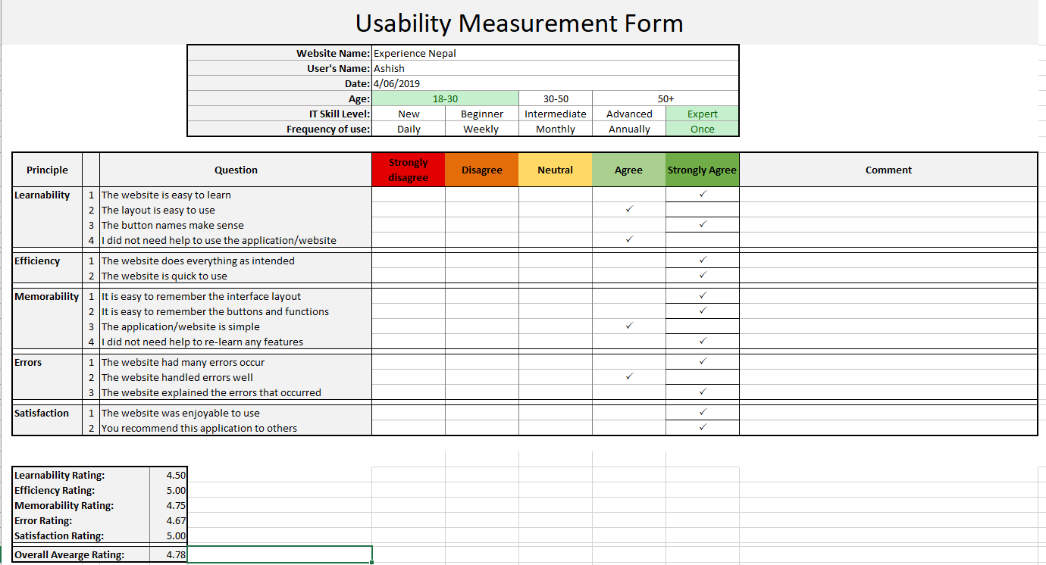

General feedback on the usability of the website:

The site looked very good, and your comments were presented in a very friendly way.

## Functional Testing Form & Results

|  |  |  |  |  |  |  |  |
| --- | --- | --- | --- | --- | --- | --- | --- |
| **Page name** | **Filename** | **Valid** | **Access** | **Total Size (kb)** | **All Browsers** | **CSS and HTML Validated** | **Responsive** |
| **About us** | **aboutus.html** | **Yes** | **Yes** | **5** | **Yes** | **Yes** | **Yes** |
| **accommodation** | **accomodation.html** | **Yes** | **Yes** | **4** | **Yes** | **Yes** | **Yes** |
| **Contact us** | **contactus.html** | **Yes** | **Yes** | **6** | **Yes** | **Yes** | **Yes** |
| **Destination** | **destination.html** | **Yes** | **Yes** | **5** | **Yes** | **Yes** | **Yes** |
| **index** | **index.html** | **Yes** | **Yes** | **4** | **Yes** | **Yes** | **Yes** |
| **media** | **media.html** | **Yes** | **Yes** | **5** | **Yes** | **Yes** | **Yes** |
| **Nepal overview** | **nepaloverview.html** | **Yes** | **Yes** | **5** | **Yes** | **Yes** | **Yes** |
| **stylesheet** | **stylesheet.css** | **Yes** | **Yes** | **4** | **Yes** | **Yes** | **Yes** |
| **Things to do** | **Thingstodo.html** | **Yes** | **Yes** | **6** | **Yes** | **Yes** | **Yes** |
| **Transport** | **Transport.html** | **Yes** | **Yes** | **4** | **Yes** | **Yes** | **Yes** |
| **Desktop site** | **Slider.html** | **Yes** | **Yes** | **5** | **Yes** | **Yes** | **Yes** |

|  |  |  |  |  |
| --- | --- | --- | --- | --- |
| Web page Document Test Plan | | | | |
| File Name: | Experience Nepal Website | | Date: | 04/06/2019 |
| Page Title: | Experience Nepal | | Tester: | Ashish |
| Browser capability | | | | |
|  | 1024x800 | 1366x788 | 1280x800 | Notes |
| IE | [This Photo](http://en.wikipedia.org/wiki/File:Green_tick.png) by Unknown Author is licensed under [CC BY-SA](https://creativecommons.org/licenses/by-sa/3.0/) | [This Photo](http://en.wikipedia.org/wiki/File:Green_tick.png) by Unknown Author is licensed under [CC BY-SA](https://creativecommons.org/licenses/by-sa/3.0/) | [This Photo](http://en.wikipedia.org/wiki/File:Green_tick.png) by Unknown Author is licensed under [CC BY-SA](https://creativecommons.org/licenses/by-sa/3.0/) |  |
| Chrome | [This Photo](http://en.wikipedia.org/wiki/File:Green_tick.png) by Unknown Author is licensed under [CC BY-SA](https://creativecommons.org/licenses/by-sa/3.0/) | [This Photo](http://en.wikipedia.org/wiki/File:Green_tick.png) by Unknown Author is licensed under [CC BY-SA](https://creativecommons.org/licenses/by-sa/3.0/) | [This Photo](http://en.wikipedia.org/wiki/File:Green_tick.png) by Unknown Author is licensed under [CC BY-SA](https://creativecommons.org/licenses/by-sa/3.0/) |  |
| Firefox | [This Photo](http://en.wikipedia.org/wiki/File:Green_tick.png) by Unknown Author is licensed under [CC BY-SA](https://creativecommons.org/licenses/by-sa/3.0/) | [This Photo](http://en.wikipedia.org/wiki/File:Green_tick.png) by Unknown Author is licensed under [CC BY-SA](https://creativecommons.org/licenses/by-sa/3.0/) | [This Photo](http://en.wikipedia.org/wiki/File:Green_tick.png) by Unknown Author is licensed under [CC BY-SA](https://creativecommons.org/licenses/by-sa/3.0/) |  |
| Document Validation | | | | |
|  | 1024x800 | 1366x788 | 1280x800 | Notes |
| HTML validation | [This Photo](http://en.wikipedia.org/wiki/File:Green_tick.png) by Unknown Author is licensed under [CC BY-SA](https://creativecommons.org/licenses/by-sa/3.0/) | [This Photo](http://en.wikipedia.org/wiki/File:Green_tick.png) by Unknown Author is licensed under [CC BY-SA](https://creativecommons.org/licenses/by-sa/3.0/) | [This Photo](http://en.wikipedia.org/wiki/File:Green_tick.png) by Unknown Author is licensed under [CC BY-SA](https://creativecommons.org/licenses/by-sa/3.0/) |  |
| CSS Validation | [This Photo](http://en.wikipedia.org/wiki/File:Green_tick.png) by Unknown Author is licensed under [CC BY-SA](https://creativecommons.org/licenses/by-sa/3.0/) | [This Photo](http://en.wikipedia.org/wiki/File:Green_tick.png) by Unknown Author is licensed under [CC BY-SA](https://creativecommons.org/licenses/by-sa/3.0/) | [This Photo](http://en.wikipedia.org/wiki/File:Green_tick.png) by Unknown Author is licensed under [CC BY-SA](https://creativecommons.org/licenses/by-sa/3.0/) |  |
| Check Spelling | [This Photo](http://en.wikipedia.org/wiki/File:Green_tick.png) by Unknown Author is licensed under [CC BY-SA](https://creativecommons.org/licenses/by-sa/3.0/) | [This Photo](http://en.wikipedia.org/wiki/File:Green_tick.png) by Unknown Author is licensed under [CC BY-SA](https://creativecommons.org/licenses/by-sa/3.0/) | [This Photo](http://en.wikipedia.org/wiki/File:Green_tick.png) by Unknown Author is licensed under [CC BY-SA](https://creativecommons.org/licenses/by-sa/3.0/) |  |
| Usability | [This Photo](http://en.wikipedia.org/wiki/File:Green_tick.png) by Unknown Author is licensed under [CC BY-SA](https://creativecommons.org/licenses/by-sa/3.0/) | [This Photo](http://en.wikipedia.org/wiki/File:Green_tick.png) by Unknown Author is licensed under [CC BY-SA](https://creativecommons.org/licenses/by-sa/3.0/) | [This Photo](http://en.wikipedia.org/wiki/File:Green_tick.png) by Unknown Author is licensed under [CC BY-SA](https://creativecommons.org/licenses/by-sa/3.0/) |  |

Copyright of the website I have used my own name and Terms and Condition link and year on it.

# What’s Next

My website is not completely working on the mobile version as I wanted. So, I will be working on the website more to make it reliable on the mobile devices. And, for some of the pages like Transport I would like to add more features on the images using lightbox and other creative things to give extra features on the images so that the user can enlarge the image and can make it more useful.