Fortune Procurement System - User Manual

Based on User Roles

Role: Employee

Dashboard Module
Instructions for the Dashboard module. As a Employee, you can access this module to view and manage your specific tasks. The interface provides key actions required for this step of the workflow.
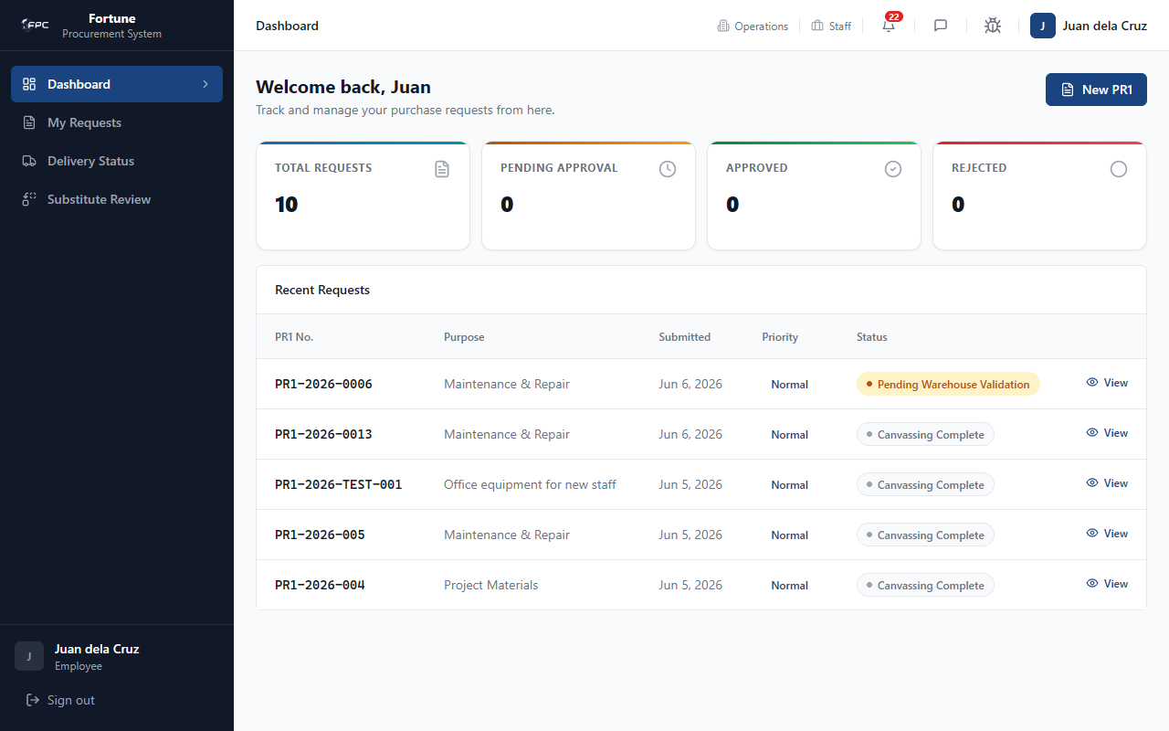

My Requests Module
Instructions for the My Requests module. As a Employee, you can access this module to view and manage your specific tasks. The interface provides key actions required for this step of the workflow.
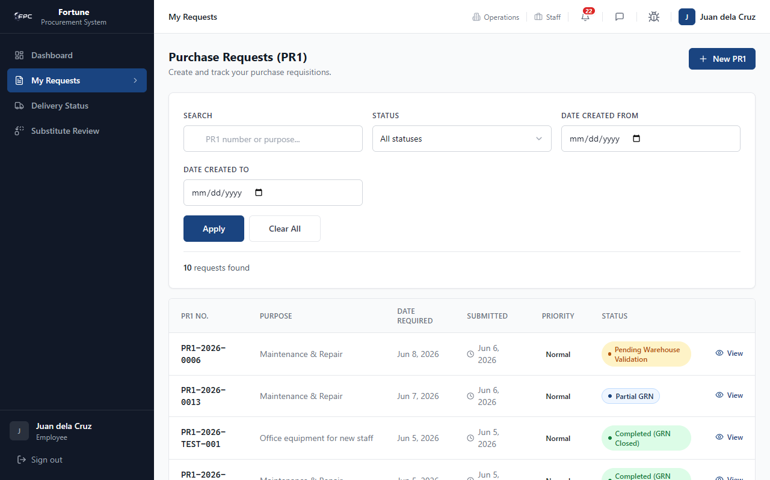

Substitute Items Module
Instructions for the Substitute Items module. As a Employee, you can access this module to view and manage your specific tasks. The interface provides key actions required for this step of the workflow.
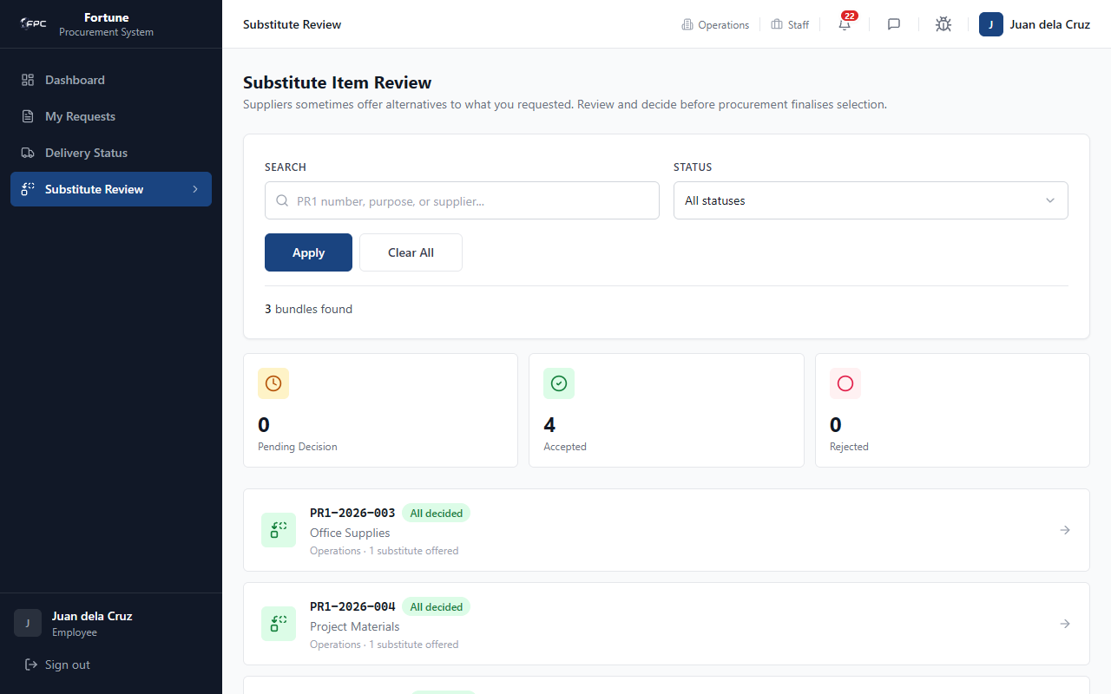

Delivery Module
Instructions for the Delivery module. As a Employee, you can access this module to view and manage your specific tasks. The interface provides key actions required for this step of the workflow.
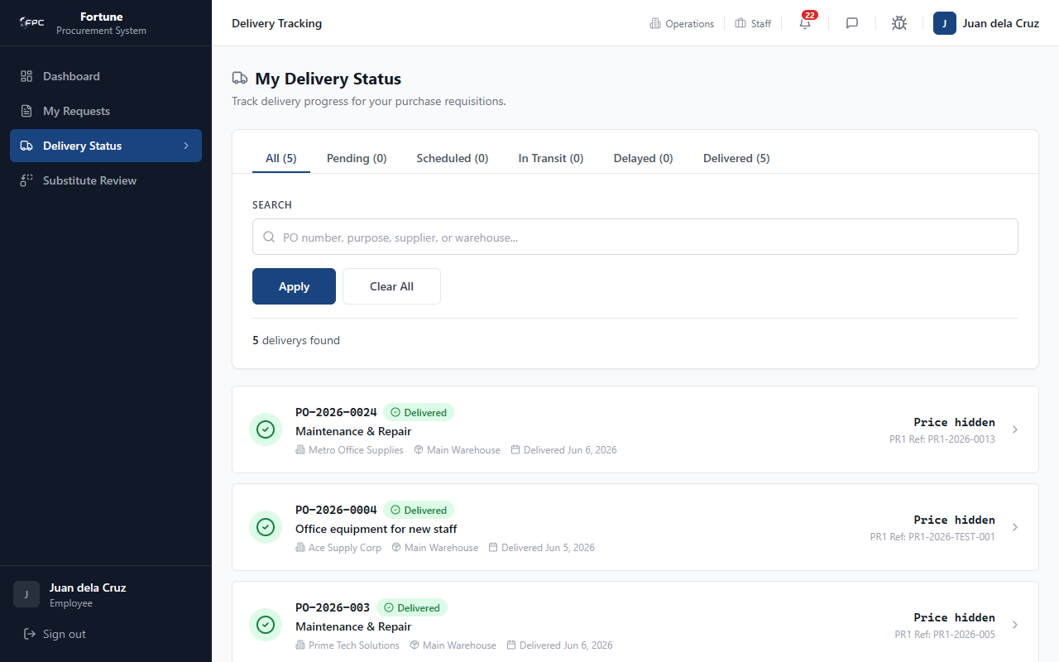

Role: Warehouse

Dashboard Module
Instructions for the Dashboard module. As a Warehouse, you can access this module to view and manage your specific tasks. The interface provides key actions required for this step of the workflow.
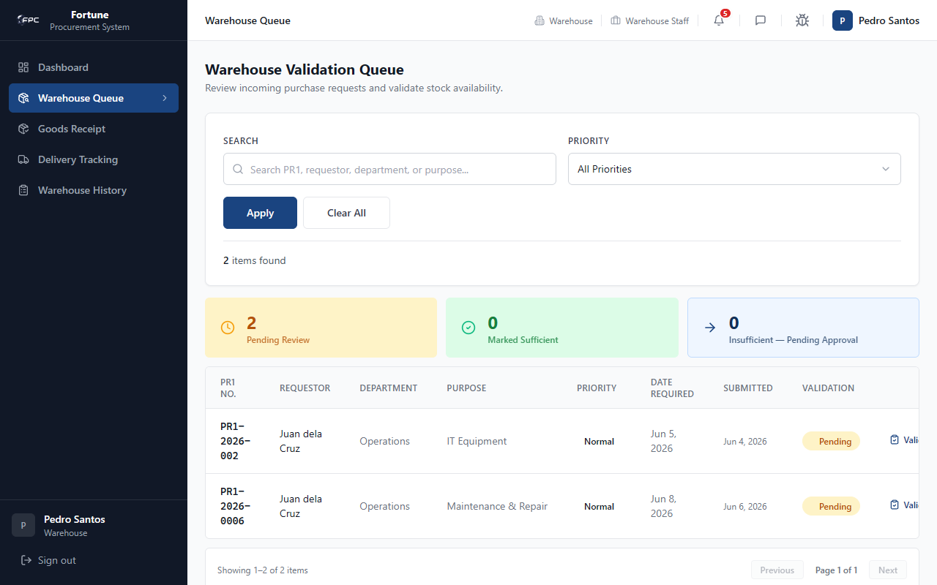

Deliveries Module
Instructions for the Deliveries module. As a Warehouse, you can access this module to view and manage your specific tasks. The interface provides key actions required for this step of the workflow.
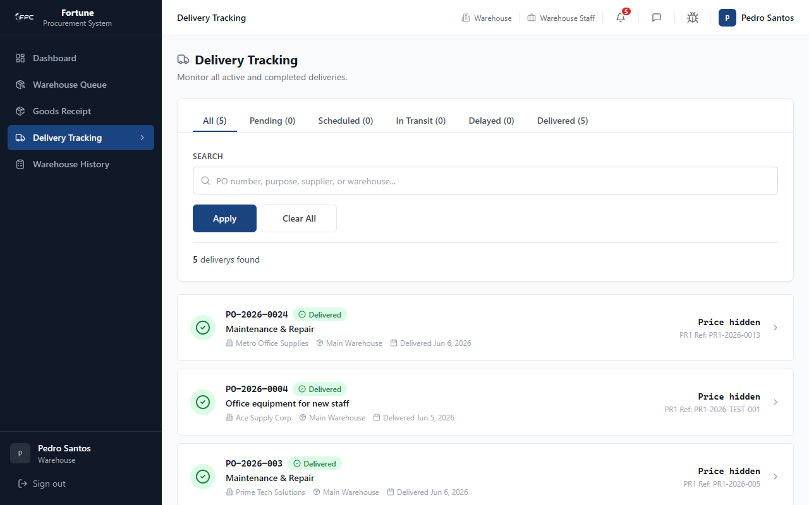

Role: Procurement

Dashboard Module
Instructions for the Dashboard module. As a Procurement, you can access this module to view and manage your specific tasks. The interface provides key actions required for this step of the workflow.
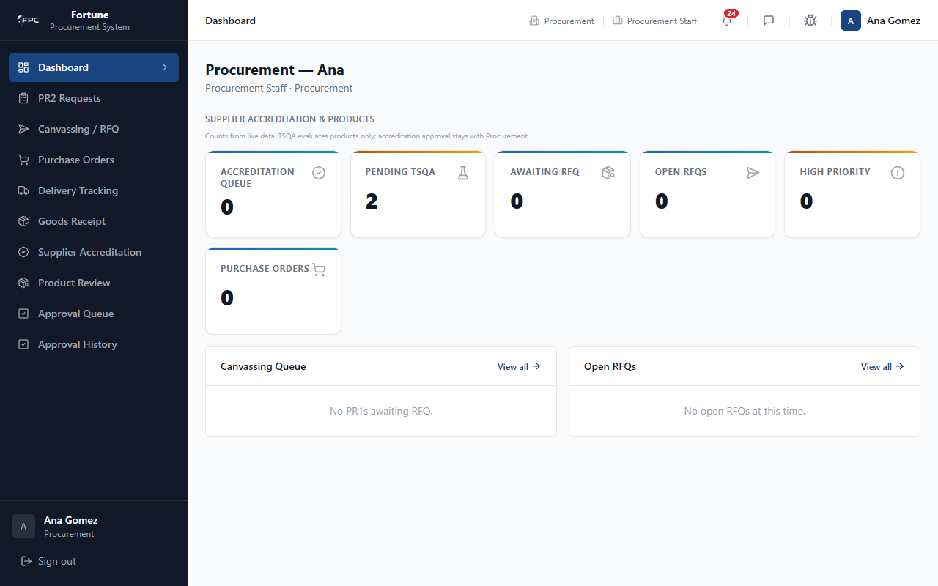

PR Approvals Module
Instructions for the PR Approvals module. As a Procurement, you can access this module to view and manage your specific tasks. The interface provides key actions required for this step of the workflow.
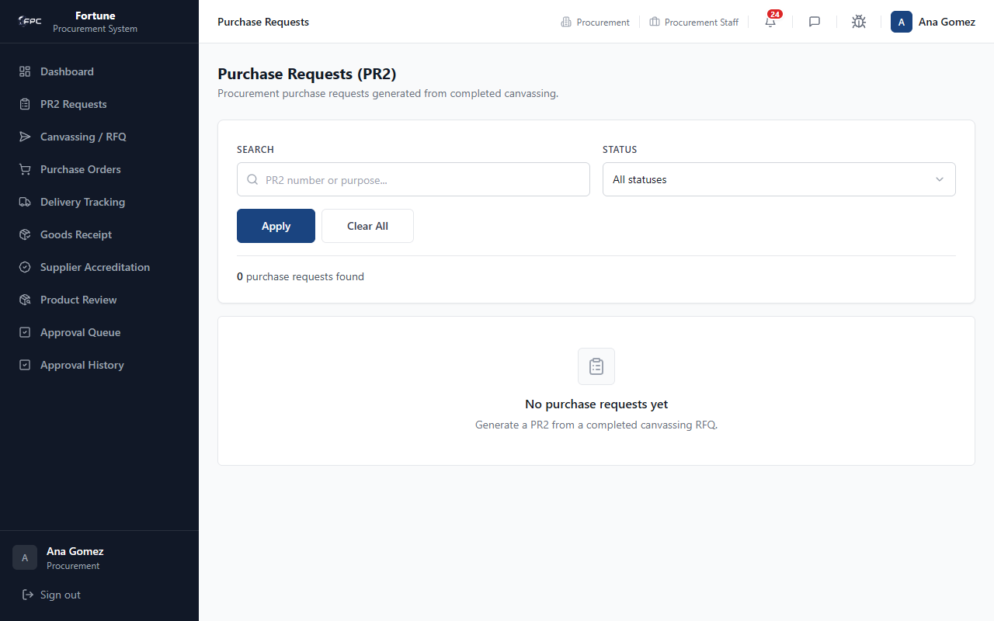

Purchase Orders Module
Instructions for the Purchase Orders module. As a Procurement, you can access this module to view and manage your specific tasks. The interface provides key actions required for this step of the workflow.
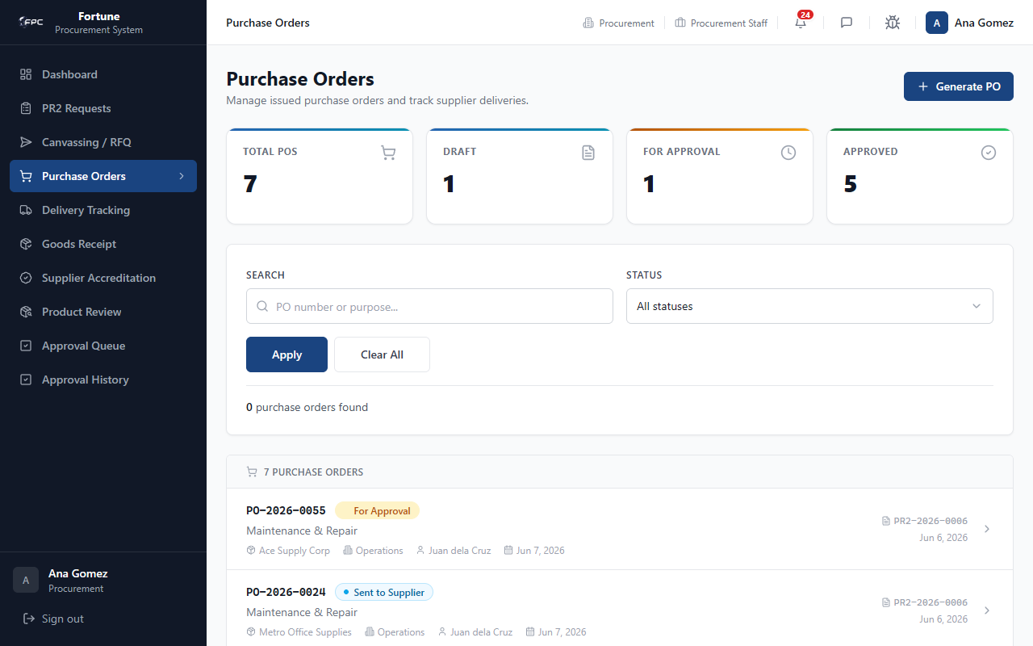

Role: Approver

Dashboard Module
Instructions for the Dashboard module. As a Approver, you can access this module to view and manage your specific tasks. The interface provides key actions required for this step of the workflow.
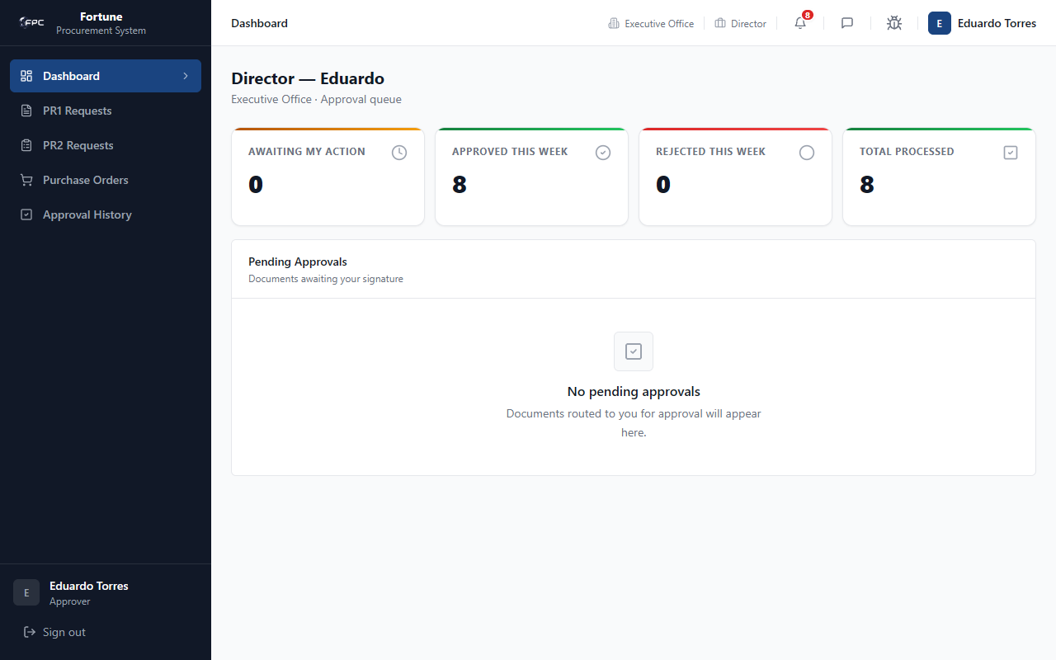

Approvals Module
Instructions for the Approvals module. As a Approver, you can access this module to view and manage your specific tasks. The interface provides key actions required for this step of the workflow.
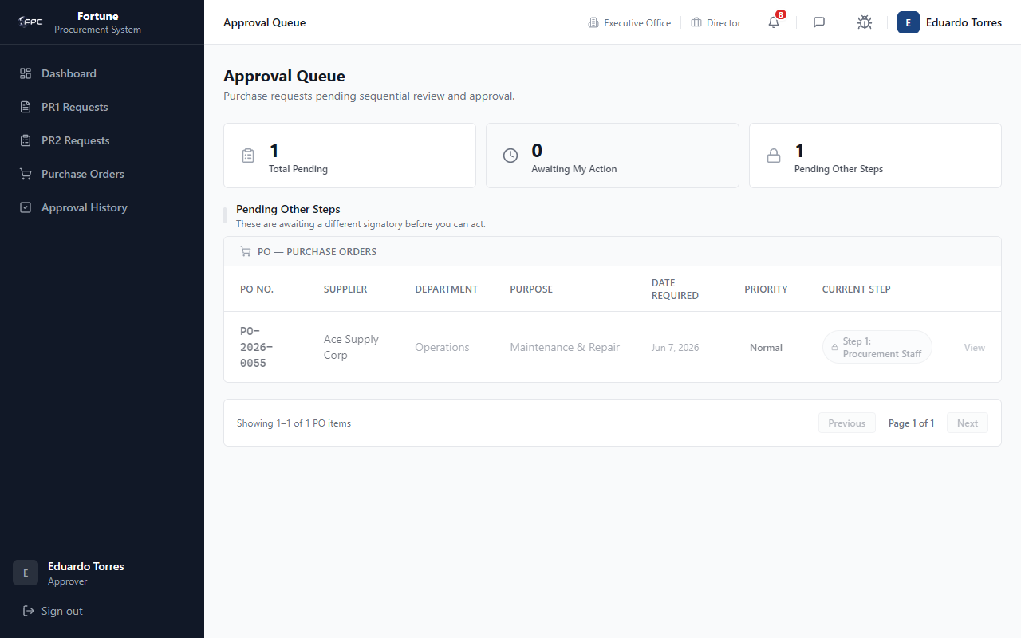

Role: Supplier

Dashboard Module
Instructions for the Dashboard module. As a Supplier, you can access this module to view and manage your specific tasks. The interface provides key actions required for this step of the workflow.
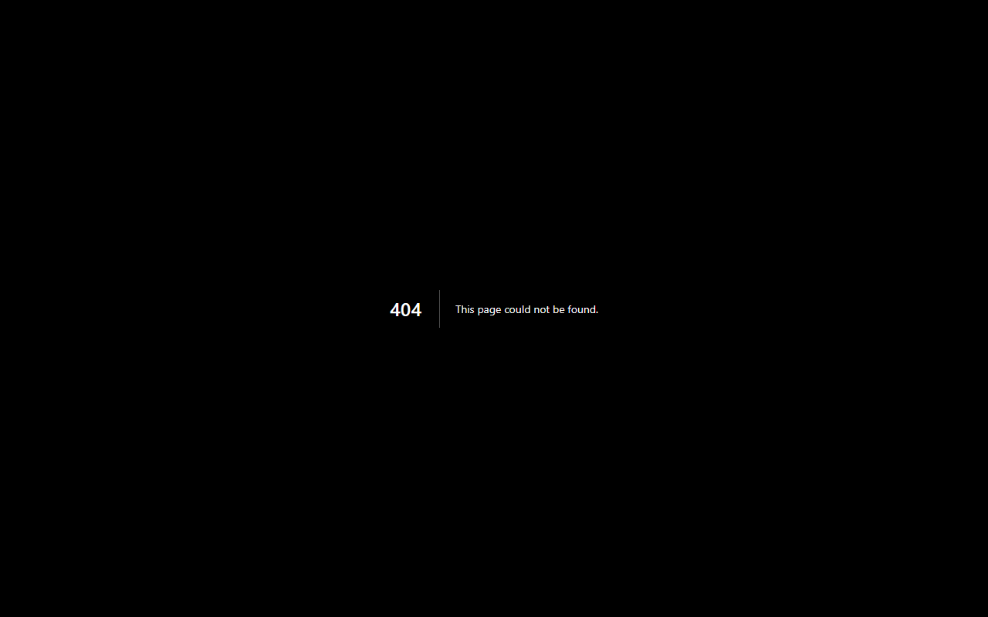

Quotations Module
Instructions for the Quotations module. As a Supplier, you can access this module to view and manage your specific tasks. The interface provides key actions required for this step of the workflow.
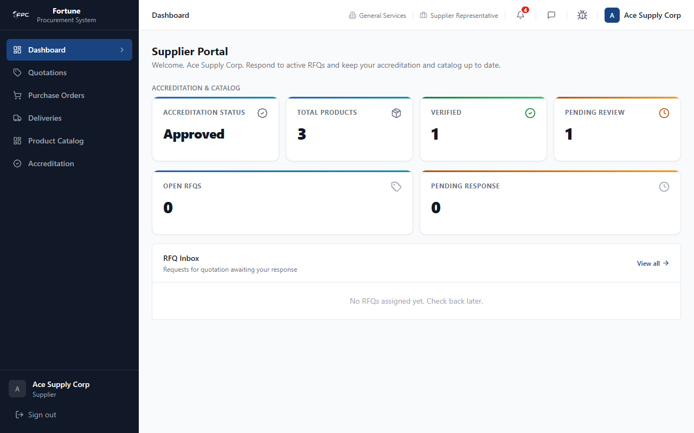

Role: TSQA

Dashboard Module
Instructions for the Dashboard module. As a TSQA, you can access this module to view and manage your specific tasks. The interface provides key actions required for this step of the workflow.
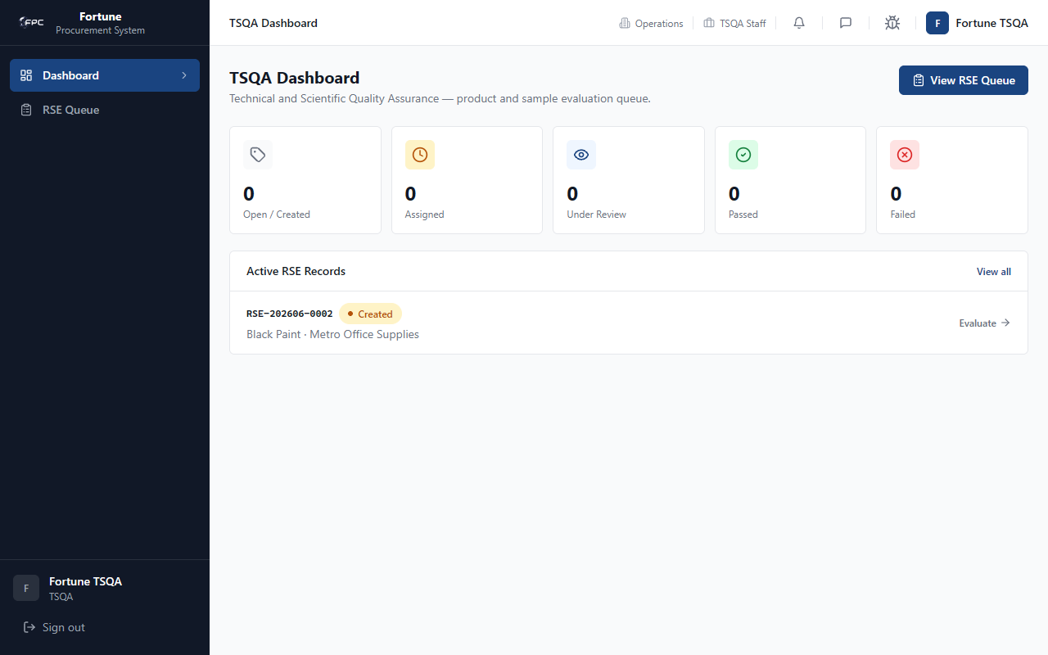

Role: Admin

Dashboard Module
Instructions for the Dashboard module. As a Admin, you can access this module to view and manage your specific tasks. The interface provides key actions required for this step of the workflow.
