LoanStar
System User Manual

Version Code aligned edition | October 2026

Table of Contents

In Word, right-click the table of contents and choose Update Field to show page numbers.

Introduction
LoanStar supports the work from a loan inquiry through application intake, verification, committee review, release, accounting, collection, and remedial handling. What you see in the menu depends on the role assigned to your account.
Use this manual for the screens and actions that are currently implemented. Each section identifies the role area where the work is done. If an item is listed in the clarification appendix, ask your system administrator before relying on it in day-to-day work.

Sign in and recover access

What it is for
Who uses this: Users with access to this work area. Lets you enter LoanStar, create an account where registration is enabled, or replace a forgotten password.

Where to find it
Use the sign-in page. Choose Forgot password when you cannot remember your password.

Screenshot guide
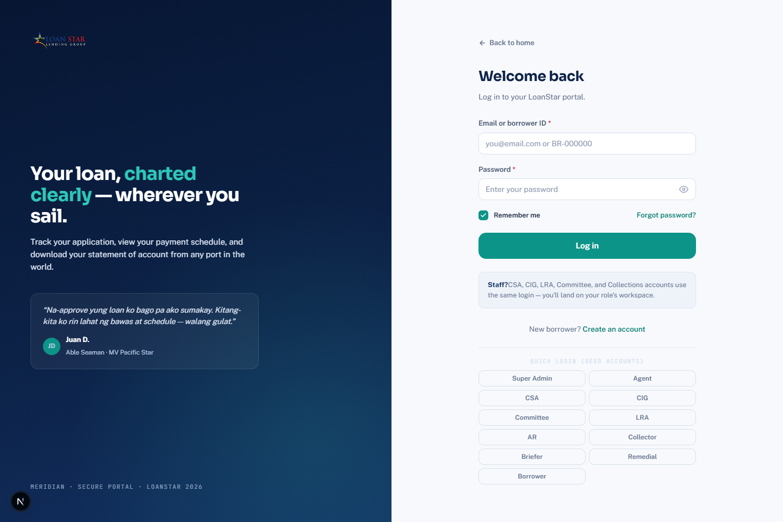
LoanStar sign-in page. Use the email and password fields, or select Forgot password when you need access recovery.

What you should see
- You should see the email and password fields and the Log in button.
- Enter your credentials, then select Log in.
- Select Forgot password before entering a new password when you need recovery.

Steps
- Enter your email address and password, then select Sign in.
- To recover access, select Forgot password and submit your email address.
- Open the reset link sent to your email, enter the new password twice, and select Update password.
- Use a password with at least eight characters.

Tips and things to watch out for
- The reset page only works when opened from the reset link or an active sign-in session.
- Registration and access-denied pages are also implemented; availability depends on the system configuration and your assigned permissions.

Your account and notifications

What it is for
Who uses this: Users with access to this work area. Lets every signed-in user keep account contact details, preferences, profile photo, and notification settings current.

Where to find it
Open Account from the application header or account menu.

Screenshot guide
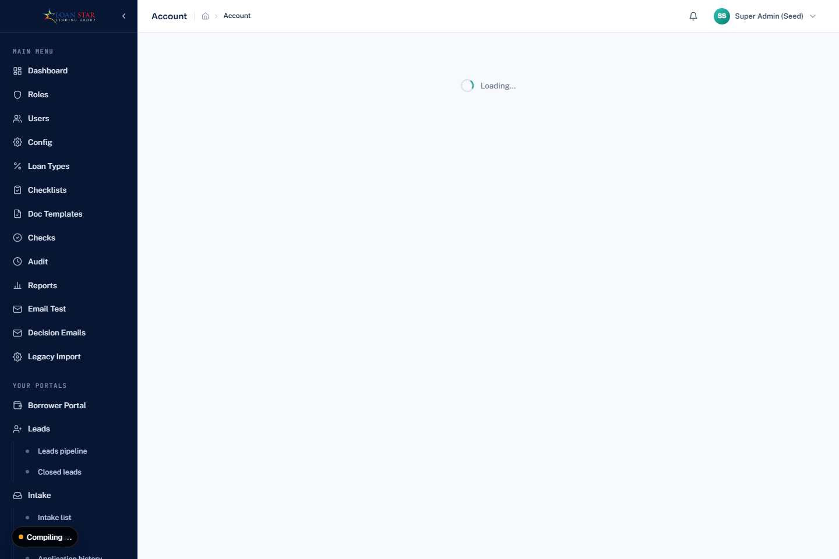
Account page opened with a seeded administrator account. Use this page to review account settings and notifications.

What you should see
- You should see the account settings area and the notification controls.
- Update only the fields you are allowed to change, then select Save account.
- Use the notification controls to review or mark notices as read.

Steps
- Upload a JPEG, PNG, or WebP photo if you want one displayed.
- Update your display name, phone number, timezone, locale, and notification choices.
- Review the notification list and select Mark all read when needed.
- Select Save account.

Tips and things to watch out for
- Profile photos must be 2 MB or smaller.
- Your email address is read-only here; ask an administrator to change it.
- The account phone number is separate from the borrower contact information kept on an application.

Dashboard and role based navigation

What it is for
Who uses this: Users with access to this work area. Provides a starting view of available work and routes you only to areas allowed by your role.

Where to find it
Select Dashboard in the left navigation.

Screenshot guide
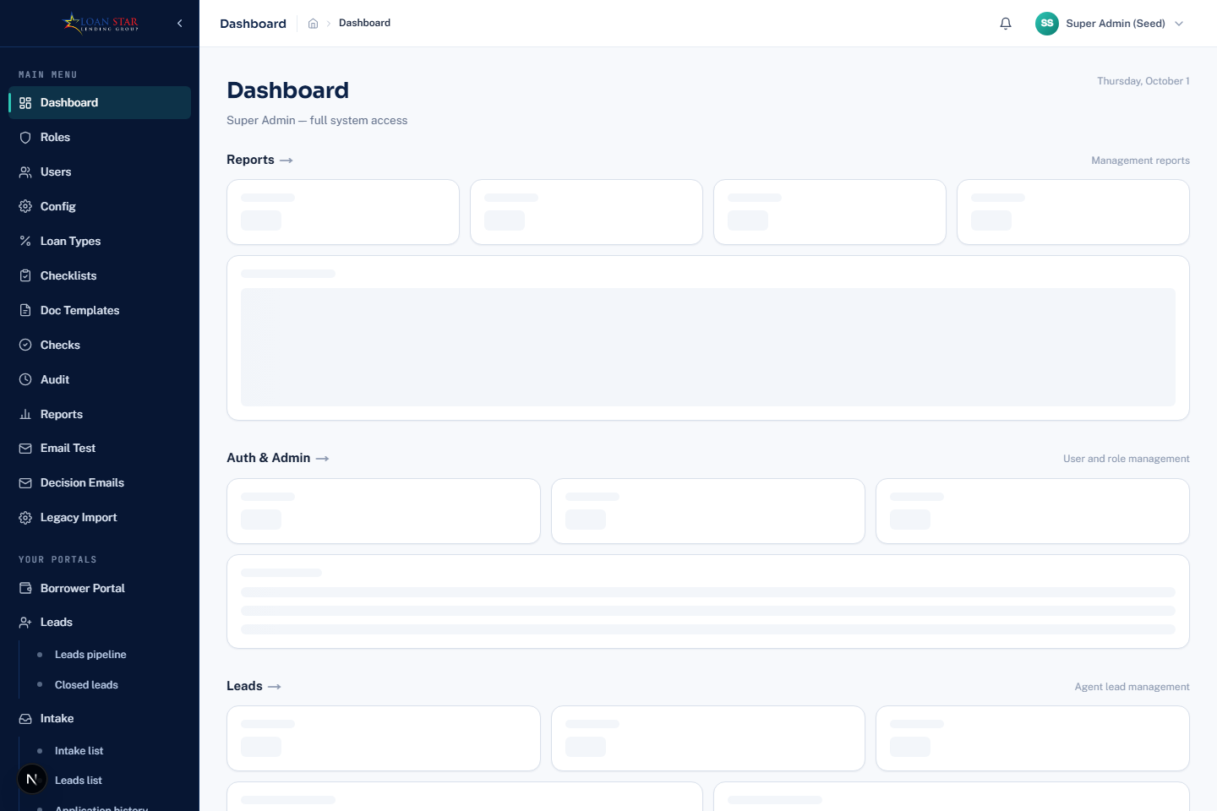
Role dashboard opened with a seeded administrator account. The available navigation reflects the signed-in role's permissions.

What you should see
- You should see dashboard cards and only the menu sections your role allows.
- Select a left-navigation work area to open its queue or supporting page.
- If a module is not visible, request the needed permission from an administrator.

Steps
- Review the dashboard tiles available to your account.
- Use the left navigation to open your work area, such as Leads, Intake, Verification, Committee, Release, Accounting, Collection, Remedial, Reports, or Administration.
- Expand a work area to open its queue, history, or supporting page.

Tips and things to watch out for
- Menu items are permission controlled. A missing menu item means your assigned role does not currently provide that area.
- The Design and computation-breakdown pages are development tools, not normal operating screens.

Borrower portal and loan application

What it is for
Who uses this: Users with access to this work area. Lets a borrower register, start or resume an application, supply information and documents, accept offers, and follow an active loan.

Where to find it
Open Borrower Portal. Select Register if you need a borrower account, then open an application from the borrower home page.

Screenshot guide
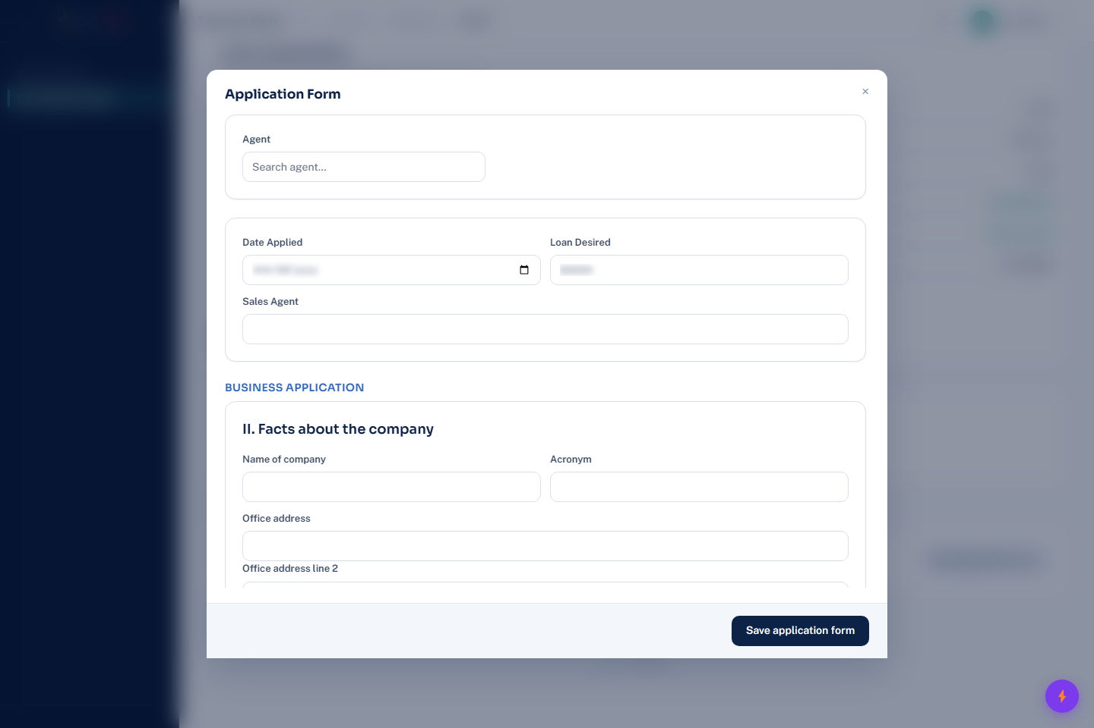
Redacted Application Form opened from the supplied borrower's active application. Personal details, form values, and background loan details are obscured.

What you should see
- You should see the Application Form window over the borrower application details, with the Agent, Date Applied, Loan Desired, and Sales Agent fields at the top.
- Select Edit application form from the application details to open this window. Complete the applicable fields, then select Save application form.
- Scroll inside the Application Form window to complete the sections that apply to your loan type, including the Business Application details shown in the screenshot.

Forms and what to enter
Open Edit application form from the application detail. The form sections below were verified in the supplied borrower's current application. Complete only the sections that appear for your loan type.

Start with the application details
- Choose the Agent when the form offers the selector, confirm Date Applied, enter the Loan Desired amount, and enter or confirm the Sales Agent.
- Use the loan amount and dates that apply to this application. Do not enter a payment amount in Loan Desired.

Complete the business section when it is shown
- Enter the company name, acronym, office address, landline and mobile numbers, nature of business, business email, website, TIN, fax number, branches, date established, and employee count.
- Use Add officer, Add stockholder, Add customer, Add supplier, Add credit reference, and Add bank account to add one row at a time. Complete the fields in the new row before adding another.

Complete personal information
- Enter legal last name and first name, middle name when applicable, civil status, present and provincial address, ownership, years of stay, place and date of birth, phone number, and dependents.
- When Ownership is Other, enter the required explanation in the Please specify field. The email field is read-only in the verified borrower form.

Add employment, spouse, and income information
- Enter employer or business information, contact details, current and previous employment details when applicable, and spouse information when applicable.
- For income, enter gross income, expenses, and net income in the matching own-income and spouse-income areas. Add Other income only when there is a real source and amount to declare.

Add references, bank information, and documents
- Use Add dependent and Add reference for each person you need to include. Enter the relationship, contact number, and address for each reference.
- Enter the bank name and account number in the ADB verification field. Upload each document against its named checklist item, then select Save application form.
- The verified SME application displayed Business Registration, representative ID, valid IDs, Mayor's Permit, TIN and community tax certificate, location sketch, bank authorization, consent form, client or supplier list, proof of transaction, bank statements, financial statements, proof of billing, and business pictures. The checklist can vary by loan type and application state.

Steps
- Create or open an application, then complete the application form and any co-borrower details.
- Save the form, add the required documents, and complete the visible checklist items.
- Review the calculation, borrower briefing, and verification items when they become available.
- Submit the application when the portal offers Submit application.
- When an offer is presented, review it and accept or send a counteroffer. After release, use the active-loan view for loan status and payment information.

Tips and things to watch out for
- A draft application can be deleted from the borrower home page before it is submitted.
- Some signing, document download, payment download, and release-document actions appear only when the application has reached the required stage.
- The borrower view includes a status timeline so you can see the application or loan progress.

Agent leads

What it is for
Who uses this: Users with access to this work area. Lets marketing or sales staff record leads, link a lead to an existing borrower, and monitor progress until closure.

Where to find it
Open Leads, then choose Leads pipeline or Closed leads.

Screenshot guide
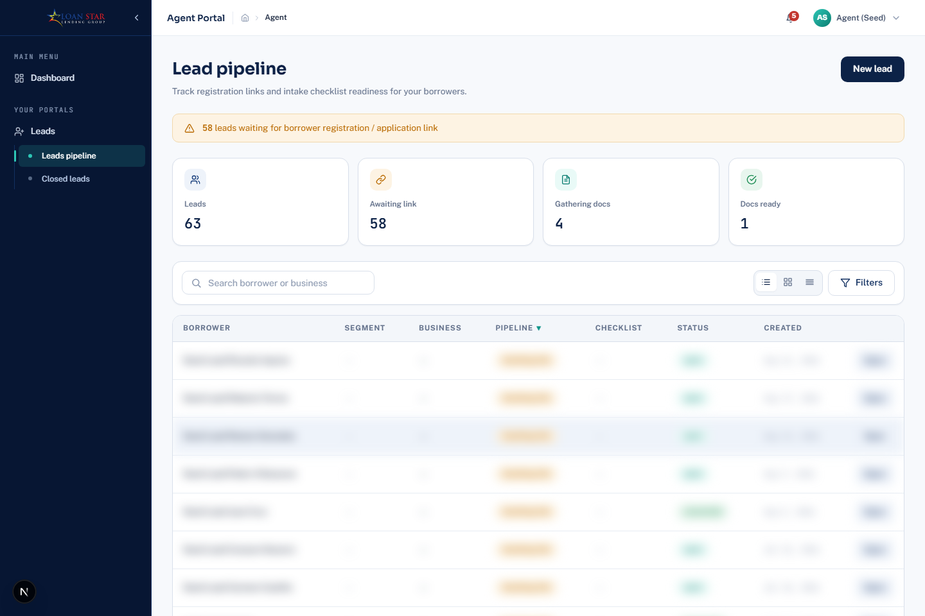
Seeded Agent Leads pipeline. The New lead button is at the upper-right.

What you should see
- You should see the Lead pipeline heading, stage counters, a search field, and filter controls.
- Select New lead at the upper right to begin a lead record.
- Use the search and filters before opening a row so you are working on the intended lead.

Steps
- Select New lead.
- Enter the lead details and select a matching existing borrower when one is shown, or continue without a match.
- Save the lead and select Open to review it.
- Use the pipeline filters, date range, search, sorting, and segment filters to narrow the list.
- Use Closed leads to review finished lead records.

Tips and things to watch out for
- The lead form can link to an existing borrower or clear that link before saving.
- The individual lead page and its New lead page are available from the leads workflow.

Intake and CSA application processing

What it is for
Who uses this: Users with access to this work area. Lets Customer Service Associates create applications, complete intake checks, calculate terms, manage borrower communication, and send complete files to verification.

Where to find it
Open Intake. Use Intake list for applications, Leads list for qualified leads, and Application history for prior work.

Screenshot guide
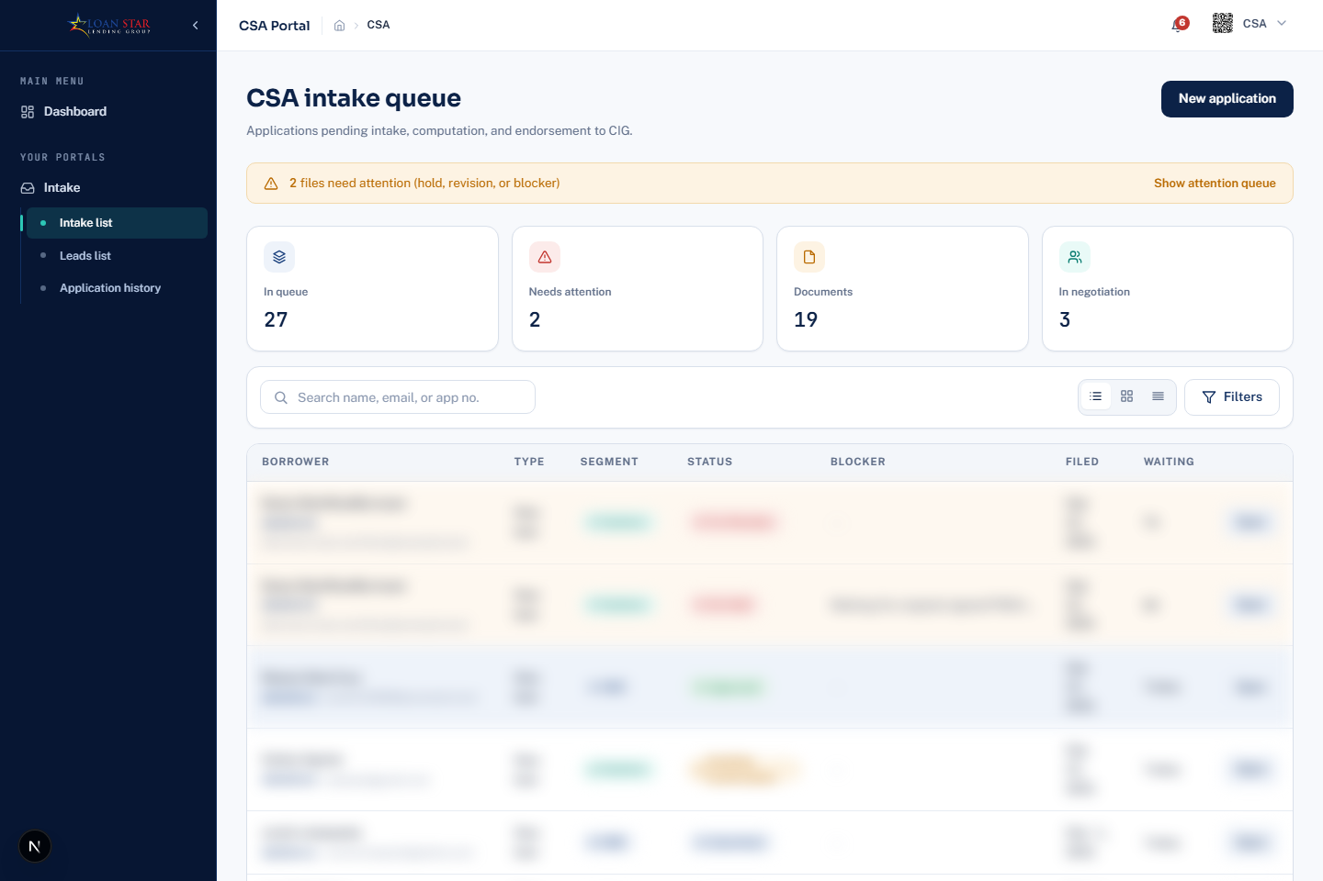
Seeded CSA Intake queue. Use the navigation and queue controls shown to open intake work.

What you should see
- You should see CSA intake queue, stage counters, a search field, and the New application button at the upper right.
- Use the Intake submenu to switch between Intake list, Leads list, and Application history.
- Find the intended application with search or filters, then open its row to continue intake work.

Steps
- Select New application or select Start application from an eligible lead.
- Open an application and complete the application form, privacy orientation, initial interview, bank authorization, and checklist items shown for the file.
- Use the computation panel to prepare or update the computation and record its required confirmation.
- Use the negotiation panel to record an offer or borrower response, and use Change owner or Connect borrower account when those actions are available.
- Record pass or fail for checks, then select Endorse to CIG when the application is ready for verification.

Tips and things to watch out for
- The CSA file can be put on hold and later cleared; it also supports recording a revision as complete.
- The option to proceed without borrower signing is available only where the application workflow allows it.
- Use Application history to find prior CSA actions rather than treating the active queue as the complete record.

CSA computation calculator and origination discounts

What it is for
Who uses this: Users with access to this work area. Lets a Customer Service Associate build the application computation, test eligible schedules, show the borrower the breakdown, and apply an origination interest discount before endorsement.

Where to find it
Open an application from Intake list and scroll to Computation.

Screenshot guide
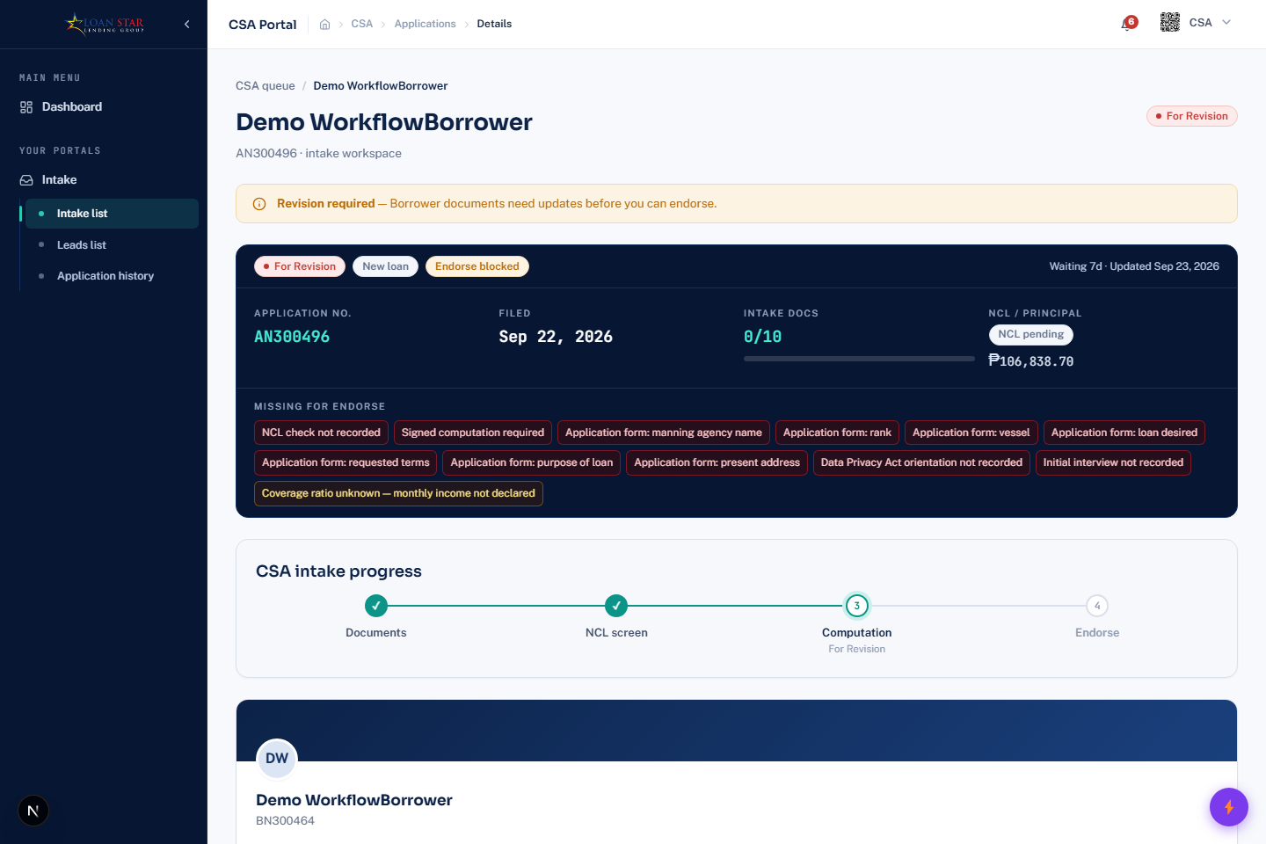
CSA application computation section. Use the calculator controls and the visible Origination discount area for the file being processed.

What you should see
- You should see the computation panel for the open CSA application.
- Enter or confirm the calculator inputs, then select Compute or Recalculate.
- Open the Origination discount controls only after reviewing the computed breakdown.

Steps
- Select the loan type and confirm the visible interest, processing fee, admin fee, and chattel mortgage fee fields.
- Choose the input mode, loan schedule, amount, terms, and add-on months, then select Compute or Recalculate.
- Review the calculation breakdown for principal, fees, deductions, net released amount, total interest, total loan, and scheduled amortization.
- Select Select discount or Edit discount under Origination discount.
- Tick eligible installments, enter the permitted percentage for each selected installment, review the total interest discount, and apply it.
- Use Full breakdown only as a supporting view; complete the normal computation review before sending the file forward.

Tips and things to watch out for
- A computation cannot be prepared until the initial interview is recorded.
- The schedule message explains special schedule constraints, including terms that must be divisible by the schedule interval.
- The computation becomes locked after the file is endorsed.
- The borrower must sign the required computation before normal endorsement; use the visible exception flow only when policy permits.

CSA settlement deductions and early settlement discounts

What it is for
Who uses this: Users with access to this work area. Lets a Customer Service Associate include a full settlement of another active loan in a new computation and apply the allowed early settlement interest discount.

Where to find it
In Computation, open Other deductions and use Offset full settlement.

Screenshot guide
CSA computation section, which contains Other deductions and the applicable early-settlement discount controls for an eligible settlement.

What you should see
- You should see the computation panel where Other deductions is available for an eligible file.
- Select Offset full settlement, then choose the active loan to settle.
- Apply an early-settlement discount only to the eligible future installments shown by the screen.

Steps
- Select the target active loan for Offset full settlement.
- Review the auto-filled remaining balance and change it only when the application allows it.
- Select Apply early settlement discount.
- Tick future installments only, set the permitted percentage for each, and review the gross interest, termination fee, and net discount.
- Apply the discount, then recalculate and review the revised deduction and net release figures.

Tips and things to watch out for
- Due and past installments are not eligible for the early settlement discount.
- The displayed net discount is the selected future interest less one month of interest shown as the termination fee.
- The partial-payment tool does not close the other loan and does not apply a discount.

Verification and CIG review

What it is for
Who uses this: Users with access to this work area. Lets Credit Investigation Group staff verify an endorsed application, collect supporting findings, and forward or return the file.

Where to find it
Open Verification. Use Verification queue for active work, Denial calls for borrower notification, Scheduled callbacks for follow-up, and History for completed actions.

Screenshot guide
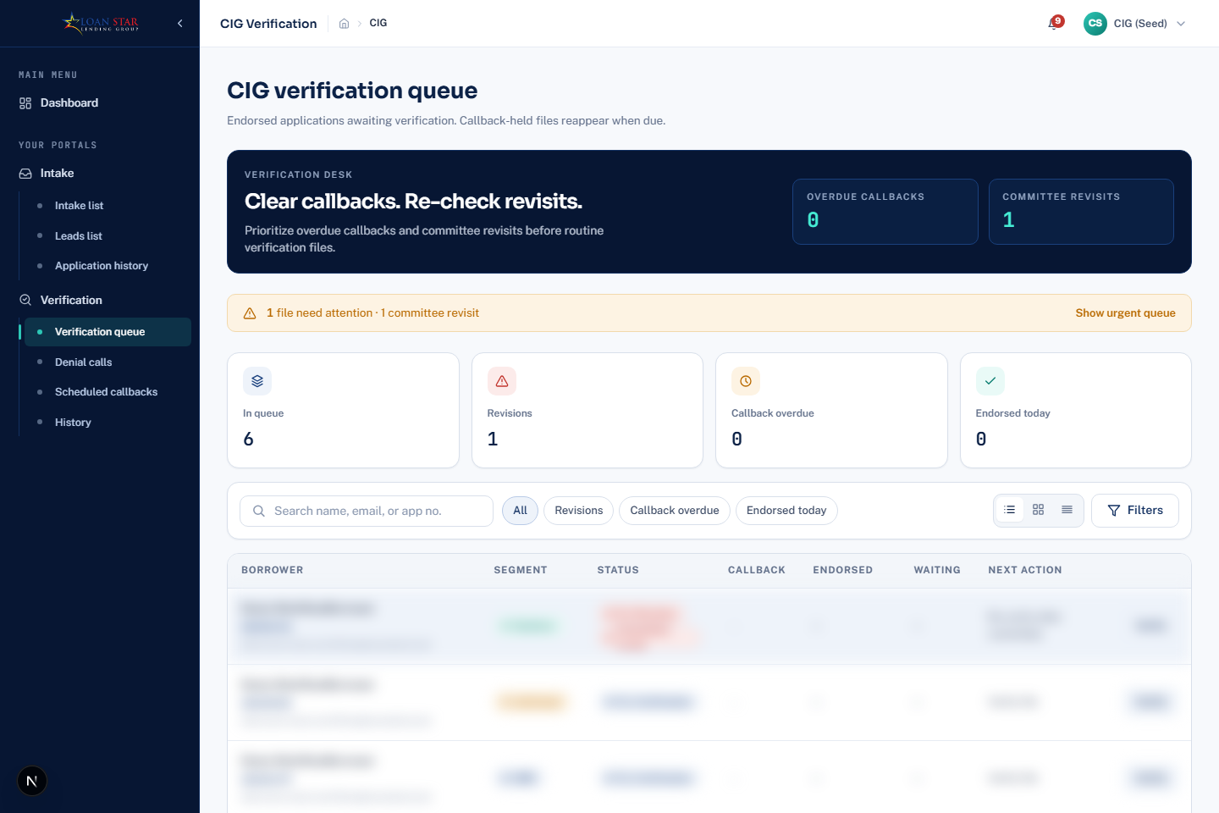
Seeded CIG Verification queue. Open a queued application from this module.

What you should see
- You should see CIG verification queue, the active work counters, a borrower-or-application search field, and a Filters button.
- Use the CIG submenu to reach denial calls, scheduled callbacks, and history when those are the task you need to complete.
- Open the intended queue item before recording findings or sending a file back for revision.

Steps
- Select Verify on an application in the verification queue.
- Review the application form and record the available borrower, employment, reference, field visit, crewing manager, and inspection findings.
- Record pass or fail on the visible checks and save each finding.
- Select Return to CSA when a correction is needed, or select Revision complete after the correction is confirmed.
- Select Submit CI report to Committee when the verification work is complete.

Tips and things to watch out for
- The verification file includes forms for CI and references, field visit, crewing manager inspection, REM inspection, and SME reloan verification when applicable.
- Use Denial calls to record Borrower informed and Callbacks to mark a scheduled callback resolved.
- An application can be cancelled from the verification file when that action is available.

Committee review and decisions

What it is for
Who uses this: Users with access to this work area. Lets authorized committee members review evidence, vote, negotiate an offer, place a file on hold, and record the final decision.

Where to find it
Open Committee, then choose Voting queue or Decision history.

Screenshot guide
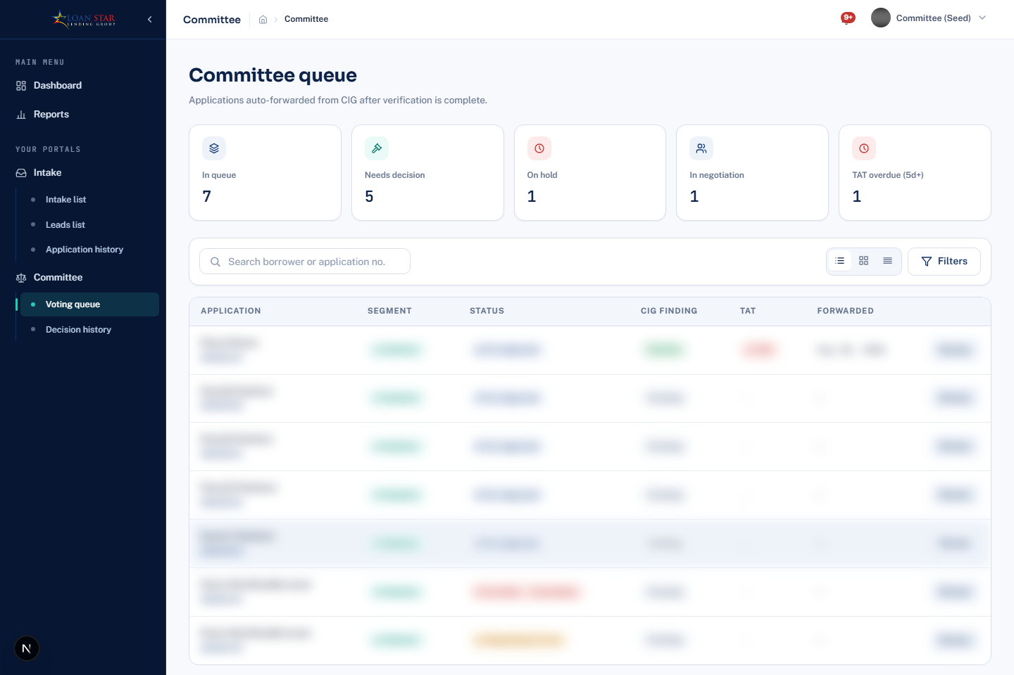
Seeded Committee queue. Use this module to open a file for review and voting.

What you should see
- You should see Committee queue, counters for in-queue and decision states, a search field, and a Filters button.
- Use the Committee submenu to switch between Voting queue and Decision history.
- Search for the application, then open its row before reviewing evidence or recording a vote.

Steps
- Select Review for an application in the voting queue.
- Review the application form and the available field visit, CI and references, crewing manager, and REM inspection records.
- Use Vote Approve or Vote Deny to record your vote.
- When a borrower counteroffer is shown, select Accept with the displayed amount if it is accepted.
- Use Approve loan, Deny loan, Hold, Clear hold, or Approve without borrower sign as allowed by the file status.

Tips and things to watch out for
- A decision email can be resent from the application when the action is shown.
- Use Decision history to locate earlier committee decisions.
- Hold and clear-hold actions are recorded separately from the final approval or denial action.

Committee offers counteroffers and approved computation

What it is for
Who uses this: Users with access to this work area. Lets committee members use the calculation and borrower negotiation information when deciding whether to approve, deny, hold, or accept a counteroffer.

Where to find it
Open an item from Committee Voting queue and review the application detail.

Screenshot guide
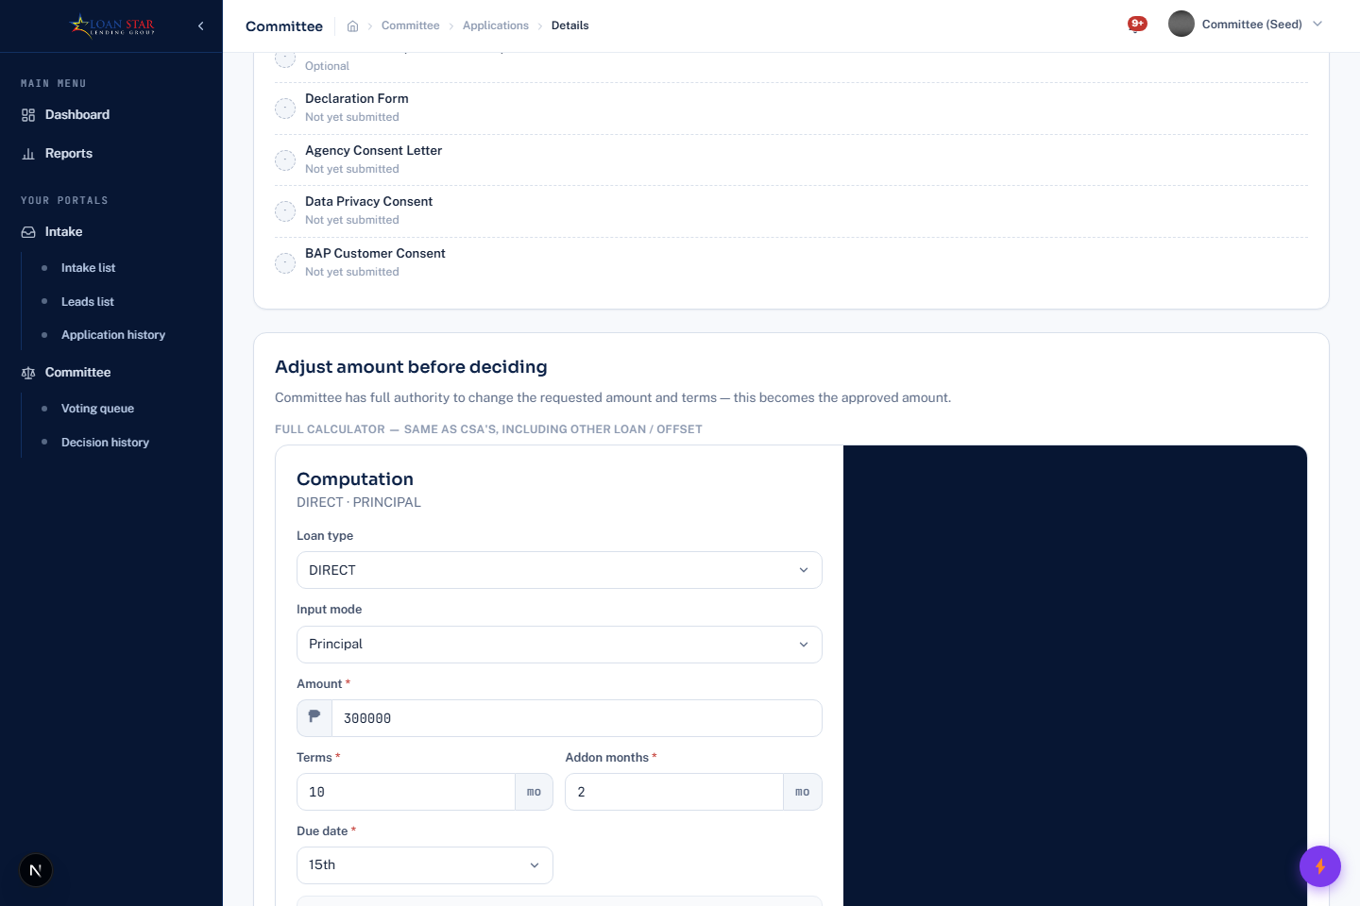
Committee application computation view. Review the calculation and any available override or counteroffer controls before recording a decision.

What you should see
- You should see the Committee computation and the application evidence in the open file.
- Review the shown terms and counteroffer details before recording a vote or decision.
- Use an override only when the file shows that control and the committee has approved the change.

Steps
- Review the visible computation, application evidence, and verification forms before voting.
- Record Vote Approve or Vote Deny as your committee vote.
- When a borrower counteroffer is displayed, compare the shown amount with the approved terms.
- Select Accept followed by the displayed counteroffer amount only when the committee accepts it.
- When the application permits an override, use the full calculator shown in the Committee file, add an optional note to the borrower, and save the override.
- Use Approve loan, Deny loan, Hold, or Clear hold according to the decision state shown by the file.

Tips and things to watch out for
- The full calculator is controlled by the application override state; it is not always available.
- A saved Committee override requires the borrower to re-sign the computation.
- A borrower may have to confirm or sign the resulting computation depending on the application state.

Release and LRA processing

What it is for
Who uses this: Users with access to this work area. Lets Loan Release Associates turn an approved file into a released and closed loan with generated documents, signatures, schedules, and release records.

Where to find it
Open Release LRA. Use Release queue for active files and Released loans for history.

Screenshot guide
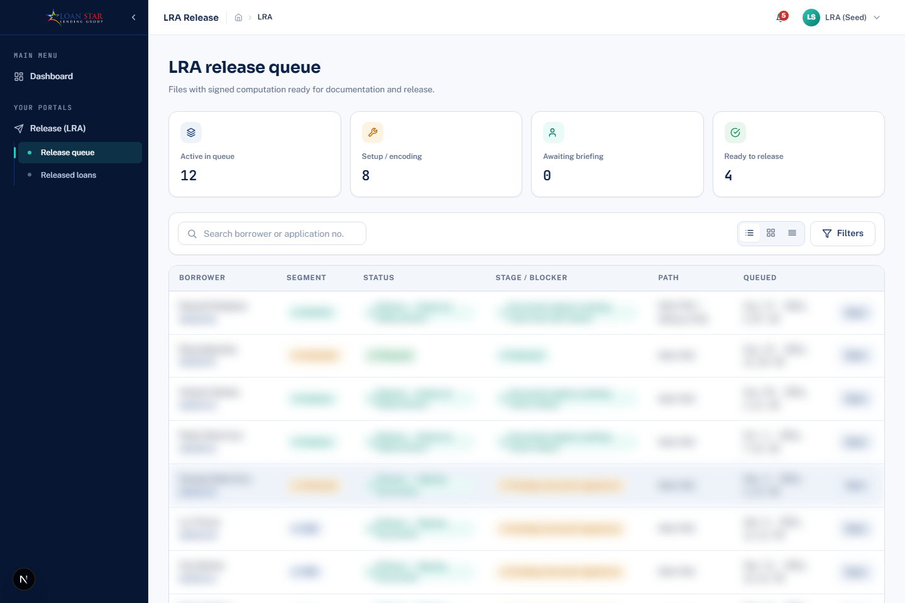
Seeded LRA Release queue. Open a queued file to begin release processing.

What you should see
- You should see LRA release queue, release-stage counters, a search field, and a Filters button.
- Use the Release LRA submenu to switch between Release queue and Released loans.
- Open a queued file before generating documents, recording signatures, or recording release.

Steps
- Open a queue item and select Start processing.
- Save the release path and build or rebuild the payment schedule when required.
- Save the PDC schedule, choose documents to generate, and generate the selected documents.
- Mark individual documents signed or use Mark all signed, then upload signed documents when required.
- Confirm physical PDCs collected, record release, and close the file when all required work is complete.

Tips and things to watch out for
- The release file supports viewing generated documents and uploading a combined signed-document file.
- The document picker, checklist, final computation sheet, and acknowledgement receipt are available through the release workflow when applicable.
- Use Released loans to review completed releases.

Collections accounts and borrower contact

What it is for
Who uses this: Users with access to this work area. Lets collection staff prioritize active accounts, review the loan file, make contact notes, request demand letters, record payments, and offer a move of payment.

Where to find it
Open Collection, then choose Accounts or a dashboard link.

Screenshot guide
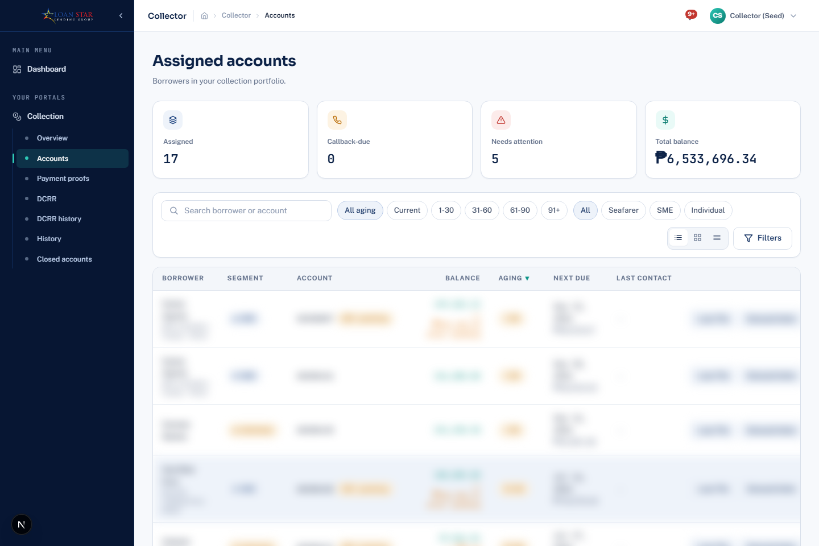
Seeded Collector Assigned accounts module. Open an account from this queue to access its loan and case files.

What you should see
- You should see Assigned accounts, collection counters, a borrower-or-account search field, and aging or segment filters.
- Use the Collection submenu to reach Accounts, DCRR, DCRR history, Collector history, and Closed accounts.
- Find and open the correct account before entering contact activity, a payment, or a move-of-payment offer.

Steps
- Use the account queue filters for aging, segment, date, and search to find an account.
- Open the loan file or case file to review the account details and checklist.
- Select Log contact to record contact activity.
- Select Demand letter when the account requires one.
- Select Record payment to enter a payment, or Move of payment to prepare a permitted rescheduling offer.

Tips and things to watch out for
- The move-of-payment screen supports recording a surcharge and replacement check before offering the change.
- The Collector dashboard can send reminders and links to the DCRR work area.
- Closed accounts and collector history provide separate review screens for past work.

Collector payment review and move of payment calculator

What it is for
Who uses this: Users with access to this work area. Lets collection staff record payments, review existing ledger discounts, and calculate a permitted move of payment with its surcharge and replacement-check actions.

Where to find it
Open Collection Accounts, choose an account, then select Record payment or Move of payment.

Screenshot guide
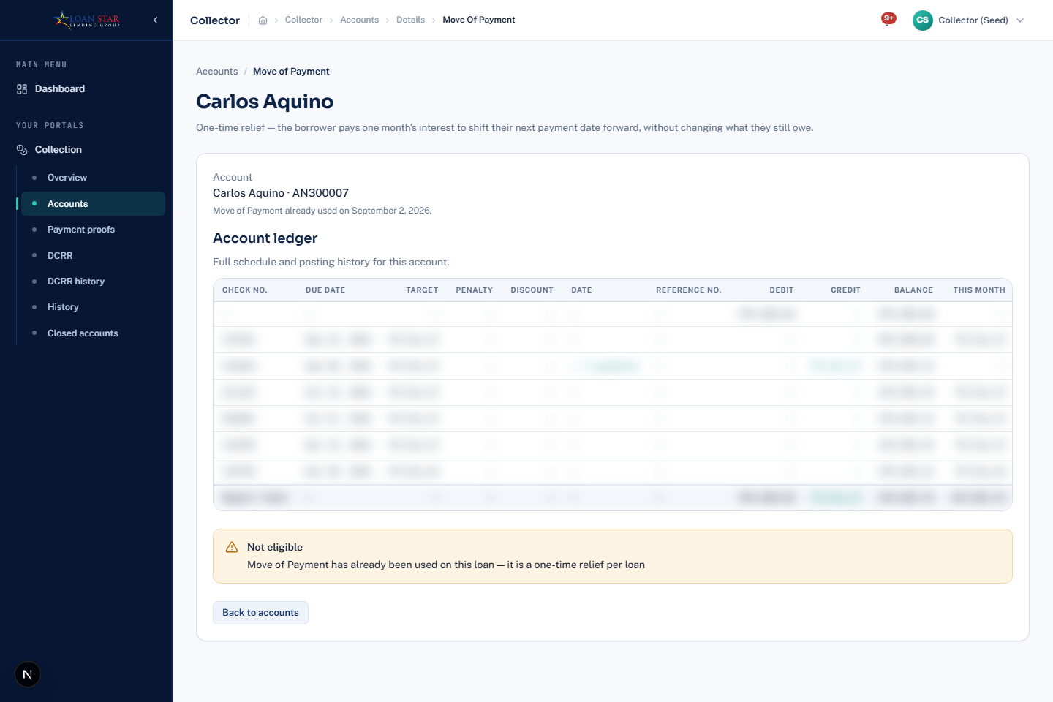
Collector Move of payment page. Use this view to select an eligible installment, review the surcharge, and prepare the move when permitted.

What you should see
- You should see the Move of payment screen for the selected collection account.
- Choose an eligible installment and review the displayed one-month-interest surcharge.
- Offer the move only after confirming the revised details; record surcharge payment separately afterward.

Steps
- Open the loan file first and review the account ledger, including any existing discount amount, and the current amount due.
- Select Record payment to enter the received amount and the payment details required by the form.
- For a schedule change, select Move of payment and choose an eligible open installment.
- Review the one-month-interest surcharge shown for the selected installment, then offer the move only after the form permits it.
- After a move is applied, record the surcharge payment. Record a replacement check only when the screen shows that the moved payment's check is on hold.

Tips and things to watch out for
- The record-payment screen displays existing origination or early-settlement discounts but the reviewed UI does not provide a Collector-entered discount or penalty-waiver field.
- A move of payment can be used only once per loan.
- Offering the move does not record the surcharge payment; it is a separate ledger action.

Daily collection report register

What it is for
Who uses this: Users with access to this work area. Lets collectors prepare a Daily Collection Report Register from recorded payments and send it for accounting review.

Where to find it
Open Collection, then DCRR builder. Use DCRR history to review prior reports.

Screenshot guide
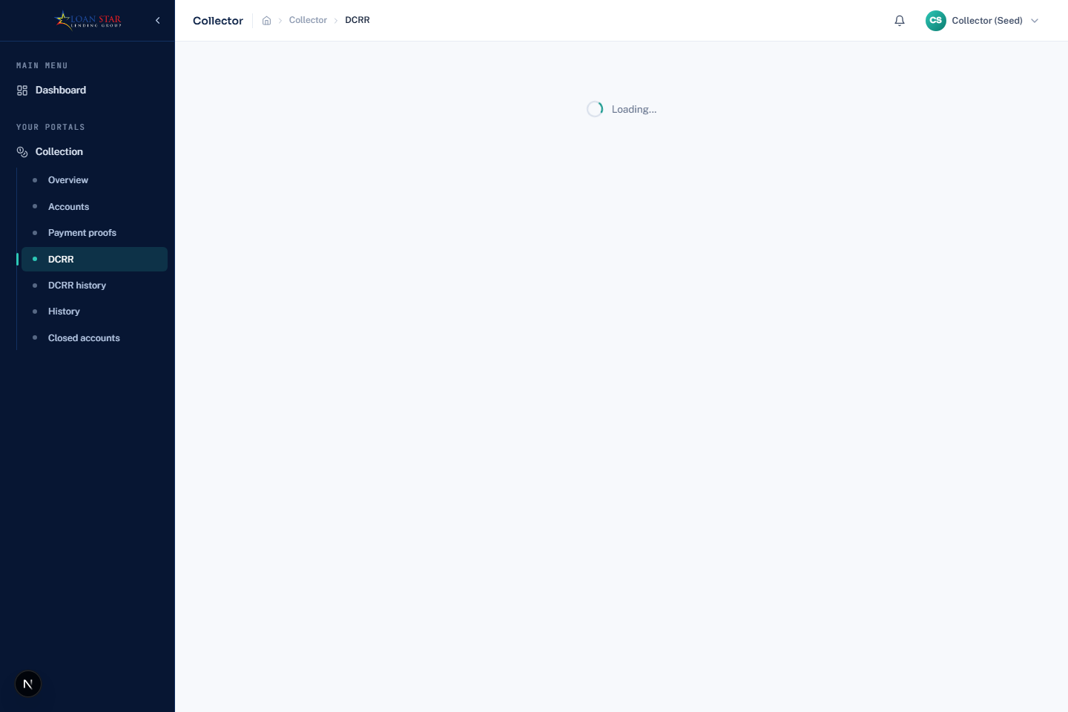
Collector DCRR builder. Start a report here, add eligible payments, review totals, and submit when the report is ready.

What you should see
- You should see the DCRR builder and its report actions.
- Start a new report, add the eligible payment records, then review the totals.
- Select Submit DCRR only after confirming the included payments and allocations.

Steps
- Select New DCRR to start a report.
- Find eligible payments and select Add to DCRR.
- Review or change an allocation when the allocation action is available.
- Review the report totals and select Submit DCRR.
- Use DCRR history to inspect submitted or returned reports.

Tips and things to watch out for
- The Proofs page is used to review payment proof and confirm or reject it before or alongside report work.
- The system also exposes a separate Remedial DCRR screen for remedial accounts.

Accounting masterlist and payment review

What it is for
Who uses this: Users with access to this work area. Lets Accounts Receivable staff manage the masterlist, inspect an account, review payment reports, and complete accounting actions.

Where to find it
Open Accounting AR. Use Masterlist for accounts, DCRR queue for submitted reports, Internal transfers for transfers, History for prior actions, and Rounding writeoffs for related cases.

Screenshot guide
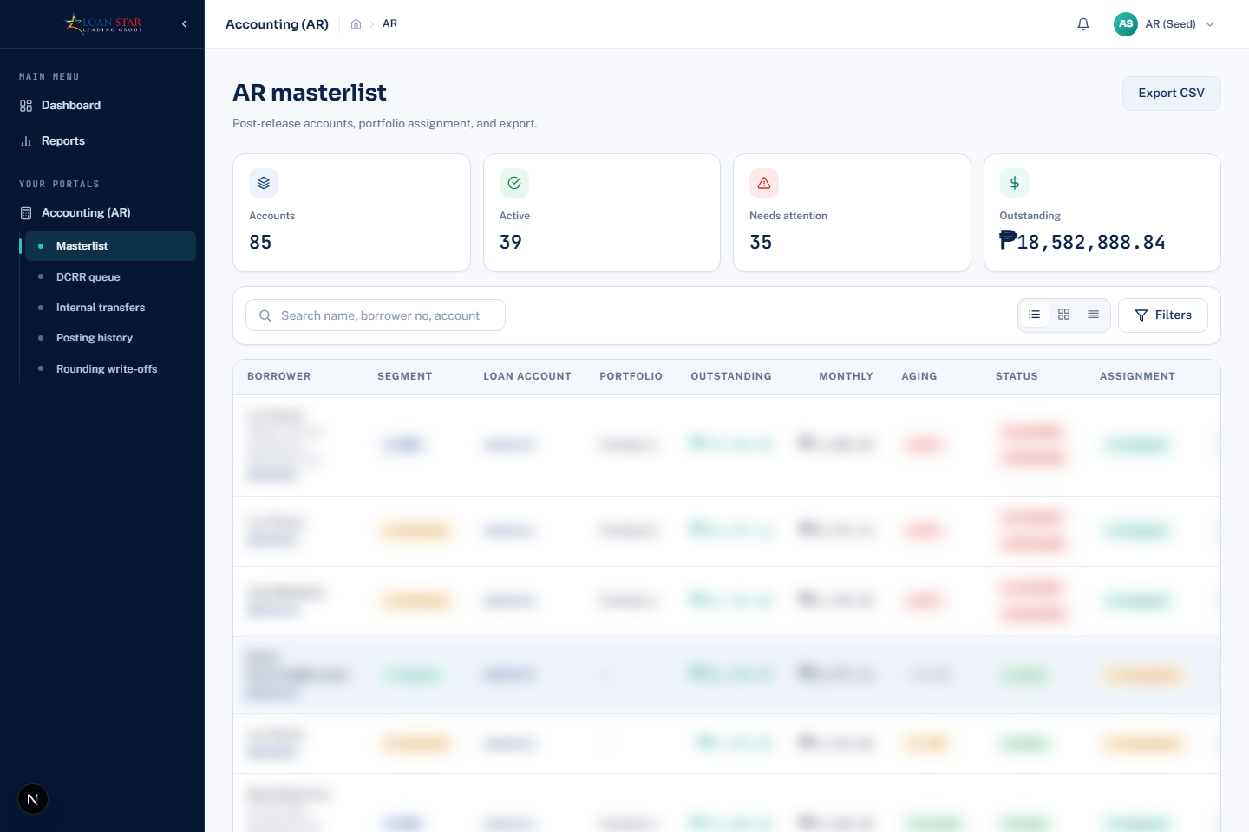
Seeded AR Masterlist. Use its search and filters to find an account.

What you should see
- You should see AR masterlist, portfolio counters, a search field, and the list of accounts.
- Use the Accounting AR submenu to switch between Masterlist, DCRR queue, Internal transfers, History, and Rounding writeoffs.
- Use search and filters first, then open the intended account or queue item for the action you need.

Steps
- Use search, filters, sorting, and Export CSV in the Masterlist to find an account.
- Open an account to review its ledger, payments, and available actions.
- Use the visible controls to mark a loan paid off, confirm remedial turnover, or open a write-off candidate when the status permits.
- Review submitted DCRRs, then reconcile, reject, or mark a report item bounced as appropriate.
- Open Internal transfers and select Confirm or Reject for each pending transfer.

Tips and things to watch out for
- The account screen includes a development-only aging simulation action; do not use it as a production accounting process.
- AR History includes separate views of account, DCRR, and internal-transfer history.
- Rounding writeoffs is a distinct review page with its own filters and account links.

Remedial accounts

What it is for
Who uses this: Users with access to this work area. Lets remedial staff work with accounts handed over for remedial collection, record payments, prepare DCRRs, and issue a demand letter when needed.

Where to find it
Open Remedial, then open an account or select Remedial DCRR.

Screenshot guide
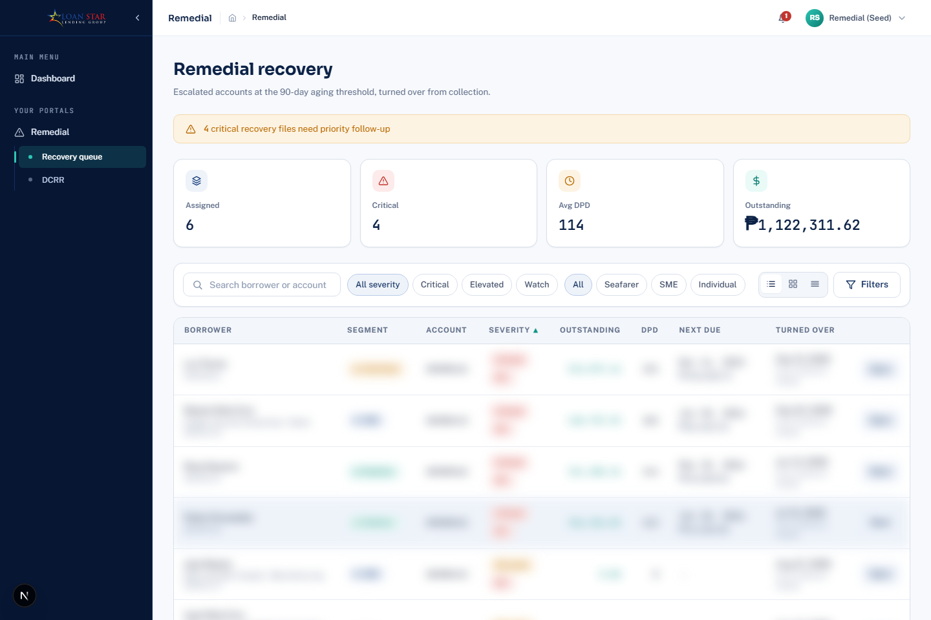
Seeded Remedial recovery queue. Open an account to review remedial actions.

What you should see
- You should see Remedial recovery, counters for assigned and delinquent work, a search field, and filters.
- Use the Remedial submenu to move between Remedial recovery and DCRR.
- Open the account from the recovery list before recording a payment, sending a demand letter, or preparing DCRR work.

Steps
- Use the remedial queue filters to find an account and select Open.
- Review the account record and select Demand letter when it is offered.
- Select Record payment to add a remedial payment.
- Use the remedial DCRR page to start a report, add payments, and submit it.

Tips and things to watch out for
- The remedial account detail and payment pages are separate from the regular collector account pages.
- Payment and DCRR actions remain subject to the account status and the permissions of the signed-in user.

Administration users and roles

What it is for
Who uses this: Users with access to this work area. Lets administrators create staff accounts, activate or deactivate them, define roles, assign permissions, and set field rules.

Where to find it
Open Users or Roles in the Administration navigation.

Screenshot guide
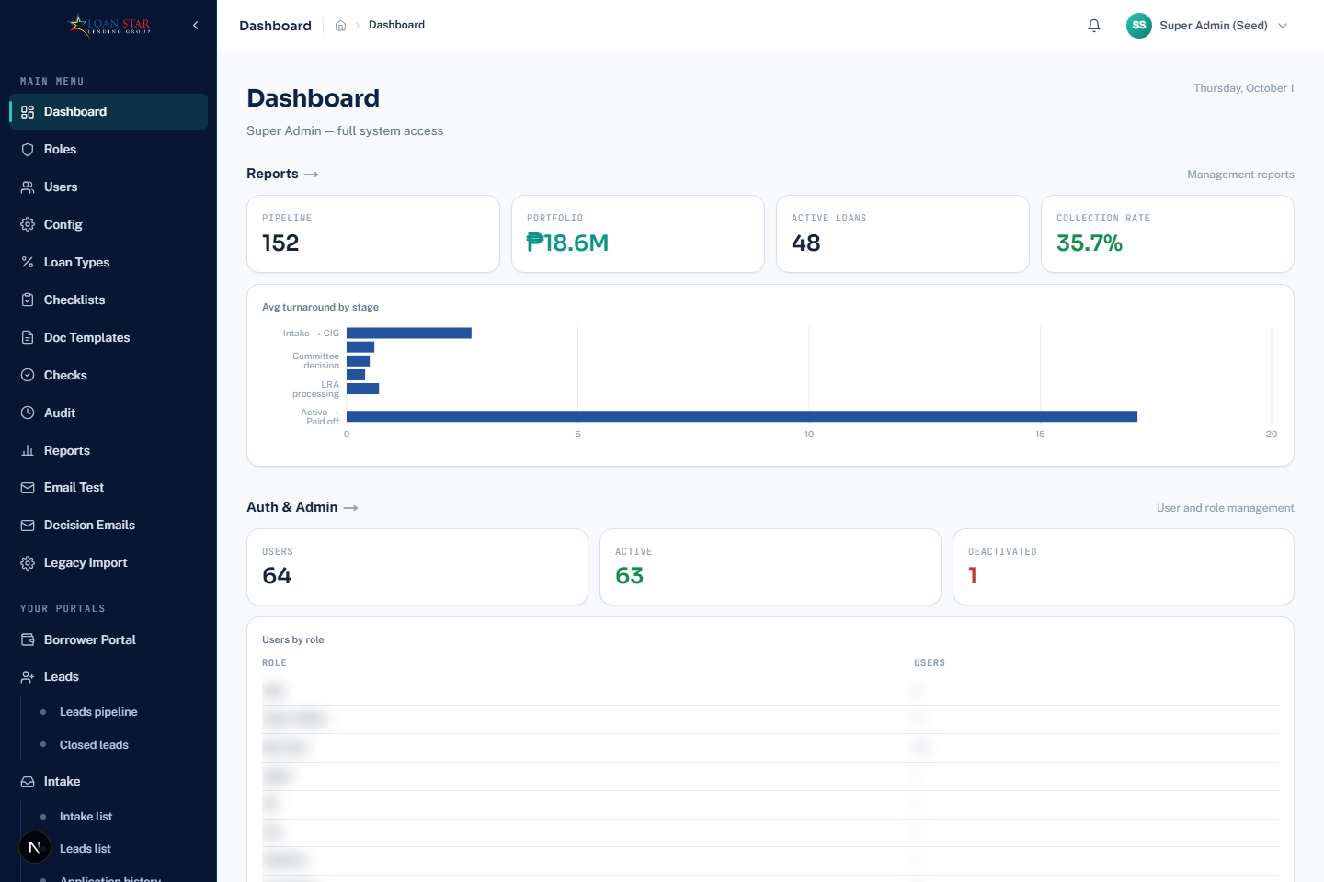
Seeded Administration workspace. Use the Administration navigation to reach Users and Roles.

What you should see
- You should see the Administration dashboard and its navigation for Users, Roles, Config, Loan Types, Checks, document templates, and audit work.
- Select Users or Roles in the Administration navigation rather than working from the dashboard summary.
- Use search and filters on the destination page before opening or changing a record.

Steps
- In Users, select Create user and enter the requested staff information.
- Use search, status, audience, and role filters to find a user.
- Select Activate or Deactivate to change a user status.
- In Roles, select Create role or open an existing role.
- Save the role details, permissions, and field rules from the role page.

Tips and things to watch out for
- Available navigation and actions are driven by assigned permissions.
- The account page shows a user’s roles but does not change them.

Administration configuration and loan types

What it is for
Who uses this: Users with access to this work area. Lets administrators maintain system settings, test communications, and manage loan type definitions.

Where to find it
Open Config, Loan Types, Email Test, or Decision Emails in Administration.

Screenshot guide
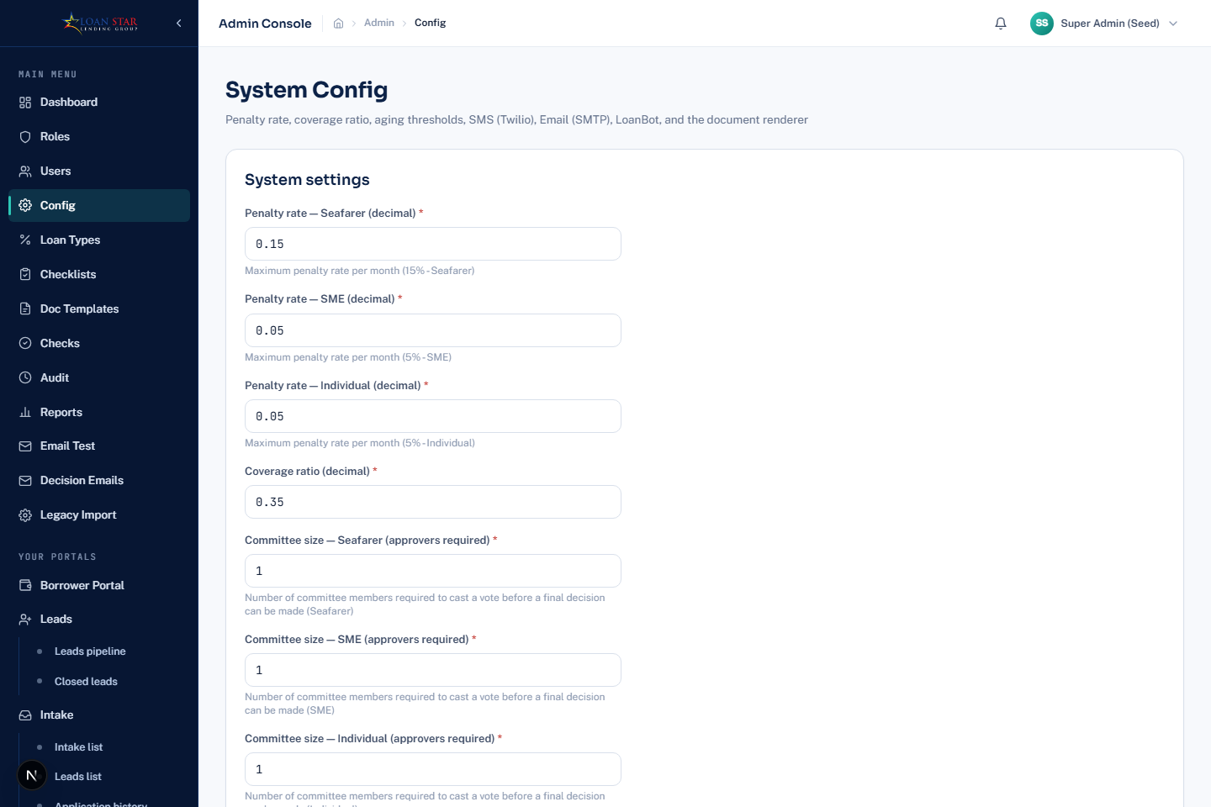
Administration configuration page. This screen is restricted to users with the applicable configuration permission.

What you should see
- You should see the restricted configuration workspace and its settings controls.
- Open Loan Types from Administration when you need to maintain loan type details.
- Save or test a setting only after confirming it is approved for production use.

Steps
- Use Config to maintain supported settings and test the configured connection or communication channel.
- Use Loan Types to add or edit loan type details and enrollment rate values.
- Use Email Test to send a test email and verify delivery settings.
- Use Decision Emails to edit and save the email templates used for decisions.

Tips and things to watch out for
- The configuration page also includes test SMS and email actions where settings are present.
- Only users with the system configuration permission see these pages.

Administration checklists and checks

What it is for
Who uses this: Users with access to this work area. Lets administrators control workflow checklists and view or manage the configured check items.

Where to find it
Open Checklists or Checks in Administration.

Screenshot guide
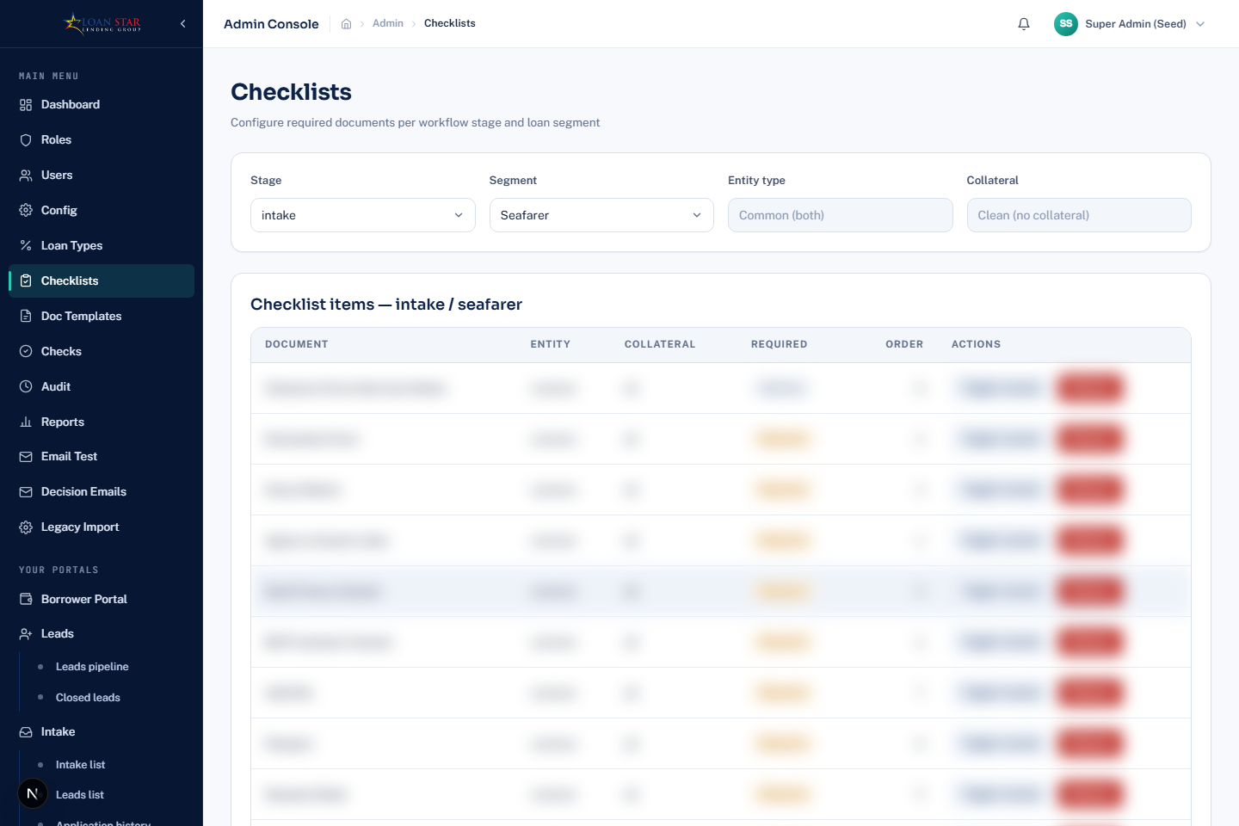
Administration checklist page. Review workflow-stage items and use the visible controls to manage their requirements.

What you should see
- You should see checklist items grouped for a workflow stage.
- Use the add or requirement controls shown for the specific item you are changing.
- Confirm an item is not required by an active process before using Remove.

Steps
- Open Checklists to review items grouped by workflow stage.
- Add an item where the page offers the add action.
- Use Toggle req/opt to change whether a checklist item is required.
- Use Remove to delete an item after confirming it is no longer needed.
- Open Checks to review the configured application checks.

Tips and things to watch out for
- Changing checklist requirements affects what staff see at the related workflow stage.
- Do not remove an item that is needed for an active compliance or release process.

Administration document templates

What it is for
Who uses this: Users with access to this work area. Lets administrators create, edit, preview, publish, download, and manage the document templates used by LoanStar.

Where to find it
Open Doc Templates in Administration.

Screenshot guide
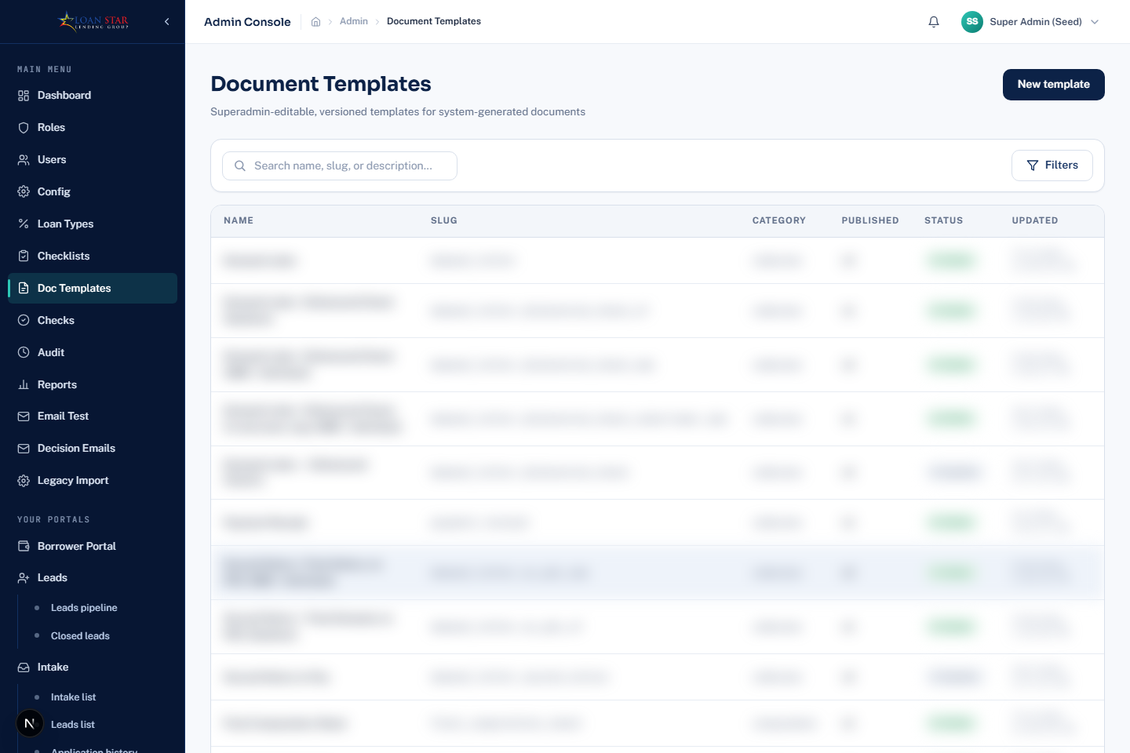
Document Templates administration page. Use the visible search, filter, and New template controls to manage templates.

What you should see
- You should see the template list, search and filter controls, and New template action.
- Open an existing template or select New template, then edit the available content and fields.
- Preview the draft before publishing it for operational use.

Steps
- Select New template and enter the template details.
- Filter by category or search to find an existing template.
- Open a template, edit its content, and use the field palette to insert the available merge fields.
- Save draft, run Preview, or Download DOCX as needed.
- Publish the draft version when it is ready for use.

Tips and things to watch out for
- Document templates support both draft and published versions.
- The editor has separate content and DOCX template capabilities; preview before publishing.

Administration audit and legacy import

What it is for
Who uses this: Users with access to this work area. Lets administrators review recorded system activity and, for super administrators, validate and run legacy-data import mappings.

Where to find it
Open Audit or Legacy Import in Administration.

Screenshot guide
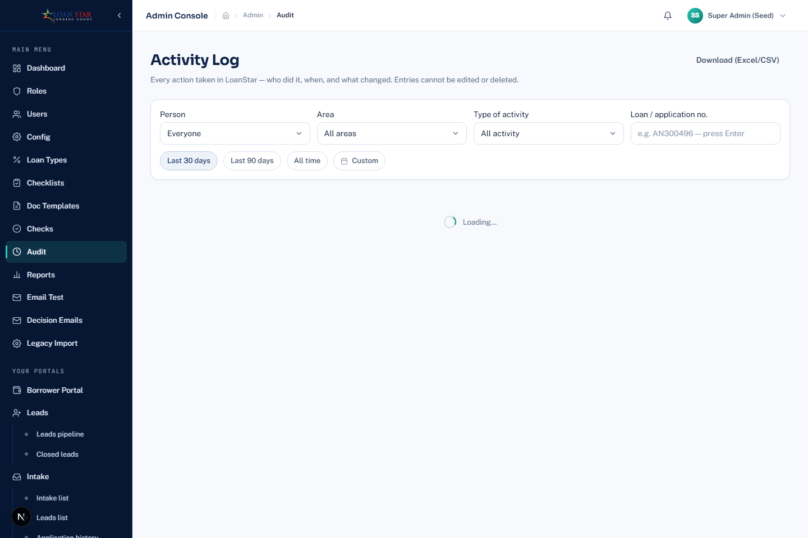
Administration audit screen. The separate Legacy Import page is available only to super administrators.

What you should see
- You should see Audit search and filter controls for recorded system activity.
- Open Legacy Import only with super-administrator access.
- Validate a mapping with a dry run before proceeding with an import.

Steps
- Use Audit filters and search to locate recorded activity.
- Open Legacy Import when you have super-administrator access.
- Load or save a mapping template, then run Validate dry run before importing.
- Review validation results before continuing with an import run.

Tips and things to watch out for
- Legacy Import is intentionally limited to super administrators.
- The mapping page allows named mappings to be saved, overwritten, loaded, or deleted.

Reports and management insights

What it is for
Who uses this: Users with access to this work area. Lets authorized users view portfolio, pipeline, collections, past-due, account, and generated management insights.

Where to find it
Open Reports, then use the report navigation for the needed view.

Screenshot guide
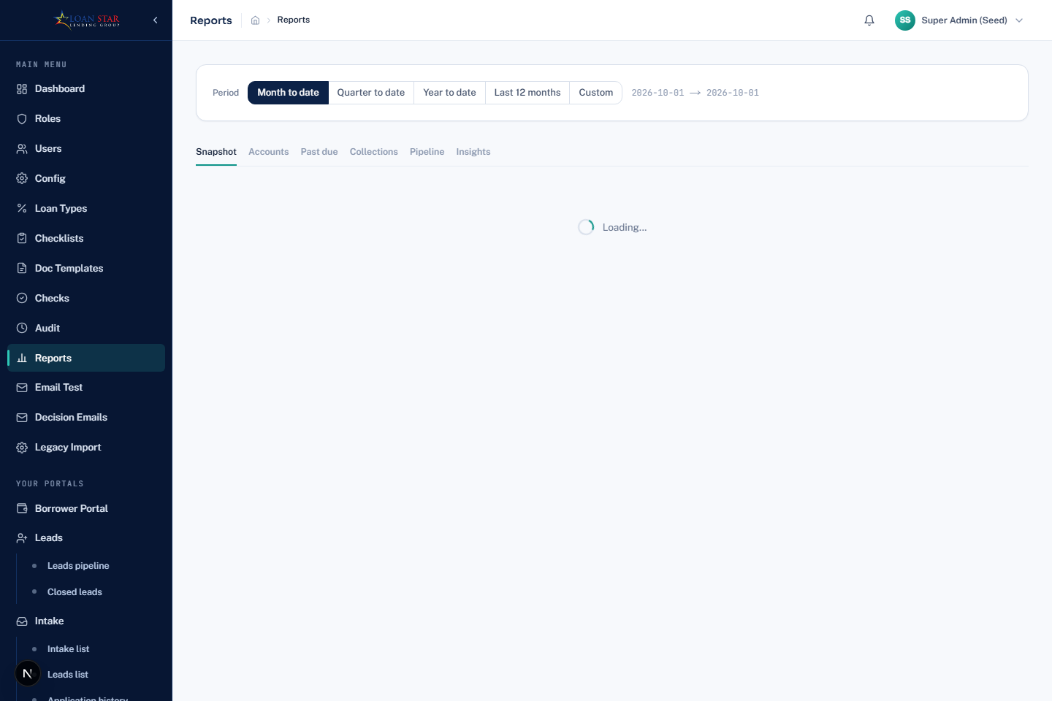
Reports dashboard opened with a seeded administrator account. Use the report navigation and visible filters for the permitted report area.

What you should see
- You should see the Reports dashboard and the available report navigation.
- Open the needed report, then set its visible period or segment filters.
- Use Export CSV or Print Export PDF only when the action appears for the report.

Steps
- Open the main Reports dashboard to view the available report panels.
- Open Pipeline, Collections, Past Due, or Accounts to focus on that subject.
- Use date, segment, and other filters shown on the selected report.
- Use Export CSV or Print Export PDF when the action is shown.
- Open Insights to generate and review the management briefing, charts, recommendations, and supporting evidence.

Tips and things to watch out for
- The reports assistant is available from the report experience where enabled and stores its conversation threads separately.
- Report results depend on the selected period and on the data available to your role.

Appendix Items Needing Clarification
- Exact registration eligibility and approval process
A registration page is implemented, but the code reviewed does not establish which people are allowed to self-register in a live deployment or how an administrator approves an account.
- Production use of the Design and computation breakdown pages
Both pages are implemented, but their page content identifies them as design or development tools. Confirm whether they should be available to any production user before documenting them as operational features.
- Availability of each workflow action for every loan type and stage
The code conditionally shows many actions according to status, role, configured checklist, and data. Confirm the business policy for every loan type before turning the general workflow descriptions into a mandatory operating procedure.

