Computer Project: Assessment of Cylinders in Cross Flows

Name: Kyle Salitrik

Date: 5/2/2014

Scoring:

|  |  |  |  |
| --- | --- | --- | --- |
| ***Section*** | **Component** | **Score** | **Out of** |
| ***Abstract*** |  |  |  |
|  | Writing |  | 5 |
| ***Analysis*** |  |  |  |
|  | Part a |  | 5 |
|  | Part b |  | 5 |
|  | Part c |  | 10 |
|  | Part d (write up) |  | 5 |
|  | Part d (code) |  | 10 |
| ***Results*** |  |  |  |
|  | Part a |  | 10 |
|  | Part b (write up) |  | 5 |
|  | Part b (coding) |  | 10 |
|  | Part c (write up) |  | 5 |
|  | Part c (coding) |  | 10 |
|  | Part d (write up) |  | 5 |
|  | Part d (coding) |  | 10 |
| ***Summary*** |  |  |  |
|  | Writing |  | 5 |
|  |  |  |  |
| ***Total*** |  |  | **100** |

# Abstract/Introduction

The purpose of this assessment is to evaluate the cross-flow on a rotating cylinder in a constant free-stream velocity field. First the stream function, tangential and radial velocities for the cylinder are derived and then evaluated with a specified cylinder radius and free stream velocity with a varying vortex strength. The effect of the varying vortex strength on the stagnation points and shape of the flow was evaluated and then an inspection of the velocity field and pressure fields around the body for K = 0 and K = 1 was performed to attain insights into how these fields interacting with the body change based on the stream function. Finally, an evaluation of viscous flow on drag to estimate a drag coefficient and flow separation angles was performed.

# Analysis

Report the following in this section in a written form:

1. Starting with  
     
   as our stream function, by plugging in $λ=U{}_{∞}R^{2}, c=K\ln\left(R\right)$ we obtain  
     
   choosing $U{}_{∞}=1, R=1$ we further simplify to  
   
2. Along the body, r = R (in our case 1), the stream function simplifies to $$ψ=Sin\left[θ\right]\left[1-1\right]-K\ln\left(1\right)=Sin\left[θ\right]*0-0=0$$

So our stream function value is 0 all around the body.

1. To find the stagnation point, we must look at where the tangential velocity is 0, b taking the derivatives of our stream function with respect to R and Theta we can obtain expressions for the tangential and radial velocities.  
     
   These equations further simplify when plugging the values for U and R to  
     
   Solving $V{}_{θ}=0$ for $sin⁡θ$ when r = 1, we obtain the stagnation point as a function of K and r to be $$\sin{θ}=\frac{K}{2}$$
2. Plot contour plots of the stream function and velocity-potential function for values of K/(UR)=0.0, 1.0, 2.0, and 3.0 (check against Fig. 8.14 in book)
   1. For each case, K is equal to 0, 1.0, 2.0 and 3.0 respectively to satisfy the relationship because both R and U are 1.0. The difference for each case signifies where the stagnation point lies. For each value of K, the stagnation points move around the body until a critical point at K = 2, where they meet and any higher value of K provides a complex result in the stagnation point causing it to move off of the body.
   2. The Matlab code plots the streamlines and velocity magnitude for each value of K. When checking against figure 8.14 in the book, the streamlines appear to follow the same trends as those provided by the book, the only difference being that the body itself is not being outlined. However, the stagnation points appear to be in the correct locations.
   3. The solutions provided by these functions is only truly valid whenever K/(UR) is less than or equal to 2.0, due to the fact that the stagnation point moves off of the body at K > 2. This can be further shown by solving the function of the stagnation point for theta, obtaining $$θ=\arcsin\left(\frac{K}{2}\right)$$

where any value of K over 2 would produce a complex result. In general, the limiting case is given by the equation: $$\sin{θ}=\frac{K }{1+R}$$ which shows us that the maximum value of K depends on the value of 1 + R, so as long as K does not exceed this value, the solutions provided are valid.

1. K/(UR)=0.0, K = 0

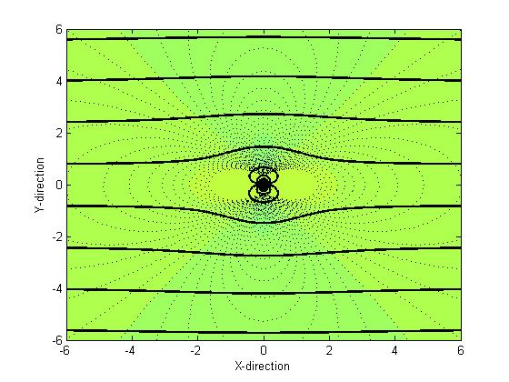

1. K/(UR)=1.0, K = 1

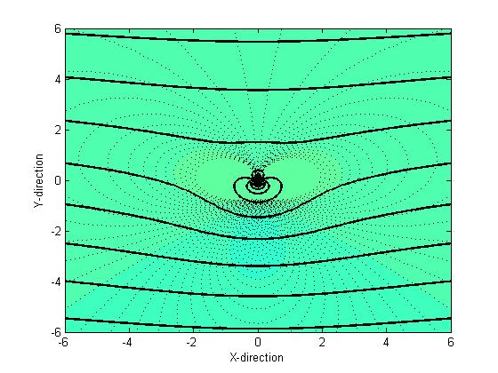

1. K/(UR)=2.0, K = 2

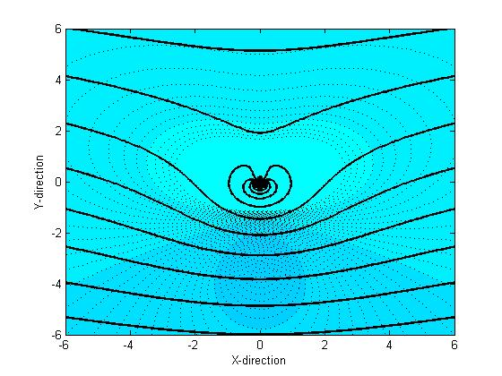

1. K/(UR)=3.0, K = 3  
   Figure : Contour plots of the stream function and velocity-potential function

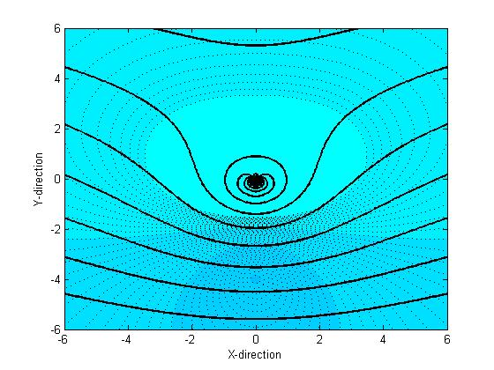

# Results

The goal of the results is to evaluate the previous analyses in terms of flow variables and extend it to viscous flow. For parts a-d, perform and report the assessments. Be sure to comment on what the results mean.

1. For N, I chose a value of 200 because it was computationally efficient and seemed to provide a good insight into what was happening on the body.
2. for K/(Ua)=0 and 1.0, plot:
   1. Velocity magnitude on the surface, , as a function of x/r:  
      From the previous analysis, the function of $V{}_{θ}$ can be re-defined in terms of $\frac{x}{r}$ by rearranging the definition of $x=r\sin{θ}$ to be $\sin{θ=\frac{x}{r}}$ to obtain an equation of: $$V{}_{θ}=-\frac{x}{R}\left(1+\frac{1}{R^{2}}\right)+\frac{K}{R}$$ 
      R = 1, simplifying the equation to $$V{}_{θ}=-2x+K$$  
      where x ranges from -1 to 1 and K varies based on the relationship of K/Ua. In this case, the values of K will be 0 and 1.
   2. Pressure on surface as a function of x/R. $$p_{s}-p_{∞}=\frac{1}{2}ρU_{∞}^{2}\left(1-4\sin^{2}{Θ}+4β\sin{θ}-β^{2}\right)$$  
        
      where $$β=\frac{K}{RU_{∞}}$$ 
      again, by using the polar relationships for sin, and plugging the values in for U and R we can obtain a simplified pressure of: $$p_{s}-p_{∞}=\frac{1}{2}ρ\left(1-4x^{2}+4Kx-K^{2}\right)$$
3. for K/(Ua)=0 and 1.0, provide table of
   1. Drag   
      To obtain the coefficient of drag, we must first calculate the drag of the cylinder in the uniform flow, which turns out to be 0 for both cases given the integral of the form:

$$-\int_{0}^{2π}{{(p}_{s}-p_{∞})cos⁡(θ) ba dθ }$$ where assuming $ρ=1000$ for water,

* 1. Lift   
     For calculating the lift, the integral form is $$-\int_{0}^{2π}{{(p}_{s}-p_{∞})sin⁡(θ) ba dθ }$$ 
     when plugging in the expression for $p_{s}-p_{∞}$, the integral takes the form of: $$-\int_{0}^{2π}{500\left(1-4\sin^{2}{Θ}+4K\sin{θ}-K^{2}\right))sin⁡(θ) ba dθ }$$ 
     which will provide a non-zero coefficient of lift when it is evaluated for K > 0 using the following formula: $$C_{L}=\frac{Lift}{0.5ρU^{2}b 2R}=\frac{Lift}{1000}$$

1. Viscous Estimation:
   1. Estimate the separation location on the upper and lower surfaces (for K/(Ua)=0, 1.0). We will estimate this as the first point where pressure is decreasing on the surface, i.e., dP/ds>0.
   2. Recalculate the drag coefficient (for K/(Ua)=0). This time assume that pressure aft of the separation point remains unchanged from the point at separation.
   3. How does this model scale with Re? How does the result compare to data?
2. Velocity magnitude on the surface, , as a function of x/R.

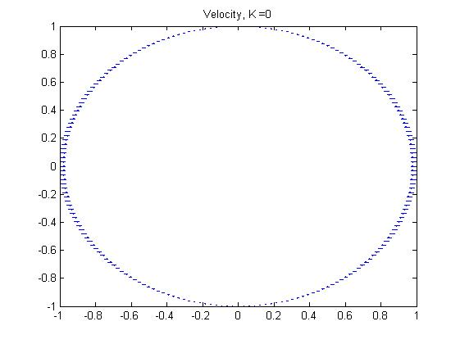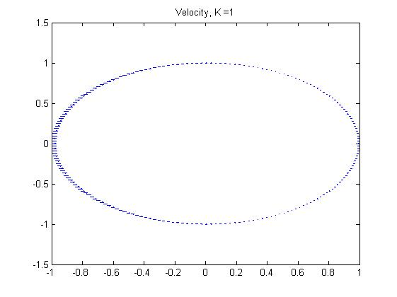

1. Pressure on surface as a function of x/R.

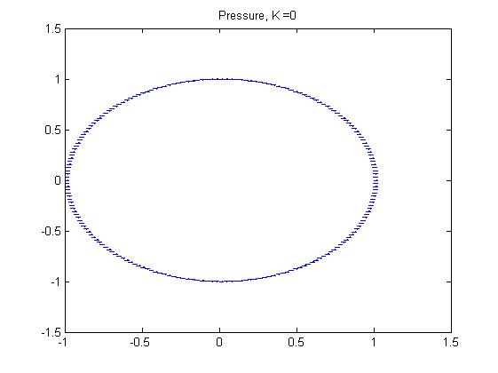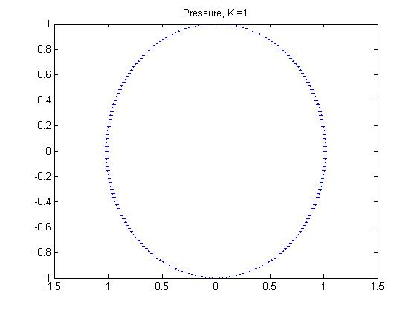

Figure : Contour plots of the stream function and velocity-potential function

Table : Table of inviscid forces

|  |  |  |
| --- | --- | --- |
| **K/(Ua)** | **Lift Coefficient** | **Drag Coefficient** |
| 0.0 | 0 | 0 |
| 1.0 | -6.28 | 0 |

Table : Table of separation angles

|  |  |  |
| --- | --- | --- |
| **K/(Ua)** | **Upper surface separation location** | **Lower Surface Separation location** |
| 0.0 |  |  |
| 1.0 |  |  |

Table : Table of Viscous Drag force

|  |  |  |
| --- | --- | --- |
| **K/(Ua)** | **Predicted Drag Coefficient** | **High-Re Drag Coefficient $$C_{D}=\frac{Drag}{\frac{1}{2}ρV_{∞}^{2}Db}$$** |
| 0.0 |  | 1.2 (as given in Table 7.2) |

# Summary

After deriving a set of governing equations for the rotating cylinder system including the stream function, tangential and radial velocities, stagnation points, pressure on the surface, drag and lift and their respective coefficients, a mathematical analysis of the system was performed. For the stream function, a relationship was formed between the vortex strength, radius of the cylinder and free stream velocity and by varying the vortex strength changes were observed in the stagnation points on the body. A critical relationship of $K≤1+R$ was found as the limiting factor of the validity of the results of the streamline function.

For the evaluation of pressure and velocity on the surface of the body, a relationship was developed to get the functions in terms of x over the radius of the cylinder and then plotted by using the quiver function in Matlab. I could not find a way to plot these functions easily using the contour plots and would have liked to improve that also the plots included appear distorted because of the limits of the plots not being the same on both axes and being able to limit these would have been useful. Also, using a higher number of divisions would provide a better look into

When calculating the coefficients of lift and drag, Matlab’s stock numerical integration was used to evaluate the integrals for lift and drag which resulted in very small numbers to the order of ${10}^{-17}$, which I rounded to 0. To improve the accuracy of these numbers, it would have been beneficial to simply perform the integrals by hand and plug in the values of K to satisfy the K/UR relationship. Also, the last improvement would have been to be able to complete the final evaluation on the coefficient of drag and flow separation with a viscous flow.

# Appendix 1: Driver Script

clear;clc;

## Plot Stream Functions

for i = 1:4  
 rankine(i-1,1,1,i);  
end

## Plot Velocity and Pressure along body

th = 0:pi/100:2*pi;  
X = meshgrid(sin(th));  
Y = meshgrid(cos(th));  
m = 5;  
for K = 0:1  
 b = X.*0;  
 v = -2.*X + K;  
 p = 500*(1 - 4.*X^2 + 4*K.*X - K^2);  
 figure(m)  
 quiver(X,Y,v,b,2)  
 str = strcat('Velocity, K = ', num2str(K)); title(str)  
 m = m + 1;  
 figure(m)  
 quiver(X,Y,p,b,2)  
 m = m + 1;  
 str = strcat('Pressure, K = ', num2str(K));  
 title(str)  
end

## Calculate Coefficients of Drag and Lift

for i = 0:1  
 D = @(theta) drag(theta, i);  
 L = @(theta) lift(theta, i);  
 Drag = -integral(D, 0, 2*pi);  
 Lift = -integral(L, 0, 2*pi);  
 M(i+1, 1) = i;  
 M(i+1, 2) = Lift/(0.5*1000*1*1*1*2);  
 M(i+1, 3) = Drag/(0.5*1000*1*1*1*2);  
end  
M = dataset({M 'K' 'Cl' 'Cd'})

# Appendix 2: Rankine Plot Function

function [ ] = rankine( K, Uinf, RG, n )

## creates a potential Flow Field for various functions

%plotting limits  
xmin=6;xmax=-xmin;dx=(xmax-xmin)/200;  
%create domain of interest (Cart)  
[X,Y]=meshgrid(xmin:dx:xmax);  
%Polar Coordinates  
R=sqrt(X.^2+Y.^2);  
TH=atan2M(Y,X);  
  
%velocity Field initialization  
u=0*R;  
v=0*R;  
  
%setup plotting  
numContour=20; %number of contours  
figure(n); clf(n); %be sure to start with a clean figure  
  
EPS=1.e-5; % this removes log(0) issues  
  
%Fluid properties  
pinf=1e5; %Pa  
rhoinf= 1; %kg/m^3  
  
  
%%%Lets start adding components  
  
%Uniform flow (adjust Uinf to modify strength)  
alpha= 0; %incidence angle in rad  
PHI = Uinf*(Y*cos(alpha)+X*sin(alpha));  
PSI = Uinf*(X*cos(alpha)-Y*sin(alpha));  
u=Uinf*cos(alpha);  
v=Uinf*sin(alpha);  
  
% Doublet  
X0=0;  
Y0=.0;  
THS=atan2M((Y-Y0),(X-X0));  
RS=sqrt((X-X0).^2+(Y-Y0).^2+EPS);  
lambda = Uinf*RG^2;  
PHI = PHI - (lambda.*sin(THS))./RS;  
PSI = PSI + (lambda.*cos(THS))./RS;  
u = u + (lambda .* cos(2.*THS)./RS);  
v = v - (lambda .* sin(2.*THS)./RS);  
  
%vortex (adjust K to modify strength)s  
X0=0;  
Y0=.0;  
THS=atan2M((Y-Y0),(X-X0));  
RS=sqrt((X-X0).^2+(Y-Y0).^2+EPS);  
PHI = -K*log(RS) + PHI;  
PSI = K*THS + PSI;  
u=u+K*sin(THS)./RS;  
v=v+K*cos(THS)./RS;  
  
  
%Bernoulli Eqn  
Vmag=sqrt(u.^2+v.^2); %calculate velocity magnitude  
Vmag=min(Vmag,1.64*Uinf); %limit to realistic values, eliminates peaks inside body  
p=0.5*rhoinf*(Uinf^2-Vmag.^2); %apply Bernoulli to get pressure field  
  
%Plot %  
CS=contourf(X,Y,Vmag,numContour*2,':','LineWidth',0.01); %filled contour of Vel Mag%CS=contourf(X,Y,p,numContour*2,':','LineWidth',0.01); %filled contour of pressure  
  
hold on  
CS=contour(X,Y,PHI,numContour,'k','LineWidth',2);  
%CS=contour(X,Y,PSI,numContour,'--b','LineWidth',2);  
xlabel('X-direction')  
ylabel('Y-direction')  
hold off

end

# Appendix 3: Lift and Drag Functions

function [ L ] = lift( theta, K )  
P = 1/2*(1000)*(1-4*(sin(theta)).^2+4*K*sin(theta) - K^2);  
L = P.*sin(theta);  
end

function [ D ] = drag( theta, K )  
P = 1/2*(1000)*(1-4*(sin(theta)).^2+4*K*sin(theta) - K^2);  
D = P.*cos(theta);  
end