Lab 4

Kyle Salitrik

997543474

There is a positive correlation between the weight and both the chest girth and head width. For every inch of chest girth, there is an approximate increase in weight of about 12.6 pounds. For every inch of head width, there is an approximate increase of 61.5 pounds. However the intercepts occur at significantly negative values. These intercepts are likely dismissible due to the fact that it would be impossible to have a bear with 0 inches of chest girth or head width, as that bear would not exist.

The coefficient of determination between the chest girth and weight is significantly higher than that of the head width. For the chest girth it is almost a 100% correlation between the two values. Therefore the chest girth appears to be the better predictor of the weight of a bear. This can also be observed in the graphs below, where the chest size has less deviation from the linear prediction of weights than the head width.

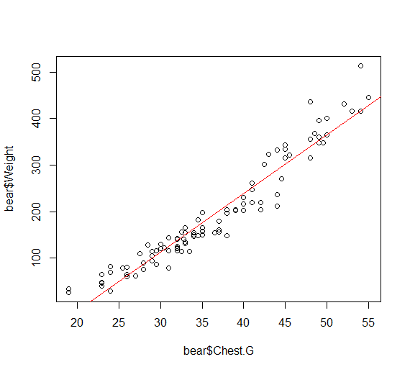

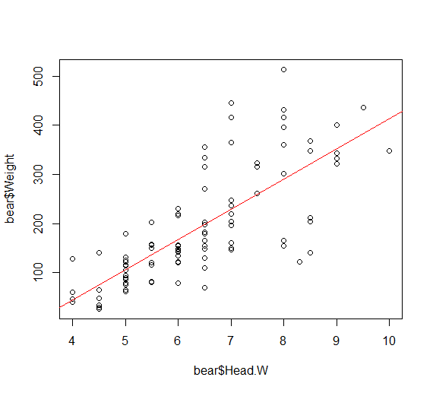

CODE

> bear=read.table('bears.txt',header=TRUE,sep='\t')

> bear=bear[bear$Obs.No==1,]

> y=bear$Weight

> X1=as.matrix(cbind(1,bear$Chest.G))

> X2=as.matrix(cbind(1,bear$Head.W))

> beta1=solve(t(X1)%*%X1,t(X1)%*%y)

> beta2=solve(t(X2)%*%X2,t(X2)%*%y)

> min_weight_pred_1 = beta1[1] + min(bear$Chest.G)*beta1[2]

> min_weight_pred_2 = beta2[1] + min(bear$Head.W)*beta2[2]

> n = dim(bear)[1]

> p = 2

> ybar = mean(bear$Weight)

> RSS1 = sum((y - X1%*%beta1)^2)

> RSS2 = sum((y - X2%*%beta2)^2)

> TSS = sum((y-ybar)^2)

> sig1 = sqrt((1/(n-p))*RSS1)

> sig2 = sqrt((1/(n-p))*RSS2)

> R1 = 1-RSS1/TSS

> R2 = 1-RSS2/TSS

> beta1

[,1]

[1,] -266.67704

[2,] 12.64615

> min_weight_pred_1

[1] -26.40019

> sig1

[1] 30.76723

> R1

[1] 0.9276481

> beta2

[,1]

[1,] -201.69709

[2,] 61.48179

> min_weight_pred_2

[1] 44.23009

> sig2

[1] 74.60694

> R2

[1] 0.5745668

> plot(bear$Chest.G,bear$Weight)

> abline(beta1[1],beta1[2],col='red')

> plot(bear$Head.W,bear$Weight)

> abline(beta2[1],beta2[2],col='red')