Lab 9

Kyle Salitrik

997543474

# Part 1

In the leverage plot, two values are above the 2*p/n value and one over the 3*p/n value. These observations occur at La Vallee and V. De Geneve.

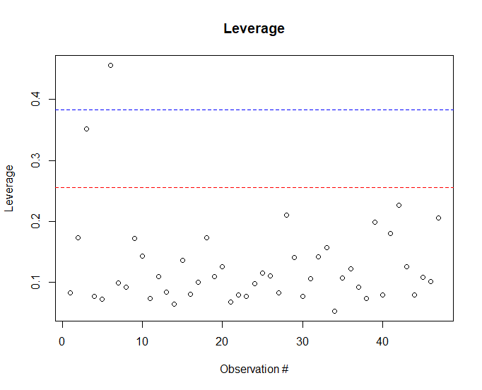

# Part 2

Looking at the Studentized residuals, it does not appear that these points with high leverage also have extreme values. The most extreme values are in Sierre, Rive Gauche, and Porrentruy.

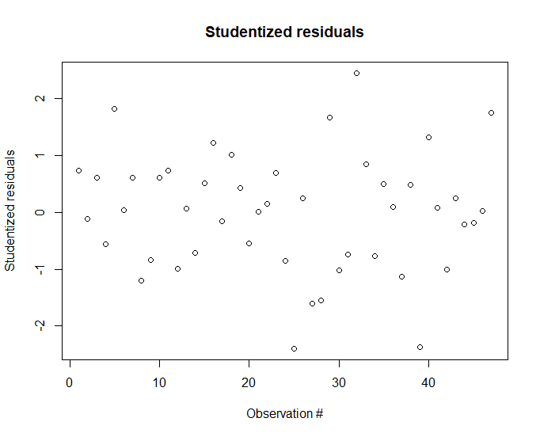

# Part 3

The points with large leverage do not show large Cook’s distance, however the extreme values within the studentized residuals do. We cannot conclude the points with large leverage are influential because their Cook’s distance is small. However the points with extreme studentized residuals most likely do influence the model significantly, indicated by the large Cook’s distance.

