The official design document for Better Curve; the best deck building tool ever built.

Better Curve

Week Four

Kevin Manning

CS 240 – Android Apps

Contents

Revision History 2

Introduction 4

Analysis 5

Prioritized use cases 5

Design 6

Use Case 1a 6

Instantiable Class Diagram: 7

Implementation 8

Screen Shots 8

Use Case 1a 8

Current Project Structure 9

# Revision History

|  |  |
| --- | --- |
| 1/5/16 | * Documentation   + Created Document   + Added Cover Sheet   + Added Table of Contents   + Added section for Revision History |
| 1/9/16 | * Documentation   + Added Use Case #1   + Added Document Description   + Added Introduction |
| 1/14/16 | * Documentation   + Revised Use Case #1     - Added Additional Screens to chart     - Extended Explanations of steps   + Updated Revisions history |
| 1/15/16 | * Documentation   + Updated Revision History * Coding   + Created Android Studio Project – Better Curve   + Added screens for Main Screen, Deck Stats, and Add Cards   + Connected screens for Main Screen, Deck Stats, and Add Cards |
| 1/16/16 | * Documentation   + Updated Revision History   + Added design and implementation sections   + Added class instantiable class diagram and screenshots subsections * Coding   + Added additional buttons to layout of Add Cards Screen   + Added Card Details screen |
| 1/17/16 | * Documentation   + Updated Revision History   + Added use case 3a     - Added to design     - Added to Implementation * Coding   + Added additional buttons to layout of Add Cards Screen   + Added Card Details screen |

|  |  |
| --- | --- |
| 1/21/16 | * Documentation   + Updated Revision History   + Corrected error in the Table of Contents (was showing an image)   + Re-aligned use case to match both design and user-centric views   + Updated project layout for increased number of activities * Coding   + Corrected screen creation to use intent system instead of a single layout   + Improved Deck Class in preparation of becoming larger data storage unit |
| 1/24/16 | * Documentation   + Updated Revision History   + Changed footer to denote page numbers   + Updated Table of Contents for altered number of pages   + Added additional, albeit temporary, files to the project layout * Coding   + Minor tweaks to layout in preparation for procedural layout generation   + Creation of InterfaceComponents object to handle layout Generation   + New methods for future required features added to Deck object |
| 1/26/16 | * Documentation   + Increased size of Revisions History for 1/31 submission   + Updated Revision History   + Corrected Use Case Diagram based on feedback * Coding   + Added Improved Listener   + Added additional layout factors and logic for deck building |
| 1/27/16 | * Documentation   + Updated Revision History   + Updated project layout * Coding   + Added a Test Class     - Unfinished due to time constraints |
| 2/4/16 | * Documentation   + Updated Revision History * Coding   + Expanded Test Cases     - Have an inheritance error   + Added add/removeCard()   + Added starting nomenclature for onPause() and onResume() |
|  |  |

# Introduction

Better Curve is a powerful, all-in-one tool for building decks for various TCGs. With pre-loaded games, the user can simply build their deck obeying the rules of the game. For one not yet added, the user can simply define a few quick rules and from there construct the deck. Afterwards, this powerful app calculates percentages for drawing cards based on the turn the resources to use them becomes available, allowing players to fine tune decks right from the builder.

# Analysis

## Prioritized use cases

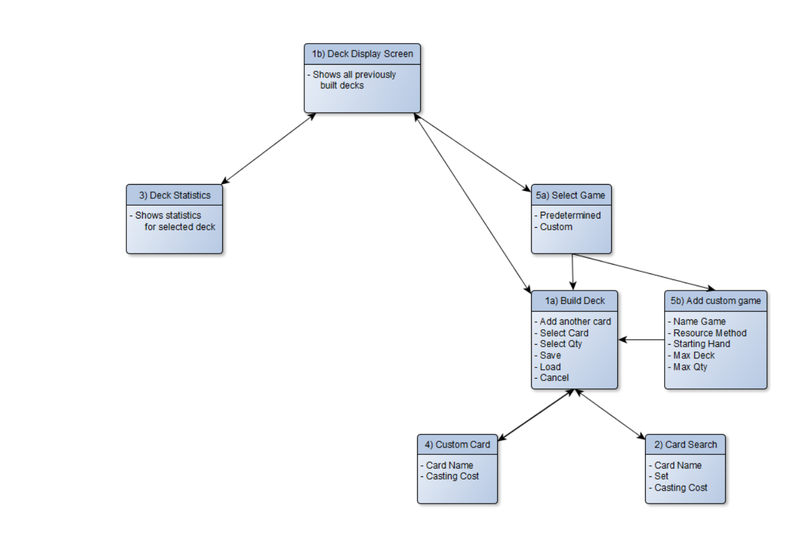

1b) The home screen, shows user created decks (saved in a file) and provides options for creating new decks, modifying/removing existing decks, or viewing stats.

5) (If New Deck) The user will be able to select which game they want to make a deck for, or create a custom set of rules.

1a) The user can add to or remove cards from their deck.

2) The user will be able to select a card from the included database for that game (or enter some basic info for a custom game)

1a) The user will be able to save the current deck, being prompted to name it.

1a) The user can also choose to cancel, without saving, at any time.

3) The user will see updated statistics of their decks curve.

3) The user can return to the home screen.

# Design

### Use Case 1a

|  |  |
| --- | --- |
| **Name** | **Value** |
| txtName |  |
| txtCost |  |
| txtQty |  |
| btnRaise | + |
| btnLower | - |
| btnAddCard | + |
| btnSave | Save Deck |
| btnLoad | Load Deck |
| btnCancel | Cancel |

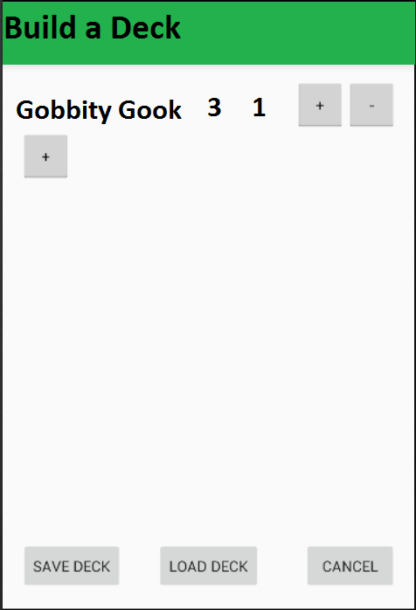

### Instantiable Class Diagram:

|  |
| --- |
| Manningk.bettercurve::Card |
| -game: String  -set: String  -set number: int  -name: String  -cost: int  -ability: String  -flavor: String  -stats: int[] |
| + public Card()  + public Card(String m_strGame, String m_strSet, int m_intSetNumberSetNumber, String m_strName,  int m_intCost, String m_strAbility, String m_strFlavor, int[] m_intStats)  + String getM_strGame()  + void setM_strGame(String m_strGame)  + String getM_strSet() + void setM_strSet(String m_strSet) + int getM_intSetNumber() + void setM_intSetNumber(short m_intSetNumber) + String getM_strName() + void setM_strName(String m_strName)  + int getM_intCost() + void setM_intCost(short m_intCost + String getM_strAbility() + void setM_strAbility(String m_strAbility)  + String getM_strFlavor() + void setM_strFlavor(String m_strFlavor)  + int[] getM_shtStats() + void setM_shtStats(short[] m_shtStats) |

# Implementation

## Screen Shots

### Use Case 1a

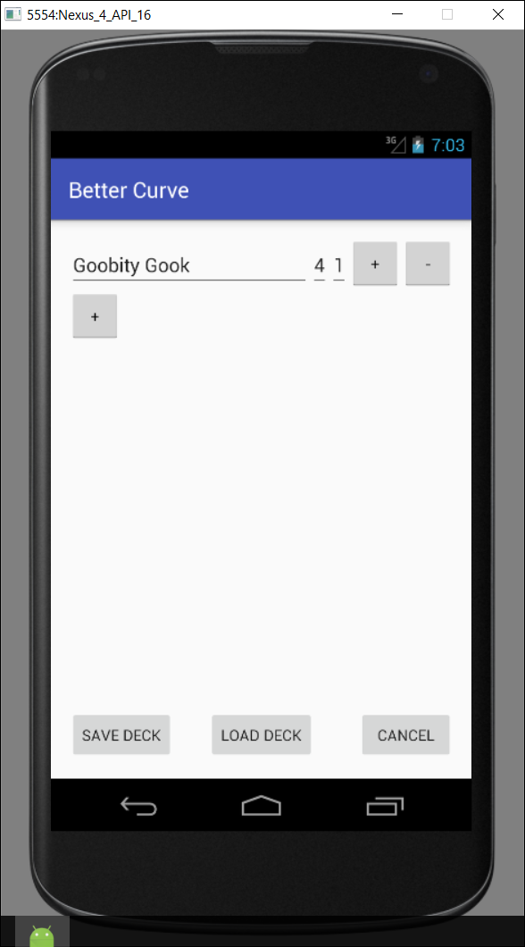

## Current Project Structure

The following diagram depicts the Better Curve project structure, leading to the files that have been added or modified to date:

* Better Curve
  + app
    - src
      * main
        + java

manningk.betterCurve

BuildDeckActivity

Card

Deck

DeckStatsActivity

ImprovedListener

InterfaceComponents

MainScreen

Manningk.betterCurve (androidTest)

DeckTest

* + - * res
        + layout

activity_add_screen.xml

activity_build_screen.xml

activity_build_test_screen.xml

activity_card_details_screen.xml

activity_custom_screen.xml

activity_main_screen.xml

activity_make_screen.xml

activity_stats_screen.xml