Received 00th January 20xx,
- G.A. Razuvaev Institute of Organometallic Chemistry of RAS, Tropinin str. 49, 603950 Nizhniy Novgorod, Russia.
- Universität Bremen, Institut für Angewandte und Physikalische Chemie, P.O. Box 330440, 28334 Bremen, Germany.
† Supplementary Information available: Tables of electronic transitions, additional figures, optimised molecular geometries. See DOI: 10.1039/x0xx00000x
Accepted 00th January 20xx
DOI: 10.1039/x0xx00000x

Excitonic coupling of electronic transitions in oligomeric phthalocyanine zinc(II) complexes
Sergey G. Makarov,*ª Sergey Yu. Ketkov ª and Dieter Wöhrle ^{b}
The excitonic coupling of the electronic transitions in a series of zinc(II) phthalocyanine (ZnPc) dimers has been studied by TD-DFT with a range-separated hybrid functional LC-BLYP. This method correctly reproduces the experimental excitonic shifts of the Q-band for known "rigid" non-conjugated binuclear phthalocyanines. The observed significant differences in the experimental UV/Vis spectra of the "edge-to-edge", "slipped-stacked" and "face-to-face" ZnPc dimers have been explained. The same TD-DFT method has been used to investigate the influence of the relative position of ZnPc molecules on the Q-band transition energies. The Coulombic contribution to excitonic coupling (according to Kasha's model) has been estimated using the transition electrostatic potential (TrESP) atomic charges. The excitonic splitting of the Q-band has been extrapolated from Pc oligomers to an infinite 1D-stack using the tight-binding model, and the main spectral features of α- and β-modifications of ZnPc have been correctly reproduced.

Introduction
Phthalocyanines (Pc) have found many "real" applications as colorants and materials for electronic devices.¹⁻³ Successful practical use of phthalocyanines (Pcs) in many fields originates from their structural versatility, photophysical properties and a wide range of solid-state arrangements. Recent potential applications include organic thin-film transistors,^{4,5} near-infrared fluorescent diagnostics and photodynamic immunotherapy of tumors.⁶
Photophysical properties of phthalocyanine metal complexes can be modified by peripheral substituents, central metal ions or by extension of the π-system.⁷⁻⁹ The extended π-system of conjugated Pc oligomers results in large redshifts of the lowest-energy absorption (Q-band). Noncovalent interactions (excitonic coupling) of the Pc π-systems are also known to significantly influence photophysical properties of phthalocyanines in aggregates, non-conjugated dimers and crystals.¹⁰⁻³⁵
Non-conjugated oligo- and polymeric phthalocyanine assemblies include well-known π-π stacked aggregates in solution¹⁴ and in the solid state.^{2,3,15,16} Besides, non-conjugated oligomers via ligand,^{10,24-31,35} metal–ligand,^{13,15,18,19,26} hydrogen-bonded²⁰ and donor-acceptor systems²¹ have also been reported. Two types of arrangement of chromophore molecules in aggregates are usually discussed: face-to-face configurations, often referred as H-type aggregates, and edge-to-edge or slipped-stacked configurations known as J-type aggregates (Fig. 1).¹⁴ A close proximity of the chromophores causes excitonic coupling of their electronic transitions, which significantly influences their photophysical properties.^{11,12,22,23}
According to Kasha’s theory,²³ "face-to-face" molecular dimers (H-aggregates) exhibit a blue-shifted absorption maximum and a suppressed radiative decay rate. In contrast, "edge-to-edge" and "slipped-stacked" dimers (J-aggregates) exhibit a red-shifted absorption maximum and an enhanced radiative decay rate. For dimers with parallel arrangement of chromophores, the interaction of the transition dipoles can be approximated by a simple point-dipole model as described by eq. 1.

$∆E≈\frac{μ^{2}(1-3\cos^{2}θ)}{4πεr^{3}}$ (1)

In eq. 1 μ and r represent the magnitude of the transition moment in the monomer and the centre-to-centre distance between the molecules, respectively. θ is the angle between the polarization axis and the line between the dipole centers. The energy change ΔE crosses zero at θ = 54.7°, i.e. two molecules behave as an H-aggregate above θ = 54.7° and as a J-aggregate below this angle.
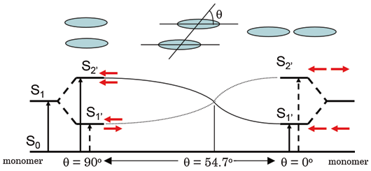
Fig. 1. Excitonic coupling of electronic transitions in molecular dimers.¹² © Hiroaki Isago with CC-BY-NC 3.0 license
Many examples of "face-to-face" phthalocyanine dimers, oligomers and aggregates^{10,24-28,34,35} and a few "edge-to-edge" and "slipped-stack" dimers and aggregates were described.^{13,18,29-32} But the exact alignment of the Pc subunits in these systems is not known, except for the crystals where slipped-stacked arrangement is typical for M(II)Pcs.^{1,2,16,17} Only a few binuclear Pcs with linkers rigid enough to ensure a well-defined geometry are known experimentally (Chart 1): a "gable" 1,³³ a "planar" 2,³¹ and a "cyclophane" 3³² bridged binuclear Pcs having "edge-to-edge" and "slipped-stack" arrangements (J-dimers). For the "face-to-face" binuclear Pcs (H-dimers) with rigid linkers such as 4²⁷ and 5,²⁸ different conformations are still possible with significantly different excitonic coupling (see below). One example of a supramolecular dimer 6¹³ can be considered as rigid although two configurations ("parallel" and "oblique") are possible.
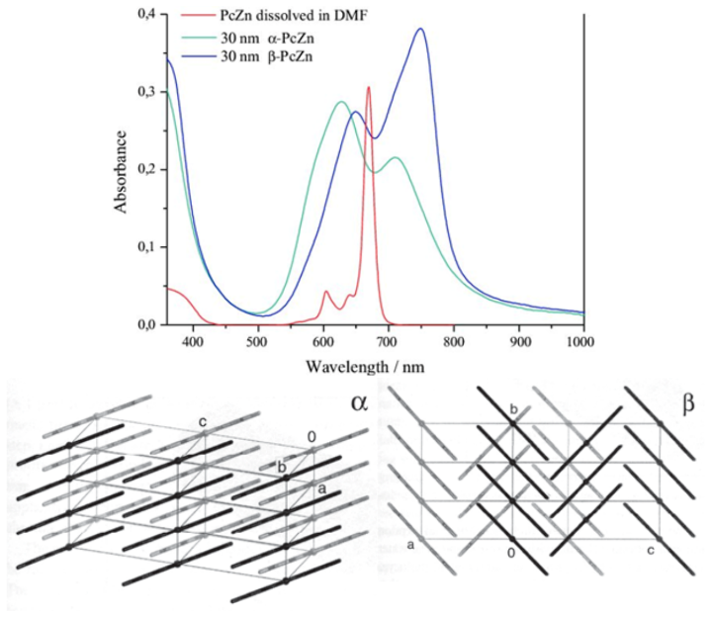
Aggregation has a more pronounced impact on the Q-band in solution than solvent effects. This results in a blue shift from λ = 660–700 nm to λ = 600–640 nm and a broadening of the Q-band in the typical case of H-aggregates.¹⁴ Similar blue shifts were observed for various covalent and supramolecular cofacial dimers.^{10,14,25-28,34,35} In the solid state, β-modification of planar M(II)Pcs is characterized by a close contact between the central metal ion and a meso-N atom of the adjacent molecule, with an inclination angle of ~45° within the stack. The inclination angle in the α-modification is 25–30°, and the direction of the tilt may vary [16, hoshino2003: α-CuPc_reinvest, law1993]. Different chromophore arrangements result in a significantly different excitonic coupling, leading to a high variability of absorption wavelengths of crystalline phthalocyanines (Fig. 2). Thus, α-modifications of CuPc and ZnPc absorb at λ ~625 and ~700 nm, β -modifications at λ ~650 and ~750 nm, and ε-CuPc exhibits an absorption at even longer wavelength of λ < 820 nm.¹⁻³ The non-planar Ti(O)Pc with the slipped-stacked arrangement similar to J-aggregates shows a strongly red-shifted Q-band absorption at λ ~700–900 nm and an efficient photoinduced charge carrier generation.³³
Fig. 2. Electronic spectra and crystal packing of α- and β-modifications of ZnPc
Slipped-stacked Pc oligomers resemble structural patterns of photosynthetic light-harvesting antenna consisting of bacteriochlorophyll dimers,³⁶ and they are photoactive in contrast to face-to-face Pc oligomers^{11-13,37} for which a non-radiative decay of the excited states is typical. Therefore, edge-to-edge dimers and J-aggregates are highly desirable to tailor the photophysical properties of Pcs. The cyclophane-fused dimer 3 is fluorescent (Φ_{f} = 0.12), a metal-free "gable" dimer 1 is also fluorescent (Φ_{f} = 0.55), a "planar" dimer 2 shows a singlet oxygen quantum yield of Φ_{Δ} = 0.08. The imidazole-bridged supramolecular dimer 6 is also fluorescent (Φ_{f} = 0.26). Surprisingly, for edge-to edge Pc dimer 2 no redshift expected according to Kasha’s theory and eq. (1) was observed. In contrast, J-dimers 3 and 6 exhibit strong bathochromic Q-band shifts (Table 1), and H-dimers are known to show hypsochromic shifts, in agreement with Kasha’s theory. It was concluded^{8,32} that the π-MO overlap is essential for an efficient excitonic coupling in Pc dimers, crystals and aggregates, and purely Coulombic coupling of the transition dipoles (eq. (1)) is not enough to explain the observed Q-band shifts. Short-range excitonic coupling in phthalocyanine dimers³⁷⁻³⁹ and crystals³⁷⁻⁴⁰ was studied previously by DFT and semi-empirical methods. It was shown that short-range excitonic coupling is very sensitive to the MO overlap^{37,39} and is related to electron- and hole-transfer integrals.^{39,41} This explains significant difference between the solid-state UV/Vis spectra of Zn(II), Ni(II) and Cu(II) Pcs having very similar crystal structures.³⁸
For selected arrangements, short-range excitonic coupling in ZnPc molecular dimers was also studied by TD-DFT.⁴² However, a more systematic study including various arrangements (r and θ) is required to provide a general explanation of the observed excitonic coupling effects in phthalocyanine oligomers and crystals.
To organise chromophores into tailored structures, it is important to predict their photophysical properties. Nowadays, machine-learning methods are growing up for predicting crystal structures of molecular materials,⁴³ which requires an accurate theoretical description of the intermolecular properties. Previously, we have studied UV/Vis/NIR spectra and energy gaps of conjugated oligomeric phthalocyanine zinc (II) complexes by TD-DFT. It was shown that calculations with a range-separated hybrid functional LC-BLYP provide a good agreement with the experimental spectra.^{8,9} The extrapolated TD-DFT Q-band energy of oligoPcs was compared to a directly calculated band gap of 1D-polyPc.
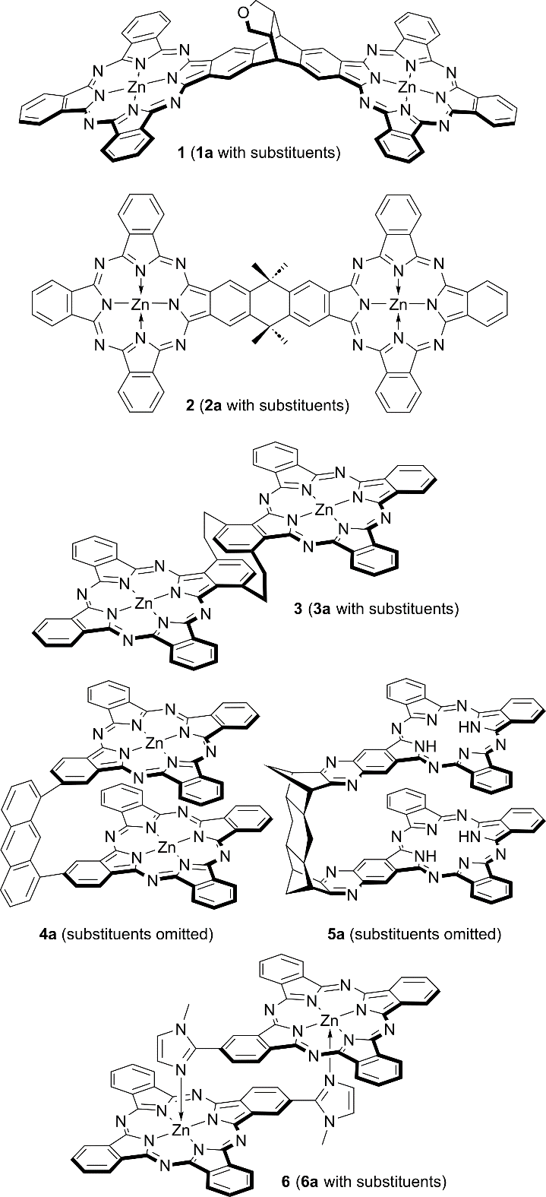
Here, we benchmark the above-mentioned LC-TDDFT approach on excitonically coupled Q-band transitions in non-conjugated binuclear ZnPcs for the first time. Then we use the same method to investigate the influence of the relative position of ZnPc molecules (r and θ in the eq. (1)) on the Q-band transition energies, and finally to explain excitonic coupling effects observed for phthalocyanine aggregates, dimers and crystals.
Chart 1. "Rigid" phthalocyanine dimers

Computational details
DFT calculations. The range-separated hybrid functional LC-BLYP (μ = 0.35)⁴⁴⁻⁴⁶ with the def2-TZVP(-f)/def2-J⁴⁷⁻⁴⁹ basis sets were used for TD-DFT calculations, similar to our previous publication.⁸ All geometries were optimised using the r2SCAN-3c functional⁵⁰ which includes a built-in def2-mTZVP basis set, D4 empirical dispersion,⁵¹ geometrical counterpoise⁵² and relativistic corrections. The optimization method was chosen from the comparison of the optimised geometries of ZnPc with its experimental gas-phase geometry.⁵³ All calculations were carried out in the ORCA 6.0.1 software,⁵⁴ with the RIJCOSX approximation,^{55,56} default grid "Defgrid2",⁵⁴ tight (ΔE < 10⁻⁸ a.u.) and very tight (ΔE < 10⁻⁹ a.u.) SCF convergence for TD-DFT and geometry optimizations, respectively. Adding diffuse functions or counterpoise correction had no noticeable effect on the transition energy (ΔE < 0.01 eV).
Transition charges were calculated by fitting the Q-band transition electrostatic potential (TrESP)⁵⁷ of the r2SCAN-3c optimised ZnPc using the CHELPG scheme⁵⁸ as implemented in the Multiwfn 3.8 software.^{59,60}
Extrapolation of TD-DFT spectra was carried out for ZnPc stacks up to the size of 5, constructed from the r2SCAN-3c optimised ZnPc molecules positioned either according to the translation vectors from β-ZnPc⁶¹ stacks or by applying shifts of Δx = 3.3–3.4 Å, Δz = 1.75–2.0 Å (Fig. 4A) to simulate the α-ZnPc stacks.
Results and discussion
Bridged binuclear phthalocyanines
"Rigid" binuclear ZnPcs 1 – 3 and 6 were selected to exclude the influence of noncovalent interactions (poorly described by DFT⁶²) on the relative position of the Pc chromophores.
The calculated Q-band wavelengths and energies for the dimers 1–3, 6 without peripheral substituents were compared to experimental wavelengths of their Q-band maxima. The results are listed in Table 1.
Table 1. Experimental and calculated Q-band wavelengths, energies and intensities for rigid non-conjugated binuclear ZnPcs 1 – 3, 6 and their substituted analogues 1a – 3a, 6a
Cpd. | Experimental (1a – 3a, 6a) |  | Theoretical (1 – 3, 6)
 | λ, nm (ΔE, eV) | 10⁻⁵ ε,  M⁻¹·cm⁻¹ | λ, nm (ΔE, eV) | Oscillator strength
ZnPc [8] | 674 (1.840) | 3.4 | 673 (1.842) | 0.472 · 2
1, 1a [32] | 694 (1.787) | 2.9 | 699 (1.773) | 1.054
 | 677 (1.832) | 3.1 | 669 (1.854) | 0.885
 |  |  | 662 (1.871) | 0.194
2, 2a [30] | 682 (1.818) | 6.9 | 693 (1.790) | 1.313
 |  |  | 681 (1.821) | 0.889
3, 3a [31] | 753 (1.647) | 0.84 | 742 (1.670) | 1.262
 | 690 (1.797) | 0.72 | 679 (1.826) | 0.794
6, 6a [12] | 700 (1.771) | 1.7 | 715 (1.733) | 1.070
 | 670 (1.851) | 1.2 | 669 (1.852) | 0.749

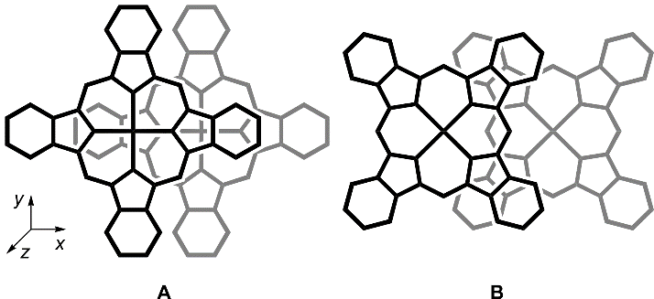
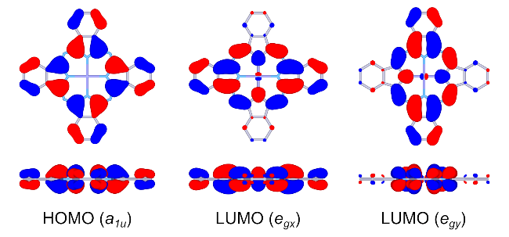
As can be seen from Table 1, the theoretical wavelengths are in agreement with the experimental ones. Therefore TD-DFT with a range-separated hybrid functional LC-BLYP correctly predicts the "through-space" excitonic coupling of the excited states of ZnPcs. For the edge-to-edge arrangements in 1 and 2, a redshift can be expected from eq. (1). However, the observed and predicted redshifts are negligible. This contrasts with a well-known blue shift for face-to-face arrangements in H-dimers and aggregates.^{10-13,25-28,34,35} Conversely, the expected redshifts are evident for "slipped-stack" arrangements in 3 and 6. Especially for the cyclophane-bridged dimer 3, the red shift is substantial and even comparable to some conjugated Pc dimers.⁷ The nearly zero red shift for the edge-to-edge dimers 1 and 2 was explained^{8,30} by the absence of the π-π overlap. Thus, it is important to study whether a general Kasha’s dipole-dipole model is still applicable, or the observed excitonic coupling in phthalocyanine aggregates, dimers and crystals is a system-specific short-range effect determined by the π-π overlap.
Fig. 4. Arrangements of the monomers in slipped-stacked ZnPc dimers
Fig. 3. Frontier MOs of ZnPc (front and side views)

Excitonic coupling between phthalocyanine molecules
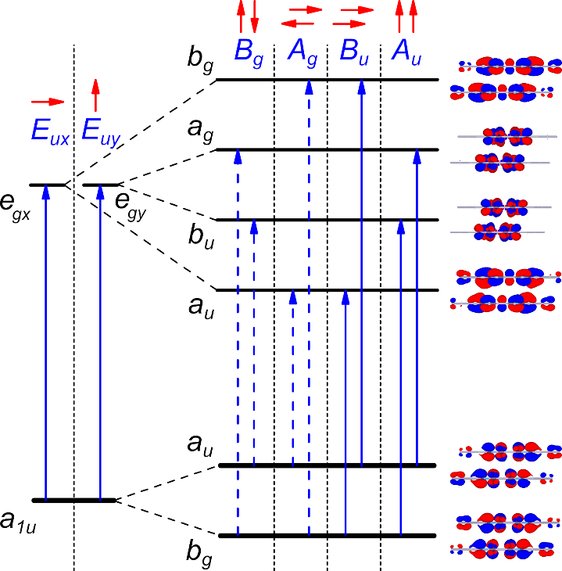
To evaluate excitonic coupling effects in oligoPcs, model zinc phthalocyanine dimers with face-to-face, slipped-stack and edge-to-edge arrangements of the Pc rings with parallel shifts (Δx) from 0 to 20 Å and interplane distances (Δz) from 0 to 6 Å were studied by TD-DFT. The corresponding distances (r) and angles (θ) can be easily calculated to compare TD-DFT transition energies to those predicted by equation (1). Phthalocyanines show intense π → π* absorption bands in the visible region of their absorption spectra. The Q-band corresponds to the doubly degenerate HOMO (a_{1u}) → LUMO (e_{g}) transition (Fig. 3).⁶³ In a Pc dimer, four Q-band transitions arise from the excitonic splitting of two degenerate E_{u} transitions of a single Pc chromophore. Two allowed B_{u} and A_{u} transitions (f ≈ 0.5) are x- and y-polarised, respectively. The remaining A_{g} and B_{g} transitions are forbidden (f ≈ 0) due to the opposite orientation of the transition dipoles. Unlike nearly "pure" Q-band transitions of monomolecular Pcs, the configuration of each Q-band transition of a Pc dimer is a combination of two main transitions involving frontier orbitals (Fig. 5). The MOs of the Pc oligomers can be approximated as linear combinations of the monomer orbitals.¹¹⁻¹³ Due to π-π overlap, bonding-antibonding interactions between these MOs result in splitting of the corresponding energy levels. In infinite stacks, this results in the formation of valence and conduction bands.^{37,41} The dependence of these energies on the arrangement of the Pc molecules is shown in Fig. 6 for the shift direction along Zn–N bond (Fig. 4A). The corresponding transition energies are listed in Table S1 of the ESI†. For the shift direction along meso-N – Zn (Fig. 4B, which approximately resembles the stack arrangement in β-ZnPc), the results are shown in Fig. S1 and Table S2 of the ESI†.
Fig. 5. Qualitative scheme of frontier MO splitting and Q-band transitions of slipped-stacked ZnPc dimers.

Angle dependence. For parallel transition dipoles, the dependence of the excitonic splitting on the angle θ (Fig. 2) is approximately described by equation (1). With "face-to-face" arrangements, the allowed B_{U} (Q_{x}) transition is blue-shifted in contrast to the corresponding forbidden A_{G} transition, which is strongly red-shifted and can participate in non-radiative decay of the excitation energy. This explains why "face-to-face" dimers are non-fluorescent. For the "slipped-stack" configurations with larger shifts (Δx), the allowed B_{u} transition becomes red-shifted with increasing dislocation and its energy drops below the corresponding A_{g} forbidden transition. This explains why the "slipped-stack" and "edge-to-edge" dimers are fluorescent. The angle corresponding to a zero splitting between B_{u} and A_{g} transitions is 54.7°, which is indicated by a vertical line in Fig. 6.
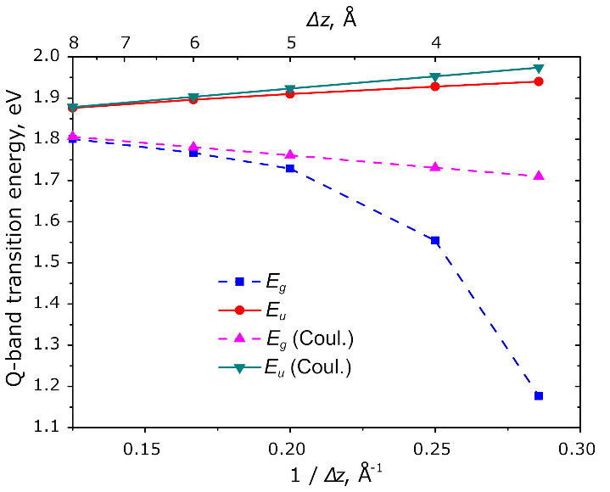
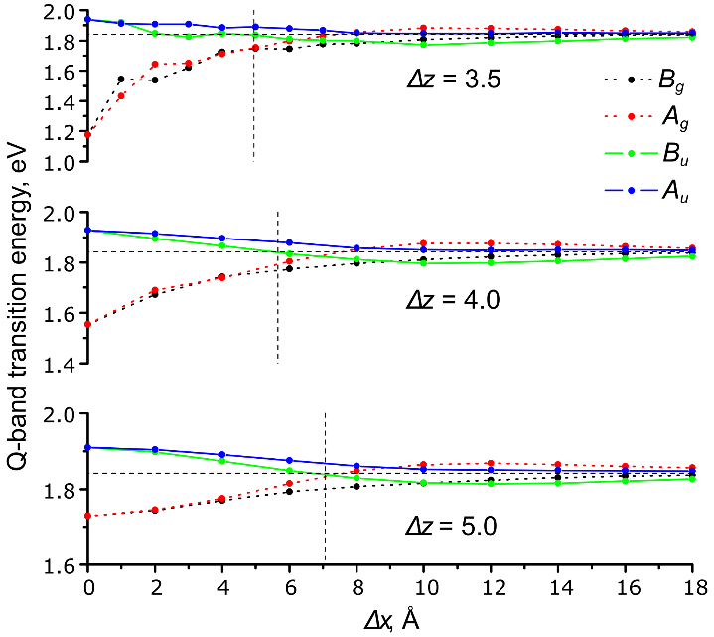
As can be seen from Fig. 6, there is a qualitative agreement between the TD-DFT results and equation (1). At the 3.5 Å interplane distance, the dependence of energy splitting on the shift is irregular due to short-range effects of the MO overlap (see below). These effects are much less pronounced already at the 4.0 Å distance. For the edge-to-edge arrangement (Δz = 0, see Fig. S2 of the ESI†), only large centre-to-centre distances r = Δx ≥ 16 Å are physically possible, which results in very small excitonic splittings, in agreement with eq. (1). For the "planar" dimer 2, this distance is 15.7 Å, and the predicted excitonic splitting is only 0.03 eV. Thus, the small redshift for the edge-to-edge dimers 1 and 2 is simply explained by the large distance between the centres of the transition dipoles. However, there is no quantitative agreement between the TD-DFT transition energies and eq. (1), which can be explained by short-range effects of the π-MO overlap,³⁷⁻⁴² as discussed below.
Fig. 7. Distance dependence of the TD-DFT Q-band transition energies of a face-to-face ZnPc dimer
Fig. 6. TD-DFT Q-band transition energies vs. parallel shifts (Δx) of two Pc molecules (arrangement in Fig. 4A). Forbidden transitions are shown by dashed lines. The horizontal line represents the Q-band energy of ZnPc, the vertical line corresponds to the zero-splitting angle of 54.7°

Distance dependence. As shown by Harcourt et al.,⁶⁴ the excitonic interactions can be divided into long-range Coulombic interactions, Dexter's short-range exchange,⁶⁵ and superexchange caused by the π-MO overlap.⁴¹ Taking into account only the Coulombic interactions leads to Kasha’s exciton model²³ often approximated as a point-dipole interaction (eq. 1). This scales as 1/r³ whereas the superexchange interaction depends on the MO overlap, which decays exponentially with distance.
To exclude the influence of the variable π-MO overlap, only perfect face-to-face (Δx = 0) and edge-to-edge (Δz = 0) arrangements were considered in order to study the distance dependence of the excitonic Q-band splitting. As can be seen from Fig. 7, at larger Δz distances the splitting dependence is almost linear with respect to 1/r (r = Δz) whereas the point-dipole approximation (eq. (1)) predicts 1/r³ decay. The Coulombic component of the excitonic coupling was evaluated using the atomic charges obtained from the fitting of the transition electrostatic potential (TrESP charges).⁵⁷
At larger distances, the TD-DFT transition energies for the dimers is well reproduced by the TrESP Coulombic contribution calculated from monomers' transition charges. Within the studied distance range, the Coulombic component scales linearly with respect to 1/r rather than 1/r³: the distances between the transition dipoles are still comparable to the size of the macrocycles, therefore the point-dipole approximation is not yet valid. Significant disagreement between the TD-DFT transition energy and the predicted Coulombic component (Fig. 7) at shorter interplane distances (Δz) indicates a large impact of the short-range effects on the excitonic coupling. Another noticeable effect is a non-symmetrical splitting at shorter distances (Fig. 2): the red shift of the A_{g} transition is larger than the blue shift of the B_{u} transition. This can be explained by a larger contribution of a lower-energy transition to the configuration of the excited state (Table S3 of the ESI†). The red-shifted A_{g} transition is forbidden, therefore H-aggregates show only a blue-shifted Q-band. In crystals, the red-shifted Q-band absorption component often extends beyond λ = 800 nm (shifts of ΔE > 0.3 eV) whereas the blue-shifted band is usually observed at λ = 600 – 650 nm (shifts of ΔE = 0.1 – 0.2 eV). For the edge-to-edge arrangement (Δz = 0), the TD-DFT Q-band splitting is only 0.05 eV at Δx = 17 Å and is purely Coulombic. Thus, a moderate ΔE ~0.15 eV blue shift well known for Pc H-aggregates,^{10,14,25-28,34,35,63} is only a "tip of the iceberg": if the A_{g} transition were allowed, it would appear at λ > 1000 nm. Thus, the short-range intermolecular electronic interactions in the Pc H-aggregates are much stronger than expected from the experimental UV/Vis spectra. This can explain a well-known excited-state quenching in aggregated Pcs¹¹⁻¹⁴ and relatively good transport properties of the Pc-based molecular conductors¹⁷ (since a short-range excitonic coupling is related to electron- and hole-transfer integrals).^{11,41}

MO analysis. The π-π MO overlap results in splitting of the HOMO and LUMO levels of the monomers as shown in Fig. 8. The HOMO and LUMO splitting pattern in the slipped-stack dimers is determined by the MO shapes of the corresponding monomers.^{37,41} The MO overlap is responsible for short-range effects (see above) often expressed as charge-resonance/charge-transfer (CR/CT) excitons.^{11,41} MO overlap and, as a consequence, the charge-transfer integrals^{41,66} are very sensitive to intermolecular arrangement. This results in a great variability of photophysical and electric properties of crystalline modifications of phthalocyanines.^{1-3,16,67}
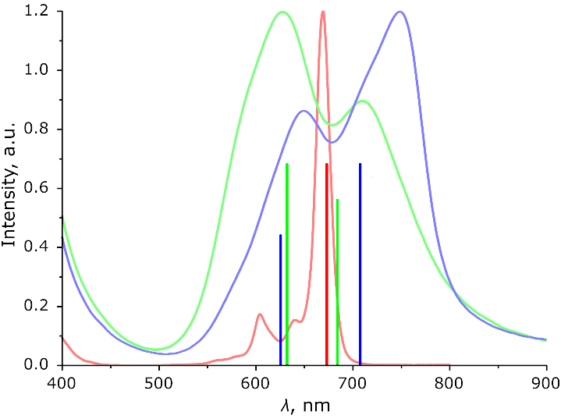
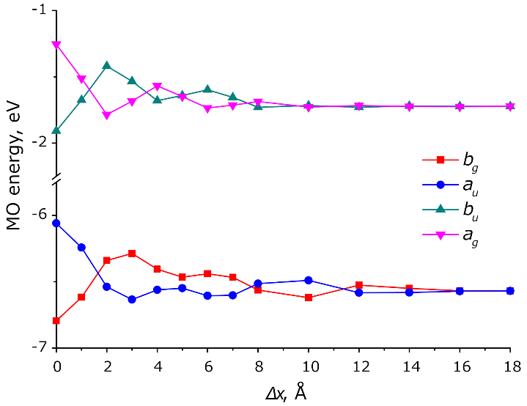
A parallel shift between Pc molecules in the dimer results in oscillations of the split MO levels with different periodicity for HOMO and LUMO which is a result of different nodal patterns of the monomers' HOMO and LUMO (Figs. 4, 8, Table S4).³⁷ The combination of these oscillations results in a complex shift dependence of the corresponding transition energies (Fig. 6). The splitting generally decreases with the shift due to decreasing overall π-MO overlap. The dependence of the splitting on the distance is exponential as a result of the exponential decay of the π -MO overlap (Fig. S3 of the ESI†). This is in contrast to the 1/r dependence of the TD-DFT transition energies at larger distances. Therefore, at the distances of 5 – 8 Å the MO splitting becomes negligible but the TD-DFT transition energies still show a non-zero excitonic splitting as a result of Coulombic coupling of the monomers’ transition dipoles.
Fig. 9. Main TD-DFT Q-band transitions (vertical lines) of ZnPc (red), ZnPc oligomers extrapolated to infinite stacks approximately reproducing the α- (green) and β-(blue) ZnPc stacks, together with experimental spectra of ZnPc in DMF, α- and β-ZnPc films, presented in the corresponding colours

Fig. 8. Energies of 2 highest occupied (a_{u}, b_{g}) and 2 of 4 lowest vacant (a_{g}, b_{u}) orbitals of the ZnPc dimers at Δz = 3.5Å and various shift values (Δx)

Size dependence. Previously optical gaps of π-conjugated Zn(II) oligoPcs were extrapolated to a 1D-polyPc using a free-electron approximation⁸ (E vs. 1/N) which is applicable for delocalised systems only.⁶⁸ For typical molecular crystals orbital and optical gaps may differ significantly.⁶⁹ Therefore, extrapolation of TD-DFT optical gaps of oligomers can be a better estimate to the optical gap of an infinite stack than the orbital gap directly calculated in periodic boundary conditions.
According to a simplified tight-binding model including only the nearest-neighbour interactions between ZnPc molecules,^{37,38} the band dispersion (width of HOMO or LUMO band) for an N-meric stack is described by the following equation (2).

ΔE = ± 2J cos[π / (N + 1)] (2)

The coupling factor J is either J_{Coul} or J_{CT} for Coulombic or charge-transfer excitonic coupling, respectively. As it was shown by Bredas et al., the HOMO and LUMO band edges are also linear against cos[π/(N+1)] for phthalocyanines and other molecular semiconductors.³⁷ Similar extrapolation was also applied for optical gaps of oligothiophenes.⁷⁰
The excitonic splitting of two Q-band transitions results in 2·N transitions for the N-meric ZnPc. The TD-DFT spectra of ZnPc oligomers are dominated by two x- and y-oriented transitions (A_{ux} and A_{uy}, respectively, see Fig. 3) which correspond to all monomers' transition dipoles (Fig. 5) pointing in the same direction. All other Q-band transitions are of zero or negligible intensity (f < 0. 02).
Equation (2) can be used to predict the excitonic splitting of optical spectra for infinite 1D-stacks in aggregates or crystals.
To study the size dependence of the excitonic splitting, larger aggregates (stacks) were calculated with the arrangements approximately resembling the β-modification of ZnPc (translation vectors taken from its X-Ray structure⁶¹). As no single-crystal X-Ray structure is available for α-ZnPc, estimated model stacks were studied. These include structures with a Δz of 3.3–3.4 Å and a Δx of 1.75–2.0 Å in the direction along the Zn–N bond (Fig. 4A), resembling the reinvestigated “brickstone” α-CuPc structure [hoshino2003], as well as along meso-N – Zn direction (Fig. 4B), similar to the classical “herringbone” α-CuPc structure [16]), were studied. The resulting Zn–Zn distance is 3.75–3.95 Å with a tilt angle of 28–31°, which is comparable to previous estimates.^{38,40} The results are shown in Fig. S4 and Table S5 of the ESI†. As can be seen from Fig. S4, the TD-DFT Q-band splitting is almost linear in respect to cos[π/(N+1)] for N = 1…5 which is in agreement with eq. (2). This indicates that the excitonic splitting of the Q-band is mostly determined by the nearest-neighbour interactions. The extrapolated to N = ∞ transition energies of 1.98 eV (λ = 626 nm) and 1.75 eV (λ = 708 nm) for a single stack of β-modification are comparable with the experimental values (Fig. 2) of 1.94 eV (640 nm) and 1.65 eV (750 nm). Oscillator strengths increase almost linearly with size (Fig. S3 of the ESI†) and with the extrapolated ratio of 1:1.55 which also agrees well with the experimental spectrum (Figs. 2, 9). Our estimates of the Q-band splitting for α-ZnPc (“brickstone” model, Fig. 4A) vary from 0.08 eV to 0.18 eV (Fig. 9 for Δx = 2.0 Å and Δz = 3.4 Å, Table S5 of the ESI†), i.e. very small variations of the intermolecular arrangement result in significant changes of the Q-band splitting. This explains why Zn(II), Ni(II) and Cu(II) Pcs have different solid-state spectra despite very similar crystal structures and solution spectra.³⁹ For the “herringbone” model stack (Fig. 4B), only blue shift with no splitting is predicted, which is more typical for aggregated Pcs in solution []. The TD-DFT results within the “brickstone” model are in a better agreement with the experimental spectrum of α-ZnPc, qualitatively reproducing its main features. The approximate agreement between the extrapolated and the experimental spectra of β-ZnPc confirms that crystal spectra are mostly determined by excitonic coupling within the stack. For a more quantitative description, the next-nearest-neighbour and the inter-stack couplings should also be considered.^{39,71}
Conclusions
Excitonic coupling of the electronic transitions in a series of zinc(II) phthalocyanine dimers was studied by TD-DFT with a range-separated hybrid functional LC-BLYP. This method correctly reproduces the experimental excitonic shifts of the Q-band for known "rigid" non-conjugated binuclear phthalocyanines.
Small excitonic redshift of the Q-band for the "edge-to-edge" Pc dimers is a result of a large distance between transition dipole centres (weak Coulombic coupling) and absence of the π-MO overlap (no short-range coupling). In contrast, the slipped-stacked arrangement of the Pc rings in dimers and crystals results in a strong redshift of the Q-band due to the π-MO overlap and the short-range excitonic coupling. The Kasha's point-dipole approximation (eq. (1)) is qualitatively applicable although the 1/r³ dependence is actually a superposition of the 1/r dependence for Coulombic coupling and the e^{-r} dependence for short-range coupling. The short-range excitonic coupling is highly sensitive to the intermolecular arrangement due to a complicated HOMO-LUMO nodal pattern which determines the bonding/antibonding character of the π-MO overlap.
The well-known ~50 nm (~0.15 eV) blue shift of the Q-band of the "face-to-face" Pc dimers (H-aggregates) is only a "tip of an iceberg": the red-shifted (by ~0.65 eV) forbidden subband is not observed in the optical spectra but such a strong excitonic coupling indirectly influences other properties. The excitonic splitting of the Q-band can be extrapolated from Pc oligomers to an infinite 1D-stack, in the frame of the tight-binding approximation (eq. (2)). This approach can be further extended to include the next-nearest-neighbour and the inter-stack couplings for predicting optical spectra of crystalline phthalocyanines.
Conflicts of interest
There are no conflicts to declare.
Data availability
The data that support the findings of this study are available in the ESI† of this article.
Acknowledgements
This work was carried out within the frames of the State Assignment of the G.A. Razuvaev Institute of Organometallic Chemistry of RAS.
Notes and references
- D. Wöhrle, G. Schnurpfeil, S.G. Makarov, A. Kazarin and O.N. Suvorova, Macroheterocycles, 2012, 5, 191.
- N.B. McKeown, Phthalocyanine Materials, Cambridge University Press, 1998.
- P. Erk and H. Engelsberg, in The Porphyrin Handbook, ed. K. M. Kadish, K. M. Smith and R. Guilard, Academic Press, San Diego, 2003, 19, 105.
- B.H. Lessard, ACS Appl. Mater. Interfaces, 2021, 13, 31321.
- Z.J. Comeau, R.R. Cranston, H.R. Lamontagne, A.J. Shuhendler and B.H. Lessard, Commun. Chem., 2022, 5, 178.
- H. Kobayashi and P.L. Choyke, Acc. Chem. Res., 2019, 52, 2332.
- S.G. Makarov, O.N. Suvorova and D. Wöhrle, J. Porphyrins Phthalocyanines, 2011, 15, 791.
- S.G. Makarov, G. Schnurpfeil, S.Yu. Ketkov and D. Wöhrle, J. Porphyrins Phthalocyanines, 2020, 24, 515.
- S.G. Makarov, G. Schnurpfeil, S.Yu. Ketkov and D. Wöhrle, J. Porphyrins Phthalocyanines, 2021, 25, 236.
- N. Kobayashi, Coord. Chem. Rev., 2002, 227, 129.
- K. Ishii and N. Kobayashi, in The Porphyrin Handbook, ed. K. M. Kadish, K. M. Smith and R. Guilard, Academic Press, San Diego, 2003, 16, 1.
- H. Isago, Optical Spectra of Phthalocyanines and Related Compounds, Springer, Tokyo, 2015.
- K. Kameyama, M. Morisue, A. Satake and Y. Kobuke, Angew. Chem. Int. Ed. 2005, 44, 4763.
- A.W. Snow, in The Porphyrin Handbook, ed. K. M. Kadish, K. M. Smith and R. Guilard, Academic Press, San Diego, 2003, 17, 129.
- M. J. Cook and I. Chambrier, in The Porphyrin Handbook, ed. K. M. Kadish, K. M. Smith and R. Guilard, Academic Press, San Diego, 2003, 17, 37.
- M. K. Engel, in The Porphyrin Handbook, ed. K. M. Kadish, K. M. Smith and R. Guilard, Academic Press, San Diego, 2003, 20, 1.
- T. Inabe and H. Tajima, Chem. Rev., 2004, 104, 5503.
- M. Hanack and D. Dini, in The Porphyrin Handbook, ed. K. M. Kadish, K. M. Smith and R. Guilard, Academic Press, San Diego, 2003, 18, 251.
- K. Ishii, N. Kobayashi, M. Fujitsuka, S. Abiko and O. Ito, J. Chem. Soc., Dalton Trans., 2002, 1735.
- M. V. Martinez-Diaz, M. S. Rodriguez-Morgade, M. C. Feiters, P. J. M. van Kan, R. J. M. Nolte, J. F. Stoddart and T. Torres, Org. Lett., 2000, 2, 1057.
- A. Escosura, M. V. Martinez-Diaz, P. Thordarson, A. E. Rowan, R. J. M. Nolte and T. Torres, J. Am. Chem. Soc., 2003, 125, 12300.
- A. Davydov, Theory of Molecular Excitons, Springer, New York, 2013.
- M. Kasha, H. R. Rawls and M. A. El-Bayoumi, Pure Appl. Chem., 1965, 11, 371.
- H. Eichhorn, D. Wöhrle and D. Pressner, Liq. Cryst., 1997, 22, 643.
- A.Yu. Tolbin, L.G. Tomilova and N.S. Zefirov, Russ. Chem. Rev., 2008, 77, 435.
- A.G. Martynov, Yu.G. Gorbunova and A.Yu. Tsivadze, Russian J. Inorg. Chem., 2014, 59, 1635.
- N. Kobayashi, H. Lam, W.A. Nevin, P. Janda, C.C. Leznoff and A.B.P. Lever, Inorg. Chem., 1990, 29, 3415.
- Y. Yamada, T. Maeno, K. Nawate and K. Tanaka, Chem. Commun., 2018, 54, 8226.
- S.G. Makarov, K.N. Maksimova, E.V. Baranov, G.K. Fukin, O. N. Suvorova, D. Wöhrle and G.A. Domrachev, Russ. Chem. Bull., 2006, 55, 1748.
- Y. Asano, M. Uchiyama, A. Fukasawa, T. Hatano, A. Muranaka and N. Kobayashi, J. Am. Chem. Soc., 2007, 129, 4516.
- Y. Asano, J. Sato, T. Furuyama and N. Kobayashi, Chem. Commun., 2012, 48, 4365.
- L. Zhao, X. Ren and X. Yan, CCS Chem., 2021, 3, 678.
- J.E. Norton and J.-L. Bredas, J. Chem. Phys., 2008, 128, 034701.
- B.L. Wheeler, G. Nagasubramanian, A.J. Bard, L.A. Schechtman, D.R. Dininny and M.E. Kenney, J. Am. Chem. Soc., 1984, 106, 7404.
- G. De La Torre, A. Hausmann, M. Sekita, G. Bottari, T. Torres and D. M. Guldi, Chem. Soc. Rev., 2013, 42, 8049.
- T. Mirkovic, R. Van Grondelle, E.E. Ostroumov, J.M. Anna, G. Govindjee and G.D. Scholes, Chem. Rev., 2017, 117, 249.
- J. L. Bredas, D. A. Da Silva Filho, J. Cornil and J. P. Calbert, PNAS, 2002, 99, 5804.
- S. Yanagisawa, I. Hamada, K. Yamauchi, T. Oguchi and T. Inaoka, Phys. Rev. B, 2014, 90, 245141.
- L. P. Doctor, F. Ziegs, B. Büchner, M. Naumann, A. Popov and M. Knupfer, J. Phys. Chem. C, 2021, 125, 12398.
- M. Kato, J. Onoe, Y. Matoba, K. Okamoto, S. Watanabe, J.-P. Bucher and M. Nakaya, J. Chem. Phys., 2020, 153, 144704.
- N. J. Hestand and F. C. Spano, Acc. Chem. Res., 2017, 50, 341.
- S. Yanagisawa, T. Yasuda, K. Inagaki, Y. Morikawa, K. Manseki and S. Yanagida, J. Phys. Chem. A, 2013, 117, 11246.
- A. O. Gudovannyy, J. M. Schäfer, O. Gerdes, D. Hildebrandt, G. Mattersteig, M. Pfeiffer and F. Ortmann, Adv. Funct. Mater., 2025, 2421048.
- A. D. Becke, Phys. Rev. A, 1988, 38, 3098.
- C. Lee, W. Yang and R. G. Parr, Phys. Rev. B, 1988, 37, 785.
- H. Iikura, T. Tsuneda, T. Yanai and K. Hirao, J. Chem. Phys., 2001, 115, 3540.
- F. Weigend and R. Ahlrichs, Phys. Chem. Chem. Phys., 2005, 7, 3297.
- F. Weigend, Phys. Chem. Chem. Phys., 2006, 8, 1057.
- A. D. Becke, J. Chem. Phys., 1993, 98, 5648.
- S. Grimme, A. Hansen, S. Ehlert and J.-M. Mewes, J. Chem. Phys., 2021, 154, 064103.
- S. Ehlert, U. Huniar, J. Ning, J. W. Furness, J. Sun, A. D. Kaplan, J. P. Perdew and J. G. Brandenburg, J. Chem. Phys., 2021, 154, 061101.
- H. Kruse and S. Grimme, J. Chem. Phys., 2012, 136, 154101.
- T. Strenalyuk, S. Samdal and H. V. Volden, J. Phys. Chem. A, 2007, 111, 12011.
- F. Neese, Wiley Interdiscip. Rev.: Comput. Mol. Sci., 2025, 15, e70019.
- B. I. Dunlap, J. Chem. Phys., 1983, 78, 3140.
- F. Neese, F. Wennmohs, A. Hansen and U. Becker, Chem. Phys., 2009, 356, 98.
- T. Renger and F. Müh, Photosynth. Res., 2012, 111, 47.
- C. M. Breneman and K. B. Wiberg, J. Comput. Chem., 1990, 11, 361.
- T. Lu and F. Chen, J. Comput. Chem., 2012, 33, 580.
- T. Lu, J. Chem. Phys., 2024, 161, 082503.
- W. R. Scheidt and W. Dow, J. Am. Chem. Soc., 1977, 99, 1101.
- J. P. Heindel, K. M. Herman, E. Apra and S. S. Xantheas, J. Phys. Chem. Lett., 2021, 12, 7574.
- H. Isago, Optical Spectra of Phthalocyanines and Related Compounds, Springer, Japan, 2015.
- R. D. Harcourt, G. D. Scholes, K. P. Ghiggino and S. Speiser, J. Chem. Phys., 1996, 105, 1897.
- D. L. Dexter, J. Chem. Phys., 1953, 21, 836.
- P. M. Kazmaier and R. Hoffmann, J. Am. Chem. Soc., 1994, 116, 9684.
- H. Jiang, Y. Li, C. Kloc, J. Ye, Y. Long, D. Fichou, W. Hu, R. Ganguly and P. Hu, Angew. Chem. Int. Ed., 2018, 57, 10112.
- J. Torras, C. Aleman and J. Casanovas, J. Phys. Chem. A, 2012, 116, 7571.
- J.-L. Bredas, Mater. Horiz., 2014, 1, 17.
- R. E. Larsen, J. Phys. Chem. C, 2016, 120, 9650.
- R.P. Fornari, P. Rowe, D. Padula and A. Troisi, J. Chem. Theory Comput., 2017, 13, 3754.

