Received 00th January 20xx,
- Address here.
- Address here.
- Address here.
† Footnotes relating to the title and/or authors should appear here.
Supplementary Information available: [details of any supplementary information available should be included here]. See DOI: 10.1039/x0xx00000x
Accepted 00th January 20xx
DOI: 10.1039/x0xx00000x

Excitonic coupling of electronic transitions in oligomeric phthalocyanine zinc(II) complexes
Sergey G. Makarov,*ª Sergey Yu. Ketkov ª and Dieter Wöhrle ^{b}
Abstract text goes here. The abstract should be a single paragraph that summarises the content of the article
Introduction

B Headings should always be subordinate to A headings e.g. Synthetic procedures, Materials and methods, Crystallography.

C headings should always be subordinate to B headings e.g. General procedure for synthesis of compound X. The main paragraph text follows directly on here.

Phthalocyanines (Pc) have found many “real” applications as colorants and in electronic devices [1-3]. Successful practical use of phthalocyanines (Pcs) in many fields became possible due to their unique structural diversity of the molecules, photophysical properties and different arrangements in the solid state. Recent potential applications include organic thin-film transistors [4, 5], near-infrared fluorescent diagnostics and photodynamic immunotherapy [6] of tumors.
Photophysical properties of phthalocyanine metal complexes can be modified with peripheral substituents, central metal ion or by extension of the π-system [7-9]. The extended π-system of conjugated Pc oligomers results in large redshifts of the lowest-energy absorption (Q-band). Noncovalent interactions (excitonic coupling) of the Pc π-systems are also known to significantly influence photophysical properties of phthalocyanines in aggregates, non-conjugated dimers and crystals [10-34].
Non-conjugated oligo- and polymeric phthalocyanine assemblies include well-known π-π stacked aggregates in solution [13] and in solid state [2, 3, 14-15]. Besides, non-conjugated oligomers via ligand [10, 23-30, 34], metal–ligand [12, 14, 17, 18, 25], hydrogen-bonded [19] and donor-acceptor systems [20] have also been reported.
Two types of arrangement of chromophore molecules in aggregates are usually discussed: with face-to-face configurations, often referred to as H-type aggregates, and edge-to-edge or slipped-stacked configurations, known as J-type aggregates (Fig. 1) [13]. A close proximity of the chromophores causes excitonic coupling of their electronic transitions, which significantly influences their photophysical properties [11, 21-22].
According to Kasha’s theory [22], “face-to-face” molecular dimers (H-aggregates) exhibit a blue-shifted absorption maximum and a suppressed radiative decay rate while “edge-to-edge” and “slipped-stacked” dimers (J-aggregates) exhibit a red-shifted absorption maximum and enhanced radiative decay rate. For dimers with parallel arrangement of chromophores, the interaction of the transition dipoles can be approximated by a simple point-dipole model:
$∆E≈\frac{μ^{2}(1-3\cos^{2}θ)}{4πεr^{3}}$ (1)
where μ and r represent the magnitude of the transition moment in the monomer and center-to-center distance between the molecules, respectively, θ is the angle between the polarization axis and the line between the dipole centers. The energy change ΔE becomes zero at θ = 54.7°, i.e. two molecules behave as an H-aggregate above θ = 54.7° and as a J-aggregate below this angle.

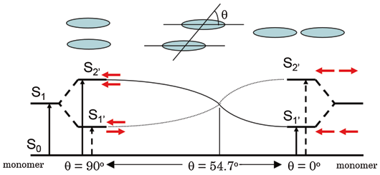
Fig. 1. Excitonic coupling of electronic transitions in molecular dimers
Although many examples of "face-to-face" phthalocyanine dimers, oligomers and aggregates [10, 23-27, 33-34] and a few "edge-to-edge" and "slipped-stack" dimers and aggregates were described [12, 17, 28-31], the exact alignment of the Pc subunits in these systems is not known, except for the crystals where slipped-stacked arrangement is typical for M(II)Pcs [1, 2, 15, 16]. Only a few binuclear Pcs with a linker rigid enough to ensure a well-defined geometry are known experimentally (Chart 1): a “gable” 1 [32], a “planar” 2 [30], and a “cyclophane” 3 [31] bridged binuclear phthalocyanines with “edge-to-edge” and “slipped-stack” arrangement (J-dimers). For “face-to-face” binuclear Pcs (H-dimers) with rigid linkers such as 4 [26] and 5 [27], different conformations are still possible with significantly different excitonic coupling (see below). One example of a supramolecular dimer 6 [12] can be considered rigid although two configurations (“parallel” and “oblique”) are possible.
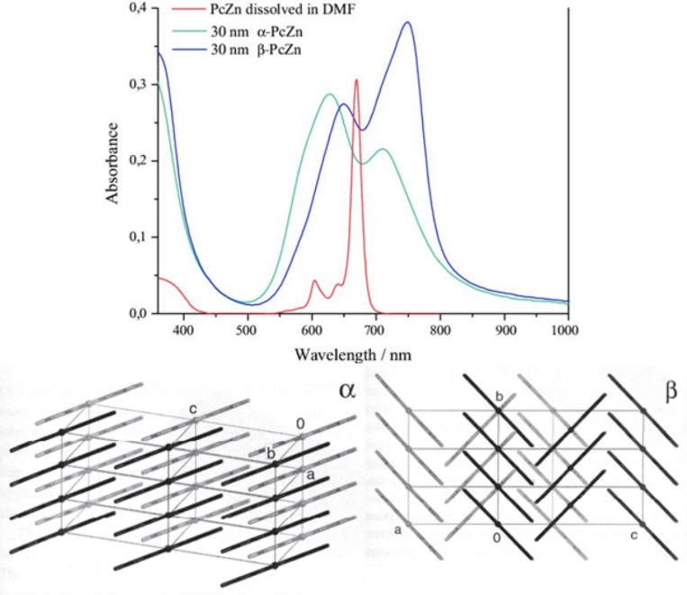
Fig. 2. Electronic spectra and crystal packing of α- and β-modifications of ZnPc [1]
The effect of aggregation on the Q-band in solution is stronger than solvent effects and typically results in a blue shift from 660-700 nm to 600-640 nm and broadening of the Q-band (H-aggregates) [13]. Similar blue shifts were observed for various covalent and supramolecular cofacial dimers [10, 12, 24-27, 33-34]. In solid state, β-modification of planar M(II)Pcs typically shows a close contact of central metal ion to a meso-N atom of an adjacent molecule in the stack, and an inclination angle of the macrocycles within the stack of ~ 45°. The inclination angle in α-modification is ~ 30°, and the metal shows a close contact to a pyrrole-N atom of an adjacent molecule. Different arrangements of chromophores results in a significantly different excitonic coupling, leading to a high variability of absorption wavelengths exhibited by crystalline phthalocyanines. Thus, α-modifications of CuPc and ZnPc absorb at λ ~ 625 and ~ 700 nm, β -modifications at λ ~ 650 and ~750 nm, and ε-CuPc at even longer wavelength λ < 820 nm [1-3]. The non-planar Ti(O)Pc with slipped-stacked arrangement similar to J-aggregates shows an extremely red-shifted Q-band absorption at λ ~ 700 - 900 nm, and an efficient photoinduced charge carrier generation [32].
Slipped-stacked Pc oligomers resemble structural patterns of photosynthetic light-harvesting antenna consisting of bacteriochlorophyll dimers [35], and they are photoactive in contrast to face-to-face Pc oligomers [11, 12, 36] for which a non-radiative decay of the excited states is typical. Therefore, edge-to-edge dimers and J-aggregates are highly desirable to tailor the photophysical properties of Pcs. Cyclophane-fused dimer 3 is fluorescent (Φ_{f} = 0.12), a metal-free “gable” dimer 1 is also fluorescent (Φ_{f} = 0.55), a “planar” dimer 2 shows a singlet oxygen quantum yield of Φ_{Δ} = 0.08; imidazole-bridged supramolecular dimer 6 is also fluorescent (Φ_{f} = 0.26). Surprisingly, for edge-to edge Pc dimer 2 no redshift expected according to Kasha’s theory and the eq. (1) was observed in contrast to slipped-stack 3 showing a strong bathochromic Q-band shift (Table 1) and H-dimers showing a significant hypsochromic shift. It was concluded [8, 31] that π-MO overlap is essential for the efficient excitonic coupling in the Pc dimers, crystals and aggregates, and purely Coulombic coupling of the transition dipoles (eq. (1)) is not enough to explain the observed Q-band shifts. Short-range excitonic coupling in phthalocyanine dimers [36-38] and crystals [36-39] were studied previously by DFT and semi-empirical methods. It was shown that short-range coupling is very sensitive to MO overlap, and is related to electron- and hole-transfer integrals [40]. However, a more systematic study including various arrangements (r and θ) are required to provide a general explanation of the observed excitonic coupling effects in phthalocyanine oligomers and crystals.
To organize chromophores into tailored structures, it is important to predict their photophysical properties. Nowadays, machine-learning methods are growing up for predicting crystal structures of molecular materials [41], which require accurate theoretical description of intermolecular properties. Previously, we have studied UV/Vis/NIR spectra and energy gaps of conjugated oligomeric phthalocyanine zinc (II) complexes by TD-DFT and have shown that calculations with range-separated hybrid functional LC-BLYP provide a good agreement with the experimental spectra [42, 43]. The extrapolated TD-DFT Q-band energy of oligoPcs was compared to a directly calculated band gap of 1D-polyPc.
Here, we benchmark the above-mentioned LC-TDDFT approach on excitonically coupled Q-band transitions in non-conjugated binuclear ZnPcs. Then we use the same method to investigate influence of the relative position of ZnPc molecules (r and θ in the eq. (1)) on the Q-band transition energies, and finally to explain excitonic coupling effects observed for phthalocyanine aggregates, dimers and crystals.

Chart 1. "Rigid" ZnPc dimers

Computational details
DFT calculations. Geometry optimizations and TD-DFT calculations were carried out as described previously [42]. Range-separated hybrid functional LC-BLYP (μ = 0.4) [55-57] with def2-TZVP(-f)/def2-J [57-59] basis sets was used for TD-DFT calculations. All geometries were optimized using B3PW91 functional [60, 61] and 6-31G(d) (6D, 7F) basis set [62-64]. DFT geometry optimizations were carried out by the Firefly 8.2.0 program [65] which is partially based on the GAMESS (US) [66], with (99, 590) pruned grid and default convergence criteria. TD-DFT calculations were carried out by ORCA 6.0.1 [67], with RIJCOSX approximation [68, 69], default grid “Defgrid2” and tight SCF convergence.
Transition charges were calculated by fitting the Q-band transition electrostatic potential (TrESP [48]) of B3PW91-optimized ZnPc using CHELPG scheme [70] as implemented in Multiwfn 3.6.1 software [71].
Extrapolation of TD-DFT spectra was carried out for ZnPc stacks of 2…5 size constructed from B3PW91-optimized ZnPc molecules positioned either according to translation vectors from β-ZnPc [54], or by applying shifts of Δx = 3.3 – 3.4Å, Δz = 1.75 – 2.0Å (Fig. 4A) to simulate α-ZnPc stacks.
Results and discussion
Bridged oligophthalocyanines
“Rigid” binuclear Pcs 1 – 3 and 6 were selected to exclude influence of noncovalent interactions (poorly described by DFT [44]) on the relative position of the Pc chromophores.
The calculated Q-band wavelengths and energies for the dimers 1 – 3, 6 without peripheral substituents are compared to experimental wavelengths of their Q-band maxima. The results are listed in the Table 1.

Table 1. Q-band wavelengths and energies for rigid non-conjugated oligoPcs 1 – 3, 6 and their substituted analogues 1a – 3a, 6a
Cpd. | Experimental (1a – 3a, 6a) |  | Theoretical (1 – 3, 6)
 | λ, nm (ΔE, eV) | 10⁻⁵ ε,  M⁻¹·cm⁻¹ | λ, nm (ΔE, eV) | Oscillator strength
ZnPc | 674 (1.840) | 3.4 | 685 (1.809) | 0.484 · 2
1, 1a | 694 (1.787) | 2.9 | 713 (1.738) | 1.050
 | 677 (1.832) | 3.1 | 680 (1.823) | 0.906
2, 2a | 682 (1.818) | 6.9 | 705 (1.758) | 1.334
 |  |  | 692 (1.790) | 0.912
3, 3a | 753 (1.647) | 0.84 | 743 (1.667) | 1.276
 | 690 (1.797) | 0.72 | 688 (1.800) | 0.833
6, 6a | 700 (1.771) | 1.7 | 723 (1.714) | 1.070
 | 670 (1.851) | 1.2 | 676 (1.832) | 0.749

As it is seen from the Table 1, theoretical wavelengths are well in agreement with the experimental ones, therefore TD-DFT with a range-separated hybrid functional LC-BLYP correctly predicts the through-space excitonic coupling of the excited states of ZnPcs. For edge-to-edge arrangements in 1 and 2, the redshift expected from eq. (1) is negligible, in contrast to a well-known blue shift for face-to-face arrangements in H-dimers and aggregates [10-12, 24-27, 33-34]. In contrast, for the cyclophane-type dimer 3, significant red shift and splitting of the Q-band is apparent both theoretically and experimentally. The practical absence of the red shift predicted by Kasha’s theory for edge-to-edge dimers 1 and 2 was explained previously [8, 29] by the absence of π-π overlap and intermolecular π-electron delocalization. Thus, it is important to study whether a general Coulombic dipole-dipole model (eq. (1)) is applicable for oligoPcs, or the observed excitonic coupling in phthalocyanine aggregates, dimers and crystals is a system-specific short-range effect determined by the π-π overlap.

Excitonic coupling between phthalocyanine molecules
To evaluate excitonic coupling effects in oligoPcs, model zinc phthalocyanine dimers with face-to-face, slipped-stacked and edge-to-edge parallel arrangements of the Pc rings with parallel shifts (Δx) from 0 to 20 Å, and interplane distances (Δz) from 0 to 6 Å, were studied by TD-DFT. The corresponding distances (r) and angles (θ) can be easily calculated to compare TD-DFT transition energies to those predicted by the equation (1). Pcs show intense π → π* transitions in the visible region of the absorption spectra. The Q-band transition originates from the doubly degenerate HOMO (a_{1u}) → LUMO (e_{g}) transition (Fig. 3) [45]. For a Pc dimer, there are four Q-band transitions arising from the excitonic splitting of two degenerate E_{U} transitions of a single Pc chromophore: an allowed B_{U} transition oriented in the shift direction (x) and A_{U} in the perpendicular direction (y), both having oscillator strengths f ≈ 0.5, and two forbidden transitions A_{G} and B_{G} with f ≈ 0, corresponding to the opposite orientation of the monomers’ transition dipoles (Fig. 5). MOs of Pc oligomers can be approximately described as linear combinations of the monomers’ MOs [11, 12]. Due to π-π overlap, the bonding-antibonding interactions between these MOs result in splitting of the corresponding energy levels and, for infinite stacks, to the formation of valence and conduction bands [36, 40]. The dependence of these energies on the arrangement of the Pc molecules (see Fig. 4) is shown in the Fig. 6 for shift direction along Zn-N bond (Fig. 4A, approx. resembles stack arrangement in α-ZnPc), the corresponding transition energies are listed in the Table S1. For shift direction along meso-N – Zn (Fig. 4B, approx. resembles stack arrangement in β-ZnPc), the results are shown in the Fig. S1 and the Table S2.
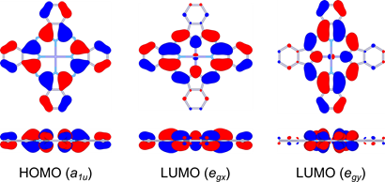
Fig. 3. Frontier MOs of ZnPc (front and side views)
Fig. 4. Arrangements of the monomers in slipped-stacked ZnPc dimers
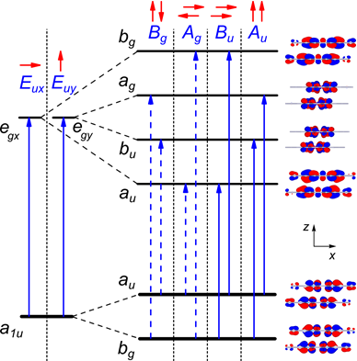
Fig. 5. Frontier MO splitting and Q-band transitions in slipped-stacked ZnPc dimers
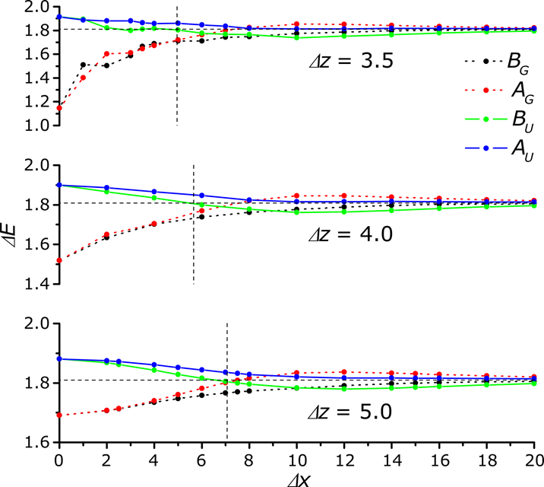
Fig. 6. TD-DFT Q-band transition energies vs. parallel shifts (Δx) between Pc molecules (arrangement in Fig. 4A). Forbidden transitions are shown by dashed lines
Angle dependence. For parallel transition dipoles, the dependence of the excitonic splitting on the angle θ (Fig. 2) is approximately described by the equation (1). With “face-to-face” arrangement, the allowed X-oriented B_{U} transition is blue-shifted, whereas the corresponding forbidden A_{G} transition is strongly red-shifted and can participate in non-radiative decay of the excitation energy. This explains why “face-to-face” dimers are non-fluorescent. For “slipped-stack” configurations with larger shifts (Δx), the allowed B_{U} transition becomes red-shifted with increasing shift and its energy drops below the corresponding A_{G} forbidden transition. This explains why “slipped-stack” and “edge-to-edge” dimers are fluorescent. The angle corresponding to zero splitting between B_{U} and A_{G} transitions corresponds to the angle of 54.7°, which is indicated by a vertical line in the Fig. 6.
As it is seen from the Fig. 6, there is a qualitative agreement between the TD-DFT results and the equation (1). At 3.5 Å interplane distance, the energy splitting dependence on the shift is nonuniform due to short-range effects of MO overlap (see below). These effects become negligible already at 4.0 Å distance. For edge-to-edge arrangement (Δz = 0), center-to-center distances r less than 16 Å are not possible which results in a very small excitonic splitting which is in agreement with the eq. (1). For “planar” dimer 2 this distance is 15.7 Å, and the predicted excitonic splitting is small. Thus, the near-absence of the redshift in edge-to-edge dimers 1 and 2 is simply explained by a large distance between transition dipole centres.
However, there is no quantitative agreement between TD-DFT transition energies and eq. (1) which can be further explained by short-range effects of π-MO overlap [36-40] (see below).
Distance dependence. As shown by Harcourt et al. [46] the excitonic interactions can be divided into long-range Coulombic interactions, Dexter's short-range exchange [47] and superexchange interactions derived from π-MO overlap [40]. Retaining only the Coulombic interactions leads to Kasha’s exciton model [22] often approximated as a point-dipole interaction (equation 1) which decays as 1/r³ whereas superexchange interaction depends on MO overlap which decays exponentially with distance.
Fig. 7. Distance dependence of the TD-DFT Q-band splitting of a face-to-face ZnPc dimer
To exclude influence of variable MO overlap, only perfect face-to-face and edge-to-edge arrangements were considered to study the distance dependence of the excitonic Q-band splitting. As it is seen from the Fig. 7, at larger Δz distances the splitting dependence is almost linear against 1/r whereas 1/r³ is expected from the eq. (1). A more detailed treatment of the Coulombic component of the excitonic coupling has been made using atomic charges obtained from the transition electrostatic potential fitting (TrESP charges) [48]. At larger distances, TD-DFT transition energy (ΔE) for dimers is well reproduced by a Coulombic interaction (ΔE_{Coul}) of monomers' transition charges. The TrESP Coulombic component is linear against 1/r rather than 1/r³, which can be explained by a short distance between the transition dipoles. Significant disagreement of TD-DFT transition energy and the predicted Coulombic component (Fig. 7) at shorter interplane distances (Δz) indicates a large impact of short-range effects on the excitonic coupling. Other noticeable effect is a non-symmetrical splitting at shorter distances (Fig. 2): the red shift of the A_{G} transition is larger than the blue shift of the B_{U} transition. This can be explained by a larger contribution of a lower-energy transition in the configuration of the excited state (Table S2). The red-shifted A_{G} transition is forbidden, therefore H-aggregates only show a blue-shifted Q-band. In crystals, the red-shifted Q-band absorption component often extends beyond 800 nm whereas the blue-shifted band is usually observed at 600 – 650 nm. For edge-to-edge arrangement (Δz = 0), the TD-DFT Q-band splitting is only 0.06 eV at Δx = 17 Å, and is purely Coulombic. Thus, moderate ~ 0.15 eV blue shift observed for H-aggregates is only a "tip of an iceberg", and the short-range intermolecular electronic interaction is much stronger than it can be expected from the experimental spectra. This can explain a well-known excited-state quenching in aggregated Pcs [11-13] and some properties of Pc-based molecular conductors [16] (since short-range excitonic coupling is related to electron- and hole-transfer integrals [11, 40]).
MO analysis. The π-π MO overlap results in splitting of HOMO and LUMO levels of the monomers as shown in the Fig. 8. HOMO and LUMO splitting pattern in the slipped-stack dimers is determined by a shape of the corresponding monomers’ orbitals [36, 40]. The MO overlap is responsible for short-range effects (see above) often expressed as charge-resonance/charge-transfer (CR/CT) excitons [11, 40]. MO overlap and, as a consequence, [40, 49] charge-transfer integrals are very sensitive to intermolecular arrangement which results in a great variability of photophysical and electric properties [1-3, 15, 40, 50] of crystalline modifications of phthalocyanines.

Fig. 8. Shift (Δx) dependence of HOMO (a_{1u}) and LUMO (e_{gx}) splitting for ZnPc dimers at Δz = 3.5Å
Fig. 9. Distance dependence of HOMO and LUMO splitting for face-to-face ZnPc dimers (Δx = 0)
Parallel shift between Pc molecules in the dimer results in oscillations of the split MO levels with different periodicity for HOMO and LUMO, as a result of different nodal patterns of the monomers’ HOMO and LUMO (see Fig. 8, Fig. 4) [36]. The splitting generally decreases with the shift due to decreasing overall π-MO overlap. The distance dependence of the splitting is exponential as a result of the exponential decay of π -MO overlap (Fig. 9). This is in contrast to 1/r dependence of the TD-DFT transition energies at larger distances. Therefore, at distances > 4Å where MO splitting becomes negligible, the TD-DFT transition energies still show a non-zero excitonic splitting as a result of Coulombic coupling of the monomers’ transition dipoles.
Size dependence. Previously, optical gaps of π-conjugated Zn(II) oligoPcs were extrapolated to a 1D-polyPc using a free-electron approximation (E vs. 1/N) [42] which is only applicable for delocalized systems [51]. For typical molecular crystals, orbital and optical gaps may differ significantly [52], therefore extrapolation of TD-DFT optical gaps of oligomers can be a better estimate to the optical gap of an infinite stack than the orbital gap directly calculated in periodic boundary conditions.
According to a simplified tight-binding model including only nearest-neighbour interactions [36, 37], the band dispersion (width of HOMO or LUMO band) for N-meric stack is described by the following equation:
ΔE = ± 2J cos[π / (N + 1)], (2)
with coupling factor J being either J_{Coul} or J_{CT} for Coulombic or charge-transfer excitonic coupling, respectively. As it was shown by Bredas et al., the MO band edges are linear against cos[π / (N + 1)] for phthalocyanines and other molecular semiconductors [36]. Similar extrapolation was also applied for optical gaps of oligothiophenes [53].
The excitonic splitting of two Q-band transitions results in 2·N transitions for the N-meric ZnPc. The TD-DFT spectrum is dominated by two x- and y-oriented transitions (A_{ux} and A_{uy}, respectively, see Fig. 3) which corresponds to all monomers' transition dipoles (Fig. 5) pointing in the same direction. All other transitions are of zero or low intensity (f < 0. 02).
The equation (2) can be used to predict excitonic splitting of optical spectra for infinite stacks in crystals.

Fig. 10. Size dependence of main TD-DFT Q-band transition energies of slipped-stacked ZnPc oligomers (resembling β-ZnPc stacks)
To study size dependence of the excitonic splitting, larger aggregates (stacks) were calculated with the arrangements approximately resembling β-modification of ZnPc (translation vectors taken from the X-Ray structure [54]). As no single-crystal X-Ray structure is available for α-ZnPc, stacks with Δz of 3.3 – 3.4Å and Δx of 1.75 – 2.0Å along Zn-N bond (Fig. 4A) were studied (Zn–Zn distance 3.75 – 3.95 Å, inclination angle 28 – 31°, see Fig. 2). The results are shown in the Fig. 10 and the Table S3. As it is seen from the Fig. 10, the TD-DFT Q-band splitting is almost linear against cos[π/(N+1)] for N = 1…5 in agreement with the eq. (2). This indicates that excitonic splitting of the Q-band is mainly determined by nearest-neighbour interactions. The extrapolated to N = ∞ transition energies of 1.97 eV (630 nm) and 1.72 eV (720 nm) for single stack of β-modification are close to the experimental values (Fig. 2) of 1.94 eV (640 nm) and 1.65 eV (750 nm). Oscillator strengths increase almost linearly with size (Fig. S3), with extrapolated ratio of 1:1.52 which is also in agreement with the experimental spectrum (Fig. 2). Our estimates of the Q-band splitting for α-ZnPc vary from 0.06 eV (23 nm) to 0.16 eV (55 nm) (Table S4), i.e. very small changes of intermolecular arrangement result in significant changes of the Q-band splitting. This explains why Zn(II), Ni(II) and Cu(II) Pcs have different solid-state spectra despite very similar crystal structures [38]. The approximate agreement between extrapolated and experimental spectra of β-ZnPc confirms that crystal spectra are determined mainly by excitonic coupling within the stack. For more quantitative description, next-nearest-neighbour and inter-stack couplings should also be considered [38].
Conclusions
Excitonic coupling of the electronic transitions in a series of zinc(II) phthalocyanine dimers was studied by TD-DFT with a range-separated hybrid functional LC-BLYP. This method correctly reproduces the experimental excitonic shifts of the Q-band for known "rigid" non-conjugated binuclear phthalocyanines.
The near-absence of the expected excitonic redshift of the Q-band for "edge-to-edge" Pc dimers is a result of large distance between transition dipole centres (weak Coulombic coupling) and absence of π-MO overlap (no short-range coupling). In contrast, slipped-stacked arrangement of the Pc rings in dimers and crystals results in strong redshifts of the Q-band due to π-MO overlap and short-range excitonic coupling.
The Kasha's point-dipole approximation (eq. (1)) is qualitatively applicable although 1/r³ is actually a superposition of 1/r for Coulombic coupling and e^{-r} for short-range coupling.
Short-range excitonic coupling is highly sensitive to intermolecular arrangement due to a complicated HOMO-LUMO nodal pattern which determines the bonding/antibonding character of the π-MO overlap.
The well-known ~ 50 nm (~ 0.15 eV) blue shift of the Q-band of "face-to-face" Pc dimers (H-aggregates) is only a "tip of an iceberg": the red-shifted (by ~ 0.65 eV) forbidden subband is not observed in the optical spectra but such a strong excitonic coupling undoubtedly influences other important properties.
The excitonic splitting of the Q-band can be extrapolated from Pc oligomers to an infinite 1D-stack, in the frame of the tight-binding approximation (eq. (2)). This approach can be further extended to include next-nearest-neighbour and inter-stack couplings for predicting optical spectra of crystalline phthalocyanines.

Author contributions
We strongly encourage authors to include author contributions and recommend using CRediT for standardised contribution descriptions. Please refer to our general author guidelines for more information about authorship.
Conflicts of interest
In accordance with our policy on Conflicts of interest please ensure that a conflicts of interest statement is included in your manuscript here. Please note that this statement is required for all submitted manuscripts. If no conflicts exist, please state that “There are no conflicts to declare”.
Data availability
A data availability statement (DAS) is required to be submitted alongside all articles. Please read our full guidance on data availability statements for more details and examples of suitable statements you can use.
Acknowledgements
The acknowledgements come at the end of an article after the conclusions and before the notes and references.
Notes and references
‡ Footnotes relating to the main text should appear here. These might include comments relevant not central to the matter under discussion, limited experimental and spectral data, and crystallographic data.
§
§§
etc.

- Citations should appear here in the format A. Name, B. Name and C. Name, Journal Title, 2000, 35, 3523; A. Name, B. Name and C. Name, Journal Title, 2000, 35, 3523.
- …
We encourage the citation of primary research over review articles, where appropriate, in order to give credit to those who first reported a finding. Find out more about our commitments to the principles of San Francisco Declaration on Research Assessment (DORA).
Formatting – please delete this box prior to submission
- Our template aims to give you an idea of what your article will look like, however the final version will be formatted in our house style and may look different.
- Please consult the Styles menu for recommended formatting for all text, including footnotes, references, tables, images and captions.
- Text should not be wrapped around graphics.
During production:
- Graphics, including tables, will be located at the top or bottom of the column following their first citation in the text. Graphics can be single column or double column as appropriate and require captions.
- Equations will be placed in the flow of the text.
- Sufficient space will be inserted around graphics for clarity of reading; a horizontal bar will also be used to separate all inserted graphics, tables and their captions from the text.
If you are experiencing difficulty using our template, please consult our ‘Using the Template’ guide, found here.

