π-Electron delocalization and electronic transitions in oligomeric and polymeric phthalocyanine zinc(II) complexes
Part 1 Linear oligo- and one-dimensional polyphthalocyanines
Sergei G. Makarov^{*a}, Günter Schnurpfeil^{b}, Sergey Yu. Ketkovª and Dieter Wöhrle^{*b∆}
ªG.A. Razuvaev Institute of Organometallic Chemistry of RAS, Tropinin str. 49, 603950 Nizhniy Novgorod, Russia
^{b}Universität Bremen, Institut für Angewandte und Physikalische Chemie, P.O. Box 330440, 28334 Bremen, Germany
Received
Accepted
ABSTRACT: In this Part 1 1D-linear oligomeric phthalocyanine zinc(II) with fully annulated (fused) phthalocyanine macrocycles are described. By semi-empirical and DFT computational methods UV/Vis/NIR spectra including energy gaps are thoroughly evaluated. The long wavelength Q-band of the oligophthalocyanines is compared with the long wavelength absorption band of analogous oligoacenes consisting of annulated benzene rings. In addition, graphene nanoribbons are considered. Especially interesting is the aromaticity under consideration of the Clar´s rule. Therefore it is the aim to get information about the extent of π-electron delocalization in such linear or semi-linear systems. Finally, the results of linear oligophthalocyanines are extrapolated to estimate the energy gap of 1D linear polyphthalocyanine by DFT, and the result is compared to the DFT calculation of the periodic structure with a plane-wave basis set. Part 2 will describe non-linear oligo- and two-dimensional polyphthalocyanines.
KEYWORDS: linear oligophthalocyanines, polyphthalocyanine, oligoacenes, polyacene, π-electron delocalization, optical gap, electronic transitions, time-dependent DFT
*Correspondence to: Sergei G. Makarov, tel: +7 831-4627370, email: makarsg@mail.ru and Dieter Wöhrle, tel: +49 421-
63135, email: woehrle@uni-bremen.de
∆SPP full member in good standing
INTRODUCTION
Phthalocyanines (Pc) have found many "real" applications as colorants and in electronic devices [1, 2]. The reason is the structural diversity of the molecule and their different arrangements in the solid state. In this context also the electronic situation in phthalocyanine molecules is of interest. The phthalocyanine 1a consists of a dianonic ligand and a central cavity containing two protons or various metal and metalloid cations. The ligand exhibit a pronounced aromatic character according to the Hückel rule with 18 π electrons in the inner ring with 16 atoms (dashed line in 1b) and 42 π electrons in the whole outer ring with 40 atoms (continuous line in 1b). Chemically, the aromaticity is demonstrated by several electrophilic substitution reactions occurring at peripheral positions of the annulated benzene rings. Physically, this is clearly evident from ¹H NMR spectra [3c, 4], and it was also confirmed by DFT calculations of a nucleus-independent chemical shift (NICS) [5] and ring currents [5d,e]. High thermal and chemical stability of phthalocyanines [1, 2] is another qualitative confirmation.
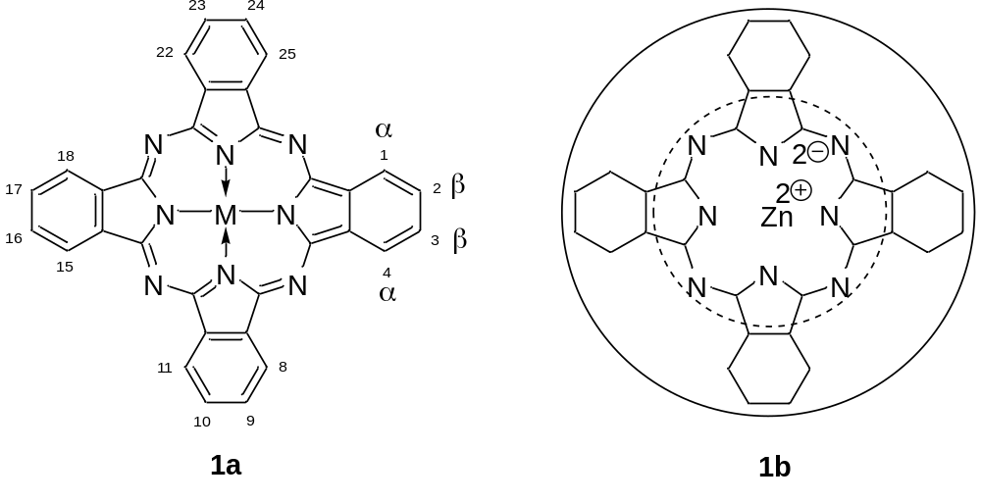
Several papers describe the electronic structure of mononuclear Pcs mainly using ZINDO and DFT techniques (for some exemplarily selected publications see [3]). Pcs show intense π→π* transitions in the visible region of absorption spectra. It became clear that the energies of the electrons in the highest occupied molecular orbitals (HOMO), the energies of the lowest unoccupied molecular orbitals (LUMO) and distribution of the electron density across the macrocyclic ring are controlled by the π-system. In the following, phthalocyanine zinc(II) complexes (ZnPc) will be selected because for the diamagnetic Zn(II) ion of closed d-electron configuration - in contrast to paramagnetic metal ions - ligand to metal and metal to ligand charge transfer bands are eliminated which simplifies analysis of the electronic transitions. For mononuclear ZnPc, the HOMO-LUMO transition corresponding to the Q-band at λ = 699 or 661 nm and two prominent transitions in the B-band region at 292/278 nm were calculated by the PM3 or ZINDO/S methods [3e,f]. The values are in approximate agreement with the experimental results of λ = 671 and λ = 349 nm, respectively, measured in THFsolution [3e] (λ = 661 nm in the vapor phase [3f,h]). On going from porphyrins to Pcs the change of methin-CH in the meso positions against aza-N and annelation of four benzene rings split the nearly degenerate HOMO to the a_{1u} and a_{2u} orbitals. Therefore a reduced mixing between Q and B excited states exists, and the Q-band shifts to the red and gains significant in intensity [3c]. According to the "four-orbital" model introduced by Gouterman [3g, 6] different degrees of configuration interactions are considered between single-electron excitations from a_{1u} (HOMO), a_{2u} (HOMO-1) and e_{g} (LUMO, LUMO+1) orbitals. The Q-band region originates from the a_{1u} → e_{g} transition and the B-band region - predominantly - from the a_{2u} → e_{g} transition.
Now it is interesting to consider the electronic structure and the resulting transitions in enlarged aromatic π-systems of phthalocyanines. This Part 1 describes linear oligomeric phthalocyanine zinc(II) complexes (linear oligoPcZn), which means the systems with fully annulated (fused) phthalocyanine macrocycles, as model compounds for a 1D polymeric (polynuclear) phthalocyanine zinc(II) complex (1D polyPcZn) 2. In Part 2 non-linear oligomeric phthalocyanines and 2D polymeric phthalocyanine will be analyzed in detail [7].
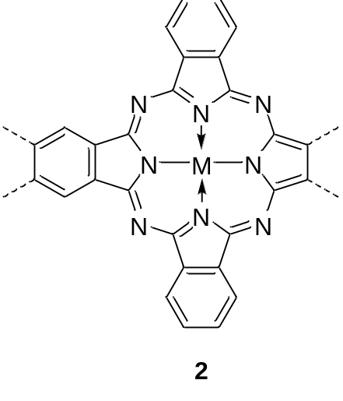
Investigations of oligomeric (oligonuclear) ZnPcs clearly indicate that π-electron delocalization caused by annulation of Pc rings results in a long wavelength shift of the Q-band and an increase of the molar extinction coefficient (for recent reviews see [8]). Table 1 shows the shift of the Q-band from the monomolecular dissolved mononuclear ZnPc 3 absorbing at λ = 674 nm, then to the dinuclear Zn₂Pc 4 absorbing at 840 nm and then to the linear trinuclear Zn₃Pc 5 absorbing at λ = 942 nm [9]. In each case the position of the B-band is not affected. These red shifts were explained by semi-empirical [3e, 9b], DFT [10a], and SAC-CI [10b] methods. A simple model of π-electron delocalization was proposed [3c] qualitatively describing π-MOs of dinuclear [3e] and trinuclear [9b] Pcs as linear combinations of the corresponding "mononuclear" π-MOs.
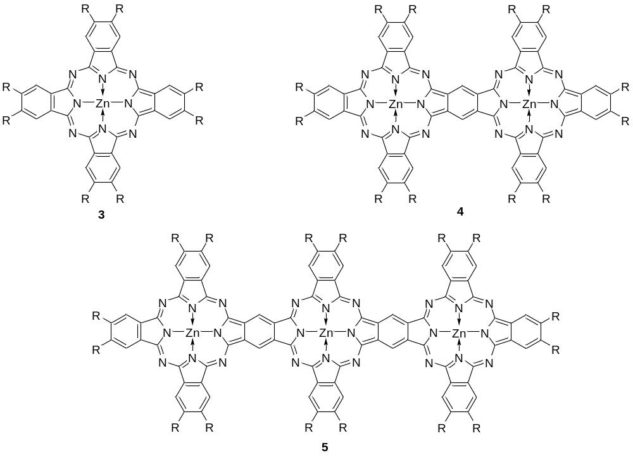
< Table 1 >
From the synthetic point of view it is difficult to prepare and separate oligomers with the number of annulated Pc rings larger than 3 as in the case of Zn₃Pc 5. The oligomers are prepared by a statistical cyclotetramerisation from a mixture of TCB, a phthalonitrile derivative and a metal salt under formation of various products. The higher is the degree of annulation the lower will be the product yield. However higher oligomers would be important for investigations of the annulation degree influence on the position of the main absorption bands. On the other hand, polyPcs are insoluble in organic solvents so the maximum extent of the π-electron delocalization of a single polymeric molecule cannot be studied. Therefore it is the objective of this paper to obtain information on the electronic situation in linear 1D oligomeric ZnPcs and 1D polymeric ZnPc by PM3, ZINDO/S and DFT calculations which provide theoretical descriptions of the π-electron delocalization.
COMPUTATIONAL METHODS
For the semi-empirical calculations the Hyperchem 7.1 program [11a] was used. All ground-state compounds were optimized by the PM3 method [11b] (the Polak-Ribiere Algorithm and the RMS gradient of 0.001 kcal Å⁻¹ mol⁻¹). The following parameters were used: Total charge: 0; spin multiplicity: 1; spin pairing: RHF; state: lowest; convergence limit: 0.00001. To calculate the UV/vis spectra the ZINDO/S method [11c] was employed with the parameters: Total charge: 0; spin multiplicity: 1; spin pairing: RHF; state: lowest; convergence limit: 0.00001; overlap weighting factors: sigma-sigma: 1.267; Pi-Pi: 0.585. The parameters for the configuration interaction calculations are: CI method: singly excited; energy criterion (maximum excitation energy): 7 eV. The resulting numbers of configurations are listed in Table S1.
DFT geometry optimizations were performed by the Firefly 8.2.0 program [12a] which is partially based on the GAMESS (US) [12b] source code. B3PW91 hybrid functional [13] and 6-31G(d) (6d, 7f) basis set [14] were used for all optimizations with default convergence criteria and (99, 590) pruned grid (NRAD = 99, LMAX = 41). The method was chosen from the comparison of the optimized geometries of naphthalene and ZnPc with those obtained from gas-phase electron diffraction and/or X-Ray experiments, or calculated with higher-level methods [15, 16]. The PM3-optimized structures (usually C₁ or C_{2v}) were selected as starting geometries. If a higher symmetry was detected during optimization within the 0.01 threshold then optimization was continued on the symmetrized geometry. The UV/Vis/NIR spectra were calculated by TD-DFT using the range-separated LC-BLYP functional [17] with µ = 0.4 together with the Def2-TZVP(-f) basis set [18a] as implemented in the ORCA 4.0.0.2 program [19a-c]. The RIJCOSX approximation (the resolution of identity for Coulomb integrals, the chain of spheres for exchange integrals) [19d-f] was employed with the Def2/J auxiliary basis set [18b], standard grids "grid5" and "gridx5", and default SCF convergence criteria. For enthalpy calculations, the geometries and frequencies were calculated by the Firefly 8.2.0 program with the B3PW91 functional, 6-31G(d,p) (6d, 7f) basis set, (99,590) pruned grid (NRAD = 99, LMAX = 41), and double number of displacements for seminumerical frequency calculations (NVIB=2). The RI-SCS-MP2 energy [19g,h] was calculated by the ORCA 4.0.0.2 program using the Def2-TZVPP basis set [18a], the Def2-TZVPP/C auxiliary basis set [18c] and the tight SCF convergence (10^{–8} Eh threshold). Calculations of the 1D periodic structure were performed as described earlier [3j] by Quantum Espresso 6.2 [20] with the PBE functional [21] and ultrasoft Vanderbilt pseudopotential [22], E_{cut} = 35 Ry; E_{rho} = 420 Ry. The number of k-points per translational unit with uniform automatic Monkhorst–Pack grid was 8×1×1. The "vacuum" spacing of 15 Å was introduced along both y and z axes. The geometry was optimized with constrained size of the cell, and the latter was optimized manually with the 0.01 Å increment.
RESULTS AND DISCUSSION
The unsubstituted zinc oligophthalocyanines of 1 – 7 size 6a – 6g, respectively, were calculated by semi-empirical (ZINDO-S // PM3) and DFT (LC-BLYP // B3PW91) methods. All DFT-optimized geometries have D_{2h} symmetry with a Zn-Zn distance of 10.70 Å; the PM3-optimized geometries have either C₁ or C_{2v} symmetry with a Zn-Zn distance of 10.82 Å. A range-separated hybrid functional was chosen for calculating electronic spectra because this type of functionals often performs well for TD-DFT calculations of phthalocyanines [23] and other large π-conjugated molecules [24] although less successful for higher excited and/or charge-transfer states [23a].
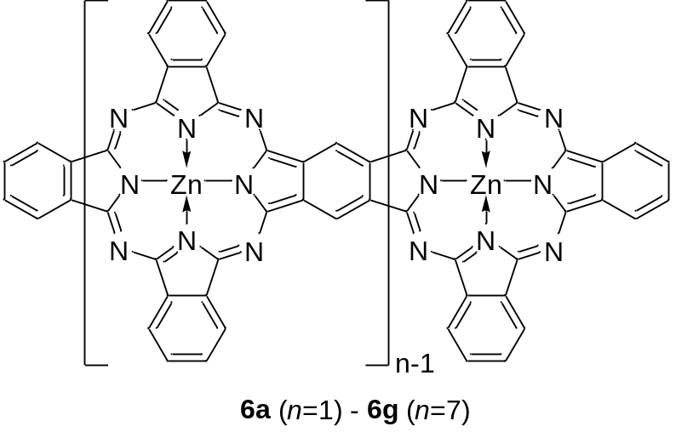
The wavelength of the lowest-energy transition increases with the number of Pc rings, as shown in Fig. 1 and in Table 2. The oscillator strength increases as well. The experimental parameters for the substituted analogues 3 – 5 of 6a – 6c, respectively, are listed in Table 1. Fig. 2 shows the calculated absorption spectra of 6a – 6d and for comparison the experimental spectra of 3 – 5 [8a, 9b] as dashed lines. It is known that the Q-band of phthalocyanines is not significantly solvent- and substituent-dependent, with only a few exceptions such as alkylthio-substituted and α-substituted Pcs [25], e.g. the Q-band maximum of ZnPc lies at λ = 670 nm in DMSO [25d] and at λ = 661 nm in the gas phase [3f,h]. The Q-band position of the substituted 6b derivatives is at λ = 835 – 850 nm for various solvents and substituents [8, 9, 26], but no gas-phase spectrum is available. Therefore no significant error should result from the comparison of the calculated gas-phase spectra of unsubstituted ZnPcs 6a – 6c to experimental solution spectra of the substituted 3 – 5. For 6a and 6b all computational methods give similar results but the differences become significant as the Pc size increases. For the B3PW91 optimized geometries, ZINDO/s underestimates the transition energies whereas the values obtained by TD-DFT with the range-separated LC-BLYP functional are close to the experimental energies obtained for the substituted analogues of 6a – 6c in solution [9b]. For the PM3 geometries, the ZINDO/s wavelengths quickly reach a λ ≈ 900 nm (E ≈ 1.4 eV) limit. This means that for larger oligoPcs accurate geometry optimization is more important for a correct π-electron delocalization description than for mononuclear [3, 23] and binuclear [3e, 10a] Pcs.
< Fig. 1 >
< Fig. 2 >
< Table 2 >
Generally, for conjugated oligomers, the optical gap either approaches a constant value or vanishes as the number of monomeric units increases. In the former case, the infinite chain of the corresponding conjugated polymer is either an insulator or a semiconductor, and in the latter case it is a metal. For linear oligophthalocyanines 6 (Table 2), the Q-band transition energy is likely decreasing to a finite value: for example, ΔE = 0.32 eV between 6a and 6b and only ΔE = 0.03 eV between 6f and 6g as calculated by TD-DFT LC-BLYP/Def2-TZVP(-f). From this tendency, we assume that linear polyPcZn 2 may have a small but a non-zero band gap.
< Fig. 3 >
Fig. 3A contains the partial MO diagrams including n occupied and 2n unoccupied energy levels of 6a – 6f (n is the number of the Pc units). The nearly degenerate MOs are shown as degenerate. The corresponding HOMO and LUMO energies are listed in the Table 3. These sets of MOs, which can be qualitatively described as linear combinations of HOMO (a_{1u}) and LUMOs (e_{gx}, e_{gy}) of the mononuclear Pc units [3e], are responsible for the Q-band transitions. As it can be seen, energy level splitting in these MO series is large for 6b and 6c [8a] but nearly equal for 6f and 6g which means the extent of π-electron delocalization is limited for larger 1D-oligoPcs. The lowest-energy Q-band of 6a corresponds to a nearly pure HOMO-LUMO transition. Increasing number of closely-lying MOs makes the corresponding excited states less "pure", i.e.the electronic transitions involve several combinations of the occupied MO → vacant MO excitations (Table 2).
< Table 3 >
Oligoacenes [24a,b, 27] consist of annulated benzene rings and they can be considered as analogues of linear oligophthalocyanines. Therefore the oligoacenes 7a – 7k are discussed below and the electronic properties are compared with oligoPcs.
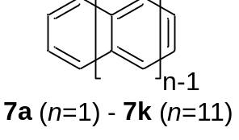
To obtain comparable theoretical results, the wavelengths of the L_{a} (HOMO-LUMO) [27e,h,r-x] transitions in 7a – 7k were computed in this work at the same level of theory as those used for 6a-6g. The calculated and experimental [27e,h,r-x] wavelengths are plotted in Fig. 4, and the values are listed in Table 4. TD-DFT with range-separated LC-BLYP functional leads to a good agreement with the experimental values for smaller oligoacenes. A similar trend was described previously [24a,b]. The semi-empirical treatment shows a good agreement for smallest oligoacenes but overestimates the excitation energy for n > 3. Unlike the Q band in oligoPcs, the La oscillator strength does not increase on going from 7a to 7k, and the transition corresponds to a nearly "pure" HOMO-LUMO excitation for each oligoacene.
< Fig. 4 >
< Table 4 >
Similar to oligoPcs, the wavelength of the lowest-energy transition in oligoacenes increases with the number of annulated rings. However, in contrast to 6a - 6g, for oligoacenes up to 7g the growth is linear (Fig. 4, Table 4). This seems to correspond to a nearly zero band gap of polyacene and resembles the well-known 1/n level spacing of the particle-in-a-box model. The λ or ΔE ratio between 7a and 7g is approx. 4 whereas between 6a and 6g it is only 1.67. Therefore the red shift of the absorption band is much smaller in the oligoPc series compared to the oligoacene series. The HOMO-LUMO gap (HLG, Figure 3B, Table 3) in oligoacenes also decreases more steeply than in oligoPcs. Thus, compared to oligoPcs, a more efficient π-electron delocalization occurs in oligoacenes. Oligoacenes 7h-k were obtained only by the matrix isolation technique [27e,h], or generated on a surface [27f,g], and their electronic structure was studied by UV/Vis spectroscopy and scanning tunneling spectroscopy (STS), respectively. The wavelength increase in the Ar matrix is also linear up to 7f and then it slows down which may indicate a change in the electronic structure. Similar trend was observed for transport gaps by scanning tunneling spectroscopy [27g]. The electronic structure of oligoacenes was extensively studied [27], but the results are controversial. CASSCF-DMRG [27b] and broken-symmetry DFT [27c,d] studies of larger oligoacenes predict their polyradical nature with "one unpaired spin with every five to six rings" [27b], and antiferromagnetic coupling is taking place. Another study by DFT [27a] shows that HLG drops down quickly up to the size n = 10, and then it starts to oscillate. Calculations by multireference methods such as CASSCF [27i], SF-EOM-CCSD [27j], DFT/MRCI [27e,k], GASPDFT [27l] and MR-AQCC [27m] reveal the multiconfigurational character of the ground states of larger oligoacenes, with increasing weight of open-shell and/or doubly excited configurations. Despite quantitatively controversial results most of the multireference methods agree qualitatively on the multiconfigurational character of the ground state of oligoacenes and on its polyradical nature, which increases with the system size [27p]. It is interesting to note that substituted nonacenes are NMR-silent [27n] which is often observed for Kekulé singlet biradicals such as teranthrene [28a], pentacenopentacene [28b], fused bisphenalenyls [28c] and ring-oxidized binuclear Pcs [26b]. Single-reference DFT calculations (Figure 4) cannot describe multireference states; this may explain why the calculated linear increase of the wavelength persists up to 7k. A similar trend was observed by pp-RPA method [27o]. Unlike polyacene, its extended analogues i.e. zigzag-edged graphene nanoribbons (ZGNR) 8 [29a] are known experimentally. They show semiconducting behavior with a band gap of ΔE = 1.5 eV for 6-ZGNR (where 6 is the number of zigzag carbon chains) and they also have a polyradical nature. Theoretical studies [29] predicted band gap values of 0.8 to 1.5 eV for 12- to 24-ZGNR. Note that graphene itself is a zero-gap semimetal [30].
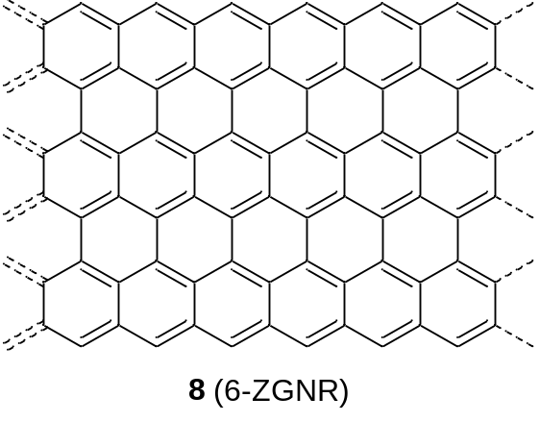
The lesser extent of the π-electron delocalization in linear oligoPcs compared to oligoacenes can be visualized using density difference maps [31] of the lowest-energy π-π* transitions (Fig. 5). In the case of oligoacenes, the entire π-system is involved whereas for oligoPcs the transition is more localized, and only a part of the π-system is "active". But oligoPcs with the same number of annulated rings as oligoacenes are absorbing at longer wavelength due to a larger number of π-electrons. This may not be correct for a larger n (see discussion above).
< Fig. 5 >
The rapid decrease of the optical gap and decreasing stability of oligoacenes are qualitatively explained by the Clar’s rule [32a,b]. There is only one aromatic sextet in the resonance structures of any oligoacene 7 (Fig. 6), therefore higher oligoacenes are essentially polyenes. This is in contrast to a hypothetical planar oligophenylene 9 where all benzene rings are aromatic. In the case of 9, π-electron delocalization is unfavorable since it is only possible by transforming some of the benzene rings into the non-aromatic quinoidal form. Other types of polyarenes include ZGNR 8 (extended polyacene), "armchair"-edged graphene nanoribbons 3p-AGNR 10 (extended polyphenylene), (3p+1)- and (3p+2)-AGNR, where p is the number of linear carbon chains. Large band gaps are typical for "all-aromatic" 3p-AGNR (1.69 eV for 10, and 1.03 eV for p = 5) [33b] and "phenacene-type" (3p+1)-AGNR [33a]; smaller band gaps were obtained for (3p+2)-AGNRs [32c] whose "partially aromatic" Clar’s structure is a combination of polyacene and polyphenylene [32d]. A similar trend of larger band gaps for more aromatic conjugated oligomers and polymers was reported previously [33e,f].
< Fig. 6 >
It is not obvious how to draw the Clar’s structures for phthalocyanines. The aromaticity of a phthalocyanine is usually described by a well-known Gouterman’s model [6] (originally proposed by K. Lonsdale [34]) including four benzene sextets and an octaaza[16]annulene ring in the centre (Fig. 7A) with 18 π-electrons for Pc(-2). Another model commonly used for porphyrins was first proposed by Rabinowitch [35], and further confirmed by calculations of ring currents [5e,36] and by comparison of NMR spectra of porphyrins, reduced porphyrins and dideazaporphin [37g,h]. It includes a (hexaaza)[18]annulene fragment with 18 π-electrons as the main macrocyclic aromatic circuit (Fig. 7B). The second model is in better agreement with the chemistry of porphyrins and porphyrazines because only one or two double bonds (or benzene rings in the case of Pcs) can be seamlessly excluded from conjugation leading to chlorins, bacteriochlorins, isobacteriochlorins [37b,c] or their azasubstituted and benzoannulated analogues [37a,d,e]. Higher hydroporphyrins are either not known or unstable due to lack of macrocyclic aromaticity [37c,f,g]. In the case of Pcs the hexaaza[18]annulene ring is fused with two of four benzene rings and only two other benzene rings remain aromatic (Fig. 7B). This model is qualitatively confirmed by the strong decrease of the HOMO-LUMO gap going from tetraazaporphyrins to phthalo-, naphthalo- and then to anthracenocyanines [3c,d]. A recent study [5d] has shown that the macrocyclic ring current of phthalocyanines also involves the benzene rings. As it was shown by topological analysis of the resonance energy [36a], macrocyclic aromaticity of porphyrinoids is a sum of contributions from all possible macrocyclic circuits i.e. 16- to 20-membered rings. Therefore the macrocyclic aromaticity of the Pc ring may not be described by a single-circuit model (Fig. 7) but rather as their combination. As it was shown by Steiner and Fowler [5e], even single-MO contributions to aromatic ring currents of porphyrins are delocalized over all 24 atoms of the macrocycle instead of following either [16]-annulene or [18]-annulene ring. Therefore we assume Clar’s structure of a Pc as a combination of those shown in Fig. 7.
< Fig. 7 >
Obviously, the π-system of 1D-PolyPcM 2 can be described as a repeating π-system of tribenzotetraazachlorin (Fig. 8A). According to Gouterman’s model [6, 34], Clar’s structure of 1D-polyPcM as shown in Fig. 8A is analogous to the Clar’s structure of polyphenylene with localized aromatic benzene sextets and octaaza[16]annulene rings connected by essentially single bonds. According to the Rabinowitch’ model [35] (Figure 8B), the structure with all aromatic Pc rings can also be drawn but with only one benzene sextet per Pc ring. The latter description is between "partially aromatic" AGNRs of 3n+2 type with small band gaps [33d] and "completely aromatic" 3n-AGNRs with large band gaps [33b]. From our calculations (Fig. 1, Table 2) it can be concluded that Clar’s structure of 1D-polyPc should be intermediate between polyacene with an efficient π-electron delocalization and polyphenylene with weak delocalization since the Q-band wavelength of 6a-g is likely increasing with size to a finite value. These results agree with the "partially aromatic" Rabinowitch’ model (Fig. 8B) better than with the "all-aromatic" Gouterman’s model (Fig. 8A).
< Fig. 8 >
Additional insights into the π-electron delocalization in linear oligoPcs can be provided by analysis of stability of the shared benzene rings in the hydrogenation reactions. It is well known that the central benzene ring of anthracene (and of higher oligoacenes) is unstable and easily undergoes addition reactions resulting in 9,10-dihydroanthracene derivatives [32a, 38]. The central benzene ring of 6b also connects two aromatic systems, and the π-electron delocalization should destabilize this ring as well. If the central benzene ring of 6b was connected to 18π-annulenes of the Pc rings by essentially single bonds (Fig. 7A) there should be no significant destabilization. According to [35] (Fig. 7B), the central benzene ring of 6b should be slightly destabilized compared to PcZn 6a because its saturation (e.g. by hydrogenation) would increase the number of benzene sextets (4 vs. 3), assuming that all Pc rings are aromatic. The calculated gas-phase hydrogenation enthalpies (Table 5) can be considered as criteria of the ring stability. Due to small energy differences the higher-accuracy method RI-SCS-MP2 was used [19g,h]. This method was chosen because it gives a good agreement (within 1 kcal/mol) of the calculated hydrogenation enthalpies of ethylene, benzene, naphthalene and anthracene with the experimental values or with those calculated by a higher-level method G2(MP2) [39].
< Table 5 >
As expected, benzene is the most stable against 1,4-hydrogenation whereas the anthracene central ring is the least stable. The stability of the ZnPc benzene rings against hydrogenation is between those of benzene and naphthalene. The central benzene ring of 6b is by 2 kcal·mol⁻¹ less stable than the benzene ring of 6a. These results agree well with the Clar’s description of 6a – 6b according to the Rabinowitch’ model [35] (Figure 7B). This slight destabilization of the central benzene ring is not enough to decrease the photostability of 4 compared to that of 3 [26d]. It is expected that in general oligo- and polyPcs are more stable than oligo- and polyacenes against chemical attack (for example by dioxygen). But the destabilized benzene ring between two annulated aromatic rings, for example in binuclear phthalocyanines, can be reduced as shown in 11a, and then the π-electron delocalization is interrupted. This is in agreement with the absence of NIR absorption in some earlier works on substituted binuclear phthalocyanines as described in our review [8a]. As we reported previously, a planar non-conjugated binuclear Pc 11b has the UV/Vis spectrum nearly identical to that of 3 [9c].
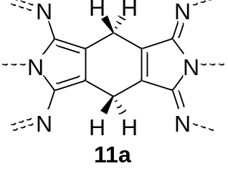
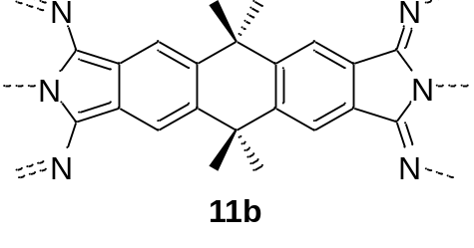
For the linear polyphthalocyanine zinc(II) complex, band gaps of ΔE = 0.90 eV (1380 nm) and ΔE = 1.04 eV (1190 nm) were obtained, respectively, by a linear extrapolation of the 6d – 6g TD-DFT optical gap in 1/n – ΔE coordinates and by an exponential extrapolation based on the 6b – 6g gap values (Table 2). Using the PBE functional [21] and a plane-wave basis set [22] as described previously for 2D-polyPcs [3j] a band gap of ΔE = 0.71 eV (1750 nm) was calculated in this work for the 1D-polyPcZn 2. The computed lattice parameter (Zn-Zn distance) is 10.77 Å for the geometry optimized by this method. The band gap is direct. This shows that polyPcZn 2 is a"small" band gap semiconductor which places this type of a conjugated polymer between the 3p- and (3p+2)-AGNRs [33] (see discussion above). Comparison with polyacenes would be more uncertain because of controversial estimations of the band gap in such systems - from near-zero [27a,f] to 1.23 eV [27e]. The linear extrapolation of the 1/n – ΔE dependence for anthracene-decacene [27e] gives the polyacene band gap of 0.4 eV which is smaller than that obtained for polyPc by the LC-BLYP method (0.9 eV).
CONCLUSION
By using different semi-empirical and DFT computational methods UV/Vis/NIR spectra including energy gaps of oligomeric phthalocyanine zinc (II) complexes and for comparison also oligoacenes were calculated. Especially DFT calculations with range-separated hybrid functional LC-BLYP are in good agreement with experimental spectra. For both systems the wavelength of the lowest-energy transition increases with the number of annulated rings more steeply for oligoacenes than for oligoPcs whereas the HOMO-LUMO transition energy approaches asymptotically a non-zero value. After electron density difference maps oligoacenes compared to linear oligoPcs exhibit a more delocalized π-electron system. But oligoPcs with the same number of annulated rings as oligoacenes are absorbing at longer wavelength due to a higher number of π-electrons. The π-electron delocalization in linear zinc(II) oligo- and one-dimensional polyphthalocyanines is comparable to that of armchair-edged graphene nanoribbons (AGNR) but less pronounced than in the case of oligoacenes and zigzag-edged graphene nanoribbons (ZGNR). The results are explained using density difference maps and Clar’s rule adapted for macrocyclic aromaticity. The energy band gap of the linear polyphthalocyanine zinc(II) complex was extrapolated using the optical gaps of oligophthalocyanines and calculated directly by DFT with a plane-wave basis set. The value of ΔE = 0.90 eV shows that the oligoPcZn is a"small" band gap semiconductor. Further, hydrogenation enthalpies of the bridging benzene ring of binuclear systems were calculated. The result is that the bridging benzene ring of a binuclear phthalocyanine is more stable against hydrogenation than the analogous bridging benzene ring of anthracene but less stable than a benzene ring of a mononuclear Pc. This is a hint for a better stability against chemical attack (for example by oxygen) of oligo- and polyPcs compared to oligo- and polyacenes. The model of Rabinowitch [35] is most preferable to describe the Pc macrocyclic aromaticity according to a 18-centered 18π-electron circuit.
Acknowledgement
DFT calculations were carried out within the frames of Russian State assignment (Theme 44.2, reg. No. AAAA-A16-116122110053-1). Semi-empirical calculations were carried out within the frames of DAAD East Partnership program.
Supporting information
Semi-empirically calculated electronic spectra of 6a – 6f, transition energy plots for 6a – 6g and 7a – 7k, calculated optical gaps of oligoacenes from literature and 1/n – ΔE plot for 6c – 6g, are given in the supplementary material. This material is available free of charge via the Internet at http://www.worldscinet.com/jpp/jpp.shtml
REFERENCES
1. (a) Erk E and Engelsberg H, Phthalocyanines Dyes and Pigments, In The Porphyrin Handbook, Vol 19, pp. 105-149, Kadish KM, Smith K and Guilard R (Eds.) Elsevier Science, San Diego, 2003. (b) Löbbert G, Phthalocyanines, In Ullmann’s Encyclopedia of Industrial Chemistry, Vol. A 20, pp. 213-241, VCH Publishers, Weinheim, 1992.
2. (a) Wöhrle D, Schnurpfeil G, Makarov SG, Kazarin A and Suvorova N. Macroheterocycles 2012; 5: 191-201. (b) Wöhrle D, Schnurpfeil G, Makarov SG and Suvorova ON. Chem Unserer Zeit 2012; 46: 12-24.
3. (a) Kobayashi N. J. Porphyrins Phthalocyanines 1999; 3: 453-467. (b) Stillman M, Mack J and Kobayashi N. J. Porphyrins Phthalocyanines 2002; 6: 296-300. (c) Kobayashi N, Mack J., Ishii K and Stillman MJ. Inorg. Chem. 2002; 41: 5350-5363. (d) Kobayashi N, Miwa H. and Nemykin VN. J. Am. Chem. Soc. 2002; 124: 8007-8020. (e) Kobayashi N and Ogata H. Eur. J. Inorg. Chem. 2004: 906-914. (f) Yuan SF and Chen ZR. J. Phys. Chem. A 2005; 109: 2582-2585. (g) Novakova V, Reimerova P, Svec J, Suchan D, Miletin M, Rhoda HM, Nemykin VN and Zimcik P. Dalton Trans. 2015; 44: 13220-13233. (h) Edwards L and Gouterman M. J. Mol. Spectrosc. 1970; 33: 292-310. (i) Martynov AG, Mack J, May AK, Nyokong T, Gorbunova YuG and Tsivadze AYu. ACS Omega 2019; 4: 7265–7284. (j) Sedlovets DM, Shuvalov MV, Vishnevskiy YV, Volkov VT, Khodos II, Trofimov OV and Korepanov VI. Mater. Res. Bull. 2013; 48: 3955-3960.
4. (a) Esposito JN, Sutton LE and Kenney ME. Inorg. Chem. 1967; 6: 1116-1120. (b) Janson TR, Kane AR, Sullivan JF, Knox K and Kenney ME. J. Am. Chem. Soc. 1969; 91: 5210-5214. (c) Zhang X, Kobayashi N and Jiang J. Spectrochim. Acta A 2006; 64: 526–531.
5. (a) Chen Z, Wannere CS, Corminboeuf C, Puchta R. and von Ragué Schleyer P. Chem. Rev. 2005; 105: 3842–3888. (b) Cissell JA, Vaid TP, DiPasquale AG and Rheingold AL. Inorg. Chem. 2007; 46: 7713-7715. (c) Gershoni-Poranne R and Stanger A. Chem. Soc. Rev. 2015; 44: 6597−6615. (d) Valiev RR and Cherepanov VN. Int. J. Quantum Chem. 2013; 113: 2563–2567. (e) Steiner E and Fowler PW. Chem. Phys. Chem. 2002: 114-116.
6. Gouterman M. J. Mol. Spectrosc. 1961; 6: 138-163.
7. Makarov S, Schnurpfeil G, Ketkov SYu and Wöhrle D, J. Porphyrins Phthalocyanines 2019, Part 2, in preparation.
8. (a) Makarov SG, Suvorova ON and Wöhrle D. J. Porphyrins Phthalocyanines 2011; 15: 791-808. (b) Kobayashi N. Coord. Chem. Rev. 2002; 227: 129-152.
9. (a) Makarov S, Litwinski C, Ermilov EA, Suvorova O, Röder B and Wöhrle D. Chem. Eur. J. 2006; 12: 1468-1474. (b) Makarov SG, Suvorova ON, Litwinski C, Ermilov EA, Röder B, Tsaryova O, Dülcks T and Wöhrle D. Eur. J. Inorg. Chem. 2007: 546–552. (c) Makarov SG, Maksimova KN, Baranov EV, Fukin GK, Suvorova ON, Wöhrle D and Domrachev GA. Russ. Chem. Bull. 2006; 55: 1748–1754.
10. (a) Litwinski C, Corral I, Ermilov EA, Tannert S, Fix D, Makarov SG, Suvorova ON, Gonzalez L, Wöhrle D and Röder B. J. Phys. Chem. B 2008; 112: 8466–8476. (b) Fukuda R and Ehara M. J. Chem. Phys. 2012; 136: 114304.
11. (a) HyperChem, rel. 7.1 Pro, Hypercube Inc., Gainesville, FL, USA, 2002 (b) Stewart JJP. J. Comp. Chem. 1989; 10: 209-220. (c) Zerner MC, Correa de Mello P and Hehenberger M. Int. J. Quantum Chem. 1982; 21: 251-259.
12. (a) Alex A. Granovsky, Firefly version 8.2.0, www http://classic.chem.msu.su/gran/firefly/index.html. (b) Schmidt MW, Baldridge KK, Boatz JA, Elbert ST, Gordon MS, Jensen JH, Koseki S, Matsunaga N, Nguyen KA, Su S, Windus TL, Dupuis M and Montgomery JA. J. Comput. Chem. 1993; 14: 1347–1363.
13. (a) Becke AD. J. Chem. Phys. 1993; 98: 5648-5652. (b) Perdew JP and Wang Y. Phys. Rev. B 1992; 45: 13244-13249.
14. (a) Hehre WJ, Ditchfield R and Pople JA. J. Chem. Phys. 1972; 56: 2257-2261. (b) Hariharan PC and Pople JA. Theor. Chem. Acc. 1973; 28: 213-222. (c) Rassolov VA, Pople JA, Ratner MA and Windus TL. J. Chem. Phys. 1998; 109: 1223-1229.
15. (a) Strenalyuk T, Samdal S and Volden HV. J. Phys. Chem. A 2007; 111: 12011-12018. (b) Ruan C, Mastryukov V and Fink M. J. Chem. Phys. 1999; 111: 3035-3041. (c) Scheidt WR and Dow W. J. Am. Chem. Soc. 1977; 99: 1101-1104.
16. (a) Baba M, Kowaka Y, Nagashima U, Ishimoto T, Goto H and Nakayama N. J. Chem. Phys. 2011; 135: 054305. (b) Fliegl H and Sundholm D. Phys. Chem. Chem. Phys. 2014; 16: 9859-9865.
17. (a) Becke AD. Phys. Rev. A 1988; 38: 3098-3100. (b) Lee C, Yang W and Parr RG. Phys. Rev. B 1988; 37: 785-789. (c) Iikura H, Tsuneda T, Yanai T and Hirao K. J. Chem. Phys. 2001; 115: 3540-3544.
18. (a) Weigend F and Ahlrichs R. Phys. Chem. Chem. Phys. 2005; 7: 3297-3305. (b) Weigend F. Phys. Chem. Chem. Phys. 2006; 8: 1057-1065. (c) Hättig C. Phys. Chem. Chem. Phys. 2005; 7: 59-66.
19. (a) Neese F. Wiley Interdiscip. Rev.: Comput. Mol. Sci. 2012; 2: 73–78. (b) Neese F. Wiley Interdiscip. Rev.: Comput. Mol. Sci. 2017; 8: e1327. (c) Neese F. Coord. Chem. Rev. 2009; 253: 526–563. (d) Dunlap BI. J. Chem. Phys. 1983; 78: 3140-3142. (e) Neese F. J. Comp. Chem. 2003; 24: 1740–1747. (f) Neese F, Wennmohs F, Hansen A and Becker U. Chem. Phys. 2009; 356: 98–109. (g) Feyereisen M, Fitzerald G and Komornicki A. Chem. Phys. Lett. 1993; 208: 359-363. (h) Grimme S. J. Chem. Phys. 2003; 118: 9095-9102. (i) Stoychev GL, Auer AA, Izsak R and Neese F. J. Chem. Theo. Comp. 2018; 14: 619-637.
20. (a) Giannozzi P, Andreussi O, Brumme T, Bunau O, Buongiorno Nardelli M, Calandra M, Car R, Cavazzoni C, Ceresoli D, Cococcioni M, Colonna N, Carnimeo I, Dal Corso A, de Gironcoli S, Delugas P, DiStasio Jr RA, Ferretti A, Floris A, Fratesi G, Fugallo G, Gebauer R, Gerstmann U, Giustino F, Gorni T, Jia J, Kawamura M, Ko H-Y, Kokalj A, Küçükbenli E, Lazzeri M, Marsili M, Marzari N, Mauri F, Nguyen NL, Nguyen H-V, Otero-de-la-Roza A, Paulatto L, Poncé S, Rocca D, Sabatini R, Santra B, Schlipf M, Seitsonen AP, Smogunov A, Timrov I, Thonhauser T, Umari P, Vast N, Wu X and Baroni S. J. Phys.: Condens. Matter 2017; 29: 465901. (b) Giannozzi P, Baroni S, Bonini N, Calandra M, Car R, Cavazzoni C, Ceresoli D, Chiarotti GL, Cococcioni M, Dabo I, Dal Corso A, Fabris S, Fratesi G, de Gironcoli S, Gebauer R, Gerstmann U, Gougoussis C, Kokalj A, Lazzeri M, Martin-Samos L, Marzari N, Mauri F, Mazzarello R, Paolini S, Pasquarello A, Paulatto L, Sbraccia C, Scandolo S, Sclauzero G, Seitsonen AP, Smogunov A, Umari P, Wentzcovitch RM. J. Phys. Condens. Matter 2009; 21: 395502.
21. (a) Perdew JP, Burke K and Ernzerhof M. Phys. Rev. Lett. 1996; 77: 3865-3868. (b) Perdew JP, Burke K and Ernzerhof M. Phys. Rev. Lett. 1997; 78: 1396.
22. Vanderbilt D. Phys. Rev. B 1990; 41: 7892-7895.
23. (a) Belosludov LV, Nevonen D, Rhoda HM, Sabin JR and Nemykin VN. J. Phys. Chem. A 2019; 123: 132-152. (b) Theisen RF, Huang L, Fleetham T, Adams JB and Li J. J. Chem. Phys. 2015; 142: 094310. (c) Mack J, Stone J and Nyokong T. J. Porphyrins Phthalocyanines 2014; 18: 630–641. (d) Mack J, Liang X, Dubinina TV, Tomilova LG, Nyokong T and Kobayashi N. J. Porphyrins Phthalocyanines 2013; 17: 489–500. (e) Lee SU. Bull. Korean Chem. Soc. 2013; 34: 2276-2280.
24. (a) Malloci G, Cappellini G, Mulas G and Mattoni A. Chem. Phys. 2011; 384: 19-27. (b) Wong BM and Hsieh TH. J. Chem. Theory Comput. 2010; 6: 3704–3712. (c) Tian B, Eriksson ESE and Eriksson LA. J. Chem. Theory Comput. 2010; 6: 2086–2094.
25. (a) Ishii K and Kobayashi N. The Photophysical Properties of Phthalocyanines and Related Compounds, In The Porphyrin Handbook, Vol 16, pp. 1-42, Kadish KM, Smith K and Guilard R (Eds.) Elsevier Science, San Diego, 2003. (b) Mack J and Stillman MJ. Electronic Structures of Metal Phthalocyanine and Porphyrin Complexes from Analysis of the UV-Visible Absorption and Magnetic Circular Dichroism Spectra and Molecular Orbital Calculations, In The Porphyrin Handbook, Vol 16, pp. 43-116, Kadish KM, Smith K and Guilard R (Eds.) Elsevier Science, San Diego, 2003. (c) Mack J and Stillman MJ. Coord. Chem. Rev. 2001; 219–221: 993–1032. (d) Ogunsipe A, Chen J-Y and Nyokong T. New J. Chem. 2004; 28: 822–827. (e) Kobayashi N, Ogata H, Nonaka N and Lukyanets EA. Chem. Eur. J. 2003; 9: 5123 – 5134.
26. (a) Tolbin AY, Pushkarev VE, Tomilova LG and Zefirov NS. Russ. Chem. Bull. Int. Ed. 2006; 55: 1155-1158. (b) Makarov SG, Piskunov AV, Suvorova ON, Schnurpfeil G, Domrachev GA, and Wöhrle D. Chem. Eur. J. 2007; 13: 3227 – 3233. (c) Dubinina TV, Tomilova LG and Zefirov NS. Russ. Chem. Rev. 2013; 82: 865 – 895. (d) Makarov SG, Schnurpfeil G, Rychagova EA, Ketkov SYu, Suvorova ON and Wöhrle D. J. Porphyrins Phthalocyanines 2017; 21: 844–849.
27. (a) Korytár R, Xenioti D, Schmitteckert P, Alouani M and Evers F. Nat. Commun. 2014; 5: 5000. (b) Hachmann J, Dorando JJ, Avilés M and Chan GK-L. J. Chem. Phys. 2007; 127: 134309. (c) Bendikov M, Duong HM, Starkey K, Houk KN, Carter EA and Wudl F. J. Am. Chem. Soc. 2004; 126: 7416-7417. (d) Jiang D and Dai S. J. Phys. Chem. A 2008; 112: 332-335. (e) Bettinger HF. Pure Appl. Chem. 2010; 82: 905-915. (e) Shen B, Tatchen J, Sanchez-Garcia E and Bettinger HF. Angew. Chem. Int. Ed. 2018; 57: 10506–10509. (f) Zuzak R, Dorel R, Kolmer M, Szymonski M, Godlewski S and Echavarren AM. Angew. Chem. Int. Ed. 2018; 57: 10500–10505. (g) Urgel JI, Mishra S, Hayashi H, Wilhelm J, Pignedoli CA, Di Giovannantonio M, Widmer R, Yamashita M, Hieda N, Ruffieux P, Yamada H and Fasel R. Nature Commun. 2019; 10: 861. (h) Tönshoff Ch and Bettinger HF. Angew. Chem. Int. Ed. 2010; 49: 4125 – 4128. (i) Torres AE, Guadarrama P and Fomine S. J. Mol. Model. 2014; 20: 2208. (j) Ibeji CU and Ghosh D. Phys. Chem. Chem. Phys. 2015; 17: 9849-9856. (k) Bettinger HF, Tönshoff Ch, Doerr M and Sanchez-Garcia E. J. Chem. Theory Comput. 2016; 12: 305−312. (l) Ghosh S, Cramer CJ, Truhlar DG and Gagliardi L. Chem. Sci. 2017; 8: 2741–2750. (m) Plasser G, Pasalic H, Gerzabek MH, Libisch F, Reiter R, Burgdörfer J, Müller Th, Shepard R and Lischka H. Angew. Chem. Int. Ed. 2013; 52: 2581 – 2584. (n) Thorley KJ and Anthony JE. Isr. J. Chem. 2014; 54: 642 – 649. (o) Yang Y, Davidson ER and Yang W. Proc. Natl. Acad. Sci. USA 2016; 113: E5098-E5107. (p) Dupuy N and Casula M. J. Chem. Phys. 2018; 148: 134112. (q) Ai Q, Jarolimek K, Mazza S, Anthony JE and Risko Ch. Chem. Mater. 2018; 30: 947−957. (r) Grimme S and Parac M. ChemPhysChem 2003; 4: 292-295. (s) Imai K, Hatano S, Kimoto A, Abe J, Tamai Y and Nemoto N. Tetrahedron 2010; 66: 8012-8017. (t) Saino N, Kawaji T, Ito T, Matsushita Y and Okamoto S. Tetrahedron Letters 2010; 51: 1313-1316. (u) Allampally NK, Florian A, Mayoral MJ, Rest Ch, Stepanenko V and Fernandez G. Chem. Eur. J. 2014; 20: 10669-10678. (v) Ito A, Uebe M., Takahashi K, Ishikawa H, Sakamaki D, Sato H, Matsumoto T, Tanaka K. Chem. Eur. J. 2016; 22: 2165-2170. (w) Mondal R, Adhikari RM, Shah BK and Neckers DC. Organic Letters 2007; 9: 2505-2508. (x) Einholz R, Fang T, Berger R, Grüninger P, Früh A, Chassé T, Fink RF and Bettinger HF. J. Am. Chem. Soc. 2017; 139: 4435−4442.
28. (a) Konishi A, Hirao Y, Nakano M, Shimizu A, Botek E, Champagne B, Shiomi D, Sato K, Takui T, Matsumoto K, Kurata H and Kubo T. J. Am. Chem. Soc. 2010; 132: 11021–11023. (b) Jousselin-Oba T, Mamada M, Marrot J, Maignan A, Adachi Ch, Yassar A and Frigoli M. J. Am. Chem. Soc. 2019; 141: 9373−9381. (c) Kubo T, Shimizu A, Uruichi M, Yakushi K, Nakano M, Shiomi D, Sato K, Takui T, Morita Y and Nakasuji K. Org. Lett. 2007; 9: 81-84.
29. (a) Ruffieux P, Wang S, Yang B, Sánchez-Sánchez C, Liu J, Dienel T, Talirz L, Shinde P, Pignedoli CA, Passerone D, Dumslaff T, Feng X, Müllen K and Fasel R. Nature 2016; 531: 489-493. (b) Son Y-W, Cohen ML and Louie SG. Nature 2006; 444: 347-349. (c) Yazyev OV. Acc. Chem. Res. 2013; 46: 2319-2328.
30. Castro Neto AH, Guinea F, Peres NMR, Novoselov KS and Geim AK. Rev. Mod. Phys. 2009; 81: 109-162.
31. (a) Dreuw A and Head-Gordon M. Chem. Rev. 2005; 105: 4009–4037. (b) Adamo C and Jacquemin D. Chem. Soc. Rev. 2013; 42: 845-856.
32. (a) Clar E. Polycyclic Hydrocarbons, Academic Press: London, 1964; Vol I and II. (b) Clar E. The Aromatic Sextet, Wiley: London, 1972. (c) Aihara J. J. Phys. Chem. A 2003; 107: 11553-11557.
33. (a) Ruffieux P, Cai J, Plumb NC, Patthey L, Prezzi D, Ferretti A, Molinari E, Feng X, Müllen K, Pignedoli CA and Fasel R. ACS Nano 2012, 6: 6930-6935. (b) Merino-Díez N, Garcia-Lekue A, Carbonell-Sanromà E, Li J, Corso M, Colazzo L, Sedona F, Sánchez-Portal D, Pascual JI and de Oteyza DG. ACS Nano 2017; 11: 11661−11668. (c) Kimouche A, Ervasti MM, Drost R, Halonen S, Harju A, Joensuu PM, Sainio J and Liljeroth P. Nat. Commun. 2015; 6: 10177. (d) Martín‐Martínez FJ, Fias S, Van Lier G, De Proft F and Geerlings P. Chem. Eur. J. 2012; 18: 6183-6194. (e) Wudl F, Kobayashi M and Heeger A. J. J. Org. Chem. 1984; 49: 3382-3384. (f) Chen W, Li H, Widawsky JR, Appayee C, Venkataraman L and Breslow R. J. Am. Chem. Soc. 2014; 136: 918-920.
34. Lonsdale K. Proc. R. Soc. Lond. A 1937; 159: 149-161.
35. Rabinowitch E. Rev. Mod. Phys. 1944; 16: 226-235.
36. (a) Aihara J, Nakagami Y, Sekine R and Makino M. J. Phys. Chem. A 2012; 116: 11718-11730. (b) Lash TD. J. Porphyrins Phthalocyanines 2011; 15: 1093–1115. (c) Wu JI, Fernández I and Schleyer PvR. J. Am. Chem. Soc. 2013; 135: 315-321. (d) Vogel E. Pure Appl. Chem. 1993; 65: 143-152. (e) Fliegl H and Sundholm D. J. Org. Chem. 2012; 77: 3408-3414.
37. (a) Dudkin SV, Makarova EA and Lukyanets EA. Russ. Chem. Rev. 2016; 85: 700-730. (b) Battersby AR. Nat. Prod. Rep. 2000; 17: 507-526. (c) Montforts F-P, Gerlach B and Höper F. Chem. Rev. 1994; 94: 327-347. (d) Fukuda T and Kobayashi N. Dalton Trans. 2008: 4685-4704. (e) Makarova EA and Lukyanets EA. J. Porphyrins Phthalocyanines 2009; 13: 188–202. (f) Otero N, Fias S, Radenković S, Bultinck P, Graña AM and Mandado M. Chem. Eur. J. 2011; 17: 3274-3286. (g) Abraham RJ, Medforth CJ, Smith KM, Goff DA and Simpson DJ. J. Am. Chem. Soc. 1987; 109: 4786-4791. (h) Bröring M. Angew. Chem. Int. Ed. 2011; 50: 2436–2438.
38. (a) Schleyer PvR, Manoharan M, Jiao H and Stahl F. Org. Lett. 2001; 3: 3643-3646. (b) Biermann D and Schmidt W. J. Am. Chem. Soc. 1980; 102: 3163-3173.
39. Curtiss LA, Raghavachari K and Pople JA. J. Chem. Phys. 1993; 98: 1293-1298.

Fig. 1. Wavelengths of the lowest-energy transition in oligoPcs 6a – 6g
Fig. 2. Electronic spectra of linear oligoPcs 6a – 6d calculated at the LC-BLYP/Def2-TZVP(-f) level (vertical lines) and the experimental spectra of 3 – 5 (dashed lines)
Fig. 3. Partial LC-BLYP/Def2-TZVP(-f) MO diagrams of oligophthalocyanines (A) and oligoacenes (B). Occupied orbitals are shown in bold
Fig. 4. Wavelength of the L_{a} transition for oligoacenes 7a – 7k
Fig. 5. Density difference isosurfaces (isovalue 0.0004 a.u.) of the lowest-energy transitions in oligoPcs 6, and L_{a} transitions in oligoacenes 7
Fig. 6. Clar’s structures of oligoacenes 7, polyphenylene 9 and 6-AGNR 10. The aromatic fragments are shown in bold.
Fig. 7. Possible Clar’s structures of monocyclic metal phthalocyanines described in [6, 34] (A) for Pcs and [35] (B). for porphyrins. The aromatic fragments are shown in bold.
Fig. 8. Possible Clar’s structures of 1D-polyPcZn according to models described in [6, 34] (A) for Pcs and [35] (B) for porphyrins. The aromatic fragments are shown in bold.
Table. 1. Main electronic absorption bands of 3 – 5 (M = Zn)
Table 2. Lowest-energy transition wavelength λ (nm), energies ΔE (eV) and oscillator strengths f of oligoPcs 6a - 6g calculated at the LC-BLYP/Def2-TZVP(-f) level of DFT
Table 3. DFT LC-BLYP/Def2-TZVP(-f) HOMO and LUMO energies and the HLG values (eV) of oligophthalocyanines and oligoacenes
Table 4. L_{a} transition wavelengths λ (nm), energies ΔE (eV) and oscillator strengths f of oligoacenes 7a-7k: experimental [27e,h,r-x] and calculated at the LC-BLYP/Def2-TZVP(-f) level of DFT
Table 5. Calculated gas-phase hydrogenation enthalpies ΔH (kcal·mol⁻¹) at 298K of benzene 9a, naphthalene 9b (in 1,4-positions), anthracene 9c (in 9,10-positions), ZnPc 8a benzene ring (in 1,4-positions), and of the central benzene ring of 8b (in unsubstituted positions)

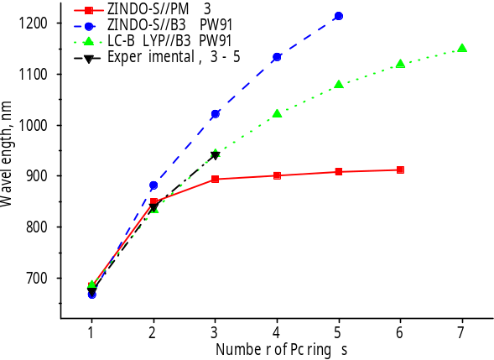
Fig. 1. Wavelengths of the lowest-energy transition in oligoPcs 6a – 6g

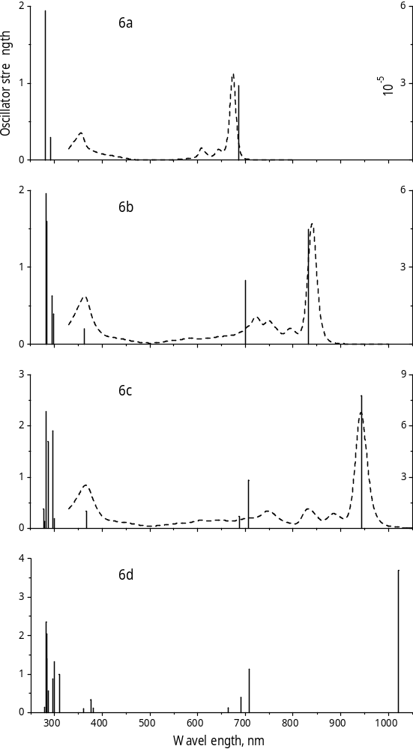
Fig. 2. Electronic spectra of linear oligoPcs 6a – 6d calculated at the LC-BLYP/Def2-TZVP(-f) level (vertical lines) and the experimental spectra of 3 – 5 (dashed lines)

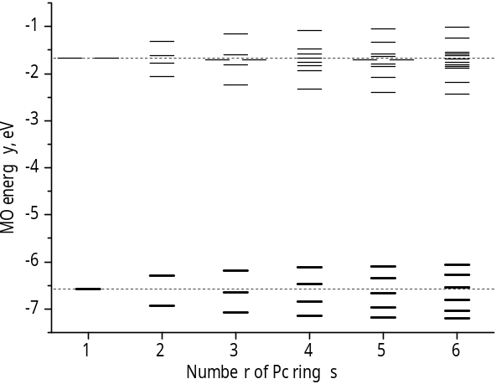
A
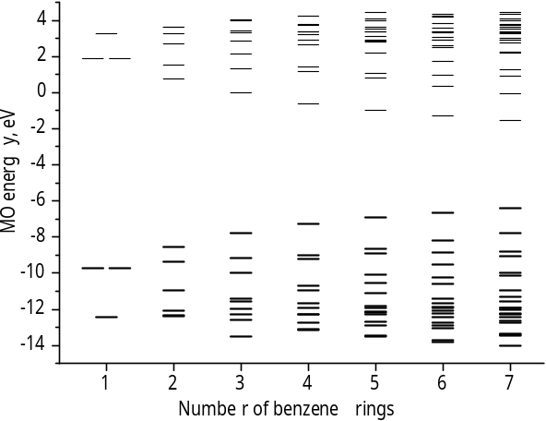
B
Fig. 3. Partial LC-BLYP/Def2-TZVP(-f) MO diagrams of oligophthalocyanines (A) and oligoacenes (B). Occupied orbitals are shown in bold

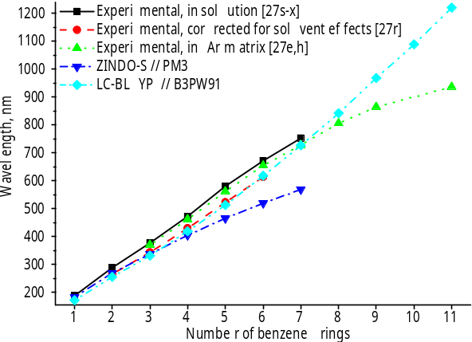
Fig. 4. Wavelength of the L_{a} transition for oligoacenes 7a – 7k

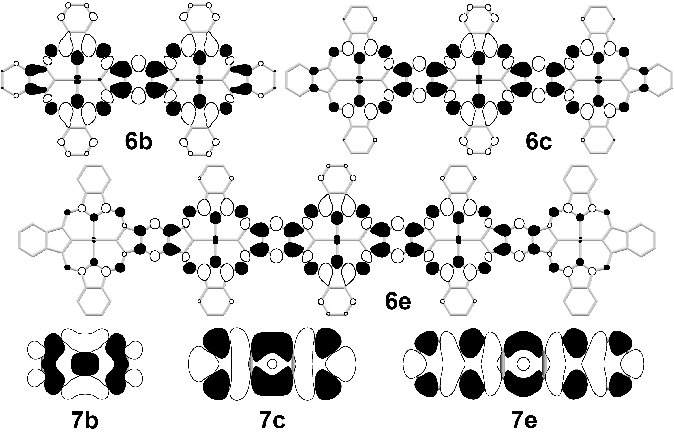
Fig. 5. Density difference isosurfaces (isovalue 0.0004 a.u.) of the lowest-energy transitions in oligoPcs 6, and L_{a} transitions in oligoacenes 7

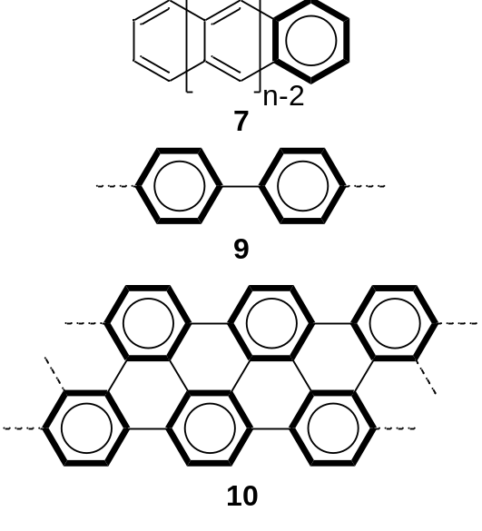
Fig. 6. Clar’s structures of oligoacenes 7, polyphenylene 9 and 6-AGNR 10. The aromatic fragments are shown in bold.

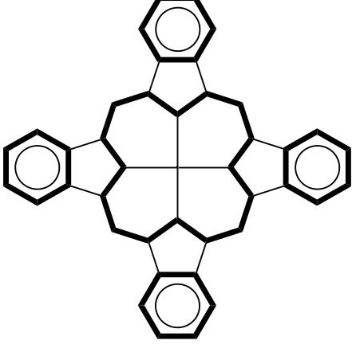
A
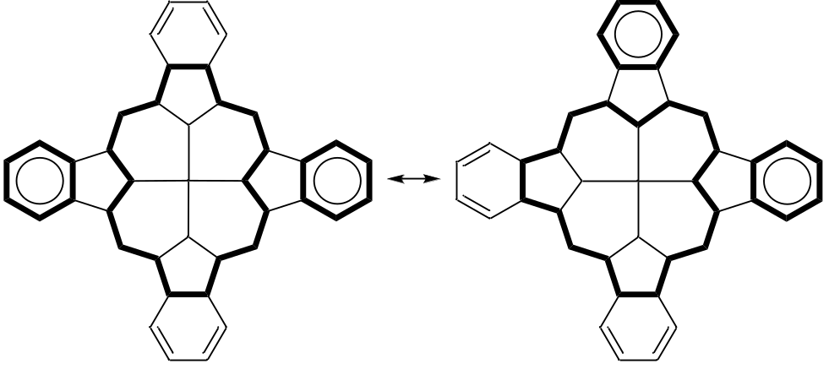
B
Fig. 7. Possible Clar’s structures of monocyclic metal phthalocyanines described in [6, 34] (A) for Pcs and [35] (B). for porphyrins. The aromatic fragments are shown in bold.

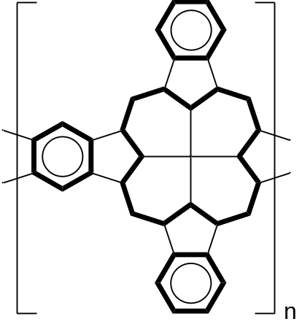
A
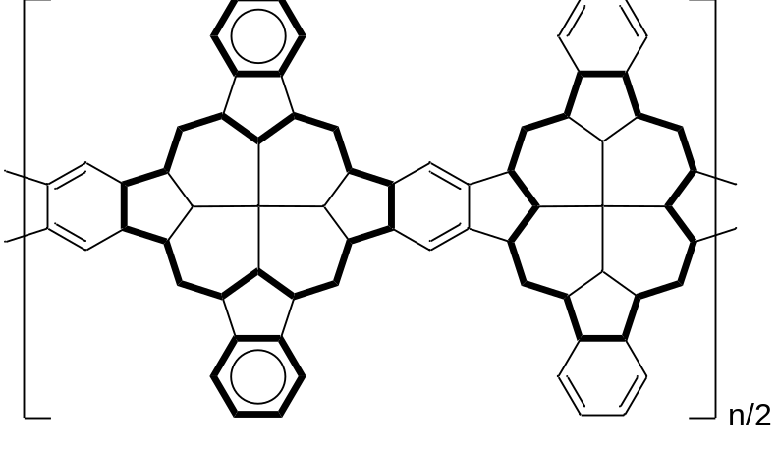
B
Fig. 8. Possible Clar’s structures of 1D-polyPcZn according to models described in [6, 34] (A) for Pcs and [35] (B) for porphyrins. The aromatic fragments are shown in bold.

Table. 1. Main electronic absorption bands of 3 – 5 (M = Zn)
Compound | Q-band |  | B-band
 | λ, nm (eV) | ε, m⁻¹cm⁻¹ | λ, nm (eV) | ε, m⁻¹cm⁻¹
ZnPc 3 | 674 (1.84) | 338 000 | 355 (3.49) | 106 000
Zn₂Pc 4 | 840 (1.48) | 470 000 | 363 (3.42) | 187 000
Zn₃Pc 5 | 942 (1.32) | 680 000 | 365 (3.40) | 253 000

Table 2. Lowest-energy transition wavelength λ (nm), energies ΔE (eV) and oscillator strengths f of oligoPcs 6a - 6g calculated at the LC-BLYP/Def2-TZVP(-f) level of DFT
Compound | λ, nm (ΔE, eV) | Oscillator strength | Contribution of HOMO-LUMO transition, %
6a | 685 (1.81) | 0.484 (x2) | 93.1
6b | 833 (1.49) | 1.495 | 78.1
6c | 943 (1.31) | 2.591 | 70.4
6d | 1021 (1.21) | 3.694 | 63.0
6e | 1078 (1.15) | 4.786 | 56.5
6f | 1119 (1.11) | 5.872 | 51.7
6g | 1150 (1.08) | 6.948 | 46.9

Table 3. DFT LC-BLYP/Def2-TZVP(-f) HOMO and LUMO energies and the HLG values (eV) of oligophthalocyanines and oligoacenes
Compound | E_{HOMO} | E_{LUMO} | HLG | Compound | E_{HOMO} | E_{LUMO} | HLG
6a | -6.57 | -1.66 | 4.91 | 7a | -9.72 | 1.86 | 11.58
6b | -6.30 | -2.06 | 4.24 | 7b | -8.55 | 0.75 | 9.3
6c | -6.18 | -2.24 | 3.94 | 7c | -7.79 | -0.04 | 7.75
6d | -6.12 | -2.33 | 3.79 | 7d | -7.28 | -0.60 | 6.68
6e | -6.08 | -2.39 | 3.69 | 7e | -6.92 | -1.00 | 5.92
6f | -6.06 | -2.42 | 3.64 | 7f | -6.64 | -1.31 | 5.33
6g | -6.05 | -2.45 | 3.60 | 7g | -6.43 | -1.54 | 4.89

Table 4. L_{a} transition wavelengths λ (nm), energies ΔE (eV) and oscillator strengths f of oligoacenes 7a-7k: experimental [27e,h,r-x] and calculated at the LC-BLYP/Def2-TZVP(-f) level of DFT
Compound | λ, nm (ΔE, eV) |  |  |  | Oscillator strength | Contribution of HOMO-LUMO transition, %
Compound | Experimental |  |  | Calculated | Oscillator strength | Contribution of HOMO-LUMO transition, %
Compound | Solution | Solvent-corrected [27r] | Argon matrix | Calculated | Oscillator strength | Contribution of HOMO-LUMO transition, %
7a | 189 (6.56) |  |  | 172 (7.21) | 0.614 × 2 | 98.8
7b | 289 (4.29) | 266 (4.66) |  | 256 (4.84) | 0.080 | 90.2
7c | 378 (3.28) | 344 (3.60) | 370 (3.35) | 332 (3.73) | 0.094 | 95.9
7d | 473 (2.62) | 430 (2.88) | 462 (2.68) | 419 (2.96) | 0.092 | 96.9
7e | 581 (2.13) | 523 (2.37) | 562 (2.21) | 513 (2.42) | 0.087 | 96.9
7f | 672 (1.85) | 614 (2.02) | 655 (1.89) | 618 (2.01) | 0.083 | 96.5
7g | 753 (1.65) |  | 728 (1.70) | 727 (1.71) | 0.079 | 95.9
7h |  |  | 806 (1.54) | 842 (1.47) | 0.075 | 95.1
7i |  |  | 865 (1.43) | 968 (1.28) | 0.071 | 94.2
7j |  |  |  | 1089 (1.14) | 0.068 | 93.2
7k |  |  | 936 (1.32) | 1220 (1.02) | 0.064 | 92.2

Table 5. Calculated gas-phase hydrogenation enthalpies ΔH (kcal·mol⁻¹) at 298K of benzene 9a, naphthalene 9b (in 1,4-positions), anthracene 9c (in 9,10-positions), ZnPc 8a benzene ring (in 1,4-positions), and of the central benzene ring of 8b (in unsubstituted positions)
Compound | ΔH
Benzene 7a | 7.5
Naphthalene 7b | -0.9
Anthracene 7c | -14.9
ZnPc 6a | 4.9
Binuclear ZnPc 6b | 2.9

