π-Electron delocalization and electronic transitions in oligomeric and polymeric phthalocyanine zinc(II) complexes. Part 2. Non-linear oligo- and two-dimensional polyphthalocyanines
Sergei G. Makarov^{*a}, Günter Schnurpfeil^{b}, Sergey Yu. Ketkovª, and Dieter Wöhrle^{*b∆}
ª G.A. Razuvaev Institute of Organometallic Chemistry of RAS, Tropinin str. 49, 603950 Nizhniy Novgorod, Russia
^{b} Universität Bremen, Institut für Angewandte und Physikalische Chemie, P.O. Box 330440, 28334 Bremen, Germany
Received date (to be automatically inserted after your manuscript is submitted)
Accepted date (to be automatically inserted after your manuscript is accepted)
ABSTRACT: Based on the results in Part 1 about linear oligo- and one-dimensional polyphthalocyanines we extended the calculations to fully annulated (fused) non-linear zinc(II) oligo- and two-dimensional polyphthalocyanines in order to get information about optical spectra and π-electron delocalization in these annulated systems. Similar non-linear annulated oligomeric benzenoid aromatic hydrocarbons (PAHs) can be considered as analogues of non-linear oligoPcs, and the electronic structures can be compared. By calculations of ¹H-NMR spectra and NICS, superaromaticity is predicted for a dication of the regular quadrilateral tetraphthalocyanine. According to DFT band gap calculations, two-dimensional zinc(II) polyphthalocyanine is predicted to be a narrow-gap semiconductor.
KEYWORDS: non-linear oligophthalocyanines, polymeric phthalocyanines, polycyclic aromatic hydrocarbons, π-electron delocalization, electronic transitions, time-dependent DFT
*Correspondence to: Sergei G. Makarov, tel: +7 831-4627370, email: makarsg@mail.ru and Dieter Wöhrle, tel: +49 421-
63135, email: woehrle@uni-bremen.de
∆SPP full member in good standing
INTRODUCTION
The successful practical use of phthalocyanines (Pcs) in many fields became possible due to their unique optical properties (see Refs. 1, 2 in Part 1 [3]) The electronic structures of mononuclear aromatic Pcs were investigated by various methods, and the main transitions of the Q-band region (λ ~ 670 nm, the a_{1u}→e_{g} transition) and the B-band region (λ ~ 350 nm, predominantly from the a_{2u}→e_{g} transition were well characterized [1]. The energies of the electrons on the highest occupied molecular orbitals (HOMOs), the energies of the lowest unoccupied molecular orbitals (LUMOs) and the distribution of electron density across the macrocyclic ring is controlled by the π-system. ZINDO and DFT techniques were used to characterize the Pc electronic structures [2]. In Part 1 we described the electronic situation and the resulting transitions in the enlarged aromatic π-systems of linear oligomeric phthalocyanine zinc(II) complexes (linear oligoPcZns) with fully annulated (fused) phthalocyanine macrocycles as model compounds for the 1D polymeric phthalocyanine zinc(II) (1D polyPcZn) [3]. The electronic structures of linear oligoPcZns were compared with analogous linear annulated oligoacenes. The DFT calculations with range-separated hybrid functional LC-BLYP were in an especially good agreement with the experimental spectra. The wavelength of the lowest-energy electronic transition increases with the increased number of annulated rings in linear oligophthalocyanines. Linear oligoacenes show a more steeply increase of the wavelength of the lowest-energy transition, and in contrast to linear oligoPcs and the HOMO-LUMO transition energy approaches asymptotically a non-zero value. After electron density difference maps oligoacenes compared to linear oligoPcs exhibit a more delocalized π-electron system. The energy band gap of the linear polyphthalocyanine zinc(II) complex was extrapolated using the optical gaps of oligophthalocyanines and calculated directly by DFT with a plane-wave basis set. The results showed that the polyPcZn is a"small" band gap semiconductor [3].
Now, in Part 2 our investigations are extended to non-linear systems. The electronic structures of non-linear oligomeric phthalocyanines (non-linear oligoPc) and the 2D polymeric phthalocyanine (2D polyPc) mainly containing the diamagnetic zinc(II) are analyzed in detail. In addition, selected non-linear polycyclic aromatic hydrocarbons (PAHs) are included in the theoretical calculations in order to evaluate the differences between these two non-linear systems.
Very few oligomeric ZnPcs could be prepared experimentally. It was shown that the π-electron delocalization in the annulated Pc rings is accompanied by a long wavelength shift and an increase in the molar extinction coefficient of the Q-band (for recent reviews see [4]): mononuclear ZnPc λ = 674 nm, binuclear ZnPc 1a λ = 840 nm, linear trinuclear ZnPc 2a λ = 942 nm (Chart 1, Table 1) [5]. These red shifts were discussed in detail when considering the literature in Part 1 [3]. In contrast to 2a the non-linear trinuclear ZnPc 3a exhibits a smaller red shift of the Q-band that splits into two components at λ = 894 nm and λ = 849 nm [5]. A simple model of π-electron delocalization was proposed to describe qualitatively the difference of the π-MOs between the linear trinuclear 2b and non-linear trinuclear 3b as linear combinations of the corresponding "mononuclear" π-MOs [5b]. The oligomers 1a-3a are prepared by a statistical cyclotetramerisation from a mixture of 1,2,4,5-tetracyanobenzene (TCB), a phthalonitrile derivative and a metal salt. The reaction products must be separated by column chromatography. The higher is the degree of annulation the lower is the yield. It was not possible to isolate oligomers higher than 3 as in the case of the compounds 2a and 3a [5]. Even the yield of 3a is lower than the yield of 2a. The only experimental example of a higher oligomer is an X-type pentanuclear phthalocyanine 4a with λ = 1040 nm (Chart 1, Table 1) recently prepared by a symmetrical cyclotetramerisation of a dicyanophthalocyanine acting as phthalonitrile derivative [6]. But higher non-linear oligomers would be important in order to see the influence of the degree of annulation on the position of the main absorption bands. In order to get theoretically more information about the extent of the π-electron delocalization and the electronic situation of non-linear oligomeric ZnPcs it is necessary to use especially DFT as molecular calculation method.

<Chart 1>

<Table 1>

Several papers report on the synthesis of the 2D polyPcs 5 (Chart 2) named in the literature as polymeric phthalocyanines (for some exemplarily selected publications see [7]). Reactions of metal precursors and TCB in bulk powdered polymers or in the gas phase thin films of polymers were obtained. Analytical investigations demonstrated that not so uniform polyPcMs were often synthesized due to the formation of side product or by products of pyrolysis at too high temperatures as discussed in some reviews [7d,f,g]). In principle the structure of a polyPc with annulated Pc rings can be between a 1D-ladder as described in Part in 1 [3] or a 2D-plane 5. Recently it was shown by STM images that by co-evaporation of iron atoms and TCB on different carriers thin uniform films of polyPcFe were obtained as 2D plain [7h]. Unfortunately, optical properties such as absorption spectra are missing in this publication so that the red shift of the Q-band can’t be confirmed. Films of polyPcCu were obtained by the reaction of Cu films with the gas phase of TCB [7j]. Because all prepared polymers are insoluble in organic solvents absorption spectra must be taken of powdered solids or thin films. Only a few papers reported on absorption features between λ ~ 1000 and ~ 2000 nm which indicate some π-electron delocalization in polyPcMs [7c,e,f,j].

<Chart 2>
COMPUTATIONAL METHODS
It was shown in Part 1 that DFT computational methods with range-separated hybrid functional LC-BLYP are in better agreement with experimental spectra than semi-empirical calculations such as PM3 and ZINDO/s [3]. Therefore DFT is mainly used for various molecular orbital and spectral calculations in this Part 2. Few semiempirical methods were employed for comparison only. Geometry optimizations, TDDFT and ZINDO/s calculations were carried out by the same methods as described previously [3]. The 2D periodic structure was calculated with 8×8×1 k-points per translational unit [3]. NMR (GIAO) shieldings [8a] were computed by the ORCA 4.0.0.2 program [8b-d] using the B3PW91 functional [9], 6-31G(d,p) (5d, 7f) [10] basis set and RIJCOSX approximation [8e-g] with the automatically generated auxiliary basis set [8h] and standard grids "grid7" and "gridx7". 1-electron GIAO integrals were calculated analytically, and for 2-electron GIAO integrals the RIJCOSX approximation was used. SCF stability analysis [8i] was used to generate the "broken-symmetry" UHF singlet state.
RESULTS AND DISCUSSION
For simplification, in the following linear and non-linear Zn(II) oligoPcs 1b - 4b, 6 - 13 the Pc rings connected via shared benzene rings are symbolized as squares. Compounds 1b - 4b are the unsubstituted analogues of experimentally prepared 1a - 4a, respectively. The linear and non-linear trinuclear Pcs 2 and 3 are the smallest possible isomeric oligoPcs. They exhibit different absorption spectra as mentioned before. The MO pattern difference was explained using the assumption that MOs of oligoPcs can be qualitatively described as linear combinations of the corresponding MOs of the mononuclear Pc. The orthogonal arrangement of the Pc rings in 3b results in nearly independent LUMO delocalization along the x and the y axes [4a]. It is interesting to study how this applies to larger oligoPcs.
The calculated spectra of the compounds 3b - 4b, 6 - 13 are shown in Fig. 1, and the wavelengths are listed in Table 2 and Table S1. Scaled experimental spectra of 3a and 4a are shown for comparison. The spectra of the phenoxy-substituted 3a and 4a exhibit a difference of 0.03 - 0.07 eV for the lowest-energy transitions in comparison to the unsubstituted analogs 3b and 4b (Fig. 1). A small distortion (twisting of the whole system) caused by the bulky substituents of 3a and 4a results in this red shift as discussed before [5b, 6]. Fig. 2 contains the MO diagrams, and the frontier MO energies are listed in Table S2. The MOs of nearly equal energies are shown as degenerate to simplify the plots. The calculation method is LC-BLYP/Def2-TZVP(-f)//B3PW91/6-31G(d). The spectra calculated semi-empirically (Fig. S1) are very similar to those calculated with TD-DFT, and the former appears even closer to the experiment (Fig. S1, Table S1, Table 1). The main difference are the more complex shapes of the ZINDO/s Q-bands due to the lower symmetry of the geometries optimized by PM3 compared to those computed by B3PW91 [3].

<Fig. 1>
The spectra of non-linear oligomers are more complex than those of linear ones due to the lower symmetry, and the transitions are less "pure" than for the linear analogues. More symmetrical 4b, 10, 12 and 13 have simple spectra; the spectrum of D_{4h}-symmetrical 10 is nearly as the simple spectrum as that of the mononuclear ZnPc [3]. Due to the presence of the higher-energy Q-band transitions at ~ 700 nm, oligoPcs 1, 2a and 3a have approximately "phthalocyanine" blue/green/blue-violet color. The color of yet unknown 10, 12 and 13 should be different since these transitions are absent. The lower-symmetry 2D-oligoPc 11 reveals the ~ 700 nm transition but with low intensity. This behavior of 2D-oligoPcs can explain the absence of the ~ 700 nm band in high-quality 2D-polyPcs 5 [11]. In addition, 10, 12 and 13 have forbidden long-wavelength transitions at 946 nm, 1045 nm and 1109 nm, respectively, whereas the low-symmetry 11 shows a transition at 984 nm with moderate intensity. In Table 2 the transition energies and the oscillator strength of 1b-3b and 10, 12 are listed.

<Table 2>

The major contributions to the Q-band transitions are provided by the orbitals corresponding to linear combinations of the frontier MOs of the n Pc fragments, i.e. n occupied and 2n unoccupied MOs (Fig. 2) [2e]. As shown in Part 1 [3] the lowest-energy Q-band transitions of the mononuclear and binuclear Zn(II) Pcs are nearly pure HOMO-LUMO excitations. The electronic transitions become less “pure” (containing more different orbital contributions) as the number of MOs and, consequently, of the excited states are increasing. The transition dipole moment of the lowest-energy transition is always oriented along the main axis (x) of a linear oligoPc, whereas strong Q-band transitions at ~ 700 nm are y-oriented. For the trinuclear Pc 3b the transition dipoles are either parallel (x+y) or perpendicular (x–y) to its C₂ symmetry axis. For the 2D-oligoPc 12, the 944 nm transition is x-polarized, and the 834 nm transition is y-polarized which agrees with the larger size of the molecule along the x axis. Obviously, the doubly degenerate Q-band transitions of 4b, 10 and 13 terminating at double degenerate upper states contain both x- and y-oriented components.

<Fig. 2>
The Q-band splitting pattern of non-linear oligoPcs compared to the linear isomers can be explained in the same way as discussed previously for trinuclear Pcs 2b and 3b [3,4a]. The frontier MOs of the binuclear Pc 1b is qualitatively described as linear combinations of the corresponding MOs of mononuclear Pc (Fig. 3A) [2e]. The non-linear oligoPcs can be built by successive addition of new Pc rings to the corresponding linear oligoPcs, so their frontier MOs can be qualitatively described as linear combinations of the MOs of the mononuclear PcZn and of the linear Zn(II) oligoPcs 1b, 2b orbitals. For example, HOMO and LUMOs of 10 (Fig. 3C) are qualitatively a sum and/or a difference of the corresponding MOs of 1b (Fig. 3B). Since the LUMO of any linear oligoPcZn has small coefficients on the "side" benzene rings [3], the lateral annulation of Pc rings does not significantly change the LUMO energy. Therefore, the LUMO energy of a non-linear oligoPc is mainly determined by its linear size. In contrast, the a_{1u}-HOMO coefficients of the mononuclear PcZn (Fig. 3A) are equally distributed between four benzene rings, and therefore the HOMO energy of a non-linear oligoPc is mainly determined by the number of "contacts" between the Pc rings, i.e. by the number of shared benzene rings. Thus, the HOMO energies are nearly equal for isomers, and slightly higher for 2D-tetraPc 10 than for non-linear tetraPcs 6 – 8. Our analysis demonstrates, therefore, that the π-electron delocalization in the non-linear 2D-oligoPcs can be qualitatively described as a combination of anisotropic "1D" LUMO delocalization and isotropic "2D" HOMO delocalization.

<Fig. 3>
Non-linear polycyclic benzenoid aromatic hydrocarbons (PAHs) can be considered as analogues of non-linear oligoPcs, and the electronic structures can be compared. Similarly, linear oligoPcs were compared to oligoacenes in Part 1 [3]. The electronic spectra of PAHs were calculated at the same level of theory as those of oligoPcs. The calculated spectra are shown in Fig. 4, and the corresponding wavelengths are listed in the Table S3 together with parameters of the experimental absorption bands in solution. The corresponding partial π-MO diagrams are included in the Fig. 5, and the MO energies are listed in the Table S4. Similarly to symmetrical 2D-oligoPcs, triphenylene 18, pyrene 21 and coronene 23 have forbidden long-wavelength transitions at 278 nm, 309 nm and 347 nm, respectively. Comparison of the computed and experimental parameters of absorption spectra (Table S3) shows that TD DFT (LC-BLYP/Def2-TZVP(-f)) overestimates the energies of the lower-lying electronic transitions in PAHs 14 – 23 by 0.3 – 0.7 eV. Then the spectra simulated by the semi-empirical ZINDO/s method appear to be even closer to the experiment (Fig. S2, Table S3).

<Fig. 4>
Generally, the lowest-energy transitions of non-linear PAHs lie at higher energy than those of oligoacenes bearing the same number of rings [3], and the corresponding HOMO-LUMO gaps are larger. This was explained a long time ago [12]: the more Clar’s sextets can be drawn the larger is the gap. The HOMO-LUMO gaps and corresponding wavelengths of 16 – 18 are similar to that of naphthalene 14 (Fig. 5) while 19 and 20 are comparable to anthracene 15. This means that, similarly to oligoPcs, efficient delocalization in isoacenes 16 – 20 occurs within their linear parts but is less efficient through their bending points. It is not possible, however, to describe such an effect on the basis of the frontier MO analysis of oligoPAHs as it was made for oligoPcs (Fig. 3). The "hexagonal" topology of 2D-PAHs 21 – 23 differs from the "orthogonal" one of 2D-oligoPcs 10 – 13, and therefore no direct comparison is possible. Perylene 22 has the lowest HOMO-LUMO gap and excited state energy but no oligoPc analogue is available. In contrast, for conjugated oligoporphyrins more types of arrangements are possible. For example, meso-meso, β-β, β'-β' triply linked oligoporphyrins [13a] display very strong redshifts of the Q-band. The influence of PAHs topology on their aromatic stabilization energy is discussed elsewhere [12d].

<Fig. 5>
It is well known that many properties of porphyrins and phthalocyanines are essentially determined by their aromaticity. Recently, "superaromaticity" was discovered for di- and hexacations of oligoporphyrin nanorings [13b]. Obviously, four phthalocyanine units of 10 form a planar ring which is also a fragment of 2D-polyPcs 5. The HOMO splitting pattern of 10 (Fig. 2) differs from those in non-cyclic oligomers, and reminds the Hückel’s π-MOs of cyclobutadiene. Stable ring-oxidized forms of phthalocyanines are well known [14, 15] including the binuclear ZnPc 1a [15a]. It can be supposed from the MO diagram (Fig. 2) that a dication of 10 may exhibit "superaromaticity" over the tetraphthalocyanine ring (a supercycle), in addition to aromaticity of individual Pc rings. Aromatic systems exhibit diatropic ring currents easily detected by ¹H-NMR spectra or NICS calculations [16]. Antiaromatic systems show strong paratropic ring currents. Chemical shifts of the protons (1) – (6), NICS(0)_{iso} and NICS(1)_{iso} at the centre for neutral 10 and its cations (Chart 3) were calculated at the B3PW91/6-31G(d,p) level of DFT. The results are shown in the Table 3. The NICS(1)_{iso} maps are shown in the Fig. S3. The ¹H chemical shifts of neutral 10 are within 1 ppm from the experimental ones for 1a – 3a [5b], and NICS(0)_{iso} is positive due to aromatic ring currents of the individual Pc rings. Compared to the neutral 10, for dication and hexacation the signals of the protons outside of the cycle are downfield-shifted, the (6) protons are strongly upfield-shifted, and the NICS(0)_{iso} value is negative. This clearly indicates the presence of a diatropic ring current over the supercycle. The closed-shell singlet (RHF) state of 10⁴⁺ shows a strong paratropic ring current, and its symmetry is lower due to the pseudo Jahn-Teller effect in the degenerate state corresponding to the D_{4h} geometry. The triplet state of 10⁴⁺ is by 2.2 kcal.mol⁻¹ lower than the closed-shell singlet, and the open-shell singlet (broken-symmetry UHF) state is by 5.7 kcal.mol⁻¹ lower than the RHF state. This also confirms its antiaromatic character. Since 10 is a fragment of the 2D-polyPc structure, local aromaticity effects may also occur in hole-doped PolyPcs 5 which can further influence their electrical and magnetic properties.

<Chart 3>

<Table 3>

These 2D-polyPcs 5 [7] can be considered as graphene-like materials. Graphene is an important two-dimensional system with semimetallic properties [17]. But in contrast to graphene a variety of transition and non-transition metals can be introduced in the Pc ligands of polyPcs. This results in variations of electric, electronic, magnetic and catalytic properties [4a, 7i-k, 18, 29]. For example, a ferromagnetic ground state with a high Curie temperature was predicted for polyPcMn whereas polyPcs with other metals have antiferromagnetic or nonmagnetic ground states [7i,j]. It was shown in Part 1 [3] and in this article that the optical gap decreases with the size of linear and non-linear oligoPcs approaching to a non-zero value. The band gap for 1D-PolyPcZn reaches a limiting value of 0.71 eV – 1.04 eV (calculated directly or extrapolated) which corresponds to a semiconductor (Part 1 [3]). Therefore the 2D polyPcZn 5 also is expected to be a "small" band gap semiconductor. We calculated the band gap of a 2D PolyPcZn 5 single layer in vacuum using a PBE functional with plane wave basis set (ultrasoft Vanderbilt pseudopotential, E_{cut} = 35 Ry; E_{rho} = 420 Ry) and obtained a value of 0.30 eV (λ = 4100 nm). It should be taken into account that the band gaps calculated by pure density functionals such as PBE are usually underestimated [20]. A similar value was reported for polyPcs of different metals using DFT with plane-wave basis sets [7i,j]. Indeed, measurements of the electrical conductivity of powders and thin films of such polymers confirmed the semiconducting behavior [7d,f,g,j]. For thin films consisting of multilayers it is expected that the band gap of polyPcs will be slightly different.
Doped PolyPcs 5 may have metallic or semimetallic properties similar to the well-known phthalocyanine molecular conductors [14d] but with higher in-plane conductivity due to a graphene-like conjugated structure. For example, the in-plane conductivity of intercalated graphite can be as high as the conductivity of copper [21]. In addition, since the tetraPc 10 is a part of the structure of 5, superaromaticity/antiaromaticity predicted for 10^{n+} may also occur in hole-doped 5 which may further influence its electrical or magnetic properties. To the best of our knowledge, no experimental results about oxidation/doping of PolyPcs are known up to now.

<Fig. 6>
The band gap in polymeric phthalocyanines 5 leading to semiconducting behavior can be explained by the Clar’s rule for phthalocyanines discussed before in Part 1 [3]. According to the Gouterman’s model [22, 23], Clar’s structure of polyPcs consists of "independent" benzene sextets and aromatic [16]annulene Pc inner rings (see in Part 1 Fig 8A [3]). Further, according to the Rabinowitch’ model [24], all Pc [18]annulene aromatic cycles can be drawn but none of the benzene rings are aromatic in this case (Fig. 6; see in Part 1 Fig 8B [3]). Therefore it can be stated that the polymers 5 should be narrow-gap semiconductors. Unfortunately, only few reports mention absorption spectra of polyPcs. Films of the monomolecular PcCu exhibit as expected the Q-band at λ ~ 700 nm and the B-band at λ ~ 350 nm [7f]. For polyPcs 5 beside the B-band at λ ~ 300 nm absorptions between λ ~ 1400 and ~ 2100 nm [7c] or at λ ~1100 and ~1900 nm [7f] or increasing absorption at λ > 800 nm [7j] were observed. No longer wavelength absorption were detected presumably because structurally defects in PolyPcs such as cyclohexadiene, isoindolenine or triazine units which are included in the polymer framework [7b,d,e,f] interrupting the π-electron delocalization.
CONCLUSION
DFT computational methods with range-separated hybrid functional LC-BLYP were used for various molecular orbital and spectral calculations of non-linear Zn(II) oligoPcs and polyPcs. Our investigation shows that the spectra of non-linear oligomers are more complex than those of linear ones reported in Part 1 [3] due to the lower symmetry. More symmetrical non-linear oligoPcs have simple spectra with a long wavelength Q-band at 800 – 1100 nm. The π-systems of non-linear oligoPcs can be built by the successive addition of new Pc rings to the corresponding linear oligoPcs, so their frontier MOs can be qualitatively described as linear combinations of the MOs of the mononuclear PcZn and of the linear oligoPcs. It is demonstrated that the π-electron delocalization in the non-linear 2D-oligoPcs can be considered as a combination of anisotropic "1D" LUMO delocalization and isotropic "2D" HOMO delocalization. The electronic structures of non-linear oligoPcs can be compared with analogous non-linear polycyclic benzenoid aromatic hydrocarbons (PAHs). Generally, the lowest-energy transitions of non-linear PAHs lie at higher energy than those of oligoacenes bearing the same number of rings, and the corresponding HOMO-LUMO gaps are larger. Similarly to oligoPcs efficient delocalization in non-linear PAHs with linear annulated benzene rings occurs within their linear parts but is less efficient through their bending points. ¹H-NMR spectra and NICS calculations were carried out for cations of the regular quadrilateral tetraphthalocyanine with different positive charges. These calculations show that the non-linear oligoPc²⁺ dication should exhibit superaromaticity over the tetraphthalocyanine ring.
The optical gap decreases with the size of non-linear zinc(II) oligoPcs approaching to a non-zero value, and the two-dimensional polyPcZn is expected to be a narrow-gap semiconductor with the calculated band gap of 0.30 eV (λ = 4100 nm). But doped PolyPcs can possess metallic or semimetallic properties.
Acknowledgements
DFT calculations of oligoPcs and oligoPAHs were carried out within the frames of Russian State assignment. The Zn complexes were studied under the RFBR Project 19-03-00755. Semi-empirical calculations were carried out within the frames of DAAD East Partnership program.
Supporting information
Semi-empirically calculated electronic spectra of non-linear Zn(II) oligoPcs and PAHs, transition energy and MO tables for 3b, 4b, 6 – 23, NICS(1)_{iso} maps of neutral 10 and its cations, are given in the supplementary material. This material is available free of charge via the Internet at http://www.worldscinet.com/jpp/jpp.shtml
REFERENCES
1. (a) Chen Z, Wannere CS, Corminboeuf C, Puchta R and von Ragué Schleyer P. Chem. Rev. 2005; 105: 3842–3888. (b) Cissell JA, Vaid TP, DiPasquale AG and Rheingold AL. Inorg. Chem. 2007; 46: 7713-7715. (c) Gershoni-Poranne R and Stanger A. Chem. Soc. Rev. 2015; 44: 6597−6615. (d) Valiev RR and Cherepanov VN. Int. J. Quantum Chem. 2013; 113: 2563–2567. (e) Steiner E and Fowler PW. Chem. Phys. Chem. 2002: 114-116.
2. (a) Kobayashi N. J. Porphyrins Phthalocyanines 1999; 3: 453-467. (b) Stillman M, Mack J and Kobayashi N. J. Porphyrins Phthalocyanines 2002; 6: 296-300. (c) Kobayashi N, Mack J., Ishii K and Stillman MJ. Inorg. Chem. 2002; 41: 5350-5363. (d) Kobayashi N, Miwa H and Nemykin VN. J. Am. Chem. Soc. 2002; 124: 8007-8020. (e) Kobayashi N and Ogata H. Eur. J. Inorg. Chem. 2004: 906-914. (f) Yuan SF and Chen ZR. J. Phys. Chem. A 2005; 109: 2582-2585. (g) Novakova V, Reimerova P, Svec J, Suchan D, Miletin M, Rhoda HM, Nemykin VN and Zimcik P. Dalton Trans. 2015; 44: 13220-13233. (h) Edwards L and Gouterman M. J. Mol. Spectrosc. 1970; 33: 292-310. (i) Martynov AG, Mack J, May AK, Nyokong T, Gorbunova YuG and Tsivadze AYu. ACS Omega 2019; 4: 7265–7284. (j) Sedlovets DM, Shuvalov MV, Vishnevskiy YV, Volkov VT, Khodos II, Trofimov OV and Korepanov VI. Mater. Res. Bull. 2013; 48: 3955-3960.
3. Makarov S, Schnurpfeil G, Ketkov SYu and Wöhrle D, J. Porphyrins Phthalocyanines 2020; 24: 515-527.
4. (a) Makarov SG, Suvorova ON and Wöhrle D. J. Porphyrins Phthalocyanines 2011; 15: 791-808. (b) Kobayashi N. Coord. Chem. Rev. 2002; 227: 129-152.
5. (a) Makarov S, Litwinski C, Ermilov EA, Suvorova O, Röder B and Wöhrle D. Chem. Eur. J. 2006; 12: 1468-1474. (b) Makarov SG, Suvorova ON, Litwinski C, Ermilov EA, Röder B, Tsaryova O, Dülcks T and Wöhrle D. Eur. J. Inorg. Chem. 2007: 546–552.
6. Pan H, Li S, Kan J, Gong L, Lin C, Liu W, Qi D, Wang K, Yan X and Jiang J. Chem. Sci. 2019; 10: 8246-8252.
7. (a) Yudasaka M, Nakanishi K, Hara T, Tanaka M and Kurita S. Jap. J. Appl. Phys. 1985; 24: L887-L889. (b) Wöhrle D, Marose U and Knoop R. Makromol. Chem. 1985; 186: 2209-2228. (c) Liao MS and Kuo K-T. J. Polym. Sci.: Part A Polym. Chem. 1900; 28: 2349-2357. (d) McKeown NB. J. Mater. Chem. 2000; 10; 1979-1995. (e) Wöhrle D, Benters R, Suvorova O, Schnurpfeil G, Trombach N and Bogdahn-Rai T. J. Porphyrins Phthalocyanines 2000; 4: 491-497. (f) Wöhrle D. Macromol. Rapid Commun. 2001; 22: 68-97. (g) Wöhrle D and Schnurpfeil G. Porphyrins and Phthalocyanines in Macromolecules. In The Porphyrin Handbook, vol. 17, Kadish KM, Smith K, Guilard R (Eds.). Elsevier Science: San Diego, 2003; 177-245. (h) Abel M, Clair S, Ourdjini O, Mossoyan M and Porte L. J. Am. Chem. Soc. 2011; 133: 1203-1205. (i) Zhou J and Sun Q. J. Am. Chem. Soc. 2011; 133: 15113-1519. (j) Sedlovets DM, Shuvalov MV, Vishnevskiy YV, Volkov VT, Khodos II, Trofimov OV and Korepanov VI. Mater. Res. Bull. 2013; 48: 3955-3960. (k) Wöhrle D, Suvorova ON, Gerdes R, Bartels O, Lapok L, Baziakina N, Makarov S and Slodek A. J. Porphyrins Phthalocyanines 2004; 8: 1020-1041.
8. (a) Stoychev GL, Auer AA, Izsak R and Neese F. J. Chem. Theo. Comp. 2018; 14: 619-637. (b) Neese F. Wiley Interdiscip. Rev.: Comput. Mol. Sci. 2012; 2: 73–78. (c) Neese F. Wiley Interdiscip. Rev.: Comput. Mol. Sci. 2017; 8: e1327. (d) Neese F. Coord. Chem. Rev. 2009; 253: 526–563. (e) Dunlap BI. J. Chem. Phys. 1983; 78: 3140-3142. (f) Neese F. J. Comp. Chem. 2003; 24: 1740–1747. (g) Neese F, Wennmohs F, Hansen A and Becker U. Chem. Phys. 2009; 356: 98–109. (h) Feyereisen M, Fitzerald G and Komornicki A. Chem. Phys. Lett. 1993; 208: 359-363. (i) Seeger R and Pople JA. J. Chem. Phys. 1977; 66: 3045-3050.
9. (a) Becke AD. J. Chem. Phys. 1993; 98: 5648-5652. (b) Perdew JP and Wang Y. Phys. Rev. B 1992; 45: 13244-13249.
10. (a) Hehre WJ, Ditchfield R and Pople JA. J. Chem. Phys. 1972; 56: 2257-2261. (b) Hariharan PC and Pople JA. Theor. Chem. Acc. 1973; 28: 213-222. (c) Rassolov VA, Pople JA, Ratner MA and Windus TL. J. Chem. Phys. 1998; 109: 1223-1229.
11. (a) Korepanov VI and Sedlovets DM. Mater. Res. Express 2019; 6: 055317. (b) Korepanov VI and Sedlovets DM. Macroheterocycles 2019; 12: 232-243.
12. (a) Clar E. Polycyclic Hydrocarbons, Academic Press: London, 1964; Vol I and II. (b) Clar E. The Aromatic Sextet, Wiley: London, 1972. (c) Aihara J. J. Phys. Chem. A 2003; 107: 11553–11557. (d) Ciesielski A, Krygowski TM and Cyranski MK. J. Chem. Inf. Model. 2008; 48: 1358–1366.
13. (a) Tsuda A and Otsuka A. Science 2001; 293: 79–82. (b) Peeks MD, Claridge TDW and Anderson HL. Nature 2017; 541: 200–203.
14. (a) Myers JF, Rayner Canham GW and Lever ABP. Inorg. Chem. 1975; 14: 461-468. (b) Turek P, Petit P, Andre JJ, Simon J, Even R, Boudjema B, Guillaud G and Maitrot M. J. Am. Chem. Soc. 1987; 109: 5119-5122. (c) Lever ABP, Milaeva ER and Speier G. The Redox Chemistry of Metallophthalocyanines in Solution. In Phthalocyanines: Properties and Applications, vol. 3, Leznoff CC, Lever ABP (Eds.). VCH: New York, 1993; 3-69. (d) Inabe T and Tajima H. Chem. Rev. 2004; 104: 5503−5533.
15. (a) Makarov SG, Piskunov AV, Suvorova ON, Schnurpfeil G, Domrachev GA and Wöhrle D. Chem. Eur. J. 2007; 13: 3227 – 3233. (b) Dubinina TV, Tomilova LG and Zefirov NS. Russ. Chem. Rev. 2013; 82: 865 – 895.
16. Chen Z, Wannere CS, Corminboeuf C, Puchta R and von Ragué Schleyer P. Chem. Rev. 2005; 105: 3842–3888.
17. Castro Neto AH, Guinea F, Peres NMR, Novoselov KS and Geim AK. Rev. Mod. Phys. 2009; 81: 109-162.
18. (a) Erk E and Engelsberg H. Phthalocyanines Dyes and Pigments. In The Porphyrin Handbook, Vol 19, Kadish KM, Smith K, Guilard R (Eds.). Elsevier Science: San Diego, 2003; 105-149. (b) Löbbert G. Phthalocyanines. In Ullmann’s Encyclopedia of Industrial Chemistry, vol. A 20. VCH Publishers: Weinheim, 1992; 213-241.
19. (a) Wöhrle D, Schnurpfeil G, Makarov SG, Kazarin A and Suvorova N. Macroheterocycles 2012; 5: 191-201. (b) Wöhrle D, Schnurpfeil G, Makarov SG and Suvorova ON. Chem Unserer Zeit 2012; 46: 12-24.
20. (a) Perdew JP and Levy M. Phys. Rev. Lett. 1983; 51: 1884-1887. (b) Krukau AV, Vydrov OA, Izmaylov AF and Scuseria GE. J. Chem. Phys. 2006; 125: 224106. (c) Chan MKY and Ceder G. Phys. Rev. Lett. 2010; 105: 196403.
21. Foley GMT, Zeller C, Falardeau ER and Vogel FL. Solid State Commun. 1977; 24: 371-375.
22. Gouterman M. J. Mol. Spectros. 1961; 6: 138-163.
23. Lonsdale K. Proc. R. Soc. Lond. A 1937; 159: 149-161.
24. Rabinowitch E. Rev. Mod. Phys. 1944; 16: 226-235.
Chart 1. Di-, tri and pentanuclear phthalocyanines 1 – 4.
Table 1. Main electronic absorption bands of 1a - 4a
Chart 2. Polyphthalocyanine 5.
Fig. 1. TDDFT spectra of non-linear Zn(II) oligoPcs calculated at the LC-BLYP/Def2-TZVP(-f) level. Experimental absorption spectra (extinction coefficients scaled down by the factor of 3·10⁵) of 3a [5b] and 4a [6].
Table 2. TDDFT Q-band transition energies, oscillator strengths and configurations for Zn(II) oligoPcs calculated at the LC-BLYP/Def2-TZVP(-f)//B3PW91/6-31G(d) level.
Fig. 2. LC-BLYP/Def2-TZVP(-f) partial MO diagrams of non-linear oligoPcZn (dashed lines – frontier MO energies of mononuclear PcZn; occupied MOs are shown in bold).
Fig. 3. Frontier MO isosurfaces (0.02 threshold) of PcZn (A), 1b (B) and 10 (C).
Fig. 4. TDDFT spectra of PAHs calculated at LC-BLYP/Def2-TZVP(-f) level.
Fig. 5. LC-BLYP/Def2-TZVP(-f) partial π-MO diagrams of PAHs (occupied MOs are shown in bold).
Chart 3. Point numbering in the 10 molecule for the ¹H chemical shift calculations.
Table 3. Calculated ¹H NMR chemical shifts and NICS for singlet-state 10⁰, 10²⁺, 10⁴⁺ and 10⁶⁺, ppm.
Fig. 6. Possible Clar’s structure of a 2D PolyPc 5.
Table 1. Main electronic absorption bands of 1a - 4a
Compound | Q-band |  | B-band
 | λ, nm (eV) | ε, m⁻¹.cm⁻¹ | λ, nm (eV) | ε, m⁻¹.cm⁻¹
binuclear ZnPc 1a | 840 (1.48) | 470 000 | 363 (3.42) | 187 000
linear trinuclear ZnPc 2a | 942 (1.32) | 680 000 | 365 (3.40) | 253 000
non-linear trinuclear ZnPc 3a | 894 (1.39)  849 (1.46) | 364 000  239 000 | 364 (3.41) | 251 000
non-linear pentanuclear Zn/H₂Pc 4a | 1040 (1.19)  901 (1.38)  824 (1.50) | 580 000  130 000  76 000 | 363 (3.41) | 350 000

Table 2. TDDFT Q-band transition energies, oscillator strengths and configurations for Zn(II) oligoPcs calculated at the LC-BLYP/Def2-TZVP(-f)//B3PW91/6-31G(d) level.
λ, nm (ΔE, eV) |  | Oscillator strength | Contributions of individual π-π* transitionsª
Experimental^{b}  in THF {10⁻⁵ ε} | LC-BLYP | (transition dipole direction)
1b (D_{2h})
840 (1.48) {4.70} | 832.8 (1.49) | 1.493 (x) | HOMO – LUMO (78%), HOMO-1 – LUMO+3 (18%)
 | 699.9 (1.77) | 0.829 (y) | HOMO – LUMO+1 (66%), HOMO-1 – LUMO+2 (27%)
2b (D_{2h})
942 (1.32) {6.80} | 943.0 (1.31) | 2.588 (x) | HOMO – LUMO (70%), HOMO-1 – LUMO+3 (16%)
 | 707.2 (1.75) | 0.942 (y) | HOMO – LUMO+1 (57%), HOMO-2 – LUMO+4 (16%),  HOMO-1 – LUMO+2 (10%)
 | 686.9 (1.81) | 0.232 (y) | HOMO – LUMO+4 (40%), HOMO-1 – LUMO+2 (33%),  HOMO-2 – LUMO+1 (21%)
3b (C₂)
894 (1.39) {3.64} | 871.4 (1.42) | 1.487 (x-y) | HOMO – LUMO (65%), HOMO-1 – LUMO+1 (13%),  HOMO-2 – LUMO+4 (10%)
849 (1.46) {2.39} | 811.2 (1.53) | 1.318 (x+y) | HOMO – LUMO+1 (63%), HOMO-1 – LUMO (12%),  HOMO-2 – LUMO+5 (12%)
 | 704.1 (1.76) | 0.462 (x-y) | HOMO-1 – LUMO+3 (40%), HOMO – LUMO+2 (36%),  HOMO-2 – LUMO+2 (13%)
 | 686.5 (1.81) | 0.348 (x+y) | HOMO-1 – LUMO+2 (39%), HOMO – LUMO+3 (36%),  HOMO-2 – LUMO+3 (13%)
10 (D_{4h})
 | 945.4 (1.31) | 0.000 | HOMO (b_{2u}) – LUMO+2 (b_{1u}) (57%),  HOMO-1 (e_{gx}) – LUMO (e_{gx}) (13%)  HOMO-2 (e_{gy}) – LUMO+1 (e_{gy}) (13%)
 | 838.8 (1.48) | 2.559 (x) | HOMO (b_{2u}) – LUMO (e_{gx}) (56%),  HOMO-1 (e_{gx}) – LUMO+3 (a_{1u}) (13%)
 | 838.8 (1.48) | 2.559 (y) | HOMO (b_{2u}) – LUMO+1 (e_{gy}) (56%),  HOMO-2 (e_{gy}) – LUMO+3 (a_{1u}) (13%)
12 (D_{2h})
 | 1045.4 (1.19) | 0.000 | HOMO – LUMO+1 (48%), HOMO-2 – LUMO (19%)
 | 943.5 (1.31) | 4.527 (x) | HOMO – LUMO (52%), HOMO-2 – LUMO+1 (16%),  HOMO-1 – LUMO+5 (10%)
 | 905.5 (1.37) | 0.109 (y) | HOMO – LUMO+4 (38%), HOMO-3 – LUMO+2 (16%),  HOMO – LUMO+2 (13%)
 | 833.6 (1.49) | 3.479 (y) | HOMO – LUMO+2 (35%), HOMO-1 – LUMO+3 (24%)
ª Major contributions of at least 10% are included; higher-energy transitions with oscillator strength of at least 0.1 are included.
^{b} For (2,6-dimethylphenoxy)-substituted derivatives 1a – 3a, respectively.

Table 3. Calculated ¹H NMR chemical shifts and NICS for singlet-state 10⁰, 10²⁺, 10⁴⁺ and 10⁶⁺, ppm.
Compound | Isotropic ¹H chemical shifts vs. TMS |  |  |  |  |  | NICS(0)_{iso} (centre) | NICS(1)_{iso} (centre)
(symmetry) | H (1) | H (2) | H (3) | H (4) | H (5) | H (6) | NICS(0)_{iso} (centre) | NICS(1)_{iso} (centre)
10⁰ (D_{4h}) | 10.03 | 8.60 | 8.69 | 10.34 | 12.27 | 13.05 | 4.31 | 3.79
10²⁺ (D_{4h}) | 10.51 | 9.21 | 9.32 | 11.03 | 15.37 | -1.10 | -6.65 | -6.55
RHF 10⁴⁺ (D_{2h}) | 5.51 | 6.32 | 5.87 | 3.57 | -8.66 | 70.10 | 48.94 | 46.11
UHF 10⁴⁺ (D_{4h}) | 8.98 | 8.50 | 8.42 | 8.74 | 8.75 | 16.16 | 6.82 | 6.24
10⁶⁺ (D_{4h}) | 9.26 | 8.86 | 8.77 | 9.23 | 11.88 | 2.25 | -4.00 | -3.97

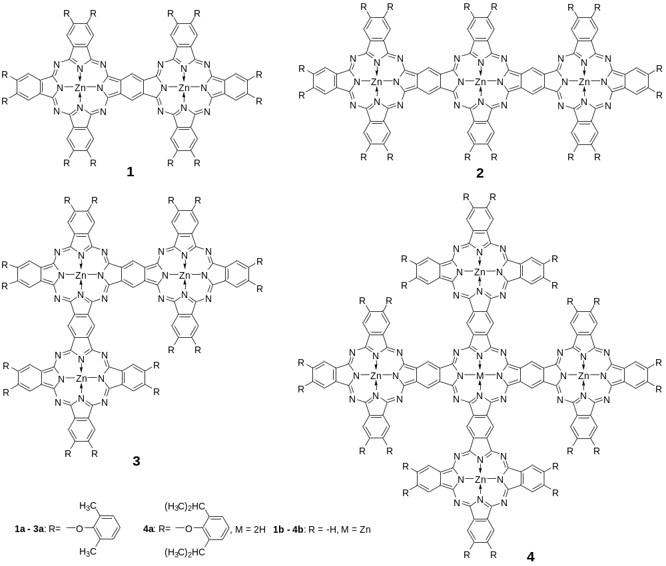
Chart 1. Di-, tri and pentanuclear phthalocyanines 1 – 4.
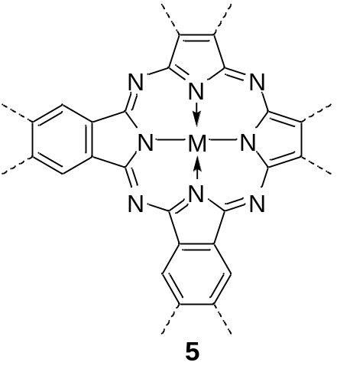
Chart 2. Polyphthalocyanine 5.
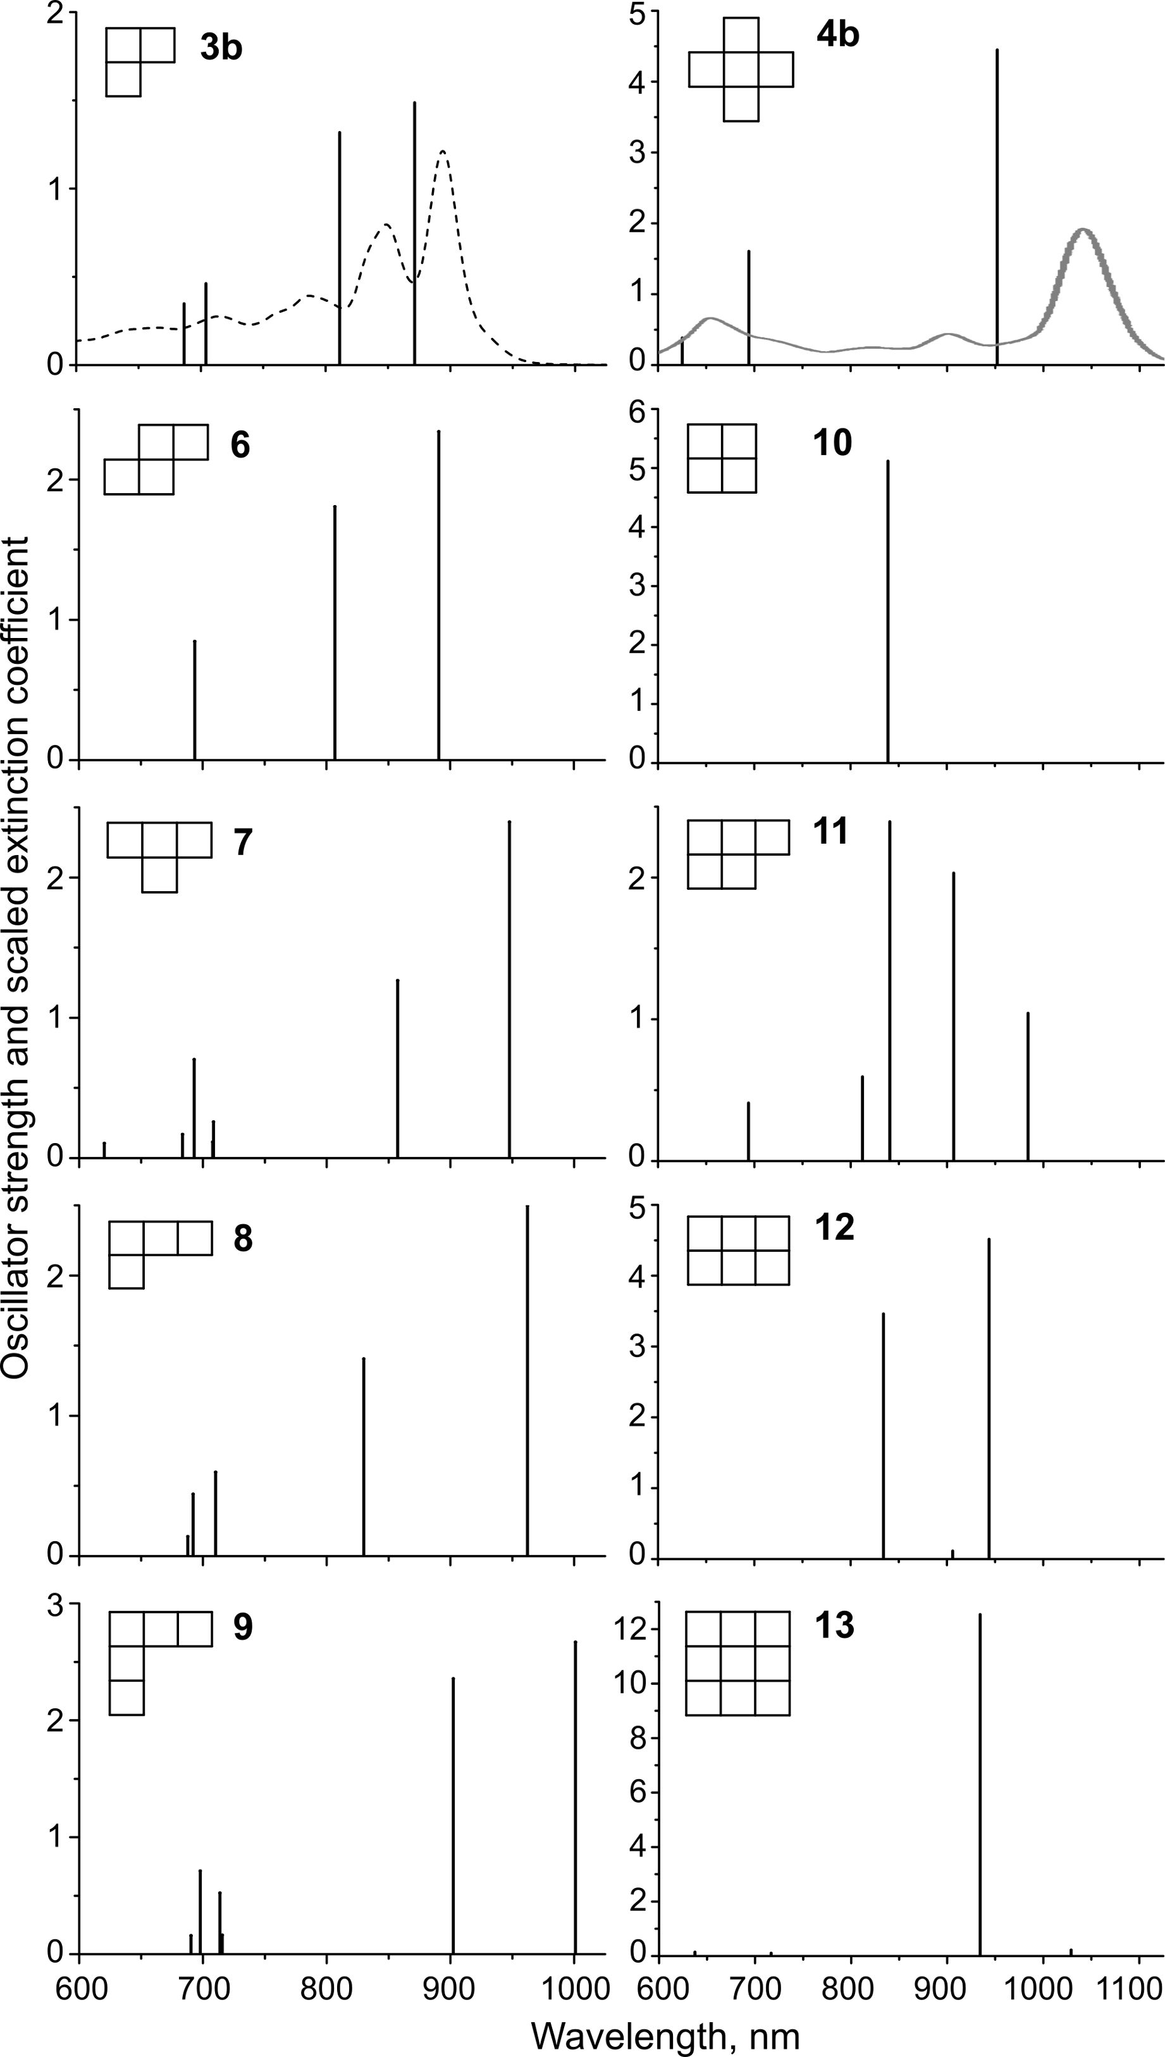
Fig. 1. TDDFT spectra of non-linear Zn(II) oligoPcs calculated at the LC-BLYP/Def2-TZVP(-f) level. Experimental absorption spectra (extinction coefficients scaled down by the factor of 3·10⁵) of 3a [5b] and 4a [6].
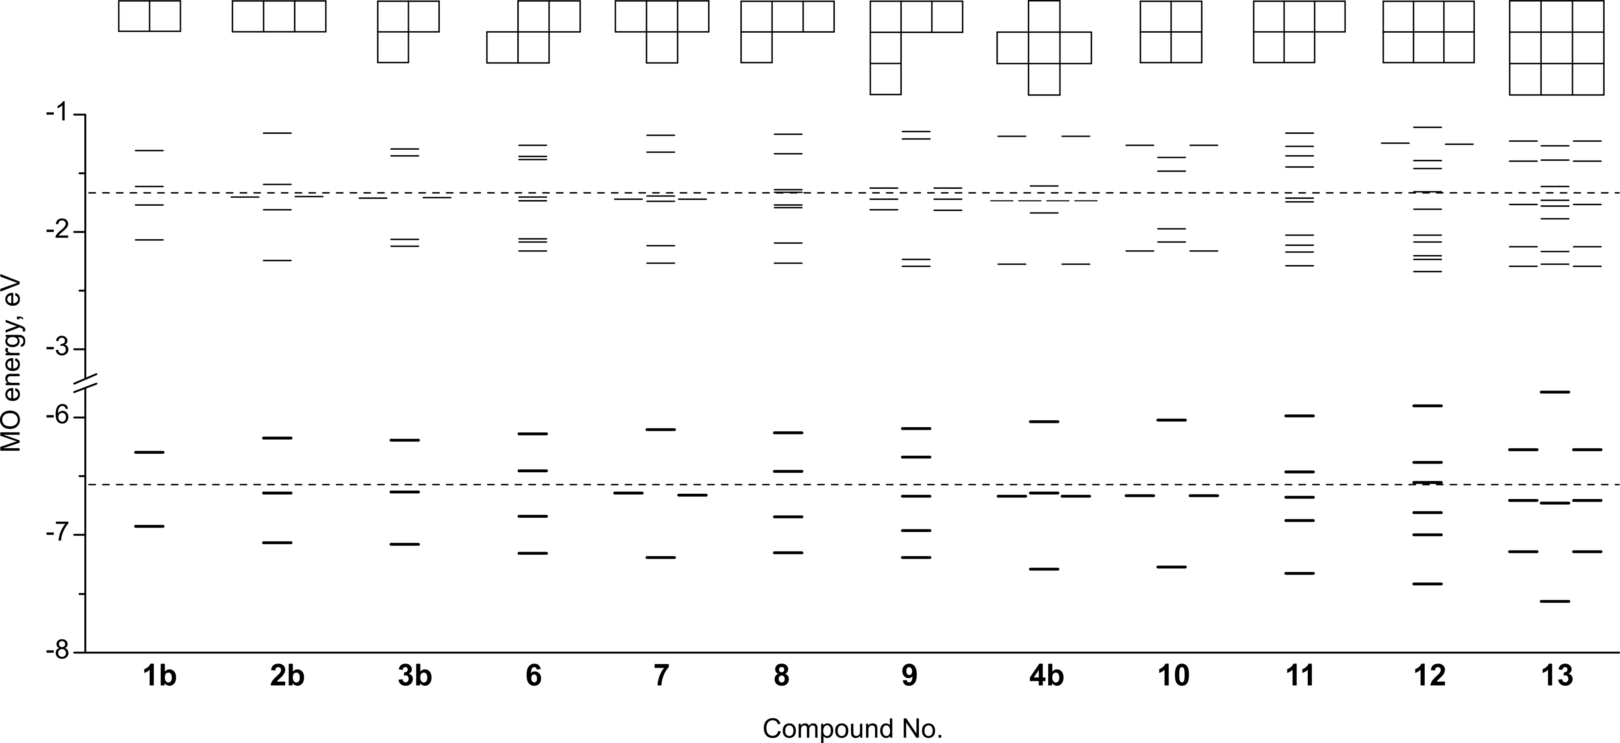
Fig. 2. LC-BLYP/Def2-TZVP(-f) partial MO diagrams of non-linear oligoPcZn (dashed lines – frontier MO energies of mononuclear PcZn; occupied MOs are shown in bold).
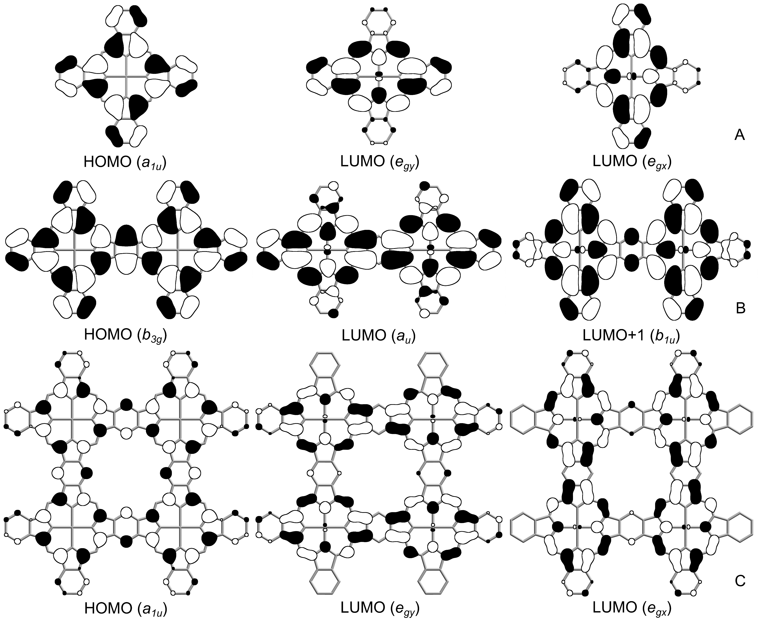
Fig. 3. Frontier MO isosurfaces (0.02 threshold) of PcZn (A), 1b (B) and 10 (C).
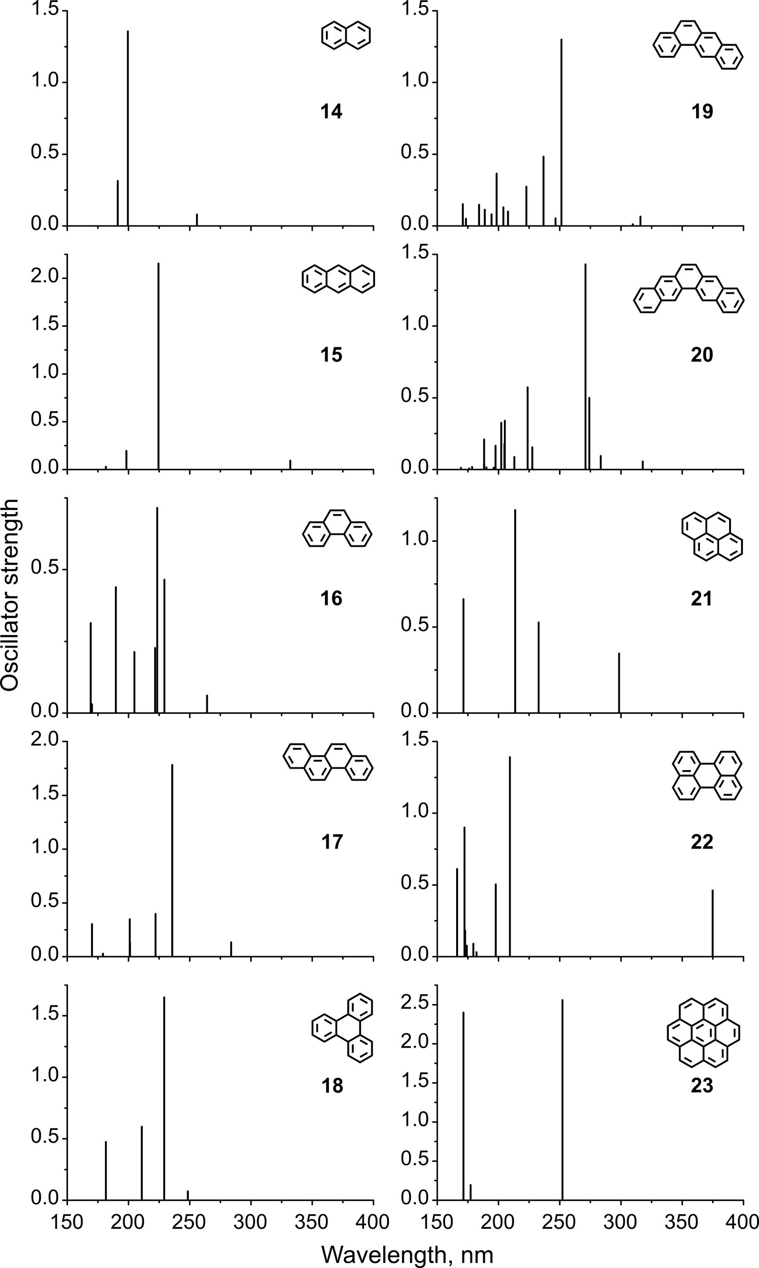
Fig. 4. TDDFT spectra of PAHs calculated at LC-BLYP/Def2-TZVP(-f) level.
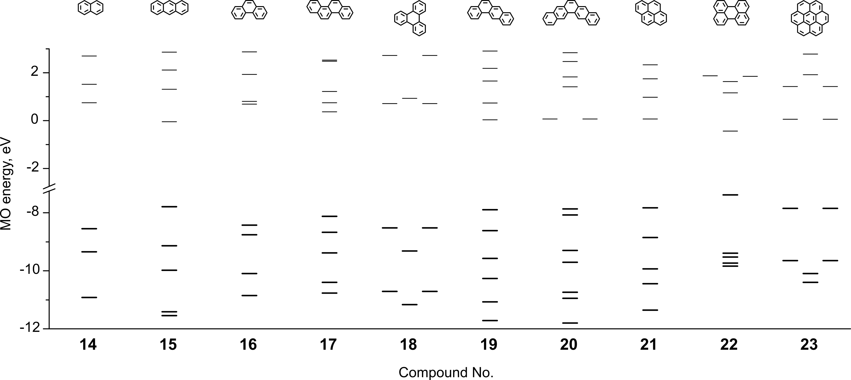
Fig. 5. LC-BLYP/Def2-TZVP(-f) partial π-MO diagrams of PAHs (occupied MOs are shown in bold).
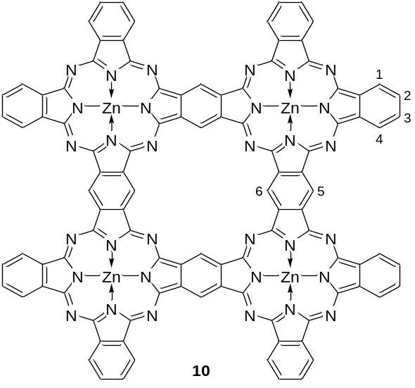
Chart 3. Point numbering in the 10 molecule for the ¹H chemical shift calculations.
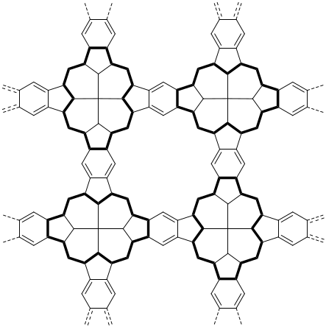
Fig. 6. Possible Clar’s structure of a 2D PolyPc 5.

