Received 00th January 20xx,
- G.A. Razuvaev Institute of Organometallic Chemistry of RAS, Tropinin str. 49, 603950 Nizhniy Novgorod, Russia.
- Universität Bremen, Institut für Angewandte und Physikalische Chemie, P.O. Box 330440, 28334 Bremen, Germany.
† Supplementary Information available: Tables of electronic transitions, additional figures, optimized molecular geometries. See DOI: 10.1039/x0xx00000x
Accepted 00th January 20xx
DOI: 10.1039/x0xx00000x

Excitonic coupling of electronic transitions in oligomeric phthalocyanine zinc(II) complexes
Sergey G. Makarov,*ª Sergey Yu. Ketkov ª and Dieter Wöhrle ^{b}
Excitonic coupling of the electronic transitions in a series of zinc(II) phthalocyanine (ZnPc) dimers has been studied by TD-DFT with a range-separated hybrid functional LC-BLYP. This method correctly reproduces the experimental excitonic shifts of the Q-band for known "rigid" non-conjugated binuclear phthalocyanines. The observed significant differences in the experimental UV/Vis spectra of "edge-to-edge", "slipped-stacked" and "face-to-face" ZnPc dimers have been explained. The same TD-DFT method has been used to investigate the influence of the relative position of ZnPc molecules on the Q-band transition energies to explain excitonic coupling effects observed for phthalocyanine aggregates, dimers and crystals. The Coulombic contribution to excitonic coupling (according to Kasha's model) has been estimated using transition electrostatic potential (TrESP) atomic charges. The excitonic splitting of the Q-band has been extrapolated from Pc oligomers to an infinite 1D-stack, in the frame of the tight-binding approximation, and the main spectral features of α- and β-modifications of ZnPc have been reproduced.
Introduction
Phthalocyanines (Pc) have found many “real” applications as colorants and materials for electronic devices [1-3]. Successful practical use of phthalocyanines (Pcs) in many fields became possible due to their unique molecular structural diversity of the molecules, photophysical properties and different arrangements in the solid state. Recent potential applications include organic thin-film transistors [4, 5], near-infrared fluorescent diagnostics and photodynamic immunotherapy of tumors [6].
Photophysical properties of phthalocyanine metal complexes can be modified by peripheral substituents, central metal ions or by extension of the π-system [7-9]. The extended π-system of conjugated Pc oligomers results in large redshifts of the lowest-energy absorption (Q-band). Noncovalent interactions (excitonic coupling) of the Pc π-systems are also known to significantly influence photophysical properties of phthalocyanines in aggregates, non-conjugated dimers and crystals [10-35].
Non-conjugated oligo- and polymeric phthalocyanine assemblies include well-known π-π stacked aggregates in solution [14] and in the solid state [2, 3, 15, 16]. Besides, non-conjugated oligomers via ligand [10, 24-31, 35], metal–ligand [13, 15, 18, 19, 26], hydrogen-bonded [20] and donor-acceptor systems [21] have also been reported. Two types of arrangement of chromophore molecules in aggregates are usually discussed: face-to-face configurations, often referred as H-type aggregates, and edge-to-edge or slipped-stacked configurations known as J-type aggregates (Fig. 1) [14]. A close proximity of the chromophores causes excitonic coupling of their electronic transitions, which significantly influences their photophysical properties [11, 12, 22, 23].
According to Kasha’s theory [23], “face-to-face” molecular dimers (H-aggregates) exhibit a blue-shifted absorption maximum and a suppressed radiative decay rate. In contrast, “edge-to-edge” and “slipped-stacked” dimers (J-aggregates) exhibit a red-shifted absorption maximum and an enhanced radiative decay rate. For dimers with parallel arrangement of chromophores, the interaction of the transition dipoles can be approximated by a simple point-dipole model as described by eq. 1.

$∆E≈\frac{μ^{2}(1-3\cos^{2}θ)}{4πεr^{3}}$ (1)

In eq. 1 μ and r represent the magnitude of the transition moment in the monomer and the center-to-center distance between the molecules, respectively. θ is the angle between the polarization axis and the line between the dipole centers. The energy change ΔE becomes zero at θ = 54.7°, i.e. two molecules behave as an H-aggregate above θ = 54.7° and as a J-aggregate below this angle.
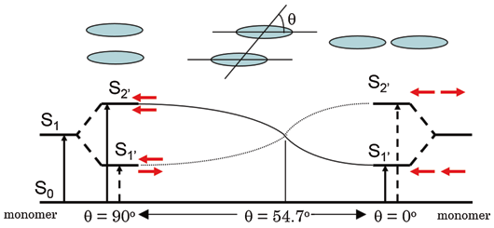
Fig. 1. Excitonic coupling of electronic transitions in molecular dimers [12]. © Hiroaki Isago with CC-BY-NC 3.0 license
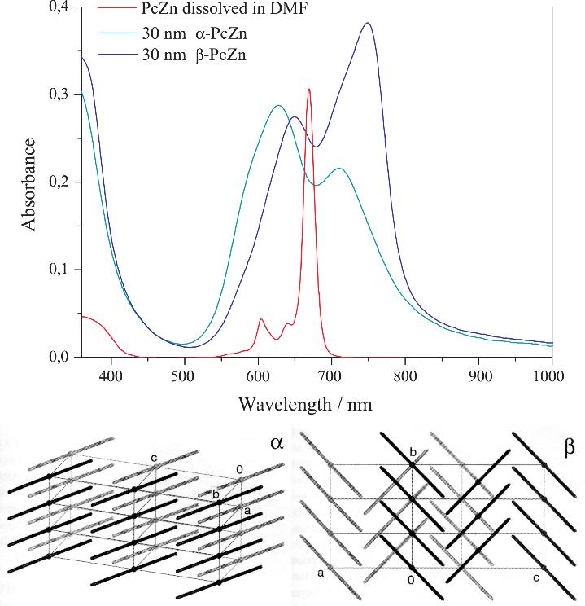
Although many examples of "face-to-face" phthalocyanine dimers, oligomers and aggregates [10, 24-28, 34, 35] and a few "edge-to-edge" and "slipped-stack" dimers and aggregates were described [13, 18, 29-32]. But the exact alignment of the Pc subunits in these systems is not known, except for the crystals where slipped-stacked arrangement is typical for M(II)Pcs [1, 2, 16, 17]. Only a few binuclear Pcs with a linker rigid enough to ensure a well-defined geometry are known experimentally (Chart 1): a “gable” 1 [33], a “planar” 2 [31], and a “cyclophane” 3 [32] bridged binuclear phthalocyanines with the “edge-to-edge” and a “slipped-stack” arrangement (J-dimers). For the “face-to-face” binuclear Pcs (H-dimers) with rigid linkers such as 4 [27] and 5 [28] different conformations are still possible with significantly different excitonic coupling (see below). One example of a supramolecular dimer 6 [13] can be considered rigid although two configurations (“parallel” and “oblique”) are possible.
Fig. 2. Electronic spectra and crystal packing of α- and β-modifications of ZnPc
The effect of aggregation on the Q-band in solution is stronger than solvent effects. This typically results in a blue shift from λ = 660-700 nm to λ = 600-640 nm with broadening of the Q-band (H-aggregates) [14]. Similar blue shifts were observed for various covalent and supramolecular cofacial dimers [10, 14, 25-28, 34, 35]. In the solid state, β-modification of planar M(II)Pcs typically shows a close contact of central metal ion to a meso-N atom of an adjacent molecule in the stack and an inclination angle of the macrocycles within the stack of ~45°. The inclination angle in the α-modification is ~30°, and the metal shows a close contact to a pyrrole-N atom of an adjacent molecule. Different arrangements of chromophores results in a significantly different excitonic coupling. This leads to a high variability of absorption wavelengths by crystalline phthalocyanines (Fig. 2). Thus, α-modifications of CuPc and ZnPc absorb at λ ~625 and ~700 nm, β -modifications at λ ~650 and ~750 nm, and ε-CuPc exhibits an absorption at even longer wavelength λ < 820 nm [1-3]. The non-planar Ti(O)Pc with the slipped-stacked arrangement similar to J-aggregates shows a strongly red-shifted Q-band absorption at λ ~700 - 900 nm and an efficient photoinduced charge carrier generation [33].
Slipped-stacked Pc oligomers resemble structural patterns of photosynthetic light-harvesting antenna consisting of bacteriochlorophyll dimers [36], and they are photoactive in contrast to face-to-face Pc oligomers [11-13, 37] for which a non-radiative decay of the excited states is typical. Therefore, edge-to-edge dimers and J-aggregates are highly desirable to tailor the photophysical properties of Pcs. The cyclophane-fused dimer 3 is fluorescent (Φ_{f} = 0.12), a metal-free “gable” dimer 1 is also fluorescent (Φ_{f} = 0.55), a “planar” dimer 2 shows a singlet oxygen quantum yield of Φ_{Δ} = 0.08. The imidazole-bridged supramolecular dimer 6 is also fluorescent (Φ_{f} = 0.26). Surprisingly, for edge-to edge Pc dimer 2 no redshift expected according to Kasha’s theory and eq. (1) was observed in contrast to slipped-stack 3 showing a strong bathochromic Q-band shift (Table 1), and H-dimers showing a significant hypsochromic shift. It was concluded [8, 32] that the π-MO overlap is essential for an efficient excitonic coupling in Pc dimers, crystals and aggregates. Purely Coulombic coupling of the transition dipoles (eq. (1)) is not enough to explain the observed Q-band shifts. Short-range excitonic coupling in phthalocyanine dimers [37-39] and crystals [37-40] was studied previously by DFT and semi-empirical methods. It was shown that short-range coupling is very sensitive to the MO overlap [37, 39] and is related to electron- and hole-transfer integrals [39, 41]. This explains the significant difference of the solid-state UV/Vis spectra of Zn(II), Ni(II) and Cu(II) Pcs (β-modifications) [38]. For selected arrangements, the short-range excitonic coupling in ZnPc dimers was also studied by TD-DFT [42]. However, a more systematic study including various arrangements (r and θ) is required to provide a general explanation of the observed excitonic coupling effects in phthalocyanine oligomers and crystals.
To organize chromophores into tailored structures, it is important to predict their photophysical properties. Nowadays, machine-learning methods are growing up for predicting crystal structures of molecular materials [43], which requires an accurate theoretical description of the intermolecular properties. Previously, we have studied UV/Vis/NIR spectra and energy gaps of conjugated oligomeric phthalocyanine zinc (II) complexes by TD-DFT. It was shown that calculations with range-separated hybrid functional LC-BLYP provide a good agreement with the experimental spectra [8, 9]. The extrapolated TD-DFT Q-band energy of oligoPcs was compared to a directly calculated band gap of 1D-polyPc.
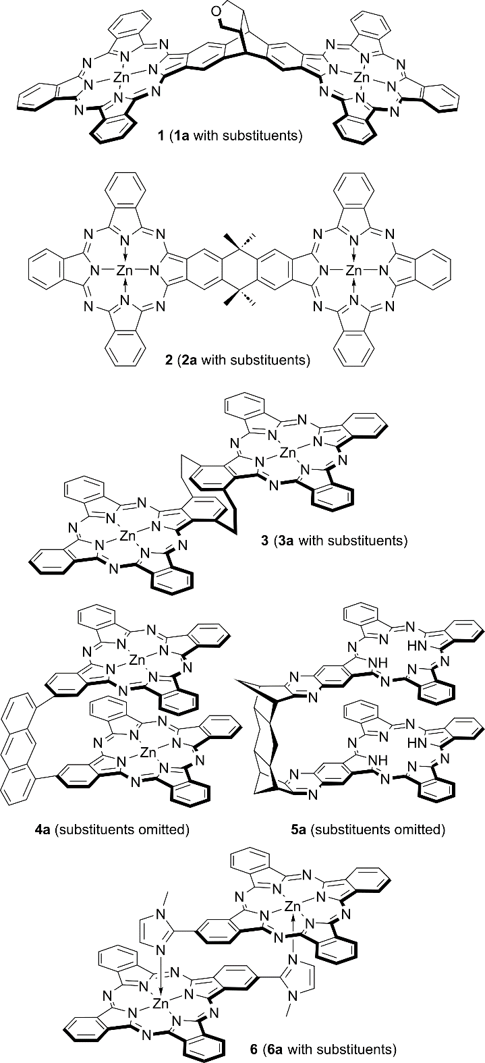
Here, we benchmark the above-mentioned LC-TDDFT approach on excitonically coupled Q-band transitions in non-conjugated binuclear ZnPcs for the first time. Then we use the same method to investigate the influence of the relative position of ZnPc molecules (r and θ in the eq. (1)) on the Q-band transition energies, and finally to explain excitonic coupling effects observed for phthalocyanine aggregates, dimers and crystals.
Chart 1. "Rigid" phthalocyanine dimers

Computational details
DFT calculations. Geometry optimizations and TD-DFT calculations were carried out as described previously [8]. Range-separated hybrid functional LC-BLYP (μ = 0.4) [44-46] with the def2-TZVP(-f)/def2-J [46-48] basis sets was used for TD-DFT calculations. All geometries were optimized using the B3PW91 functional [49, 50] and 6-31G(d) (6D, 7F) basis set [51-53]. DFT geometry optimizations were carried out by the Firefly 8.2.0 program [54] which is partially based on the GAMESS (US) [55], with pruned grid (99, 590) and default convergence criteria. TD-DFT calculations were carried out by ORCA 6.0.1 [56], with the RIJCOSX approximation [57, 58], default grid “Defgrid2” and tight SCF convergence. Adding diffuse functions or counterpoise correction has no noticeable effect on the transition energy (ΔE < 0.01 eV).
Transition charges were calculated by fitting the Q-band transition electrostatic potential (TrESP [65]) of the B3PW91-optimized ZnPc using the CHELPG scheme [59] as implemented in the Multiwfn 3.6.1 software [60].
Extrapolation of TD-DFT spectra was carried out for ZnPc stacks up to the size of 5 constructed from the B3PW91-optimized ZnPc molecules positioned either according to the translation vectors from β-ZnPc [71] or by applying shifts of Δx = 3.3 – 3.4Å, Δz = 1.75 – 2.0Å (Fig. 4A) to simulate the α-ZnPc stacks.
Results and discussion
Bridged oligophthalocyanines
“Rigid” binuclear Pcs 1 – 3 and 6 were selected to exclude the influence of noncovalent interactions (poorly described by DFT [61]) on the relative position of the Pc chromophores.
The calculated Q-band wavelengths and energies for the dimers 1 – 3, 6 without peripheral substituents are compared to experimental wavelengths of their Q-band maxima. The results are listed in the Table 1.

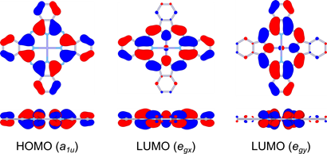
Table 1. Experimental and calculated Q-band wavelengths, energies and intensities for rigid non-conjugated oligoPcs 1 – 3, 6 and their substituted analogues 1a – 3a, 6a
Fig. 3. Frontier MOs of ZnPc (front and side views)
Cpd. | Experimental (1a – 3a, 6a) |  | Theoretical (1 – 3, 6)
 | λ, nm (ΔE, eV) | 10⁻⁵ ε,  M⁻¹·cm⁻¹ | λ, nm (ΔE, eV) | Oscillator strength
ZnPc [8] | 674 (1.840) | 3.4 | 685 (1.809) | 0.484 · 2
1, 1a [32] | 694 (1.787) | 2.9 | 713 (1.738) | 1.050
 | 677 (1.832) | 3.1 | 680 (1.823) | 0.906
2, 2a [30] | 682 (1.818) | 6.9 | 705 (1.758) | 1.334
 |  |  | 692 (1.790) | 0.912
3, 3a [31] | 753 (1.647) | 0.84 | 743 (1.667) | 1.276
 | 690 (1.797) | 0.72 | 688 (1.800) | 0.833
6, 6a [12] | 700 (1.771) | 1.7 | 723 (1.714) | 1.070
 | 670 (1.851) | 1.2 | 676 (1.832) | 0.749

As it is seen from Table 1 theoretical wavelengths are in agreement with the experimental ones. Therefore TD-DFT with a range-separated hybrid functional LC-BLYP correctly predicts the through-space excitonic coupling of the excited states of ZnPcs. For edge-to-edge arrangements in 1 and 2 the redshift compared to the monomeric ZnPc and expected from eq. (1) is negligible. This is in in contrast to a well-known blue shift for face-to-face arrangements in H-dimers and aggregates [10-13, 25-28, 34, 35]. In contrast, for the cyclophane-type dimer 3, a significant red shift and splitting of the Q-band is revealed both theoretically and experimentally. The nearly zero red shift predicted by Kasha’s theory for edge-to-edge dimers 1 and 2 was explained previously [8, 30] by the absence of the π-π overlap and by the intermolecular π-electron delocalization. Thus, it is important to study whether a general Coulombic dipole-dipole model (eq. (1)) is applicable for oligoPcs. Or the observed excitonic coupling in phthalocyanine aggregates, dimers and crystals is a system-specific short-range effect determined by the π-π overlap.

Excitonic coupling between phthalocyanine molecules
To evaluate excitonic coupling effects in oligoPcs, model zinc phthalocyanine dimers with face-to-face, slipped-stacked and edge-to-edge parallel arrangements of the Pc rings with parallel shifts (Δx) from 0 to 20 Å and interplane distances (Δz) from 0 to 6 Å were studied by TD-DFT. The corresponding distances (r) and angles (θ) can be easily calculated to compare TD-DFT transition energies to those predicted by the equation (1). Pcs show intense π → π* absorption bands in the visible region of the absorption spectra. The Q-band corresponds to the doubly degenerate HOMO (a_{1u}) → LUMO (e_{g}) transition (Fig. 3) [62]. For a Pc dimer, there are four Q-band transitions arising from the excitonic splitting of two degenerate E_{U} transitions of a single Pc chromophore: the B_{U} (x-polarized along the shift direction) and A_{U} (y-polarized) excitations (oscillator strengths f ≈ 0.5), and two forbidden transitions, A_{G} and B_{G} (f ≈ 0) corresponding to the opposite orientation of the monomers’ transition dipoles. Unlike nearly "pure" Q-band transitions of monomolecular Pcs, the configuration of each Q-band transition of a Pc dimer can be approximately described as a combination of two main MO-MO transitions (Fig. 5). MOs of Pc oligomers can be approximately described as linear combinations of the monomers’ MOs [11-13]. Due to the π-π overlap, the bonding-antibonding interactions between these MOs result in splitting of the corresponding energy levels and, for infinite stacks, to the formation of valence and conduction bands [37, 41]. The dependence of these energies on the arrangement of the Pc molecules (see Fig. 4) is shown in Fig. 6 for the shift along Zn-N bond (Fig. 4A, which approximately reproduces the stack arrangement in α-ZnPc). The corresponding transition energies are listed in Table S1 of the ESI†. For the shift direction along meso-N – Zn (Fig. 4B, which approximately reproduces the stack arrangement in β-ZnPc), the results are shown in Fig. S1 and Table S2 of the ESI†.
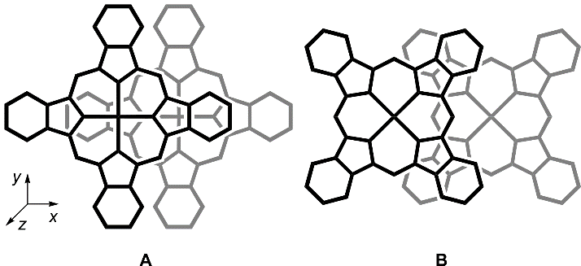
Fig. 4. Arrangements of the monomers in slipped-stacked ZnPc dimers
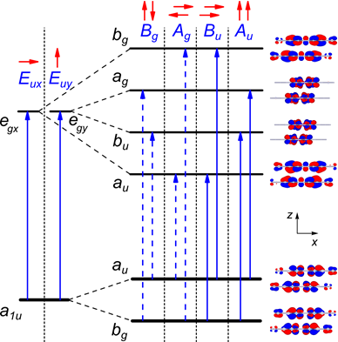
Fig. 5. Principal scheme of frontier MO splitting and Q-band transitions of slipped-stacked ZnPc dimers. The order of MOs can be different (vide infra)
Angle dependence. For parallel transition dipoles the dependence of the excitonic splitting on angle θ (Fig. 2) is approximately described by the equation (1). With “face-to-face” arrangements the allowed x-oriented B_{U} transition is blue-shifted in contrast to the corresponding forbidden A_{G} transition which is strongly red-shifted and can participate in non-radiative decay of the excitation energy. This explains why “face-to-face” dimers are non-fluorescent. For the “slipped-stack” configurations with larger shifts (Δx), the allowed B_{U} transition becomes red-shifted with increasing dislocation and its energy drops below the corresponding A_{G} forbidden transition. This explains why the “slipped-stack” and “edge-to-edge” dimers are fluorescent. The angle corresponding to zero splitting between B_{U} and A_{G} transitions is 54.7°, which is indicated by a vertical line in Fig. 6.
As it is seen from Fig. 6 there is a qualitative agreement between the TD-DFT results and equation (1). At the 3.5 Å interplane distance the energy splitting dependence on the shift is nonuniform due to short-range effects of the MO overlap (see below). These effects become negligible already at the 4.0 Å distance. For the edge-to-edge arrangement (Δz = 0, see Fig. S2 of the ESI†) the centre-to-centre distances r < 16 Å are not possible which results in a very small excitonic splitting in agreement with eq. (1). For “planar” dimer 2 this distance is 15.7 Å, and the predicted excitonic splitting is very small. Thus, the near-zero redshift in edge-to-edge dimers 1 and 2 is simply explained by a large centre-to-centre distance between transition dipoles. However, there is no quantitative agreement between TD-DFT transition energies and eq. (1) which can be further explained by short-range effects of the π-MO overlap [37-42] (see below).
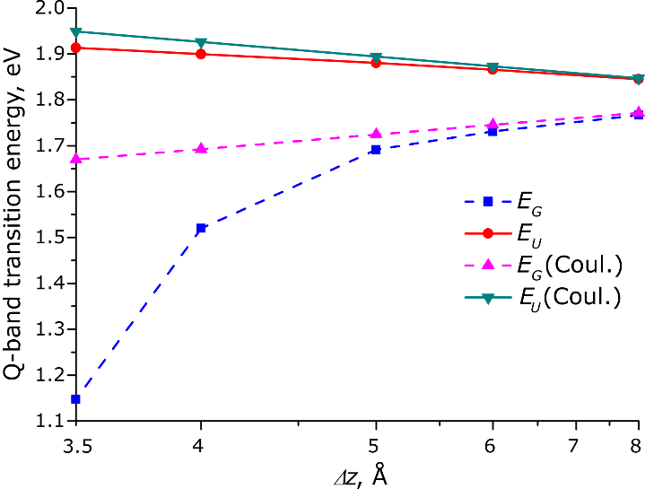
Fig. 7. Distance dependence of the TD-DFT Q-band transition energies of a face-to-face ZnPc dimer
Distance dependence. As shown by Harcourt et al. [63] the excitonic interactions can be divided into long-range Coulombic interactions, Dexter's short-range exchange [64] and superexchange interactions caused by the π-MO overlap [41]. Taking into account only the Coulomb interactions leads to the Kasha’s exciton model [23] often approximated as a point-dipole interaction (eq. 1). This decays as 1/r³ whereas the superexchange interaction depends on the MO overlap that decays exponentially with the distance.
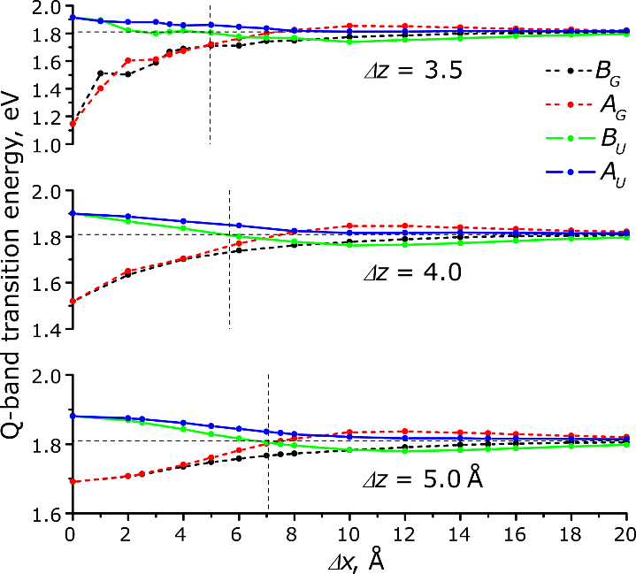
Fig. 6. TD-DFT Q-band transition energies vs. parallel shifts (Δx) of two Pc molecules (arrangement in Fig. 4A). Forbidden transitions are shown by dashed lines. Horizontal line represents the Q-band energy of ZnPc, vertical line corresponds to zero-splitting angle of 54.7° according to eq. (1)
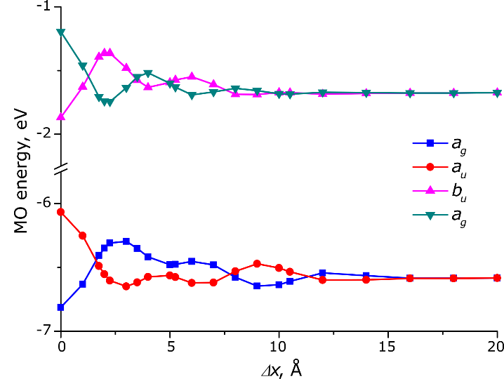
To exclude the influence of the variable MO overlap, only perfect face-to-face and edge-to-edge arrangements were considered in order to study the distance dependence of the excitonic Q-band splitting. As it is seen from Fig. 7, at larger Δz distances the splitting dependence is almost linear against 1/r (r = Δz) whereas the dependence expected from eq. (1) is 1/r³. A more detailed treatment of the Coulomb component of the excitonic coupling has been performed using the atomic charges obtained from the transition electrostatic potential fitting (TrESP charges) [65]. At larger distances the TD-DFT transition energy for dimers is well reproduced by a Coulomb contribution (ΔE_{Coul}) from monomers' transition charges. The TrESP Coulombic component is linear against 1/r rather than against 1/r³, which can be explained by a short distance between the transition dipoles. Significant disagreement between the TD-DFT transition energy and the predicted Coulombic component (Fig. 7) at shorter interplane distances (Δz) indicates a large impact of the short-range effects on the excitonic coupling. Another noticeable effect is a non-symmetrical splitting at shorter distances (Fig. 2): the red shift of the A_{G} transition is larger than the blue shift of the B_{U} transition. This can be explained by a larger contribution of a lower-energy transition to the configuration of the excited state (Table S3 of the ESI†). The red-shifted A_{G} transition is forbidden, therefore H-aggregates show only a blue-shifted Q-band. In crystals, the red-shifted Q-band absorption component often extends beyond λ = 800 nm (red shift of ΔE > 0.3 eV) whereas the blue-shifted band is usually observed at λ = 600 – 650 nm (blue shift of ΔE = 0.1 – 0.2 eV). For the edge-to-edge arrangement (Δz = 0), the TD-DFT Q-band splitting is only 0.05 eV at Δx = 17 Å and is purely Coulombic. Thus, a moderate ~0.15 eV blue shift observed for H-aggregates is only a "tip of an iceberg". The short-range intermolecular electronic interaction is much stronger than it can be expected from the experimental spectra. This can explain a well-known excited-state quenching in aggregated Pcs [11-14] and some properties of Pc-based molecular conductors [17] (since a short-range excitonic coupling is related to electron- and hole-transfer integrals [11, 41]).
Fig. 8. Energies of high-lying occupied (a_{u}, b_{g}) and low-lying vacant (a_{g}, b_{u}) orbitals of the ZnPc dimers at Δz = 3.5Å and various shift values (Δx)
MO analysis. The π-π MO overlap results in splitting of the HOMO and LUMO levels of the monomers as shown in Fig. 8. The HOMO and LUMO splitting pattern in the slipped-stack dimers is determined by the MO shapes of the corresponding monomers [37, 41]. The MO overlap is responsible for short-range effects (see above) often expressed as charge-resonance/charge-transfer (CR/CT) excitons [11, 41]. MO overlap and, as a consequence, the charge-transfer integrals [41, 66] are very sensitive to and intermolecular arrangement which results in a great variability of photophysical and electric properties of crystalline modifications of phthalocyanines [1-3, 16, 41, 67].
A parallel shift between Pc molecules in the dimer results in oscillations of the split MO levels with different periodicity for HOMO and LUMO which is a result of different nodal patterns of the monomers’ HOMO and LUMO (Figs. 4, 8) [37]. The splitting generally decreases with the shift due to decreasing overall π-MO overlap. The dependence of the splitting on the distance is exponential as a result of the exponential decay of the π -MO overlap (Fig. S3 of the ESI†). This is in contrast to the 1/r dependence of the TD-DFT transition energies at larger distances. Therefore, at the distances of 5–8 Å the MO splitting becomes negligible but the TD-DFT transition energies still show a non-zero excitonic splitting as a result of Coulombic coupling of the monomers’ transition dipoles.
Size dependence. Previously optical gaps of π-conjugated Zn(II) oligoPcs were extrapolated to a 1D-polyPc using a free-electron approximation (E vs. 1/N) [8] which is applicable for delocalized systems only [68]. For typical molecular crystals orbital and optical gaps may differ significantly [69]. Therefore, extrapolation of TD-DFT optical gaps of oligomers can be a better estimate to the optical gap of an infinite stack than the orbital gap directly calculated in periodic boundary conditions.
According to a simplified tight-binding model including only the nearest-neighbour interactions between ZnPc molecules [37, 38], the band dispersion (width of HOMO or LUMO band) for an N-meric stack is described by the following equation (2).

ΔE = ± 2J cos[π / (N + 1)] (2)

The coupling factor J is either J_{Coul} or J_{CT} for Coulombic or charge-transfer excitonic coupling, respectively. As it was shown by Bredas et al., the MO band edges are linear against cos[π/(N+1)] for phthalocyanines and other molecular semiconductors [37]. Similar extrapolation was also applied for optical gaps of oligothiophenes [70].
The excitonic splitting of two Q-band transitions results in 2·N transitions for the N-meric ZnPc. The TD-DFT spectrum is dominated by two x- and y-oriented transitions (A_{ux} and A_{uy}, respectively, see Fig. 3) which corresponds to all monomers' transition dipoles (Fig. 5) pointing in the same direction. All other transitions are of zero or low intensity (f < 0. 02).
Equation (2) can be used to predict the excitonic splitting of optical spectra for infinite stacks in crystals.
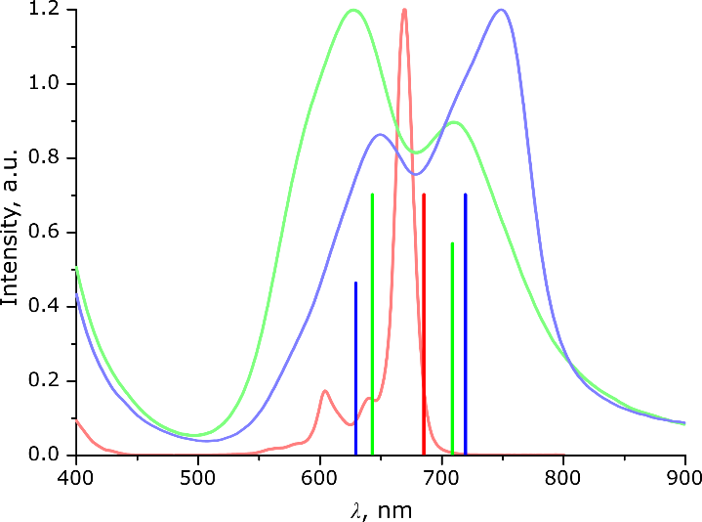
To study the size dependence of the excitonic splitting, larger aggregates (stacks) were calculated with the arrangements approximately resembling the β-modification of ZnPc (translation vectors taken from the X-Ray structure [71]). As no single-crystal X-Ray structure is available for α-ZnPc, stacks with Δz of 3.3 – 3.4Å and Δx of 1.75 – 2.0Å along the Zn-N bond (Fig. 4A) were studied (the Zn–Zn distance 3.75 – 3.95 Å, the inclination angle 28 – 31°, see Fig. 2). The results are shown in Fig. S4 and Table S3 of the ESI†. As it is seen from Fig. S4, the TD-DFT Q-band splitting is almost linear against cos[π/(N+1)] for N = 1…5 which in agreement with eq. (2). This indicates that excitonic splitting of the Q-band is mainly determined by interactions with the nearest neighbours. The extrapolated to N = ∞ transition energies of 1.97 eV (630 nm) and 1.72 eV (720 nm) for a single stack of β-modification are close to the experimental values (Fig. 2) of 1.94 eV (640 nm) and 1.65 eV (750 nm). Oscillator strengths increase almost linearly with size (Fig. S3 of the ESI†) and with the extrapolated ratio of 1:1.52 which is also in agreement with the experimental spectrum (Figs 2, 9). Our estimates of the Q-band splitting for α-ZnPc vary from 0.08 eV to 0.18 eV (Fig. 9 for Δx = 2.0Å and Δz = 3.3Å, Table S4 of the ESI†), i.e. very small variations of the intermolecular arrangement result in significant changes of the Q-band splitting. This explains why Zn(II), Ni(II) and Cu(II) Pcs have different solid-state spectra despite very similar crystal structures [39]. The approximate agreement between extrapolated and experimental spectra of β-ZnPc confirms that crystal spectra are mostly determined by excitonic coupling within the stack. For a more quantitative description, the next-nearest-neighbour and the inter-stack couplings should also be considered [39].
Fig. 9. Main TD-DFT Q-band transitions of ZnPc (red), ZnPc oligomers extrapolated to infinite stacks approximately resembling α- (green) and β-(blue) ZnPc stacks, together with experimental spectra of ZnPc in DMF, α- and β-ZnPc films, respectively (Fig. 2)

Conclusions
Excitonic coupling of the electronic transitions in a series of zinc(II) phthalocyanine dimers was studied by TD-DFT with a range-separated hybrid functional LC-BLYP. This method correctly reproduces the experimental excitonic shifts of the Q-band for known "rigid" non-conjugated binuclear phthalocyanines.
The near-zero excitonic redshift of the Q-band for the "edge-to-edge" Pc dimers is a result of a large distance between transition dipole centres (weak Coulombic coupling) and absence of the π-MO overlap (no short-range coupling). In contrast, the slipped-stacked arrangement of the Pc rings in dimers and crystals results in a strong redshift of the Q-band due to the π-MO overlap and the short-range excitonic coupling. The Kasha's point-dipole approximation (eq. (1)) is qualitatively applicable although the 1/r³ dependence is actually a superposition of 1/r dependence for Coulombic coupling and the e^{-r} dependence for short-range coupling. The short-range excitonic coupling is highly sensitive to the intermolecular arrangement due to a complicated HOMO-LUMO nodal pattern which determines the bonding/antibonding character of the π-MO overlap.
The well-known ~ 50 nm (~ 0.15 eV) blue shift of the Q-band of the "face-to-face" Pc dimers (H-aggregates) is only a "tip of an iceberg": the red-shifted (by ~ 0.65 eV) forbidden subband is not observed in the optical spectra but such a strong excitonic coupling indirectly influences other properties. The excitonic splitting of the Q-band can be extrapolated from Pc oligomers to an infinite 1D-stack, in the frame of the tight-binding approximation (eq. (2)). This approach can be further extended to include the next-nearest-neighbour and the inter-stack couplings for predicting optical spectra of crystalline phthalocyanines.
Conflicts of interest
There are no conflicts to declare.
Data availability
The data that support the findings of this study are available in the ESI† of this article.
Acknowledgements
The acknowledgements come at the end of an article after the conclusions and before the notes and references.
Notes and references
- D. Wöhrle, G. Schnurpfeil, S.G. Makarov, A. Kazarin and O.N. Suvorova, Macroheterocycles, 2012, 5, 191.
- N.B. McKeown, Phthalocyanine Materials, Cambridge University Press, 1998.
- P. Erk and H. Engelsberg, in The Porphyrin Handbook, ed. K. M. Kadish, K. M. Smith and R. Guilard, Academic Press, San Diego, 2003, 19, 105.
- B.H. Lessard, ACS Appl. Mater. Interfaces, 2021, 13, 31321.
- Z.J. Comeau, R.R. Cranston, H.R. Lamontagne, A.J. Shuhendler and B.H. Lessard, Commun. Chem., 2022, 5, 178.
- H. Kobayashi and P.L. Choyke, Acc. Chem. Res., 2019, 52, 2332
- S.G. Makarov, O.N. Suvorova and D. Wöhrle, J. Porphyrins Phthalocyanines, 2011, 15, 791.
- S.G. Makarov, G. Schnurpfeil, S.Yu. Ketkov and D. Wöhrle, J. Porphyrins Phthalocyanines, 2020, 24, 515.
- S.G. Makarov, G. Schnurpfeil, S.Yu. Ketkov and D. Wöhrle, J. Porphyrins Phthalocyanines, 2021, 25, 236.
- N. Kobayashi, Coord. Chem. Rev., 2002, 227, 129.
- K. Ishii and N. Kobayashi, in The Porphyrin Handbook, ed. K. M. Kadish, K. M. Smith and R. Guilard, Academic Press, San Diego, 2003, 16, 1.
- H. Isago, Optical Spectra of Phthalocyanines and Related Compounds, Springer, Tokyo, 2015.
- K. Kameyama, M. Morisue, A. Satake and Y. Kobuke, Angew. Chem. Int. Ed. 2005, 44, 4763.
- A.W. Snow, in The Porphyrin Handbook, ed. K. M. Kadish, K. M. Smith and R. Guilard, Academic Press, San Diego, 2003, 17, 129.
- M. J. Cook and I. Chambrier, in The Porphyrin Handbook, ed. K. M. Kadish, K. M. Smith and R. Guilard, Academic Press, San Diego, 2003, 17, 37.
- M. K. Engel, in The Porphyrin Handbook, ed. K. M. Kadish, K. M. Smith and R. Guilard, Academic Press, San Diego, 2003, 20, 1.
- T. Inabe and H. Tajima, Chem. Rev., 2004, 104, 5503.
- M. Hanack and D. Dini, in The Porphyrin Handbook, ed. K. M. Kadish, K. M. Smith and R. Guilard, Academic Press, San Diego, 2003, 18, 251.
- K. Ishii, N. Kobayashi, M. Fujitsuka, S. Abiko and O. Ito, J. Chem. Soc., Dalton Trans., 2002, 1735.
- M. V. Martinez-Diaz, M. S. Rodriguez-Morgade, M. C. Feiters, P. J. M. van Kan, R. J. M. Nolte, J. F. Stoddart and T. Torres, Org. Lett., 2000, 2, 1057.
- A. Escosura, M. V. Martinez-Diaz, P. Thordarson, A. E. Rowan, R. J. M. Nolte and T. Torres, J. Am. Chem. Soc., 2003, 125, 12300.
- A. Davydov, Theory of Molecular Excitons, Springer, New York, 2013.
- M. Kasha, H. R. Rawls and M. A. El-Bayoumi, Pure Appl. Chem., 1965, 11, 371.
- H. Eichhorn, D. Wöhrle and D. Pressner, Liq. Cryst., 1997, 22, 643.
- A.Yu. Tolbin, L.G. Tomilova and N.S. Zefirov, Russ. Chem. Rev., 2008, 77, 435.
- A.G. Martynov, Yu.G. Gorbunova and A.Yu. Tsivadze, Russian J. Inorg. Chem., 2014, 59, 1635.
- N. Kobayashi, H. Lam, W.A. Nevin, P. Janda, C.C. Leznoff and A.B.P. Lever, Inorg. Chem., 1990, 29, 3415.
- Y. Yamada, T. Maeno, K. Nawate and K. Tanaka, Chem. Commun., 2018, 54, 8226.
- S.G. Makarov, K.N. Maksimova, E.V. Baranov, G.K. Fukin, O. N. Suvorova, D. Wöhrle and G.A. Domrachev, Russ. Chem. Bull., 2006, 55, 1748.
- Y. Asano, M. Uchiyama, A. Fukasawa, T. Hatano, A. Muranaka and N. Kobayashi, J. Am. Chem. Soc., 2007, 129, 4516.
- Y. Asano, J. Sato, T. Furuyama and N. Kobayashi, Chem. Commun., 2012, 48, 4365.
- L. Zhao, X. Ren and X. Yan, CCS Chem., 2021, 3, 678.
- J.E. Norton and J.-L. Bredas, J. Chem. Phys., 2008, 128, 034701.
- B.L. Wheeler, G. Nagasubramanian, A.J. Bard, L.A. Schechtman, D.R. Dininny and M.E. Kenney, J. Am. Chem. Soc., 1984, 106, 7404.
- G. De La Torre, A. Hausmann, M. Sekita, G. Bottari, T. Torres and D. M. Guldi, Chem. Soc. Rev., 2013, 42, 8049.
- T. Mirkovic, R. Van Grondelle, E.E. Ostroumov, J.M. Anna, G. Govindjee and G.D. Scholes, Chem. Rev., 2017, 117, 249.
- J. L. Bredas, D. A. Da Silva Filho, J. Cornil and J. P. Calbert, PNAS, 2002, 99, 5804.
- S. Yanagisawa, I. Hamada, K. Yamauchi, T. Oguchi and T. Inaoka, Phys. Rev. B, 2014, 90, 245141.
- L. P. Doctor, F. Ziegs, B. Büchner, M. Naumann, A. Popov and M. Knupfer, J. Phys. Chem. C, 2021, 125, 12398.
- M. Kato, J. Onoe, Y. Matoba, K. Okamoto, S. Watanabe, J.-P. Bucher and M. Nakaya, J. Chem. Phys., 2020, 153, 144704.
- N. J. Hestand and F. C. Spano, Acc. Chem. Res., 2017, 50, 341.
- S. Yanagisawa, T. Yasuda, K. Inagaki, Y. Morikawa, K. Manseki and S. Yanagida, J. Phys. Chem. A, 2013, 117, 11246.
- A. O. Gudovannyy, J. M. Schäfer, O. Gerdes, D. Hildebrandt, G. Mattersteig, M. Pfeiffer and F. Ortmann, Adv. Funct. Mater., 2025, 2421048.
- A. D. Becke, Phys. Rev. A, 1988, 38, 3098.
- C. Lee, W. Yang and R. G. Parr, Phys. Rev. B, 1988, 37, 785.
- H. Iikura, T. Tsuneda, T. Yanai and K. Hirao, J. Chem. Phys., 2001, 115, 3540.
- F. Weigend and R. Ahlrichs, Phys. Chem. Chem. Phys., 2005, 7, 3297.
- F. Weigend, Phys. Chem. Chem. Phys., 2006, 8, 1057.
- A. D. Becke, J. Chem. Phys., 1993, 98, 5648.
- J. P. Perdew and Y. Wang, Phys. Rev. B, 1992, 45, 13244.
- W. J. Hehre, R. Ditchfield and J. A. Pople, J. Chem. Phys., 1972, 56, 2257.
- P. C. Hariharan and J. A. Pople, Theor. Chem. Acc., 1973, 28, 213.
- V. A. Rassolov, J. A. Pople, M. A. Ratner and T. L. Windus, J. Chem. Phys., 1998, 109, 1223.
- A. A. Granovsky, Firefly version 8.2.0, http://classic.chem.msu.su/gran/firefly/index.html
- M. W. Schmidt, K. K. Baldridge, J. A. Boatz, S. T. Elbert, M. S. Gordon, J. H. Jensen, S. Koseki, N. Matsunaga, K. A. Nguyen, S. J. Su, T. L. Windus, M. Dupuis and J. A. Montgomery, J. Comput. Chem., 1993, 14, 1347.
- F. Neese, Wiley Interdiscip. Rev.: Comput. Mol. Sci., 2025, 15, e70019.
- B. I. Dunlap, J. Chem. Phys., 1983, 78, 3140.
- F. Neese, F. Wennmohs, A. Hansen and U. Becker, Chem. Phys., 2009, 356, 98.
- C. M. Breneman and K. B. Wiberg, J. Comput. Chem., 1990, 11, 361.
- T. Lu and F. Chen, J. Comput. Chem., 2012, 33, 580.
- J. P. Heindel, K. M. Herman, E. Apra and S. S. Xantheas, J. Phys. Chem. Lett., 2021, 12, 7574.
- H. Isago, Optical Spectra of Phthalocyanines and Related Compounds, Springer, Japan, 2015.
- R. D. Harcourt, G. D. Scholes, K. P. Ghiggino and S. Speiser, J. Chem. Phys., 1996, 105, 1897.
- D. L. Dexter, J. Chem. Phys., 1953, 21, 836.
- T. Renger and F. Müh, Photosynth. Res., 2012, 111, 47.
- P. M. Kazmaier and R. Hoffmann, J. Am. Chem. Soc., 1994, 116, 9684.
- H. Jiang, Y. Li, C. Kloc, J. Ye, Y. Long, D. Fichou, W. Hu, R. Ganguly and P. Hu, Angew. Chem. Int. Ed., 2018, 57, 10112.
- J. Torras, C. Aleman and J. Casanovas, J. Phys. Chem. A, 2012, 116, 7571.
- J.-L. Bredas, Mater. Horiz., 2014, 1, 17.
- R. E. Larsen, J. Phys. Chem. C, 2016, 120, 9650.
- W. R. Scheidt and W. Dow, J. Am. Chem. Soc., 1977, 99, 1101.

1-43 => 1-43 (0)
55-71 => 44-60 (-11)
44-54 => 61-71 (+17)

1-10 => 1-10 (0)
11 => 11, 12
12-40 => 13-41 (+1)
41 => 43
42, 43 => 8, 9
44-71 => 44-71 (0)
72 => 12
73 => 42

