Received 00th January 20xx,
- G.A. Razuvaev Institute of Organometallic Chemistry of RAS, Tropinin str. 49, 603950 Nizhniy Novgorod, Russia.
- Universität Bremen, Institut für Angewandte und Physikalische Chemie, P.O. Box 330440, 28334 Bremen, Germany.
† Supplementary Information available: Tables of electronic transitions, additional figures, optimised molecular geometries. See DOI: 10.1039/x0xx00000x
Accepted 00th January 20xx
DOI: 10.1039/x0xx00000x

Excitonic coupling of electronic transitions in oligomeric phthalocyanine zinc(II) complexes
Sergey G. Makarov,*ª Sergey Yu. Ketkov ª and Dieter Wöhrle ^{b}
The excitonic coupling of the electronic transitions in a series of zinc(II) phthalocyanine (ZnPc) dimers has been studied using TD-DFT with a range-separated hybrid functional LC-BLYP. This method correctly reproduces the experimental excitonic Q-band shifts for structurally rigid, non-conjugated binuclear phthalocyanines. The observed significant differences in the experimental UV/Vis spectra for "edge-to-edge", "slipped-stacked" and "face-to-face" arrangements have been explained. The long-range Coulombic contribution to the excitonic coupling has been evaluated using transition electrostatic potential (TrESP) atomic charges, revealing how classical Kasha point-dipole model interfaces with short-range excitonic interactions determined by π-MO overlap. The excitonic splitting of the Q-band has been extrapolated from Pc oligomers to an infinite 1D-stack using the tight-binding model, and the main spectral features of α- and β-modifications of ZnPc have been correctly reproduced.

Introduction
Phthalocyanines (Pc) have found many "real" applications as colorants and materials for electronic devices.¹⁻³ Recent potential applications include organic thin-film transistors,^{4,5} near-infrared fluorescent diagnostics and photodynamic immunotherapy of tumors.⁶ Successful practical use of phthalocyanines (Pcs) in many fields originates from their structural versatility, photophysical properties and a wide range of solid-state arrangements.
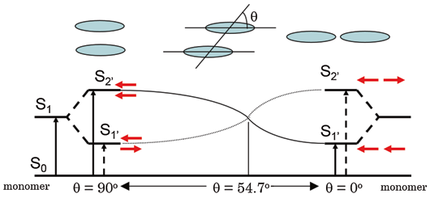
The photophysical properties of phthalocyanine metal complexes can be modified by peripheral substituents, central metal ions or by extension of the π-system.⁷⁻⁹ Noncovalent interactions (excitonic coupling) of the Pc π-systems also significantly influence the photophysical properties of phthalocyanines in aggregates, non-conjugated oligomers and crystals.¹⁰⁻³⁵ The term excitonic coupling refers to the electronic interaction between the excited states of the chromophores, whereas excitonic splitting denotes the resulting energy difference between the split electronic transitions.
Fig. 1. Excitonic coupling of electronic transitions in molecular dimers.¹² © Hiroaki Isago with CC-BY-NC 3.0 license
Non-conjugated phthalocyanine assemblies include well-known π-π stacked aggregates in solution¹⁴ and in the solid state,^{2,3,15,16} covalent^{10,24-31,35} and supramolecular^{13,15,18-21,26} oligomers. Two types of chromophore arrangement are usually discussed: face-to-face configurations, often referred as H-type aggregates, and edge-to-edge or slipped-stacked configurations known as J-type aggregates (Fig. 1).¹⁴
According to Kasha’s theory,²³ H-aggregates exhibit a blue-shifted absorption maximum and a suppressed radiative decay rate, whereas J-aggregates exhibit a red-shifted absorption maximum and an enhanced radiative decay rate. For dimers with a parallel arrangement of chromophores, the interaction of the transition dipoles can be approximated by a simple point-dipole model:

$∆E≈\frac{μ^{2}(1-3\cos^{2}θ)}{4πεr^{3}}$ (1)

where μ and r represent the magnitude of the transition moment in the monomer and the centre-to-centre distance between the molecules, respectively, and θ is the angle between the polarization axis and the centre-to-centre line. The energy change ΔE crosses zero at θ = 54.7°, separating H-aggregate (θ > 54.7°) and J-aggregate (θ < 54.7°) behaviours.
Many examples of "face-to-face" phthalocyanine dimers, oligomers and aggregates,^{10,24-28,34,35} and a few "edge-to-edge" and "slipped-stack" dimers and aggregates were described.^{13,18,29-32} But the exact alignment of the Pc subunits in these systems is not known, except for the crystals where slipped-stacked arrangement is typical for M(II)Pcs.^{1,2,16,17} Only a few binuclear Pcs with linkers rigid enough to ensure a well-defined geometry are known experimentally (Chart 1): a "gable" 1a,³¹ a "planar" 2a,²⁹ and a "cyclophane" 3a³⁰ linked binuclear Pcs having "edge-to-edge" or "slipped-stack" arrangements (J-dimers). For the "face-to-face" binuclear Pcs (H-dimers) with rigid linkers such as 4a²⁷ and 5a,²⁸ multiple conformations are still possible, which prevents an unambiguous determination of the alignment of the Pc macrocycles. A supramolecular dimer 6¹³ can also be considered as rigid although two spatial configurations ("parallel" and "oblique") are possible.
In a usual case of H-aggregates, a blue shift from λ = 660–700 nm to λ = 600–640 nm and a broadening of the Q-band are typical.¹⁴ Similar blue shifts were observed for various covalent and supramolecular cofacial dimers.^{10,14,25-28,34,35}
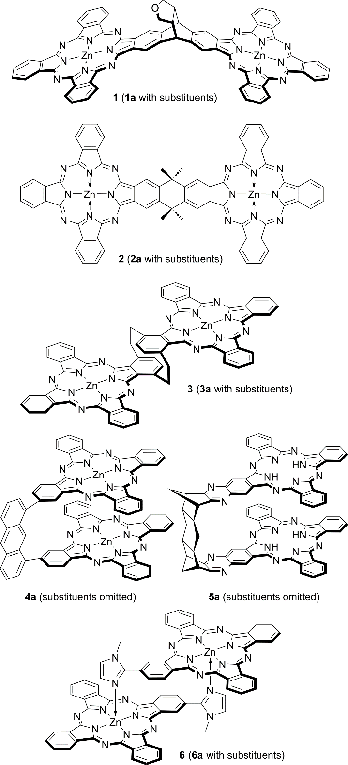
Slipped-stacked Pc oligomers resemble structural patterns of photosynthetic light-harvesting antenna consisting of bacteriochlorophyll dimers,³⁸ and they are photoactive in contrast to face-to-face Pc oligomers,^{11-13,39} for which a non-radiative decay of the excited states is typical. The cyclophane-fused dimer 3a is fluorescent (Φ_{f} = 0.12), a metal-free "gable" dimer 1a is also fluorescent (Φ_{f} = 0.55), a "planar" dimer 2a shows a singlet oxygen quantum yield of Φ_{Δ} = 0.08. The imidazole-bridged supramolecular dimer 6a is also fluorescent (Φ_{f} = 0.26). Surprisingly, for edge-to edge Pc dimer 2a no redshift predicted by Kasha’s theory and eq. (1) was observed. In contrast, J-dimers 3a and 6a exhibit strong bathochromic Q-band shifts (Table 1) in full agreement with Kasha’s theory. It was concluded^{7,29} that π-MO overlap is essential for an efficient excitonic coupling in Pc dimers, crystals and aggregates, and purely Coulombic coupling of the transition dipoles (eq. (1)) is not enough to explain the observed Q-band shifts.
Chart 1. "Rigid" phthalocyanine dimers
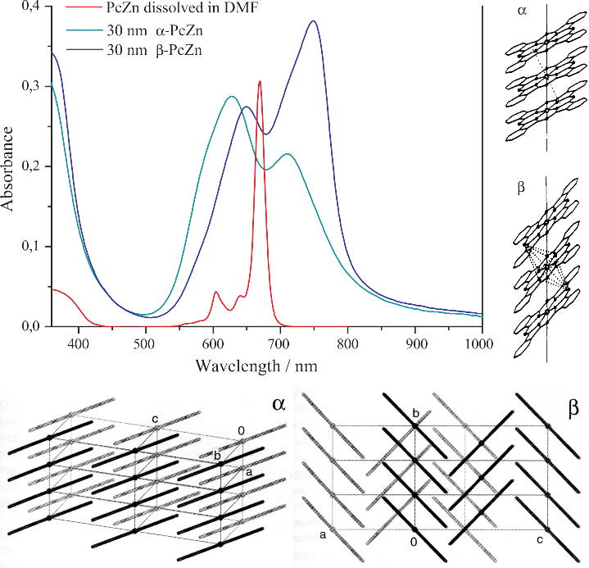
In the solid state, β-modification of planar M(II)Pcs is typically characterized by a close contact between the central metal ion and a meso-N atom of the adjacent molecule, with an inclination angle of ~45° within the stack. The inclination angle in the α-modification is 25–30°, and the molecular orientation may vary.^{16,36,37} These distinct chromophore arrangements alter the excitonic coupling significantly, leading to highly variable absorption profiles of crystalline phthalocyanines (Fig. 2). Thus, α-modifications of CuPc and ZnPc absorb at λ ~625 and ~700 nm, β -modifications at λ ~650 and ~750 nm, and ε-CuPc exhibits an absorption at even longer wavelength of λ < 820 nm.¹⁻³ The non-planar Ti(O)Pc with slipped-stacked arrangement similar to J-aggregates shows a strongly red-shifted Q-band absorption at λ ~700–900 nm and an efficient photoinduced charge carrier generation.³³
Fig. 2. Electronic spectra and crystal packing of α- and β-modifications of ZnPc
The excitonic coupling in phthalocyanine dimers³⁹⁻⁴¹ and crystals³⁹⁻⁴² was previously studied by DFT and semi-empirical methods. It was shown that short-range coupling is very sensitive to MO overlap^{39,41} and can be expressed in terms of charge-transfer integrals.^{41,43} This accounts for strong variability in solid-state UV/Vis spectra of structurally isomorphic Zn(II), Ni(II) and Cu(II) Pcs.⁴⁰ For selected Pc dimer arrangements, the excitonic coupling was investigated by TD-DFT.⁴⁴ However, a more systematic study is required for better understanding of excitonic coupling and related intermolecular properties. In light of emerging machine learning methods for molecular crystal structure prediction,⁴⁵ improving the theoretical evaluation of solid-state properties becomes essential.
Previously, we demonstrated that the range-separated hybrid functional LC-BLYP accurately reproduces the UV/Vis/NIR spectra of conjugated ZnPc oligomers.^{8,9} The extrapolated TD-DFT Q-band energy of 1D-oligoPcs is in agreement with a directly calculated band gap of 1D-polyPc.
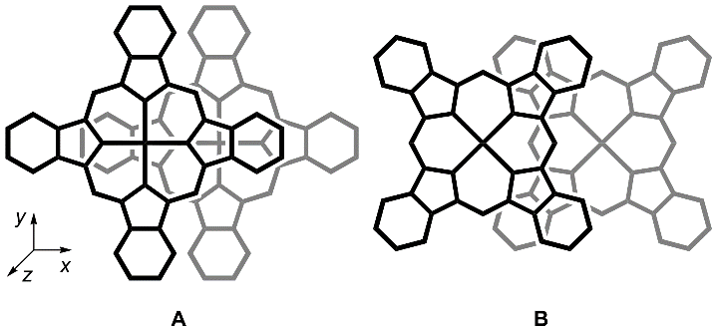
Here, we employ the same LC-TDDFT protocol to systematically investigate the dependence of the Q-band excitonic splitting on the relative spatial arrangement (r and θ) of ZnPc chromophores and finally to explain the excitonic effects observed in phthalocyanine aggregates, dimers and crystals. The applicability of this TD-DFT protocol is validated against a benchmark set of experimentally known, structurally rigid non-conjugated binuclear ZnPcs.
Fig. 3. Arrangements of the monomers in slipped-stacked ZnPc dimers with parallel shifts Δx along Zn – pyrrole-N (A, Δx_{pyrr}) and Zn – meso-N (B, Δx_{meso})
Computational details
DFT calculations. The range-separated hybrid functional LC-BLYP (μ = 0.35)⁴⁶⁻⁴⁸ with the def2-TZVP(-f)/def2-J⁴⁹⁻⁵¹ basis sets were used for TD-DFT calculations, similar to our previous publications.^{8,9} All geometries were optimised using the r2SCAN-3c functional⁵² which includes a built-in def2-mTZVP basis set, D4 empirical dispersion,⁵³ geometrical counterpoise⁵⁴ and relativistic corrections. The optimization method was chosen from the comparison of the optimised geometries of ZnPc with its experimental gas-phase geometry.⁵⁵ All calculations were carried out in the ORCA 6.0.1 software,⁵⁶ with the RIJCOSX approximation,^{57,58} default grid "Defgrid2",⁵⁶ tight (ΔE < 10⁻⁸ a.u.) and very tight (ΔE < 10⁻⁹ a.u.) SCF convergence for TD-DFT and geometry optimizations, respectively. Adding diffuse functions or counterpoise correction had no noticeable effect on the transition energy (ΔE < 0.01 eV).
The total excitonic splitting was obtained directly as the energy difference between the split TD-DFT transitions. The Coulombic component was evaluated from the transition charges of the monomers.
Transition charges were calculated by fitting the Q-band transition electrostatic potential (TrESP)⁵⁹ of ZnPc calculated at LC-BLYP/def2-TZVP//r2SCAN-3c level, using the CHELPG scheme⁶⁰ as implemented in the Multiwfn 3.8 software.^{61,62}
Extrapolation of TD-DFT spectra was carried out for ZnPc stacks up to the size of 5, constructed from the r2SCAN-3c optimised ZnPc molecules positioned either according to the translation vectors from β-ZnPc⁶³ stacks or by applying shifts of Δx_{pyrr} = 3.3–3.4 Å, Δz = 1.75–2.0 Å (Fig. 3A) to simulate the α-ZnPc stacks.
Results and discussion
Bridged binuclear phthalocyanines
"Rigid" binuclear ZnPcs 1–3 and 6 were selected to exclude the influence of noncovalent interactions (poorly described by DFT⁶⁴) on the relative position of the Pc chromophores.
The calculated Q-band wavelengths and energies for the dimers 1–3, 6 without peripheral substituents were compared to the experimental Q-band maxima of the corresponding substituted analogues. Since the Q-band position of phthalocyanines is generally less sensitive to peripheral β-substitution by alkyl, alkoxy or aryloxy groups (typically resulting in minor shifts of 5–15 nm),^{11,12} unsubstituted prototypes are commonly used for theoretical studies of Pc assemblies.^{8-10,30,31} The results are listed in Table 1.
Table 1. Experimental and calculated Q-band wavelengths, energies and intensities for rigid non-conjugated binuclear ZnPcs 1–3, 6 and their substituted analogues 1a–3a, 6a
Cpd. | Experimental (1a–3a, 6a) |  | Theoretical (1–3, 6)
 | λ, nm (ΔE, eV) | 10⁻⁵ ε,  M⁻¹·cm⁻¹ | λ, nm (ΔE, eV) | Oscillator strength
ZnPc⁸ | 674 (1.840) | 3.4 | 673 (1.842) | 0.472 · 2
1, 1a³¹ | 694 (1.787) | 2.9 | 699 (1.773) | 1.054
1, 1a³¹ | 677 (1.832) | 3.1 | 669 (1.854) | 0.885
1, 1a³¹ |  |  | 662 (1.871) | 0.194
2, 2a²⁹ | 682 (1.818) | 6.9 | 693 (1.790) | 1.313
2, 2a²⁹ |  |  | 681 (1.821) | 0.889
3, 3a³⁰ | 753 (1.647) | 0.84 | 742 (1.670) | 1.262
3, 3a³⁰ | 690 (1.797) | 0.72 | 679 (1.826) | 0.794
6, 6a¹³ | 700 (1.771) | 1.7 | 715 (1.733) | 1.070
6, 6a¹³ | 670 (1.851) | 1.2 | 669 (1.852) | 0.749

As can be seen from Table 1, the theoretical wavelengths are in agreement with the experimental ones. Therefore TD-DFT with a range-separated hybrid functional LC-BLYP correctly predicts the "through-space" excitonic coupling of the excited states of ZnPcs. For the edge-to-edge arrangements in 1 and 2, a redshift can be expected from eq. (1). However, the observed and predicted redshifts are negligible. This contrasts with a well-known blue shift for face-to-face arrangements in H-dimers and aggregates.^{10-13,25-28,34,35} Conversely, the expected redshifts are evident for "slipped-stack" arrangements in 3 and 6. Especially for the cyclophane-bridged dimer 3, the red shift is substantial and even comparable to some conjugated Pc dimers.⁷ The nearly zero red shift for the edge-to-edge dimers 1 and 2 was explained previously^{7,29} by the absence of the π-π overlap. Thus, it is important to study whether a general Kasha’s dipole-dipole model²³ is still applicable, or the observed excitonic coupling in phthalocyanine aggregates, dimers and crystals is a system-specific short-range effect determined by the π-π overlap.

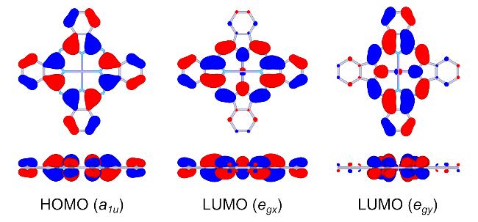
Excitonic coupling between phthalocyanine molecules
Fig. 4. Frontier MOs of ZnPc (front and side views)
To evaluate excitonic coupling effects in oligoPcs, model zinc phthalocyanine dimers with face-to-face, slipped-stack and edge-to-edge arrangements of the Pc rings (Fig. 3), with parallel shifts (Δx) = 0–20 Å and interplane distances Δz = 0–6 Å were studied by TD-DFT. The corresponding distances (r) and angles (θ) can be used to compare TD-DFT transition energies to those predicted by equation (1).
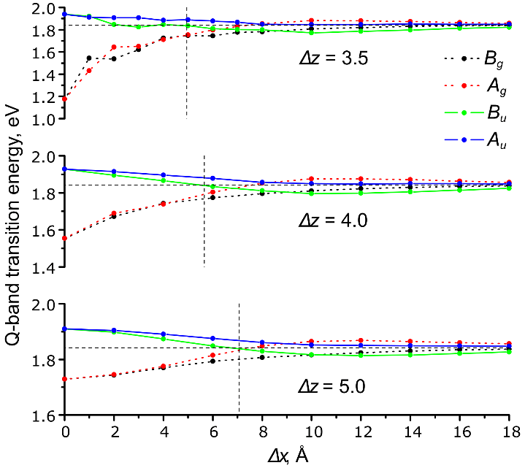
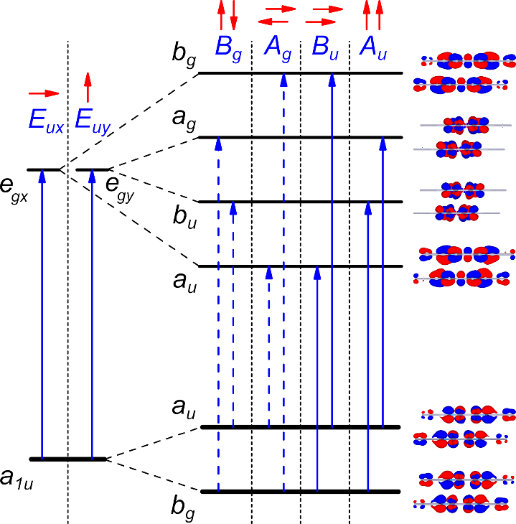
Phthalocyanines show intense π → π* absorption bands in the visible region of their absorption spectra. The Q-band corresponds to the doubly degenerate HOMO (a_{1u}) → LUMO (e_{g}) transition (Fig. 4).¹² In a Pc dimer, four Q-band transitions arise from the excitonic splitting of two degenerate E_{u} transitions of a single Pc chromophore. Two allowed B_{u} and A_{u} transitions (f ≈ 0.5) are x- and y-polarised, respectively. The remaining A_{g} and B_{g} transitions are forbidden (f ≈ 0) due to antiparallel orientation of the transition dipoles.
Fig. 6. TD-DFT Q-band transition energies vs. parallel shifts (Δx_{pyrr}) of two Pc molecules (arrangement in Fig. 3A). Forbidden transitions are shown by dashed lines. The horizontal line represents the Q-band energy of ZnPc, the vertical line corresponds to the zero-splitting angle of 54.7°
Fig. 5. Qualitative scheme of frontier MO splitting and Q-band transitions in slipped-stacked ZnPc dimers (C_{2h} symmetry)
Unlike nearly "pure" Q-band transitions of monomolecular Pcs, the configuration of each Q-band transition of a Pc dimer is a combination of two main transitions involving frontier orbitals (Fig. 5). The MOs of the Pc oligomers can be approximated as linear combinations of the monomer orbitals.¹¹⁻¹³ Due to π-π overlap, bonding-antibonding interactions between these MOs result in splitting of the corresponding energy levels. In infinite stacks, this results in the formation of valence and conduction bands.^{39,43} The dependence of these energies on the arrangement of the Pc molecules is shown in Fig. 6 for the shift direction along Zn–N bond (Fig. 3A). The corresponding transition energies are listed in Table S1 of the ESI†. For the shift direction along meso-N – Zn (Fig. 3B, which approximately resembles the stack arrangement in β-ZnPc), the results are shown in Fig. S1 and Table S2 of the ESI†.

Angle dependence. For parallel transition dipoles, the dependence of the excitonic splitting on the angle θ (Fig. 1) is approximately described by equation (1). With "face-to-face" arrangements, the allowed B_{U} (Q_{x}) transition is blue-shifted in contrast to the corresponding forbidden A_{G} transition, which is strongly red-shifted and can participate in non-radiative decay of the excitation energy. This explains why "face-to-face" dimers are non-fluorescent. For the "slipped-stack" configurations with larger shifts (Δx), the allowed B_{u} transition becomes red-shifted with increasing Δx, and its energy drops below the corresponding A_{g} forbidden transition. This explains why the "slipped-stack" and "edge-to-edge" dimers are fluorescent. The angle corresponding to zero splitting (according to eq. 1) between the B_{u} and A_{g} transitions is 54.7°, which is indicated by a vertical line in Fig. 6.
As can be seen from Fig. 6, there is a qualitative agreement between the TD-DFT results and equation (1). At the 3.5 Å interplane distance, the dependence of energy splitting on the shift is irregular due to short-range effects of the MO overlap (see below). These effects are much less pronounced already at the 4.0 Å distance. For the edge-to-edge arrangement (Δz = 0, see Fig. S2 of the ESI†), only large centre-to-centre distances r = Δx ≥ 16 Å are physically possible, which results in very small excitonic splittings, in agreement with eq. (1). For the "planar" dimer 2, this distance is 15.7 Å, and the predicted excitonic splitting is only 0.03 eV. Thus, the small redshift for the edge-to-edge dimers 1 and 2 can be explained solely by the large centre-to-centre distance of the transition dipoles. However, there is no quantitative agreement between the TD-DFT transition energies and eq. (1), which can be explained by short-range effects of the π-MO overlap,³⁹⁻⁴⁴ as discussed below.

Distance dependence. As shown by Harcourt et al.,⁶⁵ the total excitonic coupling can be partitioned into long-range Coulombic interactions and short-range coupling, the latter comprising Dexter exchange⁶⁶ and superexchange caused by the π-MO overlap. According to Hestand and Spano,⁴³ the superexchange coupling is mediated by virtual intermolecular charge-transfer (CT) states. In contrast, the Dexter exchange leads to a direct energy transfer but was shown⁶⁵ to be insignificant (relative to CT-mediated superexchange) in π-stacked chromophores. Taking into account only the Coulombic component yields Kasha’s exciton model,²³ often approximated as the point-dipole interaction (eq. 1). This component scales as 1/r³, while the superexchange interaction depends on the MO overlap, which decays exponentially with distance.
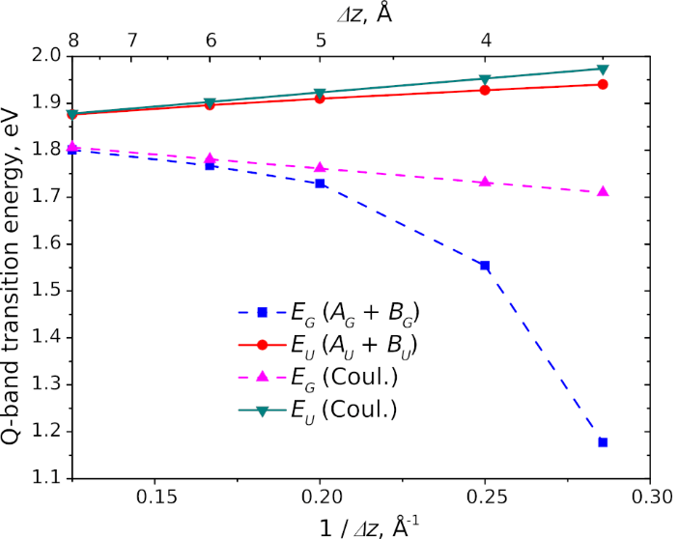
To exclude the influence of the variable π-MO overlap, only perfect face-to-face (Δx = 0) arrangement was considered in order to study the distance dependence of the excitonic Q-band splitting. As can be seen from Fig. 7, at larger r = Δz distances the splitting dependence is almost linear with respect to 1/r, while the point-dipole approximation (eq. 1) predicts a 1/r³ decay. The Coulombic component of the excitonic splitting has been evaluated using the atomic charges obtained from the fitting of the transition electrostatic potential (TrESP charges).⁵⁹ The short-range coupling contribution can be determined as the difference between the total excitonic splitting and its Coulombic component.
Fig. 7. Distance dependence of the TD-DFT Q-band transition energies of a face-to-face ZnPc dimer. Degenerate E_{G} and E_{U} transitions (D_{4h}) correspond to (A_{G} + B_{G}) and (A_{U} + B_{U}) pairs in C_{2h} symmetry of slipped-stack dimers (Fig. 5)
At larger distances, the TD-DFT transition energies for the dimers are well reproduced by the Coulombic contribution calculated from monomers' TrESP charges. Within the studied distance range, the Coulombic component scales linearly with 1/r rather than 1/r³: the distances between the transition dipoles are still comparable to the size of the macrocycles, therefore the point-dipole approximation is not yet valid. Indeed, eq. (1) significantly overestimates the splitting even at Δz = 8 Å (see Table S3A of the ESI†).
A significant discrepancy between the TD-DFT transition energy and the calculated Coulombic component (Fig. 7) at shorter interplanar distances (Δz) indicates the strong impact of short-range effects on excitonic coupling. Notably, the splitting at these distances is asymmetric: the red shift of the forbidden A_{g} transition is more pronounced than the blue shift of the allowed B_{u} transition. This asymmetry arises from a larger contribution of the lower-energy electronic configuration to the excited state (Table S3B of the ESI†).
Since the red-shifted A_{g} transition is forbidden, H-aggregates typically exhibit only a blue-shifted Q-band. In the Pc crystals where a slipped-stack arrangement partially allows this red-shifted component, it extends beyond λ = 800 nm (ΔE > 0.3 eV), while the blue-shifted subband remains at λ = 600–650 nm (ΔE = 0.1–0.2 eV). Therefore, the moderate blue shift (ΔE ≈ 0.15 eV) typically observed for Pc H-aggregates,^{10,12,14,25-28,34,35} is merely a "tip of the iceberg": if the A_{g} transition were allowed, it would appear at λ > 1000 nm. Thus, the short-range intermolecular electronic interactions in the Pc H-aggregates are much stronger than expected from the experimental UV/Vis spectra. However, this strong electronic coupling can be reflected in other properties. Specifically, it causes excited-state quenching in aggregated Pcs¹¹⁻¹⁴ (due to the dark nature of the lowest excited state) and correlates with the efficient charge transport in Pc-based molecular conductors^{17,67} (since short-range excitonic coupling is related to charge-transfer integrals^{11,43,67}).

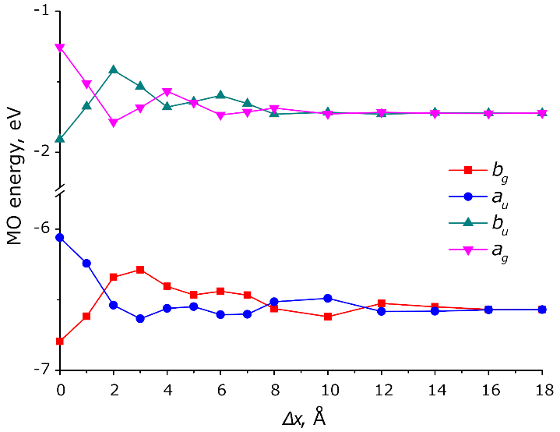
MO analysis. The π-π MO overlap results in splitting of the HOMO and LUMO levels of the monomers as shown in Fig. 8. The HOMO and LUMO splitting pattern in the slipped-stack dimers is determined by the MO shapes of the corresponding monomers.^{39,43} The MO overlap is responsible for short-range effects (see above) often expressed as charge-resonance/charge-transfer (CR/CT) excitons.^{11,43} MO overlap and, as a consequence, the charge-transfer integrals^{43,68} are very sensitive to intermolecular arrangement. This results in a great variability of photophysical and electric properties of crystalline modifications of phthalocyanines.^{1-3,16,69}
Fig. 8. Energies of 2 highest occupied (a_{u}, b_{g}) and 2 of 4 lowest vacant (a_{g}, b_{u}) orbitals of the ZnPc dimers at Δz = 3.5Å with respect to shift (Δx_{pyrr})
A parallel shift between Pc molecules in the dimer results in oscillations of the split MO levels with different periodicity for HOMO and LUMO as a result of different nodal patterns of the monomers' HOMO and LUMO (Figs. 4, 8, Table S4).³⁹ These MO level oscillations result in irregular shift dependence of the corresponding transition energies (see Fig. 6). The splitting generally decreases with the shift due to decreasing overall π-MO overlap. The distance dependence of the splitting is exponential as a result of the exponential decay of the π -MO overlap (Fig. S3 of the ESI†). This is in contrast to the 1/r dependence of the TD-DFT transition energies at larger distances. Consequently, at the distances of 5–8 Å where the MO splitting vanishes, the TD-DFT transition energy still shows a non-zero excitonic splitting due to the Coulombic coupling of the monomer transition dipoles.

Size dependence. Previously, the optical gaps of π-conjugated Zn(II) oligoPcs were extrapolated to a 1D-polyPc using a free-electron approximation⁸ (E vs. 1/N), which is applicable only to delocalised systems.⁷⁰ However, for typical molecular crystals, orbital and optical gaps can differ significantly.⁷¹ Therefore, the extrapolation of TD-DFT optical gaps of oligomers may provide a better estimate for the optical gap of an infinite stack than the orbital gap directly calculated under periodic boundary conditions.
According to a simplified tight-binding model including only the nearest-neighbour interactions between ZnPc molecules,^{39,40} the band dispersion (width of HOMO or LUMO band) for an N-meric stack is described by the following equation (2).

ΔE = ± 2J cos[π / (N + 1)] (2)

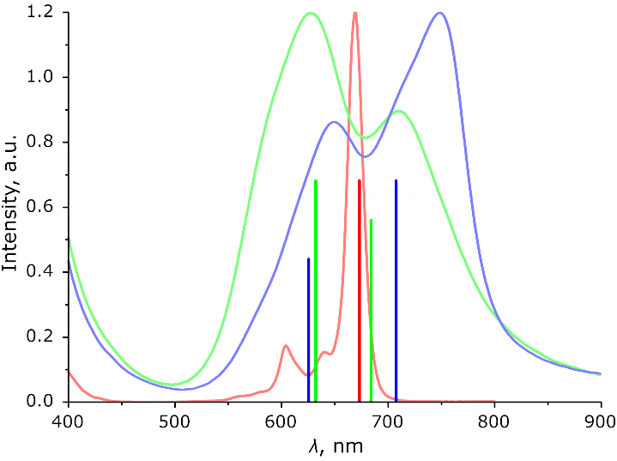
The coupling factor J is either J_{Coul} or J_{CT} for Coulombic or charge-transfer excitonic coupling, respectively. As it was shown by Bredas et al., the HOMO and LUMO band edges are also linear with respect to cos[π/(N+1)] for phthalocyanines and other molecular semiconductors.³⁹ Similar extrapolation was also applied for optical gaps of oligothiophenes.⁷²
Fig. 9. Main TD-DFT Q-band transitions (vertical lines) of ZnPc (red), ZnPc oligomers extrapolated to infinite stacks approximately reproducing the α- (green) and β-(blue) ZnPc stacks, together with experimental spectra of ZnPc in DMF, α- and β-ZnPc films, presented in the corresponding colours

Eq. (2) represents a limiting case for localized systems with high exciton binding energy and energetically well-separated Frenkel and charge-transfer (CT) states.^{39,43} An enhanced π -MO overlap may promote Frenkel-CT mixing and reduce the exciton binding energy, shifting the system toward a delocalized, band-like regime.⁶⁷ In addition, while short-range superexchange decays exponentially, long-range Coulombic coupling scales as 1/r, which may require the inclusion of next-nearest-neighbour terms. Both delocalization and long-range effects would introduce non-linear terms in eq. (2).⁷² Finally, a quantitative description would require 2D/3D cluster calculations to account for the cumulative contribution of weak, multidirectional inter-stack interactions. Thus, the extrapolated excitonic splitting (see below) should be regarded as a semiquantitative estimate.
The excitonic coupling of two Q-band transitions results in 2N transitions for the N-meric ZnPc. The TD-DFT spectra of ZnPc oligomers are dominated by two x- and y-oriented transitions (A_{ux} and A_{uy}, respectively), which correspond to the parallel alignment of all monomer transition dipoles (Fig. 5). The remaining Q-band transitions of zero or negligible intensity (f < 0.02) correspond to other transition dipole combinations (parallel and antiparallel). When extrapolating to an infinite stack under periodic boundary conditions (PBC), only these fully parallel transitions satisfy the optical selection rule (k = 0) and remain optically allowed by translational symmetry.³⁹
To study the size dependence of the excitonic splitting, larger aggregates (stacks) were calculated with the arrangements approximately resembling the β-modification of ZnPc (translation vectors taken from its X-Ray structure⁶³). As no single-crystal X-Ray structure is available for α-ZnPc, estimated model stacks were studied. These include structures with Δz = 3.3–3.4 Å and Δx_{pyrr} = 1.75–2.0 Å in the direction along the Zn–N bond (Fig. 3A), resembling the redetermined "brickstone" α-CuPc structure,³⁶ as well as along meso-N – Zn direction (Fig. 3B), similar to the classical "herringbone" α-CuPc structure¹⁶). The resulting Zn–Zn distance is 3.75–3.95 Å with a tilt angle of 28–31°, which is comparable to previous estimates.^{40,42} The results are shown in Fig. S4 and Table S5 of the ESI†. As can be seen from Fig. S4, the TD-DFT Q-band splitting is almost linear with respect to cos[π/(N+1)] for N = 1…5 which is in agreement with eq. (2). This indicates that the excitonic splitting of the Q-band is mostly determined by the nearest-neighbour interactions. The extrapolated to N = ∞ transition energies of E = 1.98 eV (λ = 626 nm) and 1.75 eV (λ = 708 nm) for a single stack of β-modification are comparable with the experimental values (Fig. 2) of 1.94 eV (640 nm) and 1.65 eV (750 nm). Oscillator strengths increase almost linearly with size (Fig. S3 of the ESI†) and with the extrapolated ratio of 1:1.55 which also agrees well with the experimental spectrum (Figs. 2, 9).
Our estimates of the Q-band splitting for α-ZnPc ("brickstone" model, Fig. 3A) vary from 0.08 eV to 0.18 eV (Fig. 9 for Δx_{pyrr} = 2.0 Å and Δz = 3.4 Å; Table S5 of the ESI†), i.e. very small variations of the intermolecular arrangement result in significant changes of the Q-band splitting. This explains why Zn(II), Ni(II) and Cu(II) Pcs have different solid-state spectra despite very similar crystal structures and solution spectra.⁴¹ For the "herringbone" model stack (Fig. 3B), only a blue shift with no splitting is predicted (Table S5), which is more typical for the aggregated Pcs in solution.^{10,14,25-28,34,35} Thus, the TD-DFT results within the "reinvestigated" model³⁶ (Fig. 9) are in a better agreement with the experimental spectrum of α-ZnPc, qualitatively reproducing its main features. The approximate agreement between the extrapolated and the experimental spectra of β-ZnPc confirms that crystal spectra are mostly determined by excitonic coupling within the stack. For a more quantitative description, the next-nearest-neighbour and the inter-stack couplings should also be considered.^{41,73}
Conclusions
Excitonic coupling of the electronic transitions in a series of zinc(II) phthalocyanine dimers was studied by TD-DFT with a range-separated hybrid functional LC-BLYP. This method correctly reproduces the experimental excitonic shifts of the Q-band for structurally rigid, non-conjugated binuclear complexes, confirming its applicability to excitonically coupled phthalocyanine assemblies.
The small to negligible excitonic redshift observed for the "edge-to-edge" Pc dimers is a result of large center-to-center distances (leading to weak Coulombic coupling) combined with the absence of π-MO overlap (responsible for short-range coupling). In contrast, the pronounced redshift of the Q-band in "slipped-stacked" arrangements results from a significant π-MO overlap and short-range excitonic coupling. While Kasha's point-dipole approximation (eq. 1) is qualitatively applicable, its 1/r³ distance dependence is shown to be a superposition of the 1/r and the e^{-r} behaviours for Coulombic and short-range coupling, respectively. The short-range excitonic coupling is highly sensitive to the intermolecular arrangement due to a complicated HOMO-LUMO nodal pattern, which determines the bonding/antibonding character of the π-MO overlap.
The well-known ~50 nm (~0.15 eV) blue shift of the Q-band of the "face-to-face" Pc dimers (H-aggregates) represents only a fraction of the total excitonic coupling: the strongly red-shifted (~0.65 eV) subband is optically forbidden and not observed in the spectra, but such an intense excitonic coupling is anticipated to indirectly influence other properties.
The excitonic splitting of the Q-band can be extrapolated from Pc oligomers to an infinite 1D-stack, within the frame of the tight-binding approximation (eq. 2). This approach can be further extended to include the next-nearest-neighbour and the inter-stack couplings for predicting the optical spectra of crystalline phthalocyanines.
Conflicts of interest
There are no conflicts to declare.
Data availability
The data that support the findings of this study are available in the ESI† of this article.
Acknowledgements
This work was carried out within the frames of the State Assignment of the G.A. Razuvaev Institute of Organometallic Chemistry of RAS.
Notes and references
- D. Wöhrle, G. Schnurpfeil, S.G. Makarov, A. Kazarin and O.N. Suvorova, Macroheterocycles, 2012, 5, 191.
- N.B. McKeown, Phthalocyanine Materials, Cambridge University Press, 1998.
- P. Erk and H. Engelsberg, in The Porphyrin Handbook, ed. K. M. Kadish, K. M. Smith and R. Guilard, Academic Press, San Diego, 2003, 19, 105.
- B.H. Lessard, ACS Appl. Mater. Interfaces, 2021, 13, 31321.
- Z.J. Comeau, R.R. Cranston, H.R. Lamontagne, A.J. Shuhendler and B.H. Lessard, Commun. Chem., 2022, 5, 178.
- H. Kobayashi and P.L. Choyke, Acc. Chem. Res., 2019, 52, 2332.
- S.G. Makarov, O.N. Suvorova and D. Wöhrle, J. Porphyrins Phthalocyanines, 2011, 15, 791.
- S.G. Makarov, G. Schnurpfeil, S.Yu. Ketkov and D. Wöhrle, J. Porphyrins Phthalocyanines, 2020, 24, 515.
- S.G. Makarov, G. Schnurpfeil, S.Yu. Ketkov and D. Wöhrle, J. Porphyrins Phthalocyanines, 2021, 25, 236.
- N. Kobayashi, Coord. Chem. Rev., 2002, 227, 129.
- K. Ishii and N. Kobayashi, in The Porphyrin Handbook, ed. K. M. Kadish, K. M. Smith and R. Guilard, Academic Press, San Diego, 2003, 16, 1.
- H. Isago, Optical Spectra of Phthalocyanines and Related Compounds, Springer, Tokyo, 2015.
- K. Kameyama, M. Morisue, A. Satake and Y. Kobuke, Angew. Chem. Int. Ed. 2005, 44, 4763.
- A.W. Snow, in The Porphyrin Handbook, ed. K. M. Kadish, K. M. Smith and R. Guilard, Academic Press, San Diego, 2003, 17, 129.
- M. J. Cook and I. Chambrier, in The Porphyrin Handbook, ed. K. M. Kadish, K. M. Smith and R. Guilard, Academic Press, San Diego, 2003, 17, 37.
- M. K. Engel, in The Porphyrin Handbook, ed. K. M. Kadish, K. M. Smith and R. Guilard, Academic Press, San Diego, 2003, 20, 1.
- T. Inabe and H. Tajima, Chem. Rev., 2004, 104, 5503.
- M. Hanack and D. Dini, in The Porphyrin Handbook, ed. K. M. Kadish, K. M. Smith and R. Guilard, Academic Press, San Diego, 2003, 18, 251.
- K. Ishii, N. Kobayashi, M. Fujitsuka, S. Abiko and O. Ito, J. Chem. Soc., Dalton Trans., 2002, 1735.
- M. V. Martinez-Diaz, M. S. Rodriguez-Morgade, M. C. Feiters, P. J. M. van Kan, R. J. M. Nolte, J. F. Stoddart and T. Torres, Org. Lett., 2000, 2, 1057.
- A. Escosura, M. V. Martinez-Diaz, P. Thordarson, A. E. Rowan, R. J. M. Nolte and T. Torres, J. Am. Chem. Soc., 2003, 125, 12300.
- A. Davydov, Theory of Molecular Excitons, Springer, New York, 2013.
- M. Kasha, H. R. Rawls and M. A. El-Bayoumi, Pure Appl. Chem., 1965, 11, 371.
- H. Eichhorn, D. Wöhrle and D. Pressner, Liq. Cryst., 1997, 22, 643.
- A.Yu. Tolbin, L.G. Tomilova and N.S. Zefirov, Russ. Chem. Rev., 2008, 77, 435.
- A.G. Martynov, Yu.G. Gorbunova and A.Yu. Tsivadze, Russian J. Inorg. Chem., 2014, 59, 1635.
- N. Kobayashi, H. Lam, W.A. Nevin, P. Janda, C.C. Leznoff and A.B.P. Lever, Inorg. Chem., 1990, 29, 3415.
- Y. Yamada, T. Maeno, K. Nawate and K. Tanaka, Chem. Commun., 2018, 54, 8226.
- S.G. Makarov, K.N. Maksimova, E.V. Baranov, G.K. Fukin, O. N. Suvorova, D. Wöhrle and G.A. Domrachev, Russ. Chem. Bull., 2006, 55, 1748.
- Y. Asano, M. Uchiyama, A. Fukasawa, T. Hatano, A. Muranaka and N. Kobayashi, J. Am. Chem. Soc., 2007, 129, 4516.
- Y. Asano, J. Sato, T. Furuyama and N. Kobayashi, Chem. Commun., 2012, 48, 4365.
- L. Zhao, X. Ren and X. Yan, CCS Chem., 2021, 3, 678.
- J.E. Norton and J.-L. Bredas, J. Chem. Phys., 2008, 128, 034701.
- B.L. Wheeler, G. Nagasubramanian, A.J. Bard, L.A. Schechtman, D.R. Dininny and M.E. Kenney, J. Am. Chem. Soc., 1984, 106, 7404.
- G. De La Torre, A. Hausmann, M. Sekita, G. Bottari, T. Torres and D. M. Guldi, Chem. Soc. Rev., 2013, 42, 8049.
- A. Hoshino, Y. Takenaka and H. Miyaji, Acta Crystallogr., Sect. B: Struct. Sci., 2003, 59, 393–403.
- K.-Y. Law, Chem. Rev., 1993, 93, 449–486.
- T. Mirkovic, R. Van Grondelle, E.E. Ostroumov, J.M. Anna, G. Govindjee and G.D. Scholes, Chem. Rev., 2017, 117, 249.
- J. L. Bredas, D. A. Da Silva Filho, J. Cornil and J. P. Calbert, PNAS, 2002, 99, 5804.
- S. Yanagisawa, I. Hamada, K. Yamauchi, T. Oguchi and T. Inaoka, Phys. Rev. B, 2014, 90, 245141.
- L. P. Doctor, F. Ziegs, B. Büchner, M. Naumann, A. Popov and M. Knupfer, J. Phys. Chem. C, 2021, 125, 12398.
- M. Kato, J. Onoe, Y. Matoba, K. Okamoto, S. Watanabe, J.-P. Bucher and M. Nakaya, J. Chem. Phys., 2020, 153, 144704.
- N. J. Hestand and F. C. Spano, Acc. Chem. Res., 2017, 50, 341.
- S. Yanagisawa, T. Yasuda, K. Inagaki, Y. Morikawa, K. Manseki and S. Yanagida, J. Phys. Chem. A, 2013, 117, 11246.
- A. O. Gudovannyy, J. M. Schäfer, O. Gerdes, D. Hildebrandt, G. Mattersteig, M. Pfeiffer and F. Ortmann, Adv. Funct. Mater., 2025, 2421048.
- A. D. Becke, Phys. Rev. A, 1988, 38, 3098.
- C. Lee, W. Yang and R. G. Parr, Phys. Rev. B, 1988, 37, 785.
- H. Iikura, T. Tsuneda, T. Yanai and K. Hirao, J. Chem. Phys., 2001, 115, 3540.
- F. Weigend and R. Ahlrichs, Phys. Chem. Chem. Phys., 2005, 7, 3297.
- F. Weigend, Phys. Chem. Chem. Phys., 2006, 8, 1057.
- A. D. Becke, J. Chem. Phys., 1993, 98, 5648.
- S. Grimme, A. Hansen, S. Ehlert and J.-M. Mewes, J. Chem. Phys., 2021, 154, 064103.
- S. Ehlert, U. Huniar, J. Ning, J. W. Furness, J. Sun, A. D. Kaplan, J. P. Perdew and J. G. Brandenburg, J. Chem. Phys., 2021, 154, 061101.
- H. Kruse and S. Grimme, J. Chem. Phys., 2012, 136, 154101.
- T. Strenalyuk, S. Samdal and H. V. Volden, J. Phys. Chem. A, 2007, 111, 12011.
- F. Neese, Wiley Interdiscip. Rev.: Comput. Mol. Sci., 2025, 15, e70019.
- B. I. Dunlap, J. Chem. Phys., 1983, 78, 3140.
- F. Neese, F. Wennmohs, A. Hansen and U. Becker, Chem. Phys., 2009, 356, 98.
- T. Renger and F. Müh, Photosynth. Res., 2012, 111, 47.
- C. M. Breneman and K. B. Wiberg, J. Comput. Chem., 1990, 11, 361.
- T. Lu and F. Chen, J. Comput. Chem., 2012, 33, 580.
- T. Lu, J. Chem. Phys., 2024, 161, 082503.
- W. R. Scheidt and W. Dow, J. Am. Chem. Soc., 1977, 99, 1101.
- J. P. Heindel, K. M. Herman, E. Apra and S. S. Xantheas, J. Phys. Chem. Lett., 2021, 12, 7574.
- R. D. Harcourt, G. D. Scholes, K. P. Ghiggino and S. Speiser, J. Chem. Phys., 1996, 105, 1897.
- D. L. Dexter, J. Chem. Phys., 1953, 21, 836.
- V. Coropceanu, J. Cornil, D. A. da Silva Filho, Y. Olivier, R. Silbey and J.-L. Brédas, Chem. Rev., 2007, 107, 926–952.
- P. M. Kazmaier and R. Hoffmann, J. Am. Chem. Soc., 1994, 116, 9684.
- H. Jiang, Y. Li, C. Kloc, J. Ye, Y. Long, D. Fichou, W. Hu, R. Ganguly and P. Hu, Angew. Chem. Int. Ed., 2018, 57, 10112.
- J. Torras, C. Aleman and J. Casanovas, J. Phys. Chem. A, 2012, 116, 7571.
- J.-L. Bredas, Mater. Horiz., 2014, 1, 17.
- R. E. Larsen, J. Phys. Chem. C, 2016, 120, 9650.
- R.P. Fornari, P. Rowe, D. Padula and A. Troisi, J. Chem. Theory Comput., 2017, 13, 3754.

