Excitonic coupling of electronic transitions in oligomeric phthalocyanine zinc(II) complexes
Sergey G. Makarov,*ª Sergey Yu. Ketkov ª and Dieter Wöhrle ^{b}
- G.A. Razuvaev Institute of Organometallic Chemistry of RAS, Tropinin str. 49, 603950 Nizhniy Novgorod, Russia.
- Universität Bremen, Institut für Angewandte und Physikalische Chemie, P.O. Box 330440, 28334 Bremen, Germany.

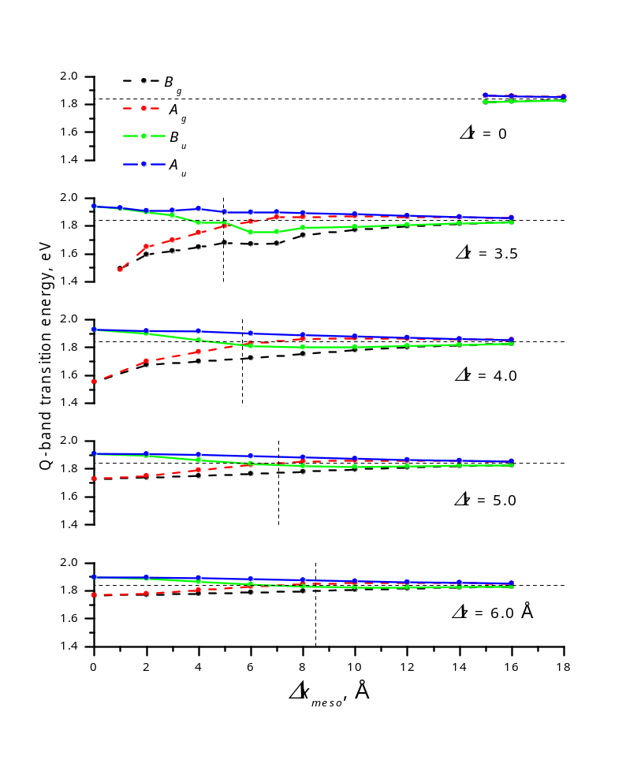
Fig. S1. TD-DFT Q-band transition energies vs. parallel shifts (Δx_{meso}) of two Pc molecules (arrangement in Fig. 3B of the main text). Forbidden transitions are shown by dashed lines. Horizontal line represents the Q-band energy of ZnPc, vertical line corresponds to zero-splitting angle of θ = 54.7°

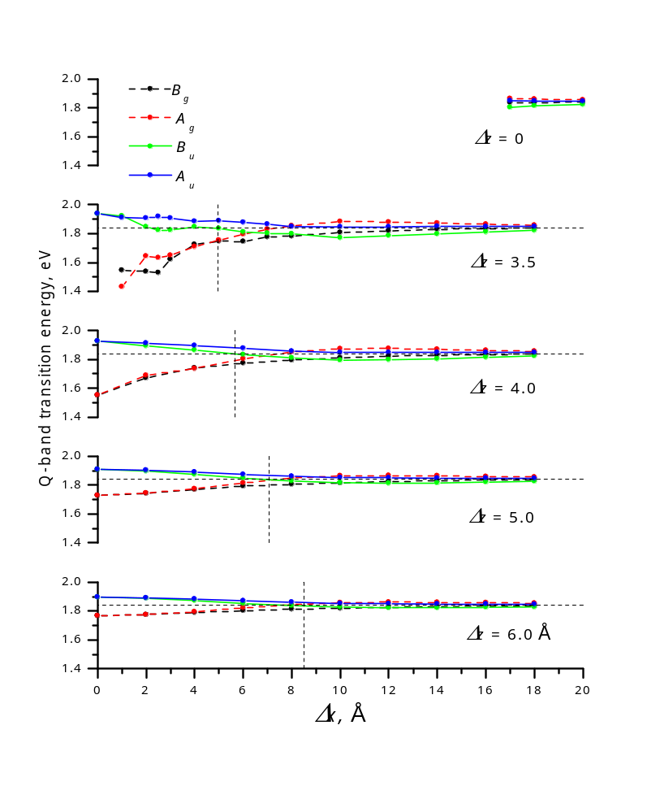
Fig. S2. TD-DFT Q-band transition energies vs. parallel shifts (Δx_{pyrr}) of two Pc molecules (arrangement in Fig. 3A of the main text). Forbidden transitions are shown by dashed lines. Horizontal line represents the Q-band energy of ZnPc, vertical line corresponds to zero-splitting angle of θ = 54.7°

Table S1. TD-DFT Q-band transition energies vs. parallel shifts (Δx_{pyrr}) of two Pc molecules (arrangement in Fig. 3A of the main text)
Shift, Å |  | Q-band transition energy, eV
Δz | Δx_{pyrr} | B_{G} | A_{G} | B_{U} (X) | A_{U} (Y)
0 | 17.0 | 1.838 | 1.865 | 1.804 | 1.851
0 | 18.0 | 1.838 | 1.861 | 1.815 | 1.849
0 | 20.0 | 1.839 | 1.856 | 1.825 | 1.847
3.5 | 0.0 | 1.177 | 1.177 | 1.940 | 1.940
3.5 | 1.0 | 1.545 | 1.432 | 1.922 | 1.912
3.5 | 2.0 | 1.537 | 1.643 | 1.846 | 1.907
3.5 | 2.5 | 1.529 | 1.632 | 1.824 | 1.918
3.5 | 3.0 | 1.621 | 1.649 | 1.825 | 1.908
3.5 | 4.0 | 1.725 | 1.710 | 1.847 | 1.885
3.5 | 5.0 | 1.747 | 1.755 | 1.835 | 1.890
3.5 | 6.0 | 1.746 | 1.796 | 1.811 | 1.879
3.5 | 7.0 | 1.777 | 1.831 | 1.802 | 1.866
3.5 | 8.0 | 1.782 | 1.854 | 1.799 | 1.849
3.5 | 10.0 | 1.808 | 1.883 | 1.772 | 1.846
3.5 | 12.0 | 1.819 | 1.880 | 1.786 | 1.846
3.5 | 14.0 | 1.830 | 1.873 | 1.797 | 1.850
3.5 | 16.0 | 1.835 | 1.865 | 1.812 | 1.849
3.5 | 18.0 | 1.837 | 1.858 | 1.822 | 1.848
4.0 | 0.0 | 1.554 | 1.554 | 1.928 | 1.928
4.0 | 2.0 | 1.672 | 1.690 | 1.894 | 1.914
4.0 | 4.0 | 1.742 | 1.738 | 1.866 | 1.896
4.0 | 6.0 | 1.774 | 1.804 | 1.833 | 1.878
4.0 | 8.0 | 1.796 | 1.852 | 1.812 | 1.857
4.0 | 10.0 | 1.811 | 1.875 | 1.796 | 1.849
4.0 | 12.0 | 1.822 | 1.876 | 1.798 | 1.848
4.0 | 14.0 | 1.830 | 1.871 | 1.805 | 1.849
4.0 | 16.0 | 1.835 | 1.863 | 1.815 | 1.849
4.0 | 18.0 | 1.837 | 1.857 | 1.824 | 1.848
5.0 | 0.0 | 1.729 | 1.729 | 1.910 | 1.910
5.0 | 2.0 | 1.744 | 1.745 | 1.898 | 1.904
5.0 | 4.0 | 1.770 | 1.775 | 1.874 | 1.891
5.0 | 6.0 | 1.793 | 1.815 | 1.848 | 1.875
5.0 | 8.0 | 1.807 | 1.848 | 1.829 | 1.861
5.0 | 10.0 | 1.816 | 1.865 | 1.817 | 1.852
5.0 | 12.0 | 1.824 | 1.868 | 1.814 | 1.850
5.0 | 14.0 | 1.830 | 1.865 | 1.816 | 1.849
5.0 | 16.0 | 1.835 | 1.860 | 1.821 | 1.848
5.0 | 18.0 | 1.837 | 1.856 | 1.827 | 1.847
6.0 | 0.0 | 1.767 | 1.767 | 1.896 | 1.896
6.0 | 2.0 | 1.774 | 1.775 | 1.889 | 1.892
6.0 | 4.0 | 1.789 | 1.795 | 1.872 | 1.883
6.0 | 6.0 | 1.803 | 1.822 | 1.853 | 1.871
6.0 | 8.0 | 1.813 | 1.844 | 1.838 | 1.861
6.0 | 10.0 | 1.820 | 1.857 | 1.828 | 1.853
6.0 | 12.0 | 1.826 | 1.861 | 1.823 | 1.850
6.0 | 14.0 | 1.831 | 1.860 | 1.823 | 1.849
6.0 | 16.0 | 1.835 | 1.857 | 1.826 | 1.848
6.0 | 18.0 | 1.837 | 1.854 | 1.829 | 1.847
8.0 | 0.0 | 1.801 | 1.801 | 1.876 | 1.876
* E (ZnPc) = 1.842 eV (E_{U})

Table S2. TD-DFT Q-band transition energies vs. parallel shifts (Δx_{meso}) of two ZnPc molecules (arrangement in Fig. 3B of the main text)
Shift, Å |  | Q-band transition energy, eV
Δz | Δx_{meso} | B_{G} | A_{G} | B_{U} (X) | A_{U} (Y)
0 | 15.0 | 1.815 | 1.864 | 1.816 | 1.863
0 | 16.0 | 1.823 | 1.860 | 1.821 | 1.858
0 | 18.0 | 1.831 | 1.855 | 1.828 | 1.853
3.5 | 0.0 | 1.177 | 1.177 | 1.940 | 1.940
3.5 | 1.0 | 1.493 | 1.485 | 1.924 | 1.928
3.5 | 2.0 | 1.593 | 1.650 | 1.898 | 1.908
3.5 | 3.0 | 1.619 | 1.698 | 1.874 | 1.910
3.5 | 4.0 | 1.648 | 1.750 | 1.822 | 1.922
3.5 | 5.0 | 1.678 | 1.799 | 1.824 | 1.898
3.5 | 6.0 | 1.669 | 1.830 | 1.752 | 1.896
3.5 | 7.0 | 1.673 | 1.862 | 1.756 | 1.899
3.5 | 8.0 | 1.733 | 1.864 | 1.785 | 1.892
3.5 | 10.0 | 1.771 | 1.870 | 1.794 | 1.883
3.5 | 12.0 | 1.797 | 1.866 | 1.806 | 1.873
3.5 | 14.0 | 1.816 | 1.862 | 1.818 | 1.863
3.5 | 16.0 | 1.826 | 1.857 | 1.825 | 1.856
4.0 | 0.0 | 1.554 | 1.554 | 1.928 | 1.928
4.0 | 2.0 | 1.675 | 1.701 | 1.900 | 1.919
4.0 | 4.0 | 1.701 | 1.770 | 1.852 | 1.917
4.0 | 6.0 | 1.725 | 1.831 | 1.809 | 1.901
4.0 | 8.0 | 1.754 | 1.861 | 1.803 | 1.889
4.0 | 10.0 | 1.782 | 1.867 | 1.803 | 1.880
4.0 | 12.0 | 1.803 | 1.864 | 1.811 | 1.870
4.0 | 14.0 | 1.818 | 1.860 | 1.820 | 1.862
4.0 | 16.0 | 1.827 | 1.856 | 1.826 | 1.855
5.0 | 0.0 | 1.729 | 1.729 | 1.910 | 1.910
5.0 | 2.0 | 1.739 | 1.751 | 1.895 | 1.908
5.0 | 4.0 | 1.751 | 1.792 | 1.864 | 1.903
5.0 | 6.0 | 1.766 | 1.831 | 1.837 | 1.893
5.0 | 8.0 | 1.781 | 1.854 | 1.821 | 1.883
5.0 | 10.0 | 1.797 | 1.861 | 1.816 | 1.874
5.0 | 12.0 | 1.811 | 1.860 | 1.819 | 1.866
5.0 | 14.0 | 1.822 | 1.858 | 1.824 | 1.859
5.0 | 16.0 | 1.829 | 1.855 | 1.828 | 1.854
6.0 | 0.0 | 1.767 | 1.767 | 1.896 | 1.896
6.0 | 2.0 | 1.771 | 1.778 | 1.887 | 1.895
6.0 | 4.0 | 1.778 | 1.804 | 1.866 | 1.891
6.0 | 6.0 | 1.787 | 1.831 | 1.845 | 1.884
6.0 | 8.0 | 1.797 | 1.848 | 1.831 | 1.876
6.0 | 10.0 | 1.808 | 1.855 | 1.825 | 1.869
6.0 | 12.0 | 1.817 | 1.856 | 1.825 | 1.862
6.0 | 14.0 | 1.825 | 1.855 | 1.827 | 1.857
6.0 | 16.0 | 1.830 | 1.853 | 1.830 | 1.853
* E (ZnPc) = 1.842 eV (E_{U})

Table S3A. TD-DFT Q-band transition energies vs. distance (Δz) for face-to-face ZnPc dimers (Δx = 0) with Coulombic component estimated using TrESP charges (Fig. 7 of the main text) and simple point-dipole model (eq. (1) of the main text). Allowed transitions are shown in bold
Δz, Å | Transition |  | Transition energy from Coulombic splitting, eV
 | Symmetry | Energy, eV | TrESP | Point-dipole
3.5 | E_{G} | 1.177 | 1.710 | 0.817
3.5 | E_{U} | 1.940 | 1.974 | 2.867
4.0 | E_{G} | 1.554 | 1.731 | 1.155
4.0 | E_{U} | 1.928 | 1.953 | 2.529
5.0 | E_{G} | 1.729 | 1.761 | 1.490
5.0 | E_{U} | 1.910 | 1.923 | 2.194
6.0 | E_{G} | 1.767 | 1.781 | 1.638
6.0 | E_{U} | 1.896 | 1.903 | 2.046
8.0 | E_{G} | 1.801 | 1.806 | 1.756
8.0 | E_{U} | 1.876 | 1.878 | 1.928

Table S3B. Major contributions of the elementary MO-MO transitions to the Q-band transitions of face-to-face ZnPc dimers. Allowed transitions are shown in bold. Doubly degenerate transitions E_{G}, E_{U} correspond to (A_{G} + B_{G}), (A_{U} + B_{U}) pairs, respectively, in C_{2h} symmetry of slipped-stacked dimers (Fig. 5 of the main text); a_{2g}, a_{1u}, e_{g}, e_{u} MOs correspond to b_{g}, a_{u}, (a_{g} + b_{g}), (a_{u} + b_{u}), respectively
Δz, Å | Transition |  | Occupied MO |  | Virtual MO |  | Contribution
 | Symmetry | Energy, eV | Symmetry | Energy, eV | Symmetry | Energy, eV
3.5 | E_{G} | 1.177 | a_{2g} | -6.794 | e_{g} | -1.254 | 4.1%
3.5 | E_{G} | 1.177 | a_{1u} | -6.060 | e_{u} | -1.908 | 94.4%
3.5 | E_{U} | 1.940 | a_{2g} | -6.794 | e_{u} | -1.908 | 38.1%
3.5 | E_{U} | 1.940 | a_{1u} | -6.060 | e_{g} | -1.254 | 53.0%
4.0 | E_{G} | 1.554 | a_{2g} | -6.602 | e_{g} | -1.436 | 16.6%
4.0 | E_{G} | 1.554 | a_{1u} | -6.265 | e_{u} | -1.745 | 80.2%
4.0 | E_{U} | 1.928 | a_{2g} | -6.602 | e_{u} | -1.745 | 44.3%
4.0 | E_{U} | 1.928 | a_{1u} | -6.265 | e_{g} | -1.436 | 47.0%
5.0 | E_{G} | 1.729 | a_{2g} | -6.489 | e_{g} | -1.579 | 41.1%
5.0 | E_{G} | 1.729 | a_{1u} | -6.422 | e_{u} | -1.643 | 53.9%
5.0 | E_{U} | 1.910 | a_{2g} | -6.489 | e_{u} | -1.643 | 45.8%
5.0 | E_{U} | 1.910 | a_{1u} | -6.422 | e_{g} | -1.579 | 45.9%
6.0 | E_{G} | 1.767 | a_{2g} | -6.481 | e_{g} | -1.622 | 46.2%
6.0 | E_{G} | 1.767 | a_{1u} | -6.468 | e_{u} | -1.635 | 48.3%
6.0 | E_{U} | 1.896 | a_{2g} | -6.481 | e_{u} | -1.635 | 46.0%
6.0 | E_{U} | 1.896 | a_{1u} | -6.468 | e_{g} | -1.622 | 46.0%

Table S4A. MO energies of ZnPc dimers at Δz = 3.5 Å, eV (MO description is shown in Fig. 5, monomer arrangement in Fig. 3A of the main text)
Δx_{pyrr}, Å | Occupied MO |  | Virtual MO
Δx_{pyrr}, Å | b_{g} | a_{u} | a_{u} | b_{u} | a_{g} | b_{g}
0 | -6.794 | -6.060 | -1.908 | -1.908 | -1.254 | -1.254
1 | -6.617 | -6.243 | -1.804 | -1.675 | -1.512 | -1.384
2 | -6.340 | -6.539 | -1.672 | -1.419 | -1.785 | -1.563
3 | -6.287 | -6.634 | -1.679 | -1.533 | -1.684 | -1.598
4 | -6.406 | -6.561 | -1.721 | -1.679 | -1.568 | -1.581
5 | -6.466 | -6.548 | -1.713 | -1.641 | -1.649 | -1.620
6 | -6.440 | -6.605 | -1.709 | -1.598 | -1.735 | -1.642
7 | -6.467 | -6.603 | -1.725 | -1.655 | -1.714 | -1.641
8 | -6.562 | -6.514 | -1.687 | -1.730 | -1.686 | -1.691
10 | -6.619 | -6.489 | -1.609 | -1.717 | -1.727 | -1.794
12 | -6.526 | -6.584 | -1.722 | -1.730 | -1.716 | -1.694
14 | -6.550 | -6.581 | -1.743 | -1.720 | -1.724 | -1.694
16 | -6.568 | -6.572 | -1.729 | -1.722 | -1.725 | -1.720

Table S4B. MO energies of ZnPc dimers at Δz = 3.5 Å, eV (MO description is shown in Fig. 5, monomer arrangement in Fig. 3B of the main text)
Δx_{meso}, Å | Occupied MO |  | Virtual MO
Δx_{meso}, Å | b_{g} | a_{u} | a_{u} | b_{u} | a_{g} | b_{g}
0 | -6.794 | -6.060 | -1.908 | -1.908 | -1.254 | -1.254
1 | -6.621 | -6.234 | -1.736 | -1.738 | -1.448 | -1.453
2 | -6.400 | -6.481 | -1.546 | -1.486 | -1.733 | -1.674
3 | -6.448 | -6.486 | -1.570 | -1.497 | -1.754 | -1.683
4 | -6.548 | -6.394 | -1.594 | -1.672 | -1.605 | -1.681
5 | -6.467 | -6.506 | -1.630 | -1.730 | -1.579 | -1.653
6 | -6.324 | -6.665 | -1.756 | -1.623 | -1.689 | -1.563
7 | -6.370 | -6.663 | -1.802 | -1.589 | -1.772 | -1.540
8 | -6.486 | -6.554 | -1.755 | -1.648 | -1.717 | -1.610
10 | -6.531 | -6.558 | -1.718 | -1.707 | -1.696 | -1.690
12 | -6.544 | -6.578 | -1.727 | -1.700 | -1.731 | -1.707
14 | -6.567 | -6.572 | -1.725 | -1.721 | -1.727 | -1.722
16 | -6.569 | -6.569 | -1.722 | -1.722 | -1.723 | -1.722

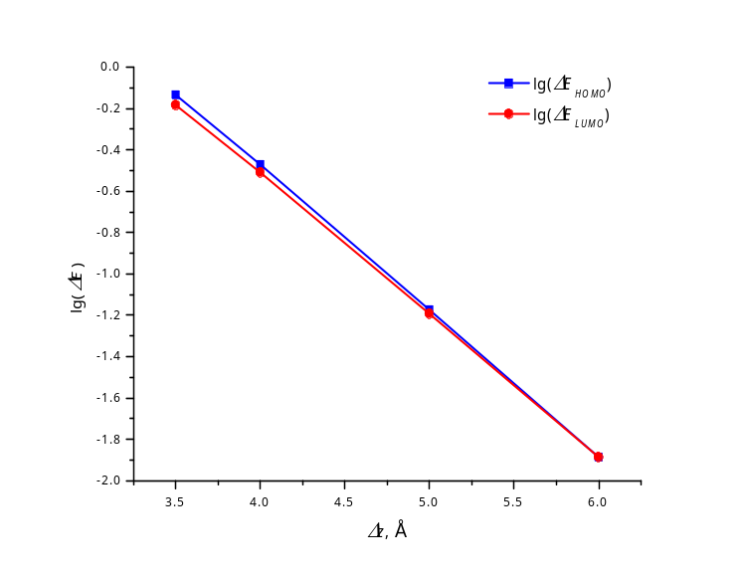
Fig. S3. Distance dependence of HOMO and LUMO splitting for face-to-face ZnPc dimers (Δx = 0)
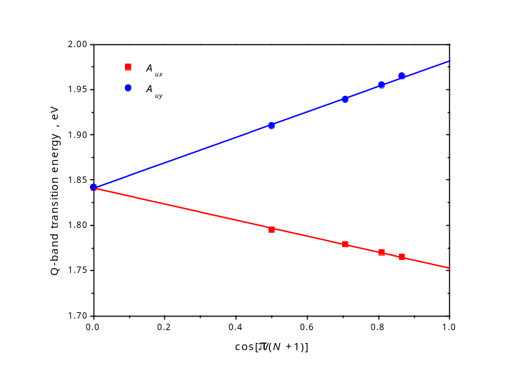
Fig. S4. Size dependence of the main TD-DFT Q-band transitions of slipped-stacked ZnPc oligomers of size N (resembling β-ZnPc stacks)

Table S5. Size dependence of TD-DFT energies of the main Q-band transitions of slipped-stacked ZnPc oligomers
Shifts, Å | Number of monomers | Q-band transition energies, eV, and oscillator strengths
Along Zn – meso-N (Fig. 3B) |  | E [A_{U} (X)] | E [A_{U} (Y)] | f (A_{UX}) | f (A_{UY})
Δx_{meso} = 3.632  Δy_{meso} = 0.185  Δz = 3.214  (β-ZnPc stack) | 1 | 1.842 | 1.842 | 0.472 | 0.472
 | 2 | 1.795 | 1.910 | 0.685 | 0.668
 | 3 | 1.779 | 1.939 | 0.957 | 0.826
 | 4 | 1.770 | 1.955 | 1.231 | 0.973
 | 5 | 1.765 | 1.965 | 1.428 | 1.114
 | ∞ | 1.752 | 1.982 | 1.547 | 1 (ratio)
Δx_{meso} = 1.75  Δy_{meso} = 0  Δz = 3.4  (approx. α-ZnPc stack) | 1 | 1.842 | 1.842 | 0.472 | 0.472
 | 2 | 1.896 | 1.900 | 0.683 | 0.606
 | 3 | 1.928 | 1.930 | 0.859 | 0.706
 | 4 | 1.943 | 1.943 | 1.036 | 0.790
 | ∞ | 1.963 | 1.965 | 1.775 | 1 (ratio)
Δx_{meso} = 2.0  Δy_{meso} = 0  Δz = 3.4  (approx. α-ZnPc stack) | 1 | 1.842 | 1.842 | 0.472 | 0.472
 | 2 | 1.896 | 1.900 | 0.683 | 0.606
 | 3 | 1.920 | 1.923 | 0.874 | 0.705
 | 4 | 1.932 | 1.935 | 1.061 | 0.798
 | ∞ | 1.953 | 1.956 | 1.819 | 1 (ratio)
Along Zn–N bond (Fig. 3A) |  | E [B_{U} (X)] | E [A_{U} (Y)] | f (B_{U}) | f (A_{U})
Δx_{pyrr} = 1.75  Δy_{pyrr} = 0  Δz = 3.3  (approx. α-ZnPc stack) | 1 | 1.842 | 1.842 | 0.472 | 0.472
 | 2 | 1.820 | 1.872 | 0.524 | 0.564
 | 3 | 1.824 | 1.889 | 0.623 | 0.662
 | 4 | 1.825 | 1.897 | 0.723 | 0.756
 | ∞ | 1.816 | 1.909 | 1 (ratio) | 1.115
Δx_{pyrr} = 2.0  Δy_{pyrr} = 0  Δz = 3.3  (approx. α-ZnPc stack) | 1 | 1.842 | 1.842 | 0.472 | 0.472
 | 2 | 1.791 | 1.891 | 0.521 | 0.598
 | 3 | 1.782 | 1.912 | 0.618 | 0.715
 | 4 | 1.778 | 1.924 | 0.730 | 0.828
 | ∞ | 1.758 | 1.942 | 1 (ratio) | 1.357
Δx_{pyrr} = 1.75  Δy_{pyrr} = 0  Δz = 3.4  (approx. α-ZnPc stack) | 1 | 1.842 | 1.842 | 0.472 | 0.472
 | 2 | 1.846 | 1.889 | 0.568 | 0.599
 | 3 | 1.854 | 1.910 | 0.682 | 0.712
 | 4 | 1.859 | 1.921 | 0.795 | 0.821
 | ∞ | 1.860 | 1.939 | 1 (ratio) | 1.070
Δx_{pyrr} = 2.0  Δy_{pyrr} = 0  Δz = 3.4  (approx. α-ZnPc stack) | 1 | 1.842 | 1.842 | 0.472 | 0.472
 | 2 | 1.823 | 1.901 | 0.563 | 0.623
 | 3 | 1.821 | 1.926 | 0.679 | 0.754
 | 4 | 1.820 | 1.939 | 0.805 | 0.881
 | ∞ | 1.812 | 1.961 | 1 (ratio) | 1.217

XYZ geometries optimized at the r2SCAN-3c level of DFT, Å
57
ZnPc
C 0.701663 6.554204 0.000000
C -0.701663 6.554204 0.000000
C 1.422571 5.364926 0.000000
C 0.703967 4.174565 0.000000
C -0.703967 4.174565 0.000000
C -1.422571 5.364926 0.000000
C 1.120422 2.780020 0.000000
C -1.120422 2.780020 0.000000
N 0.000000 1.989101 0.000000
N -2.390568 2.390568 0.000000
N 2.390568 2.390568 0.000000
H 1.231071 7.502550 0.000000
H -1.231071 7.502550 0.000000
H 2.508027 5.356475 0.000000
H -2.508027 5.356475 0.000000
C 6.554204 -0.701663 0.000000
C 6.554204 0.701663 0.000000
C 5.364926 -1.422571 0.000000
C 4.174565 -0.703967 0.000000
C 4.174565 0.703967 0.000000
C 5.364926 1.422571 0.000000
C 2.780020 -1.120422 0.000000
C 2.780020 1.120422 0.000000
N 1.989101 0.000000 0.000000
N 2.390568 -2.390568 0.000000
H 7.502550 -1.231071 0.000000
H 7.502550 1.231071 0.000000
H 5.356475 -2.508027 0.000000
H 5.356475 2.508027 0.000000
C -6.554204 0.701663 0.000000
C -6.554204 -0.701663 0.000000
C -5.364926 1.422571 0.000000
C -4.174565 0.703967 0.000000
C -4.174565 -0.703967 0.000000
C -5.364926 -1.422571 0.000000
C -2.780020 1.120422 0.000000
C -2.780020 -1.120422 0.000000
N -1.989101 0.000000 0.000000
N -2.390568 -2.390568 0.000000
H -7.502550 1.231071 0.000000
H -7.502550 -1.231071 0.000000
H -5.356475 2.508027 0.000000
H -5.356475 -2.508027 0.000000
C -0.701663 -6.554204 0.000000
C 0.701663 -6.554204 0.000000
C -1.422571 -5.364926 0.000000
C -0.703967 -4.174565 0.000000
C 0.703967 -4.174565 0.000000
C 1.422571 -5.364926 0.000000
C -1.120422 -2.780020 0.000000
C 1.120422 -2.780020 0.000000
N -0.000000 -1.989101 0.000000
H -1.231071 -7.502550 0.000000
H 1.231071 -7.502550 0.000000
H -2.508027 -5.356475 0.000000
H 2.508027 -5.356475 0.000000
Zn 0.000000 0.000000 0.000000

125
Compound 1
C 0.032844 1.293259 3.255751
C 0.032844 -1.293259 3.255751
H 0.032910 -2.387650 3.225592
H 0.032910 2.387650 3.225592
C 1.261492 0.706647 2.602144
C 2.316244 1.429237 2.068434
C 1.261492 -0.706647 2.602144
H 2.322996 2.515722 2.064498
C 2.316244 -1.429237 2.068434
H 2.322996 -2.515722 2.064498
C -1.176886 0.706455 2.571257
C -1.176886 -0.706455 2.571257
C -2.222960 1.429234 2.023244
C -2.222960 -1.429234 2.023244
H -2.231818 2.515768 2.023710
H -2.231818 -2.515768 2.023710
C -3.275706 0.703533 1.469838
C -3.275706 -0.703533 1.469838
C -4.511329 1.119495 0.826224
C -4.511329 -1.119495 0.826224
N -4.856526 2.390259 0.647421
N -5.214860 0.000000 0.460990
N -4.856526 -2.390259 0.647421
C -5.985708 2.779972 0.065649
Zn -6.982533 0.000000 -0.445487
C -5.985708 -2.779972 0.065649
C -6.355226 4.174640 -0.125806
N -6.982989 1.989976 -0.445560
N -8.752521 0.000000 -1.354016
N -6.982989 -1.989976 -0.445560
C -6.355226 -4.174640 -0.125806
C -5.714869 5.365018 0.200409
C -7.608323 4.175087 -0.767982
C -7.979554 2.780647 -0.957303
C -9.456343 1.120515 -1.714255
C -9.456343 -1.120515 -1.714255
C -7.979554 -2.780647 -0.957303
C -7.608323 -4.175087 -0.767982
C -5.714869 -5.365018 0.200409
C -6.355392 6.554629 -0.129271
H -4.748426 5.356380 0.694648
C -8.246937 5.365829 -1.096284
N -9.109798 2.390926 -1.536574
C -10.697446 0.704007 -2.349670
C -10.697446 -0.704007 -2.349670
N -9.109798 -2.390926 -1.536574
C -8.246937 -5.365829 -1.096284
C -6.355392 -6.554629 -0.129271
H -4.748426 -5.356380 0.694648
C -7.604577 6.555024 -0.768614
H -5.883248 7.502827 0.110896
H -9.213140 5.357964 -1.590994
C -11.757658 1.422404 -2.891399
C -11.757658 -1.422404 -2.891399
C -7.604577 -6.555024 -0.768614
H -9.213140 -5.357964 -1.590994
H -5.883248 -7.502827 0.110896
H -8.075213 7.503446 -1.010772
C -12.816710 0.701631 -3.432620
H -11.750276 2.507884 -2.887344
C -12.816710 -0.701631 -3.432620
H -11.750276 -2.507884 -2.887344
H -8.075213 -7.503446 -1.010772
H -13.661115 1.231131 -3.864161
H -13.661115 -1.231131 -3.864161
C 3.376656 -0.703747 1.528442
C 3.376656 0.703747 1.528442
C 4.618790 -1.119718 0.897231
C 4.618790 1.119718 0.897231
N 4.965979 -2.390526 0.722396
N 5.325329 0.000000 0.538641
N 4.965979 2.390526 0.722396
C 6.099947 -2.780356 0.150296
Zn 7.100112 0.000000 -0.355230
C 6.099947 2.780356 0.150296
C 6.471609 -4.174936 -0.037275
N 7.101118 -1.989980 -0.353093
N 8.878220 0.000000 -1.246810
N 7.101118 1.989980 -0.353093
C 6.471609 4.174936 -0.037275
C 5.828916 -5.365431 0.283838
C 7.729980 -4.175093 -0.669014
C 8.102142 -2.780587 -0.856011
C 9.585038 -1.120565 -1.601217
C 9.585038 1.120565 -1.601217
C 8.102142 2.780587 -0.856011
C 7.729980 4.175093 -0.669014
C 5.828916 5.365431 0.283838
C 6.472719 -6.554865 -0.040127
H 4.858124 -5.357231 0.769475
C 8.371836 -5.365621 -0.991625
N 9.237198 -2.390821 -1.425989
C 10.831376 -0.704040 -2.226580
C 10.831376 0.704040 -2.226580
N 9.237198 2.390821 -1.425989
C 8.371836 5.365621 -0.991625
C 6.472719 6.554865 -0.040127
H 4.858124 5.357231 0.769475
C 7.727199 -6.554961 -0.668929
H 5.998800 -7.503158 0.196056
H 9.342039 -5.357570 -1.478423
C 11.895742 -1.422561 -2.759760
C 11.895742 1.422561 -2.759760
C 7.727199 6.554961 -0.668929
H 9.342039 5.357570 -1.478423
H 5.998800 7.503158 0.196056
H 8.200111 -7.503267 -0.907004
C 12.959096 -0.701692 -3.292554
H 11.888281 -2.508028 -2.755891
C 12.959096 0.701692 -3.292554
H 11.888281 2.508028 -2.755891
H 8.200111 7.503267 -0.907004
H 13.806851 -1.231185 -3.717460
H 13.806851 1.231185 -3.717460
C 0.035209 -0.778597 4.733061
C -1.240053 -1.137349 5.514324
C 0.035209 0.778597 4.733061
H 0.927158 -1.176667 5.227701
O -2.094550 0.000000 5.427058
H -0.996340 -1.353478 6.568635
H -1.781594 -1.992215 5.094259
C -1.240053 1.137349 5.514324
H 0.927158 1.176667 5.227701
H -1.781594 1.992215 5.094259
H -0.996340 1.353478 6.568635

128
Compound 2
C -1.274825 0.704246 0.000000
C -1.274825 -0.704246 0.000000
C 0.000000 1.539445 0.000000
C 0.000000 2.430155 1.266875
C 0.000000 2.430155 -1.266875
C 0.000000 -1.539445 0.000000
C 0.000000 -2.430155 -1.266875
C 0.000000 -2.430155 1.266875
C 1.274825 -0.704246 0.000000
C 1.274825 0.704246 0.000000
C -8.559367 -6.554527 0.000000
C -9.280464 -5.365374 0.000000
C -8.562211 -4.174734 0.000000
C -8.978893 -2.780539 0.000000
C -8.559367 6.554527 0.000000
C -9.280464 5.365374 0.000000
C -8.562211 4.174734 0.000000
C -8.978893 2.780539 0.000000
C -7.155996 -6.554441 0.000000
C -6.435431 -5.365043 0.000000
C -7.154186 -4.174638 0.000000
C -6.737976 -2.780487 0.000000
C -7.155996 6.554441 0.000000
C -6.435431 5.365043 0.000000
C -7.154186 4.174638 0.000000
C -6.737976 2.780487 0.000000
C -14.411901 -0.701738 0.000000
C -13.222795 -1.422611 0.000000
C -12.032126 -0.704108 0.000000
C -10.638236 -1.120416 0.000000
C -14.411901 0.701738 0.000000
C -13.222795 1.422611 0.000000
C -12.032126 0.704108 0.000000
C -10.638236 1.120416 0.000000
C -2.493769 -1.400462 0.000000
C -3.684024 -0.702038 0.000000
C -5.077541 -1.121943 0.000000
C -2.493769 1.400462 0.000000
C -3.684024 0.702038 0.000000
C -5.077541 1.121943 0.000000
N -7.857207 -1.989394 0.000000
N -7.857207 1.989394 0.000000
N -9.847170 0.000000 0.000000
N -5.868105 0.000000 0.000000
N -10.248346 -2.391044 0.000000
N -10.248346 2.391044 0.000000
N -5.466545 -2.391439 0.000000
N -5.466545 2.391439 0.000000
Zn -7.858269 0.000000 0.000000
C 7.155996 -6.554441 0.000000
C 6.435431 -5.365043 0.000000
C 7.154186 -4.174638 0.000000
C 6.737976 -2.780487 0.000000
C 7.155996 6.554441 0.000000
C 6.435431 5.365043 0.000000
C 7.154186 4.174638 0.000000
C 6.737976 2.780487 0.000000
C 8.559367 -6.554527 0.000000
C 9.280464 -5.365374 0.000000
C 8.562211 -4.174734 0.000000
C 8.978893 -2.780539 0.000000
C 8.559367 6.554527 0.000000
C 9.280464 5.365374 0.000000
C 8.562211 4.174734 0.000000
C 8.978893 2.780539 0.000000
C 2.493769 -1.400462 0.000000
C 3.684024 -0.702038 0.000000
C 5.077541 -1.121943 0.000000
C 2.493769 1.400462 0.000000
C 3.684024 0.702038 0.000000
C 5.077541 1.121943 0.000000
C 14.411901 -0.701738 0.000000
C 13.222795 -1.422611 0.000000
C 12.032126 -0.704108 0.000000
C 10.638236 -1.120416 0.000000
C 14.411901 0.701738 0.000000
C 13.222795 1.422611 0.000000
C 12.032126 0.704108 0.000000
C 10.638236 1.120416 0.000000
N 7.857207 -1.989394 0.000000
N 7.857207 1.989394 0.000000
N 5.868105 0.000000 0.000000
N 9.847170 0.000000 0.000000
N 5.466545 -2.391439 0.000000
N 5.466545 2.391439 0.000000
N 10.248346 -2.391044 0.000000
N 10.248346 2.391044 0.000000
Zn 7.858269 0.000000 0.000000
H 0.882943 3.074398 1.296549
H -0.882943 3.074398 1.296549
H 0.000000 1.807752 2.167250
H 0.882943 3.074398 -1.296549
H 0.000000 1.807752 -2.167250
H -0.882943 3.074398 -1.296549
H 0.882943 -3.074398 -1.296549
H -0.882943 -3.074398 -1.296549
H 0.000000 -1.807752 -2.167250
H 0.882943 -3.074398 1.296549
H 0.000000 -1.807752 2.167250
H -0.882943 -3.074398 1.296549
H -9.088652 -7.502952 0.000000
H -10.365919 -5.357110 0.000000
H -9.088652 7.502952 0.000000
H -10.365919 5.357110 0.000000
H -6.626545 -7.502778 0.000000
H -5.349961 -5.356397 0.000000
H -6.626545 7.502778 0.000000
H -5.349961 5.356397 0.000000
H -15.360307 -1.231067 0.000000
H -13.214403 -2.508074 0.000000
H -15.360307 1.231067 0.000000
H -13.214403 2.508074 0.000000
H -2.521590 -2.484957 0.000000
H -2.521590 2.484957 0.000000
H 6.626545 -7.502778 0.000000
H 5.349961 -5.356397 0.000000
H 6.626545 7.502778 0.000000
H 5.349961 5.356397 0.000000
H 9.088652 -7.502952 0.000000
H 10.365919 -5.357110 0.000000
H 9.088652 7.502952 0.000000
H 10.365919 5.357110 0.000000
H 2.521590 -2.484957 0.000000
H 2.521590 2.484957 0.000000
H 15.360307 -1.231067 0.000000
H 13.214403 -2.508074 0.000000
H 15.360307 1.231067 0.000000
H 13.214403 2.508074 0.000000

122
Compound 3
C 4.568084 6.546983 -0.480033
C 5.937489 6.550230 -0.173666
C 3.874312 5.355961 -0.665606
C 4.584870 4.167795 -0.536170
C 5.958904 4.171117 -0.229528
C 6.650554 5.363140 -0.044437
C 4.188621 2.772481 -0.660137
C 6.375068 2.777735 -0.167728
N 5.286965 1.984946 -0.431197
N 7.615923 2.390324 0.103196
N 2.951718 2.385795 -0.945800
H 4.044193 7.493673 -0.574179
H 6.446824 7.499567 -0.036197
H 2.815394 5.345656 -0.905413
H 7.709921 5.357685 0.192123
C -1.124209 -0.699112 -1.747139
C -1.124209 0.699112 -1.747139
C 0.007360 -1.437167 -1.387736
C 1.199487 -0.706906 -1.340176
C 1.199487 0.706906 -1.340176
C 0.007360 1.437167 -1.387736
C 2.564525 -1.115977 -1.053167
C 2.564525 1.115977 -1.053167
N 3.347255 0.000000 -0.914279
N 2.951718 -2.385795 -0.945800
H -2.072126 -1.219467 -1.867814
H -2.072126 1.219467 -1.867814
C 11.685884 0.701508 0.982177
C 11.685884 -0.701508 0.982177
C 10.524007 1.422448 0.728585
C 9.361210 0.703906 0.473542
C 9.361210 -0.703906 0.473542
C 10.524007 -1.422448 0.728585
C 7.999037 1.119768 0.176023
C 7.999037 -1.119768 0.176023
N 7.226733 0.000000 0.003489
N 7.615923 -2.390324 0.103196
H 12.612360 1.230916 1.184510
H 12.612360 -1.230916 1.184510
H 10.515783 2.507922 0.727440
H 10.515783 -2.507922 0.727440
C 5.937489 -6.550230 -0.173666
C 4.568084 -6.546983 -0.480033
C 6.650554 -5.363140 -0.044437
C 5.958904 -4.171117 -0.229528
C 4.584870 -4.167795 -0.536170
C 3.874312 -5.355961 -0.665606
C 6.375068 -2.777735 -0.167728
C 4.188621 -2.772481 -0.660137
N 5.286965 -1.984946 -0.431197
H 6.446824 -7.499567 -0.036197
H 4.044193 -7.493673 -0.574179
H 7.709921 -5.357685 0.192123
H 2.815394 -5.345656 -0.905413
Zn 5.286575 0.000000 -0.460123
C -0.132511 2.811888 -0.784795
H 0.569314 3.521396 -1.231920
H -1.151731 3.166452 -0.964905
C -0.132511 -2.811888 -0.784795
H 0.569314 -3.521396 -1.231920
H -1.151731 -3.166452 -0.964905
C -4.568084 6.546983 0.480033
C -5.937489 6.550230 0.173666
C -3.874312 5.355961 0.665606
C -4.584870 4.167795 0.536170
C -5.958904 4.171117 0.229528
C -6.650554 5.363140 0.044437
C -4.188621 2.772481 0.660137
C -6.375068 2.777735 0.167728
N -5.286965 1.984946 0.431197
N -7.615923 2.390324 -0.103196
N -2.951718 2.385795 0.945800
H -4.044193 7.493673 0.574179
H -6.446824 7.499567 0.036197
H -2.815394 5.345656 0.905413
H -7.709921 5.357685 -0.192123
C 1.124209 -0.699112 1.747139
C 1.124209 0.699112 1.747139
C -0.007360 -1.437167 1.387736
C -1.199487 -0.706906 1.340176
C -1.199487 0.706906 1.340176
C -0.007360 1.437167 1.387736
C -2.564525 -1.115977 1.053167
C -2.564525 1.115977 1.053167
N -3.347255 0.000000 0.914279
N -2.951718 -2.385795 0.945800
H 2.072126 -1.219467 1.867814
H 2.072126 1.219467 1.867814
C -11.685884 0.701508 -0.982177
C -11.685884 -0.701508 -0.982177
C -10.524007 1.422448 -0.728585
C -9.361210 0.703906 -0.473542
C -9.361210 -0.703906 -0.473542
C -10.524007 -1.422448 -0.728585
C -7.999037 1.119768 -0.176023
C -7.999037 -1.119768 -0.176023
N -7.226733 0.000000 -0.003489
N -7.615923 -2.390324 -0.103196
H -12.612360 1.230916 -1.184510
H -12.612360 -1.230916 -1.184510
H -10.515783 2.507922 -0.727440
H -10.515783 -2.507922 -0.727440
C -5.937489 -6.550230 0.173666
C -4.568084 -6.546983 0.480033
C -6.650554 -5.363140 0.044437
C -5.958904 -4.171117 0.229528
C -4.584870 -4.167795 0.536170
C -3.874312 -5.355961 0.665606
C -6.375068 -2.777735 0.167728
C -4.188621 -2.772481 0.660137
N -5.286965 -1.984946 0.431197
H -6.446824 -7.499567 0.036197
H -4.044193 -7.493673 0.574179
H -7.709921 -5.357685 -0.192123
H -2.815394 -5.345656 0.905413
Zn -5.286575 0.000000 0.460123
C 0.132511 2.811888 0.784795
H -0.569314 3.521396 1.231920
H 1.151731 3.166452 0.964905
C 0.132511 -2.811888 0.784795
H -0.569314 -3.521396 1.231920
H 1.151731 -3.166452 0.964905

134
Compound 6
C 4.799976 -6.365855 1.346691
C 6.173650 -6.199617 1.117098
C 3.935208 -5.275401 1.365364
C 4.479020 -4.015833 1.143325
C 5.857376 -3.848968 0.914220
C 6.720336 -4.938210 0.899822
C 3.892144 -2.681371 1.102435
C 6.072417 -2.418113 0.730857
N 4.879028 -1.769005 0.855149
N 7.269251 -1.886920 0.486615
N 2.598321 -2.446899 1.303677
H 4.408170 -7.364811 1.515737
H 6.819711 -7.072849 1.112722
H 2.871681 -5.395273 1.548027
H 7.783224 -4.800341 0.726818
C -1.800357 0.180813 2.141665
C -1.643122 -1.220906 2.150310
C -0.717108 1.019635 1.864308
C 0.509936 0.428341 1.609767
C 0.670910 -0.969912 1.645675
C -0.407010 -1.806453 1.912982
C 1.797757 0.985773 1.226393
C 2.066130 -1.227589 1.318805
N 2.686699 -0.036291 1.062351
N 2.005185 2.291049 1.074480
H -2.513073 -1.840919 2.348070
H -0.835382 2.097975 1.800867
H -0.287365 -2.885118 1.915596
C 11.146884 0.289970 -0.149833
C 10.956755 1.671556 -0.300176
C 10.070128 -0.567199 0.056746
C 8.798867 -0.007225 0.102091
C 8.608258 1.378582 -0.048359
C 9.684971 2.234222 -0.247968
C 7.475153 -0.585826 0.303869
C 7.173344 1.612216 0.066736
N 6.543612 0.414961 0.262454
N 6.627952 2.824013 0.017607
H 12.154209 -0.114089 -0.193439
H 11.820554 2.311056 -0.457546
H 10.208611 -1.636816 0.180539
H 9.529889 3.303042 -0.357980
C 4.494163 6.767568 0.275734
C 3.136249 6.612037 0.591306
C 5.330582 5.665188 0.128297
C 4.771991 4.403604 0.295736
C 3.410458 4.247506 0.614497
C 2.577946 5.349794 0.769454
C 5.335650 3.060241 0.226948
C 3.176902 2.813276 0.730427
N 4.343598 2.151326 0.463509
H 4.896820 7.768075 0.146660
H 2.513122 7.495180 0.699652
H 6.383689 5.777254 -0.110286
H 1.529034 5.220867 1.018579
Zn 4.522123 0.143852 0.195515
C -3.119283 0.745108 2.429904
C -4.711703 1.930431 3.411686
C -5.257597 1.144588 2.440428
H -5.153131 2.631209 4.103915
H -6.290469 1.071143 2.131202
N -4.264137 0.409452 1.832514
N -3.357158 1.671636 3.401341
C -2.388709 2.255935 4.322086
H -2.851589 2.363876 5.306292
H -1.521205 1.598246 4.403012
H -2.057783 3.238366 3.968934
C 1.800357 -0.180813 -2.141665
C 1.643122 1.220906 -2.150310
C 0.717108 -1.019635 -1.864308
C 0.407010 1.806453 -1.912982
H 2.513073 1.840919 -2.348070
C -0.509936 -0.428341 -1.609767
H 0.835382 -2.097975 -1.800867
C -0.670910 0.969912 -1.645675
H 0.287365 2.885118 -1.915596
C -1.797757 -0.985773 -1.226393
C -2.066130 1.227589 -1.318805
N -2.686699 0.036291 -1.062351
N -2.005185 -2.291049 -1.074480
N -2.598321 2.446899 -1.303677
Zn -4.522123 -0.143852 -0.195515
C -3.176902 -2.813276 -0.730427
C -3.892144 2.681371 -1.102435
N -4.879028 1.769005 -0.855149
N -6.543612 -0.414961 -0.262454
N -4.343598 -2.151326 -0.463509
C -3.410458 -4.247506 -0.614497
C -4.479020 4.015833 -1.143325
C -6.072417 2.418113 -0.730857
C -7.475153 0.585826 -0.303869
C -7.173344 -1.612216 -0.066736
C -5.335650 -3.060241 -0.226948
C -4.771991 -4.403604 -0.295736
C -2.577946 -5.349794 -0.769454
C -3.935208 5.275401 -1.365364
C -5.857376 3.848968 -0.914220
N -7.269251 1.886920 -0.486615
C -8.798867 0.007225 -0.102091
C -8.608258 -1.378582 0.048359
N -6.627952 -2.824013 -0.017607
C -5.330582 -5.665188 -0.128297
C -3.136249 -6.612037 -0.591306
H -1.529034 -5.220867 -1.018579
C -4.799976 6.365855 -1.346691
H -2.871681 5.395273 -1.548027
C -6.720336 4.938210 -0.899822
C -10.070128 0.567199 -0.056746
C -9.684971 -2.234222 0.247968
C -4.494163 -6.767568 -0.275734
H -6.383689 -5.777254 0.110286
H -2.513122 -7.495180 -0.699652
C -6.173650 6.199617 -1.117098
H -4.408170 7.364811 -1.515737
H -7.783224 4.800341 -0.726818
C -11.146884 -0.289970 0.149833
H -10.208611 1.636816 -0.180539
C -10.956755 -1.671556 0.300176
H -9.529889 -3.303042 0.357980
H -4.896820 -7.768075 -0.146660
H -6.819711 7.072849 -1.112722
H -12.154209 0.114089 0.193439
H -11.820554 -2.311056 0.457546
C 3.119283 -0.745108 -2.429904
N 4.264137 -0.409452 -1.832514
N 3.357158 -1.671636 -3.401341
C 5.257597 -1.144588 -2.440428
C 4.711703 -1.930431 -3.411686
C 2.388709 -2.255935 -4.322086
H 6.290469 -1.071143 -2.131202
H 5.153131 -2.631209 -4.103915
H 2.057783 -3.238366 -3.968934
H 1.521205 -1.598246 -4.403012
H 2.851589 -2.363876 -5.306292

