**Exciton coupling of electronic transitions in oligomeric phthalocyanine zinc(II) complexes**

**Sergei G. Makarov**\*a**, Sergey Yu. Ketkov**a **and Dieter Wöhrle**b

*aG.A. Razuvaev Institute of Organometallic Chemistry of RAS, Tropinin str. 49, 603950 Nizhniy Novgorod, Russia*

*bUniversität Bremen, Institut für Angewandte und Physikalische Chemie, P.O. Box 330440, 28334 Bremen, Germany*

*Received*

*Accepted*

**ABSTRACT:** In this Part 1 1D-linear oligomeric phthalocyanine zinc(II) with fully annulated (fused) phthalocyanine macrocycles are described. By semi-empirical and DFT computational methods UV/Vis/NIR spectra including energy gaps are thoroughly evaluated. The long wavelength Q-band of the oligophthalocyanines is compared with the long wavelength absorption band of analogous oligoacenes consisting of annulated benzene rings. In addition, graphene nanoribbons are considered. Especially interesting is the aromaticity under consideration of the Clar´s rule. Therefore it is the aim to get information about the extent of π-electron delocalization in such linear or semi-linear systems. Finally, the results of linear oligophthalocyanines are extrapolated to estimate the energy gap of 1D linear polyphthalocyanine by DFT, and the result is compared to the DFT calculation of the periodic structure with a plane-wave basis set. Part 2 will describe non-linear oligo- and two-dimensional polyphthalocyanines.

**KEYWORDS:** phthalocyanines, oligophthalocyanines, electronic transitions, exciton coupling, time-dependent DFT

*Correspondence to: Sergei G. Makarov, Tel: +7 831-4627370, email: makarsg@mail.ru

**Introduction**

Phthalocyanines (Pc) have found many “real” applications as colorants and in electronic devices [1, 2]. Successful practical use of phthalocyanines (Pcs) in many fields became possible due to their unique structural diversity of the molecules, photophysical properties and their different arrangements in the solid state. Recent potential applications include organic thin-film transistors [3, 4], near-infrared fluorescent diagnostics [5] and photodynamic immunotherapy [6] of tumors.

Photophysical properties of phthalocyanine metal complexes can be modified with peripheral substituents, central metal ion and by extension of the π-system [7-9: ms rev, ms calc oligopc 1, 2]. The extended π-system of the conjugated Pc oligomers results in large redshifts of the lowest-energy absorption (Q-band). Noncovalent interactions (excitonic coupling) of the Pc π-systems are also known to significantly influence photophysical properties of phthalocyanines in aggregates, non-conjugated dimers and crystals [10: NK_CCR, NK_PH].

Non-conjugated oligo- and polymeric phthalocyanine assemblies include a well-known [Kameyama2005] pi-pi stacking aggregates in solution [12: 5] and in solid state [12-14: 6, 7, PcCond]. Besides, non-conjugated oligomers via ligand, metal–ligand, [15: 8] hydrogen-bonded, [16: 9] and donor–acceptor systems [17: 10] have also been reported.

Two types of arrangement of chromophore molecules in aggregates are usually discussed: with face-to-face configurations, often referred to as H-type aggregates, and slipped- stacked configurations, known as J-type aggregates.

[18-20: 14−16] According to Kasha’s theory based on point-dipole approximation, “side-by-side” molecular dimers (H-aggregates) exhibit a blue-shifted absorption maximum and suppressed radiative decay rate while “head-to-tail” dimers (J-aggregates) exhibit a red-shifted absorption maximum and enhanced radiative decay rate. For “slipped-stack” dimers, the interaction of transition dipoles is approximated by equation (1):

$∆E≈\frac{μ^{2}(1-3\cos^{2}θ)}{4πεr^{3}}$ (1)

Where μ and r represent the magnitude of the transition moment in the monomer and center-to-center distance between the molecules, respectively, θ is the angle between the polarization axis and the line connecting the dipole centers. ΔE becomes zero for θ = 54.7°, i.e. two molecules behave as an H-aggregate above 54.7° and as a J-aggregate below this angle.

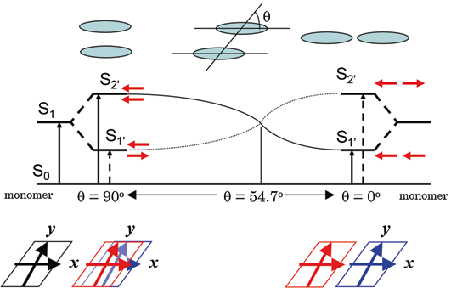

Although many examples of “face-to-face phthalocyanine dimers [10, Gorbunova_PcCrown] are well known, the exact alignment of the Pc subunits in these systems is not known, except for the crystals where slipped-stacked arrangement is typical for M(II)Pcs [12-13]. Only a few binuclear Pcs with a linker rigid enough to ensure a well-defined geometry, are known experimentally: a “gable” **1**, a “planar” **2**, and a “cyclophane” **3** bridged binuclear phthalocyanine with “edge-to-edge” arrangement (J-aggregates). For “face-to-face” binuclear Pcs with rigid linkers such as **4** and **5**, different conformations are still possible which can influence the excitonic coupling significantly (see below). An example of a coordination-type binuclear Pc **6** can be considered as rigid although two conformations (“parallel” and “oblique”) are possible.

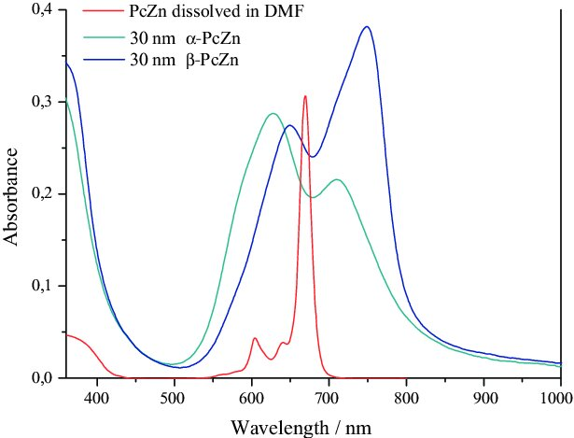

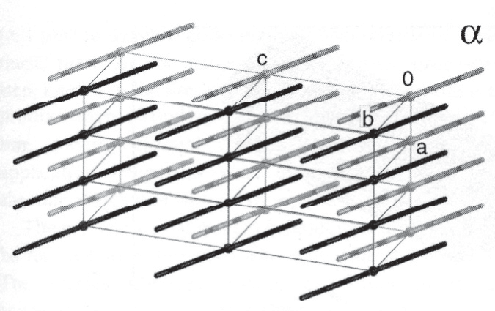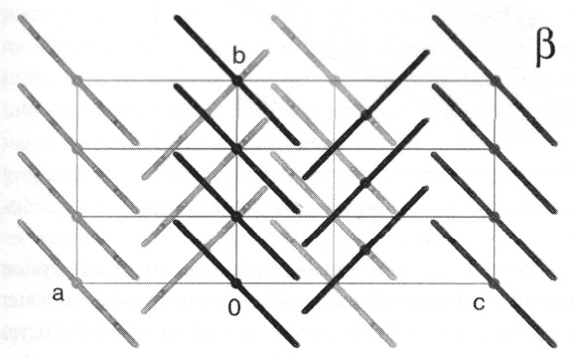

The effect of the aggregation on the Q-band in solution is stronger than solvent effects and typically results in a blue shift from 660-700 nm to 600-640 nm and broadening of the Q-band (H-aggregates). In solid state, β-modification of planar M(II)Pcs typically shows a close contact of central metal ion to a meso-N atom of an adjacent molecule in a stack, and an inclination angle of the macrocycles within the stack of ~ 45o. The inclination angle in α-modification is ~ 30o, and the metal shows a close contact to a pyrrole-N atom of an adjacent molecule. Different arrangements of the chromophores results in significantly different excitonic coupling, leading to a high variability of absorption wavelengths exhibited by crystalline phthalocyanines. Thus, α-modifications of CuPc and ZnPc absorb at λ~625 and ~700 nm, β -modifications at λ~650 and ~750 nm, and ε-CuPc at even longer wavelength λ < 820 nm. The non-planar Ti(O)Pc with slipped-stacked arrangement similar to J-aggregates shows an extremely red-shifted Q-band absorption at λ ~ 700 - 900 nm, and an efficient photoinduced charge carrier generation.

Slipped-stack Pc dimers resemble structural patterns of photosynthetic light-harvesting antenna consisting of bacteriochlorophyll dimers [cycloph_3], and they are fluorescent in contrast to face-to-face Pc oligomers. 2,4 Therefore, head-to-tail dimers and J-aggregates are highly desirable to maximize their optical properties. Cyclophane-fused dimer **3** is fluorescent (Φf = 0.12), a metal-free “gable” dimer **1** is also fluorescent (Φf = 0.55), a “planar” dimer **2** shows a singlet oxygen quantum yield of ΦΔ = 0.08; imidazole-bridged supramolecular dimer **6** is also fluorescent (Φf = 0.26).

To organize Pc chromophores into tailored structures it is therefore important to theoretically predict their photophysical properties. Previously, we have studied UV/Vis/NIR spectra and energy gaps of conjugated oligomeric phthalocyanine zinc (II) complexes by TD-DFT and have shown that calculations with range-separated hybrid functional LC-BLYP provide good agreement with experimental spectra.

**Results and discussion**

**Bridged oligophthalocyanines.** “Rigid” binuclear Pcs 1-3 and 6 were selected to benchmark the applicability of the range-separate TD-DFT approach previously applied for conjugated oligophthalocyanines [].



**1a** “gable”, **1** (substituents omitted)



**2a** “planar”, **2** (substituents omitted)



**3a** “cyclophane”, **3** (substituents omitted)

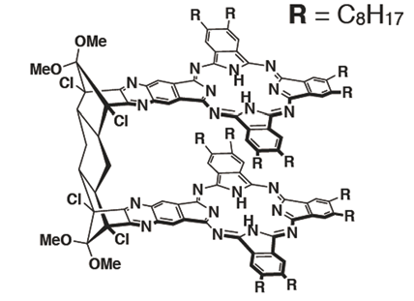

**4** “tricycle”

**5** “anthracene”



**6a** “imidazole”, **6** (substituents omitted)

The calculated Q-band wavelengths and energies for the dimers **1** – **3** without peripheral substituents (**1a** – **3a**) are compared to experimental wavelengths of their Q-band maxima. The results are listed in the Table 1.

To add solvents, centre-to-centre distances, shifts and angles (0-0 transitions therefore no vibronic subbands are considered)!

Table 1. Q-band wavelengths and energies for rigid non-conjugated oligoPcs **1** – **3** and their unsubstituted analogues **1a** – **3a**

|  |  |  |  |  |
| --- | --- | --- | --- | --- |
| Cpd. # | Experimental (1 – 3) | | Theoretical (1a – 3a) | |
|  | λ, nm (ΔE, eV) | 10-5ε, M-1·cm-1 | λ, nm (ΔE, eV) | Oscillator strength |
| ZnPc | 674 (1.840) | 3.4 | 685.3 (1.809) | 0.484x2 |
| **1, 1a** | 694 (1.787) | 2.9 | 713.3 (1.738) | 1.050 |
|  | 677 (1.832) | 3.1 | 680.3 (1.823) | 0.906 |
| **2, 2a** | 682 (1.818) | 6.9 | 705.4 (1.758) | 1.334 |
|  |  |  | 692.6 (1.790) | 0.912 |
| **3, 3a** | 753 (1.647) | 0.84 | 743.8 (1.667) | 1.276 |
|  | 690 (1.797) | 0.72 | 688.8 (1.800) | 0.833 |
| **6, 6a** (parallel) | 700 (1.771) | 1.7 | 723.4 (1.714) | 1.070 |
|  | 670 (1.851) | 1.2 | 676.7 (1.832) | 0.749 |
| **6a** (oblique) |  |  | 730.7 (1.697) | 0.960 |
|  |  |  | 696.8 (1.779) | 0.124 |
|  |  |  | 679.8 (1.824) | 0.742 |

As it is seen from the Table 1, theoretical wavelengths are well in agreement with the experimental ones, therefore TD-DFT with a range-separated hybrid functional is suitable for predicting through-space excitonic coupling of the excited states as well as for pi-delocalization effects [ms calc olibopc 1,2]. For edge-to-edge arrangements in **1** and **2**, the redshift and splitting expected from the excitonic coupling theory is negligible, in contrast to a well-known blueshift for face-to-face arrangements in H-aggregates []. In contrast, for the cyclophane-type dimer **3**, significant redshift and splitting of the Q-band appears both theoretically and experimentally. The practical absence of the redshift predicted by Kasha’s theory for edge-to-edge dimers **1** and **2** was explained previously [ms rev, asano2007] as a result of the absence of short-range interactions due to pi-pi overlap which can lead to similar shifts of the absorption bands as predicted by Kasha’s Coulombic dipole-dipole mechanism []. Thus, it is important to study whether classical Kasha’s model is applicable for oligoPcs or the observed and predicted excitonic coupling effects in phthalocyanine aggregates, dimers and crystals are a more system-specific result of the short-range pi-pi overlap (through-space conjugation).

**Excitonic interaction between phthalocyanine molecules.** To simulate excitonic coupling effects in oligoPcs, model zinc phthalocyanine dimers with slipped-stacked and edge-to-edge parallel arrangements of the Pc rings with in-plane shifts from 0 to 20 Å, and interplane distances from 0 to 6 Å, were studied by TD-DFT. Thus, centre-to-centre distances between chromophore units, and angles between transition vectors and centre-to-centre line can be calculated, and the TD-DFT transition energies can be compared to those predicted by the equation (1). For any phthalocyanine dimer, there are four Q-band transitions arising from the excitonic splitting of the two degenerate EU transitions in a single Pc chromophore: an allowed BU transition oriented in the shift direction (X) and AU in the perpendicular direction (Y), both having oscillator strengths of f ≈ 1, and two forbidden transitions AG and BG with f ≈ 0, corresponding to the opposite direction of the monomer transition dipoles. The dependence of these energies on the arrangement of the Pc molecules (see Fig. 1) is shown in the Fig. 2, the corresponding energies are listed in the Table S1.

Fig. 1A. Arrangements of the monomers in slipped-stacked ZnPc dimers -> intro

Fig. 1B. Frontier MO splitting and Q-band transitions in slipped-stacked ZnPc dimers -> intro



Fig. 2. Q-band energies vs. along-plane shifts between Pc molecules. The interplane distances (from top to bottom): 0.0, 3.5, 4.0, 5.0, 6.0A. Forbidden transitions are shown by dashed lines.

**Angle dependence.** For parallel transition dipoles, the dependence of the excitonic splitting on the angle between the dipoles and the line connecting their centers is approximately described by the equation (1). With “face-to-face” arrangement, the allowed X-oriented *BU* transition is blue-shifted, whereas the corresponding forbidden AG transition is strongly red-shifted and can participate in non-radiative decay of the excitation energy. This explains why “face-to-face” dimers are non-fluorescent. For “slipped-stack” configurations, the allowed BU transition becomes red-shifted with increasing shift and its energy drops below the corresponding AG forbidden transition. This explains why “slipped-stack” and “edge-to-edge” dimers are fluorescent. The angle corresponding to zero splitting between BU and AG transitions corresponds to the angle of 54.7°, which is indicated by a vertical line in the Fig. 2.

As it is seen from the Fig. 2, there is a qualitative agreement between the TD-DFT results and the equation (1). At 3.5A interplane distance, the energy splitting change with the shift is nonuniform due to local effects of MO overlap (see below). These effects become negligible already at 4.0A distance. For edge-to-edge arrangement, distances less than 16A are not possible which results in a very small excitonic splitting in agreement with the eq. (1). For “planar” dimer 2 this distance is as large 15.7A, and the predicted excitonic splitting is small. Thus, the near-absence of the redshift in edge-to-edge dimers 1 and 2 is simply explained by a large distance between transition dipole centres.

However, there’s no quantitative agreement between TD-DFT transition energies and eq. (1) which can be explained by short-range effects of MO overlap including charge-transfer exciton contributions [] (see below).

**Distance dependence.** As shown by Harcourt et al., 23 the excitonic interactions can be divided into long-range Coulombic interactions, short-range exchange (Dexter 24 ) and superexchange interactions deriving from pi-MO overlap. Retaining only the Coulombic interactions leads to Kasha’s exciton model which is often approximated as a point-dipole interaction (equation 1) which decays as 1/r3 whereas superexchange interaction depends on MO overlap which decays exponentially with distance.



Fig. 3A. Distance dependence of the Q-band splitting in a face-to-face ZnPc dimer

Add TrESP of edge-to-edge dimers!

Fig. 3B Distance dependence of the Q-band splitting in an edge-to-edge ZnPc dimer

To exclude influence of variable intermolecular shift (see below), only perfectly face-to-face and edge-to-edge arrangements were considered. As it is seen from the Fig. 3A, at larger distances the transition energy dependence is almost linear against 1/r whereas 1/r3 is expected from the eq. (1). A more detailed treatment of the Coulombic component of the excitonic coupling can be made using atomic charges obtained from fitting of the transition electrostatic potential (TrESP charges) []. The TrESP Coulombic component is almost linear against 1/r rather than 1/r3 which can be explained by a relatively short distance between transition dipoles and/or by a multipole contribution. Significant disagreement between TD-DFT transition energy (Fig. 2, Table S?) and the predicted Coulombic component (Fig. 3A) at shorter interplane distances indicates a large impact of short-range effects on the excitonic coupling. Other noticeable effect is a non-symmetrical splitting at shorter distances (Fig. 2): the red shift of the AG transition is larger than the blue shift of the BU transition. The red-shifted AG transition is forbidden therefore H-aggregates only show a blue-shifted Q-band. In crystals, the red-shifted Q-band absorption component often extends beyond 800 nm whereas the blue-shifted band is usually observed at

**MO analysis.** The pi-pi stacking interaction results in splitting of HOMO and LUMO levels of the monomers as shown in the Fig. 1B.

HOMO and LUMO splitting pattern in the slipped-stack dimers is determined by the shape of the corresponding monomers’ orbitals. The MO overlap is responsible for short-range effects (see above) including the formation of charge-separated excited states (charge-transfer excitons) [hestand2017]. MO overlap and, as a consequence, [hestand2017 42] superexchange and charge-transfer integrals are very sensitive to intermolecular orientations which results in very different UV/vis spectra of crystalline modifications of phthalocyanines.



Fig. 4A. Shift dependence of HOMO and LUMO splitting for ZnPc dimers at an interplane distance of 3.5A



Fig. 4B. Distance dependence of HOMO and LUMO splitting for face-to-face ZnPc dimers (ΔX = 0)

Fig. 4C. HOMO and LUMO isosurfaces

Parallel shift between Pc molecules in the dimer results in oscillations of the split MO levels with different periodicity for HOMO and LUMO, as a result of different shapes of the monomers’ HOMO and LUMO (see Fig. 4A, 4C) [Orti, Bredas]. The splitting generally decreases with the shift due to decreasing overall pi-MO overlap. The distance dependence of the splitting is exponential as a result of the exponential decay of pi-MO overlap (Fig. 4B). This is in contrast to 1/r dependence of the predicted transition energies at larger distances. Therefore at distances > 4A when MO splitting becomes negligible, the TD-DFT transition energies still show some excitonic splitting as a result of Coulombic coupling of the monomers’ transition dipoles.

**Size dependence**. According to a simplified tight-binding model [Brédas et al. PNAS 2002 5804-5809; Yanagisawa et al. PHYSICAL REVIEW B 90, 245141 (2014)], the transition energy change on going from monomeric to N-meric stack can be described by an equation:

*ΔE* ≈ *k* cos[π / (*N* + 1)], (2)

with *k* being either JCoul or *t* (electron or hole transfer integral) for Coulombic or charge-transfer coupling, respectively.

The equation (2) can be used to predict excitonic splitting for infinite stacks present in the crystals.



Fig. 5. Size dependence of the Q-band transitions in slipped-stacked ZnPc oligomers (translation vectors adopted from β -modification of ZnPc)

To study size dependence of the excitonic splitting, larger aggregates were calculated with arrangements approximately resembling ZnPc β -modification (the translation vectors taken from the X-Ray structure []) and α-modification. As no single-crystal X-Ray structure is available, stacks with interplane distance of 3.5A and parallel shifts of 1.75, 2.0 and 2.25A along Zn-N bond (see Fig. 1) were used. As it is seen from the Fig. 5, the TD-DFT excitonic splitting is linear against cos[π/(N+1)] for N = 1…4 in agreement with the eq. (2) which indicates that the excitonic splitting is mainly determined by the interactions between adjacent neighbors. The extrapolated to N = ∞ transition energies are 1.97 eV (630 nm) and 1.72 eV (720 nm) for β-modification arrangement (single stack) which is close to experimental 640 nm and 750 nm values. The estimates for alpha-modification vary from … to … which indicates strong shift dependence of the excitonic splitting for slipped-stacked arrangements. This explains different spectra of Zn(II), Ni(II), Cu(II) Pcs (same modification) despite very similar arrangement of the Pc molecules in the crystal. The qualitative agreement between predicted and experimental spectra of crystalline ZnPc confirms that the crystal spectra are determined mainly by excitonic coupling within the stack whereas quantitative predictions should also include geometric distortions and inter-stack coupling effects.