Part 1.

1.)

CREATE TABLE Authors(
LastName VARCHAR2(25),
FirstName VARCHAR2(25),
ID Number(4) Primary KEY,
Birthdate VARCHAR2(30)
);

CREATE TABLE Publishers(
Name VARCHAR2(40),
PubNumber Number(4) Primary KEY,
Address VARCHAR2(75)
);

CREATE TABLE Books(
ISBN VARCHAR2(25) Primary KEY,
Title VARCHAR2(50),
PubID Number(4),

CONSTRAINT Publisher_FK
Foreign KEY(PubID)
REFERENCES Publishers(PubNumber)
);

CREATE TABLE Dual_Authors(
AuthID Number(4),
ISBNNUM VARCHAR2(25),
AuthRank Number(4),

CONSTRAINT Author2_FK
Foreign KEY(AuthID)
REFERENCES Authors(ID),

CONSTRAINT Publisher2_FK
Foreign KEY(ISBNNUM)
REFERENCES Books(ISBN)
);

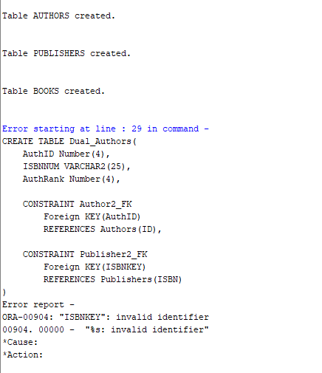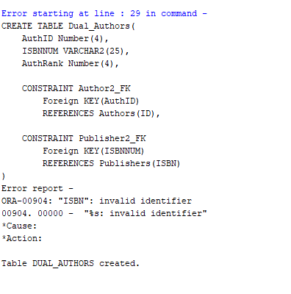

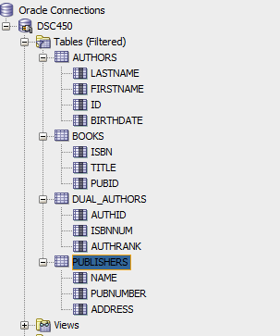

2.)

INSERT INTO Authors VALUES('King', 'Stephen', 2, 'September 9 1947');
INSERT INTO Authors VALUES('Asimov', 'Isaac', 4, 'January 2 1921');
INSERT INTO Authors VALUES('Verne', 'Jules', 7, 'February 8 1828');
INSERT INTO Authors VALUES('Rowling', 'Joanne', 37, 'July 31 1965');

INSERT INTO Publishers VALUES('Bloomsbury Publishing', 17, 'London Borough of Camden');
INSERT INTO Publishers VALUES('Arthur A Levine Books', 18, 'New York City');

INSERT INTO Books VALUES('1111-111','Databases from Outer Space',17);
INSERT INTO Books VALUES('2222-232','Revenge of SQL',17);
INSERT INTO Books VALUES('3333-323','The Night of the Living Databases',18);

INSERT INTO Dual_Authors VALUES(2, '1111-111', 1);
INSERT INTO Dual_Authors VALUES(4, '1111-111', 2);
INSERT INTO Dual_Authors VALUES(4, '2222-232', 1);
INSERT INTO Dual_Authors VALUES(7, '2222-232', 1);
INSERT INTO Dual_Authors VALUES(37, '3333-323', 1);
INSERT INTO Dual_Authors VALUES(2, '3333-323', 2);

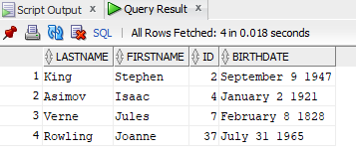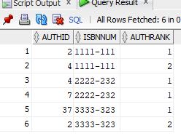

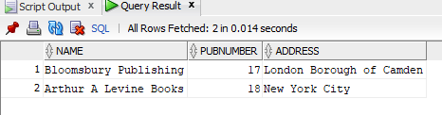

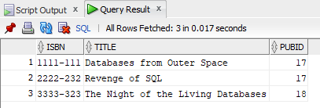

3.)

CREATE TABLE Students(
StudentID Number(7) Primary KEY,
FirstName VarChar2(15),
LastName VarChar2(15),
DOB VarChar2(25),
Telephone VarChar2(10),
AdvisorID Number(4),

Constraint Advisor_FK
Foreign Key(AdvisorID)
REFERENCES Advisor(ID)
);

CREATE TABLE Advisor(
ID Number(4) Primary Key,
Name VARCHAR2(30),
ResearchArea VARCHAR2(25),
Department VarChar2(25),

Constraint Dept_FK
Foreign Key(Department)
REFERENCES Departments(Name)
);

CREATE TABLE Departments(
Name VARCHAR2(25) Primary KEY,
Chair VARCHAR2(45),
Endowment Number(15)
);

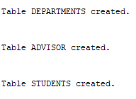

4.)

# -*- coding: utf-8 -*-
"""
Keiland Pullen

Winter 2022
DSC 450: Database Processing for Large-Scale Analytics
Assignment Module 2
"""

def validateInsert(insertStatement):
''' Part 1. 4 - Write a python function to validate SQL insert statements...

'''

statement = insertStatement.split();
statement2 = insertStatement.split('(');
statement3 = statement2[1];
statement3 = statement3[:-2];

# print(statement); # For testing values of original statement
# print(statement2); # For testing values of values

if ((statement[0].lower() == "insert") and (statement[1].lower() == "into") and (insertStatement[-1] == ";")) :
#print("Inserting " + statement2[1] + " into " + statement[2] + " table.") ;
print("Inserting (" + statement3 + ") into " + statement[2] + " table.") ;
else:
print("Invalid insert");

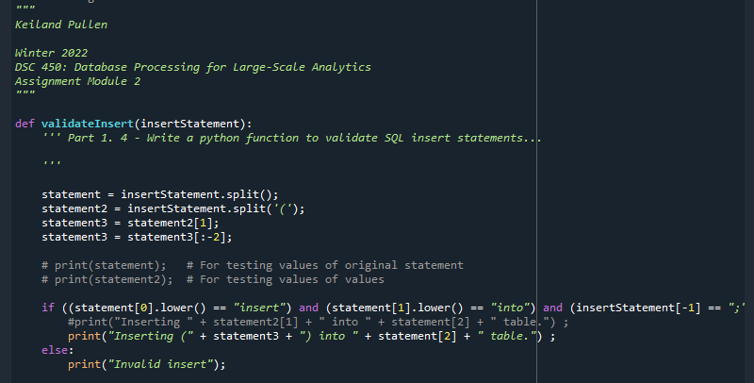

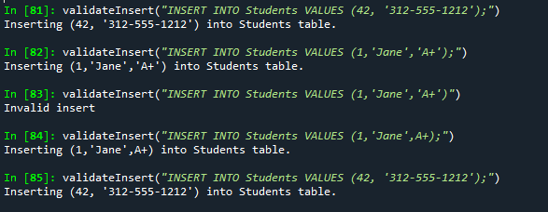

Part 2.)

(Date, Client, Office, Floor, Building, City, Executive)

a.)

The problem with the attribute City being dependent on the attribute Building is that several buildings could belong in the same city. For example:

Building City
Sears Tower Chicago
Hancock Chicago
Leaning Tower Pisa
Empire New York
Daley Chicago

b.)

To convert to Second Normal Form:

Primary keys are Client and Office and they have Functional Dependency with Date, so our first table will be :
(Client, Office, Data)

Client has a partial Functional Dependency with Executive, so the second table will be:
(Client, Executive)

The Office also has a partial Functional Dependency with Floor, Building and City, the last table will be:
(Office, Floor, Building, City)

c.)

For Third Normal Form, the tables will be:

(Client, Office, Date) is the first table because there is no Transitive Functional Dependency.

(Client, Executive) is the second table because there is no Transitive Functional Dependency.

The following tables are created because the Office is the Primary Key and the remaining attributes have Transitive Functional Dependencies.

(Office, Floor Building)
(Building, City)

Part 3.)

(First, Last, GPA, Honor, Credits)

a.)

Yes, the schema is in Second Normal Form.

b.)

No, the schema is not in Third Normal Form. To do so, the table will need to be split as there is a Transitive Functional Dependency between GPA and Honor. The decomposition would be:

(First, Last, GPA, Credits)

(GPA Honor)

