Part 1

1.)

SELECT FNAME, MINIT, LNAME, DNO
FROM EMPLOYEE
WHERE DNO = ( SELECT DNO
FROM EMPLOYEE
WHERE FNAME='Franklin'
and MINIT = 'T'
and LNAME='Wong');

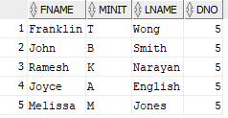

2.)

SELECT PROJECT.PNAME, PROJECT.PNUMBER, sum(HOURS) as TotalHoursPerWeek
FROM PROJECT
Left Join WORKS_ON ON WORKS_ON.PNO = PROJECT.PNUMBER
group by project.pname, project.pnumber
order by pnumber;

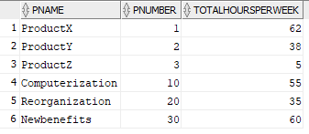

3.)

SELECT DEPARTMENT.DNAME, AVG(EMPLOYEE.SALARY) AS AvgSalary
FROM DEPARTMENT, EMPLOYEE
WHERE DEPARTMENT.DNUMBER = EMPLOYEE.DNO
GROUP BY department.dname, department.dnumber
order by department.dnumber ASC;

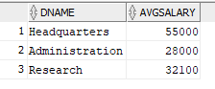

4.)

SELECT AVG(SALARY) AS Avg_Female_Salary
FROM EMPLOYEE
WHERE sex='F';

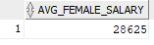

5.)

SELECT DEPARTMENT.DNAME, COUNT(EMPLOYEE.DNO) AS Num_Dept_Employees
FROM DEPARTMENT, EMPLOYEE
WHERE DEPARTMENT.DNUMBER = EMPLOYEE.DNO
GROUP By DEPARTMENT.DNAME
HAVING AVG(SALARY) > 42000;

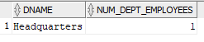

6.)

SELECT FNAME, MINIT, LNAME
FROM EMPLOYEE
WHERE SALARY <
(SELECT MAX(SALARY) FROM EMPLOYEE)
AND (SELECT MAX(SALARY) FROM EMPLOYEE) - SALARY <=21000;

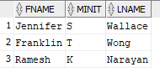

7.)

a.)
SELECT FNAME, MINIT, LNAME
FROM EMPLOYEE
WHERE sex='F';

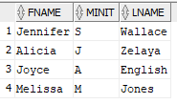

b.)
SELECT FNAME, MINIT, LNAME
FROM EMPLOYEE
WHERE SEX =
(SELECT DISTINCT SEX FROM EMPLOYEE WHERE SEX='F')
Order By LNAME;
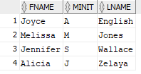

8.)

SELECT FNAME, MINIT, LNAME
FROM EMPLOYEE
MINUS
SELECT FNAME, MINIT, LNAME
FROM EMPLOYEE
WHERE SSN IN (
SELECT ESSN
FROM WORKS_ON);

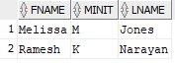

Part 2

# -*- coding: utf-8 -*-
"""
Keiland Pullen

Winter 2022
DSC 450: Database Processing for Large-Scale Analytics
Assignment Module 4

"""
import csv
import sqlite3

RecordTable = '''CREATE TABLE RecordNumber(
License NUMBER(6),
Renewed DATE, --MMYYYY
Status VARCHAR(10),
Status_date DATE, --MMDDYYYY
Driver_type CHAR(15),
License_type VARCHAR(15),
Original DATE, --MMDDYYYY
Name CHAR(30),
Sex CHAR(7),
Chauffeur_city CHAR(15),
Record_Num VARCHAR(12) NOT NULL UNIQUE,

CONSTRAINT Rec_pk
PRIMARY KEY(Record_Num)
);
'''
ChauffeurTable = '''CREATE TABLE CHAUFFEUR
(
CHAUFFEURCITY VARCHAR2(30),
CHAUFFEURSTATE VARCHAR2(20),
CONSTRAINT Chauffeur_PK
PRIMARY KEY(CHAUFFEURCITY)
);'''

conn = sqlite3.connect("ChauffeurDatabase.db")

cursor = conn.cursor()

cursor.execute("DROP TABLE IF EXISTS CHAUFFEUR")
cursor.execute(ChauffeurTable)

cursor.execute("DROP TABLE IF EXISTS RecordNumber")
cursor.execute(RecordTable)

fd = open("Public_Chauffeurs_Short_hw3.csv","r")
readFile = csv.reader(fd)
# for row in reader:
# print(row)

#fd.close()

for line in readFile:
# print(line)
license = line[0]
renewed = line[1]
status = line[2]
status_date = line[3]
driver_type = line[4]
license_type = line[5]
original_date = line[6]
name = line[7]
sex = line[8]
chauffeur_city = line[9]
chauffeur_state = line[10]
record_num = line[11]

# print(license)
# print(renewed)
# print(status)
# print(status_date)
# print(driver_type)
# print(license_type)
# print(original_date)
# print(name)
# print(sex)
# print(chauffeur_city)
# print(chauffeur_state)
# print(record_num)

cursor.execute("INSERT OR IGNORE INTO RecordNumber VALUES (?,?,?,?,?,?,?,?,?,?,?);",
(license, renewed, status, status_date, driver_type, license_type,
original_date, name, sex, chauffeur_city, record_num))

cursor.execute("INSERT OR IGNORE INTO CHAUFFEUR VALUES (?, ?);"
, (chauffeur_city, chauffeur_state))

HowManyRows = cursor.execute("SELECT COUNT(*) FROM CHAUFFEUR;").fetchall()
for Rows in HowManyRows:
print(Rows)

print ("\n")

HowManyMissingDates = cursor.execute("SELECT COUNT(*) FROM RecordNumber WHERE original = 'NULL'")
for MissingDates in HowManyMissingDates:
print(MissingDates)

conn.commit()
conn.close()

a.)
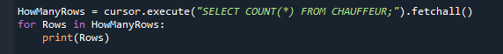

b.)

Part 3

a. & b.

"""
Keiland Pullen

Winter 2022
DSC 450: Database Processing for Large-Scale Analytics
Assignment Module 5
"""

import json
import sqlite3
import urllib

TwitterTable = '''CREATE TABLE Tweet(
created_at varchar2(40),
id_str varchar2(40),
text varchar2(250),
source varchar2(100),
in_reply_to_user_id number(25),
in_reply_to_screen_name varchar(40),
in_reply_to_status_id number(25),
retweet_count number(10),
contributors varchar2(100)
);'''

conn = sqlite3.connect("Twitter.db")

cursor = conn.cursor()

cursor.execute("DROP TABLE IF EXISTS TWEET")

cursor.execute(TwitterTable)

tweetData = 'http://cdmgcsarprd01.dpu.depaul.edu/DSC450/tweet_data.txt'

webFD = urllib.request.urlopen('http://cdmgcsarprd01.dpu.depaul.edu/DSC450/tweet_data.txt')

webFD.readline()

ln = webFD.readline()

tweeter = json.loads(ln[6:])

tweeter.keys()

# print (ln[6:])

# print(tweeter)
# print("\n")
# print(tweeter.keys())

# print(tweeter['created_at'])
# print(tweeter['id_str'])
# print(tweeter['text'])
# print(tweeter['source'])
# print(tweeter['in_reply_to_user_id'])
# print(tweeter['in_reply_to_screen_name'])
# print(tweeter['in_reply_to_status_id'])
# print(tweeter['retweet_count'])
# print(tweeter['contributors'])

# print("\n")

cursor.execute("INSERT OR IGNORE INTO Tweet VALUES (?,?,?,?,?,?,?,?,?);",
(tweeter['created_at'], tweeter['id_str'], tweeter['text'], tweeter['source'], tweeter['in_reply_to_user_id'],
tweeter['in_reply_to_screen_name'], tweeter['in_reply_to_status_id'], tweeter['retweet_count'],
tweeter['contributors']))

DisplayTweet = cursor.execute("SELECT * FROM TWEET;").fetchall()
for Rows in DisplayTweet:
print(Rows)

