Part 1.)

A.

1.
SELECT * FROM ANIMAL
WHERE acategory = 'rare'
ORDER BY timetofeed;

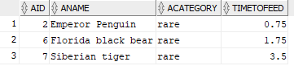

2.
SELECT aname, acategory FROM ANIMAL
WHERE aname LIKE ('%bear%');

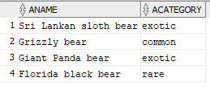

3.
SELECT aname, acategory FROM ANIMAL
WHERE aname LIKE ('%tiger%')
AND acategory != 'common';

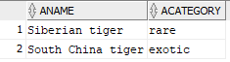

4.
SELECT aname FROM ANIMAL
WHERE aname NOT LIKE ('%tiger%');

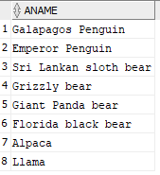

5.
SELECT aname, zid from ANIMAL
INNER JOIN HANDLES
JOIN zookeeper
on handles.zookeepid = zookeeper.zid
on animal.aid = handles.animalid;

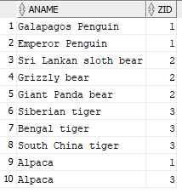

6.
SELECT aname, zid from ANIMAL
LEFT OUTER JOIN HANDLES
JOIN zookeeper
on handles.zookeepid = zookeeper.zid
on animal.aid = handles.animalid;

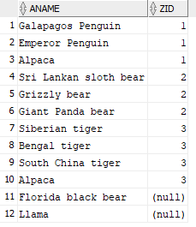

7.
SELECT zname, avg(timetofeed) from ANIMAL
LEFT OUTER JOIN HANDLES
JOIN zookeeper
on handles.zookeepid = zookeeper.zid
on animal.aid = handles.animalid
group by zname;

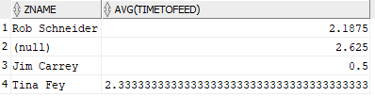

8.
SELECT assigned, zname, aname from ANIMAL
LEFT OUTER JOIN HANDLES
JOIN zookeeper
on handles.zookeepid = zookeeper.zid
on animal.aid = handles.animalid
order by assigned;

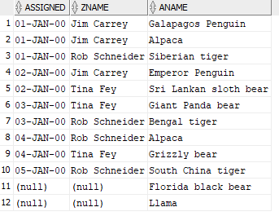

B.)
1.
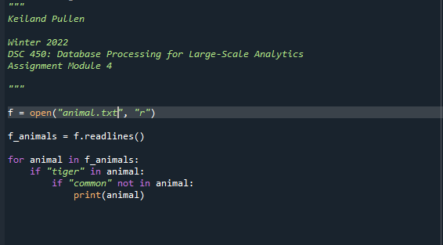

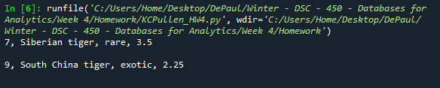

2.
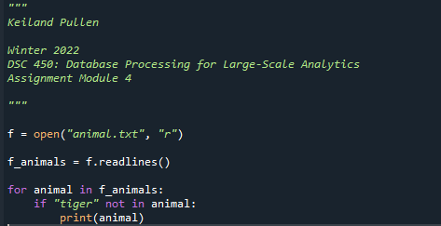

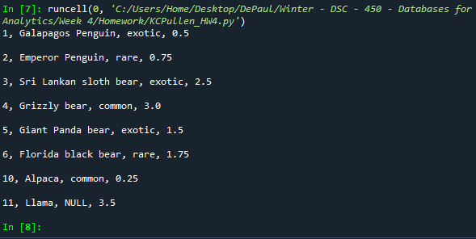

Part 2.)

A.

Person (First, Last, Address)

Employer (Job, Salary, Assistant)

Employee (First, Last, Job)

B.

Drop Table Person
Drop Table Employer
Drop Table Employee

Create Table Person
(
First varchar2(12) NOT NULL,
Last varchar2(20)NOT NULL,
Address varchar2(75) ,

CONSTRAINT Person_PK
PRIMARY KEY(First, Last)
);

Create Table Employer
(
Job varchar2(20) NOT NULL,
Salary varchar2(7),
Assistant var(5),

CONSTRAINT Employer_PK
PRIMARY KEY(Job)
);

Create Table Employee
(
First varchar2(12) NOT NULL,
Last varchar2(20) NOT NULL,
Job varchar2(20) NOT NULL,

CONSTRAINT Employee_PK
PRIMARY KEY(First, Last, Job)

CONSTRAINT Person_FK_1
FOREIGN KEY(First, Last)
References Person(First, Last)

CONSTRAINT Employer_FK_2
FOREIGN KEY(Job)
References Employer(Job)
);

C.
See attached file, KCPullen_HW4.py to view the python code.

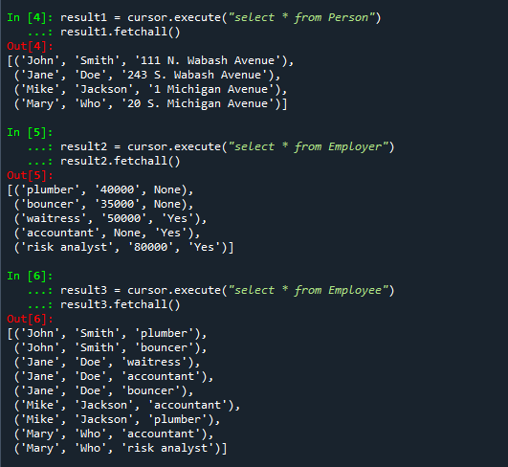

D.

jobs_with_no_sal = cursor.execute("Select * from Employer where salary is NULL")
jobs_with_no_sal.fetchall()

