Part 1.

a.)
- Find all the animals that take less than 2.5 hours to feed

timeToFeed = cursor.execute('SELECT * FROM Animal WHERE TimeToFeed < 2.5')
timeToFeed.fetchall()

- Find both the rare and exotic animals in a single query.

rareAndExotic = cursor.execute('SELECT * FROM Animal WHERE ACategory="rare" or ACategory="exotic" ')
rareAndExotic.fetchall()

- Return the listings for all animals whose rarity is missing (NULL) in the database.

rarityMissing = cursor.execute('SELECT * FROM Animal WHERE ACategory is NULL')
rarityMissing.fetchall()

- Find the rarity rating of all animals that require between 1 and 2.5 hours to be fed.

rarityRatingFeed = cursor.execute('SELECT ACategory FROM Animal WHERE TimeToFeed >= 1 and TimeTOFeed <= 2.5')
rarityRatingFeed.fetchall()

- Find the min and max feeding time amongst all the animals in the zoo.

minMaxFeedingTime = cursor.execute('SELECT MIN(TimeToFeed), MAX(TimeToFeed) from Animal')
minMaxFeedingTime.fetchall()

- Find the average feeding time for all of the exotic animals.

avgFeedingTime = cursor.execute('SELECT AVG(TimeToFeed) from Animal')
avgFeedingTime.fetchall()

- Determine how many NULLs there are in the ACategory column using SQL

howManyNulls = cursor.execute('SELECT COUNT(*) - COUNT(ACategory) FROM Animal' )
howManyNulls.fetchall()

- Find all animals named 'Alpaca', 'Llama' or any other animals that are not listed as exotic

allAlpachaLlama = cursor.execute('SELECT * FROM Animal where AName="Alpaca" or AName="Llama" or ACategory != "exotic" ')
allAlpachaLlama.fetchall()

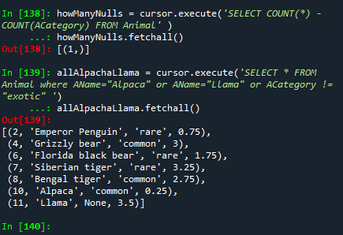

b.)

result = cursor.execute('SELECT * FROM Animal')
#result.fetchall()
allAnimalsFile = result.fetchall()

af = open("animal.txt","w")

separator = ", "

for animalTxt in allAnimalsFile:
af = open("animal.txt","a")
print(separator.join(map(str, animalTxt)) )
af.write(separator.join(map(str, animalTxt)) )
af.write("\n")

af.close()

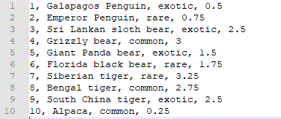

c.)

fileOpen = open("animal.txt","r")

animalList = fileOpen.readlines()

newlist = []

for line in animalList:
newLine = line[:-1]
thisLine = newLine.split(",")

print ("["+thisLine[0]+",'"+thisLine[1]+"',"+"'"+thisLine[2]+"',"+thisLine[3]+"]")
newLine = ("["+thisLine[0]+",'"+thisLine[1]+"',"+"'"+thisLine[2]+"',"+thisLine[3]+"]")
#print(newLine)
newlist.append(newLine)

print (newlist)

cursor = conn.cursor()
cursor.executemany("INSERT INTO Animal VALUES (?,?,?,?);", newlist)

newResult = cursor.execute('SELECT * FROM Animal')
newResult.fetchall()

