Part 1

- True
- False
- True
- False
- False
- True

Part 2

- PurchaseAmt Number (6,2) Not Null
Check (PurchaseAmt >= 0.00 and PurchaseAmt <= 9999.99)

- Street varchar2(18),
Check ( SUBSTR(Street , 1, 4) = “rue”)

- Q1.)
SELECT StudentID, Name
FROM Student
Where GradYear >= (
( SELECT MAX(GradYear)
FROM Student ) - 1
) ;

Q2.)
SELECT Name, CName, CGrade
FROM Student
LEFT JOIN Grade
ON Student.StudentID = Grade.StudentID
WHERE Name LIKE '% Muriel %'
ORDER BY CGrade ;

Q3.)
SELECT Name, GradYear,
FROM Student
Left JOIN Grade
ON Student.StudentID = Grade.StudentID
WHERE StudentID IN (
SELECT StudentID
From Grade
Where Count(StudentID) =< 1
) ;

Q4.)
UPDATE Student
SET GradYear = GradYear + 3
WHERE Address LIKE '% Chicago %' ;

Q5.)
ALTER Table Course
ADD Chair varchar2(28);

Part 3

- The following are the missing values in the W column:
Hawk --- because A determines W, and the value of A is 3, which gives a value of Hawk.
Dog --- because A determines W, and the value of A is 4, which gives a value of Dog.
CatHawk --- because A is 5, a combined value of 2 and 3, which gives the values of Cat and Hawk.

- Does XY determine W? (XY → W ?)
Yes, if {XY → ZA}
then {XY → Z}
and {XY→A}
and {A→W}
then {XY→W}
using the Pseudo Transitivity Rule.

- What functional dependencies (if any) can you assume? For S (P, Q, U, M, N)
P → Q, U → M are two FDs that stand out, but in this case QM might be determined by PUN, so maybe, PUN → QM

- In Second Normal Form
TVShows (ShowTitle, Year, Channel, Length, Zip, City, State, Lead, Salary)

Table2 (ShowTitle, Cost)

- In Third Normal Form
TVShows (ShowTitle, Year, Channel, Length, Zip, Lead)

Table2 (ShowTitle, Cost)

Table3 (Zip, City, State)

Table4 (Lead, Salary)

Part 4

CREATE VIEW HoopSchool AS
SELECT student.studentid, student.name, student.address, student.gradyear,
course.cname, course.credits, course.department,
grade.cgrade
FROM Student
INNER JOIN Grade
ON Student.StudentID = Grade.StudentID
INNER JOIN Course
ON Course.CName = Grade.CName;

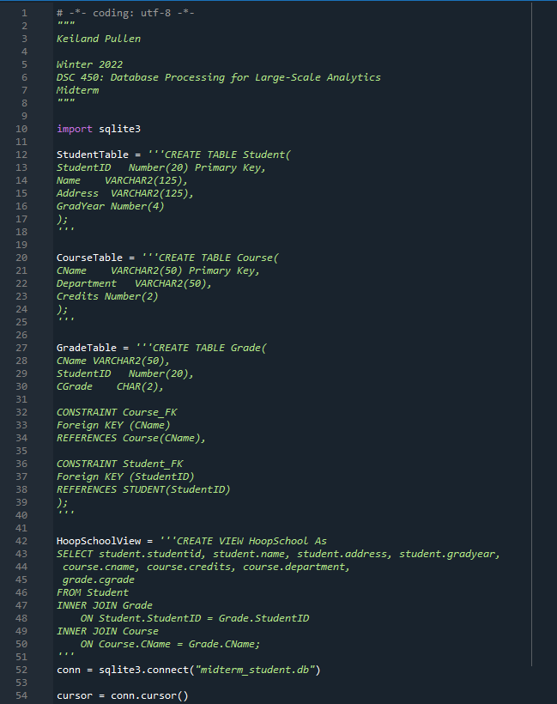





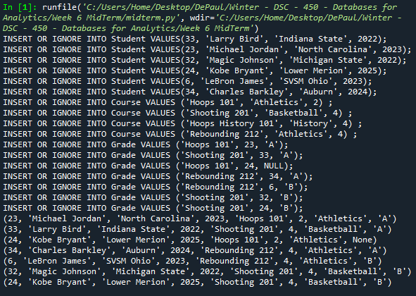

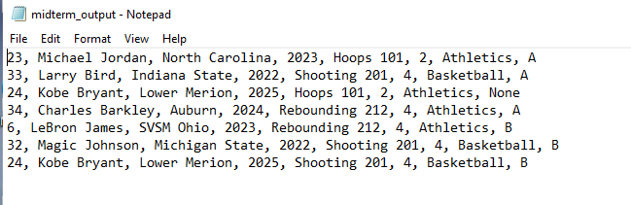

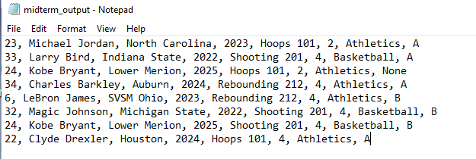



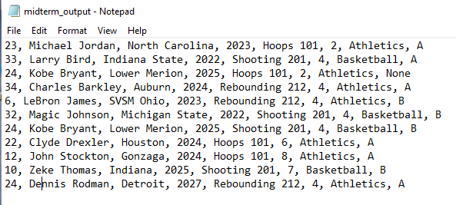

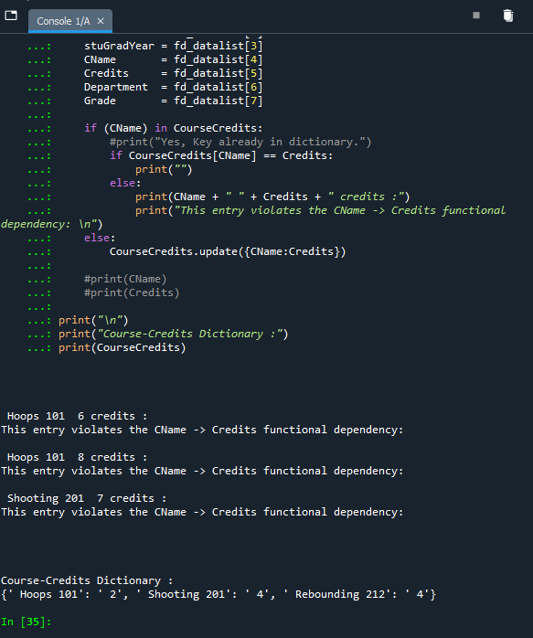

SELECT avg(gradyear), department
FROM HoopSchool
GROUP BY department;

2.)

