Part 1

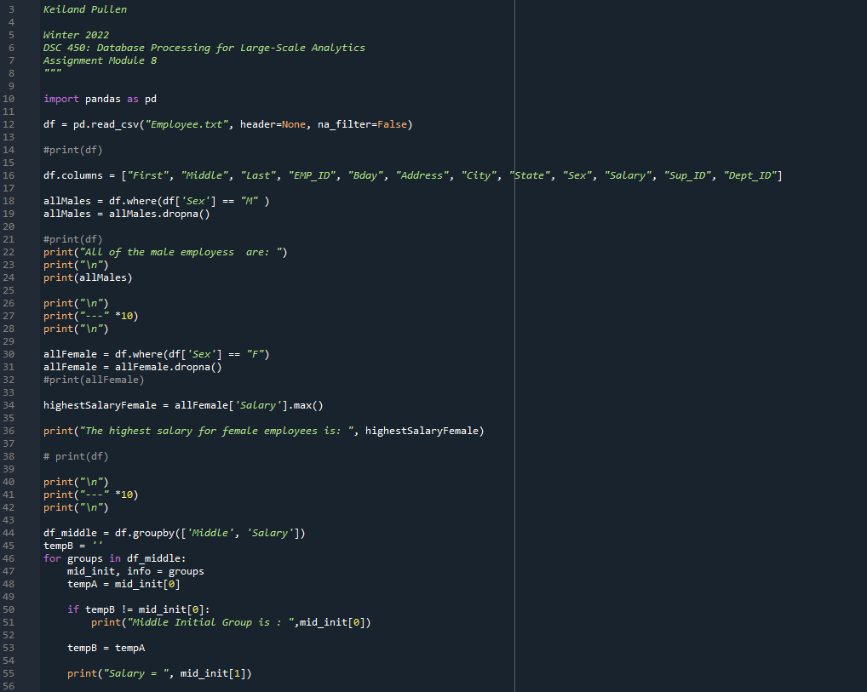

Part 1a.)

import pandas as pd

df = pd.read_csv("Employee.txt", header=None, na_filter=False)

#print(df)

df.columns = ["First", "Middle", "Last", "EMP_ID", "Bday", "Address", "City", "State", "Sex", "Salary", "Sup_ID", "Dept_ID"]

allMales = df.where(df['Sex'] == "M" )
allMales = allMales.dropna()

#print(df)
print("All of the male employess are: ")
print("\n")
print(allMales)

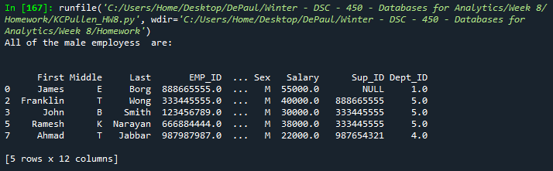

Part 1b.)

allFemale = df.where(df['Sex'] == "F")
allFemale = allFemale.dropna()
#print(allFemale)

highestSalaryFemale = allFemale['Salary'].max()

print("The highest salary for female employees is: ", highestSalaryFemale)



Part 1c.)

df_middle = df.groupby(['Middle', 'Salary'])
tempB = ''
for groups in df_middle:
mid_init, info = groups
tempA = mid_init[0]

if tempB != mid_init[0]:
print("Middle Initial Group is : ",mid_init[0])

tempB = tempA

print("Salary = ", mid_init[1])

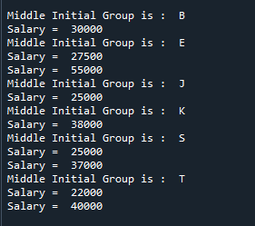

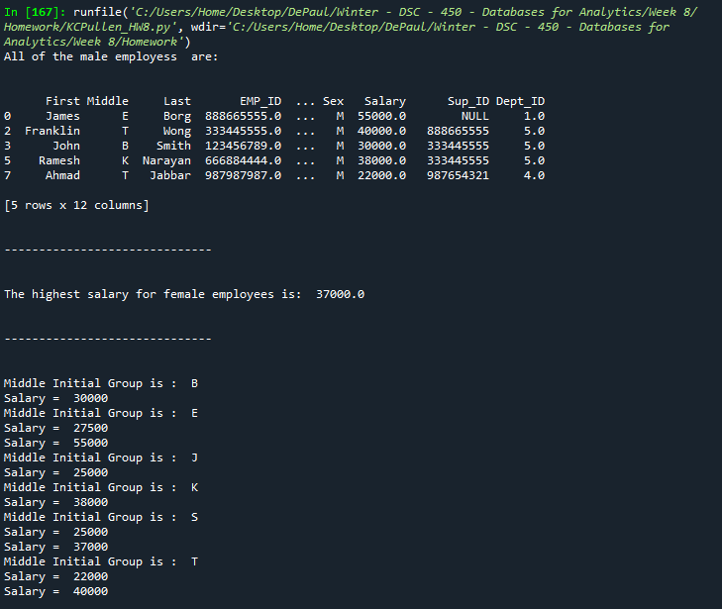

Part 2.)

SET SERVEROUTPUT ON;

DECLARE
MidPct Number(2);
Fin Number(2);
HW Number(2);

st_id char(3);
st_name varchar2(20);
st_mid Number(3);
st_fin Number(3);
st_hw Number(3);
st_grade Number(4,1);
fin_grade char(1);

cursor st_cursor IS
( SELECT ID, NAME, MIDTERM, FINAL, HOMEWORK
FROM student);
BEGIN
SELECT MIDPCT, FINPCT, HWPCT INTO MidPct, Fin, HW
FROM WEIGHTS;

DBMS_OUTPUT.PUT_LINE(' Weights are ' || MidPct || ', ' || Fin || ', ' || HW);

open st_cursor;
loop
fetch st_cursor INTO st_id, st_name, st_mid, st_fin, st_hw;
exit when st_cursor%notfound;
st_grade := (st_mid + st_fin + st_hw) / 3;

if (st_grade > 90) and (st_grade < 100)
then fin_grade := 'A';
elsif (st_grade > 80) and (st_grade < 89.99)
then fin_grade := 'B';
elsif (st_grade > 65) and (st_grade < 79.99)
then fin_grade := 'C';
else fin_grade := 'F';
end if;

DBMS_OUTPUT.PUT_LINE( st_id || ' ' ||st_name || '' || ' ' || st_grade || ' ' || fin_grade);
end loop;

END;

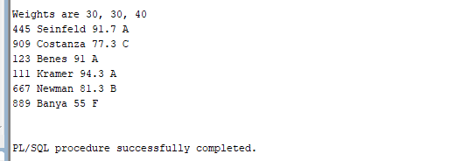

Part 3.)

A.)

CREATE OR REPLACE TRIGGER course_full
BEFORE INSERT OR UPDATE on ENROLLMENT
FOR EACH ROW

DECLARE
numRows Number(1);
BEGIN
SELECT STUDENTS
INTO NumRows
FROM SECTION
WHERE SECTION.SECTIONID = :NEW.SECTIONID;

-- numRows := 4;
IF (numRows >= 5) THEN
raise_application_error(-20102, 'Limit reached for that section');
END IF;

UPDATE SECTION
SET Students = Students + 1
WHERE SECTION.SECTIONID = :NEW.SECTIONID;
END;

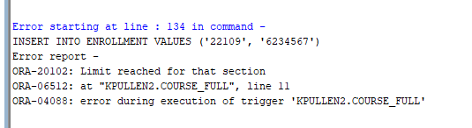

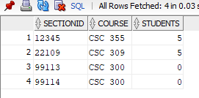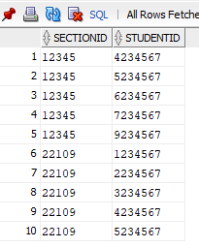

B.)

CREATE OR REPLACE TRIGGER course_remove
AFTER DELETE on ENROLLMENT
FOR EACH ROW

DECLARE

BEGIN

UPDATE SECTION
SET Students = Students - 1
WHERE SECTION.SECTIONID = :OLD.SECTIONID;
END;

