Part 1

a.)
start = time.time()

qry = cursor.execute("SELECT * FROM Tweet where id_str LIKE '%88%' or id_str LIKE '%7777%' ")
print ("Total number of Tweets with 88 or 7777 anywhere is: ",len(qry.fetchall() ))
end = time.time()

print ("Start Time = ", start)
print ("End Time = ",end)
print ("The total time is ", ( end - start )," seconds")

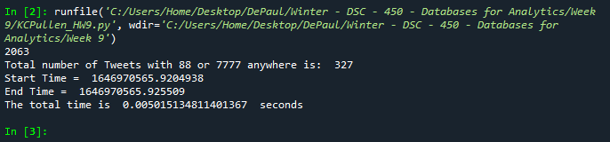

b.)
start = time.time()
num = 1
for i in range(lineCount):
tweetLines = webFD.readline()
try:
tDict = json.loads(tweetLines.decode('utf8'))

if ('88' in tDict['id_str']) or ('7777' in tDict['id_str']):
# print(num)
num = num + 1

except ValueError:
print("Error here")

print('The number of 88 and 7777 was: ', num)

end = time.time()

print ("Start Time = ", start)
print ("End Time = ",end)
print ("The total time is ", ( end - start )," seconds")

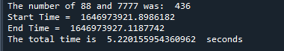

c.)
start = time.time()
qry2 = cursor.execute("SELECT COUNT(DISTINCT in_reply_to_user_id) From Tweet;")
qry2fetchall = cursor.fetchall()
print('The number of unique values is :',qry2fetchall)

end = time.time()
print ("Start Time = ", start)
print ("End Time = ",end)
print ("The total time is ", ( end - start )," seconds")

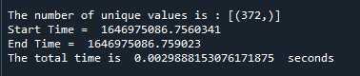

d.)

replyUserIdSet = set()

start = time.time()

for i in range(lineCount):
tweetLines = webFD.readline()
try:
tDict = json.loads(tweetLines.decode('utf8'))

replyUserIdSet.add(tDict['in_reply_to_user_id'])

except ValueError:
print("Nothing to see here")

#print(replyUserIdSet)
print ('The numnber of unique values is :', len(replyUserIdSet) )

end = time.time()
print ("Start Time = ", start)
print ("End Time = ",end)
print ("The total time is ", ( end - start )," seconds")

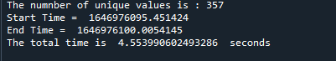

e.)

import matplotlib.pyplot as plt
Import numpy as np

txtLen = []
usrLen = []

for i in range(1, 41):
tweetLines = webFD.readline()
try:
tDict = json.loads(tweetLines.decode('utf8'))

textLength = len(tDict['text'])
userLength = len(tDict['user']['screen_name'])

txtLen.append(textLength)
usrLen.append(userLength)

# print(textLength, userLength)

except ValueError:
print("Nothing to see here")

x = np.array(txtLen)
y = np.array(usrLen)

plt.scatter(x, y)
plt.show()

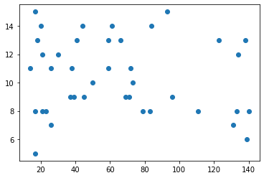

Part 2.)

a.)

CREATE INDEX TweetIndex
ON Tweet (userid)

b.)

CREATE INDEX UserIndex
ON User (friends_count, screen_name)

c.)

CREATE MATERIALIZED VIEW PartOneA AS
SET TIMING ON;

SELECT * FROM Tweet;
WHERE id_str LIKE '%88%'
OR id_str LIKE '%7777%';

SET TIMING OFF;

Part 3.)

a.)
Yes, this schedule is serializable.
T1
T2

T3

b.)
No, this schedule is not serializable because it contains a cycle:
T2 → T3 →T1 would be the equivalent serial schedule.

T1
T3
T2

