Problem 1.)

First Decision Tree:

Model Summary
Specifications | Growing Method | CRT
Specifications | Dependent Variable | Diagnosis
Specifications | Independent Variables | Symptom_1, Symptom_2, Symptom_3, Symptom_4, Symptom_5, Symptom_6, Symptom_7, Symptom_8, Symptom_9, Symptom_10, Symptom_11
Specifications | Validation | Cross Validation
Specifications | Maximum Tree Depth | 10
Specifications | Minimum Cases in Parent Node | 10
Specifications | Minimum Cases in Child Node | 5
Results | Independent Variables Included | Symptom_10, Symptom_7, Symptom_1, Symptom_9, Symptom_11, Symptom_6, Symptom_3, Symptom_8, Symptom_5, Symptom_4, Symptom_2
Results | Number of Nodes | 11
Results | Number of Terminal Nodes | 6
Results | Depth | 3

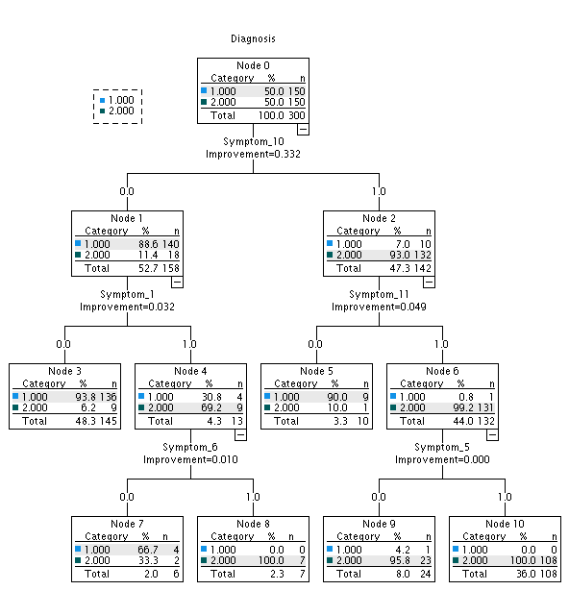

Classification
Observed | Predicted
Observed | 1 | 2 | Percent Correct
1 | 149 | 1 | 99.3%
2 | 12 | 138 | 92.0%
Overall Percentage | 53.7% | 46.3% | 95.7%
Growing Method: CRT
Dependent Variable: Diagnosis

Final Decision Tree:

Model Summary
Specifications | Growing Method | CRT
Specifications | Dependent Variable | Diagnosis
Specifications | Independent Variables | Symptom_1, Symptom_2, Symptom_3, Symptom_4, Symptom_5, Symptom_6, Symptom_7, Symptom_8, Symptom_9, Symptom_10, Symptom_11
Specifications | Validation | Cross Validation
Specifications | Maximum Tree Depth | 10
Specifications | Minimum Cases in Parent Node | 5
Specifications | Minimum Cases in Child Node | 2
Results | Independent Variables Included | Symptom_10, Symptom_7, Symptom_1, Symptom_9, Symptom_11, Symptom_6, Symptom_3, Symptom_8, Symptom_5, Symptom_4, Symptom_2
Results | Number of Nodes | 31
Results | Number of Terminal Nodes | 16
Results | Depth | 8

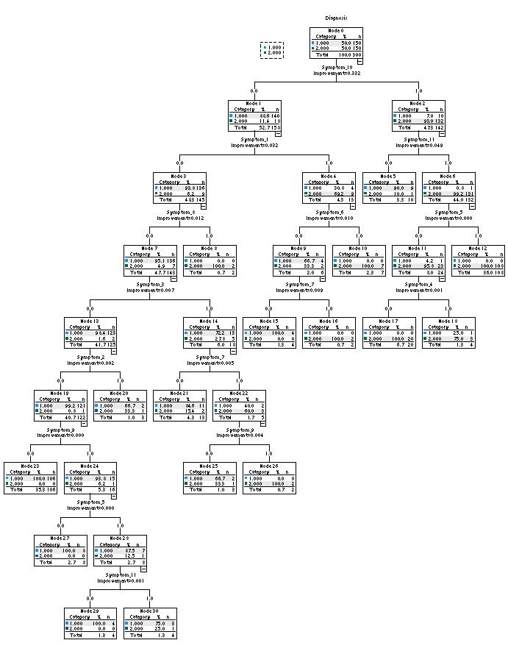

Classification
Observed | Predicted
Observed | 1 | 2 | Percent Correct
1 | 149 | 1 | 99.3%
2 | 6 | 144 | 96.0%
Overall Percentage | 51.7% | 48.3% | 97.7%
Growing Method: CRT
Dependent Variable: Diagnosis

- Several decision trees were built. The above are the first and final trees.
- The final tree has 31 total nodes. The final tree has 6 terminal nodes.
- The most important nodes are Symptom_10, Symptom_1 and Symptom 11. Those 3 nodes displayed the best improvement in the model. This is something that I will need to investigate further.
- The final decision tree is definitely more complex with 8 different levels.

Problem 2.)

- The following will display that the “Red-Wine” data has 6 classes. The distribution graph is also below.

Statistics
quality
N | Valid | 1599
N | Missing | 0

quality
 |  | Frequency | Percent | Valid Percent | Cumulative Percent
Valid | 3 | 10 | .6 | .6 | .6
Valid | 4 | 53 | 3.3 | 3.3 | 3.9
Valid | 5 | 681 | 42.6 | 42.6 | 46.5
Valid | 6 | 638 | 39.9 | 39.9 | 86.4
Valid | 7 | 199 | 12.4 | 12.4 | 98.9
Valid | 8 | 18 | 1.1 | 1.1 | 100.0
Valid | Total | 1599 | 100.0 | 100.0

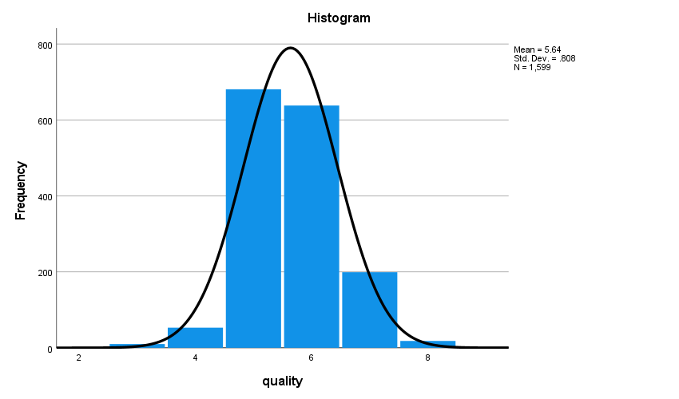

2.)

Model Summary
Specifications | Growing Method | CRT
Specifications | Dependent Variable | quality
Specifications | Independent Variables | fixedacidity, volatileacidity, citricacid, residualsugar, chlorides, freesulfurdioxide, totalsulfurdioxide, density, pH, sulphates, alcohol
Specifications | Validation | Cross Validation
Specifications | Maximum Tree Depth | 5
Specifications | Minimum Cases in Parent Node | 5
Specifications | Minimum Cases in Child Node | 2
Results | Independent Variables Included | alcohol, density, chlorides, volatileacidity, citricacid, sulphates, totalsulfurdioxide, fixedacidity, pH, residualsugar, freesulfurdioxide
Results | Number of Nodes | 61
Results | Number of Terminal Nodes | 31
Results | Depth | 5

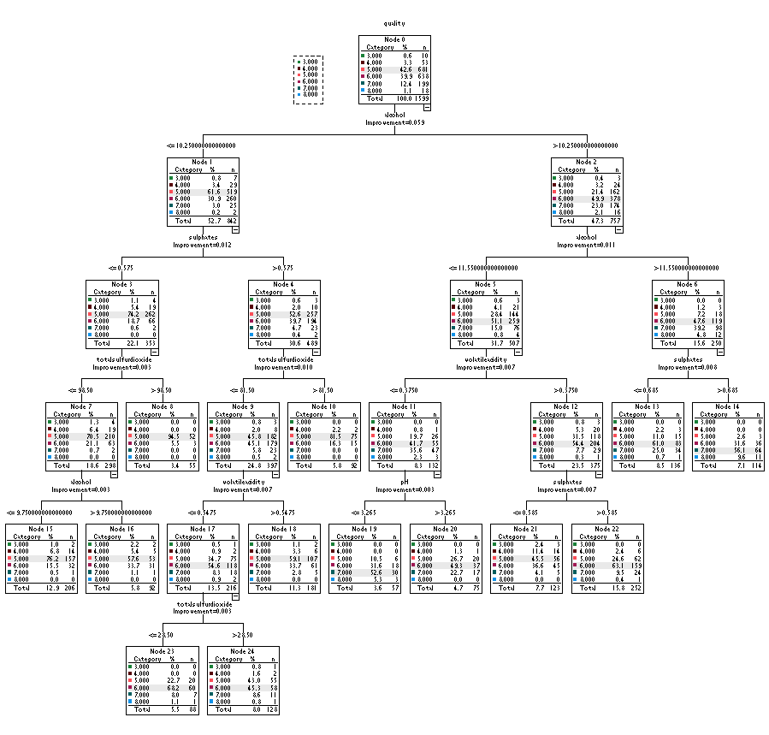

Risk
Method | Estimate | Std. Error
Resubstitution | .380 | .012
Cross-Validation | .430 | .012
Growing Method: CRT
Dependent Variable: quality

Classification
Observed | Predicted
Observed | 3 | 4 | 5 | 6 | 7 | 8 | Percent Correct
3 | 0 | 0 | 9 | 1 | 0 | 0 | 0.0%
4 | 0 | 0 | 41 | 12 | 0 | 0 | 0.0%
5 | 0 | 0 | 500 | 172 | 9 | 0 | 73.4%
6 | 0 | 0 | 187 | 397 | 54 | 0 | 62.2%
7 | 0 | 0 | 12 | 93 | 94 | 0 | 47.2%
8 | 0 | 0 | 0 | 4 | 14 | 0 | 0.0%
Overall Percentage | 0.0% | 0.0% | 46.8% | 42.5% | 10.7% | 0.0% | 62.0%
Growing Method: CRT
Dependent Variable: quality

3.)

Model Summary
Specifications | Growing Method | CRT
Specifications | Dependent Variable | quality (Binned)
Specifications | Independent Variables | fixedacidity, volatileacidity, citricacid, residualsugar, chlorides, freesulfurdioxide, totalsulfurdioxide, density, pH, sulphates, alcohol
Specifications | Validation | Cross Validation
Specifications | Maximum Tree Depth | 5
Specifications | Minimum Cases in Parent Node | 100
Specifications | Minimum Cases in Child Node | 50
Results | Independent Variables Included | alcohol, density, chlorides, volatileacidity, fixedacidity, totalsulfurdioxide, sulphates, pH, citricacid, freesulfurdioxide, residualsugar
Results | Number of Nodes | 25
Results | Number of Terminal Nodes | 13
Results | Depth | 5

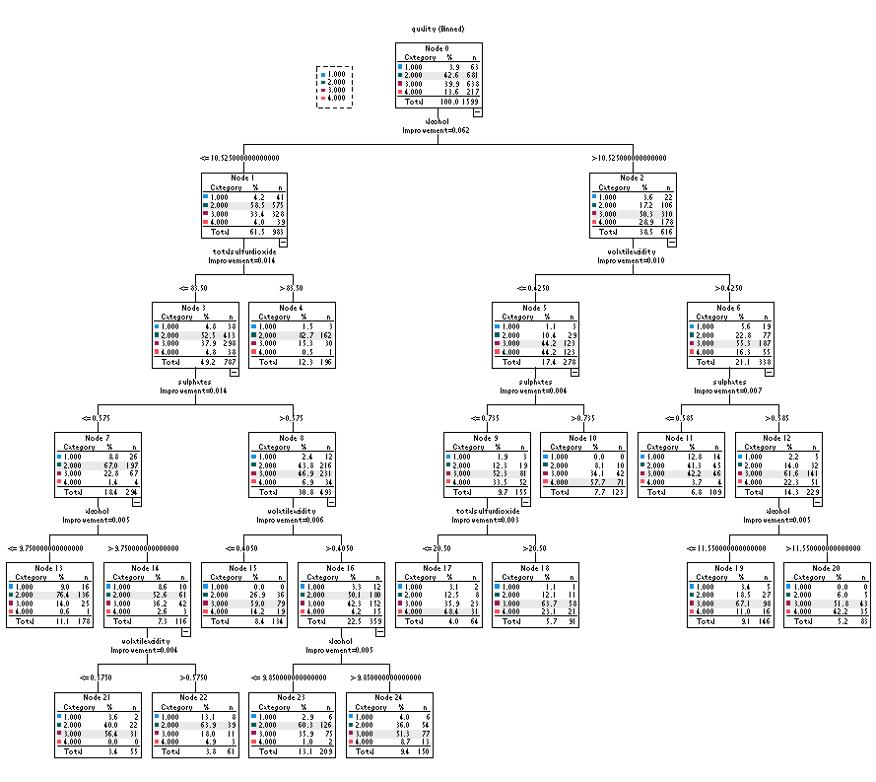
Risk
Method | Estimate | Std. Error
Resubstitution | .376 | .012
Cross-Validation | .422 | .012
Growing Method: CRT
Dependent Variable: quality (Binned)

Classification
Observed | Predicted
Observed | 1 | 2 | 3 | 4 | Percent Correct
1 | 0 | 33 | 28 | 2 | 0.0%
2 | 0 | 463 | 200 | 18 | 68.0%
3 | 0 | 141 | 432 | 65 | 67.7%
4 | 0 | 7 | 108 | 102 | 47.0%
Overall Percentage | 0.0% | 40.3% | 48.0% | 11.7% | 62.4%
Growing Method: CRT
Dependent Variable: quality (Binned)

4.) For this case, the performance and accuracy on the binned data appears to be slightly better than that of the data pre-binned. Again, I’ll need to study and review this a bit more.

Problem 3.)

- Red ~> No
Height ~> Short ~> No
Width ~> Thin ~> No

- Blue ~> Width ~> Fat ~> Yes
Height ~> Tall ~> Yes

- Green ~> Height ~> Short ~> No
Width ~> Fat ~> Yes

- Green ~> Height~> Tall ~> Yes
Width ~> Thin ~> No

- Blue ~> Height ~> Short ~> No
Width ~> Thin ~> No

Example | Color | Height | Width | Class
A | Red | Short | Thin | No
B | Blue | Tall | Fat | Yes
C | Green | Short | Fat | Unknown
D | Green | Tall | Thin | Unknown
E | Blue | Short | Thin | No

