Kristina Collins
EECS 600
PS5: Trajectory Action Server & Client

This project incorporates a trajectory action server and client into the framework used in PS4.

The joint position and velocity data for when the trajectory server is run are plotted in rqt_plot, below, as shown in the video included in this file.

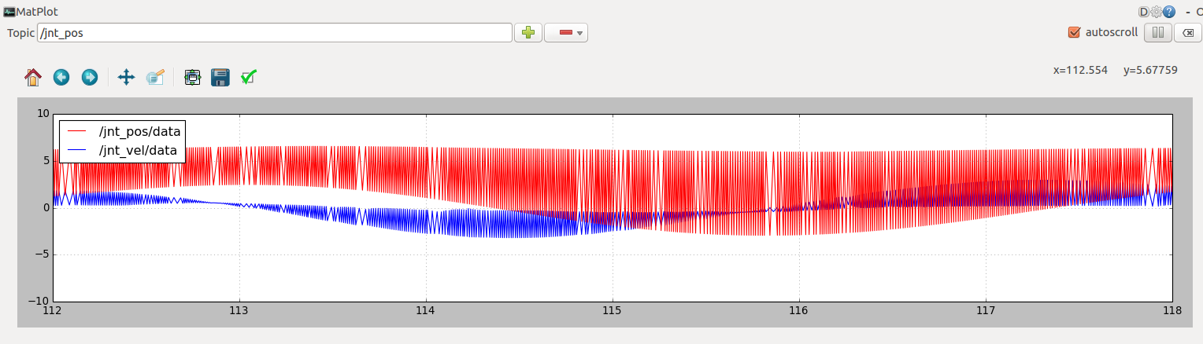
The jnt_trq variable commands a sinusoid:

