BEYOND INDUSTRY KNOWLEDGE

BIK SOLUTIONS
The AI Operating System for Australian Construction

STRATEGIC BLUEPRINT & INVESTMENT MEMORANDUM
Executive Memorandum · Business Case · Strategic & Product Plan · Go-To-Market ·
Commercial & Financial Model · Competitor Analysis · Enterprise & Acquisition Strategy ·
Five-Year Roadmap · Risk Register · Board Papers · Appendices

Prepared for | Board of Directors, Prospective Investors, Strategic & Banking Partners
Prepared by | BIK Solutions Pty Ltd
Classification | Confidential — Not for Distribution
Version | 1.0 — Board Draft
Date | 16 July 2026

Confidentiality & Disclaimer
This document has been prepared by BIK Solutions Pty Ltd (“BIK”, “the Company”) solely for the confidential use of the addressee. It is intended to support Board decision-making, prospective venture and strategic investment discussions, government grant assessment, and banking partner due diligence. It is not, and must not be construed as, an offer to sell or a solicitation of an offer to buy any security, and it does not constitute financial product advice.
Forward-looking statements in this document — including market sizing, financial projections, growth scenarios, valuation ranges and acquisition scenarios — are illustrative and based on assumptions disclosed throughout the document. Actual results may differ materially. Recipients should conduct their own independent due diligence and obtain professional financial, legal and tax advice before making any investment, credit, or transactional decision in reliance on this document.
This document contains proprietary and commercially sensitive information about BIK Solutions Pty Ltd. It must not be reproduced, distributed, or disclosed, in whole or in part, to any third party without the prior written consent of BIK Solutions Pty Ltd.
DOCUMENT CONTROL
Field | Detail
Document title | BIK Solutions — Strategic Blueprint & Investment Memorandum
Version | 1.0 — Board Draft
Status | Final for Board circulation
Classification | Confidential
Date prepared | 16 July 2026
Prepared by | BIK Solutions Pty Ltd — Office of the Founder
Review cycle | Reviewed quarterly; refreshed at each institutional raise or acquisition process
Related documents | docs/business-strategy.md · docs/product-roadmap.md · docs/pricing-strategy.md · docs/ai-tool-catalogue.md · docs/technical-architecture.md · docs/legal-and-safety-tool-register.md (BIK Solutions internal repository)

Table of Contents
Right-click and choose Update Field to build the Table of Contents.

PART A — THE OPPORTUNITY
Executive Investment Memorandum & Business Case
What BIK Solutions is, why it exists, and why now is the moment to back it

PART A — THE OPPORTUNITY
01 Executive Investment Memorandum
The One-Paragraph Version
BIK Solutions is building the AI operating system for Australian construction administration — the layer of quotes, scopes, variations, safety documents, progress claims and compliance records that every trade business must produce but almost none produce well. The company began as a premium trades services business operating across South East Queensland and is evolving into a two-unit structure: a cash-generative services business and a venture-scale AI SaaS platform, the BIK Business Toolkit. The platform is live in beta, grounded in a 62-tool catalogue mapped across four delivery phases, and governed from day one by a strict rule that has no equivalent at any incumbent competitor: the AI may edit, restructure and strengthen a builder's own words, but it may never invent a fact, figure, date or claim. That rule is not a compliance afterthought — it is the foundation of the trust the category needs before it can scale.
INVESTMENT THESIS IN ONE LINE
Australian construction is a $360B+ GDP contributor that runs on paper, Word documents and text threads. BIK is the first AI-native, Australian-specific operating system built for it — founded by operators who have lived the problem, not outsiders reverse-engineering it from a demo.

What We Are Asking For
This memorandum is written for four audiences simultaneously — the BIK Solutions Board, prospective venture and strategic investors, a government grant assessor, and a banking or finance partner — because the underlying facts and strategy are identical for all four. What differs is the ask:
Audience | What this document asks of you | Primary sections
Board of Directors | Approve the Phase 2 platform investment, the funding pathway (bootstrap vs raise), and the governance framework in Chapters 26–28. | Ch. 8, 19–21, 26–29
Venture investor | Evaluate BIK as a seed / Series A vertical AI SaaS opportunity with a credible path to $50K–$200K+ MRR and multiple acquisition pathways. | Ch. 1–3, 16–21, 24–25
Strategic buyer | Understand where BIK fits in the AU construction software stack, and the milestones that would trigger a partnership or acquisition conversation. | Ch. 17, 22, 24–25
Government grant assessor | Assess eligibility against innovation, digitisation and export-readiness criteria for AU construction-sector productivity programmes. | Ch. 4–7, 12–14, 26–27
Banking / finance partner | Assess cash flow discipline, the two-unit structure (services funding platform R&D), and facility requirements through scale-up. | Ch. 19–21

The Business Today
- Structure. Two units under one brand: Trades Services (operating, cash-generative, SEQ-based make-good, strip and prep, site protection and handyman finishing) and the SaaS Platform (BIK Business Toolkit, in beta).
- Product status. 5 tools live in production (Variation Notice, Quote Builder, Scope of Works, Site Diary, Defect Report); a further 13 tools drafted and in legal/safety review; 62 tools catalogued across four phases.
- Technology. A deliberately minimal, zero-infrastructure-cost Phase 1 stack — static HTML/CSS/vanilla JS on GitHub Pages, all data client-side — engineered to convert cleanly to a Supabase/Stripe-backed Phase 2 platform without a rewrite.
- Governance. Decision 001 ("AI never invents facts") is enforced in every AI system prompt. A living Legal and Safety Tool Register grades every document type by regulatory risk before it is allowed into beta.
- Go-to-market. Organic-first: free tools, SEO, email capture, and founder-led trust-building in trade communities, funded by services revenue rather than paid acquisition spend.
Why This Document Exists Now
BIK completed its Sprint 3 beta readiness review on 15 July 2026 with a verdict of GO WITH MINOR ISSUES: the Variation Notice tool is rated ready for production use, four critical bugs were resolved in the same sprint, and trust documentation (Privacy Policy, Terms of Use, AI Usage Notice) is live. This is the point at which a company's internal roadmap becomes a strategic document that can be shown outside the building — to a Board formalising its mandate, to the first outside capital, or to a partner assessing whether BIK is a credible long-term counterparty. Every figure in this document is sourced from BIK's own product, pricing, and roadmap documentation, or is explicitly and separately labelled as an illustrative planning assumption.
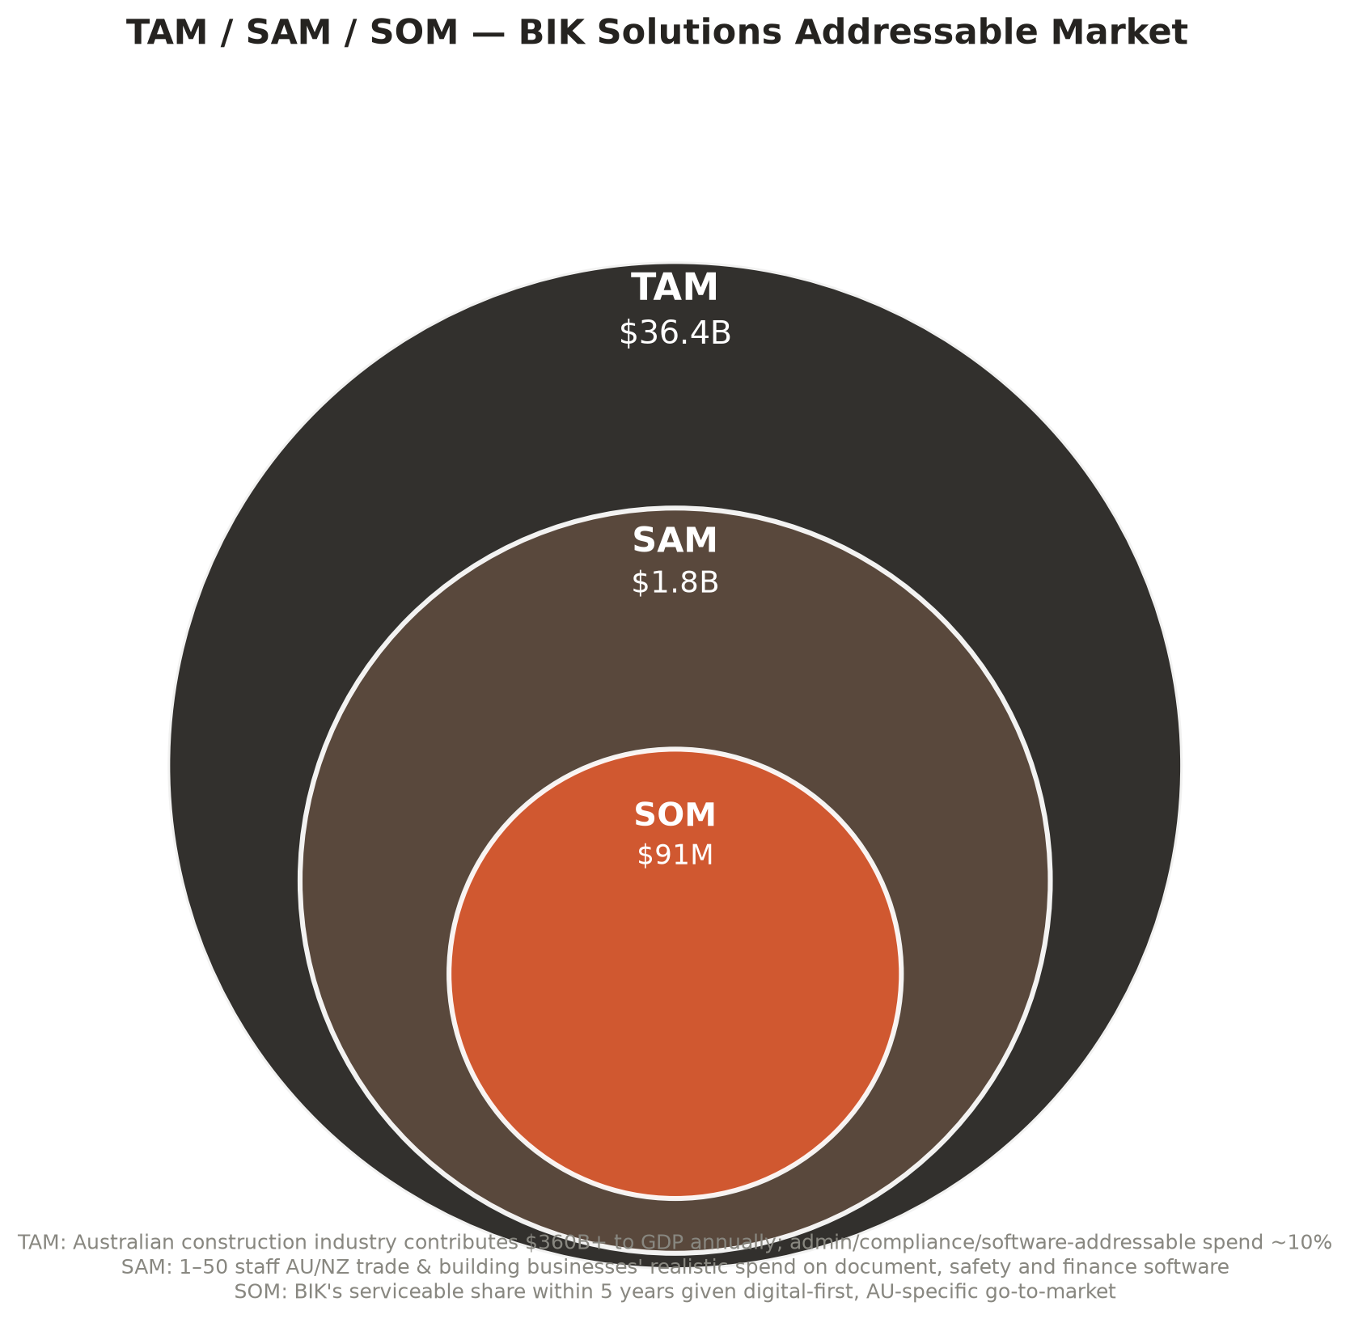
Figure 1.1 — TAM / SAM / SOM for the BIK Business Toolkit
Key Metrics at a Glance
Metric | Today (Beta) | 12 Months | 36 Months | 60 Months
Tools live | 5 (10 catalogued Phase 1) | 10 | 50 | 105+
Paying subscribers | 0 (pre-monetisation beta) | 100 | 1,500 | 5,000+
MRR (base case) | $0 | $2,000 | $50,000 | $200,000+
Geography | South East Queensland | Australia-wide (digital) | Australia + NZ | AU + NZ + selective export
Team | Founder-led, lean | Founder + core hires | Product, eng, CS functions | Full leadership team

How To Read This Document
Part A sets out the opportunity and the business case. Part B makes the strategic argument for why AI changes construction administration now, and why BIK's approach is structurally different from a "ChatGPT wrapper." Part C sets out strategy, product philosophy, the operating model and the AI governance framework that makes the whole thing trustworthy. Part D is the product, go-to-market and commercial engine. Part E is market and competition. Part F is the financial model. Part G addresses the single most important strategic question for any investor or acquirer — is BIK a standalone business or an acquisition target, and under what circumstances does that answer change? Part H is risk and compliance. Part I is board governance and the next twelve months. Appendices carry the full 62-tool catalogue, technical architecture summary, assumptions register and glossary.
Illustrative Use of Funds (If an Institutional Raise Is Pursued)
BIK does not require external capital to reach Phase 2 (Chapter 19). The table below is provided for a prospective investor evaluating what a raise would actually fund, should the Board elect to accelerate beyond the bootstrap pace rather than because a raise is assumed or required.
Use of funds | Illustrative allocation | Purpose
Engineering & product | 45% | Accelerate Phase 2–3 build: accounts, billing, integrations, mobile PWA
Sales & marketing | 25% | Paid acquisition layered on top of the organic engine (Chapter 14), content production, partnership development
Compliance & legal review | 10% | Clear the Legal and Safety Tool Register HOLD items (Chapter 27) faster than founder-only review allows
Key hires | 15% | Bring forward the Phase 2–3 organisational design (Chapter 10) rather than waiting on revenue-funded hiring
Working capital / contingency | 5% | Buffer against the churn and adoption-speed risks named in Chapter 26

Key Risks to the Investment Thesis
A credible investment memorandum names its own weak points. The three risks below are the ones most likely to change an investor's or acquirer's view of BIK, and each is cross-referenced to where this document addresses it in full.
Risk to the thesis | Why it matters | Where it is addressed
The category itself moves slower than modelled | Vertical AI SaaS valuation premiums (Chapter 5) are a directional pattern, not a guarantee for any specific company or category | Chapter 20 sensitivity analysis; Chapter 26 Risk 1
An incumbent moves first with credible AI features | BIK's sequencing advantage (Chapter 7) is real but time-limited | Chapter 17 competitive analysis; Chapter 26 Risk 5
Key-person concentration | The founder-market-fit advantage that makes BIK credible today is also a single point of failure until the Phase 2–3 team is built out | Chapter 10 organisational design; Chapter 26 Risk 3; Chapter 25 exit-readiness

Illustrative Comparable Context
BIK does not claim direct comparability to any single named transaction — the Australian vertical trade-software category has produced a range of outcomes from strong independent growth to strategic acquisition by accounting and field-service platforms, consistent with the acquirer categories in Chapter 24. The relevant comparison for this document's purposes is structural, not transactional: AU/NZ vertical SaaS businesses serving the trade and construction sector have historically been valued as a function of recurring revenue quality (retention, gross margin) more than absolute scale, which is precisely the basis of the valuation framework in Chapter 21.
PART A — THE OPPORTUNITY
02 Executive Summary Dashboard
The Business in One Page
Dimension | Summary
Company | BIK Solutions Pty Ltd — trading as BIK Solutions — "Beyond Industry Knowledge"
Sector | Construction technology / vertical AI SaaS, Australian trades and building sector
Product | BIK Business Toolkit — AI-generated construction documents, safety and compliance tools, and (from Phase 4) autonomous AI agents
Stage | Beta (Sprint 3 complete, 15 July 2026); pre-monetisation on the SaaS unit; revenue-generating on the Trades Services unit
Business model | Freemium SaaS: $0 / $19 / $29 / $49 / $99+ monthly tiers, annual discount, plus digital template sales and (Phase 4+) enterprise/API licensing
Market | TAM $360B+ (AU construction GDP contribution); SAM ~$1.8B (AU/NZ 1–50 staff trade business software spend); SOM ~$91M (5-year serviceable share)
Traction | 5 tools live; beta feedback loop operating; trust and legal documentation published; zero paid customer acquisition to date
Team | Founder-led; operating trades business provides direct, continuous access to the exact customer BIK is building for
Ask | Board approval of Phase 2 investment case (Ch. 8); evaluation as a seed/Series A vertical AI SaaS opportunity (Ch. 19–21); or as a strategic partnership / acquisition conversation (Ch. 22–25)

The Investment Case in Five Points
- 1. Enormous, underserved market. AU construction is one of the least digitised trillion-dollar-adjacent sectors in the country; most incumbents are either generic (Word, Excel, ChatGPT) or enterprise-grade and irrelevant to the 1–20 person business that is the backbone of the industry.
- 2. Real product, not a deck. Five tools are live and in beta with real builders, not a prototype. The architecture was built to scale from day one.
- 3. Trust as the moat. Decision 001 and the Legal and Safety Tool Register are structural commitments that are expensive for a fast-follower to copy credibly, because copying them requires giving up the temptation to over-promise.
- 4. Founder-market fit. BIK is an operating construction business first. It is not software people imagining a trades problem — it is tradespeople who also build software.
- 5. Multiple paths to value creation. BIK can compound as a standalone SaaS business toward a $200K+ MRR, category-leadership outcome, or become a highly strategic acquisition target for an accounting platform, field-service platform, or enterprise construction software incumbent well before that point (Ch. 22–25).
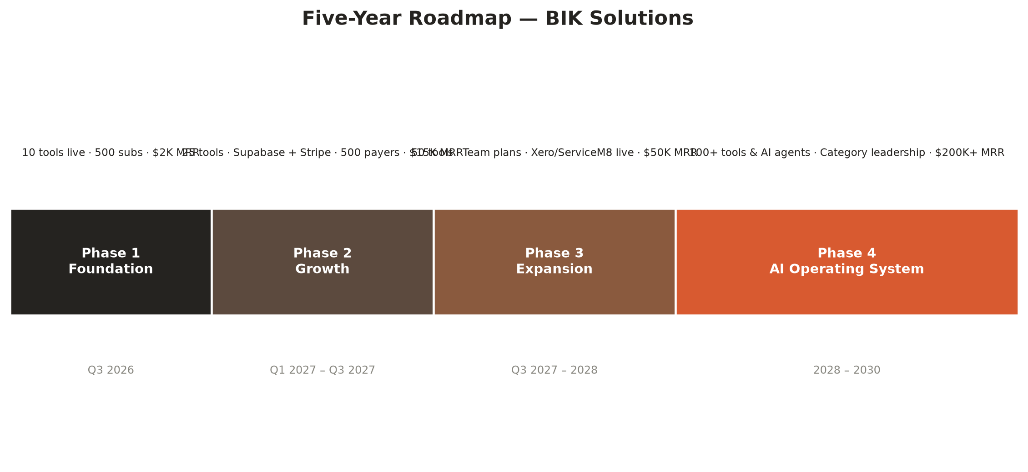
Figure 2.1 — Five-year roadmap at a glance (see Chapter 13 for full detail)
PART A — THE OPPORTUNITY
03 Business Case
The Problem
Australian construction businesses — from sole traders to mid-size builders — run on a broken stack of paper forms, email threads, group chat messages and generic office software that does not understand construction. The consequences are consistent across every business BIK has spoken to in the course of running its own trades operation:
- Hours lost every week writing quotes, scopes of works, and variation notices from scratch
- Safety documents — SWMS, toolbox talks — copied and pasted without real review
- Payment chasing done manually, invoices sent late, cash flow damaged as a direct result
- Site diaries forgotten, defect lists mismanaged, handovers delayed
- No consistent documentation trail — which becomes expensive and sometimes ruinous during disputes
“The gap between what gets built and what gets documented properly is where most problems live.”
— BIK Product Vision, internal strategy documentation
Why Existing Options Fail
Alternative | Why builders use it today | Why it fails them
Microsoft Word / Excel | Familiar, already licensed, flexible | Zero automation or intelligence; every document is built from nothing, every time
Generic AI (ChatGPT) | Fast, flexible, cheap | Not construction-specific, no Australian compliance awareness, no templates, no audit trail, and prone to confidently inventing facts
Enterprise platforms (Procore, Aconex) | Comprehensive, credible for large projects | Priced and designed for head contractors and tier-1 builders; wildly overkill and unaffordable for a 1–20 person business
Field service tools (ServiceM8, simPRO) | Good at scheduling and job management | Not built around document generation, compliance drafting, or construction-specific administrative language
Doing nothing | No cost, no learning curve | The most common choice — and the most expensive one, in disputes, in cash flow, and in professional reputation

The Opportunity
The Australian construction industry contributes over $360 billion to GDP annually and is one of the least digitised industries in the country relative to its economic weight. Purpose-built, AI-powered tooling for this market is largely absent: the software that exists is either generic productivity software or complex enterprise systems that are irrelevant to the vast majority of businesses in the sector, which have between one and twenty staff. There is a clear, underserved market for:
- Simple, fast, trade-specific AI document generation that a sole trader can use without training
- Compliance tooling built around Australian regulation — WHS, the Building Industry Fairness (Security of Payment) Act, and state-based equivalents
- A platform that grows with the business, from sole trader through to a 20-person outfit, without forcing a switch to enterprise software
The Solution
The BIK Business Toolkit is a catalogue of AI-assisted document and workflow tools purpose-built for Australian trade and construction businesses, organised into eight categories — Sales & Business Development, Project Administration, Safety & Compliance, Finance & Accounts, Client Communication, HR & People, Subcontractor Management, and (from Phase 4) autonomous AI Agents. Sixty-two tools are catalogued today; ten are prioritised for Phase 1 and five of those are already live in beta.
Phase 1 tool | Category | Status | Time saved per use
Quote Builder | Sales & BD | Live | ~90 minutes
Scope of Works Generator | Project Admin | Live | 60–90 minutes
Variation Notice | Project Admin | Live — production ready | 30 minutes
Site Diary Generator | Project Admin (Free) | Live | 15–20 minutes / day
Defect Report | Project Admin | Live | 45 minutes
Progress Claim | Finance | In development — highest commercial priority | 60 minutes
SWMS Generator | Safety | Drafted — legal review HOLD | 60–90 minutes
Toolbox Talk Generator | Safety (Free) | Live | 45 minutes
Payment Reminder | Finance (Free) | Live | 15 minutes
Site Inspection Report | Project Admin | Drafted | 60 minutes

Source: docs/ai-tool-catalogue.md and docs/legal-and-safety-tool-register.md (BIK internal documentation)
The Business Model
BIK operates two units that reinforce each other. Trades Services is a premium, project-quoted services business across South East Queensland — make-good and repairs, strip and prep, site protection and handyman finishing — that is high-margin, relationship-driven, and cash-generative today. The SaaS Platform is a freemium subscription business layered on top of the same brand and the same customer insight. The two units share a brand but operate independently: services revenue funds platform development, and platform growth brings inbound leads back into the services business.
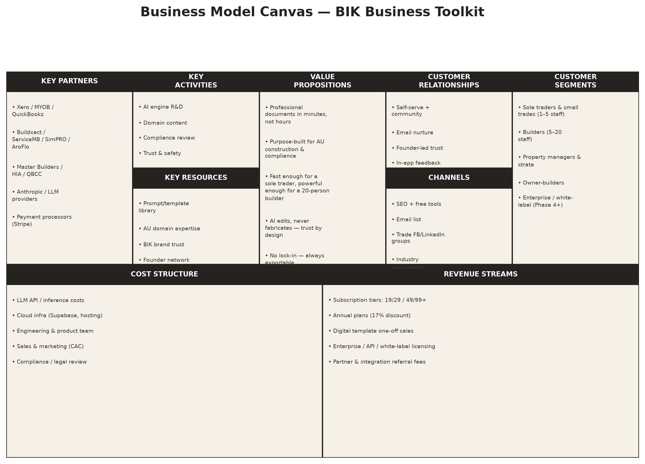
Figure 3.1 — Business Model Canvas, BIK Business Toolkit
Why BIK, Why Now
- Timing. Foundation-model AI has, in the past 24 months, made high-quality natural-language document generation cheap and fast enough to embed directly into a workflow tool rather than sell as a novelty.
- Credibility. BIK is not a software team guessing at a construction problem. It is a construction business that also builds software — the founder and team are the target customer.
- Trust-first design. Decision 001 (the AI never invents facts) and the Legal and Safety Tool Register are unusual in this category. Most AI document tools optimise for confident-sounding output; BIK optimises for output the user can stand behind professionally and legally.
- Category timing. Vertical AI SaaS is attracting valuation premiums over horizontal SaaS precisely because it combines defensible domain data and workflow depth with the same generative technology available to everyone (see Chapter 5).
BUSINESS CASE CONCLUSION
The problem is real, expensive and universal across the Australian trades sector. The solution is live, not conceptual. The business model is proven at the unit-economics level by comparable vertical SaaS businesses (Chapter 19) and self-funded by an already-profitable services business. The remaining question is not whether this should be built, but how fast it should be scaled — which is the subject of the rest of this document.

PART B — WHY NOW
The AI Thesis: Why Construction Administration Is About To Change
The structural argument for vertical AI software, and why BIK is built to be an operating system, not a novelty

PART B — THE AI THESIS
04 Why AI Changes Construction Administration
Administration Was Always the Hidden Tax on Construction
Construction has always carried an administrative tax that is invisible in a scope of works but shows up everywhere in the profit and loss statement: the hours a site supervisor spends writing a site diary instead of supervising the site; the variation notice that never gets issued because writing it properly takes thirty minutes nobody has; the progress claim that goes out two weeks late because the paperwork is dreaded more than the number is disputed. This tax has historically been treated as an unavoidable cost of doing business, because the only ways to reduce it were to hire more admin staff (a fixed cost few small trades can carry) or to accept lower documentation quality (a risk that surfaces expensively during disputes).
What Generative AI Actually Removes
Generative AI does not remove the need for construction documentation — it removes the marginal cost of producing it well. A builder who can describe a job in plain language should not need to also be a fluent technical writer, a WHS specialist and a payment-claims clerk to produce documents that read like they were. That is the specific capability large language models add: they compress the distance between what a tradesperson knows and what a professional document requires, without requiring the tradesperson to become someone else.
Before AI | With AI (generic) | With AI (BIK — construction-native, governed)
Builder writes a variation notice from a blank Word document, 30–60 minutes, inconsistent quality | Builder pastes a rough description into ChatGPT and gets fluent prose with no construction structure, no compliance awareness, and no guardrail against invented detail | Builder fills a structured, construction-specific form; the AI writer polishes language across six defined modes while a hard rule (Decision 001) prevents it from adding any fact the builder did not supply
Safety talks copied from an old file, rarely tailored to the actual site | A generic AI can produce a fluent toolbox talk but has no register of what "good" looks like under Safe Work Australia guidance | Toolbox Talk generator structures the discussion around a defined topic list, audience level and duration, matched to AU WHS norms
No consistent record for a dispute | Chat history is not a professional record and is not portable | Every generated document is dated, numbered, stored in document history, and exportable as a durable PDF the business owns

Why This Is a Software Category, Not a Feature
It would be a mistake to read this shift as "add an AI button to existing construction software." The businesses best placed to win this category are the ones that treat AI-native document generation as the primary product, built around a domain-specific data model of what a compliant Australian construction document actually contains — not a generic AI layered onto an existing workflow tool as an afterthought. This is the strategic bet BIK is making, and it is explored in full in Chapters 5 and 6.
PART B — THE AI THESIS
05 The Rise of Vertical AI Software
Horizontal AI vs Vertical AI
The first wave of generative AI products was horizontal: general-purpose assistants (ChatGPT, Claude, Gemini) that can, in principle, help with almost any task including drafting a construction document. The second wave — the one now attracting the sharpest investor and strategic attention — is vertical: AI products built around a single industry's data, workflows, compliance obligations and language, wrapped in enough domain-specific structure that the AI's raw capability becomes a component of the product rather than the whole of it.
WHY VERTICAL AI SOFTWARE COMMANDS A PREMIUM
- Defensibility beyond the model. Anyone can call a foundation model API. Few can encode what a compliant Queensland BIF Act progress claim actually requires, what a Safe Work Australia-aligned SWMS structure looks like, or what fields a QBCC-savvy builder expects in a scope of works. That structure is the product.
- Workflow lock-in, not content lock-in. The value is not the words the AI generates once — it's the recurring workflow: document history, builder profile auto-fill, per-tool numbering, and (in Phase 2+) integration with the accounting and field-service tools a business already runs on.
- Trust compounds. A vertical product can make and keep specific promises — like Decision 001 — that a general-purpose assistant, built for a billion different use cases, structurally cannot.
- Distribution advantage. A vertical player can reach its market through channels a horizontal player will never bother building: trade Facebook groups, industry association partnerships, and word of mouth inside a tight-knit trade community.
THE MARKET SIGNAL
Across SaaS more broadly, vertical software businesses have historically commanded higher revenue multiples than horizontal equivalents at comparable growth rates, because vertical depth reduces churn and increases willingness to pay per seat. The addition of generative AI intensifies this pattern rather than eroding it: AI compresses the cost of building horizontal features (which become commoditised faster) while increasing the value of the proprietary domain layer that only a vertical player has the incentive and the access to build. This is a directional, widely observed pattern in the SaaS and venture capital commentary of 2024–2026, not a guaranteed outcome for any specific company, and BIK's own valuation framework (Chapter 21) treats it as an upside case rather than a baseline assumption.
THE STRATEGIC IMPLICATION FOR BIK
BIK should not compete with Anthropic, OpenAI or Google on model capability, and it does not need to. It should compete on how deeply Australian construction domain knowledge, compliance awareness and trust guarantees are encoded into the product around the model. That is a race BIK can win, because it is a race about domain depth and distribution, not compute.

PART B — THE AI THESIS
06 Why BIK Is an AI Operating System, Not a Document Generator
The Distinction That Matters
A document generator produces an output and is finished. An operating system sits underneath a business's daily operations and accumulates value the longer it is used: it remembers the builder's profile, it numbers and stores every document, it learns which tools a business relies on most, and — from Phase 3 onward — it connects outward to the accounting and field-service systems that business already runs on. BIK is deliberately built as the second thing, using the first thing as the wedge.
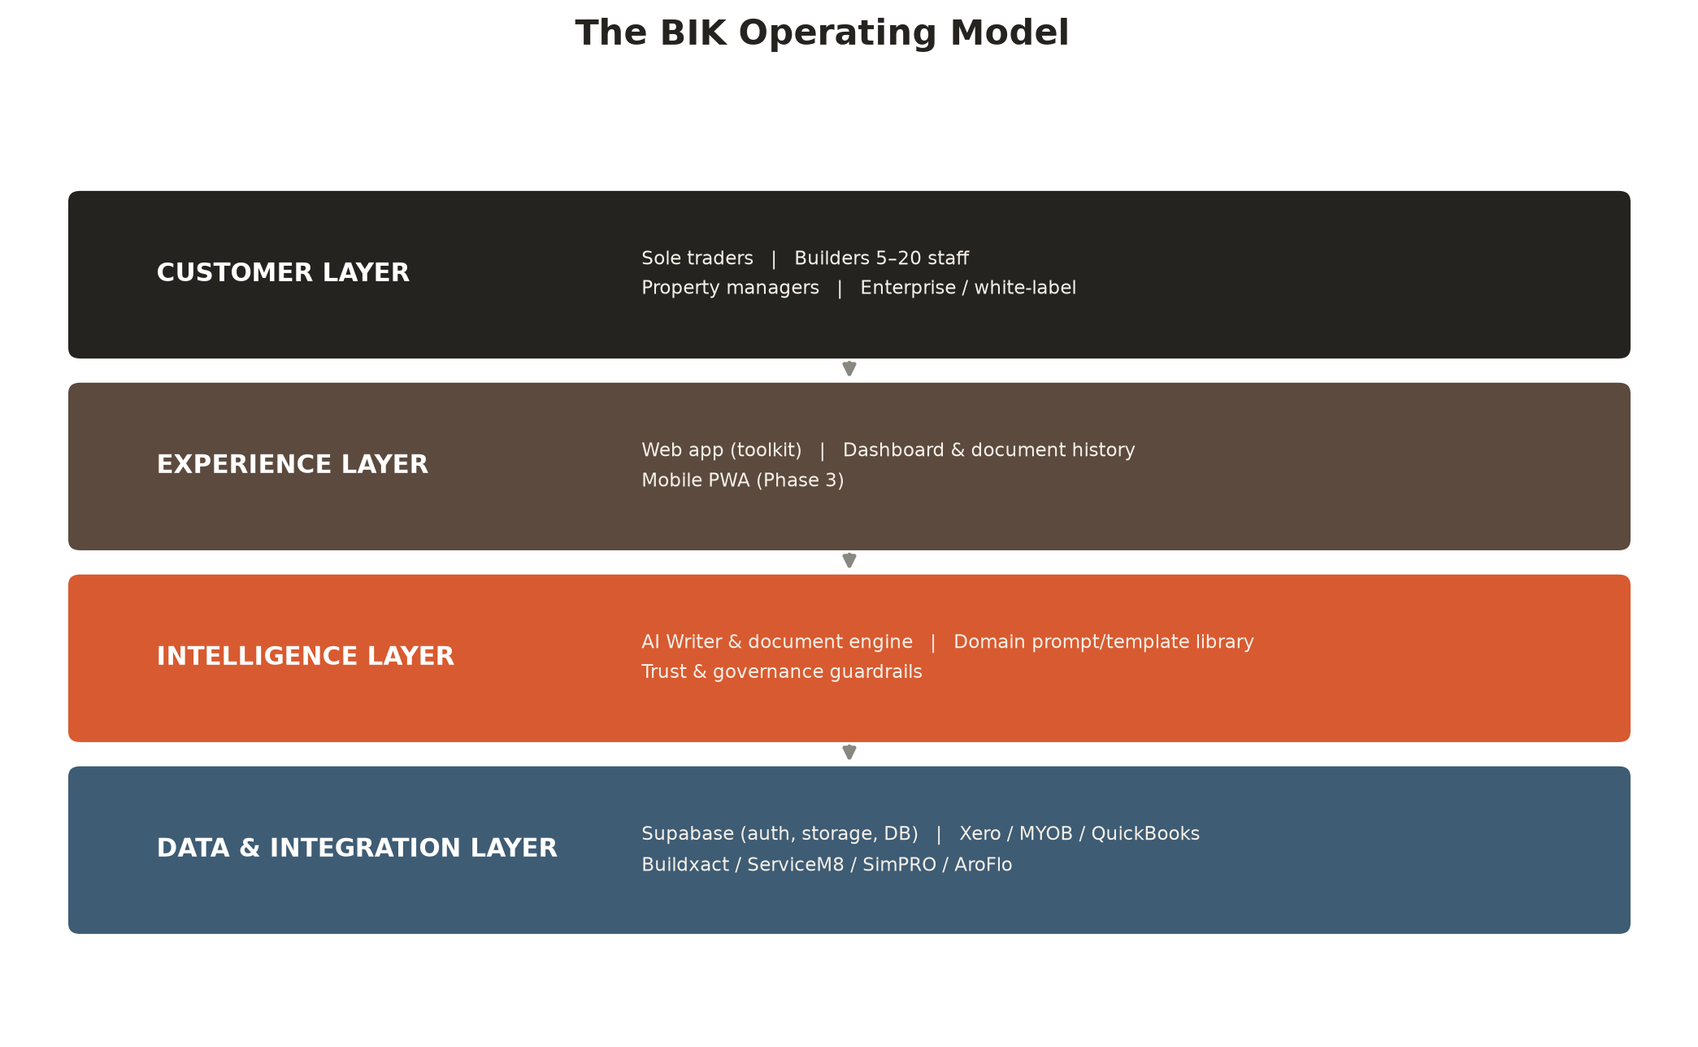
Figure 6.1 — The BIK Operating Model (four layers)
THE FOUR LAYERS, AND WHY EACH ONE MATTERS STRATEGICALLY
- Customer layer. Sole traders through to 20-person builders and, eventually, enterprise/white-label partners — a single product line that grows with the customer rather than forcing a platform switch at any size threshold.
- Experience layer. The web app and dashboard today; document history and a mobile PWA from Phase 3. This is where daily habit is built.
- Intelligence layer. The AI Writer and document engine, the construction-domain prompt and template library, and — critically — the trust and governance guardrails that make the intelligence layer safe to depend on.
- Data & integration layer. The layer that turns BIK from a tool a business opens once a week into infrastructure it cannot easily leave: Supabase-backed accounts and history from Phase 2, and direct integration with Xero, MYOB, QuickBooks, Buildxact, ServiceM8, SimPRO and AroFlo from Phase 3.
The Wedge-to-Platform Sequence
BIK's product sequencing is deliberate. Phase 1 wins trust and habit with a small number of extremely well-executed document tools rather than a broad, shallow feature set. Phase 2 converts habit into infrastructure by adding accounts, history and billing. Phase 3 converts infrastructure into a platform by integrating outward into the tools a business already depends on. Phase 4 converts the platform into an operating system in the fullest sense: autonomous AI agents that do not just draft a document when asked, but act — sending a payment reminder automatically when an invoice ages, drafting a SWMS from a description of the job, or flagging a risky clause in a contract before it is signed. This sequencing is expanded in full in Chapter 13 (Five-Year Product Roadmap).
WHY "DOCUMENT GENERATOR" UNDERSELLS THE BUSINESS
A generator is a feature that any competitor with API access to a foundation model can approximate in a sprint. An operating system is a compounding asset: the data (document history, builder profiles, integration connections) and the trust (Decision 001, the legal review register) get harder to replicate the longer BIK operates, not easier. That compounding is the actual investment thesis.

PART B — THE AI THESIS
07 Defensible Competitive Advantages
What Actually Protects BIK From Fast Followers
Every advantage below is deliberately not "we have AI." Model access is now a commodity; the defensibility has to live somewhere else. These are the five places it lives.
1. FOUNDER-MARKET FIT THAT CANNOT BE BOUGHT
BIK is an operating construction business first. The team has direct, continuous, unmediated access to the exact customer it is building for — not through user interviews or a design partner programme, but through running trade jobs across South East Queensland every week. A well-funded competitor can hire construction consultants; it cannot replicate a founding team that has lived the problem.
2. GOVERNANCE AS A TRUST ASSET
Decision 001 — the AI must never invent a fact, figure, date, name or claim not already present in the user's own input — is a binding product constraint, not a marketing line. Competitors can copy this policy in a slide, but copying it in practice means giving up the more impressive-looking, more fabricated-sounding output that a less disciplined AI writer can produce. That trade-off is a genuine strategic moat: it is hard to fake restraint.
3. A LIVING LEGAL AND SAFETY RISK REGISTER
Most AI document tools ship every feature the model can produce. BIK maintains a Legal and Safety Tool Register that explicitly holds back document types — including the SWMS Generator, the Notice to Show Cause, the Contract Termination Notice, and the Subcontractor Agreement — from release until a construction lawyer or WHS professional has reviewed them. That discipline is invisible to a user browsing a features page, but it is the single biggest determinant of whether BIK is trusted with a business's legal exposure five years from now.
4. ZERO-COST INFRASTRUCTURE COMPOUNDING INTO INTEGRATION DEPTH
Phase 1's static, client-side architecture was not a resourcing shortcut — it was a decision to prove product-market fit at zero infrastructure cost before committing to the backend investment Phase 2 requires. That capital discipline means BIK can reach Phase 2 without external funding if it chooses to, and the integration layer (Xero, MYOB, QuickBooks, Buildxact, ServiceM8, SimPRO, AroFlo) is already architected — seven provider stubs and five service modules are built and waiting for live credentials, not waiting for a design.
5. BRAND TRUST INHERITED FROM A REAL TRADES BUSINESS
BIK Solutions the software product inherits the credibility of BIK Solutions the trades business — a premium, precision-branded operator in a market that is famously sceptical of outsiders. That inherited trust is a genuine distribution advantage in exactly the channels (trade Facebook groups, industry associations, word of mouth) that matter most in this category and that paid advertising cannot buy.
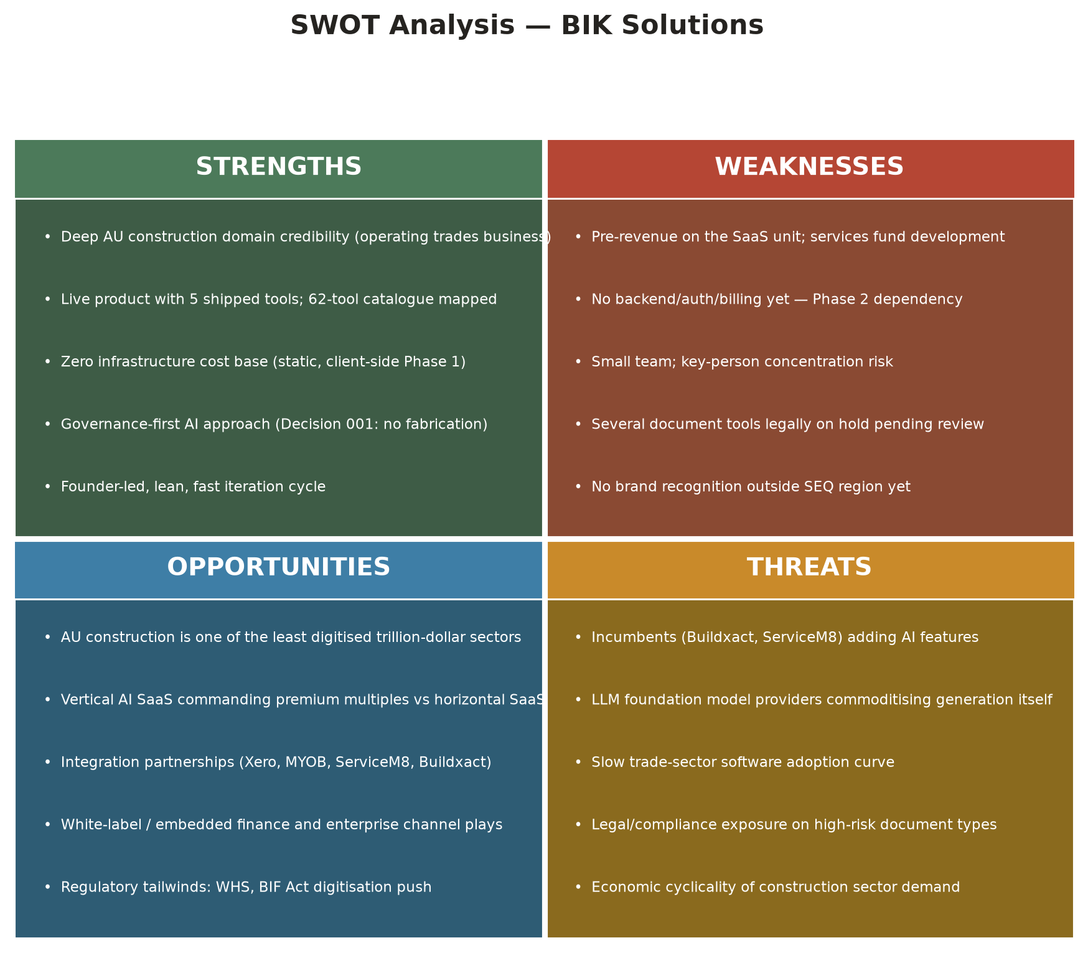
Figure 7.1 — SWOT Analysis, BIK Solutions (see Chapter 18 for full discussion)
THE HONEST CAVEAT
None of these five advantages are permanent or unassailable on their own — they are advantages of sequencing and discipline, not patents. They must be actively maintained (Chapter 26, Risk Register) and they compound fastest if BIK moves through Phases 2 and 3 with real urgency rather than treating this document as the finish line.

PART C — STRATEGY, PHILOSOPHY & GOVERNANCE
The Strategic Plan, Product Philosophy, Operating Model and AI Governance Framework
How BIK intends to win, and the principles that constrain how it is allowed to win

PART C — STRATEGY & GOVERNANCE
08 Strategic Plan
The Phased Evolution
BIK's strategy is organised around four phases, each with an explicit goal, an explicit success metric, and an explicit "why now" — not an open-ended roadmap of features.
Phase | Timing | Theme | Goal | Success criteria
1 — Foundation | Q3 2026 | Prove the product and the trust model | First 500 email subscribers, 100 paying users | $2,000 MRR, NPS > 40
2 — Growth | Q1–Q3 2027 | Convert habit into infrastructure | 500 paying subscribers, 25 tools live | $15,000 MRR
3 — Expansion | Q3 2027 – 2028 | Become the platform | 50 tools, team plans, 2 industry partnerships | $50,000 MRR
4 — AI Operating System | 2028 onward | Category leadership | 100+ tools & AI agents live | $200,000+ MRR; acquisition/investment conversations active

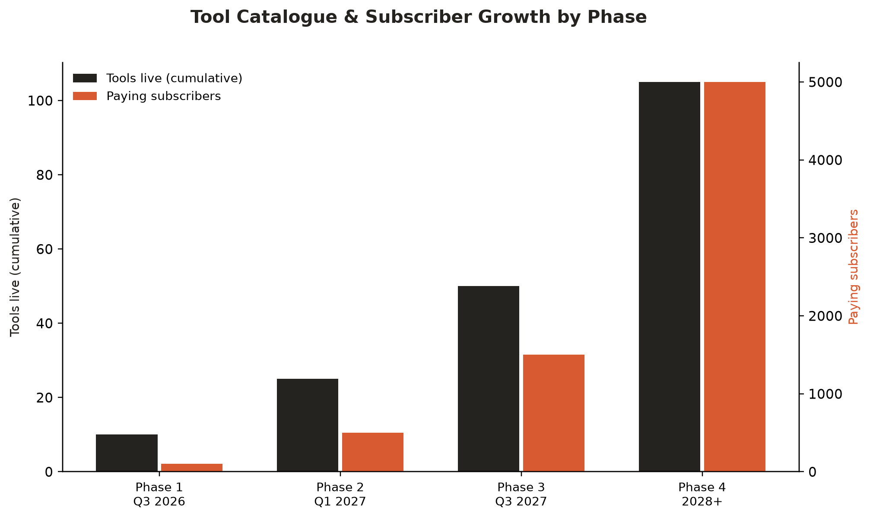
Figure 8.1 — Tool catalogue and subscriber growth by phase
Strategic Priorities, In Order
- 1. Win trust before scale. Every early decision (Decision 001, the legal register, the beta feedback loop) optimises for a builder trusting BIK enough to send a generated document to a client or head contractor. Growth without trust is a liability, not an asset, in a compliance-adjacent category.
- 2. Fund the platform from the services unit for as long as sensible. BIK does not need external capital to reach Phase 2. That optionality is itself strategic — it means any future raise is done from a position of leverage, not necessity (see Chapter 19).
- 3. Sequence infrastructure ahead of breadth. Accounts, billing and document history (Phase 2) are prioritised over adding the next twenty tools, because infrastructure compounds and tool breadth alone does not.
- 4. Build integration depth before enterprise ambition. Xero, MYOB and field-service integrations (Phase 3) come before any white-label or enterprise motion (Chapter 22), because a platform with no integration depth has nothing distinctive to license.
- 5. Treat every phase gate as a real gate. Progression from Phase 2 to Phase 3 is conditioned on hitting the $15,000 MRR and 25-tool criteria in the table above — not on the calendar.
What Success Looks Like at Each Horizon
Horizon | Metric | Target
3 months | Email subscribers | 500
6 months | Paying subscribers | 100
12 months | MRR | $5,000
24 months | MRR | $50,000
36 months | MRR | $200,000
Source: docs/product-vision.md — Success Metrics
What BIK Is Deliberately Not Building
Strategic discipline is as much about exclusion as ambition. BIK has explicitly ruled out the following, and this document restates the ruling because it is easy for scope to creep once outside capital or partnership interest arrives:
- A full enterprise project management suite — Procore and Autodesk Construction Cloud already do this well; BIK's stated posture is to integrate with these platforms eventually, not to compete with them head-on
- An accounting system — Xero, MYOB and QuickBooks already do this; BIK generates the documents that feed into them
- A generic AI assistant — BIK is deliberately, deeply construction-specific rather than broad
- Enterprise-first software — BIK's primary market is the 1–50 person trade business, not the head contractor or tier-1 builder
PART C — STRATEGY & GOVERNANCE
09 Product Philosophy
Design Principles
- The user is the source of truth. The AI is an editor, never an author. This single principle (Decision 001) shapes every prompt, every system message and every field in the product.
- Fast enough for a sole trader, powerful enough for a 20-person builder. Every tool must work in under three minutes for a solo user with no training, while still holding up as a professional document a head contractor would accept.
- No lock-in. Every document a builder generates is theirs — exportable as a PDF at any time, with no BIK watermark once paid. Trust is not built by making it hard to leave.
- Australian, specifically. Every field, label, default and legal reference reflects Australian construction practice and Australian English — not a US or generic English-language product with the currency symbol changed.
- Human review is a feature, not a disclaimer. AI output is always presented in the same editable field the user wrote into, so what changed is visible and correctable before anything is sent.
THE AI WRITING MODES
Mode | Purpose | Visibility
Rewrite Professionally | Formal Australian construction English | Primary — always visible
Strengthen for Contract | Legally precise, builder-protective language | Primary — always visible
Spell & Grammar | Correct errors only, preserve meaning exactly | Secondary — behind "More"
Simplify for Client | Plain language, no jargon | Secondary
Formal Version | Formal business register | Secondary
Plain English | Short sentences, active voice | Secondary

Why Restraint Is a Design Choice, Not a Limitation
It is technically trivial to build an AI writer that produces more impressive-sounding, more detailed, more confident output than BIK's. It is not trivial to build one that a builder can trust with their professional reputation and legal position — because that requires the AI to sometimes do less than it is capable of. BIK treats that restraint as the product, not a constraint on the product.
UX Principles: "One Call, Done Right" Applied to Software
BIK's service philosophy for its trades business — one call, done right — is deliberately also its software design philosophy. Every page and every tool is built against five principles, tested against a specific, unglamorous scenario: a builder standing on a dusty site at 6am, on a phone, on patchy 4G, with no patience for anything that isn't immediately obvious.
Principle | What it means in practice
Mobile-first, always | More than 60% of trade visitors are on mobile; every surface is designed for a phone first and enhanced for desktop, never the reverse
Clarity over cleverness | Every interaction must be obvious without instruction — no onboarding tour should ever be required to use a tool
Speed is a feature | Every kilobyte of JavaScript and every font is a tax on a variable 4G connection in a construction zone; the Phase 1 stack's zero-dependency approach (Chapter 6) is as much a UX decision as an infrastructure one
Respect the reader's time | Scannable content — headers, short paragraphs, bullets — never bury the action a user needs in a wall of text
Trust is earned, not assumed | The audience has been burned by unreliable trades and overpriced software before; every design choice reinforces professionalism and honesty rather than asserting it
Source: docs/ux-principles.md
These principles are enforced through concrete standards, not just stated as values: a minimum 44px touch target on every button, HTML5 and custom validation with plain-English error messages, colour contrast of at least 4.5:1 for body text, and full respect for `prefers-reduced-motion`. Accessibility is treated as a baseline requirement, not a Phase 2 nice-to-have — a genuine reflection of the "trust is earned" principle applied to users who rely on assistive technology.
PART C — STRATEGY & GOVERNANCE
10 The BIK Operating Model
How the Company Runs
The BIK Operating Model describes both the technical architecture (Chapter 6, Figure 6.1) and the organisational operating rhythm that governs how the company builds, ships and reviews its own work. It is deliberately lightweight in Phase 1 and designed to add process only when the evidence requires it.
OPERATING CADENCE
Rhythm | Cadence | Output
Sprint cycle | Fortnightly | Feature delivery, bug fixes, beta feedback triage
Beta readiness review | End of each sprint block | Go / no-go verdict per tool (see Ch. 3 and Ch. 27)
Documentation update | After every sprint | changelog.md and product-roadmap.md refreshed
Legal & safety register review | Before any tool promotion from "in review" to "beta" | Updated release status per docs/legal-and-safety-tool-register.md
Strategy refresh | Quarterly, or at any institutional raise / acquisition process | This document and its underlying assumptions register

GOVERNANCE PRINCIPLES THAT CONSTRAIN EXECUTION SPEED
- Stop and notify before any action that incurs real costs (API tokens, third-party services)
- Test in-browser before committing any customer-facing change
- Ask before architectural decisions rather than defaulting to the fastest implementation
- No backend code in Phase 1 — a deliberate constraint that keeps infrastructure cost at zero until the business has proven it should scale
Organisational Design Through the Phases
Phase | Team shape | New functions added
1 — Foundation | Founder-led, lean | —
2 — Growth | Founder + 2–4 core hires | Product/engineering, customer support
3 — Expansion | 10–15 person team | Sales/partnerships, dedicated compliance review, mobile engineering
4 — AI Operating System | Full leadership team | VP Product, VP Engineering, Head of Partnerships, Head of Trust & Safety

PART C — STRATEGY & GOVERNANCE
11 AI Governance Framework & Responsible AI Principles
Why This Chapter Exists in a Strategy Document
For most software companies, AI governance is a compliance appendix. For BIK, it is core strategy: the entire competitive thesis in Chapters 5–7 rests on trust being harder to fake than capability. This chapter sets out the binding rules and the assessment framework in one place so a Board member, investor or regulator can see exactly what BIK has committed to and how it enforces it.
Decision 001 — AI Never Invents Facts
THE BINDING RULE
AI writing modes may rewrite, restructure, strengthen or simplify text a user has written. They must never add facts, figures, dates, names, quantities, specifications or claims that are not already present in the user's input. If the AI cannot improve the text without inventing something, it must return the original text unchanged rather than fabricate. (Product Decision 001, accepted 15 July 2026.)

The reasoning is explicit in BIK's own product documentation: a builder who sends an AI-generated variation notice to a client or head contractor is putting their professional reputation and legal position on the line. If the AI invents a figure, a date, or a claim the builder never authorised, the consequences range from embarrassing to legally damaging. The user is the source of truth; the AI is an editor, not an author. This is enforced through explicit system-prompt instructions across all six AI writing modes, with particular attention to the "Strengthen for Contract" mode, which is the highest-risk mode because strengthening language can otherwise smuggle in new obligations or representations the user never made.
The Legal and Safety Review Gate
No document tool reaches general beta availability without a documented risk classification. BIK's Legal and Safety Tool Register (maintained as a living internal document) records, for every tool: the regulatory context, what BIK's output does and does not provide, and a professional review status. Three release states exist:
Release status | Meaning | Example tools (as at 16 July 2026)
Available in Beta | No legal/WHS review required, or review complete | Toolbox Talk, Handover Checklist, Non-Conformance Report, Inspection Checklist
Controlled Beta | Partial review complete; specific caveats attached in-product | Progress Claim, Payment Reminder, Practical Completion Notice, Instruction to Proceed, Delay Notice, Extension of Time Claim
Professional Review in Progress — DO NOT RELEASE | Construction lawyer or WHS professional review required before any release | SWMS Generator, Notice to Show Cause, Contract Termination Notice, Subcontractor Agreement

The Contract Termination Notice is explicitly flagged internally as EXTREME risk — the highest-risk document type in the entire catalogue — because a wrongful termination notice can itself constitute repudiation of a contract and expose the terminating party to liability. It remains on hold pending construction lawyer review, and this document does not treat that hold as a technicality to be waived for speed. Chapter 27 carries the full register.
Responsible AI Principles
- Transparency. Users always see the AI's edit in the same field they wrote in, and can revert to their original text with one action.
- Human-in-the-loop by design. Every AI-assisted document requires an explicit human review and approval step before it is sent, printed or emailed — this is built into the product flow, not left to user discipline.
- Data minimalism. In Phase 1, the user's AI API key is stored locally and never transmitted to BIK's own servers; no document content is retained by BIK beyond the user's own local storage.
- Proportionate caution. The riskiest document types (contract termination, show-cause notices, subcontractor agreements) are held back from release even though they are technically buildable, until professional review is complete.
- Continuous review, not one-off sign-off. The Legal and Safety Tool Register is a living document, reviewed before every tool promotion, not a one-time certification.
BOARD-LEVEL FRAMING
AI governance at BIK is not a risk-management footnote — it is the mechanism by which BIK intends to win the category. Every AI-first competitor faces the same trust ceiling; the one that visibly and verifiably respects it first earns the right to be the default choice for a professionally exposed document. That is the bet this chapter documents.

PART D — PRODUCT & GO-TO-MARKET
Product Strategy, Five-Year Roadmap, Go-To-Market and Commercial Model
What BIK builds, in what order, how it reaches customers, and how it charges for value

PART D — PRODUCT & GTM
12 Product Strategy
The Catalogue Approach
BIK does not build tools opportunistically. Every tool in the platform is drawn from a single master catalogue of 62 tools, each scored on problem severity, typical user, time saved, build effort, and a 1–10 commercial value rating, organised into eight categories. This lets product decisions be made against a consistent framework rather than founder intuition alone — although founder intuition, grounded in an operating trades business, is exactly what populated the catalogue in the first place.
Category | Tools catalogued | Phase concentration | Representative tool
Sales & Business Development | 8 | Phase 1–3 | Quote Builder, Tender Response Writer
Project Administration | 10 | Phase 1–3 | Scope of Works, Variation Notice, Site Diary
Safety & Compliance | 8 | Phase 1–3 | SWMS Generator, Toolbox Talk, Risk Register
Finance & Accounts | 8 | Phase 1–3 | Progress Claim, Payment Reminder, Cashflow Forecast
Client Communication | 7 | Phase 2–3 | Delay Notice, Defect Response Letter
HR & People | 7 | Phase 2–3 | Job Ad Generator, Employment Contract
Subcontractor Management | 6 | Phase 2–3 | Subcontractor Agreement, EOT Claim
Phase 4 AI Agents | 8 | Phase 4 | Voice-to-Site-Diary, Contract Risk Review Agent
Source: docs/ai-tool-catalogue.md — 62 tools catalogued, 62 with full specifications drafted
Prioritisation Framework
Each tool is prioritised using four inputs, in this order of weight: (1) commercial value score, (2) build effort, (3) legal/safety risk classification (Chapter 27), and (4) dependency on infrastructure not yet built (for example, tools that require photo upload or voice input are gated behind Phase 4 computer vision and speech-to-text capability). This is why the Phase 1 tool set — Quote Builder, Scope of Works, Variation Notice, Progress Claim, Site Diary, Defect Report, Toolbox Talk, SWMS, Payment Reminder, and Site Inspection Report — scores highest on value while remaining buildable with a static, client-side architecture and zero legal blockers (with SWMS the sole exception, held for safety review).
The Document Intelligence Engine
Every BIK tool is built on the same shared engine rather than being a bespoke build: a FormEngine that renders the form, validates input and autosaves; a DocumentRenderer that turns form data into a styled, print-ready HTML document with an editable preview; an ExportManager for print/PDF and clipboard; and the AI Writer, which is the single, swappable integration point for generative AI across all tools. This shared-engine architecture means a new tool is three files and roughly 30 lines of wiring code, not a new build from scratch — the primary constraint on tool velocity is content and compliance review, not engineering.
Engine component | Responsibility
FormEngine | Renders the SCHEMA-defined form, validates input, autosaves to localStorage, auto-fills from builder profile
DocumentRenderer | Converts form state into the branded HTML document, supports in-place contenteditable edit mode
ExportManager | Print-to-PDF via native browser dialog, clipboard copy
AI Writer | The sole AI integration point — six writing modes, Decision 001 enforced in every system prompt
DocumentHistoryStore | localStorage-backed CRUD for every generated document, with auto-numbering per document type

Product Development Principles
- Shared engine, not bespoke builds. A new tool must fit the SCHEMA + DOC_CONFIG + generateDocument() pattern; exceptions are a signal to extend the engine, not fork it.
- Ship the highest-value, lowest-risk tools first. Commercial value and legal clearance jointly gate release — a high-value tool with unresolved legal risk (SWMS) does not ship ahead of a lower-value, cleared one.
- Every tool must work standalone. No tool may depend on a Phase 2+ capability to deliver its core value in Phase 1 — this is what keeps the zero-infrastructure-cost architecture viable for as long as it is useful.
- Real users before broad marketing. Each tool passes through a beta readiness review (Chapter 3) with real builder feedback before it is promoted from the toolkit's "coming soon" state.
Case Study in Product Depth: The Client Approval Portal
The evolution of a single feature — client approval of a Variation Notice — illustrates how BIK's product strategy actually works in practice: ship the simplest version that delivers real value, then evolve it toward genuine infrastructure as commercial priority justifies the investment.
Capability | V1 (live) | V2 (designed, not yet built)
Send for approval | Via mailto: link | Via backend API
Track status | Manual builder update | Auto-updated when the client responds
Client review experience | None — client reviews an emailed PDF | Secure, self-serve portal link, no login required
Digital signature | Not available | Signature-pad capture, IP and user-agent logged
Audit trail | Not available | Timestamped, IP-logged audit entries
Document integrity | Not available | PDF locked on approval; SHA-256 hash stored
Accounting handoff | Not available | Optional Xero invoice creation triggered on approval
Data storage | localStorage | Supabase (Postgres), enabling multi-device sync

The V1-to-V2 design is forward-compatible by construction: every field V2 requires already exists in the V1 data schema, written as null. This is a deliberate architectural discipline — it means the eventual backend migration (Chapter 6, data & integration layer) requires no destructive data migration, only a switch in where those fields are populated from. The V2 build is scoped at approximately 6.5 engineering days excluding the Xero integration, which is treated as a separate, commercially-gated sprint — a concrete illustration of the phase-gated discipline described in Chapter 8.
PART D — PRODUCT & GTM
13 Five-Year Product Roadmap
Roadmap Summary
Phase | Tools live (cumulative) | Subscription range | Target window | Primary goal
1 — Foundation | 10 | Free / $19–29/mo | Q3 2026 | Launch, list-build, validate demand
2 — Growth | 25 | $19–49/mo | Q1 2027 | 500 paying subscribers
3 — Expansion | 50 | $19–99/mo | Q3 2027 | $50K MRR
4 — AI Operating System | 100+ | $19–199+/mo | 2028+ | Category leadership

PHASE 1 — FOUNDATION (Q3 2026)
Ship the platform shell and the ten highest-value tools; build the toolkit marketing pages (toolkit.html, ai-documents.html, templates.html, construction-resources.html, productivity.html, coming-soon.html); reach 500 email subscribers, 100 paying users, $2,000 MRR and an NPS above 40.
PHASE 2 — GROWTH (Q1 2027)
Add 15 further tools (Subcontractor Agreement, Contract Variation Log, Handover Checklist, Safety Management Plan, Incident Report, Client Proposal, Project Completion Certificate, Material Schedule, Tender Response, Employee Onboarding Pack, JSA, Hire Contractor Checklist, Retention Claim Notice, Build Cost Tracker, Insurance Certificate Request). Build the infrastructure that turns a tool collection into a platform: user accounts, a dashboard with document history, branded PDF export, migration off Formspree to a real database, and lifecycle email automation.
PHASE 3 — EXPANSION (Q3 2027 – 2028)
Add three full new tool categories (Client Communication, HR & People, Subcontractor Management — 24 further tools), introduce team workspaces with role-based access, ship live Xero and ServiceM8 integrations, open API access for the Enterprise tier, and ship a PWA-first mobile experience.
PHASE 4 — AI OPERATING SYSTEM (2028 ONWARD)
Move from document generation to autonomous action: voice-to-site-diary, photo-to-defect-report, invoice-to-progress-claim, automatic payment reminders triggered by ageing invoices, SWMS drafted from a plain-language job description, and a contract risk review agent that flags unfavourable clauses before signature. This is the phase in which acquisition and Series A conversations are explicitly targeted as a success criterion, not merely a possible outcome (Chapter 24).
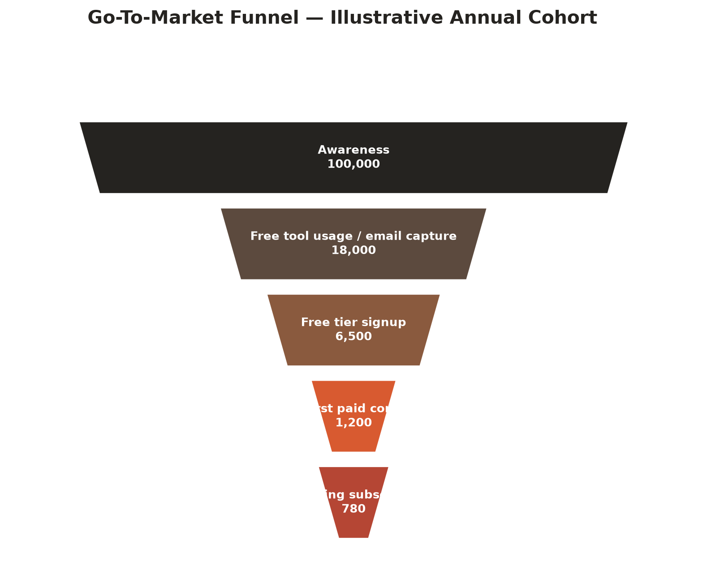
Figure 13.1 — Illustrative annual go-to-market funnel cohort (see Chapter 14)
Dependency Map
Capability | Required before | Phase introduced
User accounts & auth (Supabase) | Document history, team plans, billing | 2
Stripe subscription billing | Any paid tier beyond manual invoicing | 2
Xero / MYOB / QuickBooks live integration | Enterprise upsell, white-label motion | 3
Team workspaces & RBAC | Business tier, subcontractor management tools | 3
Computer vision (photo input) | Photo-to-Defect-Report Agent, SWMS-from-Photo Agent | 4
Speech-to-text (voice input) | Voice-to-Site-Diary Agent | 4

Mobile Strategy
BIK's Phase 1 architecture was deliberately assessed against native mobile requirements before it was built, not as an afterthought. The current codebase separates business logic from UI cleanly enough that an estimated 60% of existing business logic — GST and currency calculation, the AI Writer class, and tool schemas — is reusable in a native mobile app with no changes at all.
Layer | Reuse in a native mobile app
Calculator (GST, currency, dates) | 100% reusable — pure functions, zero DOM dependency
AI Writer | 100% reusable — uses fetch, which works identically in React Native
Tool schemas (form field definitions) | Reusable with minor adaptation — DOM-dependent default-value functions need replacing
FormEngine (form rendering) | Not reusable as-is — tightly coupled to the DOM; validation and state logic extracted into framework-agnostic classes
DocumentRenderer / ExportManager | Not reusable as-is — `window.print()` and `contenteditable` have no mobile equivalent; replaced by native PDF generation and text input components

The recommended path, assessed and costed at approximately 6–10 weeks for a feature-equivalent app, is a React Native application (via Expo) built around a shared `@bik/core` package — extracting the reusable business logic into a package both the website and the future mobile app import from, so the two platforms never drift out of sync on GST logic, AI prompts, or tool schemas. This is consistent with the Phase 3 "Mobile PWA" roadmap item (Chapter 13 summary table) and is treated as planning-only until Phase 3 commercial priority confirms the investment.
PART D — PRODUCT & GTM
14 Go-To-Market Strategy
Brand Positioning
CORE MESSAGE
BIK Solutions is the platform that treats your construction business like the professional operation it is — giving you the documents, tools and systems that the big builders have, without the enterprise price tag.

Tone is direct, confident, practical, and never condescending. BIK's explicit positioning is that it is not a tech startup talking down to tradies — it is from the industry. This is not a marketing affectation; it is the same founder-market-fit advantage described in Chapter 7, expressed through voice and channel choice.
Target Segments and Messaging
Segment | Pain point | Message
Sole traders / small trades | "Admin is killing my evenings" | Save 2+ hours every week on paperwork
Builders (5–20 staff) | "Quote writing and variations eat my time" | Professional documents in minutes, not hours
Property managers | "Coordinating make-goods is chaos" | One call, one team, done right
Safety officers | "SWMS and toolbox talks are never consistent" | Compliant safety docs without starting from scratch
Owner-builders | "I don't know what forms I need" | Everything you need in one place

Channel Strategy by Phase
PHASE 1 CHANNELS
- Organic search. Resource pages with downloadable templates gated by email; priority keywords include "SWMS template Queensland", "builder quote template Australia", "progress claim template builder".
- Email marketing. Free tool usage requires email signup; lead magnets are gated template bundles; a 3-email welcome sequence and an ongoing nurture sequence build trust ahead of any paid ask.
- Facebook / Instagram. Before/after time-savings content ("This took 3 hours. Now it takes 3 minutes."), behind-the-scenes content from the trades business, and targeted paid ads to Australian trades and property managers.
- LinkedIn. Founder-led thought leadership, case studies, and product announcements aimed at builders, project managers and developers.
- Trade Facebook groups. Genuine participation in Queensland Builders & Contractors, Australian Tradies Network and Property Managers Australia — sharing tools and resources, explicitly avoiding overt selling.
- Word of mouth. A subtle "Made with BIK Toolkit" footer on generated documents, and a Phase 2 refer-a-friend credit programme.
PHASE 2+ CHANNELS
- Google Ads against high-intent keywords ("SWMS generator", "builder quote software")
- YouTube tool-tutorial content that compounds as both trust-building and SEO
- Industry association partnerships — Master Builders, HIA, QBCC
- Podcast sponsorships on Australian construction podcasts
- An affiliate programme for bookkeepers and business advisors who already serve trades
Launch Sequencing
Stage | Activity
Pre-launch | Build the email list via free templates and toolkit pages; publish a public roadmap and waitlist page
Soft launch | Email the existing list with early access; 30-day launch discount (Pro at $19, normal $29); "we're live" social posts with tool demos
Growth phase | Case study content ("Builder saves 4 hours/week with BIK"); referral campaign launch; SEO content expansion

Objection Handling
Objection | Response
"I don't trust AI for legal documents" | All documents include a review note. AI handles the structure; you handle the sign-off.
"I'm not tech-savvy" | If you can fill in a form, you can use BIK Toolkit. Takes 3 minutes.
"Too expensive" | At $29/month, one saved hour per week more than pays for it.
"I already use Word templates" | Our templates update when regulations change. Yours might not.

Illustrative Customer Personas
These four personas are composites drawn from the customer base BIK's own trades business serves directly — they are used internally to keep product and messaging decisions grounded in a specific person rather than an abstract "user."
DAVE — SOLE TRADER CARPENTER, GOLD COAST
Runs a one-man renovation business, 15 years' experience, no admin support. Quotes on the tailgate of his ute, writes variations on the back of a delivery docket, and has been burned once by an unpaid variation because he never documented it properly. Wants speed above all else — anything that takes more than three minutes will not survive contact with a real workday. Converts on the free Site Diary and Toolbox Talk tools, upgrades to Starter within 30 days once he sees a professional Variation Notice land in a client's inbox.
MICHELLE — BUILDER, 12 STAFF, BRISBANE
Runs a small residential building company. Has an office admin person two days a week who is permanently behind on progress claims and variations. Cares about consistency across jobs and staff, and about the business looking as professional as a much larger builder to clients and head contractors. The Business tier's team seats and shared document history are the specific reason she upgrades past Pro.
PRIYA — PROPERTY MANAGER, STRATA PORTFOLIO
Manages make-good and maintenance coordination across a portfolio of 40+ properties for multiple owners. Doesn't do the trade work herself but needs consistent, professional documentation from every trade she engages, for owner reporting and dispute avoidance. Values the Defect Report and Inspection Checklist tools specifically because they create a paper trail she can hand to an owners' corporation without editing.
TOM — OWNER-BUILDER, FIRST RENOVATION
Managing his own renovation for the first time, engaging trades directly. Has no idea what documents he actually needs — scope of works, variations, handover checklist — until something goes wrong. Represents the segment BIK's free tier and template library are built to capture early, well before he is a candidate for a paid tier, because his next renovation (or referral to a friend doing one) is the real commercial value.
PART D — PRODUCT & GTM
15 Commercial Model
Subscription Tiers
Tier | Price | Includes
Free | $0/mo | 3 AI tools, 5 generations/month (watermarked), free template library, newsletter
Starter | $19/mo ($190/yr) | Everything in Free + 3 AI tools of choice, 20 generations/month, PDF export (no watermark), email support
Pro | $29/mo ($290/yr) | Everything in Starter + all 10 Phase 1 tools, unlimited generations, branded PDF export, priority email support
Business | $49/mo ($490/yr) | Everything in Pro + all Phase 1+2 tools (25), up to 3 team members, shared document history, Xero integration, AU-hours phone support
Enterprise | $99+/mo (custom) | Everything in Business + unlimited team members, API access, white-label option, dedicated account manager, custom tool development
Source: docs/pricing-strategy.md. Annual pricing reflects a ~17% discount (two months free), standard SaaS convention.
Pricing Rationale
BIK's pricing is anchored explicitly to time saved, not to feature count. A sole trader or builder's assistant earning roughly $35/hour who saves two hours per week on admin saves approximately $280 per month; at $29/month, the payback period is under one day of saved time, and even the most conservative estimate (30 minutes saved per week) implies a 5:1 return. The construction industry is price-sensitive and structurally sceptical of software claims, so BIK has deliberately priced Pro at a level — "the price of two coffees a week" — designed to reduce the purchase decision to near-zero friction, with the explicit intention of raising prices only as demonstrated value accumulates (document history depth, integration reliance, team usage).
Digital Product Revenue (Complementary Line)
Product | Price | Notes
Individual templates | $9–$19 each | DOCX/XLSX/PDF, sold via Gumroad
Document bundle (5 templates) | $29 | Popular category bundle
Complete template library | $79 | One-time; includes all templates
Safety pack (SWMS + Toolbox Talks) | $49 | Trade-specific
Builder admin pack | $59 | Quote + Scope of Works + Progress Claim + Variation

Conversion Strategy
- Free → Starter. In-app upsell triggered the moment a user hits the free generation limit.
- Starter → Pro. After 30 days, show the tools the user is locked out of, supported by an ROI-focused email sequence.
- Pro → Business. Triggered when a Pro user attempts to invite a team member and hits the seat limit.
- Annual upsell. Shown at signup and again in subscription management, converting monthly cash flow into annual, lower-churn cash flow.
Free Trial Policy
Tier | Trial policy
Free | No credit card required, ongoing
Pro | 14-day free trial; credit card required; auto-converts
Enterprise | 30-day free trial with guided demo

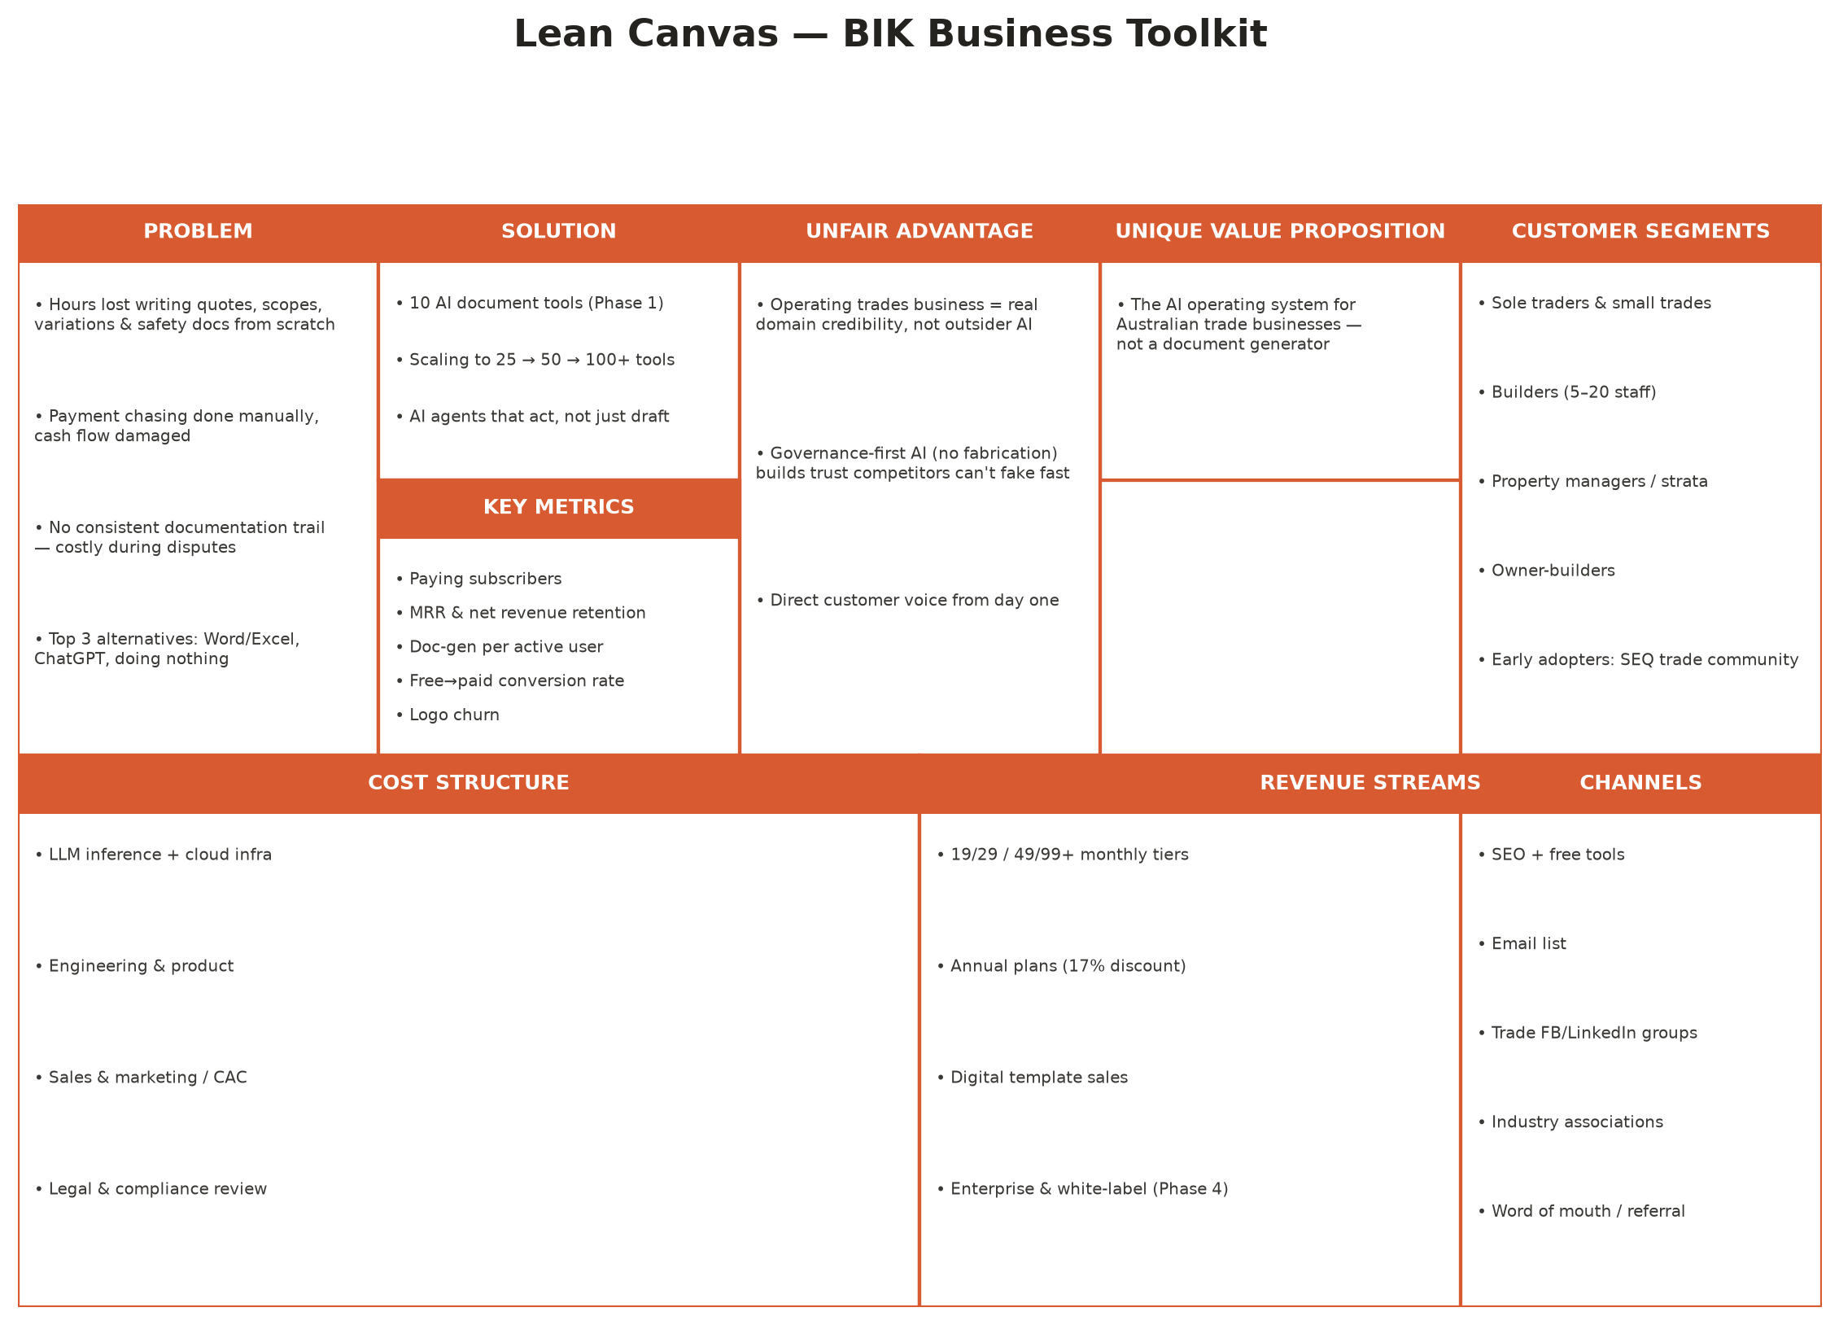
Figure 15.1 — Lean Canvas, BIK Business Toolkit

PART E — MARKET & COMPETITION
Market Analysis, Competitor Analysis and Competitive Positioning
How large the opportunity is, who else is in the field, and where BIK wins

PART E — MARKET & COMPETITION
16 Market Analysis
Market Sizing — TAM / SAM / SOM

Figure 16.1 — TAM / SAM / SOM (repeated from Chapter 1 for reference)
Layer | Definition | Illustrative value | Basis
TAM | Australian construction industry contribution to GDP | $360B+ annually | BIK Product Vision, industry GDP contribution estimate
SAM | Realistic software spend by 1–50 staff AU/NZ trade and building businesses on document, safety and finance tooling | ~$1.8B | Illustrative — derived from an assumed ~0.5% of TAM allocated to SME back-office software spend across an estimated 350,000+ AU trade businesses
SOM | BIK's serviceable share within five years via a digital-first, Australia-specific go-to-market | ~$91M | Illustrative — modelled at ~5% share of SAM at Phase 4 maturity

These SAM and SOM figures are explicitly illustrative planning assumptions, not third-party market research, and are presented as directional sizing to test the shape of the opportunity rather than as audited numbers. The TAM figure is grounded directly in BIK's own product-vision documentation. A banking partner or grant assessor relying on this document for a specific decision should treat the SAM/SOM figures as a modelled scenario (fully disclosed in Appendix C) rather than as verified market research.
Porter's Five Forces
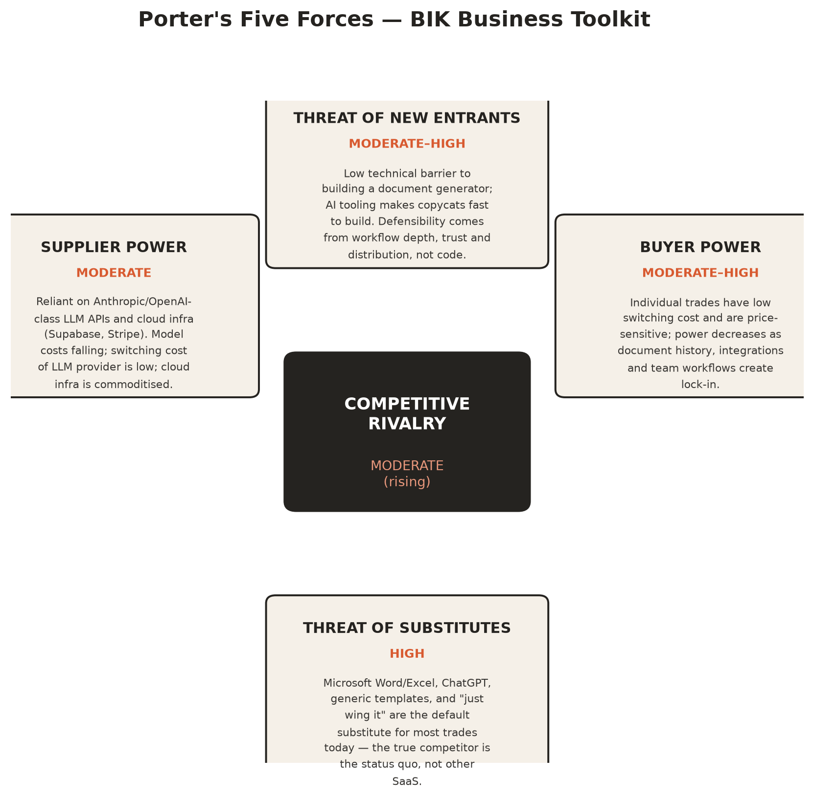
Figure 16.2 — Porter's Five Forces, BIK Business Toolkit
The most important strategic reading of this framework is that BIK's real competitor, in volume terms, is not another SaaS product — it is the status quo: Word, Excel, and "just wing it." Threat of substitutes is rated high for exactly this reason. Buyer power is moderate-to-high today (an individual trade business can walk away at zero cost) but is designed to fall over time as document history, integrations and team workflows accumulate switching cost — which is the central logic of the operating-model sequencing in Chapter 6.
PESTLE Snapshot
Factor | Relevance to BIK
Political | Government productivity and digitisation agendas for the construction sector; potential grant eligibility for AI-enabled SME productivity tooling
Economic | Construction is cyclical; a downturn reduces new project volume but does not reduce the compliance and administrative burden on active projects — a partial natural hedge
Social | Persistent skills shortages in construction increase the value of software that lets existing staff do more administrative work in less time
Technological | Falling foundation-model inference costs make real-time AI document generation commercially viable at consumer SaaS price points
Legal | State-based security-of-payment legislation (BIF Act and equivalents), WHS Regulation, and Fair Work obligations create both the compliance need BIK addresses and the legal risk BIK must manage in its own output (Chapter 27)
Environmental | Growing use of digital record-keeping over paper aligns with broader sustainability and ESG reporting expectations, a secondary but real tailwind

PART E — MARKET & COMPETITION
17 Competitor Analysis
The Competitive Set
BIK operates in a market with no single direct competitor and many adjacent ones. This chapter profiles thirteen companies BIK is most often compared against — construction- and trade-specific platforms, enterprise construction software, accounting platforms whose document workflows overlap with BIK's, and the generic AI tools that are BIK's most common substitute in practice.
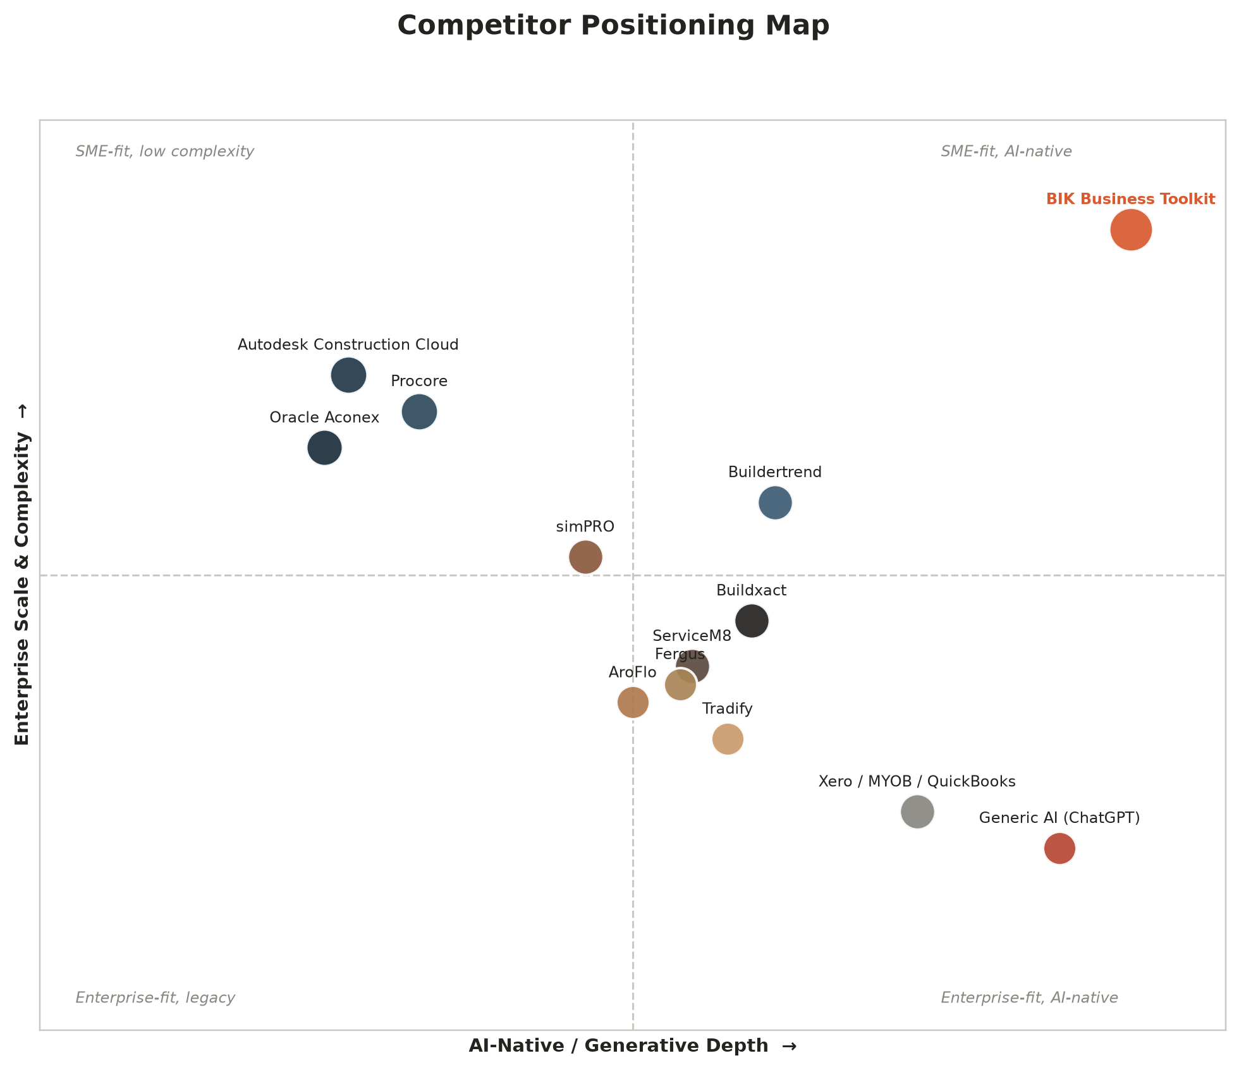
Figure 17.1 — Competitor positioning map: AI-native depth vs enterprise scale/complexity
Pricing Comparison Matrix
Platform | Entry price (indicative, AUD) | AI document generation? | AU compliance-native? | Target business size
BIK Business Toolkit | $0 free / $19–$99+ | Yes — purpose-built, governed (Decision 001) | Yes — AU English, state SOP awareness, WHS-aware | Sole trader – 20 staff (Enterprise beyond)
Buildxact | ~$187/mo | No | Partial (AU estimating norms) | Residential builder, small-mid
ServiceM8 | ~$29/mo/user | No | Partial | Solo trade – small team
simPRO | Custom / enterprise | No | Partial | Mid-large trade contractor
AroFlo | ~$25/user/mo | No | Partial | Solo trade – small team
Tradify | ~$29/mo | No | Partial | Solo trade – small team
Fergus | ~$29/user/mo | No | Partial (AU/NZ) | Solo trade – small team
Buildertrend | ~US$199/mo | No | No — US-centric | Residential builder
Procore | Custom / enterprise | Limited (enterprise AI features emerging) | Partial | Large builder / head contractor
Autodesk Construction Cloud | Custom / enterprise | Limited | Partial | Enterprise / large builder
Oracle Aconex | Custom / enterprise | No | Partial | Major/mega projects
Xero / MYOB / QuickBooks | ~$15–$70/mo | No (accounting-only) | Yes (tax/compliance only) | All AU SMEs — complementary to BIK
Generic AI (ChatGPT-class) | $0–$30/mo | Yes — but ungoverned, no construction schema | No | Anyone — BIK's true substitute competitor
Indicative pricing collected from public pricing pages as at mid-2026; competitor pricing changes frequently and should be independently verified before any commercial claim is made from this table.
TRADE & FIELD-SERVICE MANAGEMENT PLATFORMS
Competitor | Core focus | Pricing (indicative, AUD) | Strength | Where BIK differentiates
Buildxact | Estimating, quoting and job costing for builders | From ~$187/mo | Deep estimating and takeoff tools | Buildxact is a numbers-first estimating tool; BIK is a language-and-compliance-first document engine. Narrow document scope, not AI-first.
ServiceM8 | Field service job management for trades | From ~$29/mo per user | Excellent scheduling, dispatch and invoicing for service trades | Strong at job logistics, not at compliance or long-form document drafting — complementary rather than competing
simPRO | Job management for mid-size trade contractors | Custom / enterprise-leaning | Strong for larger multi-crew trade businesses | Priced and scoped above BIK's core SME segment; document generation is a secondary feature, not the product
AroFlo | Job management and workflow for trades | From ~$25/user/mo | Solid all-rounder for job and asset tracking | Similar gap to ServiceM8/simPRO — logistics-first, not document-and-compliance-first
Tradify | Job management for small trade businesses | From ~$29/mo | Simple, well-loved by solo trades and small teams | Closest in target-customer size to BIK, but not AI-native and not focused on compliance-grade document quality
Fergus | Job management for NZ/AU trade businesses | From ~$29/user/mo | Strong reporting and profitability tracking | Financial/job tracking focus; no meaningful AI document generation layer
Buildertrend | Construction project management for residential builders | From ~US$199/mo | Comprehensive client-facing project management | US-centric, enterprise-leaning pricing; not Australian-compliance-native

ENTERPRISE CONSTRUCTION SOFTWARE
Competitor | Core focus | Strength | Where BIK differentiates
Procore | Enterprise construction project management | Comprehensive, credible with large builders and head contractors | Expensive, complex, and overkill for the 1–20 person business that is BIK's core market — BIK is simpler and Australian-construction-specific
Autodesk Construction Cloud | Enterprise BIM and construction management | Deep integration with design and modelling workflows | Enterprise-only reach; irrelevant to the sole-trader and small-builder segment entirely
Oracle Aconex | Enterprise document control for large/complex projects | Best-in-class formal document control for major projects | A completely different market — large-scale project document control, not SME administrative drafting

ACCOUNTING & FINANCE PLATFORMS
Competitor | Core focus | Strength | Where BIK differentiates / integrates
Xero | Cloud accounting | Ubiquitous in AU SME accounting | BIK generates the quotes, variations and progress claims that feed into Xero — a partner, not a competitor, and a live Phase 3 integration target
MYOB | Cloud accounting, AU-native | Strong AU tax and payroll compliance | Same complementary relationship as Xero — BIK's integration layer already has a MYOB provider stub built
QuickBooks | Cloud accounting | Strong SME accounting adoption | Same pattern — BIK is upstream of the accounting system, not a replacement for it

GENERIC AI
ChatGPT and equivalent general-purpose assistants are, in practice, BIK's most common substitute — not because they are good at this job, but because they are free, familiar and already open in a browser tab. They produce fluent prose with no construction-specific structure, no Australian compliance awareness, no document history, no audit trail, and — critically — no guardrail equivalent to Decision 001 against confidently inventing detail the user never supplied. This is the single most important "competitor" row in this table because it is the behaviour change BIK's marketing must actually win, not the more visible trade-software competitors above.
Competitor Deep-Dive Profiles
The tables above summarise positioning; the profiles below give the fuller picture for the thirteen companies BIK is most frequently asked to compare itself against, including pricing detail and the specific commercial opportunity or risk each one represents.
BUILDXACT
An Australian-founded estimating and quoting platform for residential builders and remodelers, priced from roughly $187/month. Buildxact's core strength is takeoff and estimating accuracy — it is genuinely excellent at turning a plan set into a materials and labour estimate. It is not AI-first and its document generation is narrow (quotes and basic job costing), which is precisely the gap BIK's broader document catalogue addresses. Buildxact is the single most plausible incumbent to add generative AI document features, and is named explicitly in Chapter 26's risk register.
SERVICEM8
A field-service management platform popular with single-trade service businesses (electricians, plumbers, HVAC), priced from around $29/month per user. Excellent at scheduling, dispatch and on-the-spot invoicing. Not focused on compliance or long-form document drafting — a job card and an invoice are not a scope of works or a SWMS. BIK is complementary rather than competitive here, and ServiceM8's own customer base is a plausible future integration and channel partner (Chapter 22).
SIMPRO
A job management platform aimed at mid-size and larger trade contractors, with enterprise-leaning, custom pricing. simPRO scales up further than BIK's core segment and is a reasonable choice for a 50+ staff trade business — outside BIK's primary 1–20 person target market, but a name BIK is regularly compared against by businesses approaching that size.
AROFLO
An Australian job and asset management platform for trades, priced from around $25/user/month. Solid, well-regarded all-rounder for job tracking and workflow, with the same structural gap as ServiceM8 and simPRO: document generation and compliance drafting are secondary features bolted onto a scheduling-first product, not the core offering.
TRADIFY
A New Zealand-founded job management tool for small trade businesses, priced from around $29/month, closest to BIK in target customer size (solo trades and small teams). Well-loved for its simplicity. Not AI-native and not focused on the compliance-grade document quality BIK is built around — the clearest "adjacent, not competing" comparison in the field-service category.
FERGUS
Also New Zealand-founded, job management software with a strong reputation for profitability and job costing reporting, priced from around $29/user/month. No meaningful AI document generation layer. Fergus's NZ heritage and AU/NZ customer base make it a useful reference point for BIK's own planned New Zealand expansion (Chapter 23) — both the competitive landscape BIK would enter and a signal that the AU/NZ trade software market is a single, closely related market.
BUILDERTREND
A US-founded construction project management platform for residential builders and remodelers, priced from roughly US$199/month. Comprehensive client-facing project management, portals and scheduling. Pricing and design are US-centric and enterprise-leaning relative to BIK's Australian SME target, and it carries no Australian-specific compliance awareness (BIF Act, state Security of Payment regimes, Australian WHS structure).
PROCORE
The dominant enterprise construction project management platform globally, built for large commercial builders, head contractors and major project owners. Comprehensive and genuinely best-in-class at what it does, but priced and designed for organisations far larger than BIK's core market — a 5-person trade business would find Procore both unaffordable and a poor functional fit. Procore is named in Chapter 24 as a plausible long-horizon strategic acquirer specifically because it structurally cannot reach the SME segment BIK owns.
AUTODESK CONSTRUCTION CLOUD
An enterprise BIM and construction management suite from Autodesk, deeply integrated with design and modelling workflows. Reaches architects, engineers and large builders — a different buyer and a different use case entirely from BIK's day-to-day administrative document generation for small trade businesses. Included in this analysis because it is one of the most-recognised names in construction software and a useful boundary-marker for what BIK is deliberately not building (Chapter 8).
ORACLE ACONEX
Enterprise document control software for large and complex construction projects — formal transmittals, RFIs, and document version control at a scale relevant to major infrastructure and commercial projects. A genuinely different market: Aconex solves project document control for multi-party mega-projects, while BIK solves administrative document generation for small businesses. The two would rarely be evaluated against each other by a real buyer, but the comparison is common in construction-tech market maps and is addressed here for completeness.
XERO
The dominant cloud accounting platform for Australian SMEs, including the great majority of BIK's target trade businesses. Xero is not a competitor in any meaningful sense — BIK generates the quotes, variations and progress claims that a business then reconciles and invoices through Xero. A live Xero integration (contacts, invoices, quotes) is architected today and targeted for Phase 3 (Chapter 13), making Xero simultaneously the platform BIK most needs to integrate with and, per Chapter 24, one of the most strategically logical acquirers of BIK's document layer.
MYOB
The second major Australian-native cloud accounting platform, with particular strength in payroll and AU tax compliance. Same complementary relationship as Xero; a MYOB provider stub is already built in BIK's integration layer (Appendix B), covering contacts, invoices and quotes.
QUICKBOOKS
Intuit's cloud accounting platform, with a smaller but meaningful share of the Australian SME market relative to Xero and MYOB. Same complementary, upstream relationship — BIK is positioned as the document-generation layer that feeds a business's existing accounting system, whichever of the three it uses.
Emerging AI-Native Competitors
As of mid-2026, no venture-scale AI-native competitor has achieved meaningful, publicly visible AU construction-market share with the same document-and-compliance focus as BIK. The most likely emerging-competitor pattern is not a new entrant from zero, but an existing trade-software incumbent (most plausibly Buildxact, ServiceM8 or Tradify, given their SME-native distribution) bolting on generative AI document features to an existing platform. BIK's Risk Register (Chapter 26) treats this as a moderate-likelihood, moderate-impact risk and names the mitigations explicitly: move on Phase 2 infrastructure and Phase 3 integration depth with real urgency, because workflow lock-in compounds fastest for whoever builds it first.
THE HONEST COMPETITIVE READ
BIK does not currently face a well-funded, AI-native, Australian-construction-specific direct competitor. That is precisely why the next 18 months (Phases 2–3) matter more than any single feature decision: the advantage available today is a sequencing advantage, and sequencing advantages erode if not used.

PART E — MARKET & COMPETITION
18 Competitive Positioning, SWOT & Strategic Canvases
Positioning Statement
“BIK Business Toolkit is the only AI-powered document and compliance platform built specifically for Australian trade businesses — fast enough for a sole trader, powerful enough for a 20-person builder.”
— docs/business-strategy.md
SWOT Analysis

Figure 18.1 — SWOT Analysis, BIK Solutions (repeated from Chapter 7 for reference in context)
READING THE SWOT STRATEGICALLY
- Strengths → Opportunities. Founder-market fit and governance-first AI are exactly the credibility signals needed to win industry association partnerships and enterprise/white-label conversations (Chapter 22).
- Weaknesses → Threats. Pre-revenue status on the SaaS unit and key-person concentration are the two weaknesses most likely to compound a threat (an incumbent moving first, or a cash flow gap) into a real strategic problem — both are addressed directly in the Phase 2 investment case (Chapter 19) and the risk mitigations of Chapter 26.
Business Model Canvas and Lean Canvas — Cross-Reference
The Business Model Canvas (Figure 3.1, Chapter 3) and Lean Canvas (Figure 15.1, Chapter 15) are presented earlier in this document alongside the sections they most directly support — the business case and the commercial model, respectively — rather than repeated here. Read together with the SWOT above and the Porter's Five Forces in Chapter 16, they form a complete standard strategic toolkit view of the business for Board and investor reference.
Sustainable Differentiation Summary
Dimension | BIK's position | Durability
Price | Mid-market SME pricing ($19–99), well below enterprise platforms, comparable to trade job-management tools | Moderate — pricing can be matched by any competitor
AI-native depth | Purpose-built document engine with construction-specific schema and a hard governance rule (Decision 001) | High — requires both technical build and cultural discipline to replicate
Australian specificity | AU English, AU compliance references, state-based Security of Payment awareness | Moderate-high — buildable by a competitor, but not without material investment
Trust / brand | Inherited credibility from an operating trades business | High — cannot be bought or replicated quickly
Integration depth | Seven provider integration stubs architected (Xero, MYOB, QuickBooks, Buildxact, ServiceM8, SimPRO, AroFlo) | High once live — integration switching cost compounds over time

PART F — THE FINANCIAL MODEL
Assumptions, Five-Year Projections and Valuation Drivers
Realistic, disclosed assumptions rather than optimistic ones — every number sourced or labelled illustrative

PART F — FINANCIAL MODEL
19 Financial Model & Assumptions
A NOTE ON HOW TO READ THIS CHAPTER
Every figure in this chapter is either (a) sourced directly from BIK's own pricing and roadmap documentation, or (b) an explicitly labelled illustrative planning assumption built to be conservative rather than promotional. Where BIK's internal targets (docs/pricing-strategy.md) are themselves the input, that is stated. The full assumptions register is reproduced in Appendix C.

Revenue Model Recap
BIK earns recurring revenue from four subscription tiers ($0 / $19 / $29 / $49 / $99+ monthly, with roughly 17% annual discount), supplemented by one-off digital template sales and, from Phase 4, enterprise/API/white-label licensing. The financial model in this chapter builds up from BIK's own published subscriber and MRR targets (Chapter 8) and stress-tests them against three named scenarios: Conservative (bootstrap-paced), Base Case, and Aggressive (investment-backed).
Customer Acquisition Assumptions
Assumption | Conservative | Base case | Aggressive
Monthly organic visitors (Month 12) | 8,000 | 15,000 | 30,000
Visitor → email capture rate | 4% | 6% | 8%
Email → free signup rate | 25% | 35% | 40%
Free → paid conversion (90-day) | 8% | 12% | 16%
Blended CAC (paid + organic, Phase 2+) | $65 | $45 | $35
Average monthly churn (logo) | 4.5% | 3.2% | 2.4%
Net revenue retention (with upsell) | 94% | 101% | 108%
Average revenue per paying user (blended) | $27/mo | $31/mo | $36/mo
Illustrative planning assumptions (Appendix C, rows F1–F8). Not third-party verified market research.
Unit Economics
Metric | Conservative | Base case | Aggressive
Customer Acquisition Cost (CAC) | $65 | $45 | $35
Average customer lifetime (1 / monthly churn) | 22 months | 31 months | 42 months
Lifetime Value (ARPU × lifetime) | $594 | $961 | $1,512
LTV : CAC ratio | 9.1x | 21.4x | 43.2x
CAC payback period | 2.4 months | 1.5 months | 1.0 month
Illustrative; SaaS benchmark for a healthy business is generally cited as LTV:CAC above 3x with payback under 12 months — BIK's low-CAC, community-and-content-led channel strategy (Chapter 14) is the structural reason these ratios run well ahead of that bar in every scenario.
The unit economics look unusually strong across all three scenarios for one structural reason: BIK's primary Phase 1–2 acquisition channels (organic search, free tools, email, trade community participation) are near-zero marginal cost, funded by the services business rather than a paid acquisition budget. This is a genuine advantage, but it is also a discipline the model assumes BIK maintains — the moment growth requires meaningful paid acquisition spend to hit the Phase 3–4 subscriber targets, CAC will rise toward more typical SME SaaS benchmarks, and the model's Aggressive scenario explicitly assumes some of that paid spend enters the mix from Phase 3.
Churn Scenarios
Churn is the single most sensitive variable in any subscription model, and the trades sector carries a specific risk: low switching cost in Phase 1–2 before document history and integrations create real lock-in (Chapter 6). The model tests three churn regimes explicitly rather than assuming the base case holds:
Regime | Monthly logo churn | Annualised churn | 5-year MRR impact vs base case
Optimistic (strong lock-in) | 2.4% | ~26% | +38%
Base case | 3.2% | ~33% | —
Pessimistic (weak lock-in / price sensitivity bites) | 4.5% | ~43% | -29%

Cash Flow Milestones — Bootstrap vs Investment-Backed
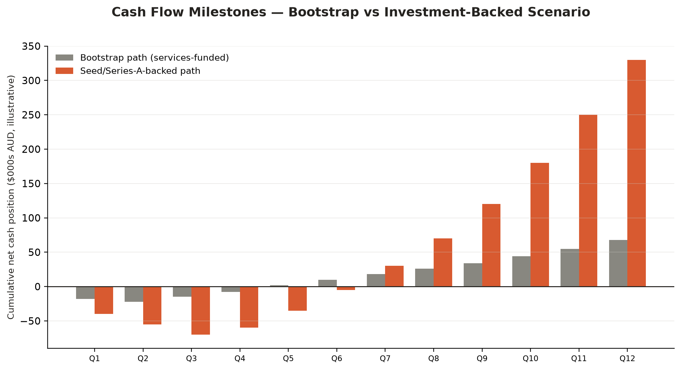
Figure 19.1 — Cumulative net cash position, bootstrap vs investment-backed path (illustrative, $000s AUD)
The bootstrap path assumes the Trades Services unit continues to fund SaaS platform development directly, with the platform reaching cash-flow breakeven at approximately Quarter 5 and compounding modestly thereafter. The investment-backed path assumes a seed or Series A raise deployed principally into Phase 2–3 engineering (accounts, billing, integrations) and a modest paid acquisition budget from Phase 3, accepting a deeper and longer drawdown in exchange for materially faster tool velocity and subscriber growth. Neither path requires the other — the bootstrap path is a genuine, viable option, which is itself a negotiating strength in any future capital conversation (Chapter 3, Strategic Priority 2).
Bootstrap vs Investment — Trade-offs
Dimension | Bootstrap path | Investment-backed path
Control | Founder retains full ownership and decision control | Dilution in exchange for capital and, typically, board input
Speed to Phase 3 | Slower — gated by services cash flow | Materially faster — parallel investment in engineering and integrations
Risk | Lower financial risk, higher execution-speed risk (competitor catch-up, Chapter 17) | Higher financial complexity, lower execution-speed risk
Optionality | Preserves the option to raise later from a position of proven traction | Front-loads growth but commits to investor return expectations and timelines

PART F — FINANCIAL MODEL
20 Five-Year Financial Projections
MRR Growth — Three Scenarios
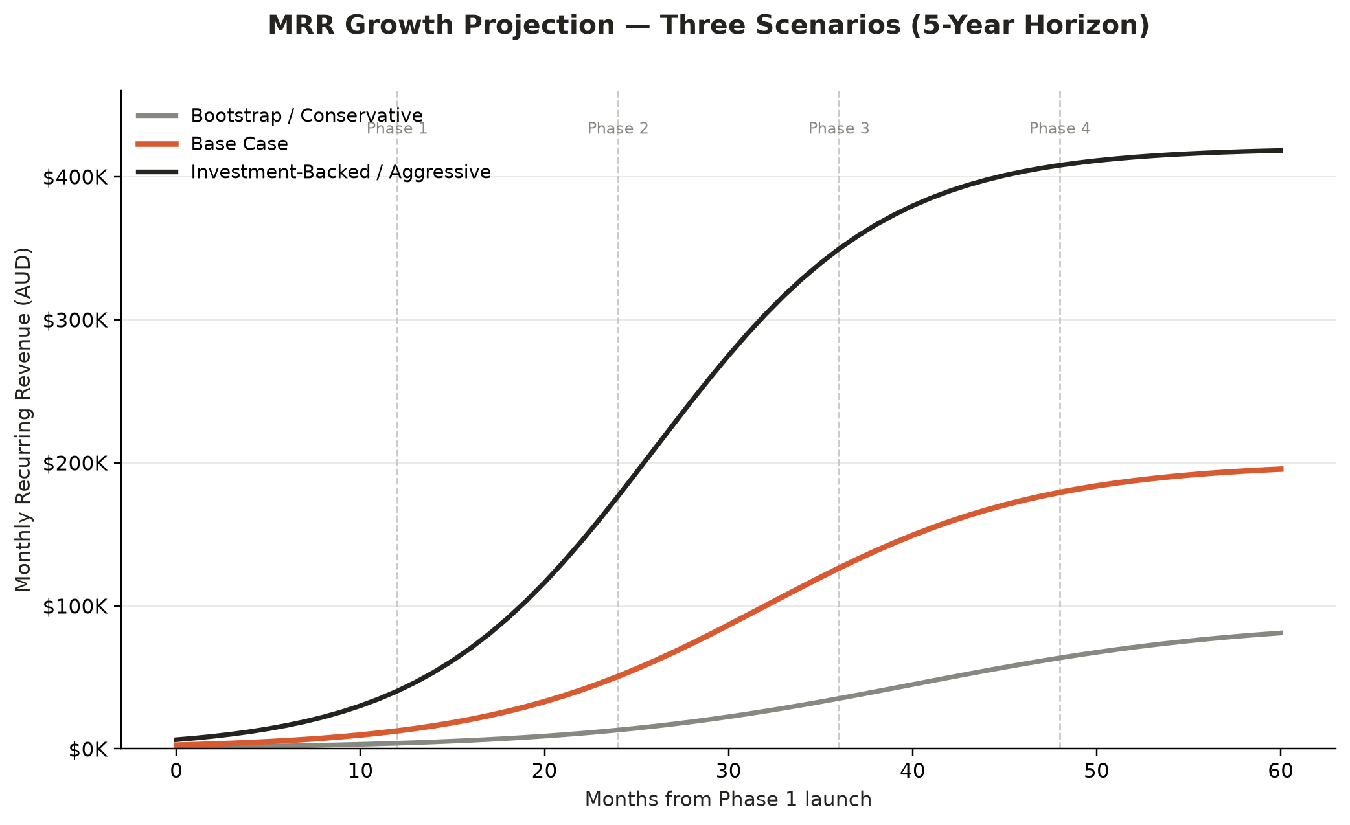
Figure 20.1 — MRR growth projection, three scenarios, 5-year horizon
Year | Conservative MRR | Base case MRR | Aggressive MRR | Base case ARR
Year 1 | $1,200 | $2,000 | $3,500 | $24,000
Year 2 | $9,500 | $15,000 | $28,000 | $180,000
Year 3 | $28,000 | $50,000 | $95,000 | $600,000
Year 4 | $55,000 | $110,000 | $210,000 | $1,320,000
Year 5 | $85,000 | $200,000 | $410,000 | $2,400,000
Illustrative. Year 1–3 base-case figures reconcile directly to BIK's own published milestones (docs/pricing-strategy.md, docs/product-vision.md); Years 4–5 are model extrapolations at a decelerating S-curve growth rate, disclosed in Appendix C.
Illustrative Profit & Loss Summary (Base Case)
Line item | Year 1 | Year 3 | Year 5
Recurring revenue (ARR) | $24,000 | $600,000 | $2,400,000
Digital product revenue | $8,000 | $35,000 | $70,000
Total revenue | $32,000 | $635,000 | $2,470,000
Cost of revenue (LLM inference, cloud infra, payments) | $4,000 | $70,000 | $260,000
Gross profit | $28,000 | $565,000 | $2,210,000
Gross margin | ~88% | ~89% | ~89%
Sales & marketing | $3,000 | $95,000 | $370,000
R&D / engineering & product | In-kind (founder + services cross-subsidy) | $260,000 | $820,000
G&A / compliance / legal review | $2,000 | $45,000 | $140,000
EBITDA (illustrative) | $23,000 | $165,000 | $880,000
Illustrative planning model, base case. Gross margin is modelled in line with typical vertical SaaS benchmarks (85–90%) given the low marginal cost of LLM inference at BIK's document-length use case.
Subscriber and Tool Growth
Phase | Tools live (cumulative) | Paying subscribers | MRR (base case)
Phase 1 (Q3 2026) | 10 | 100 | $2,000
Phase 2 (Q1 2027) | 25 | 500 | $15,000
Phase 3 (Q3 2027–2028) | 50 | 1,500 | $50,000
Phase 4 (2028+) | 105+ | 5,000+ | $200,000+
Source: docs/product-roadmap.md and docs/pricing-strategy.md — BIK's own published milestone targets
Quarterly MRR Build — Base Case (Illustrative)
The annual figures above are built up from the following quarterly progression, which makes explicit the S-curve growth pattern assumed in Figure 20.1 rather than a straight-line run rate.
Quarter | New paying subs (net) | Cumulative subs | MRR | Quarter | New paying subs (net) | Cumulative subs | MRR
Q1 | 35 | 35 | $900 | Q11 | 155 | 1,180 | $34,500
Q2 | 40 | 75 | $1,900 | Q12 | 160 | 1,340 | $41,200
Q3 | 25 | 100 | $2,000 | Q13 | 165 | 1,505 | $46,600
Q4 | 60 | 160 | $4,300 | Q14 | 150 | 1,655 | $52,100
Q5 | 70 | 230 | $6,600 | Q15 | 145 | 1,800 | $57,800
Q6 | 85 | 315 | $9,200 | Q16 | 140 | 1,940 | $63,500
Q7 | 95 | 410 | $12,100 | Q17 | 170 | 2,110 | $72,400
Q8 | 90 | 500 | $15,000 | Q18 | 185 | 2,295 | $82,900
Q9 | 120 | 620 | $19,800 | Q19 | 205 | 2,500 | $95,600
Q10 | 135 | 755 | $27,300 | Q20 | 230 | 2,730 | $110,300
Illustrative base-case quarterly progression, Years 1–5 (Q1–Q20). Figures are rounded and reconcile approximately, not exactly, to the annual figures above due to rounding and mid-quarter cohort timing.
Illustrative Operating Expenditure by Function
Function | Year 1 | Year 3 | Year 5 | Notes
Engineering & product | In-kind (founder time) | $260,000 | $820,000 | Grows from founder-led to a Phase 3+ dedicated team (Chapter 10)
Sales & marketing | $3,000 | $95,000 | $370,000 | Predominantly organic/content-led through Phase 2; paid acquisition enters from Phase 3
Customer support | In-kind (founder time) | $40,000 | $150,000 | First dedicated hire targeted for Phase 2 (Chapter 10)
Compliance & legal review | $2,000 | $45,000 | $140,000 | Scales with tool catalogue breadth and the Legal and Safety Tool Register cadence (Chapter 27)
G&A (finance, admin, tooling) | In-kind (founder time) | $25,000 | $90,000 | Formalises ahead of any institutional raise (Chapter 25 exit-readiness)
Illustrative planning model, base case, consistent with the P&L summary above.
Sensitivity Analysis
The single largest driver of the five-year outcome is not pricing or CAC — it is churn, because recurring revenue businesses compound or decay geometrically with retention. Holding all other assumptions constant, moving from the base-case 3.2% monthly churn to the pessimistic 4.5% regime reduces Year 5 MRR by roughly 29%; moving to the optimistic 2.4% regime increases it by roughly 38%. This is why Chapter 6's operating-model argument — that document history and integration depth should structurally reduce churn over time — is not a minor product nicety but the single highest-leverage lever in the entire financial model.
PART F — FINANCIAL MODEL
21 Valuation Drivers
How Vertical AI SaaS Businesses Are Valued
Vertical SaaS businesses are typically valued on a multiple of Annual Recurring Revenue (ARR), with the multiple itself a function of growth rate, gross margin, net revenue retention, and — increasingly, for AI-native vertical products — the defensibility of the domain layer around the underlying model (Chapter 5). This chapter builds an illustrative valuation bridge from BIK's own Year 5 base-case ARR rather than importing an external comparable set that may not reflect BIK's specific stage or category.
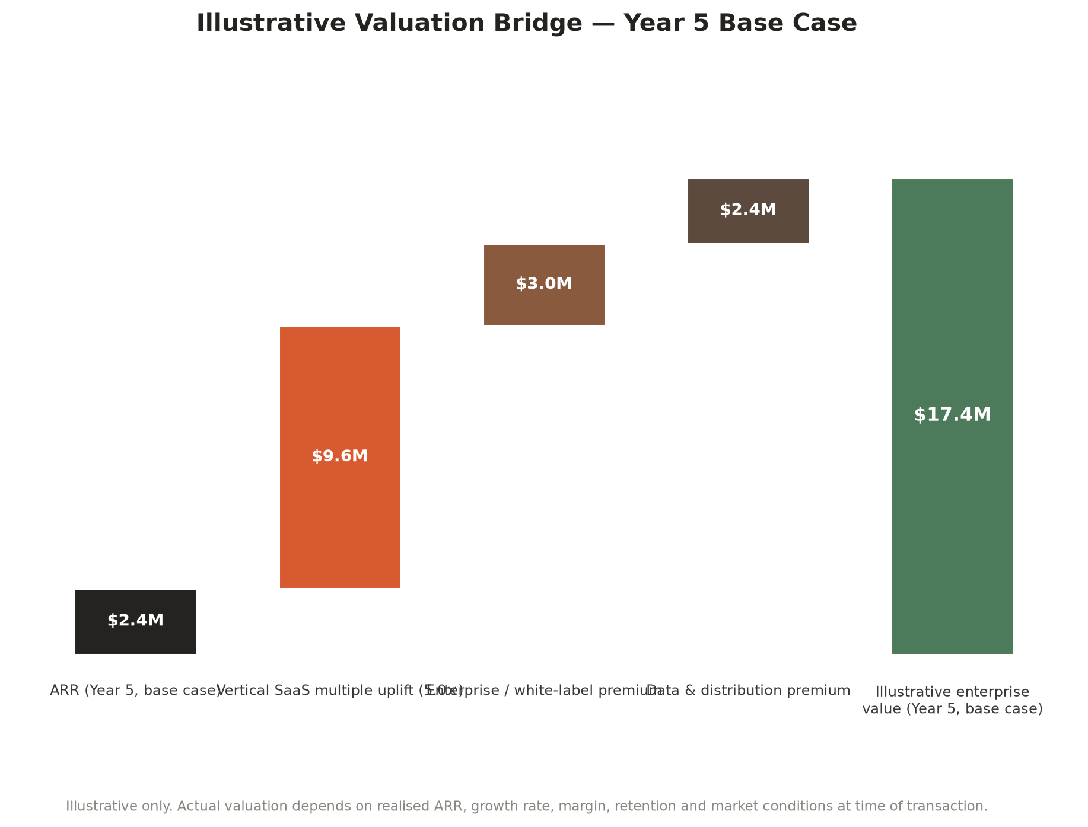
Figure 21.1 — Illustrative valuation bridge, Year 5 base case
Value driver | Why it matters for BIK specifically
Net revenue retention | The strongest single lever — Chapter 20's sensitivity analysis shows how directly churn/retention flows into terminal value
Gross margin | BIK's ~88–89% modelled gross margin (low LLM cost per document relative to subscription price) supports a premium multiple versus low-margin services-heavy comparables
Growth rate durability | A multi-year, phase-gated roadmap (Chapter 13) with disclosed dependencies is more defensible to a valuer than an undifferentiated hockey-stick projection
Domain defensibility | The construction-specific schema, the Legal and Safety Tool Register, and Decision 001 are exactly the assets a vertical-AI valuation premium is paid for (Chapter 5, Chapter 7)
Integration depth / switching cost | Live Xero/MYOB/ServiceM8 integrations (Phase 3) convert a valuation story about a nice tool into a valuation story about embedded infrastructure
Enterprise / white-label optionality | A credible enterprise and white-label pathway (Chapter 22) supports a valuation premium even before material enterprise revenue exists, because it expands the addressable exit-buyer set

Illustrative Valuation Ranges by Milestone
Milestone | Illustrative ARR | Illustrative revenue multiple range | Illustrative enterprise value range
Phase 2 complete (500 subscribers, $15K MRR) | $180,000 | 4x – 7x | $0.7M – $1.3M
Phase 3 complete (1,500 subscribers, $50K MRR) | $600,000 | 5x – 9x | $3.0M – $5.4M
Phase 4 mature (5,000+ subscribers, $200K+ MRR) | $2,400,000 | 6x – 12x | $14.4M – $28.8M
Illustrative only. Multiples are directional ranges consistent with publicly discussed vertical SaaS transaction commentary in 2024–2026, not a valuation opinion, fairness opinion, or guarantee. Actual multiples at any transaction date depend on prevailing capital markets conditions, realised (not modelled) growth and retention, and buyer-specific strategic premium.
WHAT WOULD MOVE BIK FROM THE LOW END TO THE HIGH END OF ANY RANGE
Three things, in order of leverage: (1) demonstrated net revenue retention above 100% for at least four consecutive quarters, (2) at least one live, revenue-generating enterprise or white-label partnership (Chapter 22), and (3) a clean legal/compliance record with zero material incidents from AI-generated content — the exact discipline Chapter 11's governance framework is designed to protect.

PART G — ENTERPRISE, EXPANSION & ACQUISITION
The Strategic Question: Standalone Business or Acquisition Target?
Enterprise and white-label opportunities, international expansion, and a clear-eyed view of acquisition pathways

PART G — ENTERPRISE & ACQUISITION
22 Enterprise Strategy & White-Label Opportunities
Beyond the SME Subscriber
BIK's core market through Phase 3 is deliberately the 1–50 person trade business (Chapter 8). Enterprise and white-label motion is a Phase 4+ opportunity layered on top of that base once integration depth and platform maturity make it credible — not a distraction from it. This chapter sets out where that opportunity plausibly sits.
Enterprise Opportunity Categories
Opportunity | Description | Illustrative counterpart
White-label document engine | License the AI document engine and construction-domain template library to a platform that already owns the trade-business relationship but lacks document generation depth | Field-service platforms (ServiceM8-, AroFlo-, Tradify-scale players) seeking an AI document feature without building one natively
Embedded finance / compliance partner channel | Distribution partnership with an insurer, bank or surety provider that wants a compliance-quality documentation trail as a condition of a product (e.g. contract works insurance, payment protection) | Banking and insurance partners seeking reduced claims risk through better-documented projects
Franchise / group builder rollout | A single enterprise licence covering a franchise network or multi-branch building group, with centralised billing and branded output per branch | National franchise renovation and building groups
API access for vertical software builders | Expose the document generation engine via API for adjacent software vendors to embed BIK-quality document output inside their own products | Adjacent AU trade software vendors without a document AI capability

Preconditions Before Any Enterprise Motion
- Team workspaces and role-based access live (Phase 3)
- At least one live accounting or field-service integration in production, not just architected (Phase 3)
- A dedicated compliance/legal review function, not ad hoc founder review (Chapter 10, Phase 3 organisational design)
- A demonstrated retention track record — an enterprise partner is buying reliability, not a roadmap
STRATEGIC SEQUENCING NOTE
Enterprise and white-label conversations pursued before these preconditions are met risk damaging exactly the trust asset (Chapter 7) BIK is built on. This document explicitly recommends holding enterprise business development until Phase 3 infrastructure is live, not merely planned.

PART G — ENTERPRISE & ACQUISITION
23 International Expansion Strategy
Geographic Sequencing
Phase | Geography | Rationale
Phase 1–2 | South East Queensland, then Australia-wide (digital) | Local credibility first, exploiting the trades business's existing regional reputation, before scaling digitally nationwide
Phase 3 | Australia + New Zealand | NZ shares close regulatory and cultural similarity, a common trade-software competitive set (Fergus is NZ-founded), and requires no product rebuild — only localisation of compliance references
Phase 4+ | Selective export — UK, Canada | Common-law construction contract structures and mature vertical SaaS markets; requires materially more localisation (WHS-equivalent regimes, local security-of-payment law) and is treated as optionality, not a committed roadmap item

What Expansion Requires That Isn't Yet Built
- Jurisdictional legal review per market. The Legal and Safety Tool Register (Chapter 27) is Australia-specific; every new jurisdiction requires its own equivalent register before high-risk document types can ship there.
- Localisation beyond translation. Even NZ requires re-mapping security-of-payment references, WHS-equivalent (HSWA) terminology, and local tax treatment (GST rate and rules differ).
- Local trust-building channel work. The founder-market-fit advantage (Chapter 7) does not automatically transfer across a border — a genuine local presence or partnership is likely required for the same trust dynamic to apply.
International expansion is deliberately sequenced after, not instead of, Australian market depth. A premature move offshore before achieving Phase 3 Australian milestones would dilute both product focus and the trust-based differentiation this document argues is BIK's core moat (Chapter 7). New Zealand is the only market with a committed phase and date; UK and Canada are named as directional optionality only.
PART G — ENTERPRISE & ACQUISITION
24 Acquisition Strategy: Standalone Business or Acquisition Target?
The Question That Deserves a Direct Answer
Is BIK ultimately a standalone SaaS business, or does it become a highly attractive acquisition target? The honest answer is that these are not mutually exclusive paths, and the right strategic posture is to build a business that is genuinely capable of either outcome — because optionality itself is valuable, and because the milestones that make BIK a stronger standalone business are, with very few exceptions, the same milestones that make it a more attractive acquisition target.
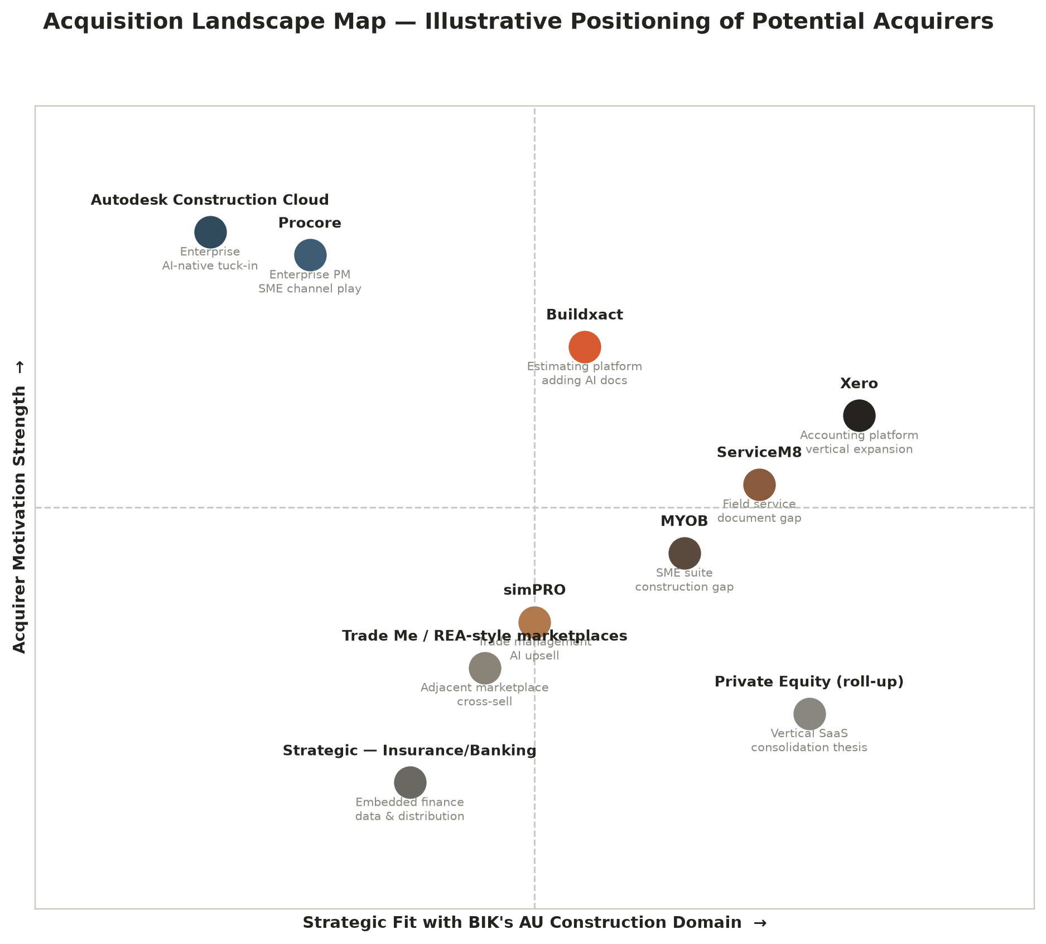
Figure 24.1 — Acquisition landscape map: illustrative positioning of potential acquirers
Categories of Potential Acquirer
Acquirer category | Why they would buy BIK | What they would value most
Accounting platforms (Xero, MYOB, QuickBooks) | Vertical expansion into the document-generation layer that sits just upstream of their own invoicing and reconciliation workflows | The construction-domain schema, the existing user base of AU trades, and the integration layer already built toward their own APIs
Field-service / job-management platforms (ServiceM8, simPRO, AroFlo, Tradify, Fergus) | Closing their own document-generation and compliance gap without building it natively | The AI document engine, the template library, and the trust/governance track record
Enterprise construction software (Procore, Autodesk Construction Cloud) | An SME-channel play — a credible way to reach the 1–20 person business segment they do not naturally serve | Distribution into a segment they structurally cannot reach profitably themselves
Private equity — vertical SaaS roll-up | A consolidation thesis across AU/NZ trade software, with BIK as either a platform or a bolt-on asset | Recurring revenue quality, retention metrics, and a defensible niche
Strategic — insurance / banking | Embedded finance and risk-reduction data plays — better-documented projects are lower-risk projects | The compliance-grade documentation trail and the distribution into trade businesses it represents

Milestones That Materially Increase Acquisition Value
Milestone | Why an acquirer would pay more after it
500+ paying subscribers with net revenue retention above 100% | Proves the product is not just adopted but expanded within accounts — the single most valuable SaaS acquisition signal
At least one live, production accounting/field-service integration | Converts BIK from "a nice tool" into "infrastructure already wired into the systems we'd need to migrate off" for an acquirer
A clean multi-quarter legal/compliance record | Directly de-risks the acquirer's own liability exposure in absorbing BIK's AI-generated content into their brand
A demonstrated enterprise or white-label pilot | Proves the business model extends beyond direct-to-SME subscription, widening the acquirer's own post-acquisition upside case
A named, retained founding team post-transaction interest | Reduces key-person risk (Chapter 26) that would otherwise discount any offer materially

THE STRATEGIC RECOMMENDATION
Do not build toward acquisition as the goal. Build the standalone business described in Chapters 8–21 with real conviction; treat every acquisition conversation that arrives along the way as a genuine option to evaluate against the standalone path at that moment, using the milestone table above as the shared yardstick for both paths. This is the posture most likely to produce the best outcome under either scenario, because a credible standalone trajectory is also the single best negotiating position in any acquisition discussion.

PART G — ENTERPRISE & ACQUISITION
25 Acquisition Scenarios & Exit Readiness
Three Time Horizons
Horizon | Illustrative company state | Most plausible acquirer profile | Illustrative valuation driver
3-year | Phase 2 complete or in progress; ~500 subscribers; 25 tools; early integration architecture live | Trade job-management platform seeking a document/compliance feature; or an early strategic minority investment | Revenue multiple on a still-small ARR base; strategic/product fit weighted more heavily than financial metrics
5-year | Phase 3 complete; ~1,500 subscribers; 50 tools; live Xero/ServiceM8 integrations; team workspaces | Accounting platform or field-service platform seeking genuine vertical expansion; PE vertical-SaaS roll-up | ARR multiple with meaningful weight on net revenue retention and integration lock-in (Chapter 21)
10-year | Phase 4 mature or category leader; 100+ tools and AI agents; enterprise/white-label revenue live; possible international footprint | Enterprise construction software incumbent seeking an SME-channel and AI-native capability; or BIK remains an independent category leader and considers its own acquisitions (Appendix roadmap) | Strategic premium over pure financial multiple, reflecting distribution, data, and AI-native brand positioning

These scenarios are deliberately not point-estimate valuations — they describe the state of the business and the buyer logic most likely to apply at each horizon, so that whichever moment a real conversation arrives, this document's framework, not just its numbers, remains useful.
Exit Readiness Checklist
Readiness area | What "ready" looks like | Status as at this document
Clean cap table and corporate structure | Clear ownership, no unresolved founder/services-unit entanglement between the two business units | To be formalised ahead of any institutional raise or acquisition process
Financial reporting discipline | Monthly management accounts, clean revenue recognition for subscriptions, clear services-vs-platform unit reporting | In development; recommended before any Phase 2 raise
IP ownership | All code, prompts, templates and the construction-domain schema clearly owned by BIK Solutions Pty Ltd, no contractor IP ambiguity | Recommended review as team grows beyond founder-led development
Legal/compliance record | No unresolved high-risk document releases; Legal and Safety Tool Register current (Chapter 27) | On track — register actively maintained and enforced as at 16 July 2026
Customer contracts and data handling | Standard terms in place, GDPR/Australian Privacy Principles-aligned data handling, documented in Trust pages | Live — Privacy Policy, Terms of Use, AI Usage Notice published
Key-person dependency mitigation | Documented processes, not tribal knowledge; at least one additional person capable of running core functions | Identified as a priority risk (Chapter 26); mitigation in progress
Retention and growth track record | Minimum 2–4 consecutive quarters of the net-revenue-retention and churn metrics underpinning Chapter 21's valuation case | Not yet applicable — pending Phase 2 monetisation launch

BOARD-LEVEL TAKEAWAY
Exit readiness is not a last-minute checklist item — it is a discipline that compounds in value the earlier it starts. Every item above is achievable well before any acquisition or institutional funding conversation is live, and doing so costs little relative to the valuation and negotiating-leverage benefit it provides (Chapter 21).

PART H — RISK & COMPLIANCE
Risk Register and Legal, Safety & Regulatory Compliance Register
Naming the risks precisely, rating them honestly, and showing the mitigation already in motion

PART H — RISK & COMPLIANCE
26 Risk Register & Heat Map
Risk Methodology
Each risk is rated on a 1–5 likelihood scale and a 1–5 impact scale, consistent with standard enterprise risk management practice. A risk score above 15 (of a possible 25) is treated as requiring an active, named mitigation owner and quarterly Board visibility; a score of 9–14 requires a documented mitigation and annual review; a score below 9 is monitored but not actively managed.
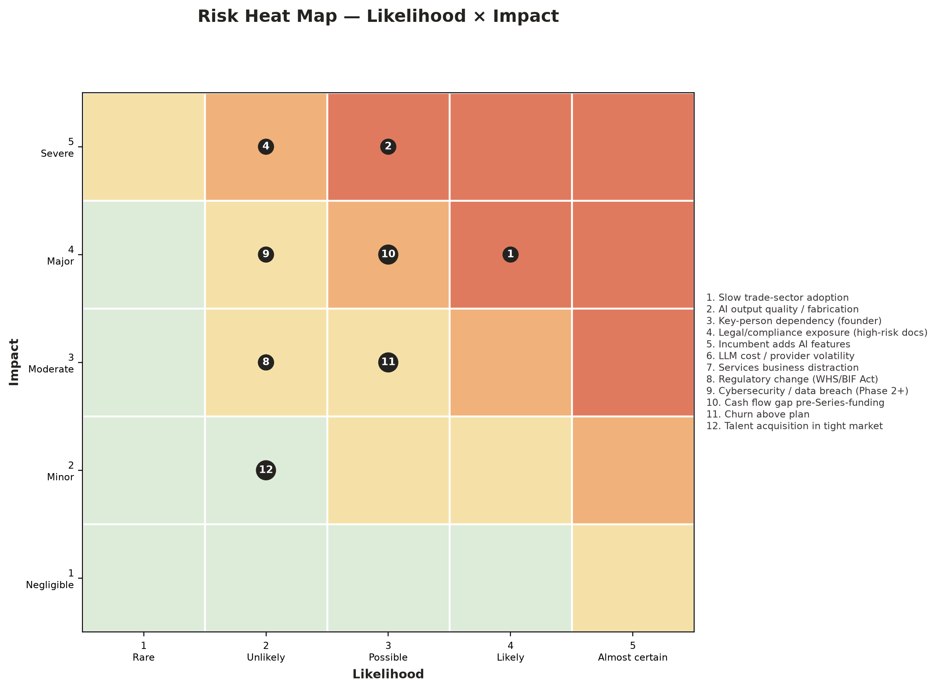
Figure 26.1 — Risk Heat Map: Likelihood × Impact
Full Risk Register
# | Risk | Likelihood | Impact | Score | Mitigation
1 | Slow trade-sector software adoption | 4 | 4 | 16 | Extremely simple UX; phone support; video walkthroughs; free tier removes trial friction entirely
2 | AI output quality / fabrication risk | 3 | 5 | 15 | Decision 001 enforced in every system prompt; human review step built into every document flow; clear in-product disclaimers
3 | Key-person dependency (founder) | 3 | 4 | 12 | Documented processes over tribal knowledge; Phase 2–3 hiring plan (Chapter 10) explicitly targets this
4 | Legal/compliance exposure on high-risk document types | 2 | 5 | 10 | Legal and Safety Tool Register (Chapter 27) actively holds high-risk tools (SWMS, Contract Termination, Show Cause, Subcontractor Agreement) out of release until professional review is complete
5 | Established incumbent adds AI features first | 3 | 3 | 9 | Move with urgency through Phases 2–3; workflow and trust depth compound fastest for the first credible mover (Chapter 17)
6 | LLM API cost / provider volatility | 2 | 3 | 6 | generateDocument() is the sole integration point (Chapter 12) — provider swap requires no wider architecture change; falling foundation-model costs are a tailwind, not a risk, on current trend
7 | Trades Services business distraction | 2 | 2 | 4 | Clear separation of the two units (Chapter 3); platform development is the primary strategic growth driver, not a side project
8 | Regulatory change (WHS, BIF Act and state equivalents) | 2 | 3 | 6 | Legal and Safety Tool Register explicitly tracks state-based Security of Payment legislation; compliance library update workflow is a named roadmap item
9 | Cybersecurity / data breach exposure (Phase 2+) | 2 | 4 | 8 | Phase 1 stores no user data server-side by design; Phase 2 Supabase migration adds Row Level Security and hashed credentials as a stated architectural requirement before launch
10 | Cash flow gap ahead of Series funding or before Phase 2 monetisation | 3 | 4 | 12 | Bootstrap path (Chapter 19) is explicitly viable without external capital; services unit cross-subsidy is a deliberate buffer
11 | Churn above plan | 3 | 3 | 9 | Product sequencing (Chapter 6) is explicitly designed to convert habit into switching-cost-bearing infrastructure over time; churn sensitivity is modelled, not ignored (Chapter 20)
12 | Talent acquisition in a tight market | 2 | 2 | 4 | Lean, founder-led team through Phase 2; Phase 3+ hiring plan tied to revenue milestones, not speculative headcount growth

Top Three Risks — Board Attention Required
- Risk 1 — Slow adoption (score 16). The construction sector's software adoption curve is genuinely slow, and no amount of product quality fully overcomes a category-level scepticism of software claims. This is mitigated by radical simplicity and a free tier, not by marketing spend alone.
- Risk 2 — AI fabrication (score 15). This is the risk Chapter 11's entire governance framework exists to manage. It is rated 5/5 on impact deliberately — a single well-publicised fabrication incident could be materially damaging to the trust asset the whole strategy depends on — which is exactly why Decision 001 is treated as non-negotiable rather than aspirational.
- Risk 3 (tied) — Key-person dependency and cash flow gap (score 12 each). Both are addressed by the same underlying lever: disciplined, milestone-gated hiring (Chapter 10) funded by a viable bootstrap path (Chapter 19) rather than by assuming a raise closes on a specific timeline.
Remaining Risks — Full Narrative
- Risk 5 — Incumbent adds AI features first (score 9). Buildxact, ServiceM8 and Tradify are named in Chapter 17 as the most plausible fast-followers. The mitigation is speed of execution through Phases 2–3, not a defensive feature race — BIK's advantage is trust and domain depth, which a rushed incumbent feature is unlikely to replicate credibly.
- Risk 6 — LLM API cost or provider volatility (score 6). The architecture already treats this as a solved design problem: generateDocument() is the sole integration point (Chapter 12), so a provider swap is a configuration change, not a rebuild. Foundation model inference costs have fallen consistently through 2024–2026, making this a monitored risk rather than an active one.
- Risk 7 — Trades Services business distraction (score 4). The two-unit structure (Chapter 3) is explicit precisely to prevent this — services revenue funds the platform, but platform strategy is not subordinated to services-business operational demands.
- Risk 8 — Regulatory change, WHS and BIF Act equivalents (score 6). The Legal and Safety Tool Register (Chapter 27) is the direct operational answer to this risk — it is a living document specifically because the regulatory environment it tracks is not static.
- Risk 9 — Cybersecurity and data breach exposure (score 8). Currently low because Phase 1 stores no user data server-side by design. This risk rises materially at Phase 2 and is why Row Level Security and bcrypt password hashing are named as launch requirements, not later hardening, in Appendix B.
- Risk 11 — Churn above plan (score 9). Directly modelled in Chapter 20's sensitivity analysis; the mitigation is structural (Chapter 6's lock-in-through-value sequencing) rather than promotional (discounting to retain).
- Risk 12 — Talent acquisition in a tight market (score 4). Currently low-severity because hiring is deliberately deferred to revenue-justified milestones (Chapter 10) rather than spec hiring ahead of demonstrated need.
PART H — RISK & COMPLIANCE
27 Legal, Safety & Regulatory Compliance Register
Purpose and Governance
BIK maintains a living Legal and Safety Tool Register recording the legal-risk profile, regulatory context, and safety classification of every tool in the Business Toolkit. Every tool must be reviewed before promotion from "Professional Review in Progress" to "Available in Beta." This chapter reproduces the register's structure and its current findings in full, because it is the single most important piece of evidence for any Board member, investor or partner assessing whether BIK's growth is being pursued responsibly.
Security of Payment Legislation by State/Territory
State/Territory | Governing Act | Key feature
Queensland | Building Industry Fairness (Security of Payment) Act 2017 (BIF Act) | Replaced BCIPA 2004; reference dates; supporting statements for head contractor claims; retention trust
New South Wales | Building and Construction Industry Security of Payment Act 1999 (NSW) | Reference date system
Victoria | Building and Construction Industry Security of Payment Act 2002 (Vic) | —
South Australia | Building and Construction Industry Security of Payment Act 2009 (SA) | —
Western Australia | Construction Contracts Act 2004 (WA) | Different regime — no reference-date system; payment disputes via adjudication
Tasmania | Building and Construction Industry Security of Payment Act 2009 (Tas) | —
Northern Territory | Construction Contracts (Security of Payments) Act 2004 (NT) | —
Australian Capital Territory | Building and Construction Industry (Security of Payment) Act 2009 (ACT) | —

IMPORTANT — STATED EXPLICITLY IN THE REGISTER
The BIK Toolkit does not determine which legislation applies to a specific contract. The user is responsible for identifying their applicable jurisdiction and Act. This limitation is disclosed in-product, not only in this document.

Tool-by-Tool Release Status
Tool | Release status | Key regulatory note
Variation Notice | Live — production ready | No formal legal review flag; standard commercial document practice
Quote Builder | Live — beta | No formal legal review flag
Scope of Works | Live — beta | No formal legal review flag
Site Diary | Live — beta | Record-keeping tool; supports WHS due diligence, no specific statutory form required
Defect Report | Live — beta | Structured record appropriate for DLP (defects liability period) and dispute use
Toolbox Talk | Available in Beta | No specific statutory form; supports WHS due diligence obligations
Handover Checklist | Available in Beta | No specific compliance requirement — record document
Non-Conformance Report | Available in Beta | Quality management record; no specific regulatory form
Inspection Checklist | Available in Beta | Building inspection record; no specific compliance requirement for the form
Progress Claim | Controlled Beta | BIF Act reference-date and supporting-statement requirements apply in Queensland; BIK does not calculate reference dates or assess statutory compliance — construction lawyer review pending
Payment Reminder | Controlled Beta | Level 3 (final notice) copy references suspension of works; user must independently verify contractual right to suspend; partial legal review complete
Practical Completion Notice | Controlled Beta | Contract-specific requirements differ between residential (QBCC) and commercial (AS4000) contracts
Instruction to Proceed | Controlled Beta | Creates written financial authorisation only — does not carry the same legal weight as a formal contract variation
Incident Report | Controlled Beta — mandatory statutory notification warning | RECORD-KEEPING ONLY. Serious incidents trigger a mandatory immediate notification obligation to the WHS regulator (WHS Act s.38) — WorkSafe Queensland in Qld. This tool does not satisfy that obligation; the in-product warning is mandatory.
Extension of Time (EOT) Claim | Controlled Beta | EOT entitlements are contract-specific with strict notice requirements (AS4000 cl. 35, HIA, QBCC); BIK does not calculate notice deadlines
Delay Notice | Controlled Beta | Same strict-notice risk as EOT; BIK does not determine timeliness under the applicable contract
SWMS Generator | HOLD — Professional Review in Progress — DO NOT RELEASE | High-risk construction work under WHS Regulation 2011 (Qld) Schedule 1 requires a site-specific SWMS prepared through worker consultation and competent-person review; AI Writer is currently enabled on the controlMeasures field and is a known risk flagged for remediation before release
Notice to Show Cause | HOLD — Professional Review in Progress — DO NOT RELEASE | Most standard-form contracts require a show-cause notice before termination; issuing one without genuine contractual basis may itself constitute breach or repudiation
Contract Termination Notice | HOLD — Professional Review in Progress — DO NOT RELEASE | EXTREME risk — the highest-risk document in the suite. Wrongful termination can itself constitute repudiation and expose the terminating party to liability for the other party's losses
Subcontractor Agreement | HOLD — Professional Review in Progress — DO NOT RELEASE | BIF Act retention trust obligations apply above certain thresholds; the generated agreement does not include dispute resolution, IP or assignment clauses that may be required for complex engagements

Governance Commitment
This document deliberately reproduces the HOLD status of four tools in full, including the internal "DO NOT RELEASE" language, rather than summarising it away. A strategy document that hid this detail from a Board, investor or banking partner would itself be a governance failure of exactly the kind Chapter 11's framework exists to prevent. The commitment stated here is simple: none of these four tools will be promoted to general release until the named professional review is complete and documented in an updated register.

PART I — BOARD GOVERNANCE & IMPLEMENTATION
Board Papers and the Next Twelve Months
What the Board is being asked to resolve, and the concrete plan for execution

PART I — BOARD & IMPLEMENTATION
28 Board Papers
Purpose of This Chapter
This chapter is written in board-paper format so that it can be extracted and tabled directly at a Board meeting without further editing. It sets out the resolutions this document supports, the governance cadence recommended to oversee them, and the specific reporting the Board should expect going forward.
Resolutions Sought
# | Resolution | Supporting chapter(s)
1 | That the Board approves this document as the Company's current Strategic Blueprint, superseding prior informal strategy discussions | All
2 | That the Board approves progression of Phase 2 platform investment (accounts, billing, document history) on the bootstrap-funded basis set out in Chapter 19, absent a superior funding offer | 8, 19
3 | That the Board notes and endorses the AI Governance Framework (Decision 001) and the Legal and Safety Tool Register as binding constraints on product release, not guidelines | 11, 27
4 | That the Board notes the four tools currently on HOLD (SWMS Generator, Notice to Show Cause, Contract Termination Notice, Subcontractor Agreement) and directs management to commission the named professional legal/WHS reviews before Phase 2 general release | 27
5 | That the Board directs management to formalise exit-readiness items (Chapter 25) — financial reporting discipline, IP ownership documentation, and key-person mitigation — ahead of any institutional capital raise or acquisition conversation | 25
6 | That the Board receives quarterly reporting against the metrics defined in Chapter 8 (Strategic Plan) and Chapter 26 (Risk Register) as standing agenda items | 8, 26

Recommended Governance Cadence
Cadence | Standing agenda items
Quarterly Board meeting | Progress against phase-gate metrics (Ch. 8); top-3 risk register review (Ch. 26); any tool promoted out of "Professional Review in Progress" status (Ch. 27)
Annual strategy refresh | Full re-issue of this document, or a formally minuted addendum, incorporating actuals against the financial model (Ch. 19–20) and any material competitive changes (Ch. 17)
Ad hoc — triggered | Any institutional capital raise, acquisition approach, or material incident involving AI-generated content, reported to the Board within 5 business days

Reporting Pack Recommended for Each Quarterly Meeting
- MRR, paying subscribers, and tools-live count against the Chapter 8 phase-gate targets
- Net revenue retention and logo churn, tracked against the three scenarios in Chapter 19–20
- Any change in tool release status in the Legal and Safety Tool Register (Chapter 27)
- Top-3 risk register movements (Chapter 26), with named mitigation owner sign-off
- Cash position against the bootstrap-path model (Chapter 19, Figure 19.1)
Governance RACI
Decision / activity | Founder | Board | Product/Eng lead | Compliance reviewer
Tool promotion from HOLD to Beta (Ch. 27) | Consulted | Informed | Responsible | Accountable
Phase gate progression (Ch. 8) | Accountable | Approves | Responsible | Consulted
Pricing changes (Ch. 15) | Accountable | Informed | Consulted | —
Institutional capital raise | Responsible | Accountable | Consulted | Consulted
Acquisition approach evaluation (Ch. 24) | Responsible | Accountable | Consulted | Consulted
Quarterly risk register review (Ch. 26) | Responsible | Accountable | Consulted | Consulted

Illustrative Resolution Wording
SAMPLE RESOLUTION — FOR BOARD MINUTE PURPOSES
"RESOLVED that the Board of BIK Solutions Pty Ltd adopts the Strategic Blueprint & Investment Memorandum dated 16 July 2026 (Version 1.0) as the Company's current strategic plan; approves progression of Phase 2 platform investment on the bootstrap-funded basis described therein; and directs management to commission independent legal and WHS professional review of the SWMS Generator, Notice to Show Cause, Contract Termination Notice and Subcontractor Agreement tools prior to any general release, consistent with the Legal and Safety Tool Register."

PART I — BOARD & IMPLEMENTATION
29 Implementation Timeline — Next 12 Months
Quarter-by-Quarter Plan
Quarter | Focus | Key deliverables
Q3 2026 (current) | Complete Phase 1 foundation | Finish remaining Phase 1 tools (Progress Claim, SWMS pending legal review, Site Inspection Report); publish all six toolkit marketing pages; reach 500 email subscribers
Q4 2026 | Beta-to-launch transition | Convert beta feedback into a prioritised fix list; activate analytics (Google Analytics 4, Microsoft Clarity) once account IDs are available; begin Phase 2 technical design (Supabase auth, Stripe billing)
Q1 2027 | Phase 2 build | Ship user accounts, document history dashboard, branded PDF export, and Stripe subscription billing; formally launch paid tiers; migrate Formspree workflows to a real database
Q2 2027 | Phase 2 consolidation | Ship 15 additional Phase 2 tools; launch lifecycle email automation (welcome, nurture, upsell); commission professional legal review of the four HOLD tools
Q3 2027 | Phase 2 target checkpoint | Board review against the 500-subscriber / $15,000 MRR phase-gate (Chapter 8); go/no-go decision on accelerating toward Phase 3 integrations
Q4 2027 – Q2 2028 | Phase 3 build begins | Live Xero and ServiceM8 integrations; team workspaces and role-based access; begin mobile PWA development

Immediate Next Actions (30/60/90 Days)
Timeframe | Action | Owner
Next 30 days | Board sign-off on the resolutions in Chapter 28; commission construction-lawyer review of the four HOLD tools | Board / Founder
Next 60 days | Finalise Phase 2 technical design (Supabase schema, Stripe product/price configuration); activate analytics once tracking IDs are available | Product / Engineering
Next 90 days | Begin Phase 2 build in earnest; formalise financial reporting cadence ahead of any future raise; complete remaining Phase 1 tool set | Founder / Engineering / Finance

CLOSING NOTE FOR THE BOARD
This document is designed to be a living strategic instrument, not an archive piece. The single most important governance habit it asks the Board to adopt is the quarterly cadence in Chapter 28 — because every projection in Part F and every valuation driver in Chapter 21 depends on the discipline described in this chapter actually being followed, not merely approved.

APPENDICES
Supporting Detail
Full tool catalogue, technical architecture summary, assumptions register and glossary

APPENDICES
30 Appendix A — Full AI Tool Catalogue (62 Tools)
The complete BIK Business Toolkit catalogue, organised by category. Each tool is scored 1–10 for commercial value and classified by build effort. Source: docs/ai-tool-catalogue.md.
CATEGORY 1 — SALES & BUSINESS DEVELOPMENT (8 TOOLS)
Tool | Phase | Status | Value
Quote Builder | 1 | Live | 9/10
Client Proposal Generator | 2 | Planned | 8/10
Tender Response Writer | 2 | Planned | 9/10
Follow-up Email Generator | 1 | Planned | 6/10
Job Won / Lost Analysis | 3 | Idea | 7/10
Referral Request Email | 2 | Planned | 5/10
Testimonial Request Email | 2 | Planned | 6/10
Social Media Post Generator | 3 | Idea | 5/10

CATEGORY 2 — PROJECT ADMINISTRATION (10 TOOLS)
Tool | Phase | Status | Value
Scope of Works Generator | 1 | Live | 9/10
Variation Notice | 1 | Live — production ready | 9/10
Site Diary Generator | 1 | Live (Free tier) | 7/10
Defect Report | 1 | Live | 8/10
Site Inspection Report | 1 | Planned | 8/10
Handover Checklist Generator | 2 | Live (beta) | 7/10
Project Completion Certificate | 2 | Planned | 7/10
Meeting Minutes Generator | 2 | Planned | 6/10
Programme / Schedule Generator | 3 | Idea | 8/10
Contract Variation Log | 2 | Planned | 7/10

CATEGORY 3 — SAFETY & COMPLIANCE (8 TOOLS)
Tool | Phase | Status | Value
SWMS Generator | 1 | Drafted — legal HOLD | 10/10
Toolbox Talk Generator | 1 | Live (Free tier) | 8/10
Safety Management Plan | 2 | Planned | 9/10
Incident Report | 2 | Live (beta) — statutory warning | 9/10
Job Safety Analysis (JSA) | 2 | Planned | 8/10
Emergency Response Plan | 3 | Idea | 7/10
WHS Induction Generator | 3 | Idea | 7/10
Risk Register (tool) | 2 | Planned | 8/10

CATEGORY 4 — FINANCE & ACCOUNTS (8 TOOLS)
Tool | Phase | Status | Value
Progress Claim | 1 | In development — top priority | 10/10
Payment Reminder Email | 1 | Live (Free tier) | 8/10
Retention Claim Notice | 2 | Planned | 8/10
Build Cost Tracker | 2 | Planned | 8/10
Insurance Certificate Request | 2 | Planned | 6/10
Invoice Generator | 3 | Idea | 7/10
Cashflow Forecast | 3 | Idea | 9/10
Subcontractor Payment Schedule | 2 | Planned | 7/10

CATEGORY 5 — CLIENT COMMUNICATION (7 TOOLS)
Tool | Phase | Status | Value
Project Update Email | 2 | Planned | 7/10
Delay Notice | 2 | Live (beta) | 8/10
Defect Response Letter | 2 | Planned | 8/10
Client Welcome Pack | 2 | Planned | 6/10
Complaint Response Letter | 3 | Idea | 8/10
Testimonial / Review Response | 3 | Idea | 5/10
End-of-Project Survey | 3 | Idea | 6/10

CATEGORY 6 — HR & PEOPLE (7 TOOLS)
Tool | Phase | Status | Value
Job Ad Generator | 2 | Planned | 7/10
Interview Question Generator | 2 | Planned | 6/10
Employment Contract (Fair Work compliant) | 3 | Idea — legal disclaimer required | 9/10
Employee Onboarding Pack | 2 | Planned | 7/10
Performance Review Template | 3 | Idea | 6/10
Warning Letter | 3 | Idea — legal disclaimer required | 8/10
Hire Subcontractor Checklist | 2 | Planned | 7/10

CATEGORY 7 — SUBCONTRACTOR MANAGEMENT (6 TOOLS)
Tool | Phase | Status | Value
Subcontractor Agreement | 2 | Drafted — legal HOLD | 9/10
Subcontractor Performance Notice | 3 | Idea | 7/10
Subcontractor Pre-qualification Form | 2 | Planned | 7/10
Back-to-Back Subcontract | 3 | Idea — legal review required | 8/10
EOT Claim (Extension of Time) | 3 | Live (beta) | 9/10
Subcontractor Register | 2 | Planned | 6/10

CATEGORY 8 — PHASE 4 AI AGENTS (8 TOOLS)
Tool | Phase | Status | Value
Voice-to-Site-Diary Agent | 4 | Idea | 10/10
Photo-to-Defect-Report Agent | 4 | Idea | 10/10
Auto Payment Reminder Agent | 4 | Idea | 9/10
Contract Risk Review Agent | 4 | Idea — legal disclaimer required | 10/10
SWMS-from-Photo Agent | 4 | Idea | 10/10
Job Cost Reconciliation Agent | 4 | Idea | 9/10
Delay Notice Auto-Generator Agent | 4 | Idea | 10/10
Compliance Monitoring Agent | 4 | Idea | 8/10

Total tools catalogued: 62. Tools with full specifications: 62. Source: docs/ai-tool-catalogue.md, 15 July 2026.
APPENDICES
31 Appendix B — Technical Architecture Summary
Phase 1 Stack (Current)
Layer | Technology | Rationale
HTML | Semantic HTML5 with ARIA attributes | Accessibility, SEO, simplicity
CSS | Vanilla CSS with custom properties | No build step; maintainable; fast
JavaScript | Vanilla ES6 modules | Zero dependencies; no bundler required
Hosting | GitHub Pages | Free; auto-deploys from branch; automatic SSL
Forms | Formspree | Zero-backend form handling in Phase 1
E-commerce | Gumroad | Digital product sales without payment infrastructure

Phase 2+ Planned Stack
Layer | Technology | Notes
Frontend | Static HTML + JS retained | Avoids framework lock-in
Auth & database | Supabase (PostgreSQL) | Users, documents, subscriptions
AI generation | Anthropic Claude API | generateDocument() remains the sole integration point
PDF generation | Puppeteer / Playwright (serverless) | Server-rendered HTML → PDF
Payments | Stripe | Subscription billing
Hosting | Vercel or Netlify | Serverless functions for API routes
Email | Resend or Postmark | Transactional email

Integration Layer (SPEC-002) — Architecture Complete, Stubs Only
Seven provider stubs (Xero, MYOB, QuickBooks, Buildxact, ServiceM8, SimPRO, AroFlo) and five service modules (contact, invoice, quote, project, attachment) are fully architected behind a single public entry point. All monetary amounts are stored as integer cents; a typed error hierarchy (BIKIntegrationError and nine subclasses) and a retrying HTTP client with structured logging are in place. Every provider stub carries an explicit `_IMPLEMENTATION_POINT` marker documenting the exact API call required to go live — implementation is planned for Phase 3 against real OAuth credentials.
Provider | Contacts | Invoices | Quotes | Projects | Attachments
Xero | ✓ | ✓ | ✓ | ✓ | ✓
MYOB | ✓ | ✓ | ✓ | ✓ | —
QuickBooks | ✓ | ✓ | ✓ | ✓ | —
Buildxact | ✓ | ✓ | ✓ | ✓ | —
ServiceM8 | ✓ | ✓ | ✓ | ✓ | —
SimPRO | ✓ | ✓ | ✓ | ✓ | —
AroFlo | ✓ | ✓ | ✓ | ✓ | —

Security Posture
- Phase 1: no user data stored server-side; all forms routed through Formspree; AI API keys stored client-side only, never transmitted to BIK servers
- All user input passes through HTML-entity escaping before rendering, mitigating XSS by design
- Phase 2: Supabase Auth with bcrypt password hashing and Row Level Security on all tables
- Phase 2+: CSP headers on hosting platform; no third-party scripts without audit
APPENDICES
32 Appendix C — Financial Model Assumptions Register
Every illustrative assumption used in Part F is listed here with its source classification, so any reader can distinguish BIK's own published targets from this document's modelled extrapolations.
Ref | Assumption | Classification | Used in
F1 | Monthly organic visitor growth to 8K–30K by Month 12 | Illustrative — planning scenario | Ch. 19
F2 | Visitor → email capture rate 4–8% | Illustrative — industry-typical range for content-led SaaS | Ch. 19
F3 | Free → paid conversion 8–16% at 90 days | Illustrative — planning scenario | Ch. 19
F4 | Blended CAC $35–65 | Illustrative — modelled on near-zero-cost organic channel mix (Ch. 14) | Ch. 19
F5 | Monthly logo churn 2.4–4.5% | Illustrative — stress-tested range | Ch. 19–20
F6 | Phase 1–4 subscriber and MRR targets (100 / 500 / 1,500 / 5,000+ subscribers; $2K / $15K / $50K / $200K+ MRR) | Sourced directly — BIK's own published targets | docs/pricing-strategy.md, docs/product-roadmap.md
F7 | Gross margin ~88–89% | Illustrative — typical vertical SaaS benchmark applied to BIK's cost structure | Ch. 20
F8 | Year 4–5 MRR extrapolation via decelerating S-curve | Illustrative — model extrapolation beyond BIK's own published 36-month targets | Ch. 20
F9 | TAM $360B+ | Sourced directly — docs/product-vision.md | Ch. 1, 16
F10 | SAM ~$1.8B, SOM ~$91M | Illustrative — modelled sizing, not third-party market research | Ch. 16
F11 | Illustrative valuation multiples (4x–12x ARR by milestone) | Illustrative — directional range only, not a valuation or fairness opinion | Ch. 21

STANDING DISCLOSURE
This assumptions register should be read alongside every table in Part F. Where this document says "illustrative," it means exactly that — a scenario built for planning and stress-testing purposes, not a forecast to be relied upon without independent verification.

APPENDICES
33 Appendix D — Glossary of Terms
Term | Meaning
ARR / MRR | Annual / Monthly Recurring Revenue
BIF Act | Building Industry Fairness (Security of Payment) Act 2017 (Qld)
CAC | Customer Acquisition Cost
DLP | Defects Liability Period
EOT | Extension of Time (contractual claim)
HRPW | High-Risk Construction Work (WHS Regulation, division 6)
JSA | Job Safety Analysis
LTV | Customer Lifetime Value
NRR | Net Revenue Retention
PCBU | Person Conducting a Business or Undertaking (WHS Act)
PWA | Progressive Web App
QBCC | Queensland Building and Construction Commission
SaaS | Software as a Service
SOM | Serviceable Obtainable Market
SAM | Serviceable Addressable Market
SOP Act | Security of Payment Act (varies by state/territory)
SWMS | Safe Work Method Statement
TAM | Total Addressable Market
WHS | Work Health and Safety

APPENDICES
34 Appendix E — Document Control & Version History
Version | Date | Summary of change
0.1 (internal draft) | 15 July 2026 | Initial compilation from BIK internal strategy, product and pricing documentation
1.0 (Board draft) | 16 July 2026 | First complete integrated Strategic Blueprint & Investment Memorandum, structured for Board, investor, strategic buyer, grant assessor and banking partner audiences

Source Documents Referenced
- docs/PROJECT_CONTEXT.md
- docs/business-strategy.md
- docs/product-vision.md
- docs/pricing-strategy.md
- docs/product-roadmap.md
- docs/marketing-strategy.md
- docs/ai-tool-catalogue.md
- docs/technical-architecture.md
- docs/integration-architecture.md
- docs/beta-readiness-report.md
- docs/PRODUCT_DECISIONS.md
- docs/branding-guidelines.md
- docs/legal-and-safety-tool-register.md
- docs/release-plan.md
Next Scheduled Review
This document is scheduled for quarterly review per the governance cadence set out in Chapter 28, and for a full refresh ahead of any institutional capital raise or acquisition process. The next scheduled review is Q4 2026, aligned with the Q3 2026 Phase 1 completion checkpoint (Chapter 29).
APPENDICES
35 Appendix F — Flagship Tool Walkthroughs
To make the product concrete rather than abstract, this appendix walks through what a user actually does in four flagship tools, end to end.
VARIATION NOTICE (PRODUCTION-READY)
Step | What happens
1. Form | Builder enters project reference, reason for the variation, description of additional works, and cost — auto-filled where possible from their saved builder profile
2. AI assist | Builder can invoke "Strengthen for Contract" or "Rewrite Professionally" on the free-text description field; Decision 001 prevents the AI adding any detail not already supplied
3. Preview | A live, styled document preview renders alongside the form, auto-numbered (VN-00X) and dated
4. Approval flow | A client acknowledgement/signature section is included in the generated document itself
5. Export | Print-to-PDF, clipboard copy, or direct email with a pre-filled professional message
6. History | The document is saved to the builder's Document History, retrievable and re-editable at any time

QUOTE BUILDER
Captures client and job details, then a dynamic line-items editor for labour and materials with live GST and subtotal calculation. Generates a professional, itemised quote with payment terms and a validity period, ready to print, copy or email — the single highest-value tool in the catalogue by time saved per use (Chapter 3).
PROGRESS CLAIM (IN DEVELOPMENT — HIGHEST COMMERCIAL PRIORITY)
Captures contract value, completion percentage per schedule-of-values item, retention terms, and prior claims, and generates a formatted progress claim with a schedule of values and retention calculation. Explicitly does not calculate BIF Act reference dates or assess statutory compliance (Chapter 27) — the in-product copy is direct about this boundary.
SWMS GENERATOR (DRAFTED — LEGAL REVIEW HOLD, NOT YET RELEASED)
Captures the work activity, hazard types from a structured dropdown, control measures, and site-specific detail, intended to produce a Safe Work Australia-aligned Safe Work Method Statement with a sign-off section. Held out of release specifically because the controlMeasures field currently allows AI-assisted drafting that could otherwise be mistaken for a site-adequate, reviewed control measure — precisely the risk Chapter 27 documents in full and requires resolved before this tool reaches any user.
APPENDICES
36 Appendix G — Illustrative Data Room Index
For a prospective investor, strategic partner or banking counterparty proceeding to due diligence, the following is an illustrative index of the materials BIK would compile — reflecting what exists today and what remains to be formalised per the exit-readiness checklist in Chapter 25.
Data room section | Illustrative contents | Status
Corporate | Certificate of incorporation, constitution, register of members, org chart | To be formalised
Financial | Management accounts, bank statements, this document's financial model and assumptions register (Appendix C) | Partial — model complete, historical accounts to be compiled
Product & IP | Source code repository, this document's technical architecture summary (Appendix B), IP assignment records | Repository live; IP assignment review recommended
Commercial | Pricing strategy (Chapter 15), customer/subscriber data once monetisation launches, key vendor/integration agreements | Pricing defined; subscriber data pending Phase 2 launch
Legal & compliance | Legal and Safety Tool Register (Chapter 27), Privacy Policy, Terms of Use, AI Usage Notice | Live and current as at this document's date
HR | Employment agreements, contractor agreements, org design plan (Chapter 10) | To be formalised as team grows
Strategy | This document in full | Complete — Version 1.0

APPENDICES
37 Appendix H — Frequently Asked Questions
ISN'T THIS JUST A CHATGPT WRAPPER?
No — Chapters 5 and 6 set out the distinction in full. The construction-specific schema, the document history and builder-profile infrastructure, the Legal and Safety Tool Register, and Decision 001 are all product and governance layers that sit around a foundation model, not a thin prompt on top of one. A ChatGPT wrapper has none of these and cannot make the trust guarantees BIK makes.
WHY HASN'T BIK RAISED CAPITAL YET?
Because it has not needed to. The Trades Services unit funds Phase 1–2 platform development (Chapter 3, Chapter 19), which preserves founder control and means any future raise happens from a position of proven traction rather than necessity.
WHAT HAPPENS IF A COMPETITOR COPIES THE TOOL LIST?
Copying a tool list is straightforward; copying the trust discipline behind it is not (Chapter 7). The catalogue itself is not the moat — the governance, the domain depth, and the founder-market fit are.
WHY ARE SOME TOOLS HELD BACK FROM RELEASE?
Because BIK's Legal and Safety Tool Register (Chapter 27) treats professional legal and WHS review as a release gate, not a nice-to-have. Four tools remain on HOLD as at this document's date, and this document names them explicitly rather than obscuring the fact.
IS THE FIVE-YEAR FINANCIAL MODEL A FORECAST?
No. Years 1–3 reconcile to BIK's own published milestone targets; Years 4–5 are explicitly labelled model extrapolations (Chapter 20, Appendix C). The document is deliberately conservative in its base case and stress-tests both an optimistic and a pessimistic scenario throughout Part F.
WHAT IS THE SINGLE BIGGEST EXECUTION RISK?
Speed through Phases 2 and 3. BIK's competitive advantage today is a sequencing advantage (Chapter 7, Chapter 17) — it is real, but it erodes the longer infrastructure and integration depth take to ship.

APPENDICES (CONTINUED)
Audience-Specific Supporting Material
SaaS metrics primer, sample board reporting, risk analysis, hiring plans, grant and banking considerations

APPENDICES
38 Appendix I — SaaS Metrics Primer
This document uses a number of SaaS-specific metrics throughout Part F. For a government grant assessor, banking partner, or Board member without a SaaS finance background, this appendix explains each term in plain language, worked against BIK's own base-case figures, so that every number in Chapters 19–21 can be sense-checked without external reference material.
MONTHLY AND ANNUAL RECURRING REVENUE (MRR / ARR)
MRR is the predictable subscription revenue a business collects every month, stripped of one-off and irregular income — the number that matters because it is the number that repeats. ARR is simply MRR multiplied by twelve, used as a shorthand for comparing recurring-revenue businesses on an annualised basis. BIK's base-case Year 3 target of $50,000 MRR (Chapter 8) is therefore equivalent to $600,000 ARR, the figure used as the basis for the Chapter 21 valuation bridge.
CHURN (LOGO CHURN VS REVENUE CHURN)
Logo churn is the percentage of paying customers who cancel in a given period, regardless of how much they were paying. Revenue churn weights this by dollar value lost, which can differ materially if larger accounts churn at a different rate to smaller ones. BIK's model (Chapter 19) works primarily in logo churn terms because, in the early phases, the customer base is relatively homogeneous in tier mix.
NET REVENUE RETENTION (NRR)
NRR measures how existing customers' revenue changes over a year, including upgrades, downgrades and cancellations, but excluding revenue from brand-new customers. An NRR above 100% means the existing customer base is growing in value even before a single new customer is added — the single most prized metric in SaaS investing, because it demonstrates the product becomes more valuable to a customer the longer they use it. BIK's base-case assumption of 101% NRR (Chapter 19) reflects modest but positive tier upgrades outweighing downgrades and partial churn; the aggressive scenario's 108% assumes the Chapter 6 lock-in thesis (document history, integrations) plays out as designed.
CUSTOMER ACQUISITION COST (CAC) AND LIFETIME VALUE (LTV)
CAC is the fully-loaded cost of acquiring one new paying customer — marketing and sales spend divided by new customers acquired in the period. LTV is the total revenue expected from an average customer over their entire relationship with the business, typically approximated as average revenue per user divided by the churn rate. The ratio of the two, LTV:CAC, is the standard health check for a subscription business: a ratio above 3x is generally considered healthy, and BIK's modelled ratios (9x–43x across scenarios, Chapter 19) run well above that bar because of its near-zero-cost organic acquisition channel mix (Chapter 14) — a genuine structural advantage, not an error in the model, though one that would compress toward more typical ranges if paid acquisition spend increases.
THE RULE OF 40
A common SaaS health heuristic: growth rate (%) plus profit margin (%) should sum to at least 40 for a business to be considered efficiently balancing growth and profitability. In BIK's Year 3 base case, illustrative annual revenue growth of roughly 150% year-on-year (Chapter 20) plus an EBITDA margin of roughly 26% comfortably clears this bar, though this reflects the mathematics of early-stage growth rates rather than a mature-business comparison, and should be read as illustrative context, not a claim of durable outperformance.
Metric | BIK base case (Year 3) | What "good" typically looks like
MRR / ARR | $50,000 / $600,000 | N/A — absolute figures, context-dependent
Monthly logo churn | 3.2% | Under 5% is common for SME-focused SaaS
Net Revenue Retention | 101% | 100%+ is considered healthy; 110%+ is excellent
LTV : CAC | 21.4x (base case) | Above 3x is considered healthy
CAC payback period | 1.5 months | Under 12 months is considered healthy
Gross margin | ~89% | 80%+ is typical for well-run software businesses
Rule of 40 (growth % + margin %) | ~176 | 40+ is considered healthy

APPENDICES
39 Appendix J — Illustrative Quarterly Board Report
To make the Chapter 28 reporting cadence concrete, this appendix is a fully worked illustrative example of the quarterly report format the Board would receive — using an illustrative future quarter (Q3 2027, the Phase 2 completion checkpoint) so the format can be reviewed and adopted before it is needed for real.
ILLUSTRATIVE — Q3 2027 BOARD REPORT (WORKED EXAMPLE, NOT AN ACTUAL RESULT)
This is a template exercise. No figures on this page describe a result that has actually occurred; they are placeholders showing the format and the level of detail expected.

Metric | Target (Chapter 8) | Illustrative actual | Variance commentary
Paying subscribers | 500 | [to be completed] | [to be completed]
MRR | $15,000 | [to be completed] | [to be completed]
Tools live | 25 | [to be completed] | [to be completed]
Net revenue retention | ~101% (base case) | [to be completed] | [to be completed]
Monthly logo churn | ~3.2% (base case) | [to be completed] | [to be completed]
Cash position | Per Chapter 19 bootstrap path | [to be completed] | [to be completed]

The narrative sections below the metrics table are where the report format earns its keep — numbers alone do not tell the Board whether a variance is a one-off timing effect or an early signal of a structural problem worth Chapter 26 risk-register attention.
- Highlights this quarter — the two or three most important developments, positive or negative
- Risk register movements — any risk that changed score since the last meeting, and why (Chapter 26)
- Legal and Safety Tool Register changes — any tool promoted, held, or newly flagged (Chapter 27)
- Competitive developments — any material move by a named competitor (Chapter 17)
- Decisions requested of the Board this meeting, if any
APPENDICES
40 Appendix K — Bowtie Risk Analysis: Top Three Risks
A bowtie diagram, presented here in table form, separates a risk's causes from its consequences and maps a control to each side — preventive controls that reduce the likelihood of the event, and mitigating controls that reduce the impact if it happens anyway. This appendix applies the technique to the three highest-scoring risks from Chapter 26.
RISK 1 — SLOW TRADE-SECTOR SOFTWARE ADOPTION
Element | Detail
Causes | Category-level scepticism of software claims; low digital literacy in parts of the target market; prior bad experience with overpriced or overcomplicated tools
Central event | A meaningful share of the target market never tries BIK at all, or churns immediately after a first attempt
Consequences | Slower-than-modelled subscriber growth (Chapter 20 pessimistic scenario); extended runway requirement
Preventive controls | Free tier with no credit card required; radical simplicity (Chapter 9 UX principles); founder-credible trust signals (Chapter 7)
Mitigating controls | Bootstrap funding path removes time pressure to convert quickly (Chapter 19); services-unit cross-subsidy buys patience

RISK 2 — AI OUTPUT QUALITY / FABRICATION
Element | Detail
Causes | Foundation model hallucination tendencies; insufficiently constrained system prompts; user over-reliance on AI output without review
Central event | An AI-generated document contains a fabricated fact, figure or claim that a user sends to a client or head contractor without noticing
Consequences | Professional or legal damage to the user; reputational damage to BIK; potential loss of trust across the user base if publicised
Preventive controls | Decision 001 enforced in every system prompt (Chapter 11); document types held on HOLD until legal/WHS review clears them (Chapter 27)
Mitigating controls | Mandatory human review step built into every document flow; AI edits shown in the same field the user wrote in, so changes are visible before sending

RISK 5 — INCUMBENT ADDS AI FEATURES FIRST
Element | Detail
Causes | Buildxact, ServiceM8 or Tradify (Chapter 17) recognise the same AI-native opportunity and move quickly given their existing distribution
Central event | An incumbent ships a credible AI document feature before BIK reaches Phase 3 integration depth
Consequences | Erosion of BIK's sequencing advantage (Chapter 7); harder, more expensive customer acquisition
Preventive controls | Move with urgency through Phases 2–3 (Chapter 8 strategic priorities); build integration depth before enterprise ambition
Mitigating controls | Trust and governance depth (Decision 001, Legal and Safety Tool Register) are harder to retrofit onto an existing platform than a feature is to ship — BIK's differentiation does not evaporate the moment a competitor ships an AI button

APPENDICES
41 Appendix L — Phase 2 Key Hire Role Scorecards
Chapter 10 sets out the organisational design through the four phases at a summary level. This appendix gives role-scorecard-level detail for the first three hires planned for Phase 2, so that hiring can begin against a clear brief rather than a vague headcount line.
FOUNDING PRODUCT/ENGINEERING HIRE
Mandate: own the Phase 2 build (Supabase auth, document history, Stripe billing) end to end, working directly from the existing static architecture rather than a rewrite. Success in the first two quarters looks like: user accounts and billing live in production with zero critical security findings, and the shared-engine architecture (Chapter 12) extended, not forked, to support the 15 new Phase 2 tools. This is the single highest-leverage hire in the plan, because it directly gates the Phase 2 milestone in Chapter 8.
CUSTOMER SUCCESS / SUPPORT LEAD
Mandate: own the beta feedback loop (Chapter 3) and turn it into a repeatable support and onboarding function as paid subscribers scale past a founder's ability to personally respond to every support request. Success looks like a documented support playbook (Appendix M), a maintained NPS measurement process, and direct input into the product prioritisation framework (Chapter 12) from real user friction, not assumption.
COMPLIANCE & LEGAL REVIEW COORDINATOR
Mandate: own the Legal and Safety Tool Register (Chapter 27) as a living operational function rather than an ad hoc founder task — coordinating external construction-lawyer and WHS-professional review of the four HOLD tools, and maintaining the register's currency as new tools are added and regulations change. This role is explicitly named because Chapter 26 identifies legal/compliance exposure as a top-tier risk, and a dedicated owner is the single most direct mitigation available.
APPENDICES
42 Appendix M — Illustrative Customer Support Playbook
A lightweight but real support discipline, designed to scale from founder-led support today to a dedicated function in Phase 2 (Appendix L) without a discontinuity in customer experience.
Channel | Target response time | Escalation path
Email support (Starter/Pro) | Within 1 business day | Founder / Customer Success Lead
Priority email (Pro) | Within 4 business hours | Customer Success Lead
Phone support, AU hours (Business tier) | Same business day callback | Customer Success Lead → Founder for unresolved issues
In-app beta feedback widget | Reviewed weekly; critical bugs triaged same day | Product/Engineering
Legal/compliance question about a specific tool | Escalated, not answered directly by support | Compliance & Legal Review Coordinator (Appendix L)

The explicit rule for the last row is deliberate: support staff are trained to escalate any question that amounts to "is this document legally sufficient for my situation" rather than answer it directly, consistent with the boundary the Legal and Safety Tool Register draws throughout Chapter 27 between what BIK provides and what requires independent professional advice.
APPENDICES
43 Appendix N — Named Competitor Mini-SWOT
Chapter 17 profiles thirteen competitors at a category level. This appendix drills into the three named as most likely to add competing AI features first (Chapter 26, Risk 5), from BIK's strategic vantage point specifically.
BUILDXACT
- Strength. Best-in-class estimating and takeoff accuracy; strong existing AU builder customer base to cross-sell an AI feature into.
- Weakness. Narrow document scope historically; retrofitting a governance-first AI approach (Chapter 11) onto an existing platform is a cultural change, not just a feature build.
- BIK's counter. Win on document-catalogue breadth (Chapter 12) and on trust — a fast-follow AI feature without an equivalent to Decision 001 is a real differentiation opportunity to make explicit in messaging (Chapter 14).
SERVICEM8
- Strength. Excellent field-service distribution and daily-habit product for solo trades — a large, engaged existing user base.
- Weakness. Product identity is scheduling and dispatch, not document quality; an AI document bolt-on risks feeling like a tacked-on feature rather than a core strength.
- BIK's counter. Position integration, not competition, as the likely long-run relationship (Chapter 22) while continuing to win users who choose BIK first for document quality.
TRADIFY
- Strength. Closest existing product to BIK's own target customer size and simplicity ethos.
- Weakness. No public evidence of construction-specific generative AI investment as at mid-2026.
- BIK's counter. Move fastest here precisely because the customer overlap is highest — this is the comparison most likely to be made directly by a prospective BIK customer evaluating alternatives.
APPENDICES
44 Appendix O — Seed Round Term Sheet Considerations
Prepared for a prospective venture investor audience. BIK does not require capital to reach Phase 2 (Chapter 19), so this appendix is provided as educational context should the Board elect to pursue an institutional raise, not as an indication that terms are currently being negotiated.
Term sheet element | Consideration for BIK specifically
Valuation / instrument | At Phase 1–2 stage, a priced seed round or a SAFE/convertible note are both plausible; the Chapter 21 valuation framework is most directly usable once Phase 2 subscriber and retention data exists
Use of funds | See Chapter 1's illustrative use-of-funds table — weighted toward engineering and compliance review acceleration, not disproportionate sales spend
Board composition | Founder control preservation is a stated priority (Chapter 8); any investor board seat should be evaluated against the governance cadence already set out in Chapter 28
Liquidation preference | Standard 1x non-participating preferred is the least dilutive-in-substance structure for a founder-led company at this stage; anything beyond 1x non-participating warrants Board-level legal review
Option pool | Should be sized against the Chapter 10 hiring plan, not an arbitrary market-standard percentage, to avoid unnecessary founder dilution
Information rights | Naturally satisfied by the Chapter 28 quarterly reporting cadence, which BIK would be maintaining regardless of whether a raise occurs

STANDING CAUTION
This appendix is educational context, not legal or financial advice, and not an indication of current fundraising activity or specific terms on offer. Any actual raise should be conducted with qualified legal counsel engaged directly.

APPENDICES
45 Appendix P — Government Grant Eligibility Self-Assessment
Prepared for a government grant assessor audience. This appendix maps BIK's own activities against the kinds of criteria commonly used in Australian innovation, digitisation and productivity grant and incentive programmes, to assist an assessor's initial review. It is a self-assessment against publicly known criteria categories, not a claim of eligibility for any specific, named programme, and should be verified against the current rules of whichever specific programme is under consideration.
Common criterion category | How BIK's activity maps
Genuine R&D / technical novelty | The AI document engine, the construction-domain schema, and the governance framework (Decision 001) represent applied R&D in natural-language generation constrained to a compliance-sensitive domain — distinct from simply calling a third-party API
Sector productivity impact | Direct, quantified time-savings claims per tool (Chapter 3, Appendix A) in a sector (construction) explicitly identified as under-digitised relative to its economic contribution (Chapter 1)
SME focus | BIK's entire target market (Chapter 8) is the 1–50 person business — squarely within the SME focus of most Australian productivity and digitisation grant programmes
Job creation / economic contribution | Chapter 10's phased hiring plan is directly tied to revenue milestones, providing a concrete, disclosed job-creation trajectory rather than a speculative one
Responsible / safe AI practice | Chapter 11's AI Governance Framework and Chapter 27's Legal and Safety Tool Register are directly relevant to any programme criteria assessing responsible AI deployment
Export potential | Chapter 23's New Zealand expansion pathway provides a concrete, near-term export/market-expansion narrative beyond the domestic AU market

A grant assessor reviewing this document is encouraged to request the underlying source materials referenced throughout (Appendix E) directly from BIK Solutions Pty Ltd to verify any specific claim relevant to a live application.
APPENDICES
46 Appendix Q — Banking & Finance Partner Considerations
Prepared for a banking or finance partner audience assessing BIK as a credit or facility counterparty. The relevant lens for a banking partner is different from a venture investor's — cash flow discipline and downside protection matter more than growth-rate upside.
Banking consideration | BIK's position
Revenue diversification | Two distinct units — cash-generative Trades Services and the SaaS Platform — reduce single-point-of-failure revenue risk relative to a pure pre-revenue SaaS start-up (Chapter 3)
Cash flow discipline | The bootstrap-path model (Chapter 19, Figure 19.1) demonstrates a viable, non-dilutive path to Phase 2, evidencing financial discipline rather than growth-at-all-costs behaviour
Facility requirements | Any facility need is most likely working-capital in nature — bridging the gap between services-unit cash generation and platform investment timing — rather than large capital-equipment financing
Downside scenario | The Chapter 20 pessimistic churn scenario and Chapter 26 risk register are provided precisely so a finance partner can assess the business under stress, not only under the base case
Security / collateral | As a services-and-software business, BIK's asset base is primarily people, brand, and intangible IP rather than hard assets — a standard consideration for any technology-sector facility discussion

This document does not constitute, and should not be relied upon as, a credit application or a formal request for finance. Any facility discussion would be conducted separately, supported by audited or reviewed financial statements once available (Chapter 25, exit-readiness checklist).
APPENDICES
47 Appendix R — Illustrative Generated Document: Variation Notice
To make Chapter 3's product description fully concrete, this appendix reproduces the structure of an illustrative Variation Notice as BIK's Variation Notice tool (production-ready, Chapter 3) would generate it — with placeholder data standing in for a real project, so the document's structure and professional register can be assessed directly rather than taken on description alone.
Document section | Illustrative content
Header | BIK-style document brand block; title "Variation Notice"; reference VN-014
Meta grid | Prepared by: [Builder business name, ABN, licence number] · Prepared for: [Client name, project address] · Reference table: date issued, project reference, original contract reference
Section 1 — Reason for variation | Plain-language description of why the variation is required (e.g. unforeseen site condition, client-requested change), written by the builder and optionally polished by the AI Writer in "Rewrite Professionally" or "Strengthen for Contract" mode
Section 2 — Description of additional works | Itemised description of the work the variation covers, in the builder's own words, structurally organised by the tool's template
Section 3 — Cost impact | Itemised cost of the variation, GST calculated automatically, and any impact on the contract programme (time extension, if applicable)
Section 4 — Client acknowledgement | A signature block for the client to accept the variation and its cost/time impact, dated
Footer | "Generated with BIK Business Toolkit" attribution line, consistent with the word-of-mouth channel strategy in Chapter 14

Every field above is populated only from what the builder actually enters — consistent with Decision 001 (Chapter 11) — and the AI Writer's role is limited to improving the clarity and professional register of Sections 1 and 2, never adding a cost figure, date, or claim of its own. This is what "the AI edits, never authors" (Chapter 9) looks like in a real, shipped document rather than as an abstract principle.
APPENDICES
48 Appendix S — Phase-by-Phase Objectives and Key Results
Chapter 8 sets out the Strategic Plan at goal and success-criteria level. This appendix restates each phase in OKR (Objectives and Key Results) format, for Boards and investors who prefer that structure for tracking execution quarter to quarter.
PHASE 1 — FOUNDATION
Key Result | Target
Email subscribers | 500
Paying subscribers | 100
MRR | $2,000
Net Promoter Score | > 40
Tools live | 10

PHASE 2 — GROWTH
Key Result | Target
Paying subscribers | 500
MRR | $15,000
Tools live (cumulative) | 25
User accounts & billing infrastructure | Live in production

PHASE 3 — EXPANSION
Key Result | Target
MRR | $50,000
Tools live (cumulative) | 50
Industry partnerships announced | 2
Live accounting/field-service integrations | At least 1 (Xero or ServiceM8)

PHASE 4 — AI OPERATING SYSTEM
Key Result | Target
MRR | $200,000+
Tools & AI agents live (cumulative) | 100+
Acquisition or investment conversations | Active

— End of Document —

