CS 532 EC 0.2 - ODU CS Linux

Kimberley Cossey

2024-01-15

## **Part #1 - Setting up directory, file, and permissions**

### Creating a course directory & text file

I named my class directory websci_202401 to match the names I use on my regular computer. I forgot to include the course number in the title like you suggested, so I will need to go back and edit the directory name when I figure out how to do that.

Using the nano command took me to a new screen to make the test.txt file. I made a mistake when I created the file - I hit “enter” after typing the last class. I didn’t know how to fix the file after I had saved it, so my line counts and some of my sorting commands had an extra blank line.

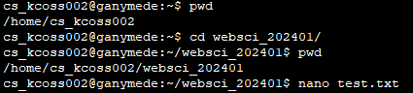

mkdir & nano commands

### Permissions

I forgot to do this when I created the file. I was able to fix it later in the process.

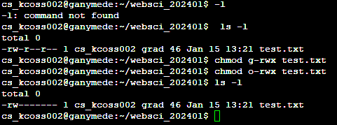

chmod view and edit

## **Part #2 - Command Descriptions**

### Question #1

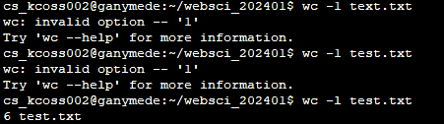

wc -l

This command printed the number of lines that were in the test file. It took a couple of tries because I have trouble telling the difference between 1 and the letter “l” when I have to use that font. In my case I had 6 lines since it counted the blank line.

### Question #2

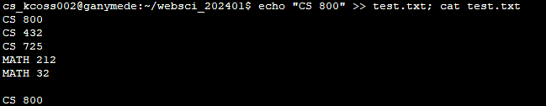

echo "CS 800" >> test.txt; cat test.txt

This command added “CS 800” to a new line at the end of the test file, so now the test file has 7 lines.

### Question #3

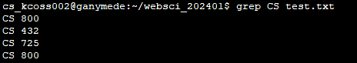

grep CS test.txt

grep printed the full text of all the lines in the test file that included the string “CS”.

### Question #4

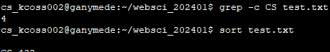

grep -c CS test.txt

This command printed the number of lines in the test file that included the string “CS”.

### Question #5

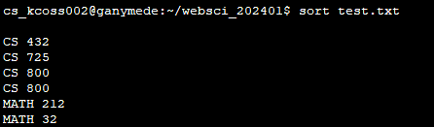

sort test.txt

The basic sort command sorted the lines in the text file by alphabetical order of the first letter, then by ascending order of the first digit of the class number, and finally then showed the full text of the file. It looks like the blank line was sorted to the top.

### Question #6

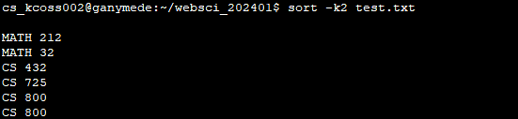

sort -k2 test.txt

Adding the -k2 sorted the lines in the file by reverse alphabetical order, but still sorted the first digit of the class number as ascending (as in, it didn’t reverse sort the first digit from 9 to 1). The blank line is still sorted to the top.

### Question #7

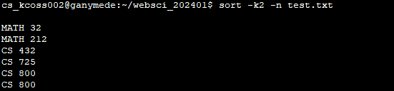

sort -k2 -n test.txt

Adding the -n sorted the lines in the file by reverse alphabetical order, then sorted the class numbers ascending by their full numeric value (it finally recognized that 32 was less than 212).

### Question #8

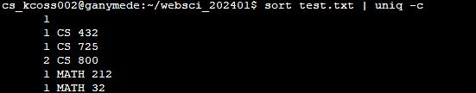

sort test.txt | uniq -c

Adding the uniq -c command sorted the lines in alphabetical order, then by full numerical value of the classes. It also returned the number of lines that contained (or maybe exactly matched) each string. It shows that there are 2 lines that have the string CS 800, so this would be a good way to check for duplicates in longer files.

## **References**

### Basic Linux commands

* <https://www.digitalocean.com/community/tutorials/linux-commands>

### Creating directories & files

* <https://www.redhat.com/sysadmin/create-delete-files-directories-linux>
* <https://www.freecodecamp.org/news/how-to-save-and-exit-nano-in-terminal-nano-quit-command/>

### How to do permissions

* <https://www.cs.odu.edu/~zeil/cs252/latest/Public/protection/index.html>