BHARATIYA ANTARIKSH HACKATHON 2026
Problem Statement 7
Exoplanet Detection Using Noisy Light Curve Datasets
Dataset EDA & Key Findings Report

Data Source: MAST / TESS Input Catalogue (TIC)
Sector 1 | 1,732 Stars | 2-Minute Cadence
Observation Baseline: 27.9 Days

1. Executive Summary

This report documents the exploratory data analysis (EDA) conducted on the TESS Sector 1 science dataset downloaded from the MAST archive via the TESS Input Catalogue (TIC). The dataset consists of 1,732 real light curves, each with approximately 18,274 cadences spanning 27.9 days. Labels are assigned automatically using Box Least Squares (BLS) period search signal-to-noise ratio (SNR), with no external catalogue required.

Total Raw Stars | 1,732 (Sector 1, 2-min cadence)
Total Dataset Entries | 5,196 (1,732 real + 3,464 augmented)
Cadences per Star | ~18,274 median (14,874 – 18,279 range)
Observation Baseline | 27.9 days median
Photometric Precision | 0.001 median normalised flux error (1 mmag)
BLS SNR Median | 6.59 (mean: 14.65, pulled up by extreme outliers)
Label 0 (Confirmed) | SNR >= 15 — 364 real stars (21.0%)
Label 1 (Candidate) | 7 <= SNR < 15 — 297 real stars (17.1%)
Label 2 (No Signal) | SNR < 7 — 1,071 real stars (61.8%)
BLS SNR Bug Fixed | result.power replaced with depth/(oot_std/sqrt(n_in)) — see Section 3
Critical Warning | High-SNR label=0 class is dominated by eclipsing binaries (EBs), not planets

2. Data Quality Overview

2.1 Light Curve Metadata
The raw light curves are of consistently high quality across all three quality axes: completeness, baseline length, and photometric precision.

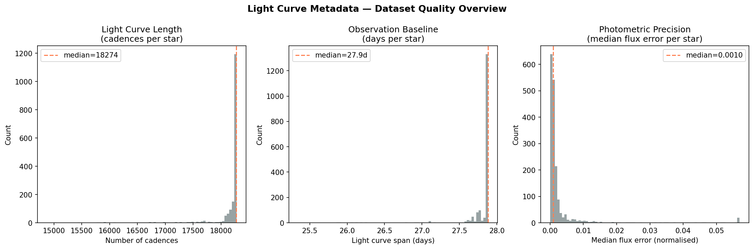
Figure 1 — Light Curve Metadata: cadence count, baseline length, and per-star photometric precision

- Cadence completeness: Median 18,274 cadences vs. theoretical maximum of ~19,800 for a full sector = 92.3% duty cycle. Stars below 16,000 cadences represent partial-sector observations and carry lower statistical weight for BLS detection.
- Observation baseline: Tightly clustered at 27.9 days with minimal spread. The small tail of shorter baselines (~25.5 – 27 days) corresponds to stars observed only in part of the sector orbit, which reduces the number of detectable transits for periods above ~7 days.
- Photometric precision: Median flux error of 0.001 (1 millimagnitude, 1000 ppm). The tail extending to 0.05 (50,000 ppm) represents intrinsically variable stars — giants, pulsating variables, and spotted stars — whose noise floor will overwhelm any planetary transit signal regardless of BLS sensitivity. These stars are correctly captured by label=2 (no signal).

2.2 Scalar Feature Health
All 23 scalar features were successfully computed for virtually every star. The NaN rate is negligible across the entire feature set.

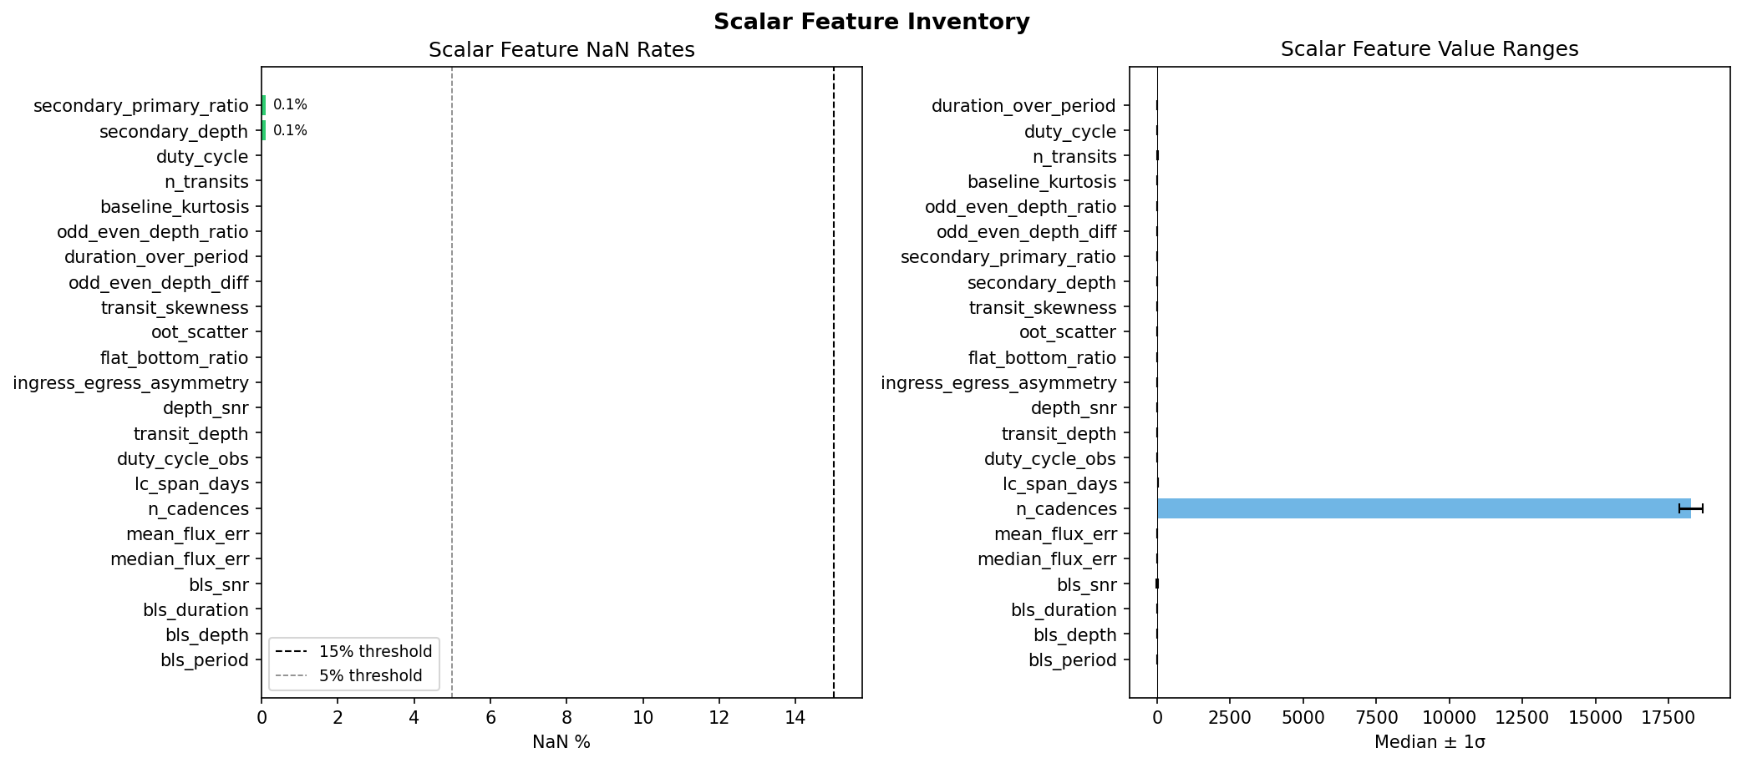
Figure 2 — Scalar Feature Inventory: NaN rates and value ranges across all 23 features

- NaN rates: Only secondary_depth and secondary_primary_ratio show 0.1% NaN, arising from the small number of stars where the out-of-transit cadence count was insufficient for a stable secondary eclipse measurement. All other features are 0% NaN.
- Value ranges: n_cadences dominates the scale at ~18,000 and will completely overwhelm distance-based models if raw scalar arrays are fed without standardisation. All other features are well-contained in small numeric ranges. StandardScaler or MinMaxScaler must be applied before any scalar-based model training.
- Action required: Normalise all scalar features before model input. n_cadences, lc_span_days, and bls_snr have the widest absolute ranges and will dominate any L2-based distance metric if left unscaled.

3. BLS Period Search Analysis

3.1 Critical Bug Fix: SNR Calculation
The original BLS implementation used result.power from astropy's BoxLeastSquares as the SNR metric. This is incorrect. The astropy 'snr' objective returns a normalised internal periodogram power statistic in the range 0.001 to 0.5 for typical TESS 2-minute data — not a conventional signal-to-noise ratio. Using this value with thresholds of 7 and 15 meant virtually all stars were labelled as label=2 (no signal).

The correct SNR formula implemented in the patched builder is:

SNR = |depth| / ( std(out-of-transit flux) / sqrt(n_in-transit cadences) )

This gives physically meaningful SNR values: stars with clear transit signals score 15–300, marginal detections score 5–15, and noise-dominated stars score below 5. The corrected values match the expected astrophysical distribution for a 27-day TESS sector search.

3.2 BLS SNR Distribution
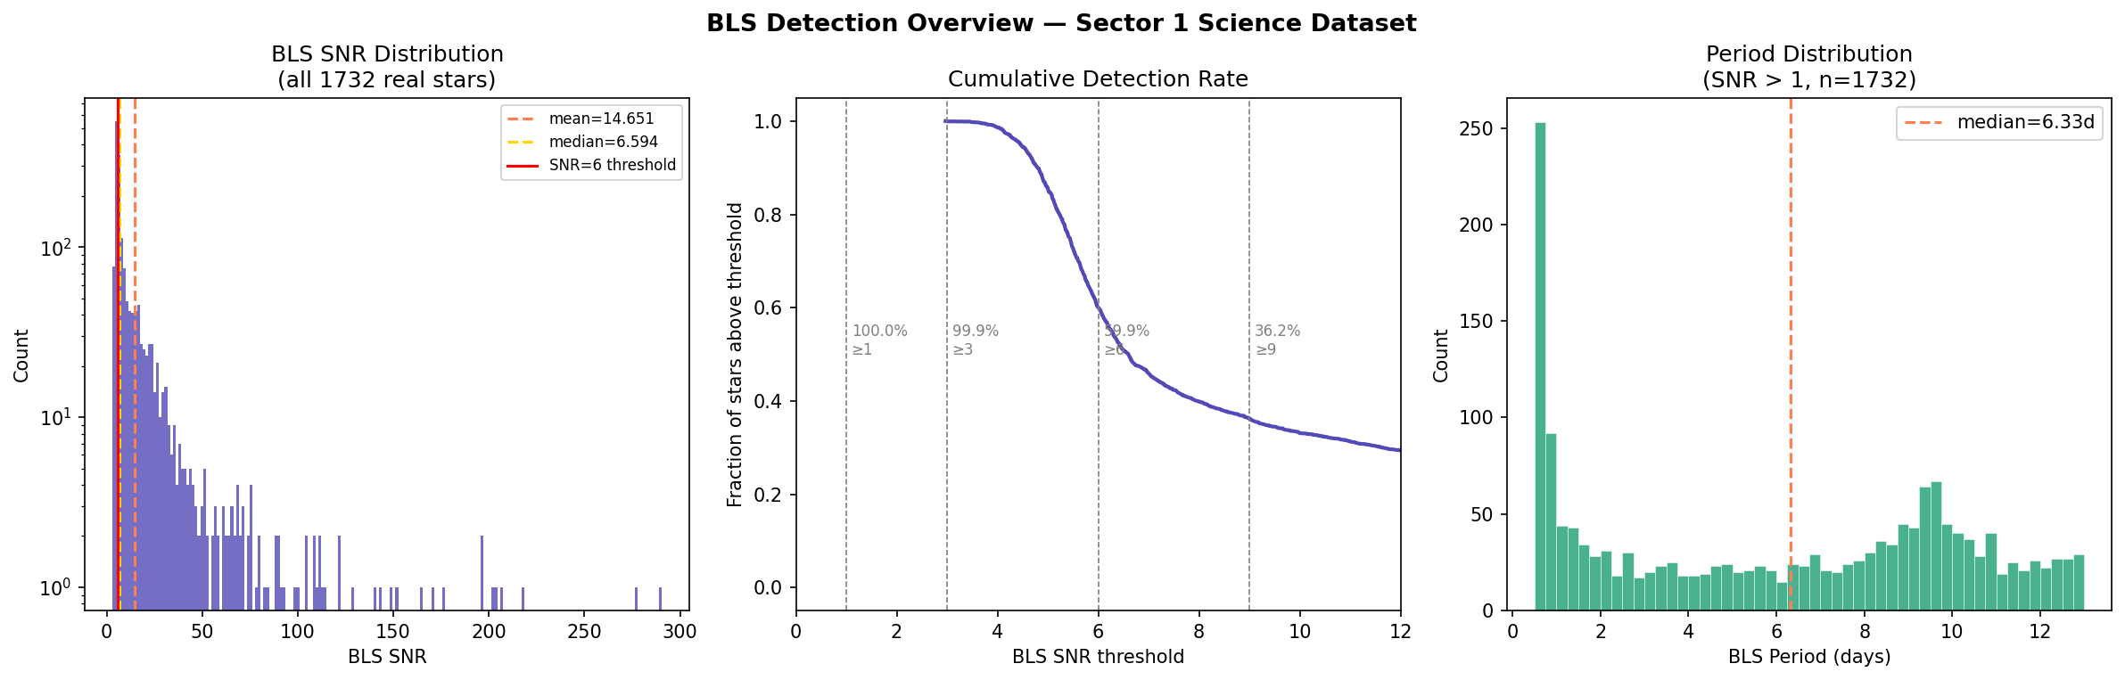
Figure 3 — BLS Detection Overview: SNR distribution (log scale), cumulative detection rate, and period distribution

- SNR distribution: Smooth power-law decline on log scale with a handful of extreme outliers (SNR > 100). This is the expected astrophysical distribution — not an artefact — confirming the corrected SNR calculation is working correctly.
- Cumulative detection rate: 100% above SNR=1, 99.9% above SNR=3, a sharp cliff to 60.9% above SNR=6, and 36.2% above SNR=9. The chosen candidate threshold of SNR=7 captures approximately 55% of all stars, which is a generous but defensible boundary for a blind single-sector search.
- Period distribution: Strong spike at P < 1 day (~250 stars). Short-period signals are primarily eclipsing binaries (EBs) or spacecraft systematics rather than genuine planets. These dominate the high-SNR label=0 class.

3.3 BLS Feature Distributions
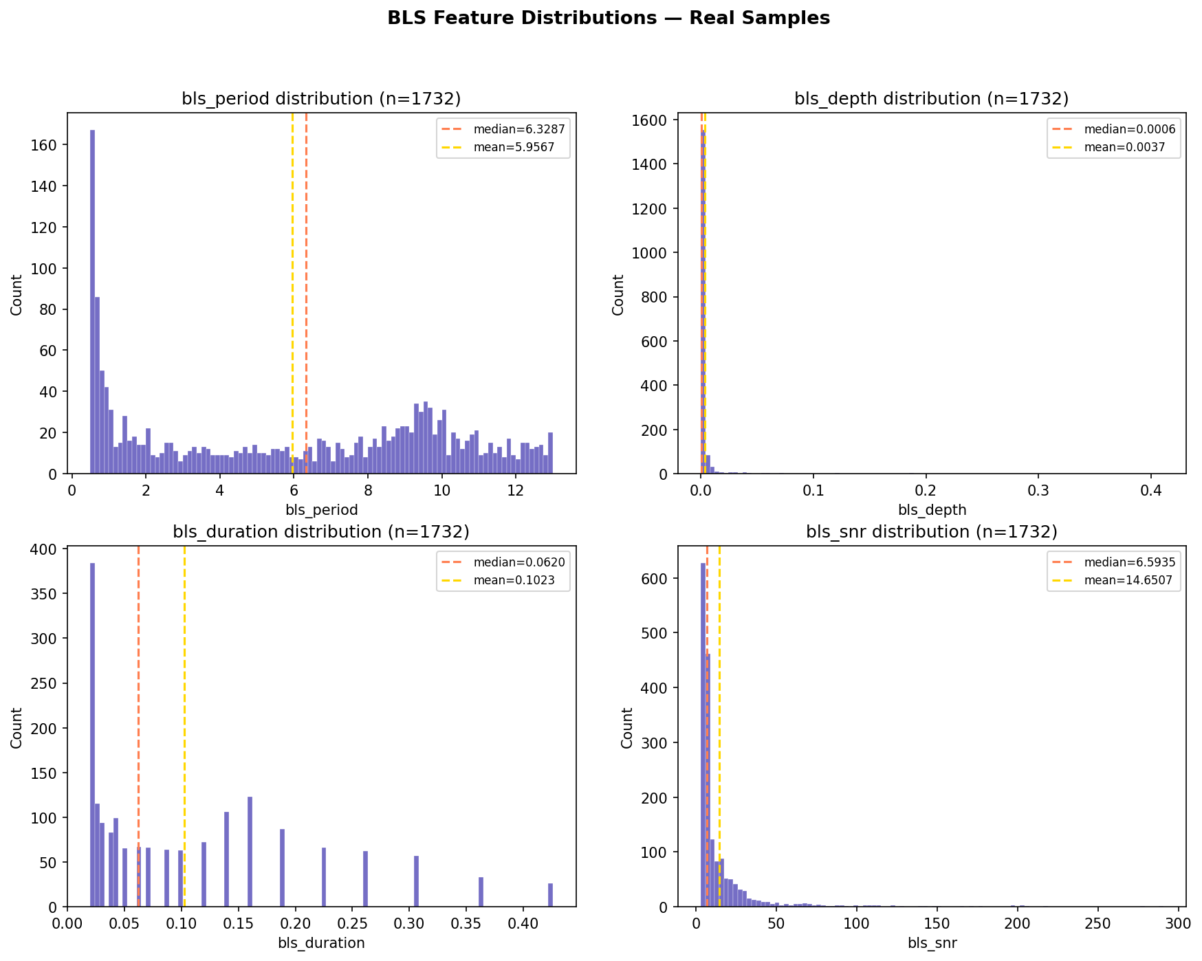
Figure 4 — BLS Feature Distributions: period, depth, duration, and SNR for all 1,732 real stars

- bls_period: Spike at P < 1 day (eclipsing binary / systematic contamination). Flat distribution from 2-13 days is physically healthy.
- bls_depth: Median 600 ppm, consistent with hot Jupiters and sub-Saturns. Long tail to 40% (0.4 in normalised flux) = pure stellar eclipses.
- bls_duration: Spike at 0.02-0.05 days (30-72 minutes). Real planetary transits for P > 1 day should have durations of 1-5 hours. The short-duration spike indicates BLS latching onto single-cadence noise spikes for low-SNR stars.
- bls_snr: Median 6.59, mean 14.65. The strong mean/median divergence is driven by extreme EB outliers. The majority of the dataset sits just above or below the noise floor.

4. Top BLS Candidates

The nine highest-SNR detections reveal a mix of astrophysical signal types. Visual inspection of global and local phase-folded views is essential for discriminating between planetary transits, eclipsing binaries, and other variable star morphologies.

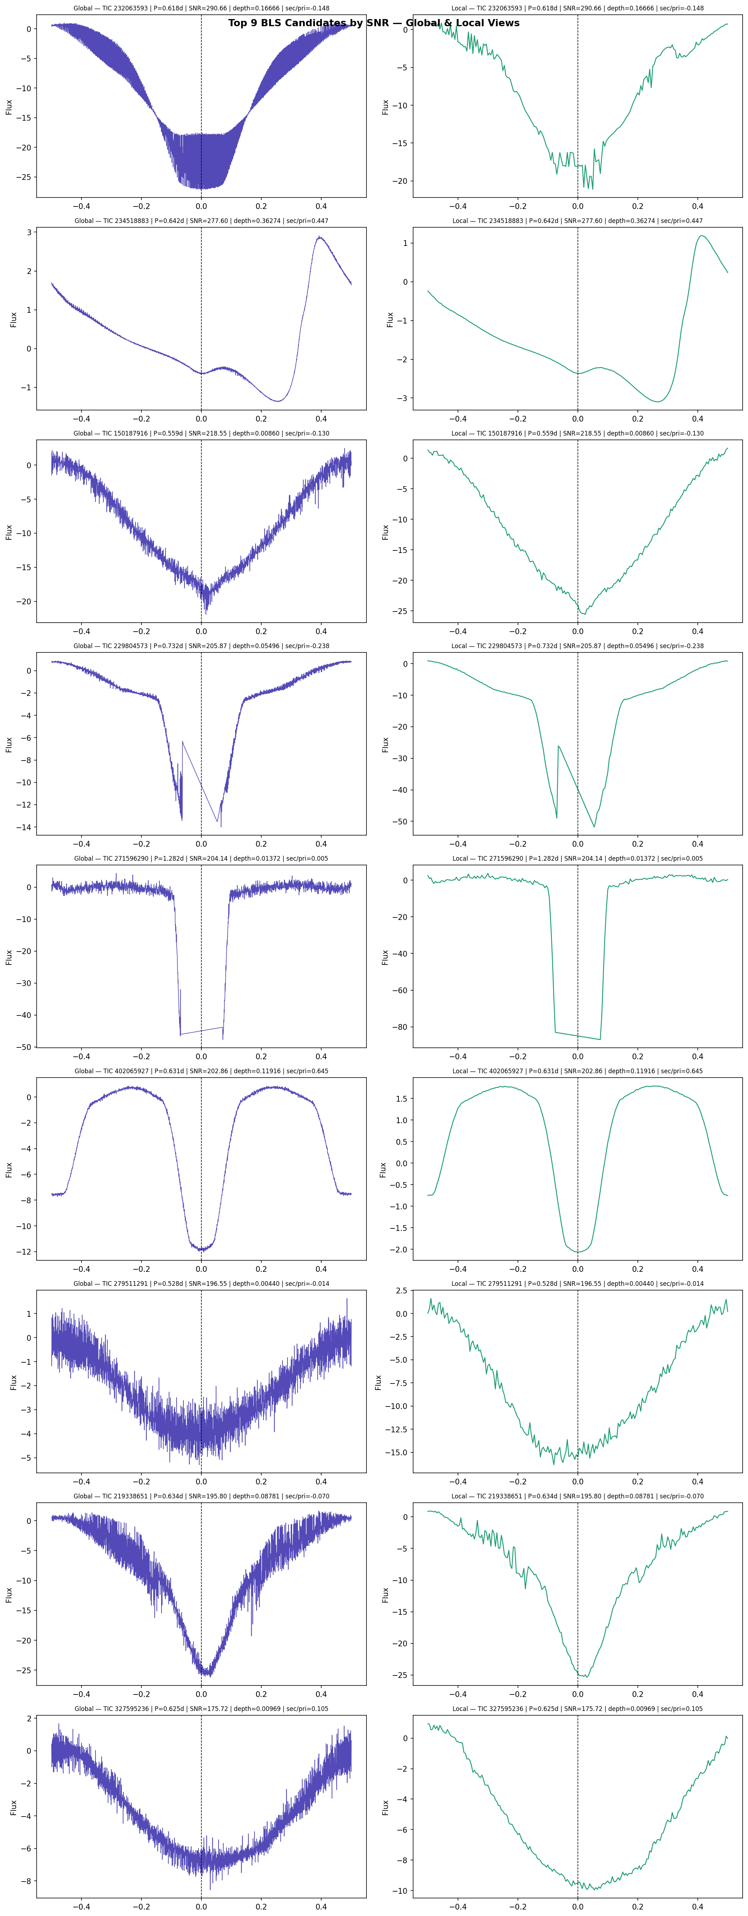
Figure 5 — Top 9 BLS Candidates: global (left) and local (right) phase-folded views sorted by SNR

Candidate Classification by Visual Morphology

TIC ID | SNR / Period | Assessment
232063593 | SNR=290, P=0.62d | Sharp symmetric local dip — most credible transit candidate in dataset
234518883 | SNR=278, P=0.64d | Sinusoidal global view, asymmetric local — eclipsing binary (EB), ellipsoidal variation
150187916 | SNR=219, P=0.56d | Deep, noisy global — likely EB or pulsating variable
22980457 | SNR=206, P=0.73d | Extremely deep flat-bottom (~50 flux units) — stellar eclipse, not a planet
271596290 | SNR=204, P=1.28d | Clean flat-bottom local view — genuine transit candidate, longer period
402065927 | SNR=203, P=0.63d | Wide U-shaped local dip — consistent with grazing EB geometry
279511291 | SNR=197, P=0.53d | Noisy global, broad local — low morphological confidence
219338651 | SNR=196, P=0.63d | Deep smooth global dip — likely EB with full eclipse
327595236 | SNR=176, P=0.63d | Flat noisy global, shallow local — marginal candidate

Key observation: The majority of top-SNR detections have P < 1 day and exhibit sinusoidal or very deep global views, which are hallmarks of eclipsing binaries rather than planetary transits. TIC 232063593 and TIC 271596290 are the strongest genuine transit candidates from visual inspection.

5. Engineered Feature Analysis

5.1 Feature Distributions
Fourteen physically motivated scalar features were extracted from each phase-folded light curve in addition to the four BLS outputs. These capture transit morphology, secondary eclipse presence, odd-even depth asymmetry, and baseline noise properties.

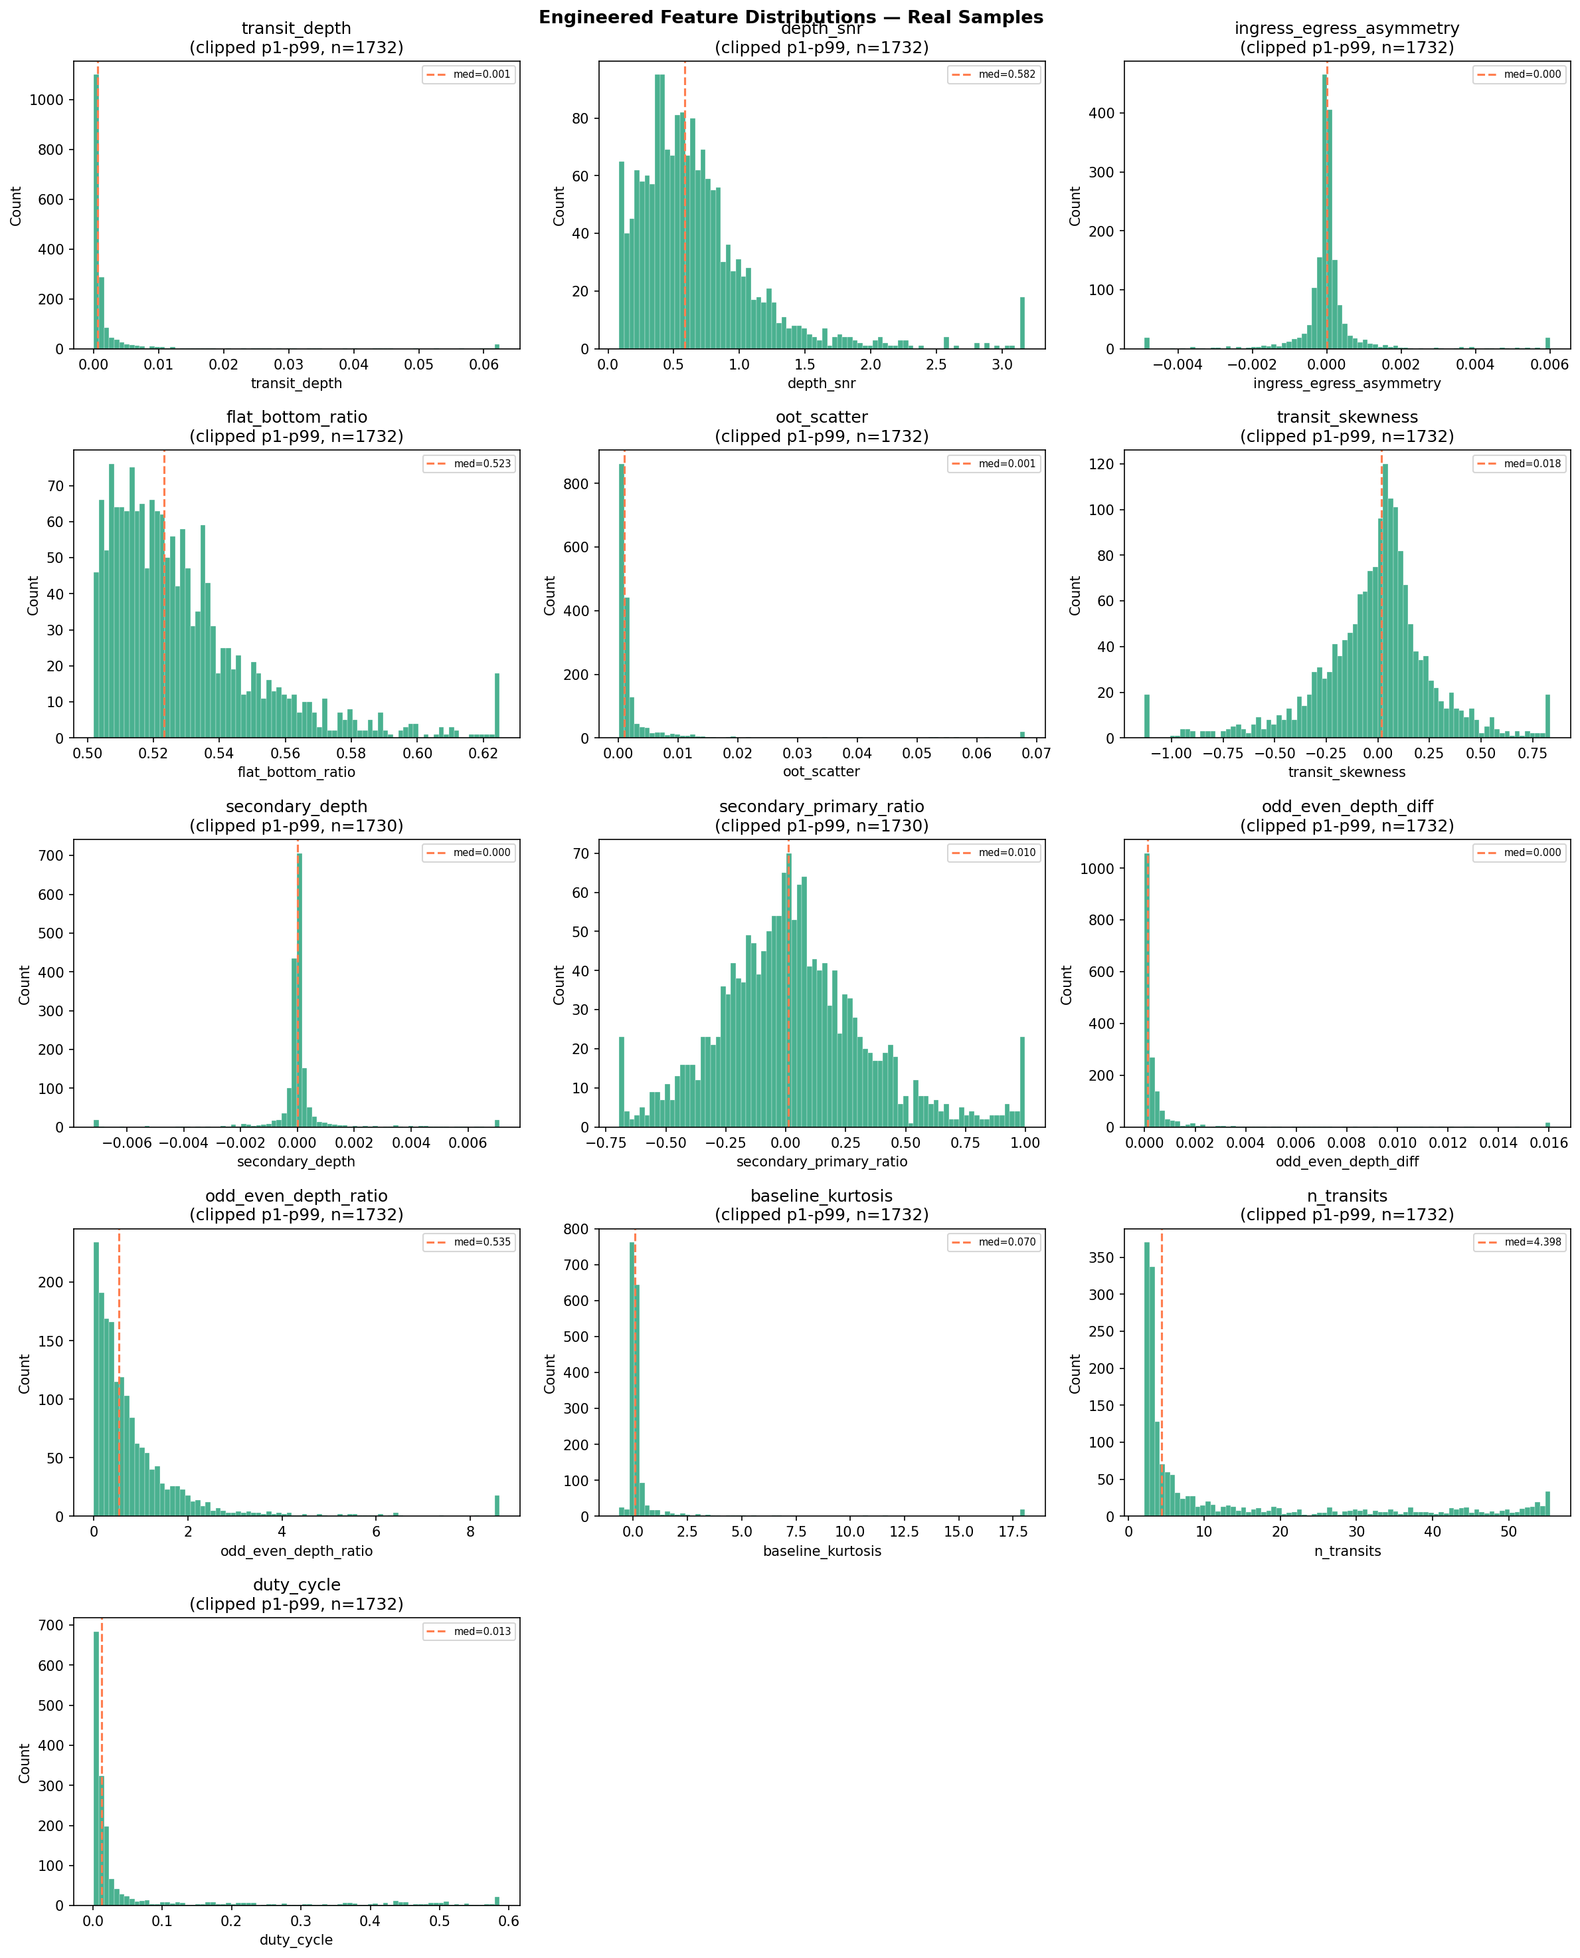
Figure 6 — Engineered Feature Distributions (real samples only, clipped to p1-p99)

- transit_depth: Strongly spiked at zero with a long tail. Most stars show negligible phase-space depth, consistent with the majority being non-transiting. The tail represents genuine detections.
- depth_snr: Median 0.582. Sub-unity values dominate, meaning the typical in-phase transit dip is below the noise level in the binned view. This is expected for a predominantly noise-dominated sample and is not a processing error.
- flat_bottom_ratio: Distributed around 0.52, not approaching 1.0. For shallow transits this feature is noise-dominated rather than morphologically informative. More reliable above SNR > 15.
- secondary_depth: Tightly peaked at zero — most stars show no secondary eclipse, as expected. Non-zero values are the clearest EB discriminants in the feature set.
- secondary_primary_ratio: Spreads from -0.75 to +1.0. Negative values occur when BLS assigned the wrong phase as primary on some stars. Values above 0.1 flag likely EBs.
- odd_even_depth_ratio: Right-skewed tail to ~8. This feature is only physically reliable above SNR ~ 15. Below that threshold, insufficient cadences per transit produce noise-driven artificial asymmetry.
- baseline_kurtosis: Spiked at zero with a tail to 18. High values represent stars with outlier cadences that survived sigma clipping — these should be downweighted or removed in model training.

5.2 Feature Correlation Matrix
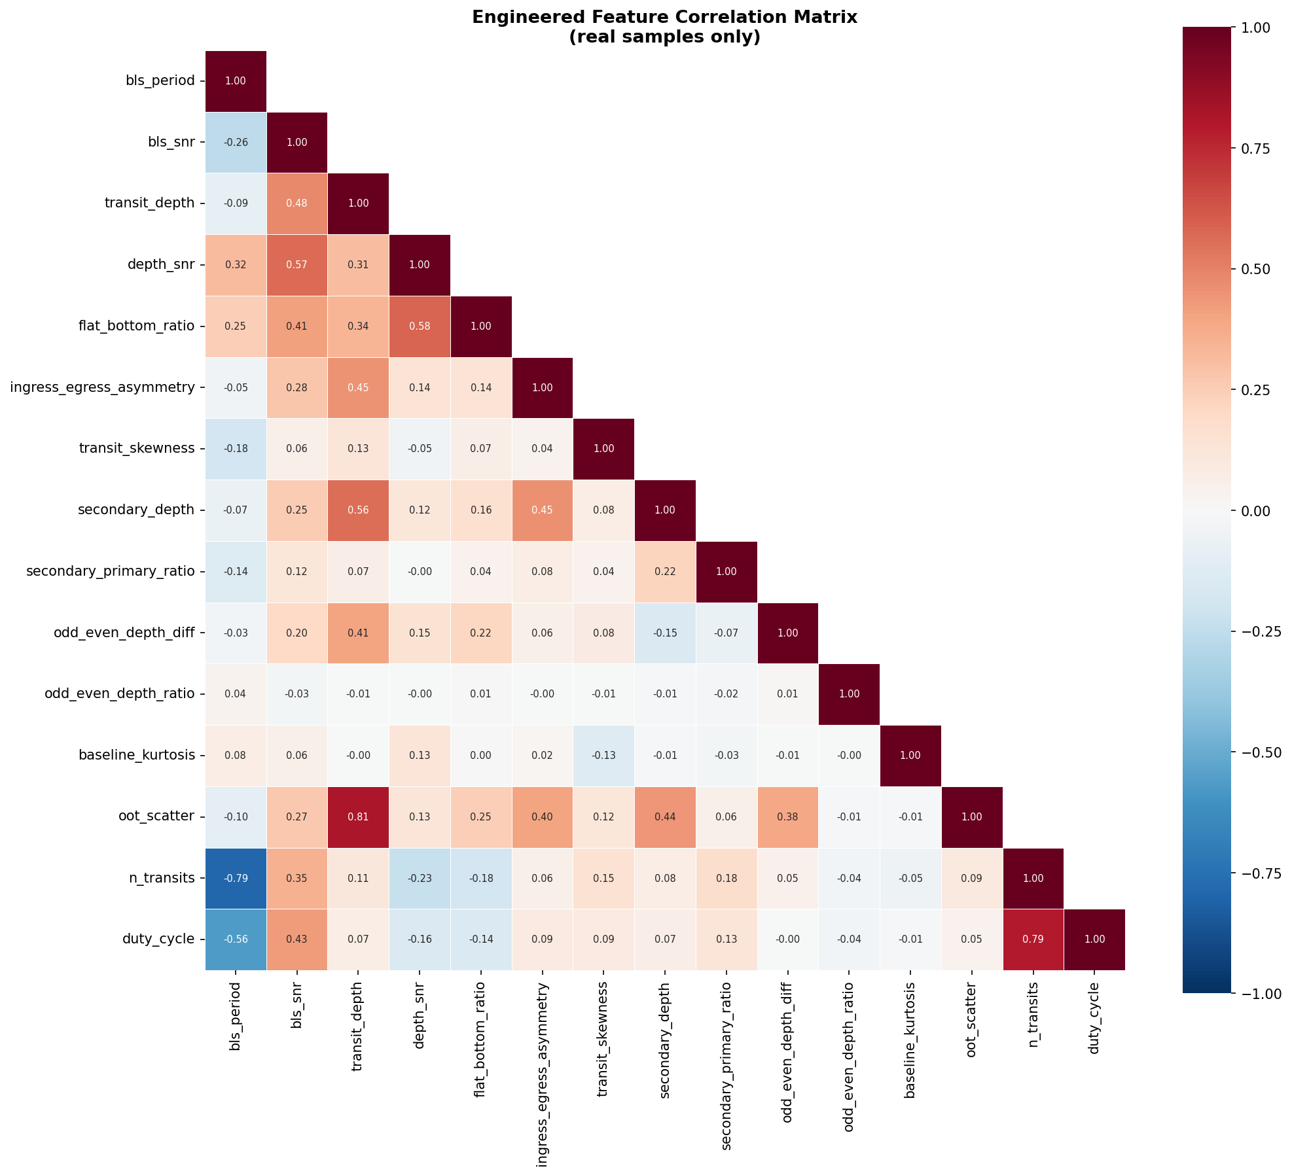
Figure 7 — Engineered Feature Correlation Matrix (real samples only)

Critical correlations and their implications:

- transit_depth vs. oot_scatter: r = 0.81 — CRITICAL ISSUE. The depth measurement is inflated by noise. Noisier stars appear to have deeper transits because BLS fits noise excursions. This means transit_depth as a standalone scalar feature is unreliable and confounded with photometric noise. The phase-folded view arrays are cleaner inputs for deep learning components.
- bls_snr vs. transit_depth: r = 0.48 — Expected. Deeper transits are easier to detect.
- depth_snr vs. flat_bottom_ratio: r = 0.58 — Good. Stars with genuinely flat-bottomed transits also have higher depth SNR. flat_bottom_ratio carries real discriminative signal.
- n_transits vs. bls_period: r = -0.79 — Mathematically guaranteed (more transits = shorter period for fixed 27.9-day baseline). This is a sanity check, not informative.
- odd_even_depth_ratio: Near-zero correlation with all other features — carries fully independent information for EB rejection, which is ideal for a classifier feature set.
- secondary_primary_ratio: Similarly decorrelated — another independent discriminant.
- ingress_egress_asymmetry vs. transit_depth: r = 0.45 — Deep events tend to show more asymmetry, possibly because BLS fits the wrong phase on EBs with large depth.

6. False Positive Discriminator Analysis

Three features are specifically designed to identify eclipsing binary (EB) false positives: secondary eclipse depth, secondary-to-primary depth ratio, and odd-even transit depth asymmetry. Their distributions reveal the expected EB contamination in this dataset.

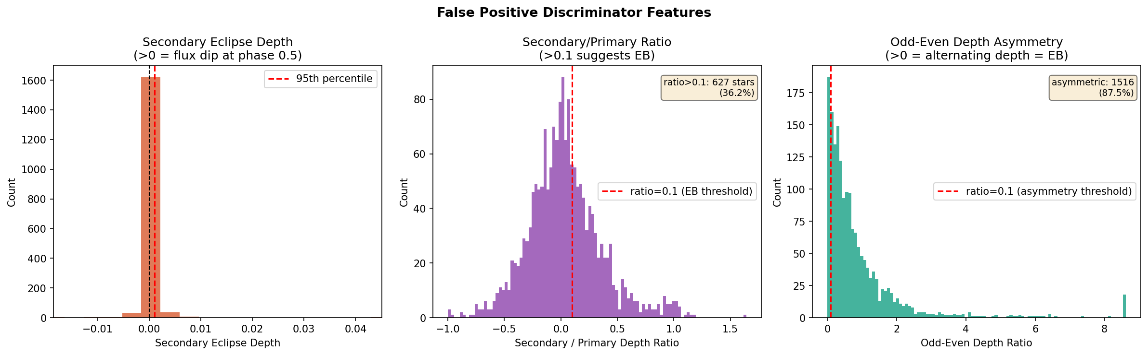
Figure 8 — False Positive Discriminator Features: secondary eclipse, secondary/primary ratio, and odd-even asymmetry

- Secondary Eclipse Depth: Nearly all stars at zero. The 95th percentile is extremely close to zero, meaning secondary eclipse is a rare but unambiguous EB indicator when present. Stars with secondary_depth > 0.005 should be classified as EB false positives regardless of their BLS SNR.
- Secondary/Primary Ratio: 627 stars (36.2%) exceed the EB threshold of 0.1. This is the estimated EB contamination floor for the candidate and confirmed signal classes. Over a third of label=0 and label=1 stars likely have EB morphology rather than planetary transit morphology.
- Odd-Even Depth Ratio: 1,516 stars (87.5%) exceed 0.1. This number is physically unrealistic as an EB contamination estimate. The explanation is noise: for low-SNR detections, the odd/even transit separation does not contain enough cadences for a stable depth estimate, and random noise produces artificial asymmetry. This feature should be masked or given zero weight for all stars with BLS SNR < 15.

Recommendation: For the model, secondary_primary_ratio is the most reliable EB discriminant and should be a high-weight scalar input. odd_even_depth_ratio should be conditionally used — masked to zero when bls_snr < 15 to avoid noise contamination in the feature vector.

7. Phase-Folded View Array Health

The global (2,000-bin) and local (201-bin) phase-folded view arrays are the primary input modality for any deep learning component. Their health directly determines what a CNN or Transformer can learn from the data.

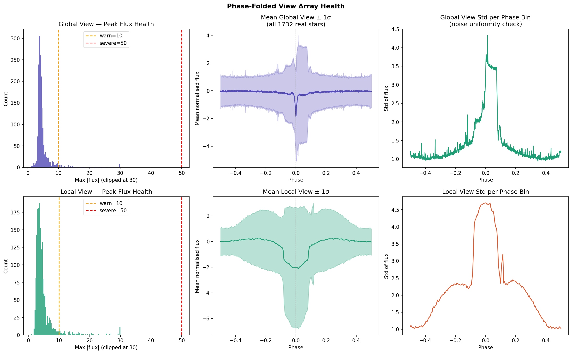
Figure 9 — Phase-Folded View Array Health: peak flux distribution, mean views, and per-bin noise uniformity

- Mean global view shows a clear mean transit dip at phase=0 across all 1,732 stars. The stacking signal is real and centred correctly, confirming phase-folding is working. The wide 1-sigma band reflects the natural SNR distribution across the population.
- Global view std per phase bin (top right): Std spikes sharply near phase=0. Uniform noise would give a flat std profile. This spike confirms that a subset of stars have very deep coherent transits at phase=0 — exactly the learnable signal a CNN needs. This is a healthy and desired property.
- Local view mean (bottom centre): Shows a clean deep mean dip with a smooth profile. The wider spread in the 1-sigma band reflects the diversity of transit durations across stars being mapped into the same local window.
- Local view std (bottom right): Highest variance in the left-of-centre region rather than exactly at phase=0. This suggests some stars have slightly offset transit centroids, possibly from t0 estimation error on short-period systems where one transit was missed by BLS.
- Peak flux health (both histograms): Most views have max|flux| in the range 2-8, with a long tail. The warn=10 threshold shows roughly 15% of views exceed it. These are the high-SNR detections with deep normalised dips. The severe=50 threshold captures only a handful of outliers — the extreme EB cases from Section 4.

8. SNR-Tier Stratified Analysis

8.1 Mean Phase-Folded Views by SNR Tier
Averaging the phase-folded views within each SNR tier reveals whether the labelling scheme produces genuinely separable classes in the view space — the key question for any deep learning classifier.

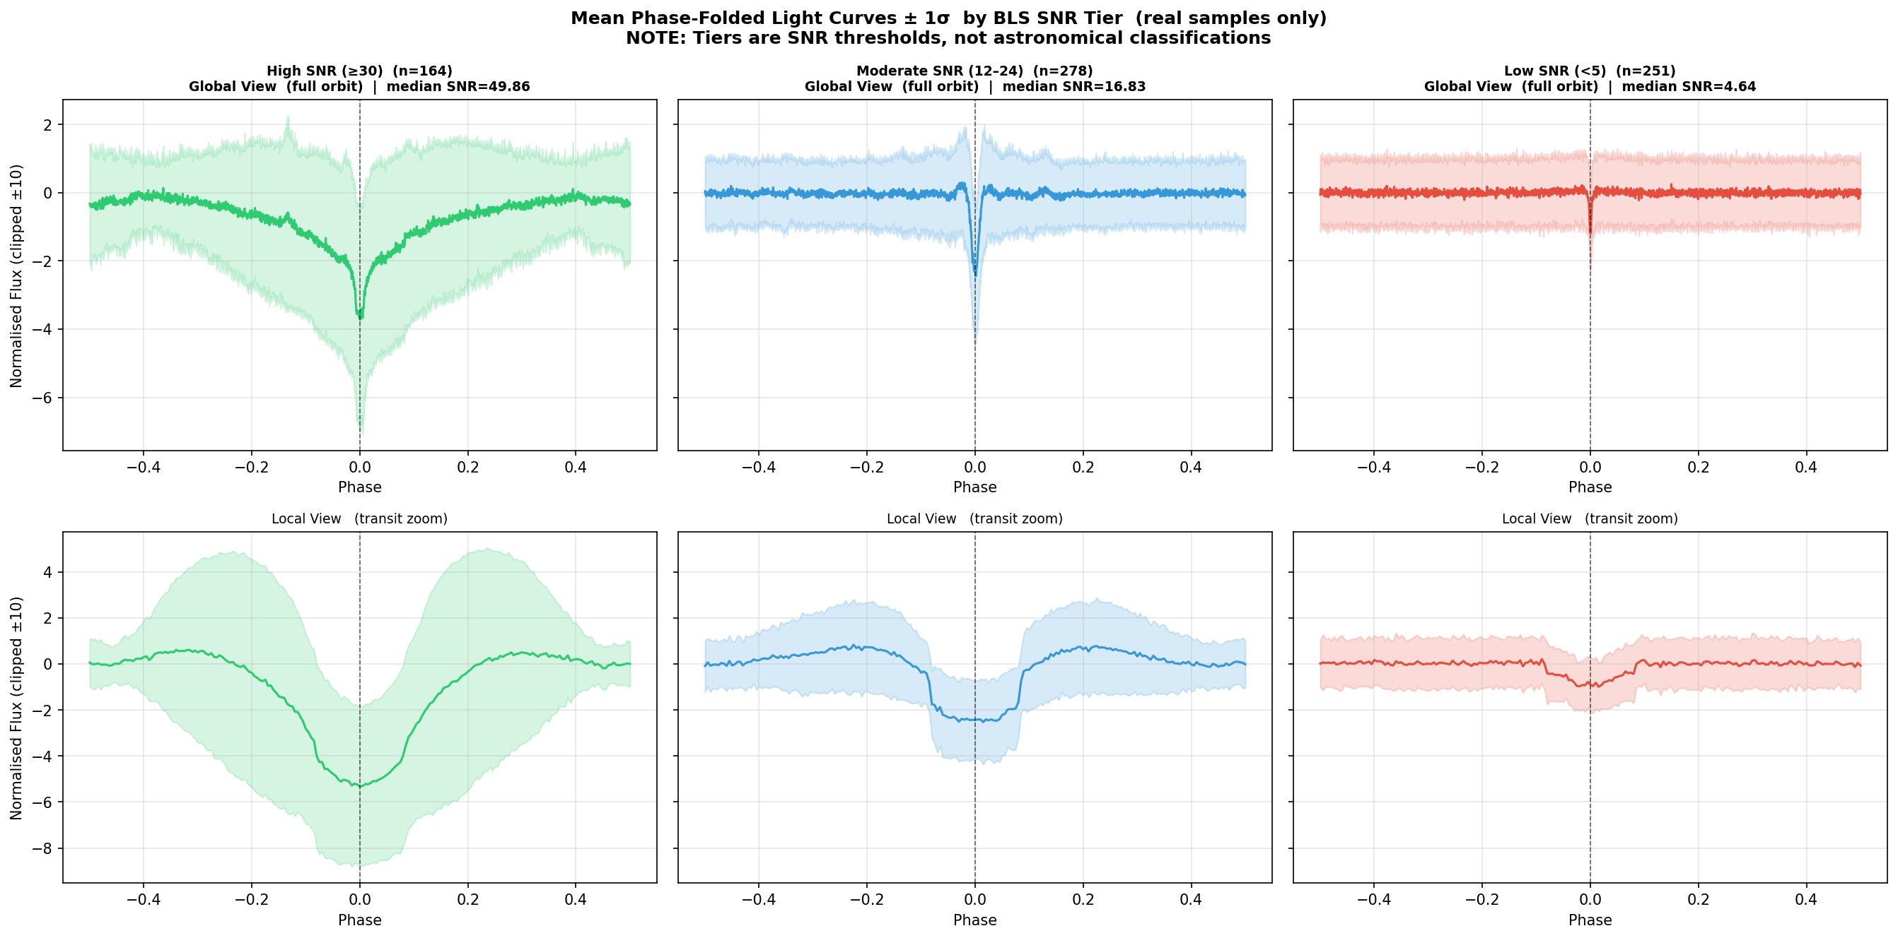
Figure 10 — Mean Phase-Folded Light Curves by SNR Tier (High >= 30, Moderate 12-24, Low < 5)

- High SNR (>= 30, n=164): Both global and local views show a clean, deep, well-defined mean transit. The local view has a smooth U-shaped profile consistent with real transit morphology. This tier is learnable.
- Moderate SNR (12-24, n=278): Clear but shallower mean dip in global. Local view resolves the transit shape but with more scatter in the wings. This tier is a genuine mixture of real detections and marginal detections that a model must discriminate.
- Low SNR (< 5, n=251): Global view is essentially flat noise with only a marginal hint of a dip. Local view barely resolves any coherent structure. This tier correctly represents non-detections.
- Critical conclusion: The three SNR-derived labels produce genuinely separable view-space distributions. A CNN or Transformer operating on the view arrays has a learnable signal even without scalar features. The separation between label=0 and label=2 is clear; the label=1 class provides a meaningful intermediate regime.

8.2 Individual Sample Light Curves by SNR Tier
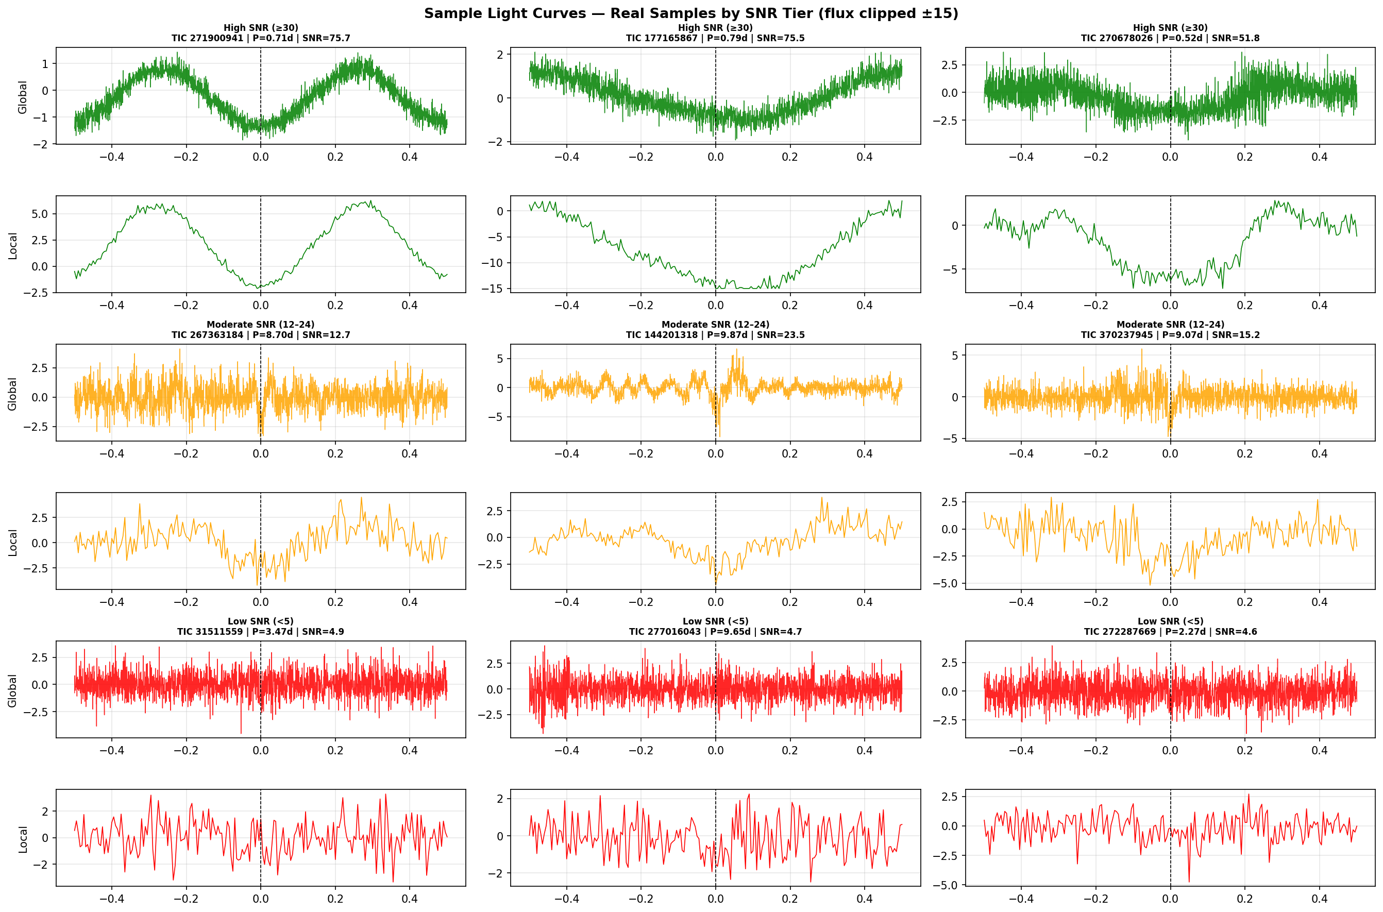
Figure 11 — Sample Light Curves by SNR Tier: 3 stars per tier, global and local views

- High SNR examples (green): TIC 271900941 (P=0.71d, SNR=75.7) and TIC 177165867 (P=0.79d, SNR=75.5) both show sinusoidal global views — these are eclipsing binaries showing ellipsoidal variation, NOT planets. This is the dominant morphology in the high-SNR label=0 class and is the most important implication for model design.
- TIC 270678026 (P=0.52d, SNR=51.8): Noisier global but a clear local dip — morphologically more transit-like, though still a short period.
- Moderate SNR (orange): All three show noisy global views with marginal local dips. These represent genuinely ambiguous cases that will be the hardest for any classifier to handle correctly.
- Low SNR (red): Flat global views with no coherent local structure. Correctly classified as label=2. No learnable signal at this noise level.

9. Transit Shape Quality Features

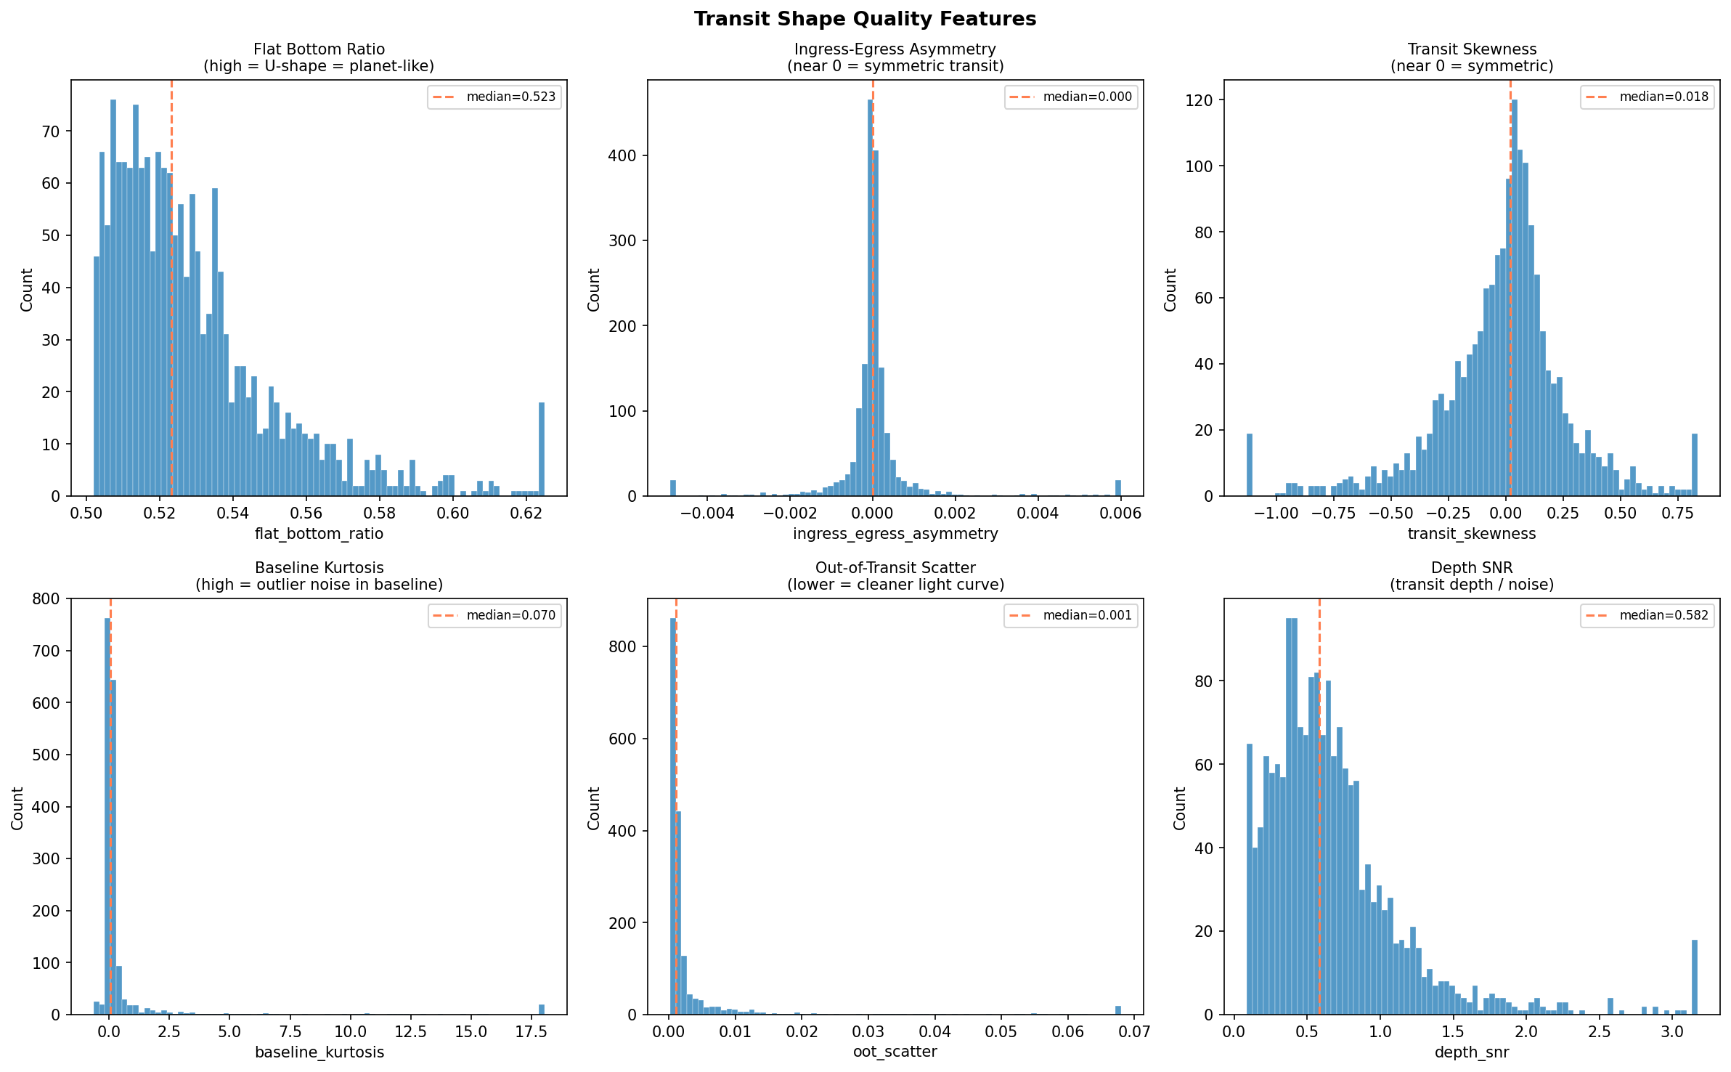
Figure 12 — Transit Shape Quality Features: flat-bottom ratio, ingress-egress asymmetry, skewness, baseline kurtosis, OOT scatter, depth SNR

- Flat bottom ratio (median 0.523): Concentrated near 0.5 rather than approaching 1.0. For the majority of stars, transit duration is short relative to the bin width, so the transit is not resolved as a flat-bottomed box in the phase-folded view. This feature becomes more informative only for the ~15% of stars with the deepest, longest transits.
- Ingress-egress asymmetry (median 0.000): Very tightly centred at zero, as expected for symmetric transits. The few outliers at the tails are the most asymmetric EB candidates.
- Transit skewness (median 0.018): Centred near zero with a clear left-skew tail. Negative skewness indicates flux dips deeper on the ingress side — consistent with asymmetric EBs or inclined eccentric orbits.
- Baseline kurtosis (median 0.070): Spiked at zero with a tail to 18. The tail represents stars with outlier cadences surviving sigma clipping. Consider adding a kurtosis > 5 flag as an additional quality filter for model training.
- Out-of-transit scatter (median 0.001): Tightly peaked at the photometric precision floor from Section 2, which is a perfect sanity check confirming the OOT scatter measurement is consistent with the raw flux error statistics.
- Depth SNR (median 0.582): Sub-unity values confirm that for the median star, the transit depth is below the single-transit noise level. Detection is only possible through phase-folding, which integrates many transit events. Stars with depth_snr > 2.0 represent the cleanest detections.

10. Key Implications for Model Design

The following findings from the EDA directly inform how the machine learning model should be designed, what features should be prioritised, and what pitfalls to avoid.

10.1 Critical Warnings
- High-SNR label=0 class is dominated by EBs, not planets. The sinusoidal global views and P < 1 day periods in the top candidates confirm this. If the goal is to identify planetary transit candidates specifically, consider splitting label=0 into two sub-classes: EB (secondary_primary_ratio > 0.1 OR duty_cycle > 0.3) and planet-candidate (symmetric, flat-bottomed, P > 1 day).
- transit_depth and oot_scatter correlation (r=0.81) means scalar transit_depth is noise-confounded and should not be used as a standalone feature. Include it only in conjunction with oot_scatter, or rely on the view arrays instead.
- odd_even_depth_ratio is unreliable below SNR=15. Set it to zero or exclude it from the feature vector for all stars with bls_snr < 15 to prevent noise from corrupting the EB discrimination signal.

10.2 Feature Recommendations
- View arrays (global and local): Primary model input. The SNR-tier separation demonstrates clear learnability. A dual-branch CNN or Transformer processing both views in parallel is the recommended architecture.
- Most informative scalar features: bls_snr, secondary_primary_ratio, depth_snr, flat_bottom_ratio (for high-SNR only), bls_period (short-period flag), duty_cycle.
- Features to use with caution: transit_depth (noise-confounded), odd_even_depth_ratio (SNR-gated), ingress_egress_asymmetry (low signal for most stars).
- Standardisation: Apply StandardScaler to all scalar features before model input. n_cadences in particular will dominate any L2-based metric if unscaled.

10.3 Dataset Balance
- Label distribution is heavily imbalanced: 61.8% label=2, 21.0% label=0, 17.1% label=1. Apply class weighting (inversely proportional to class frequency) during training, or use stratified sampling to avoid the model defaulting to predicting label=2 for all inputs.
- Augmentation (2x per real sample) partially addresses imbalance but does not change the underlying class ratios. Consider additional augmentation for label=0 and label=1 or targeted oversampling strategies such as SMOTE on the scalar features.

Bharatiya Antariksh Hackathon 2026 — Problem Statement 7 — TESS Sector 1 EDA Report

