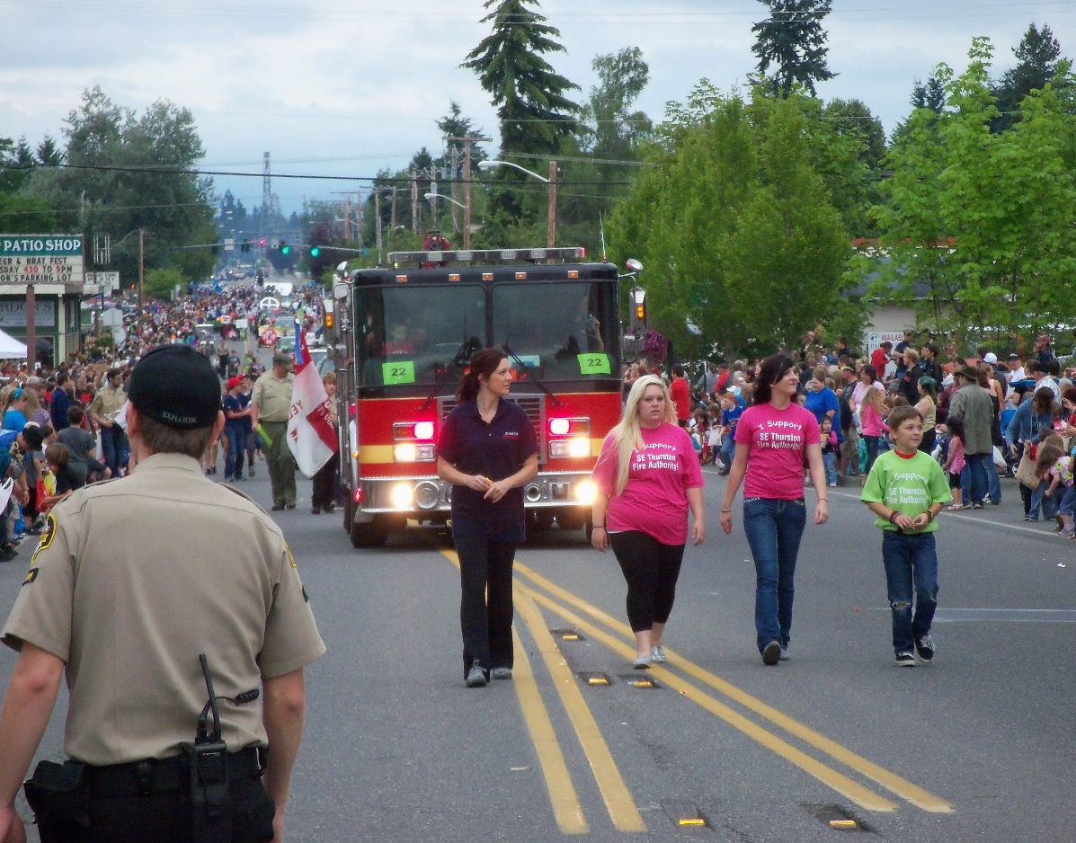

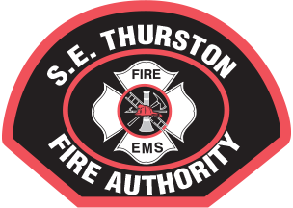S.E. Thurston Fire Authority

2015

Mission Statement:

To prevent Loss of Life, Personal Injury, and Damage from Fire, Disaster and Medical Emergencies through: Emergency Response, Training, Public Education, and Information.

**“Take Care of People – Put out Fires” (Don Miller Yelm City Council 2005)**

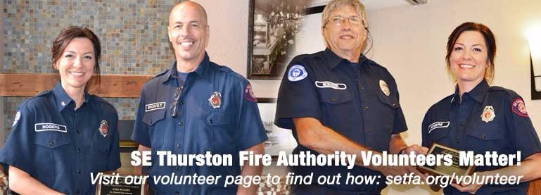

# Contents

Chief’s Message 3

District Profile……………………………………………………………...4

Organization Chart 5

3-year Tax Summary ………………………………………………..….6

Revenue Sources………………………………………………………….7

Expenditures…………………………………………………….………….8

Emergency Responses…………………………………..……….…….9

Public Education………………………………………………………….10

**To Our Citizens:**

2015 brought several successes to S.E. Thurston Fire Authority. The largest being the award of two grants from FEMA in the fourth quarter of 2015. One of these replaced an expiring grant from 2014 which eliminated any layoff of career staff. The second grant is specific to funding our volunteer program. Collectively these grants provide 1.6 million over a four-year period. These grants will allow S.E. Thurston Fire Authority to maintain all uniformed career staff as well as being a substantial boost to our volunteer program. This has resulted in our ability to staff both the Yelm and Rainier stations 100% of the time in the third and fourth quarter of 2015. The ability of S.E. Thurston Fire Authority to effectively mitigate critical situations is directly related to the availability of units. In 2015 we witnessed an 8% increase in calls for help. S.E. Thurston Fire Authority had overlapping calls 34% of the time or 1,188 times in which S.E. Thurston Fire Authority was handling multiple calls at the same time. There are predictable consequences if we are unable to arrive at an emergency call in a timely fashion. It is imperative S.E. Thurston Fire Authority continue to staff two stations 100% of the time. In addition, beginning in late 2015, we have added, on a part-time basis, an aid unit to reduce transport times when needed as well as having an additional response unit during periods of time when we are receiving multiple calls simultaneously.

Looking ahead to 2016 we will continue to staff two stations 100% of the time while strengthening our aid unit program through the use of volunteers and career staff. S.E. Thurston Fire Authority is vigorously pursuing grant funding to upgrade our outlying stations to accommodate 24 hour in-station staffing.

Again, we thank you for your continued support of the Fire Authority. Should you have any questions please do not hesitate to contact us.

Respectfully,

Mark King

Fire Chief

**District profile**

S.E. Thurston Fire Authority (SETFA) is a Category B department serving a primarily residential population of approximately 30,000 citizens covering 84 square miles and encompassing both the city of Yelm and Rainier with a total assessed value of $1,804,009, 972.

|  |
| --- |
| E:\Users\Chief\Desktop\map 1 (new) .jpg |

**Organization Chart**

1-Career Lt. FF / EMT

4-Career FF/ EMT’s

Floating LT. FF/EMT

Aid Unit Coordinator

1- Career Lt. FF / EMT

4-Career FF / EMT’s

1-Career Lt. FF / EMT

4-Career FF / EMT’s

Volunteer programs

EMT recruits

Fire Academy Recruits

C-shift Captain

B-shift Captain

Pub-ed

Volunteer Coordinator

A-shift Captain

Facilities

Office Manger

Fire Chief

Board of Fire Commissioners

# 3- Year Tax Collection Summary

**Revenue Sources**

|  |  |  |
| --- | --- | --- |
| Cash Carry Forward | | $115,000.00 |
| Taxes |  | $2,781,798.00 |
| Space facility rent | | $13,682.00 |
| M-1 funds | | $36,471.00 |

**Total Revenue $2,946,951.00**

**Expenditures**

|  |  |  |  |
| --- | --- | --- | --- |
| Firefighter EMT Wages | | | $ 1,598,555.00 |
| Firefighter EMT Benefits | | | $ 345,000.00 |
| Administrative Wages | | | $ 281,883.00 |
| Administrative Benefits | | | $ 87,332.00 |
| Vehicle Maintenance / Fuel | | | $ 63,796.00 |
| Training | |  | $ 69,500.00 |
| All other consumables | | | $ 439,052.00 |
| **Total** |  |  | $ 2,885,118.00 |

**Emergency Response Summary January 1, 2015 – December 31, 2015**

|  |  |
| --- | --- |
| **INCIDENT COUNT** | |
| **INCIDENT TYPE** | **# INCIDENTS** |
| EMS | 2639 |
| FIRE | 740 |
| **TOTAL** | **3379** |

|  |  |
| --- | --- |
| **OVERLAPPING CALLS** | |
| **# OVERLAPPING** | **% OVERLAPPING** |
| **1,188** | **34.0%** |

|  |  |  |
| --- | --- | --- |
| **LIGHTS AND SIREN - AVERAGE TURNOUT TIME (Dispatch to Enroute)** | | |
| **Station** | **EMS** | **FIRE** |
| Station 24 | 0:01:27 | 0:02:23 |
| Station 21 | 0:01:13 | 0:01:55 |
| **AVERAGE FOR ALL CALLS** | | **0:01:20** |

|  |  |  |  |  |
| --- | --- | --- | --- | --- |
|  | **LIGHTS AND SIREN - AVERAGE RESPONSE TIME (Dispatch to Arrival)** | | | |
| **Station** | | **Number of Emergency Responses** |  | **Response time to 90% of all events** |
| **Station 24** | |  | 0:13:33 | 0:11:45 |
| City of Rainer | | **271** |  | **7:07** |
| Zone 41-A (Area surrounding the City of Rainer) | | **229** |  | **11:14** |
| Zone 42-A (Vail area) | | **44** |  | **13:53** |
| Zone 43-1 (Macintosh area) | | **45** |  | **14:45** |
| **Station 21** | |  |  |  |
| City of Yelm | | **1,375** |  | **06:14** |
| Zone 21-A (area surrounding the City of Yelm) | | **955** |  | **09:46** |
| Zone 22-A ( Lake Lawrence Area) | | **345** |  | **14:14** |
| Zone 23-A ( Hannus Rd / 123rd) | | **123** |  | **10:17** |

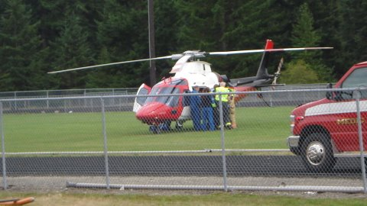

Public Education / Prevention Activities

|  |
| --- |
| Number of Public events 18  Total Hours 122 |
| Prairie Days, Rainier Round-Up Days, Christmas in the Park, Family Fun Days, Home and Garden Show, Relay for Life, Yelm High School Football Games, Rainier High School Football Games. |

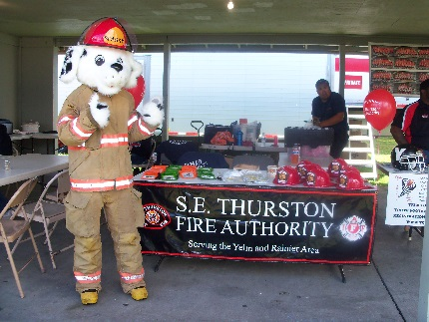 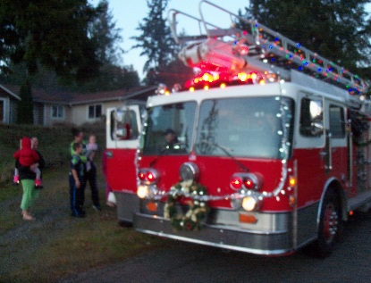 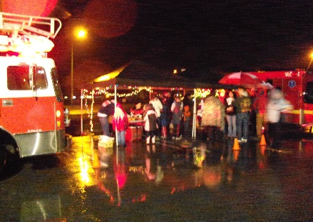

|  |  |
| --- | --- |
| Number of Station Tours, Day Care & School Visits: | Hours |
| 24 | 42 |

