Assignment-4

Q1. Write a select command that produces the order number,amount and date for all rows in the orders table.

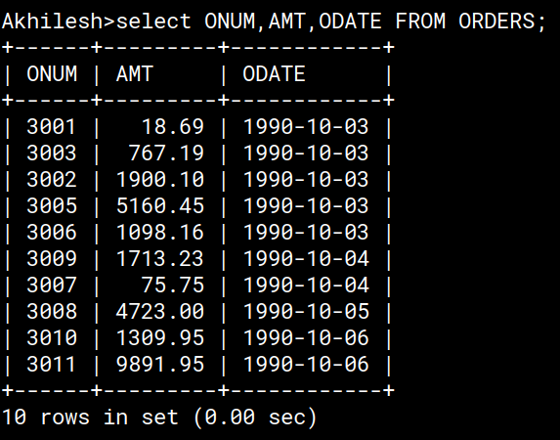

Q2. Write a query that produces all rows from the Customers table for which the salesperson’s number is 1001.

