Assignment-5

Q1. Write a query that will give you all orders for more than Rs. 1,000.

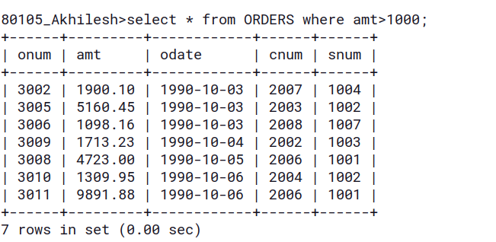
Q2. Write a query that will give you the names and cities of all salespeople in London with a commission above 0.10.

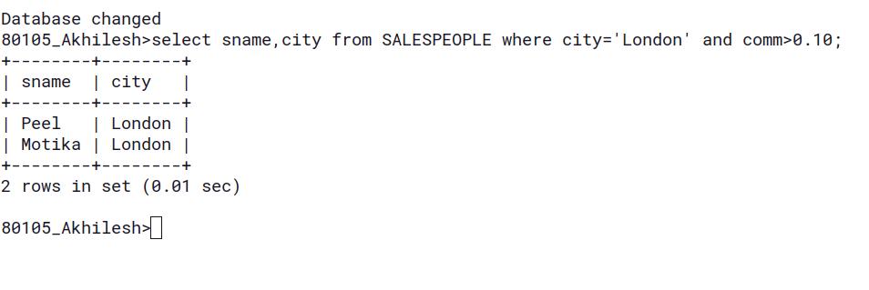

Q3. Write a query on the Customers table whose output will exclude all customers with a rating <= 100,unless they are located in Rome.

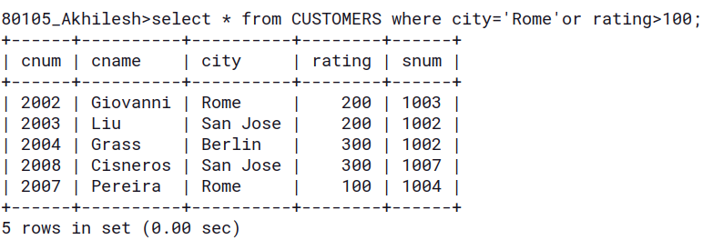

Q4. What will be the output from the following query?
select * from orders
where (amt < 1000 OR
NOT (odate = ‘1990-10-03’
AND cnum > 2003));

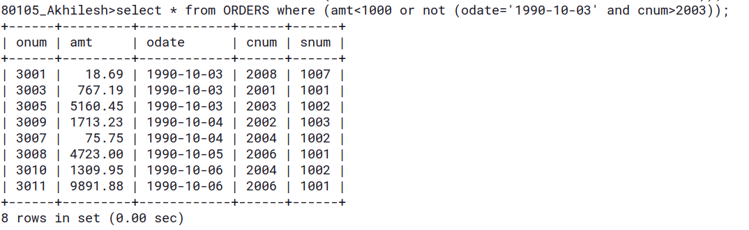

Q5. What will be the output of the following query?
Select * from orders
where NOT ((odate = ‘1990-10-03’ OR snum
> 1006) AND amt>= 1500);

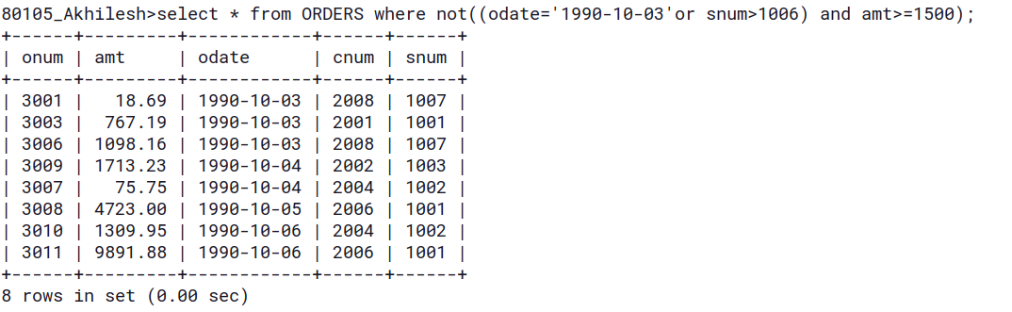

Q6. What is a simpler way to write this query?
Select snum,sname,city,comm from salespeople where
comm > 0.12 OR comm < 0.14);

