ASSIGNMENT-6
Q.1)Write two different queries that would produce all orders taken on october 3rd or 4th , 1190.
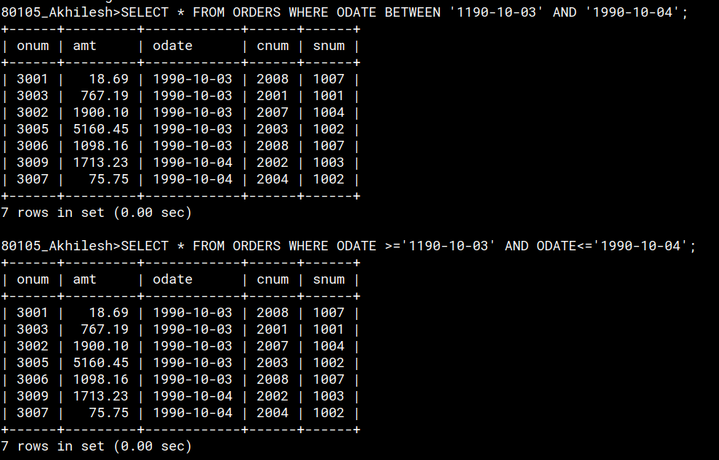
Q.2)Wite a query that selects all of the customers serviced by peel or motika
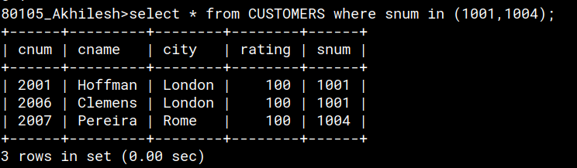
Q.3)Write a query that will produce allthe customers whose names begin with a letter from ‘A’ to ‘G’
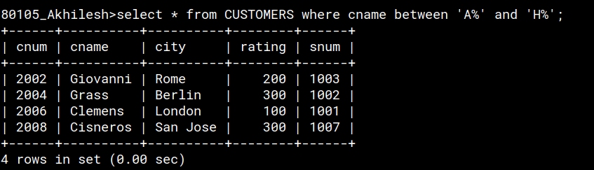
Q.4)Write a query that selects all the customers whose names begin with the letter ‘c’.
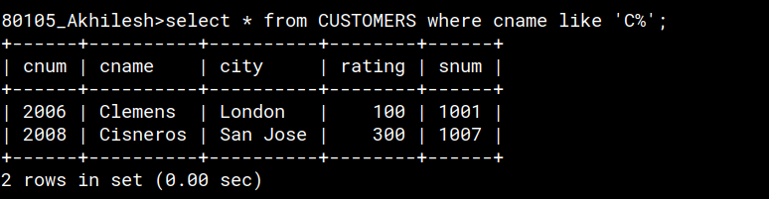
Q.5)Write a query that selects all orders except those with zeroes or NULLs in the amt field.
