1) Create a union of two queries that shows the names, cities, and ratings of all
customers. Those with rating of 200 or greater will also have the words “High
Rating”, while the others will have the words “Low Rating”.
Assignment 13
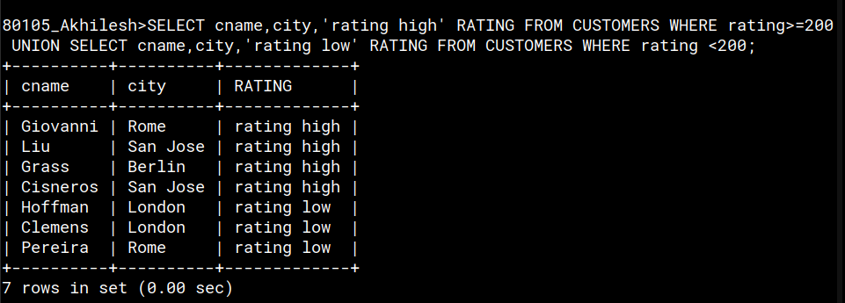

2) Write a command that produces the name and number of each salesperson and
each customer with more than one current order. Put the results in alphabetical
order.
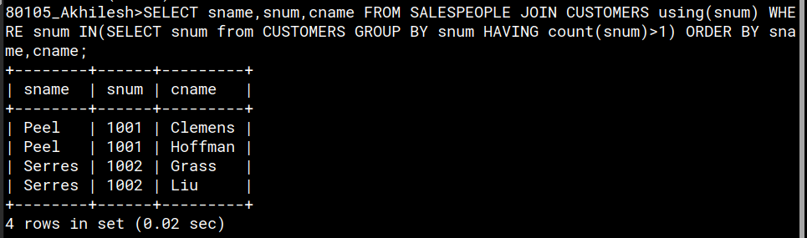

3) Form a union of three queries. Have the first select the snums of all salespeople in
San Jose; the second, the cnums of all customers in San Jose; and the third the
onums of all orders on October 3. Retain duplicates between the last two queries
but eliminate any redundancies between either of them and the first.

