SQL Assignment 7
Summarizing data with aggregation Functions .
1)
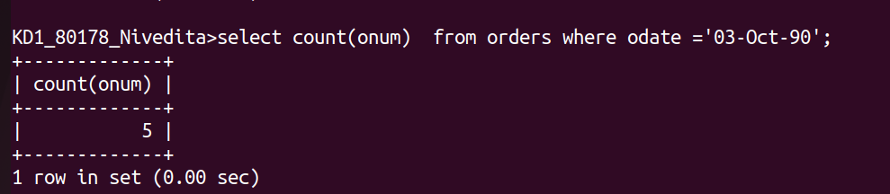
2)

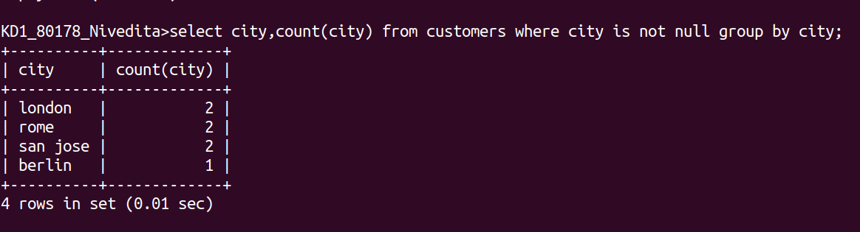
3)
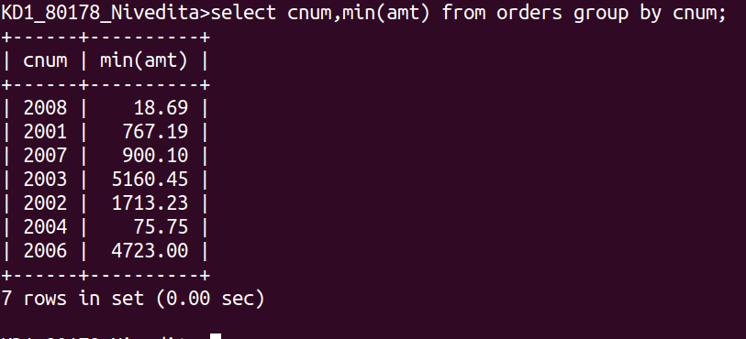

4)
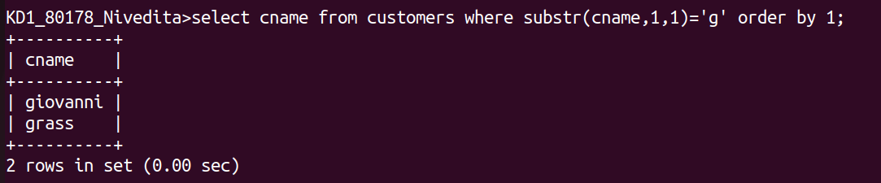
5)

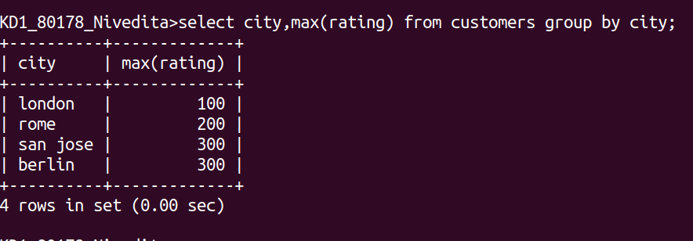
6)
