SQL Assignment 12

Using the Operators IN,Any and ALL.
1)

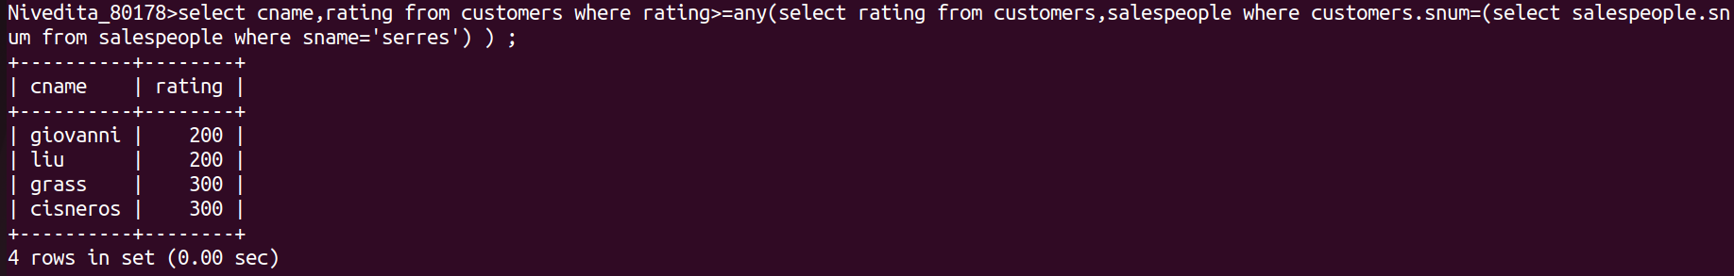
2)

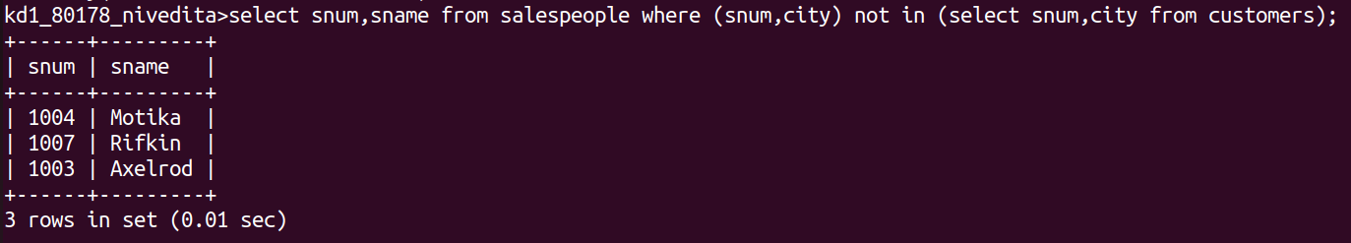
3)

