SQL Assignment 5
Relational and Logical Operators.
1)Write a query that will give you all orders for more than Rs.1,000.
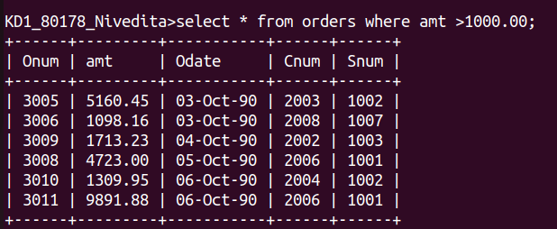
2)Write a query that will give you the names and cities of all salespeople on London with a commission above .10.

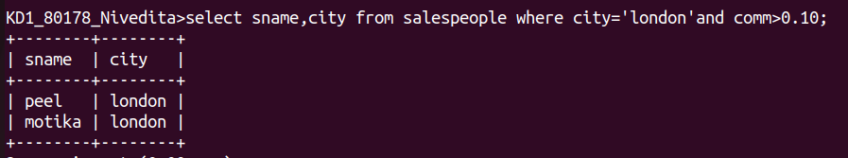

3)Write a query on the Customers tables whose output will exclude all customers with rating<=100,unless they are located in Rome.
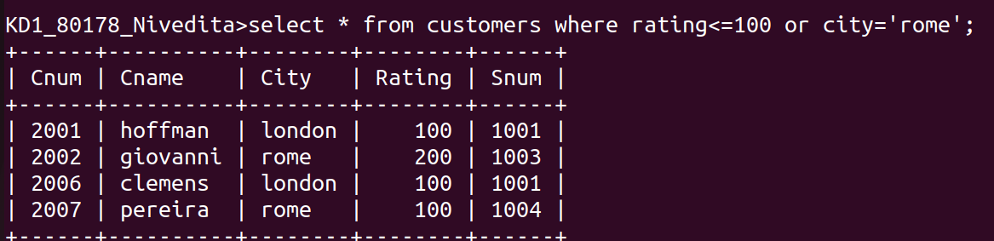
4)What will be the output from the following query?
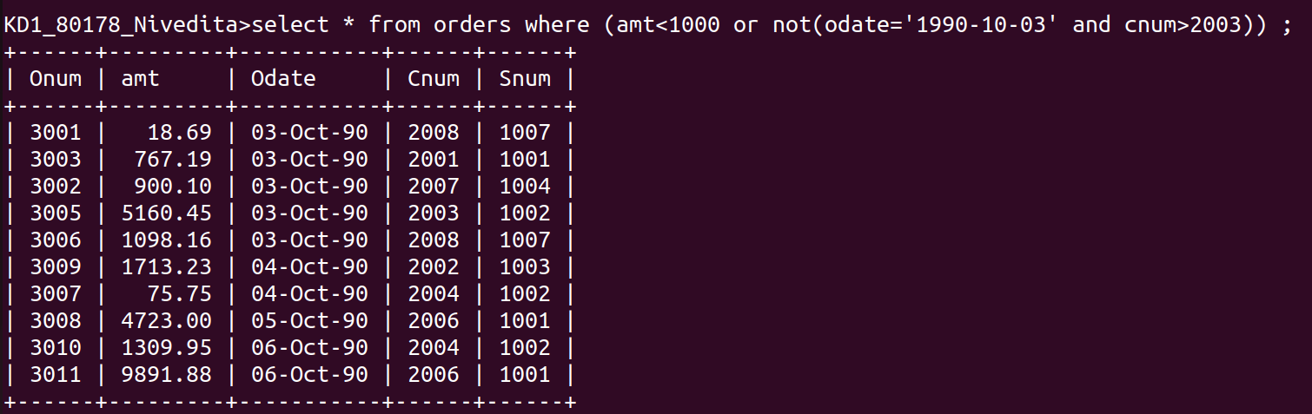
5)What will be the output from the following query?
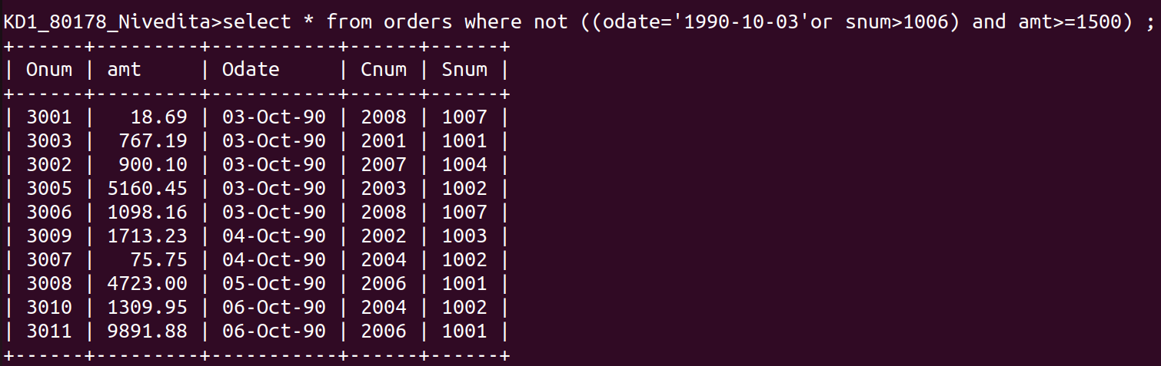

6)What is a simpler way to write this query?
