SQL Assignment 11
Subqueries
1)

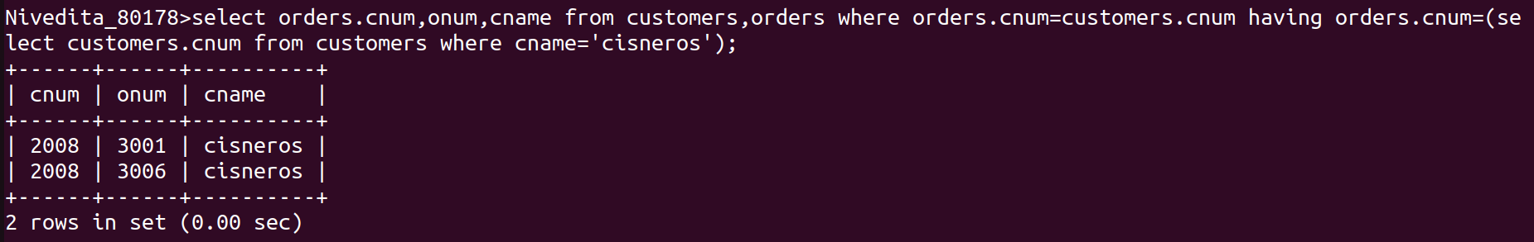
2)

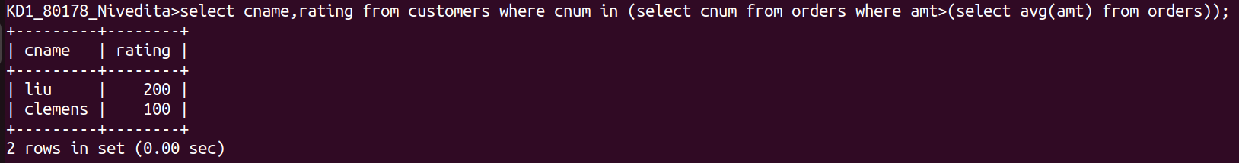
3)

