SQL Assignment 13

Using the Union Clause.
1)
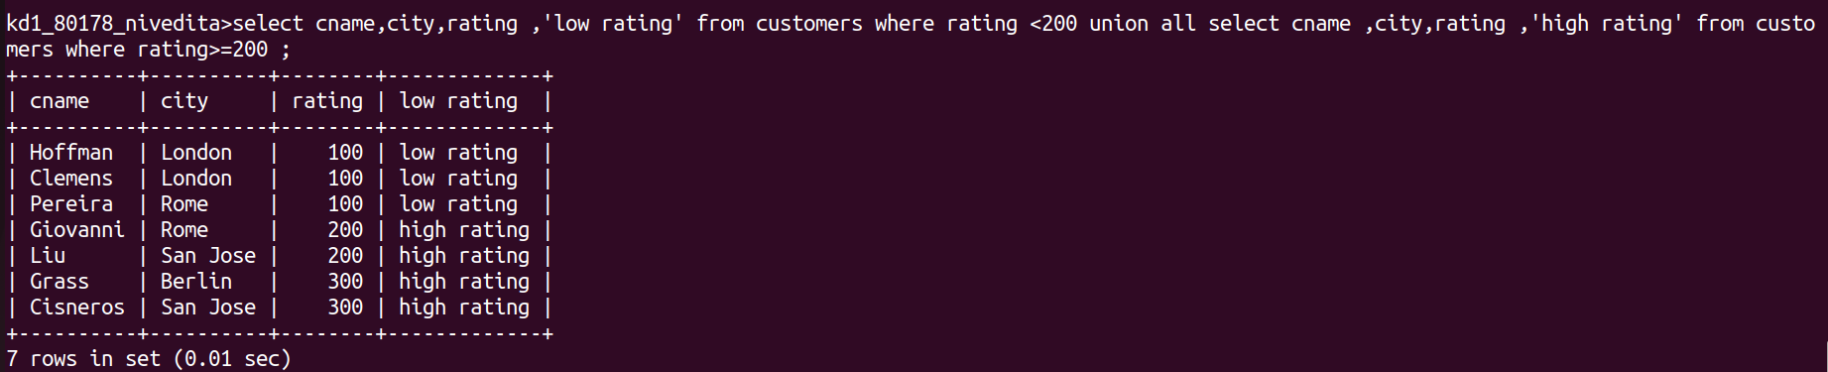

2)

3)

